**2.A.Distributed Database Design and Implementation**

**Aim:**

To configure MongoDB's replica sets and sharding, then perform CRUD operations to test data distribution, high availability, and fault tolerance in a distributed database environment.

**Procedure:**  
const { MongoClient } = require('mongodb');

// Function to set up the database and perform operations

async function run() {

const uri = "mongodb://localhost:27025"; // Connect to the mongos router instance

const client = new MongoClient(uri);

try {

await client.connect();

console.log("Connected to MongoDB via mongos router on port 27025");

const adminDb = client.db("admin");

// Step 1: Enable Sharding on Database

console.log("Enabling sharding on 'myDatabase'...");

await adminDb.command({ enableSharding: "myDatabase" });

console.log("Sharding enabled on 'myDatabase'.");

// Step 2: Shard the Collection

console.log("Sharding collection 'myDatabase.myCollection' on 'userId'...");

await adminDb.command({

shardCollection: "myDatabase.myCollection",

key: { userId: 1 }

});

console.log("Sharding enabled for 'myDatabase.myCollection'.");

// Step 3: Insert Data

const db = client.db("myDatabase");

const collection = db.collection("myCollection");

console.log("Inserting documents...");

await collection.insertMany([

{ userId: 1, name: "Alice", age: 25, location: "Region1" },

{ userId: 2, name: "Bob", age: 30, location: "Region2" },

{ userId: 3, name: "Charlie", age: 28, location: "Region3" }

]);

console.log("Documents inserted.");

// Step 4: Query Data

console.log("Querying all documents...");

const docs = await collection.find().toArray();

console.log("Documents in 'myCollection':", docs);

// Step 5: Update Data

console.log("Updating document with userId 1...");

await collection.updateOne(

{ userId: 1 },

{ $set: { age: 26 } }

);

console.log("Document updated.");

// Step 6: Delete Data

console.log("Deleting document with userId 2...");

await collection.deleteOne({ userId: 2 });

console.log("Document deleted.");

// Step 7: Check Sharding Status (using `sh.status()` isn't available in Node.js)

console.log("Sharding status can be checked in the MongoDB shell using `sh.status()`.");

} finally {

await client.close();

}

}

run().catch(console.dir);  
  
  
**output:**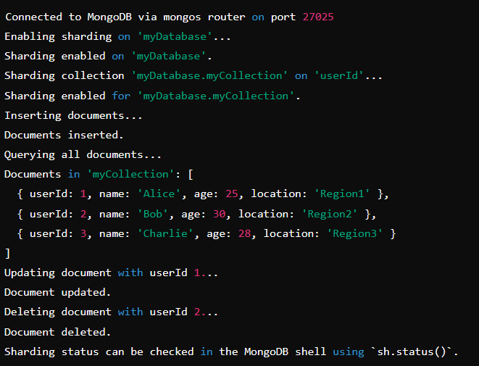

**Result:**

Thus To configure MongoDB's replica sets and sharding, then perform CRUD operations to test data distribution, high availability, and fault tolerance in a distributed database environment has been completed successfully.

**2.B. Row level and statement level triggers**

**Aim:**

 To create row level and statement level triggers in mongodb.

**Procedure:**

// Load environment variables from the .env file (e.g., MongoDB connection URI)

require('dotenv').config();

// Import MongoClient from the MongoDB package to interact with the database

const { MongoClient } = require('mongodb');

// MongoDB connection URI retrieved from the .env file (you can store it securely here)

const uri = process.env.MONGODB_URI;

async function main() {

  // Create a new MongoClient instance using the connection URI and options

  const client = new MongoClient(uri, { useNewUrlParser: true, useUnifiedTopology: true });

  try {

    // Connect to MongoDB using the MongoClient instance

    await client.connect();

    console.log("Connected to MongoDB!");

    // Access the 'mydb' database

    const db = client.db("mydb");

    // Access the 'users' collection in the 'mydb' database

    const usersCollection = db.collection("users");

    // Insert sample data into the 'users' collection to simulate real-world data

    await usersCollection.insertMany([

      { name: "John Doe", email: "john@example.com", age: 30 },

      { name: "Jane Smith", email: "jane@example.com", age: 25 },

      { name: "Emily Davis", email: "emily@example.com", age: 35 }

    ]);

    console.log("Sample data inserted.");

    // 2. Row-Level Trigger (Document-Level Trigger):

    // Create a change stream to listen for updates on documents in the 'users' collection.

    // We filter the events to only capture 'update' operations on documents.

    const rowLevelChangeStream = usersCollection.watch([

      { $match: { 'operationType': 'update', 'fullDocument._id': { $exists: true } } }

    ]);

    // Set up an event listener that reacts to document update changes

    rowLevelChangeStream.on('change', (next) => {

      // This will log the details of the updated document when a row-level update occurs

      console.log("Row-Level Trigger: Document Updated", next);

    });

    // 3. Statement-Level Trigger (Collection-Level Trigger):

    // Create another change stream to listen for any change in the 'users' collection.

    // This captures all operations: insert, update, and delete on any document in the collection.

    const statementLevelChangeStream = usersCollection.watch();

    // Set up an event listener for all changes in the collection (insert, update, delete)

    statementLevelChangeStream.on('change', (next) => {

      // This will log the details of any change in the collection

      console.log("Statement-Level Trigger: Change Detected in Collection", next);

    });

    // Simulating updates to trigger the change streams:

    setTimeout(async () => {

      // Simulate an update operation on a specific document (row-level trigger)

      console.log("Updating user...");

      await usersCollection.updateOne(

        { name: "John Doe" },  // Filter to update document with 'name' equal to 'John Doe'

        { $set: { age: 31 } }  // Update the 'age' field to 31

      );

      // Simulating another update on a different user to test collection-level trigger

      console.log("Updating another user...");

      await usersCollection.updateOne(

        { name: "Emily Davis" },  // Filter to update document with 'name' equal to 'Emily Davis'

        { $set: { email: "emily.davis@example.com" } }  // Update the 'email' field

      );

      // Simulating document insertion to test collection-level trigger

      console.log("Inserting new user...");

      await usersCollection.insertOne({ name: "Michael Johnson", email: "michael@example.com", age: 40 });

    }, 2000); // Wait for 2 seconds before performing the updates and insert

  } catch (err) {

    // If any error occurs during the operations, log it

    console.error("Error:", err);

  }

}

// Run the 'main' function and handle any potential errors

main().catch(console.error);

**Output:**

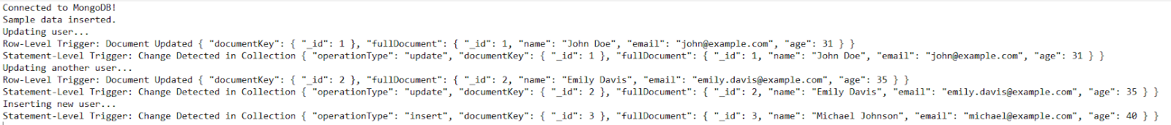

**Result:**

Thus To create row level and statement level triggers in mongodb has been completed successfully.

**2.C.Accessing a Relational Database using PHP, Python and R**

**Aim:**

To Accessing a Relational Database using PHP, Python and R.

**Procedure:**

1. **Accessing a Relational Database using PHP (MySQL with PDO)**

<?php

// Step 1: Define database connection variables

$host = 'localhost'; // The host where the MySQL database is running (usually localhost for local development)

$db = 'mydatabase'; // The name of the database you want to connect to

$user = 'root'; // The username for connecting to the MySQL server

$pass = ''; // The password associated with the user (in this case, empty for local setup)

// Step 2: Set the Data Source Name (DSN) to connect to the database

$dsn = "mysql:host=$host;dbname=$db"; // The DSN contains the MySQL host and database name for the connection

// Step 3: Try to establish a connection to the database

try {

    // Create a new PDO instance using the DSN, username, and password

    $pdo = new PDO($dsn, $user, $pass);

    // Set the PDO error mode to exception. This will throw exceptions in case of errors, instead of just warnings.

    $pdo->setAttribute(PDO::ATTR_ERRMODE, PDO::ERRMODE_EXCEPTION);

    // Step 4: Create table if it doesn't exist

    $pdo->exec("

        CREATE TABLE IF NOT EXISTS mytable (

            id INT AUTO_INCREMENT PRIMARY KEY,

            column_name VARCHAR(255) NOT NULL

        )

    ");

    // Step 5: Insert sample data into the table

    $pdo->exec("INSERT INTO mytable (column_name) VALUES ('Alice')");

    $pdo->exec("INSERT INTO mytable (column_name) VALUES ('Bob')");

    $pdo->exec("INSERT INTO mytable (column_name) VALUES ('Charlie')");

    // Step 6: Query the database to retrieve data from the table

    $stmt = $pdo->query("SELECT * FROM mytable"); // This executes an SQL query to fetch all rows from 'mytable'

    // Step 7: Fetch all the results and display them

    $rows = $stmt->fetchAll(PDO::FETCH_ASSOC); // Fetch the results as an associative array (key-value pairs)

    foreach ($rows as $row) { // Loop through each row returned by the query

        echo $row['column_name'] . "<br>"; // Print the value of 'column_name' from each row

    }

} catch (PDOException $e) {

    // If there's an error while connecting or querying, catch the exception and display an error message

    echo "Connection failed: " . $e->getMessage();

}

?>  
  
**output:**

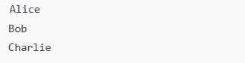

**2.Accessing a Relational Database using Python (MySQL with mysql-connector)**

import mysql.connector

# Step 1: Establish a connection to the MySQL database

conn = mysql.connector.connect(

    host='localhost',  # The hostname of the MySQL server, typically 'localhost' for local databases

    user='root',       # The username for connecting to MySQL

    password='',       # The password for the MySQL user (empty string here for local development)

    database='mydatabase'  # The name of the database to connect to

)

# Step 2: Create a cursor object to execute SQL queries

cursor = conn.cursor()  # A cursor is an object used to interact with the database and execute queries

# Step 3: Create the table `mytable` (if it doesn't already exist)

cursor.execute("""

    CREATE TABLE IF NOT EXISTS mytable (

        id INT AUTO_INCREMENT PRIMARY KEY,

        name VARCHAR(255),

        age INT

    )

""")

# Step 4: Insert sample data into `mytable`

cursor.execute("INSERT INTO mytable (name, age) VALUES (%s, %s)", ('Alice', 30))

cursor.execute("INSERT INTO mytable (name, age) VALUES (%s, %s)", ('Bob', 25))

cursor.execute("INSERT INTO mytable (name, age) VALUES (%s, %s)", ('Charlie', 35))

# Commit the changes to the database

conn.commit()

# Step 5: Execute an SQL query to retrieve data from the table

cursor.execute("SELECT * FROM mytable")  # This executes the query that selects all rows from 'mytable'

# Step 6: Fetch all rows from the result set

rows = cursor.fetchall()  # The `fetchall()` method retrieves all rows returned by the query as a list of tuples

# Step 7: Iterate over the rows and print the data

for row in rows:  # Loop through the list of rows

    print(row)  # Print each row (each row is a tuple representing a record)

# Step 8: Close the cursor and connection to free up resources

cursor.close()  # Close the cursor object

conn.close()  # Close the connection to the MySQL server

**output:**

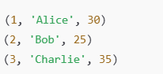

**3.Accessing a Relational Database using R (MySQL with RMySQL)**

# Step 1: Install and load the RMySQL package

install.packages("RMySQL")  # Install the RMySQL package (uncomment this line if not installed)

library(RMySQL)  # Load the RMySQL package to interact with MySQL databases from R

# Step 2: Establish a connection to the MySQL database

con <- dbConnect(RMySQL::MySQL(),  # Create a connection object to the MySQL database

                 host = "localhost",  # The hostname for the MySQL server

                 user = "root",  # The username for the MySQL connection

                 password = "",  # The password for the MySQL user (empty here for local development)

                 dbname = "mydatabase")  # The database name to connect to

# Step 3: Create the table if it does not exist

dbExecute(con, "

  CREATE TABLE IF NOT EXISTS mytable (

    id INT AUTO_INCREMENT PRIMARY KEY,

    column_name VARCHAR(255) NOT NULL

  )

")

# Step 4: Insert sample data into 'mytable'

dbExecute(con, "INSERT INTO mytable (column_name) VALUES ('Alice')")

dbExecute(con, "INSERT INTO mytable (column_name) VALUES ('Bob')")

dbExecute(con, "INSERT INTO mytable (column_name) VALUES ('Charlie')")

# Step 5: Execute an SQL query to retrieve data from the table

result <- dbGetQuery(con, "SELECT * FROM mytable")  # Execute the SQL query to fetch all rows from 'mytable'

# Step 6: Print the result (the query result is returned as a data frame in R)

print(result)  # Output the result (a data frame) to the console

# Step 7: Close the connection to the database

dbDisconnect(con)  # Close the database connection to free up resources

**Output:  
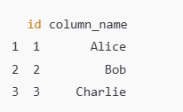**

**Result:**

               Thus To Accessing a Relational Database using PHP, Python and R.

               Has been completed successfully