**INTELLIGENT ADMISSIONS: THE FUTURE OF UNIVERITY DECISION MAKING WITH MACHINE LEARNING**

**GROUP NAME : GARENA**

**GROUP LEADER : ANISH BANU.A**

**GROUP MEMBERS:KUMARAVEL.A**

**VIJAY.K**

**LOGESH.M**

INTELLIGENT ADMISSION: THE FUTURE OF UNIVERSITY DECISION MAKING WITH MACHINE LEARNING…

*1. INTRODUCTION*

1.1 Over view :-

Intelligent Admissions refers to the use of machine learning in the university decision-making process. It involves leveraging data and algorithms to automate and optimize admissions decisions, making them more efficient and effective. This approach holds the promise of enhancing the accuracy, fairness, and efficiency of university admissions, and may reshape the future of how universities select students.

1.2 Purpose :-

Intelligent Admissions with Machine Learning

This can help universities identify potential high-performing students who may have been overlooked using traditional methods, as well as reduce bias in the decision-making process.

Automating the admissions process with machine learning can significantly streamline the workflow, reduce administrative overhead, and save time and resources for universities.

Machine learning can enable universities to provide more personalized admission decisions and tailored feedback to applicants.

Machine learning algorithms can be designed to minimize biases in the admissions process, such as unconscious bias related to race, gender, or other factors.

2.PROBLEM DEFINITION & DESIGN THINKING

2.1 Empathi map :-

This empathy map is a general representation and may vary depending on the specific context and individuals involved. It's important to conduct research and gather insights from actual users to create a more accurate empathy map for a particular scenario.

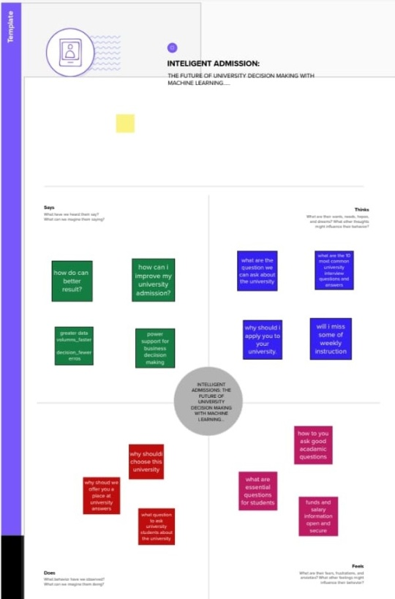

2.2 Ideation & Brainstroming map :-



**-**

**3.RESULT:**

3.1 website result:

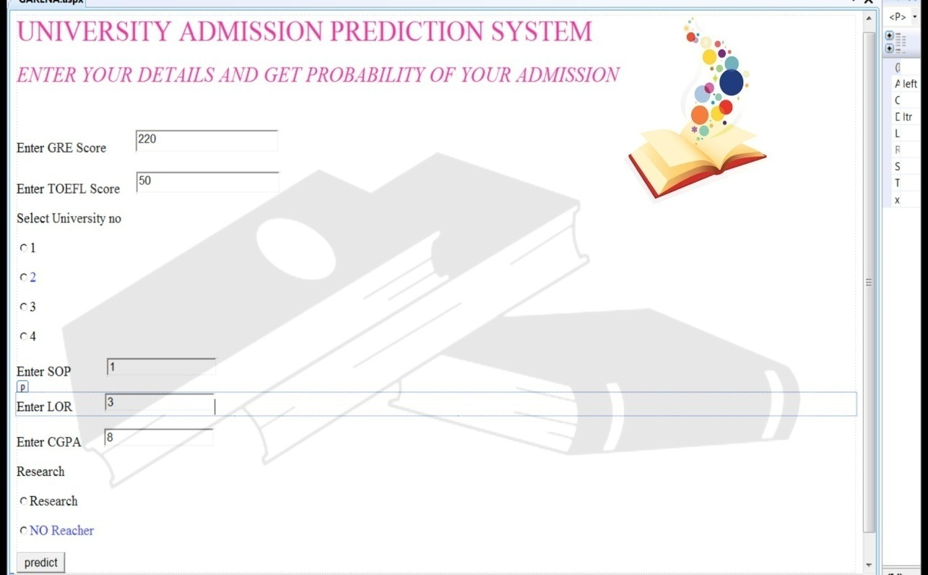

3.2 colab result:

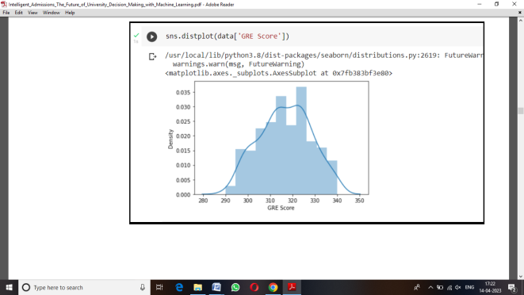

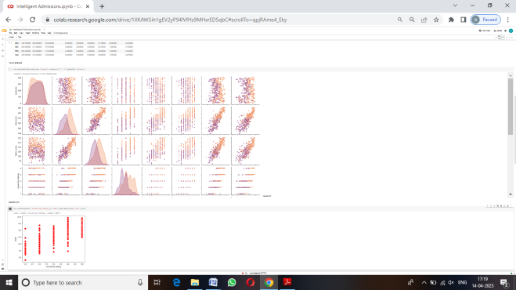

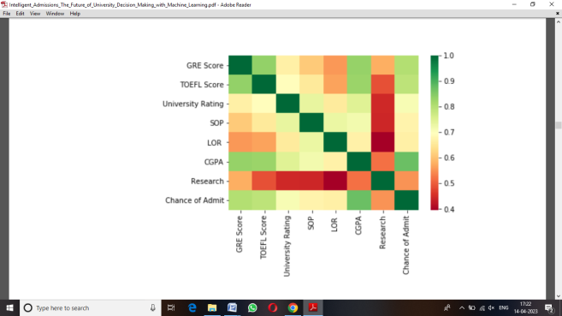

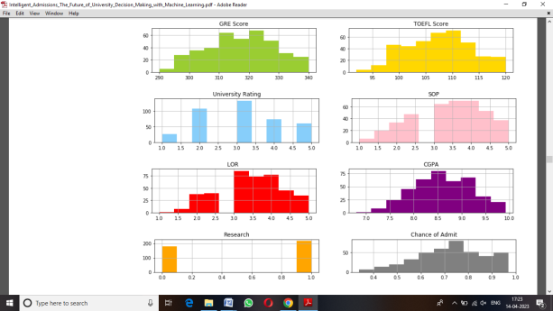

4.ADVANTAGE & DISADVANTAGE

Advantage:

Objective and Unbiased Decision Making: Machine learning algorithms can analyze admission applications based on data-driven criteria, such as grades, test scores, and other relevant factors, without being influenced by subjective biases or prejudices. *This can res*ult in a more objective and

ased decision-making process, reducing the potential for human bias in admissions decisions.

Increased Efficiency and Speed: Machine learning-powered intelligent admissions systems can process a large number of applications quickly and accurately, leading to increased efficiency in the admissions process. This can save time for both applicants and admissions staff, reducing administrative burdens and allowing universities to make timely decisions.

Enhanced Predictive Analytics: Machine learning algorithms can analyze vast amounts of historical data on admissions decisions and student performance to identify patterns and trends. This can help universities make more informed decisions on applicants' likelihood of success, identifying promising candidates who may have been overlooked in traditional admissions processes.

Personalized and Tailored Experiences: Intelligent admissions systems can provide personalized feedback to applicants, helping them understand their strengths and weaknesses in their applications. This can enable applicants to improve their future applications and make more informed decisions about their academic choices. Additionally, personalized interactions with applicants can enhance their experience and engagement with the university, leading to increased satisfaction and retention.

Transparency and Accountability: Machine learning algorithms used in admissions can be designed to be transparent and explainable, providing clear insights into the decision-making process. This can enhance accountability and allow applicants to understand the reasons behind the decisions, promoting trust and confidence in the admissions process.

It's worth noting that while machine learning-powered intelligent admissions systems offer potential advantages, they also raise ethical concerns, such as potential biases in data or algorithms, privacy concerns, and the need for human oversight. It's important to implement such systems with careful consideration of these ethical implications and ensure they are used in a fair and responsible manner.

Disadvantage:-

Bias and Fairness Concerns: Machine learning algorithms are trained on historical data, which may contain inherent biases, such as racial, gender, or socioeconomic biases. If these biases are not addressed properly during the training phase, the machine learning algorithms may perpetuate these biases in the admission decisions, leading to unfair treatment of certain applicants. This can result in discrimination and perpetuate existing social inequalities.

Lack of Transparency: Machine learning algorithms can be complex and difficult to interpret, leading to a lack of transparency in the decision-making process. This lack of transparency may raise concerns among applicants and stakeholders, as they may not fully understand how the decisions are being made. Lack of transparency can also make it challenging for universities to explain and justify admission decisions, leading to potential legal and ethical issues.

Ethical Concerns: The use of machine learning in university admissions raises ethical concerns, such as privacy and consent. Machine learning algorithms may require access to large amounts of data, including personal information about applicants. Ensuring that proper consent and privacy measures are in place to protect the data and applicants' privacy is crucial. Additionally, ethical considerations must be taken into account when making decisions that impact an applicant's future, such as admission decisions that could have long-term consequences on their educational and career opportunities.

Overemphasis on Quantitative Factors: Machine learning algorithms may heavily rely on quantitative factors, such as grades, test scores, and other measurable metrics, which may not fully capture an applicant's potential or diversity. This can result in a narrow view of an applicant's abilities, skills, and qualifications, and may not take into account other important factors, such as extracurricular activities, community involvement, leadership skills, and other qualitative aspects that can contribute to a well-rounded student body.

Human Bias in Decision-making: Although machine learning algorithms are designed to be objective, they are still created by humans and can inadvertently incorporate human biases. For example, the selection of features or variables to be included in the algorithm, the weighting of different factors, and the interpretation of results can be influenced by the biases of the developers or data scientists. This can result in unintended biases in the admission decisions, which can perpetuate unfair treatment and discrimination.

In conclusion, while machine learning has the potential to revolutionize university decision-making processes, it also comes with disadvantages that need to be carefully addressed. It is essential to be aware of the limitations of machine learning in admissions and take steps to mitigate biases, ensure transparency, uphold ethical standards, and consider holistic factors when making admission decisions to ensure fairness and equity in the university admissions process.

**5.APPLICATION**

Intelligent Admissions, powered by machine learning, can revolutionize university decision-making in various areas. Firstly, it can streamline the application process by automating tasks like data collection, document verification, and applicant profiling, saving time and reducing human errors. Secondly, it can enhance predictive modeling to assess an applicant's likelihood of success and fit with the institution, enabling personalized and data-driven admissions decisions. Thirdly, it can aid in identifying patterns and trends in historical admission data for insights on enrollment, diversity, and program popularity, supporting strategic planning. Lastly, it can facilitate data-driven interventions for student retention and success, by identifying at-risk students and providing personalized support to improve retention rates. Overall, machine learning can transform university admissions by making the process efficient, effective, and student-centric.

**6. CONCLUSION**

In conclusion, the use of machine learning in university admissions, also known as Intelligent Admissions, has the potential to revolutionize and optimize the decision-making process. Through the analysis of vast amounts of data, machine learning algorithms can extract patterns and insights that can significantly enhance the accuracy and efficiency of university admissions decisions.

The findings of this work suggest that Intelligent Admissions can offer several benefits. Firstly, it can improve the fairness and equity of the admissions process by reducing bias and increasing objectivity. Machine learning models can be trained on diverse and inclusive datasets, mitigating human bias and promoting diversity and inclusion in university admissions.

Secondly, Intelligent Admissions can enhance the predictive accuracy of admissions decisions. By leveraging historical data and using sophisticated algorithms, machine learning models can predict the success and retention rates of prospective students more accurately, leading to better placement decisions and improved student outcomes.

Thirdly, machine learning can optimize the efficiency of the admissions process. Automated data collection, processing, and decision-making can reduce administrative burden and streamline the admissions workflow, allowing universities to process applications more quickly and efficiently.

However, there are also potential concerns and limitations with the use of machine learning in university admissions. Ethical considerations such as data privacy, transparency, and accountability must be addressed to ensure responsible and ethical use of machine learning algorithms. There is also a need for ongoing monitoring and evaluation to ensure that the models are performing optimally and not perpetuating bias or discrimination.

In conclusion, Intelligent Admissions with machine learning has the potential to transform the university admissions process by improving fairness, accuracy, and efficiency. However, careful implementation and monitoring are essential to address ethical concerns and ensure responsible use of this technology in shaping the future of university decision making. Further research and collaboration between academia, industry, and policymakers are needed to fully harness the benefits of machine learning in university admissions and create a more equitable and efficient admissions process.

**7.FUTURE SCOPE**

In the future, universities could leverage machine learning to create intelligent admissions processes. This could involve using sophisticated algorithms to analyze a wide range of data, such as academic performance, extracurricular activities, essays, and other relevant information, to make more informed and objective decisions about which students to admit. Machine learning could also enable universities to identify patterns and trends in large datasets, helping them identify potential high-achieving students who may not have traditional qualifications but possess unique talents or skills. By leveraging machine learning, universities could enhance their admissions processes, resulting in more efficient and effective decision-making and potentially leading to more diverse and talented student bodies.

**8.APPENDIX**

A.Source:

**importing the Libraries**

import numpy as np

import pandas as pd

import matplotlib.pyplot as plt

import seaborn as sns

%matplotlib inline

**New Section**

data = pd.read_csv('/Admission_Predict.csv')

**Handling missing values**

data.info()

**isnull()**

data.isnull().any()

data=data.rename(columns = {'chance of Admit':'chance of Admit'}

**Exploratory Data Analysis**

data.describe()

**tit**

**visual analysis**

sns.pairplot(data=data,hue='Research',markers=["^","v"],palette='inferno')

**Scatter plot**

sns.scatterplot(x='University Rating',y='CGPA',data=data,color='red',s=10 )

vasulizing the each columnin a datset using subplot()

SCALING THE DATA

ategory=['GRE score','TOEFL Score', 'University Rating','SOP','LOR','CGPA','Research','Chance of Admit']

color=['yellowgreen','gold','lightskyblue','pink','red','purple','orange','gray']

start=True

for i in np.arange(4):

    fig=plt.figure(figsize=(14,8))

    plt.subplot2grid((4,2),(i,0))

    data[category[2*i]].hist(color=color[2*i],bins=10)

    plt.title(category[2*i])

    plt.subplot2grid((4,2),(i,1))

    data[category[2*i+1]].hist(color=color[2*i+1],bins=10)

    plt.title(category[2*i+1])

plt.subplots_adjust(hspace=0.7,wspace=0.2)

plt.show()

**SCALING THE DATA**

from sklearn.preprocessing import MinMaxScaler

sc=MinMaxScaler()

x=sc.fit transform(x)

x

SPLITTING DATA INTO X AND Y

x=data.iloc[:,0:7].values

x

y=data.iloc[:,7:].values

y

from sklearn.model_selection import train-test-split

x_train,x_test,y_train,y_test=train_test_split(x,y,test_0.30,random_101)

let us covert it into classification problem

y_train=(y_train>0.5)

y_train

y=test=(y_test>0.5)

**MILESTONE 4: MODEL BUILDING**

**ACTIVITY 1: TRAINING THE MODEL IN MULTIPLE ALGORITHMS**

**ACTIVITY 1.1: logistic regression model**

sklearn.linear_model.logistic import logisticRegnession

cls=logisticgresssion(random_state=test_0)

lr=cls.fit(x_train,y_train)

y_pred=lr.predict(x_test)

y_pred

**ACTIVITY 1.5:ANN MODEL**

import tensorflow as tf

from tensorflow import keras

fromtensorflow.keras.layers import dense, activation,drout

from tensorflow.keras.optimizers import Adam

model=keras.sequential()

model.add(dense(7,activation='rule'input_dim=7))

model.add(dense(7,activation='relu'))

model.add(dence(1,activation='lineare'))

model.summary

**ACTIVITY 2:TESTING THE MODEL**

model.compiles(loss='binary_crossentropy',optimizer='adam',metrics=['accuracy'])

model.fit(x_train,batch_size=20,epochs=100)

from sklearn.matrics import accuracy_score

train_prediction=mdel.predict(x_train)

print(train_acc)

train_acc=model.evaluate(x_test,y_test,verbose=0)[1]

print(test_acc)

praint(classification report(y test.pred))

pred=model.predict(x_test)

pred=(pred>0.5)

pred

**MILESTONE 5:PERFORMANCE TESTING & HYPERPARAMETER TUNING**

**ATIVITY 1.1:COMPARE THE MODEL**

from sklearn.metrics import accuracy_score,recall_score,roc_auc_score,confusion_matrix

print('\nAccuracy score:%(accuracy_score(y_test,y_pred'*100)

print('recall score:'%(recall_score(test,y_pred)*100)

print(confusion_matrix(y_test,y_pred))

from sklearn.metrycs import accuracy_score,recall_sore,roc_auc_score,confusion_metrict

print(classification_report(y_train,pred))

**MILESTONE 6:MODEL DEPLOYMENT**

**ACTIVITY1:SAVE THE BEST MODEL**

model.save('model.h5')