**Competitive programming lab assignment 1**

Name: Anjali m s

Roll no: AM.SC.P2CSC19009

1. Bubble Sort.

#include<iostream>

using namespace std;

voidBubblesort(intarr[],int n)

{

inti,j,temp;

for(i=0;i<n;i++)

{

for(j=0;j<n-i-1;j++)

{

if(arr[j]>arr[j+1])

{

temp = arr[j];

arr[j]=arr[j+1];

arr[j+1]=temp;

}

}

}

}

void display(intarr[],int n)

{

int i;

for( i=0;i<n;i++)

{

cout<<arr[i]<<" " ;

}

}

int main()

{

intn,i;

cout<<"Enter the Size of array ";

cin>>n;

intarr[n];

cout<<"Enter the Elements:";

for( i=0;i<n;i++)

{

cin>>arr[i];

}

cout<<"Before sort Elements:";

display(arr,n);

Bubblesort(arr,n);

cout<<endl<<"After sort Elements:";

display(arr,n);

return 0;

}

OUTPUT:

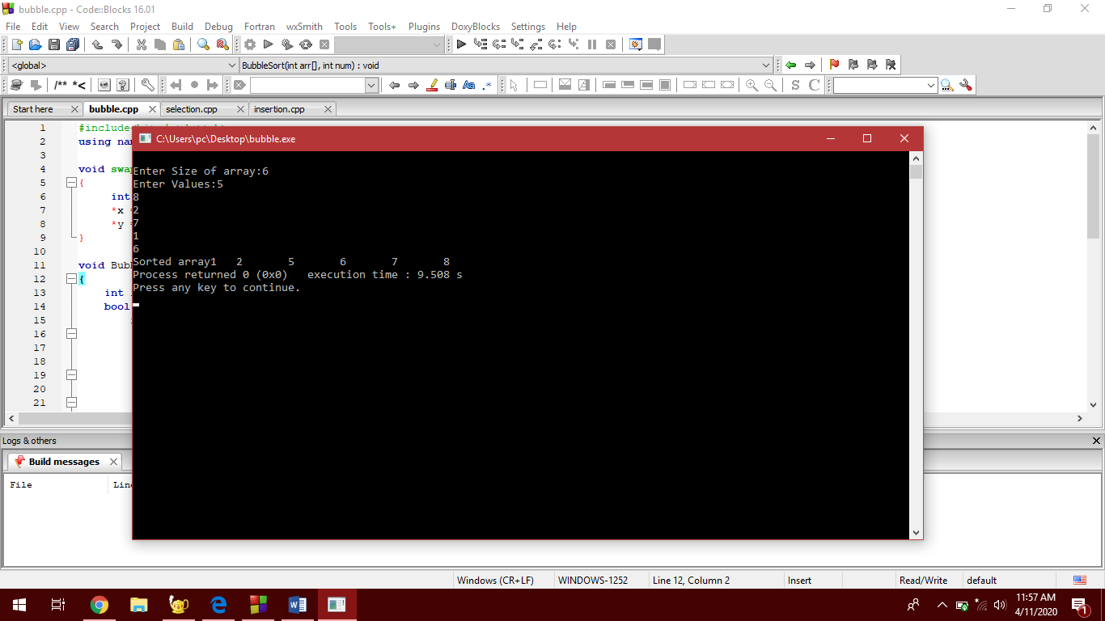

1. Selection Sort.

Source Code:

#include<bits/stdc++.h>

using namespace std;

void swap(int *x,int *y){

int temp = *x;

*x = *y;

*y = temp;

}

voidSelectionSort(intarr[], int size)

{

inti, j, min;

for (i=0;i<size-1;i++)

{

min = i;

for(j=i+1;j<size;j++)

{

if(arr[j]<arr[min])

min=j;

}

swap(&arr[min], &arr[i]);

}

}

int main()

{

inta,i;

cout<<"\nEnter size of Array:";

cin>>a;

intarr[a];

cout<<"Enter elements: ";

for(i = 0; i< a; i++){

cin>>arr[i];

}

SelectionSort(arr, a);

cout<<"Sorted array";

for (i=0;i<a;i++)

{

cout<<arr[i]<<"\t";

}

return 0;

}

OUTPUT:

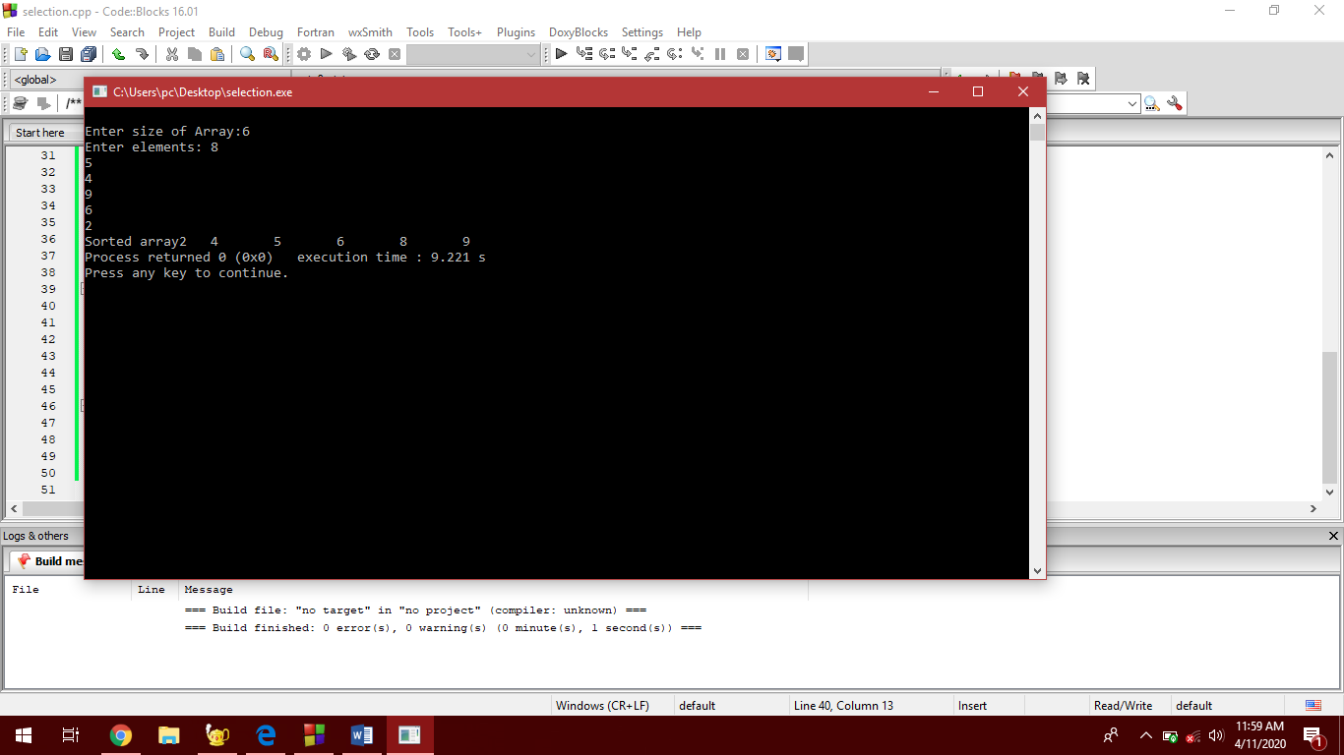

1. Insertion Sort

Source Code:

#include<bits/stdc++.h>

using namespace std;

voidInsertionSort(intarr[], int size)

{

int key;

for(inti=1;i<size;i++)

{

key = arr[i];

int j = i-1;

while(j >= 0&&arr[j]>key)

{

arr[j+1]=arr[j];

j=j-1;

}

arr[j+1]=key;

}

}

int main()

{

inta,i;

cout<<"\nEnter Array Size";

cin>>a;

intarr[a];

cout<<"Enter elements :";

for(i = 0; i< a; i++)

{

cin>>arr[i];

}

InsertionSort(arr, a);

cout<<"Sorted array";

for (i = 0; i< a; i++)

{

cout<<arr[i]<<"\t";

}

return 0;

}

Output:

