PANIMALAR ENGINEERING COLLEGE

DEPARTMENT OF CSE

SELENIUM - IDE

SANGEETHA N

CSE B

(211414104233)

**SELENIUM-IDE**

**Introduction:**

The Selenium-IDE (Integrated Development Environment) is the tool you use to develop your Selenium test cases. It’s an easy-to-use Firefox plug-in and is generally the most efficient way to develop test cases. It also contains a context menu that allows you to first select a UI element from the browser’s currently displayed page and then select from a list of Selenium commands with parameters pre-defined according to the context of the selected UI element. This is not only a time-saver, but also an excellent way of learning Selenium script syntax.

Selenium IDE is a fully featured Integrated Integrated Development Environment (**IDE**) that installs as a plug-in in Mozilla Firefox and enables developers to test their web applications through **Selenium**. With the **Selenium IDE**, you can record user interactions with the web browser and play them back to test for errors.

**IDE Features**

**Menu Bar**

The File menu has options for Test Case and Test Suite (suite of Test Cases). Using these you can add a new Test Case, open a Test Case, save a Test Case, export Test Case in a language of your choice. You can also open the recent Test Case. All these options are also available for Test Suite.

The Edit menu allows copy, paste, delete, undo, and select all operations for editing the commands in your test case. The Options menu allows the changing of settings. You can set the timeout value for certain commands, add user-defined user extensions to the base set of Selenium commands, and specify the format (language) used when saving your test cases. The Help menu is the standard Firefox Help menu; only one item on this menu–UI-Element Documentation–pertains to Selenium-IDE.

**Toolbar**

The toolbar contains buttons for controlling the execution of your test cases, including a step feature for debugging your test cases. The right-most button, the one with the red-dot, is the record button.

_images/chapt3_img06_IDE_features.png

**speed control**

Speed Control: controls how fast your test case runs.

**run all** Run All: Runs the entire test suite when a test suite with multiple test cases is loaded.

**run** Run: Runs the currently selected test. When only a single test is loaded this button and the Run All button have the same effect.

**pause resume**Pause/Resume: Allows stopping and re-starting of a running test case.

**step** Step: Allows you to “step” through a test case by running it one command at a time. Use for debugging test cases.

**testrunner** Test Runner Mode: Allows you to run the test case in a browser loaded with the Selenium- Core TestRunner. The TestRunner is not commonly used now and is likely to be deprecated. This button is for evaluating test cases for backwards compatibility with the TestRunner. Most users will probably not need this button.

Apply Rollup Rules: This advanced feature allows repetitive sequences of Selenium commands to be grouped into a single action. Detailed documentation on rollup rules can be found in the UI-Element Documentation on the Help menu.



**record** Record: Records the user’s browser actions. **The other tab -** Source displays the test case in the native format in which the file will be stored. By default, this is HTML although it can be changed to a programming language such as Java or C#, or a scripting language like Python. See the Options menu for details. The Source view also allows one to edit the test case in its raw form, including copy, cut and paste operations.

The Command, Target, and Value entry fields display the currently selected command along with its parameters. These are entry fields where you can modify the currently selected command. The first parameter specified for a command in the Reference tab of the bottom pane always goes in the Target field. If a second parameter is specified by the Reference tab, it always goes in the Value field.

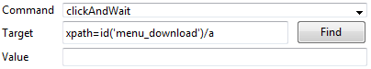

If you start typing in the Command field, a drop-down list will be populated based on the first characters you type; you can then select your desired command from the drop-down.

**TESTING AN APPLICATION USING SELENIUM-IDE:**

Selecting command from popup menu:

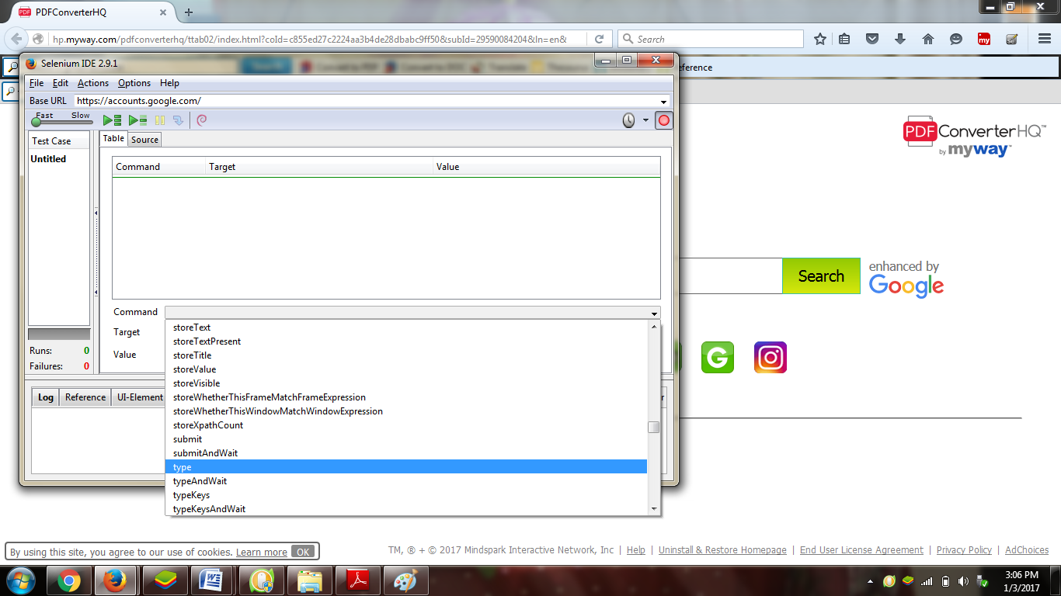

For target press select button

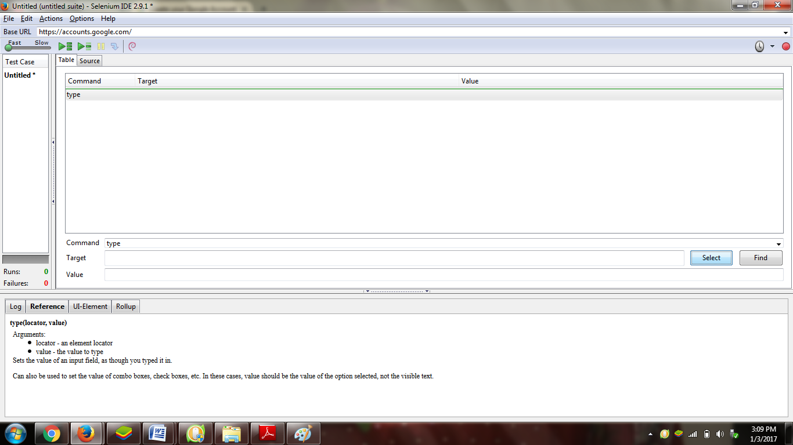

Choose the target from application

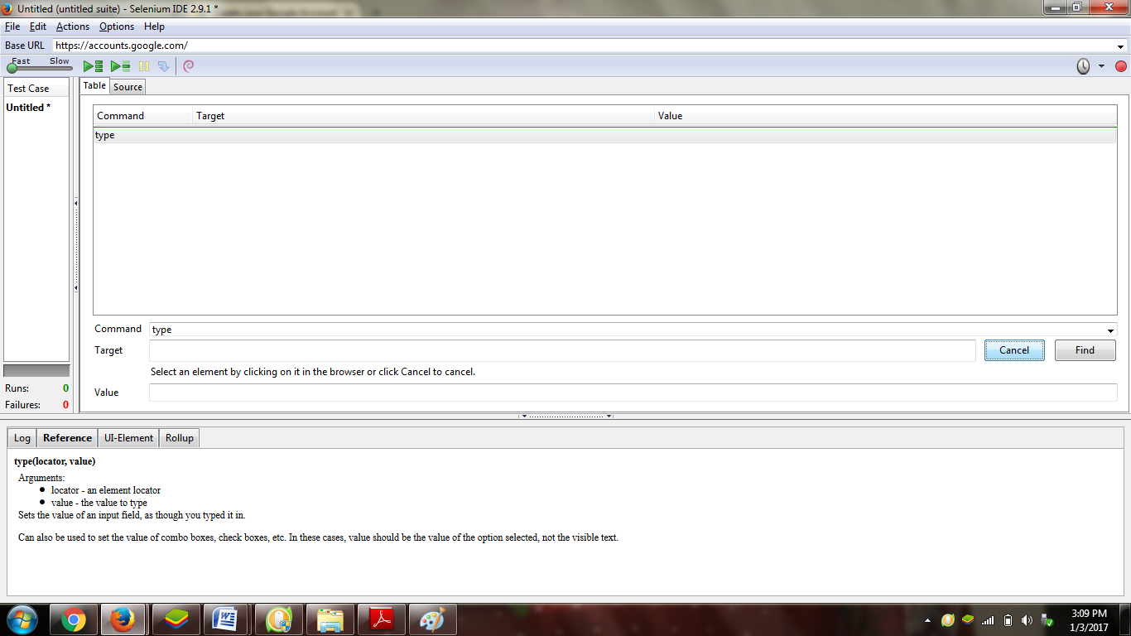

Copying the target from application:

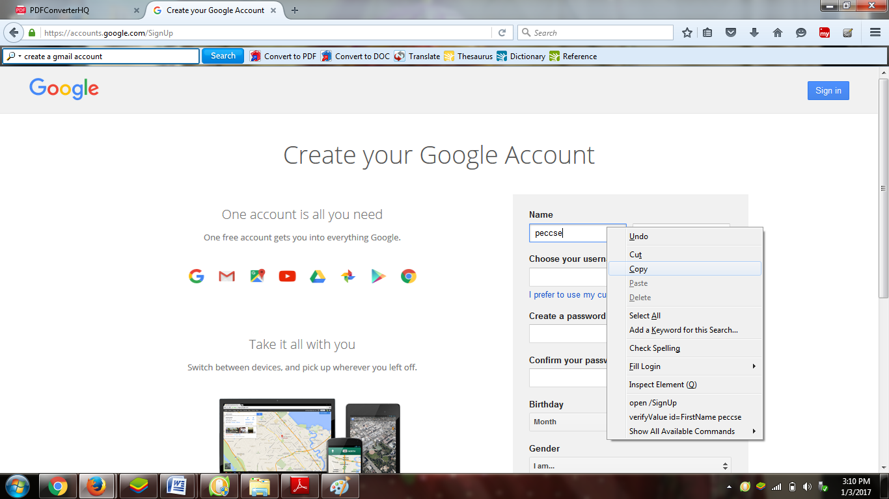

Target gets copied:

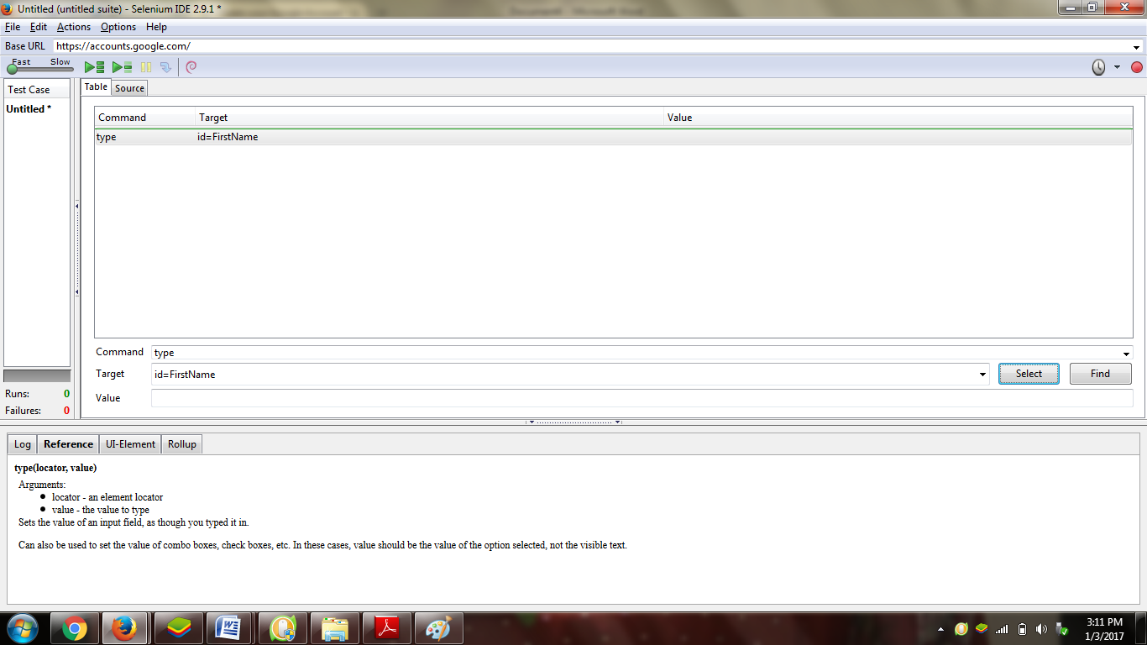

Following the same for rest test case and running the test cases:

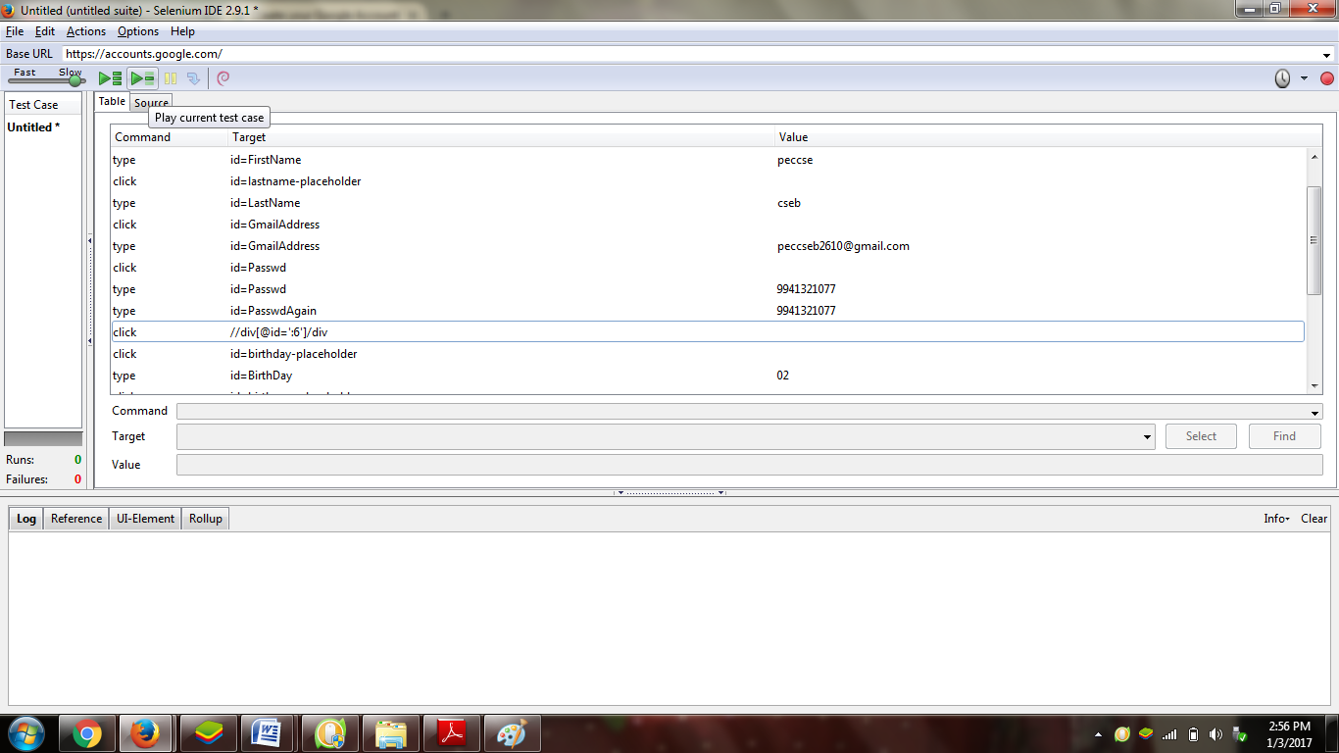

Test case gets executed successfully

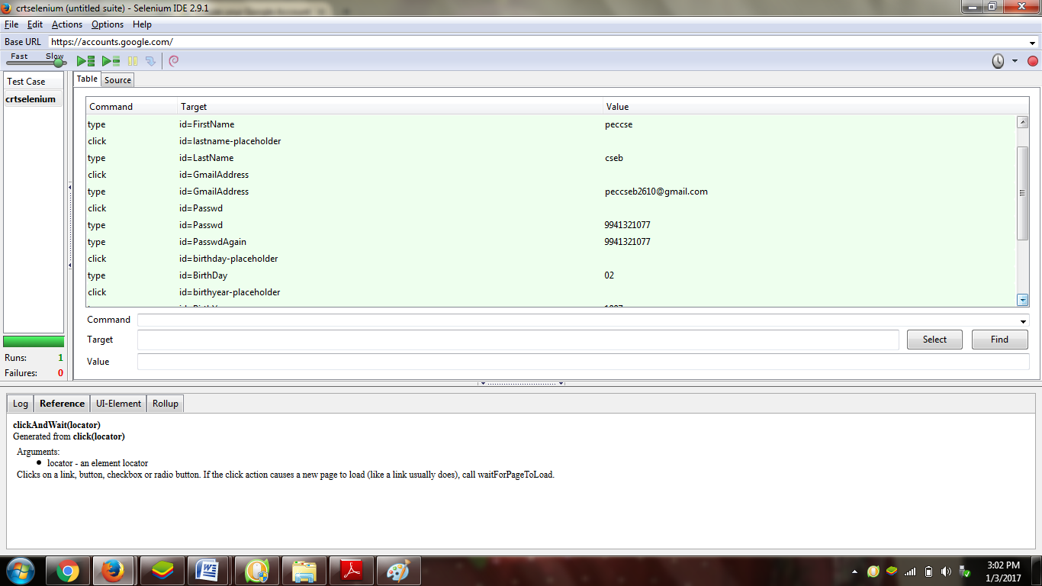

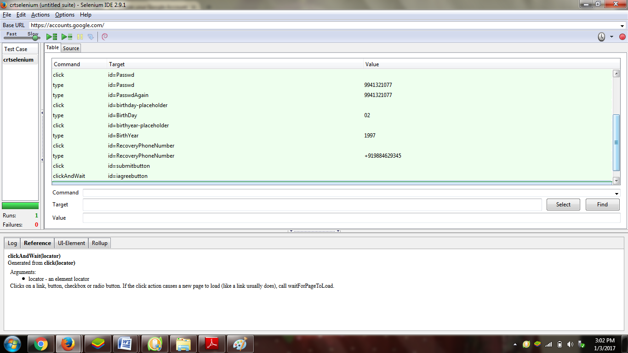

Application gets tested:

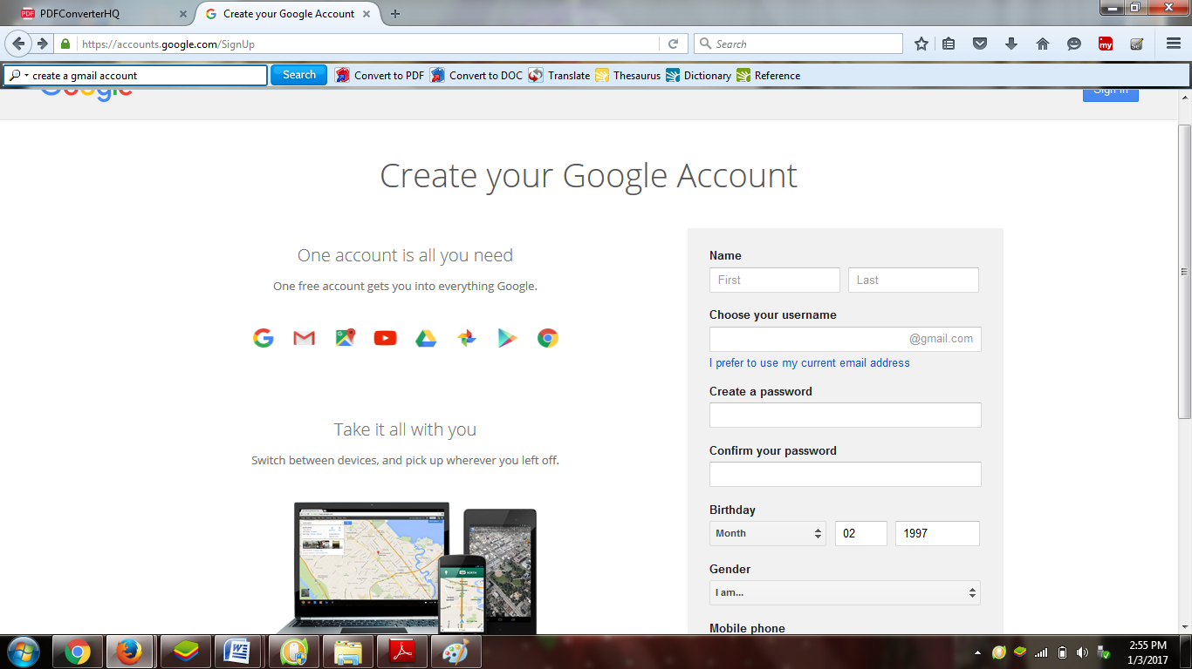

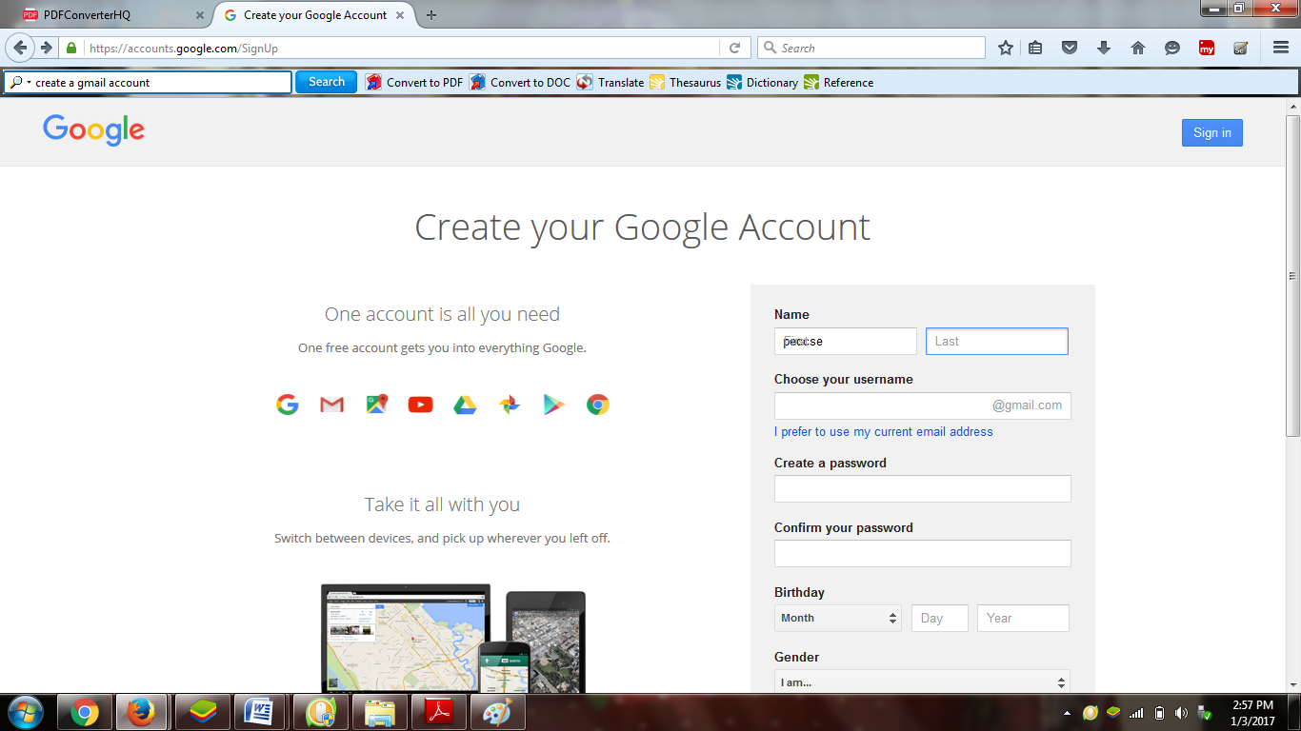

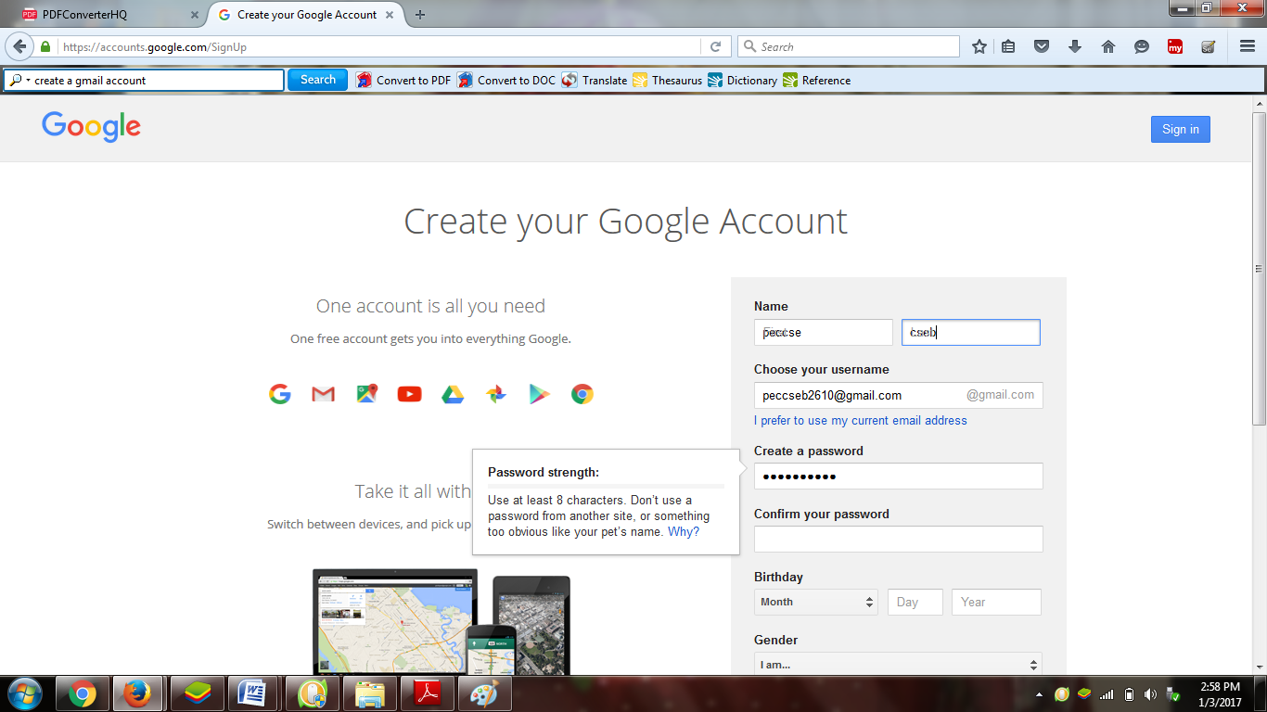

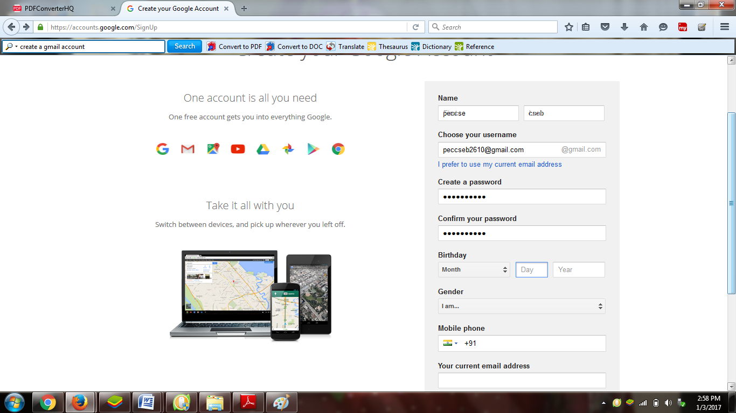

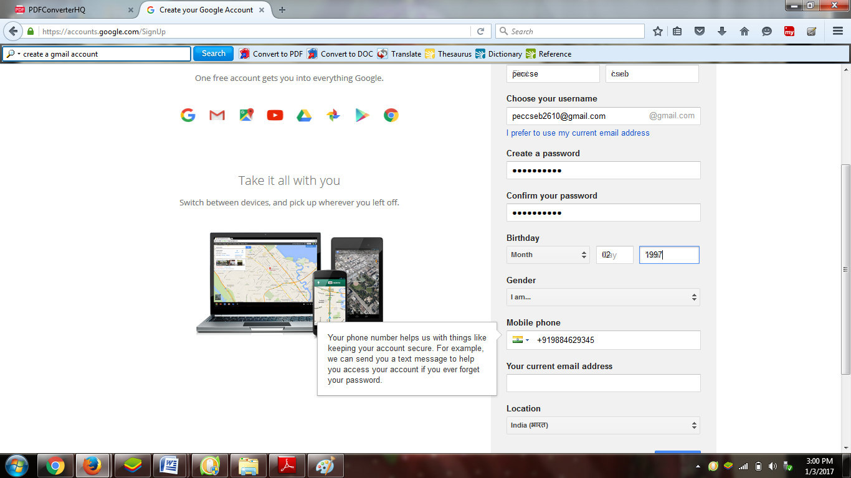

Testing using selenium IDE :

Opening selenium IDE:

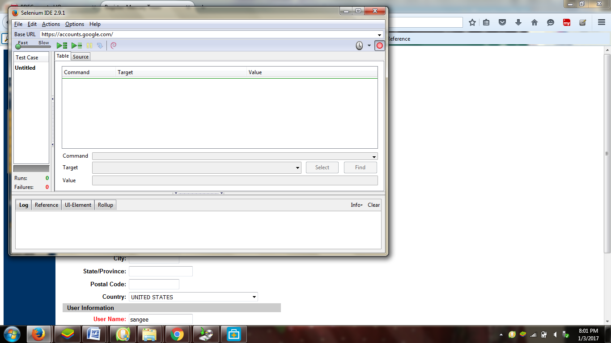

Selecting the command type:

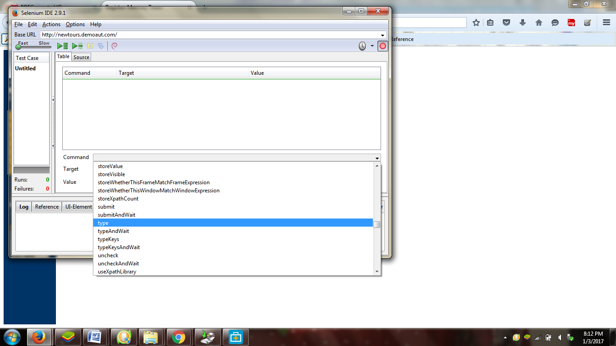

Copying the target:

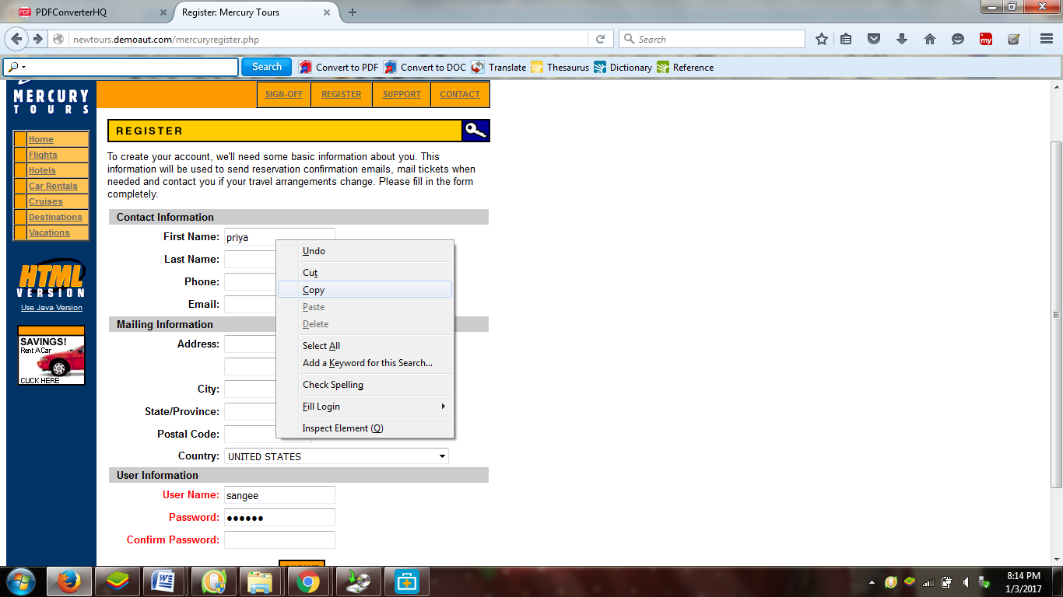

Running the test cases:

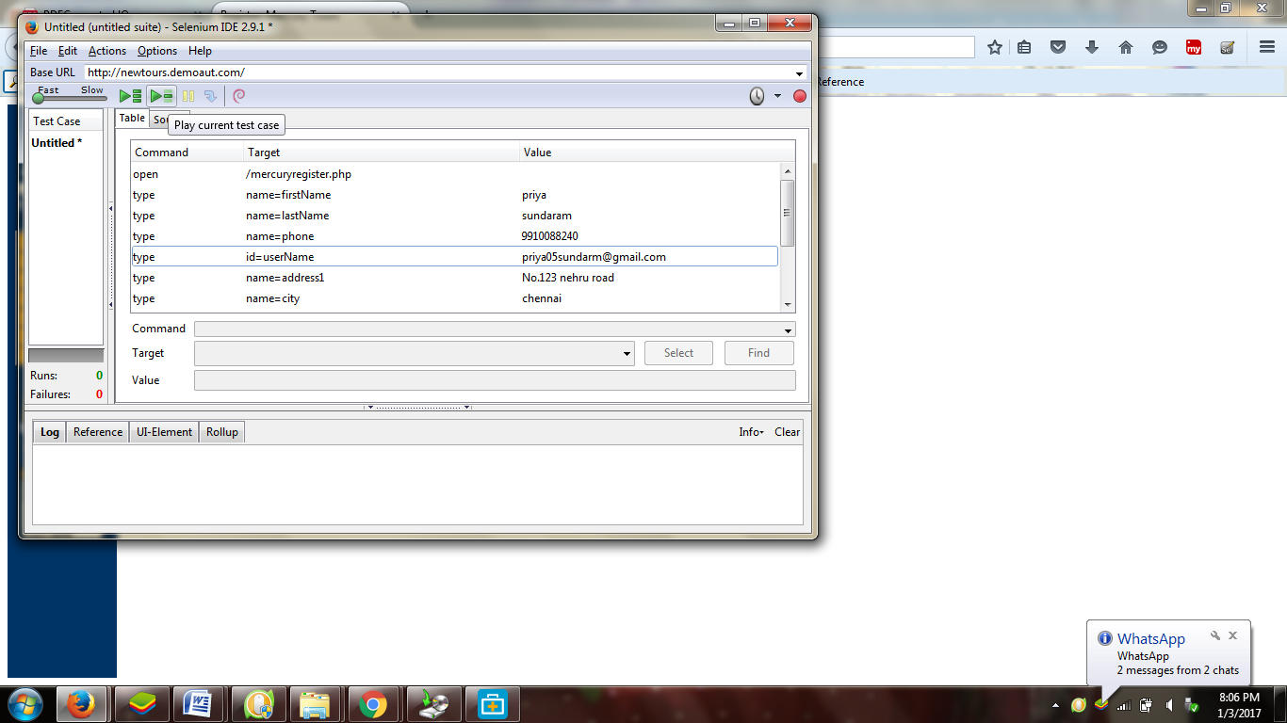

Test cases get executed successfully:

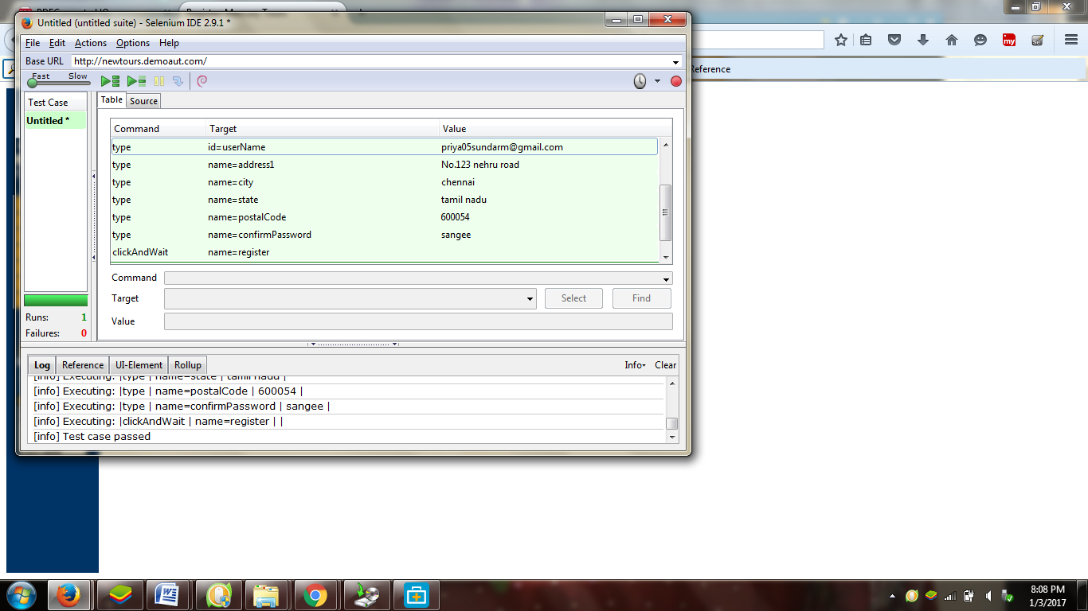

Application gets tested:

