WEEK 3 TASK REPORT
Advanced Data Analysis and Visualization in Logistics
Internship Project | Python-based Logistics Analytics
Prepared by: Anjali

1. Objective
The objective of this task is to perform advanced exploratory data analysis (EDA) and visualization on a hypothetical logistics dataset using Python. The analysis focuses on delivery performance, shipment volume, transportation cost, distance, warehouse delays, carriers, and route regions. The goal is to identify patterns, relationships, operational bottlenecks, and cost drivers that could support data-driven logistics decisions.

2. Dataset Simulation and Structure
A hypothetical dataset containing 300 logistics orders was generated for this task. The dataset is simulated rather than obtained from a real company. Each row represents one logistics order. Key variables include order ID, carrier, route region, distance in kilometres, shipment volume in kilograms, warehouse delay in days, fuel price index, delivery time in days, transport cost in INR, and delivery status.
Variable | Type | Purpose
distance_km | Numeric | Measures route distance
shipment_volume_kg | Numeric | Measures shipment size
warehouse_delay_days | Numeric | Measures internal delay
fuel_price_index | Numeric | Represents fuel-cost conditions
delivery_time_days | Numeric | Measures delivery performance
transport_cost_inr | Numeric | Measures transportation cost
carrier | Categorical | Identifies logistics carrier
route_region | Categorical | Groups orders by region
delivery_status | Categorical | On Time/Late classification

3. Data Quality and Preprocessing
The dataset was inspected for missing values, abnormal observations, variable types, and consistency. A small number of missing values were intentionally introduced to simulate a realistic analytical scenario. Numeric missing values were replaced with their median values because the median is less sensitive to extreme observations than the mean. Outliers were assessed using the interquartile range (IQR) rule. Instead of deleting potentially useful logistics observations, values outside the IQR limits were clipped to the corresponding lower and upper bounds.

4. Exploratory Data Analysis
The mean delivery time is 3.93 days and the median is 3.88 days. The average transportation cost is approximately ₹4,495, while the median is ₹4,580. Approximately 9.0% of simulated orders are classified as late using the 5.5-day threshold. These descriptive statistics provide an initial view of service performance and cost behaviour.

5. Visualizations and Interpretation

Figure 1 – Delivery Time Distribution
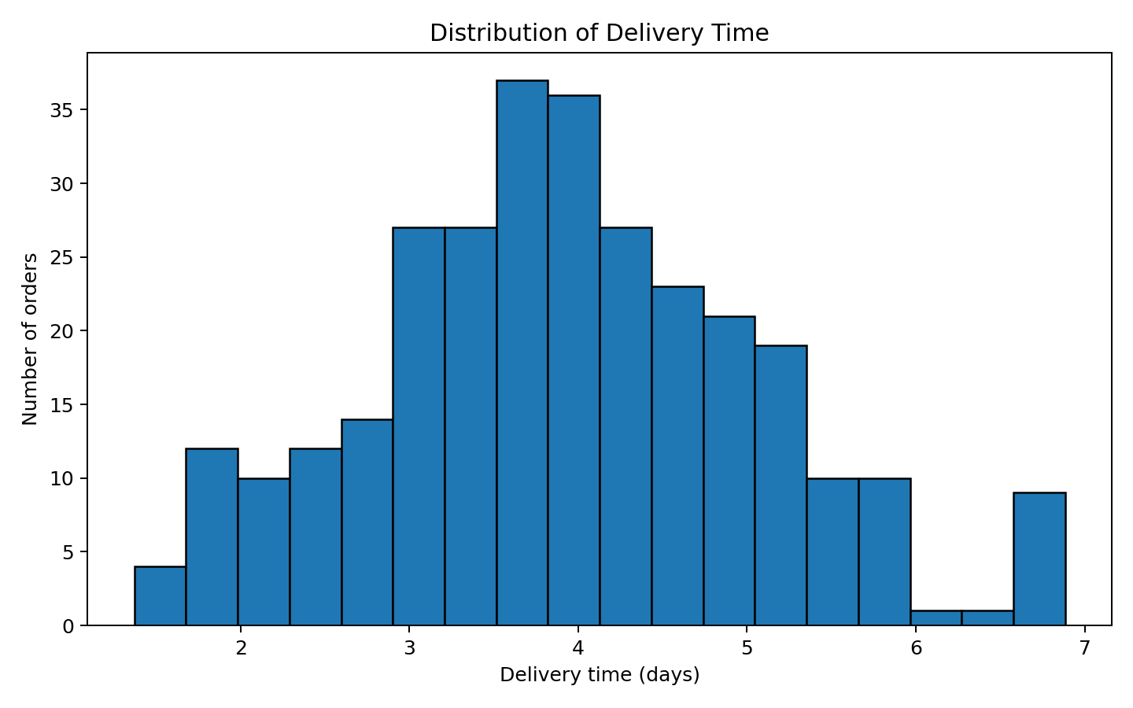
A histogram is appropriate for examining the distribution and spread of delivery time. It helps identify concentration of orders around typical delivery durations and whether the distribution contains a long tail of slower deliveries.

Figure 2 – Average Shipment Volume by Route Region
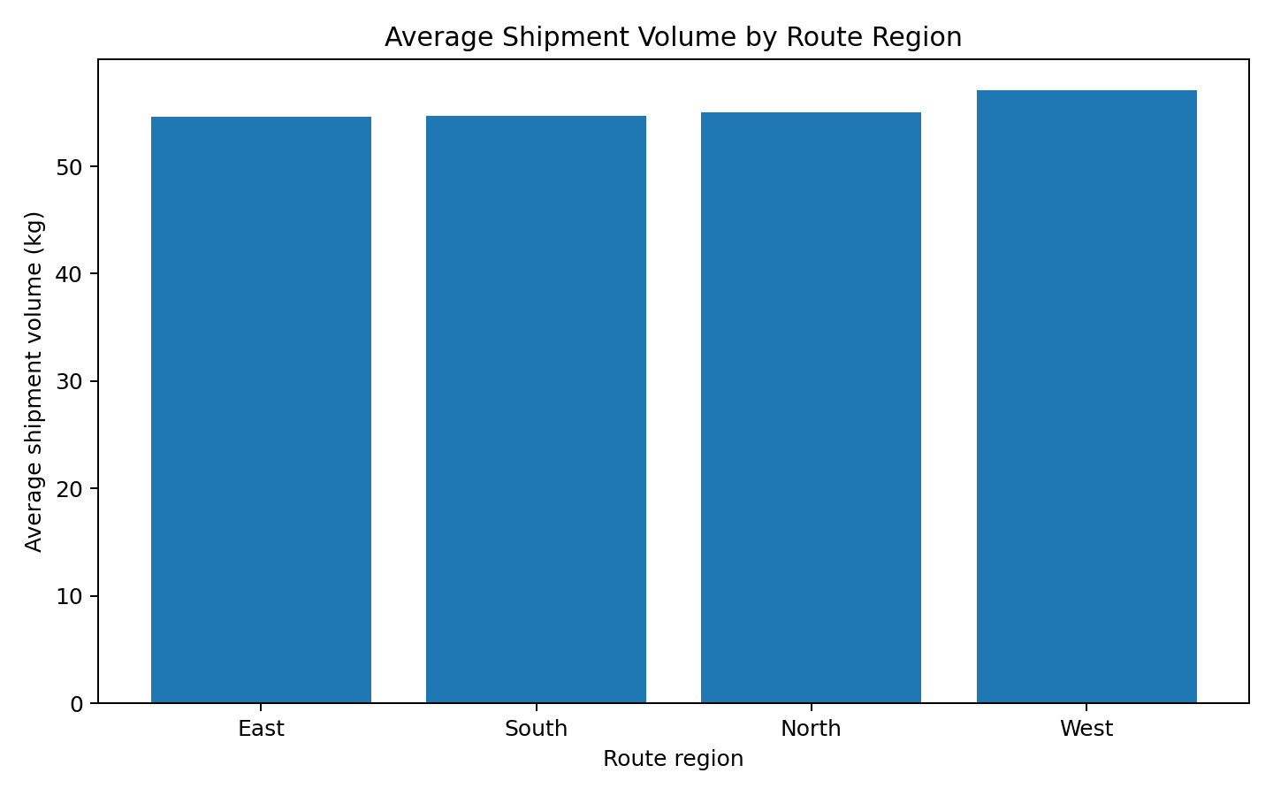
A bar chart compares average shipment volume across regions. The West region has the highest average shipment volume at approximately 57.1 kg in this simulation. This can help planners identify regions that may require greater capacity.

Figure 3 – Distance vs Transport Cost
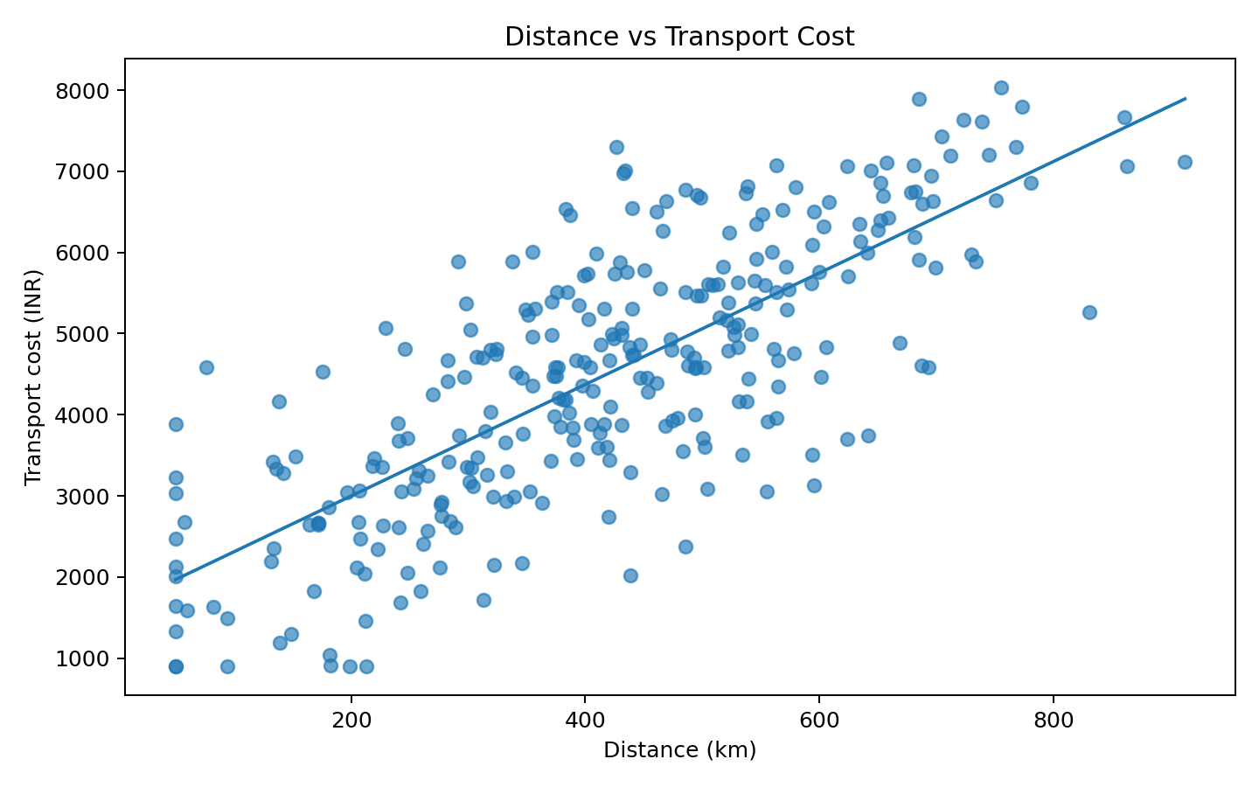
A scatter plot is used to assess the relationship between distance and transport cost. The Pearson correlation in this simulated dataset is 0.76, indicating a strong positive association in the generated data: longer routes generally require higher transport expenditure.

Figure 4 – Warehouse Delay vs Delivery Time
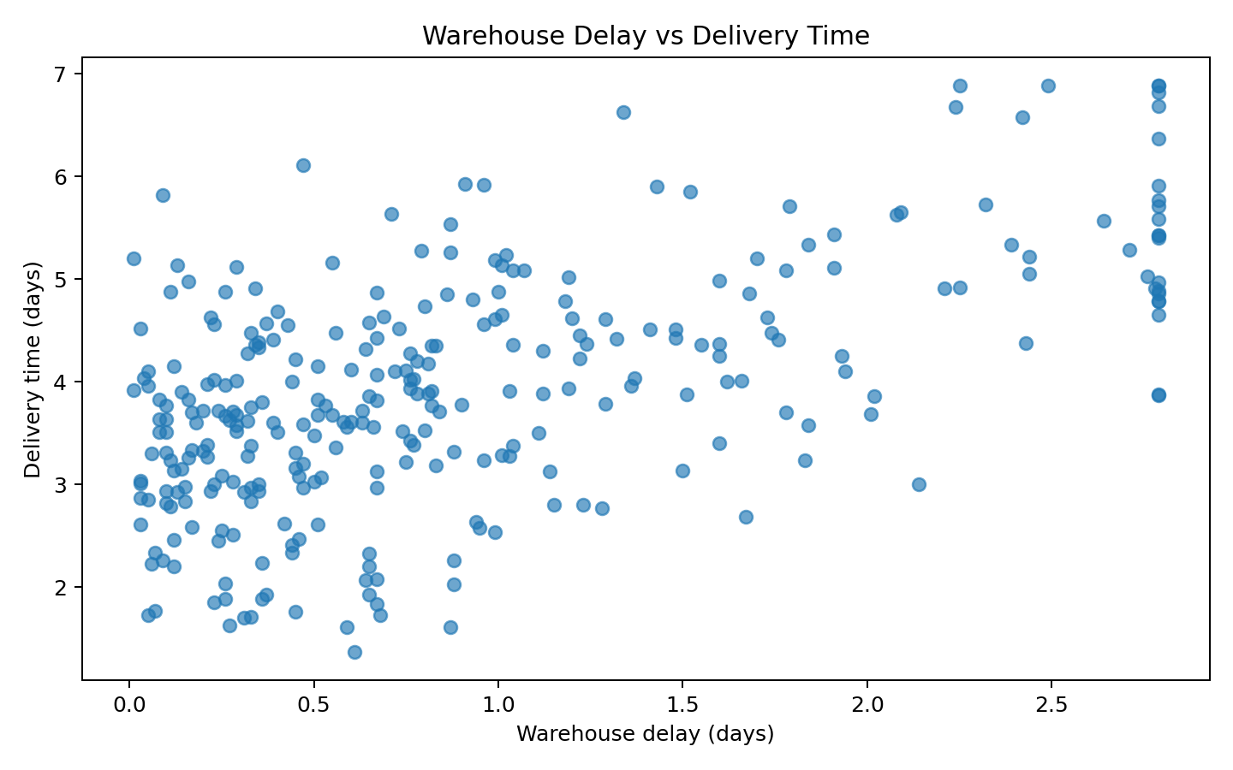
This scatter plot evaluates whether internal warehouse delays are associated with longer delivery times. The correlation is 0.58. A positive relationship would suggest that reducing avoidable warehouse delays may improve delivery performance.

Figure 5 – Correlation Matrix
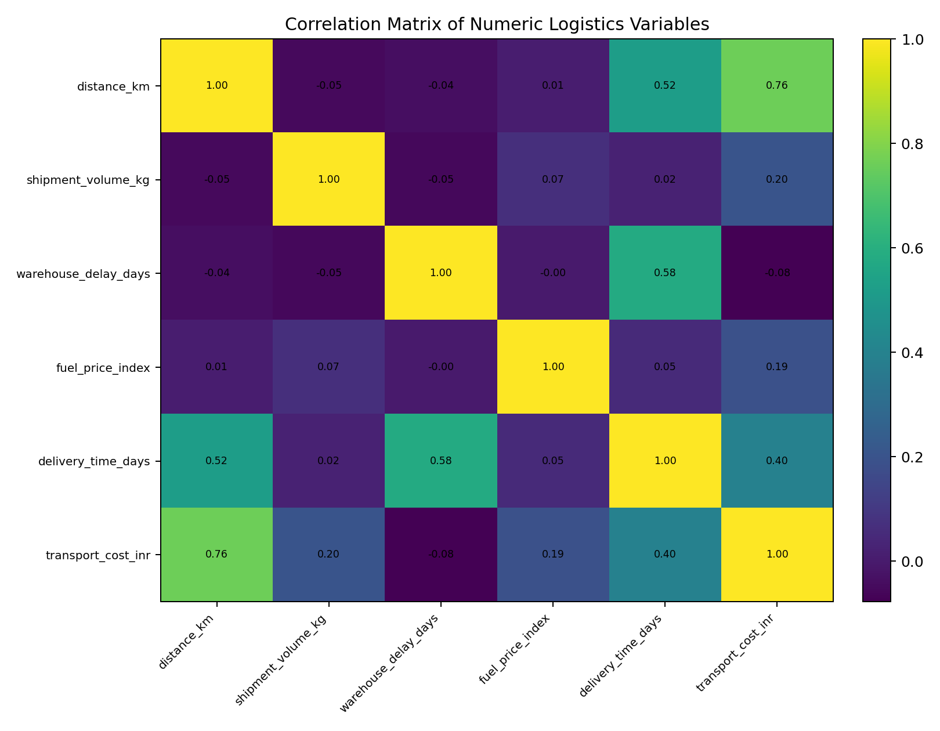
The correlation matrix summarizes linear relationships among numerical variables. It helps compare relationships simultaneously and supports deeper investigation. Shipment volume and transport cost have a correlation of 0.20 in the simulation.

Figure 6 – Average Transport Cost by Carrier
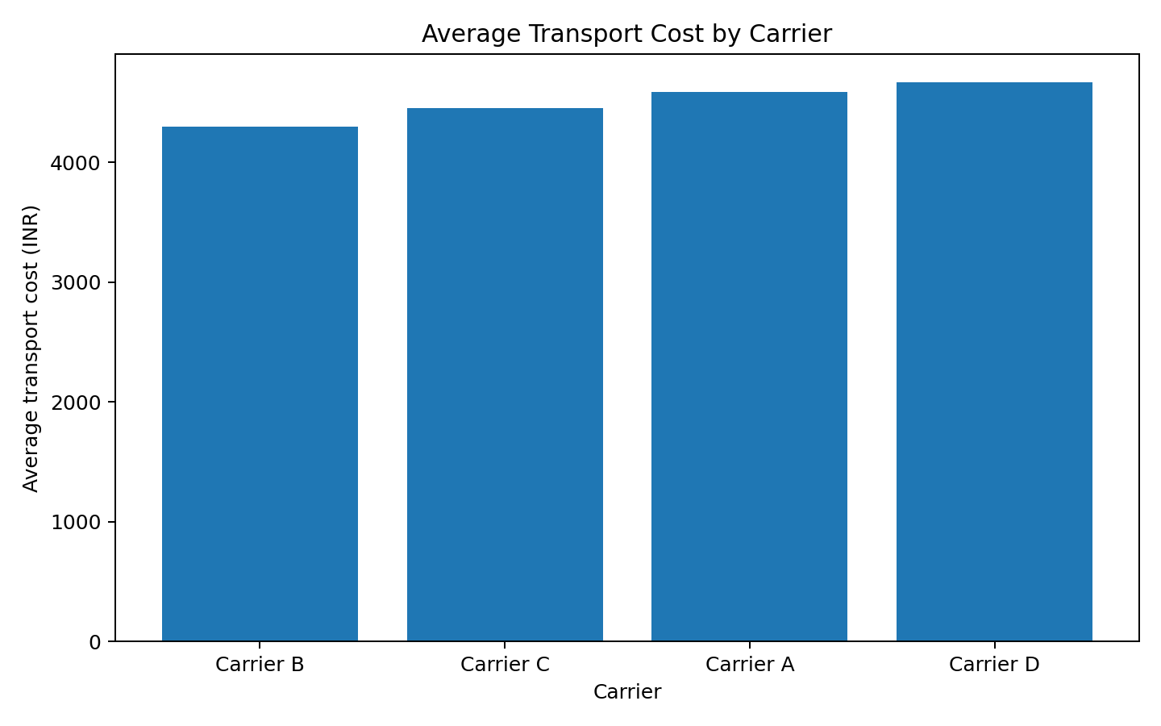
The carrier comparison shows differences in average simulated transport cost. Carrier B has the lowest average simulated cost at approximately ₹4,294. This observation is descriptive of the simulated dataset and should not be interpreted as a real-world carrier recommendation without actual operational and service-quality data.

6. Analytical Insights
- Delivery performance: 9.0% of simulated orders are classified as late under the defined threshold. This makes delivery-time monitoring an important operational KPI.
- Cost driver: Distance has a correlation of 0.76 with transport cost, showing that route length is an important cost-related variable in this simulated dataset.
- Warehouse bottleneck: Warehouse delay has a correlation of 0.58 with delivery time. Monitoring warehouse processing time could therefore help explain service delays.
- Shipment size: Shipment volume has a correlation of 0.20 with transport cost, indicating that larger shipments tend to require greater transport expenditure in the simulation.
- Route capacity: The West region has the highest average simulated shipment volume, suggesting that capacity planning by region may be useful.
- Carrier comparison: Carrier B has the lowest average simulated cost. A real-world evaluation should also include delivery reliability, distance mix, service-level agreements, and quality before drawing operational conclusions.

7. Visualization Method Justification
Histograms were selected to show distributions; bar charts were used for category-level comparisons; scatter plots were used to investigate relationships between two numeric variables; and a correlation matrix was used to summarize multiple pairwise linear relationships. These visualization types are commonly used in EDA because they translate numeric results into patterns that are easier to interpret and communicate.

8. Python Tools and Code
The analysis uses Python with pandas for data loading, inspection, grouping, descriptive statistics, missing-value handling, and correlation analysis. Matplotlib is used to create the visualizations. The complete executable Python script is included separately in the GitHub project.
import pandas as pd
import matplotlib.pyplot as plt
df = pd.read_csv("week3_logistics_dataset.csv")
# Missing-value handling
numeric_cols = [
"distance_km", "shipment_volume_kg", "warehouse_delay_days",
"fuel_price_index", "delivery_time_days", "transport_cost_inr"
]
for col in numeric_cols:
df[col] = df[col].fillna(df[col].median())
# Correlation analysis
print(df[numeric_cols].corr())
# Example visualization
plt.scatter(df["distance_km"], df["transport_cost_inr"])
plt.xlabel("Distance (km)")
plt.ylabel("Transport cost (INR)")
plt.title("Distance vs Transport Cost")
plt.show()

9. Recommendations Based on the Simulated Analysis
- Track delivery time and warehouse delay as separate KPIs so that operational delays can be distinguished from transportation delays.
- Use route distance and shipment volume when estimating transport budgets because both variables are associated with simulated transport cost.
- Monitor high-volume regions for capacity planning and potential resource constraints.
- Compare carriers using both cost and service-level measures rather than cost alone.
- Repeat the analysis with real historical logistics data before making business decisions.

10. Reflection and Conclusion
This task demonstrates how exploratory analysis and visualization can convert logistics records into operational insights. Data quality is essential because missing, inconsistent, or extreme observations can distort averages, correlations, and visual patterns. A structured workflow—inspection, cleaning, descriptive analysis, correlation analysis, visualization, and interpretation—creates a stronger foundation for decision-making. The results in this report are based on a simulated dataset created specifically for the internship exercise; therefore, the findings should be treated as an analytical demonstration rather than actual company performance.

Appendix: Files Included in the GitHub Project
- week3_logistics_dataset.csv
- week3_cleaned_logistics_dataset.csv
- week3_advanced_logistics_analysis.py
- README.md
- charts/01_delivery_time_distribution.png
- charts/02_shipment_volume_by_route.png
- charts/03_distance_vs_transport_cost.png
- charts/04_warehouse_delay_vs_delivery_time.png
- charts/05_correlation_heatmap.png
- charts/06_average_cost_by_carrier.png

