Sreekanth V Swamidas

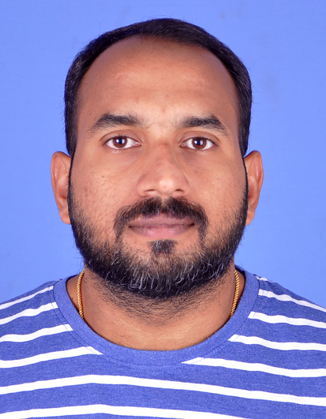  Mobile: 0091-70253 76401  0091-80894 06240  Permanent home address:  Vrindavan, Vadavathoor PO, Kottayam-686010, Kerala, India  E-mail address:  Sreekanthswamidas@gmail.com  About Me  DOB & PLACE:  May 22, 1986  Kottayam, Kerala, India.  Height: 5’9" (172 cm)  Nationality:  Indian  Language:  English, Hindi and Malayalam  Education  BSC Mathematics  CMS College 2003 - 2006  Kottayam, Kerala, India.  Advanced Skills and knowledge areas  - Computer Fundamental, Ms- Windows XP, Ms- Work, Ms-Excel, E-mail/ Internet  - Valid manual driving license  Professional Courses and Certificates:  - BSS advanced DIP in Occupational Safety, Health and environmental management  - Certified for obtain supervisor training from National Security Institute UAE (NSI)  - Defensive driving | Competency Summary  Experiences:  - Security Operations coordinator at Transguard Group LLC under Emirates group in UAE.  - Worked as Sales Exicutive at TV Sundram Iyengar and sons Ltd Malapuram, Pathanamthitta and Kottayam branches.  - Worked as Sales Exicutive at Popular Mega Motors division of TATA commercial vehicles in Kottayam.  Professional Profile:  - Oprations coordinator and office administration with 9+ years’ experience in relevant field.  - Graduation in BSc Mathematics and diploma in occupational safety, health and environmental management.  - Good knowledge in computer application.  Security Operations Cordinator (Dec2009 to Dec 2020)  Transguard Group LLC  Abu Dhabi, UAE  - Conduct a minimum of twice daily site check/inspections ensuring adherence to the contract by the security provider and report as appropriate.  - Viewing and assessing documents on the T&A time and attendance for all the concerned staff.  - To conduct reviews of all incident reports for further actions and advice the Management team.  - To respond to requests by the client and/or the manager for information on incidents  - Support the manager and act as a point of contact for the client during times of absence and support the security designated deputized Management team member  - Support the manager by conducting quality checks of security service provider reports and adherence to KPIs.  - Ensure replacement keys are cut and issued promptly following the correct procedure  - Respond to all client requests for information and support and advise the manager  - Ensure Security Service Provider is informed of any notified events  - Respond to all requests relating to access control card issue to the client  - Manage lost and found procedures and respond promptly to request for collection/handover of the property  - Attend all reported incidents/emergencies, support and follow-up reports to the manager.  Sales Exicutive (May 2007 To Dec 2009)  TV Sundram Iyengar and Son’s LTD authorised dealer of Mahindra commercial vehicles (LCV)  Day-to-day responsibilities might include:  - Communicating with customers via telephone, and in person.  - Suggesting suitable vehicles based on customer needs.  - Negotiating the final price for the sale.  - Selling accessories or other services once a vehicle has been chosen.  - Completing the paperwork for each sale.  - Increase the customer database and prospecting potential sales.  - Liaising with the service team to ensure sold vehicles are prepped to a high standard and are ready for delivery within the agreed  - Planning and implementation of market strategy.  - Identifying product segments.  - Keeping tab on competitor activities.  - Developing customer network, product wise and segment wise.  Sales Exicutive (Jun 2006 to Apr 2007)  Popular Mega Motors authorised dealer of TATA commercial vehicles  Kottayam  Day-to-day responsibilities might include:  - Meet potential customers and create cold calls.  - Achive monthly targets.  - Monitor market competitors activities.  - Conduct vehicle demo activities to increase monthly sales.  - Prepare daily reports and submit to the sales manager.  ***************************************************************************************************

