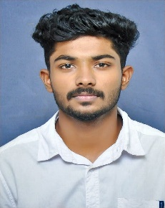

**AJIN ALOSIOUS**

CHELACKAL HOUSE,THATTEKKANNI,IDUKKI,PIN-685606

ajinalosious82@gmail.com,+91-9526647591

# OBJECTIVES

Looking forward to work in stimulating and challenging environment that will convert my potential into performance and recognition for hard work, honesty and sincerity, thereby contributing to the growth of the organization and myself.

# EDUCATIONAL QUALIFICATIONS

|  |  |  |  |  |  |
| --- | --- | --- | --- | --- | --- |
| YEAR | COURSE | SPECIALIZATION | INSTITUTE | BOARD/UNIVERSITY | AGGREGATE |
| 2020 | Degree | Bachelor of Business Administration | Indhira Gandhi college of Arts and Science | Mahatma Gandhi University | In pursuing |
| 2018 | +2(HSC) | Political Commerce | St. George HSS Vazhathope | State Board | 61% |
| 2016 | 10th |  | St. George HSS Vazhathope | State Board | 75% |

# TECHNICAL SKILLS

* **Operating Systems**​-Good exposure to Ubuntu, Windows 8, 10
* **Software-** Microsoft office, Adobe Photoshop

# ADDITIONAL EXPOSURES

* Member of National Service Scheme
* Member in Bharath Scouts and Guide

# HOBBIES

* Playing Badminton
* Playing Volleyball
* Listening Music
* Traveling

# PERSONAL PROFILE

**Nationality** : Indian

**Gender** : Male

**Religion** : Christian

**Date of Birth** ​:19/02/2000

**Languages known** ​: English, Malayalam, (Hindi, Tamil-Basics)

# DECLARATION

I do hereby declare that the particulars given above are true and correct to the best of my knowledge and belief.

**Ajin Alosious**