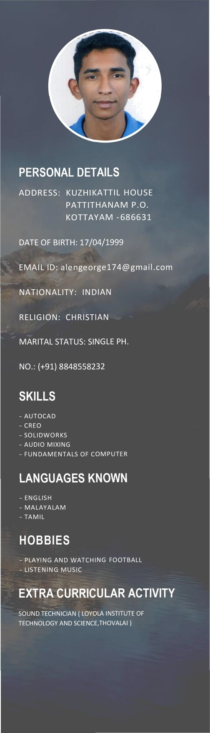

EN EO E

*MECHANICAL ENGINEER*

# CAREER OBJECTIVE

To enhance a career that tests my personal abilities, add value and make an attempt to achieve organization and individual

goals. Also to further enhance my skills through learning and meet the challenge in any giving chance.

EDUCATION

* BACHELOR OF ENGINEERING (MECHANICAL)

LOYOLA INSTITUTE OF TECHNOLOGY AND SCIENCE, THOVALAI ANNA UNIVERSITY, CHENNAI, TAMILNADU - 2021

CGPA — 7.93

* HIGHER SECONDARY EDUCATION (1 2th) (CBSE) MARY MOUNT PUBLIC SCHOOL AND JUNIOR COLLEGE, KATTACHIRA, KOTTAYAM, KERALA - 2017

CGPA - 6

* HIGH SCHOOL EDUCATION (1 Oth) (CBSE)

MARY MOUNT PUBLIC SCHOOL AND JUNIOR COLLEGE, KATTACHIRA, KOTTAYAM, KERALA - 2015

CGPA - 8.4

MY PROJECTS

* WALL CLIMBER USING VACUUM
* TOOL CONDITION MONITORING IN CONVENTIONAL LATHE USING VIBRATION ANALYSIS published in INTERNATIONAL JOURNAL OF SCI ENTI FIC ENGINEERING AND RESEARCH (IJSER)

[Volume 05 Issue 04 April, 2021]

# ACHIEVEMENTS

BEST PROJECT AWARD (KALAM AWARD) FROM **KALASALINGAM ACADEMY OF RESEARCH AND EDUCATION** IN MARCH 2020

# INTERNSHIP

BOSCH INDUSTRIES, BENGALURU (ATTENDED 5 DAYS TRAINING PROGRAM IN JUNE 2019)