ASSIGNMENT-9.1
HT NO:2303A51644
Batch No:28
Course:AI Assisted Coding
Problem 1:
Consider the following Python function:
def find_max(numbers):
return max(numbers)
Prompt:
Generate documentation for the given Python function using all three formats:
1. Python docstring
2. Inline comments
3. Google-style documentation

After writing the documentation, critically compare the three approaches by
discussing their advantages, disadvantages, and suitable use cases.
Finally, recommend the most effective documentation style for a
mathematical utilities library and justify the choice.
Given Python Code:
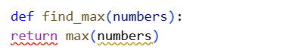
Generate Python Docstring:
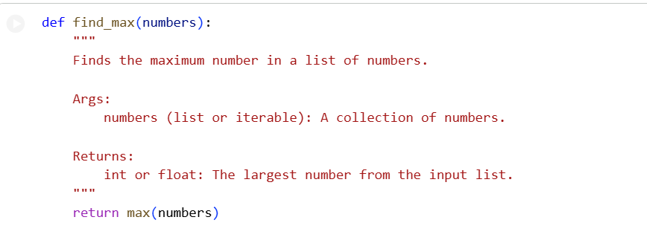

Generate Inline Comments:

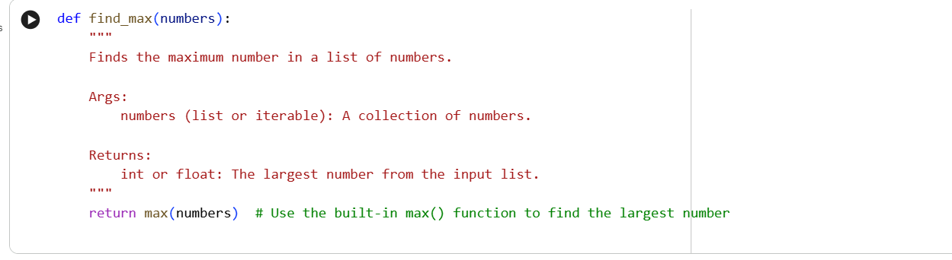

Generate Google-style Documentation:

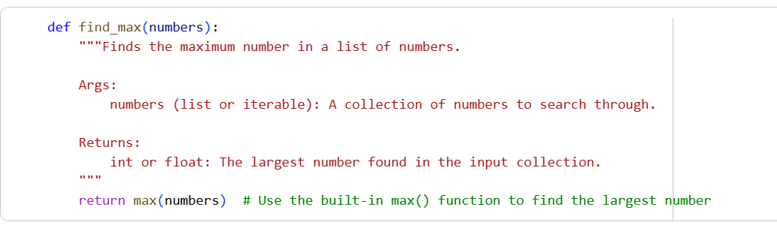

Justification:
1. Google-style docstrings provide clear and well-structured documentation for mathematical functions.
2. They clearly define inputs, outputs, and exceptions using Args, Returns, and Raises sections.
3. This format improves readability, especially for functions involving formulas and edge cases.
4. Developers can quickly understand function usage without reading the implementation.
5. Google-style docstrings are easier to write and maintain than reStructuredText.
6. They support automated API documentation using tools like Sphinx with Napoleon.
7. Consistency across functions improves collaboration in team projects.
8. Inline comments alone cannot describe complete function behavior effectively.
9. Google-style docstrings balance professionalism with simplicity.
10. Hence, they are ideal for a mathematical utilities library.

Problem 2:
Consider the following Python function:
def login(user, password, credentials):
return credentials.get(user) == password
Prompt:
Generate documentation for the given Python login function using:
1. Python docstring
2. Inline comments
3. Google-style documentation

Then compare the three documentation approaches and recommend which
style is most helpful for new developers onboarding a project, with
proper justification.
Given Python Code:
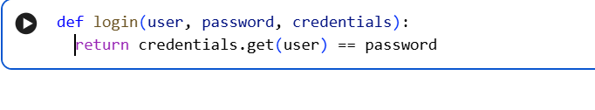Generate Python Docstring:
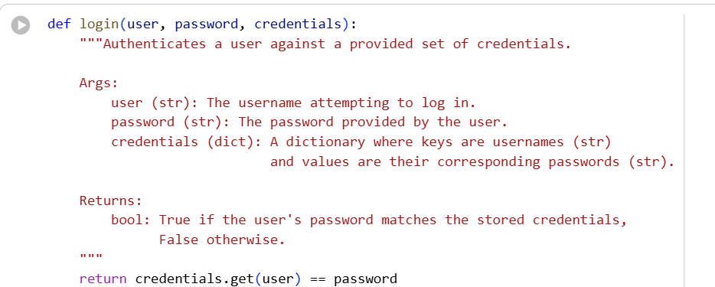

Generate Inline Comments:

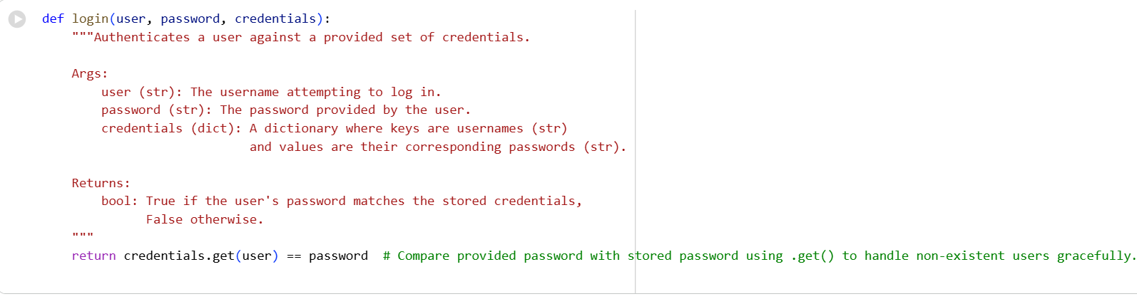

Generate Google-style Documentation:

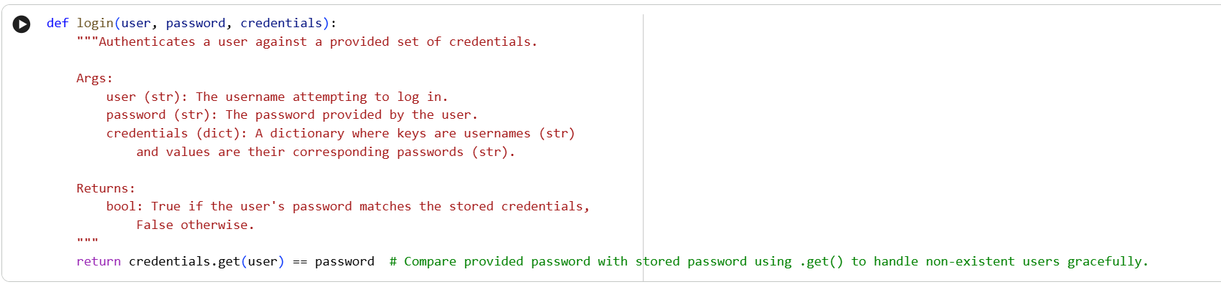
Justification:
1. Google-style docstrings are easy to read and understand due to their simple, structured format.
2. Clear sections like Args, Returns, and Raises help new developers quickly grasp function usage.
3. The learning curve is low compared to reStructuredText-based Python docstrings.
4. Consistent formatting across the codebase improves navigation and predictability.
5. New developers can understand APIs without deeply reading implementation details.
6. Google-style docstrings balance conciseness with sufficient detail.
7. They reduce confusion during onboarding and speed up developer productivity.
8. Automated documentation can be generated using Sphinx with the Napoleon extension.
9. Inline comments alone cannot provide a complete overview of function behavior.
10. Therefore, Google-style docstrings are ideal for onboarding new developers effectively.

Problem 3:

Calculator (Automatic Documentation Generation)

Task: Design a Python module named calculator.py and

demonstrate automatic documentation generation.

Prompt:

Design a Python module named calculator.py.

Tasks:

1. Create functions add(a, b), subtract(a, b), multiply(a, b), and divide(a, b).

2. Add appropriate Python docstrings to each function for automatic documentation generation.

3. Show how to display the module documentation in the terminal using Python documentation tools.

4. Generate and export the module documentation in HTML format using the pydoc utility and

verify the output in a web browser.

Python Code:

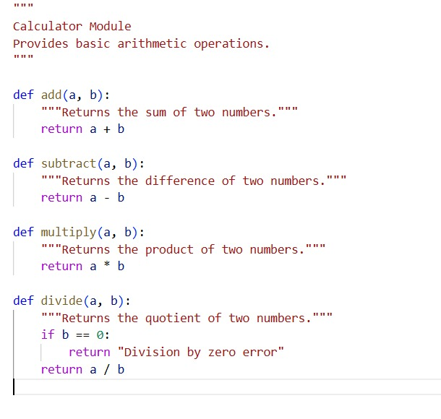
Python Code Output:
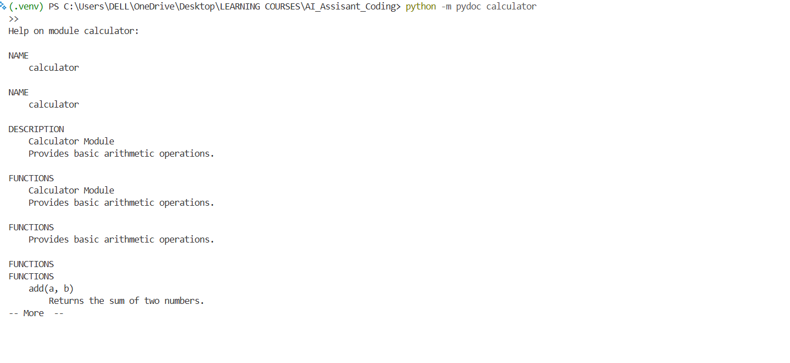

Creating HTML File from Python file

HTML Code:

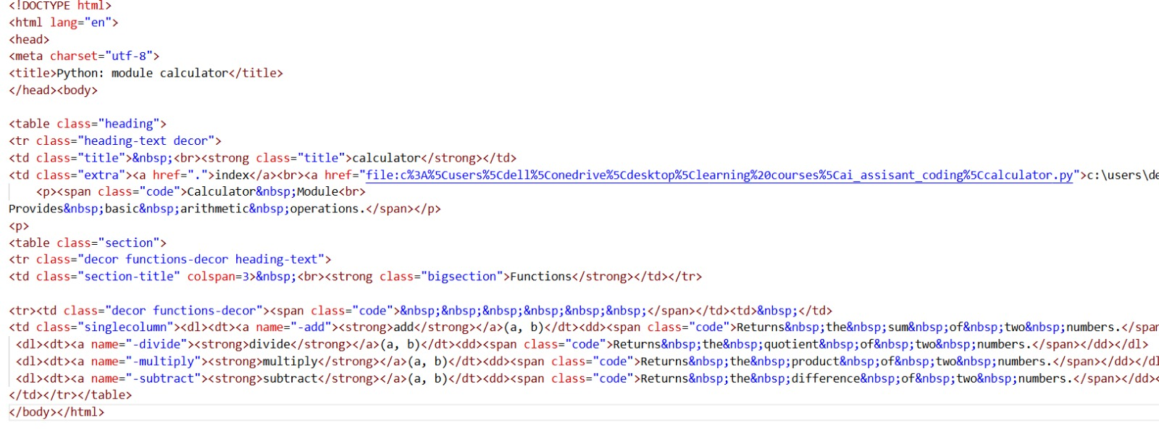
HTML Code Output:
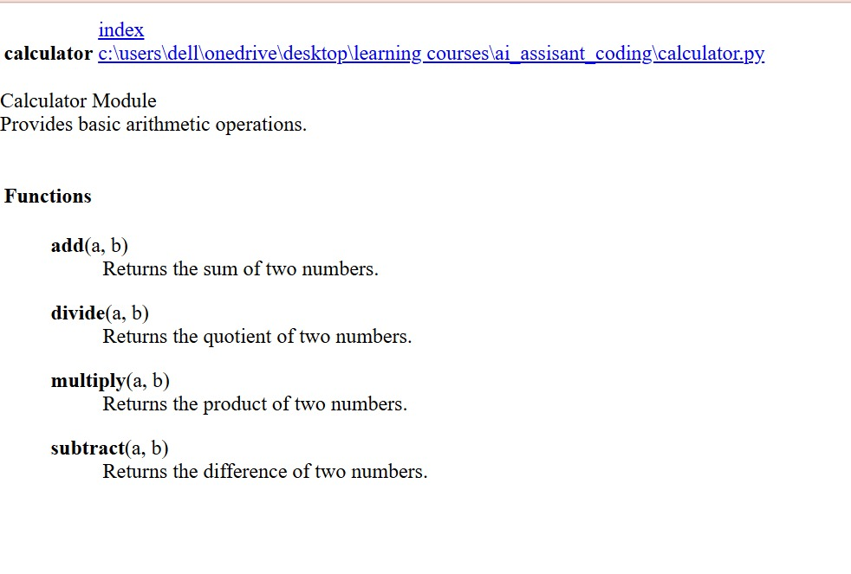
Justification:
- Task demonstrates automatic documentation generation using Python docstrings.
- Docstrings help explain the purpose and functionality of each calculator function.
- Using pydoc reduces the need for manual documentation writing.
- Terminal-based documentation allows quick access during development.
- HTML documentation provides a clear and user-friendly presentation.
- Automatic documentation ensures consistency across the module.
- Well-documented code improves readability and maintainability.
- It helps new developers understand the module easily.
- The approach follows standard Python documentation practices.
- This task highlights the importance of documentation in professional software development.

Problem 4: Conversion Utilities Module
Task:
1.Write a module named conversion.py with functions:
decimal_to_binary(n)
binary_to_decimal(b)
decimal_to_hexadecimal(n)
2. Use Copilot for auto-generating docstrings.
3. Generate documentation in the terminal.
4. Export the documentation in HTML format and open it in a
browser.
Prompt:
Create a Python module named conversion.py with number conversion
functions.
Use an AI tool to auto-generate clear Python docstrings for each function.
Generate the module documentation in the terminal and export the
documentation in HTML format using pydoc.
Python Code:

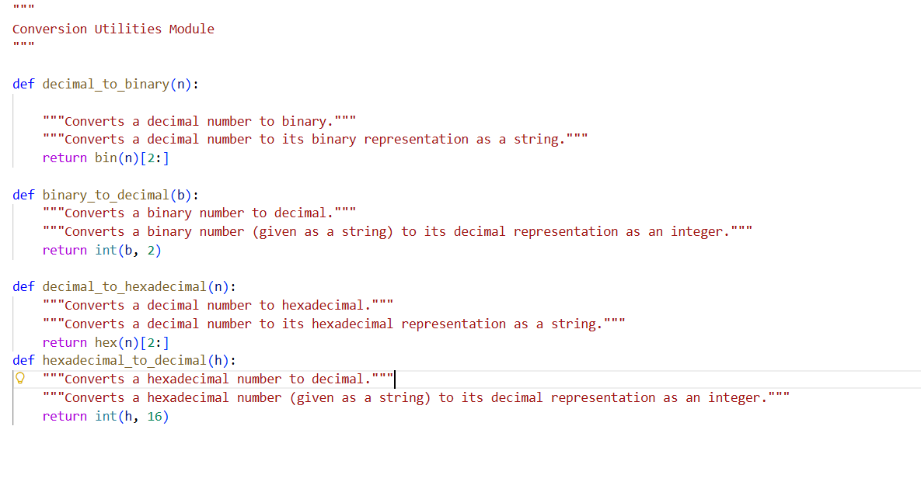
Python Code Output:
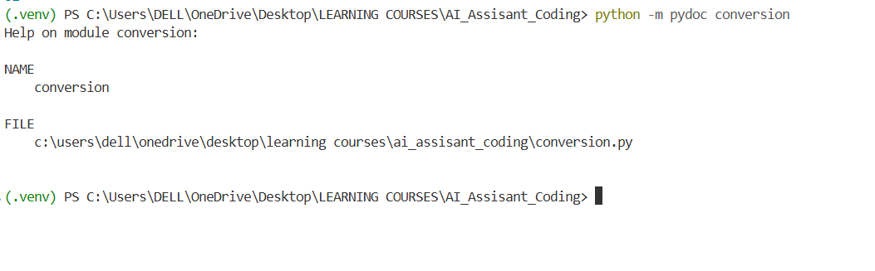Creating HTML File from Python file
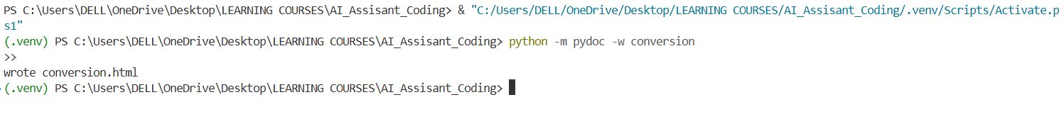

HTML Code:

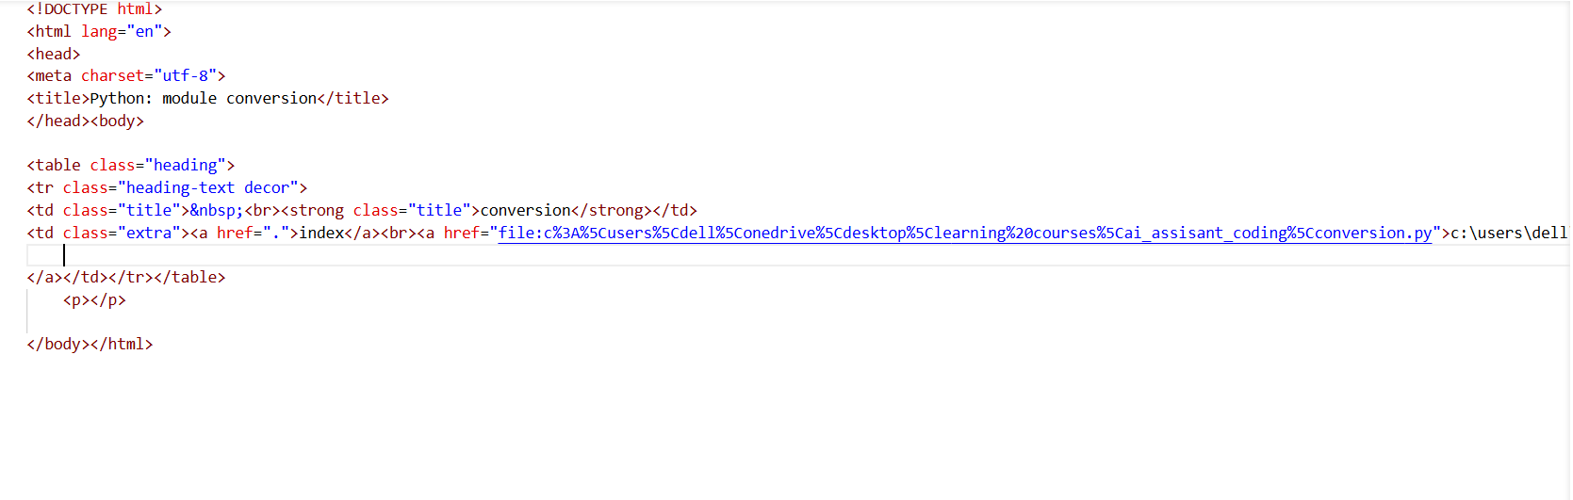HTML Code Output:
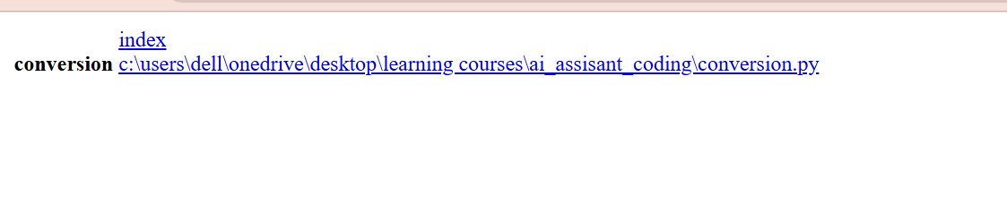

Justification:
1.Task demonstrates the use of automatic documentation generation for utility functions.
2. Using Copilot helps in generating accurate and consistent docstrings quickly.
3. Docstrings clearly explain the purpose and functionality of each conversion function.
4. Automatic documentation reduces manual documentation effort.
5.Terminal-based documentation allows quick reference during development.
6. HTML documentation provides a clear and readable presentation of the module.
7. Well-documented code improves readability and maintainability.
8. It helps new developers understand the conversion logic easily.
9. Using pydoc follows standard Python documentation practices.
10. This task highlights the importance of documentation in real-world software development.

Problem 5 – Course Management Module
Task:
1. Create a module course.py with functions:
add_course(course_id, name, credits)
remove_course(course_id)
get_course(course_id)
2. Add docstrings with Copilot.
3. Generate documentation in the terminal.
4. Export the documentation in HTML format and open it in a
browser.
Prompt:
Create a Python module named course.py for managing course information.
Add meaningful Python docstrings using an AI tool.
Generate the module documentation in the terminal and export it in HTML
format using the pydoc utility.
Python Code:
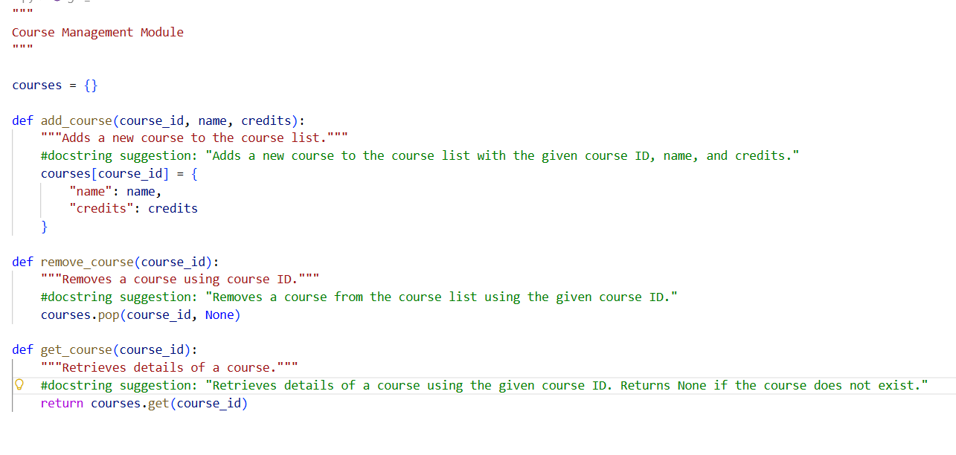
Python Code Output:
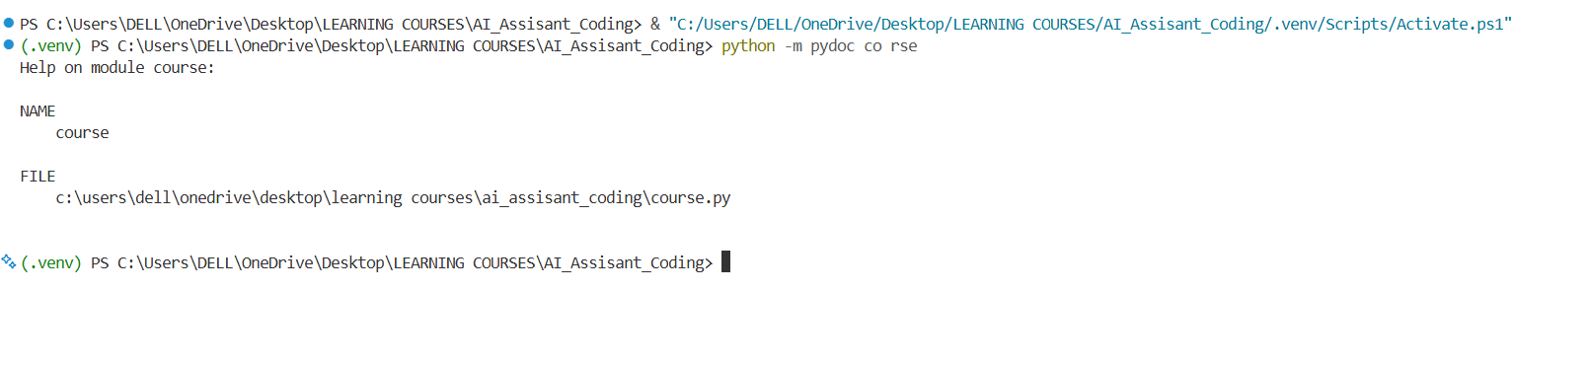

Creating HTML File from python file
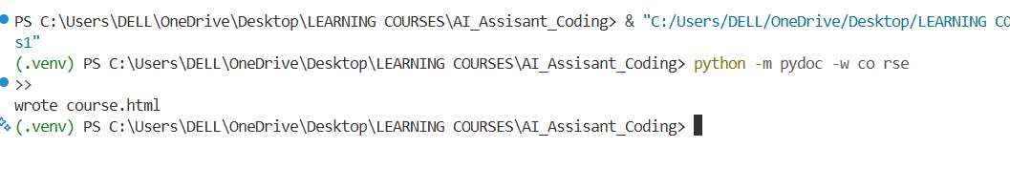
HTML Code:
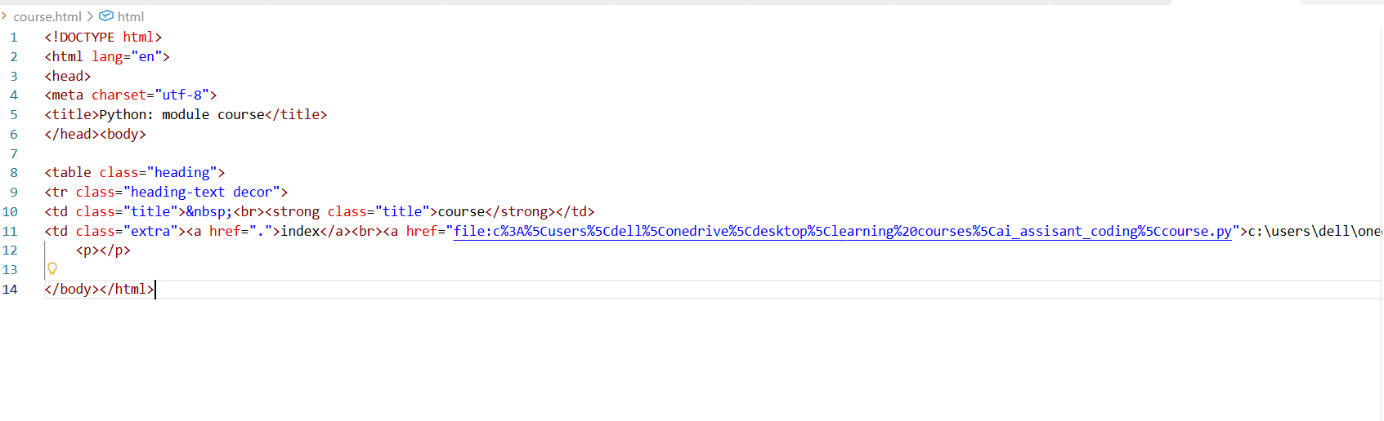
HTML Code Output:
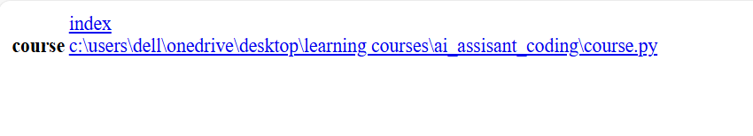

Justification:
- Task demonstrates automatic documentation generation for a real-world module.
- Using Copilot helps generate consistent and accurate docstrings efficiently.
- Docstrings clearly explain the purpose of each course management function.
- Automatic documentation reduces manual documentation effort.
- Terminal documentation provides quick reference for developers.
- HTML documentation offers a structured and readable view of the module.
- Well-documented code improves readability and maintainability.
- It helps new developers understand the course workflow easily.
- Using pydoc follows standard Python documentation practices.
- This task highlights the importance of documentation in software development.

