**ENTITY RELATIONSHIP DIAGRAM**

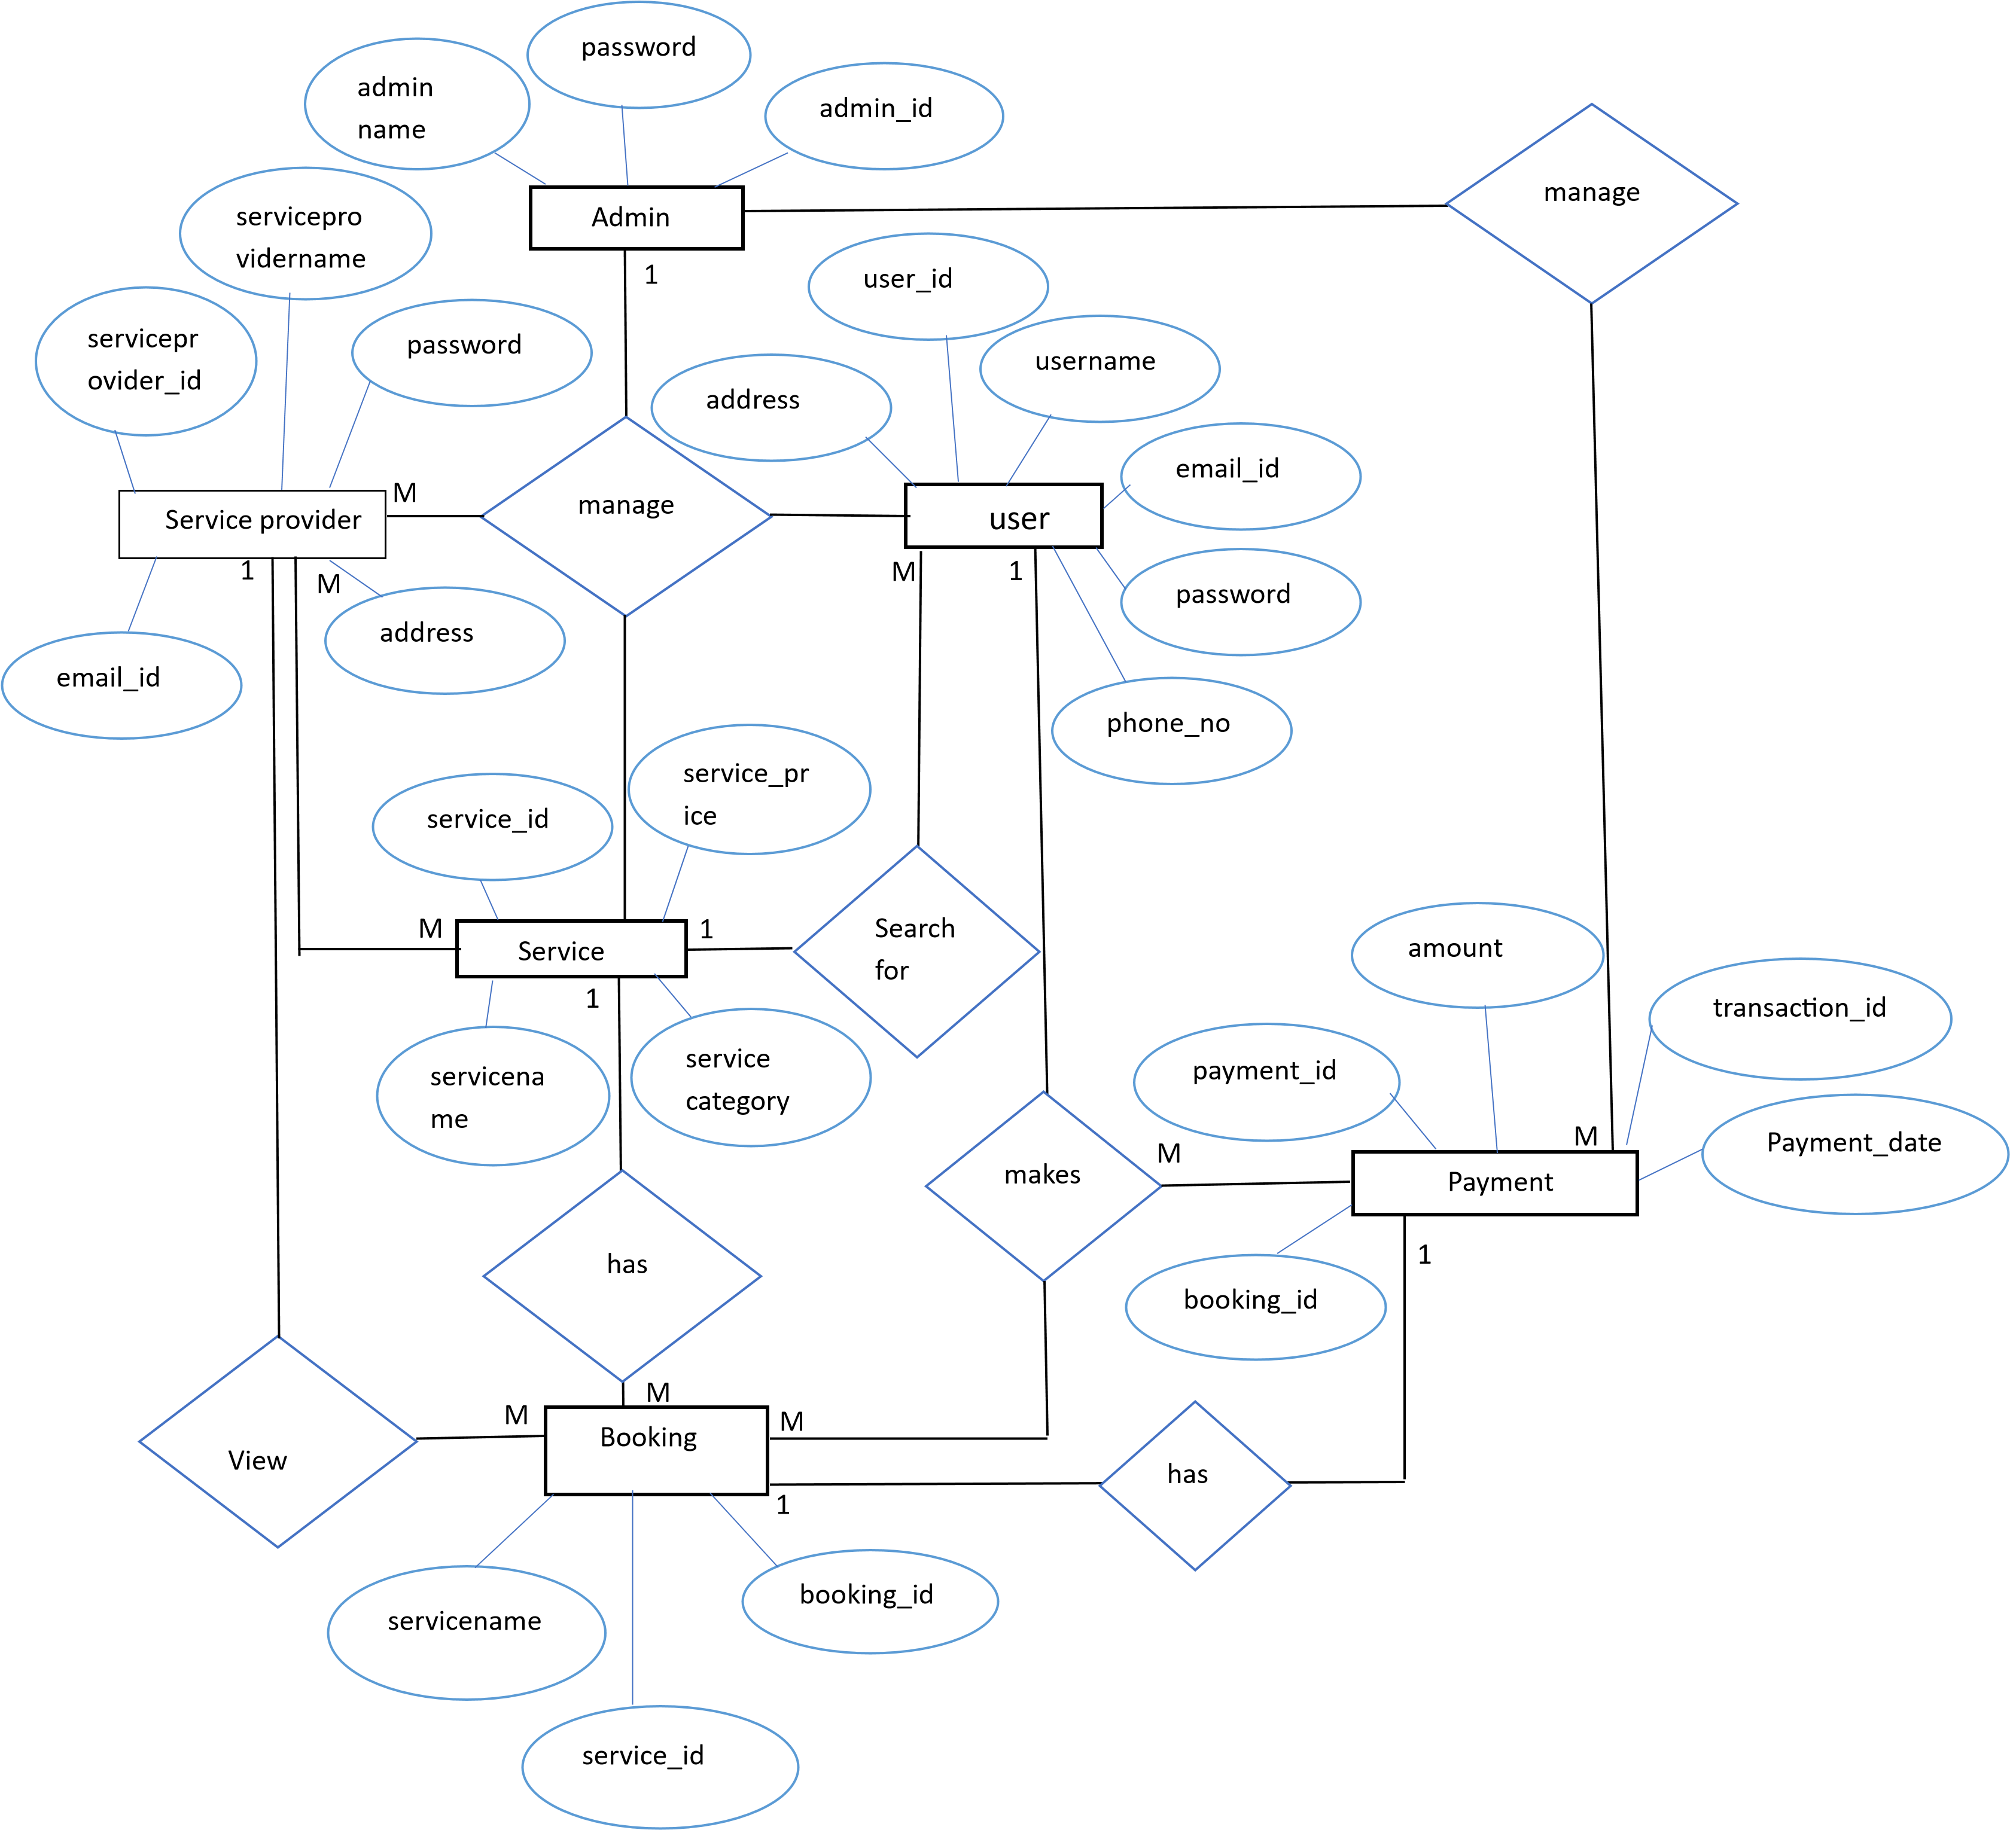

**SEQUENCE DIAGRAM**

**REGISTRATION**

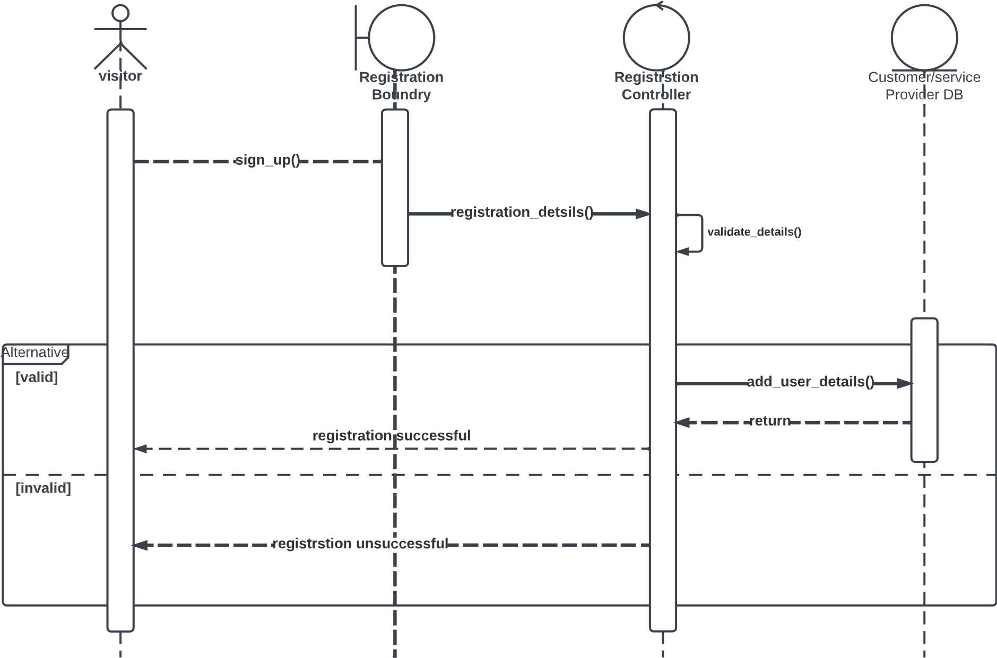

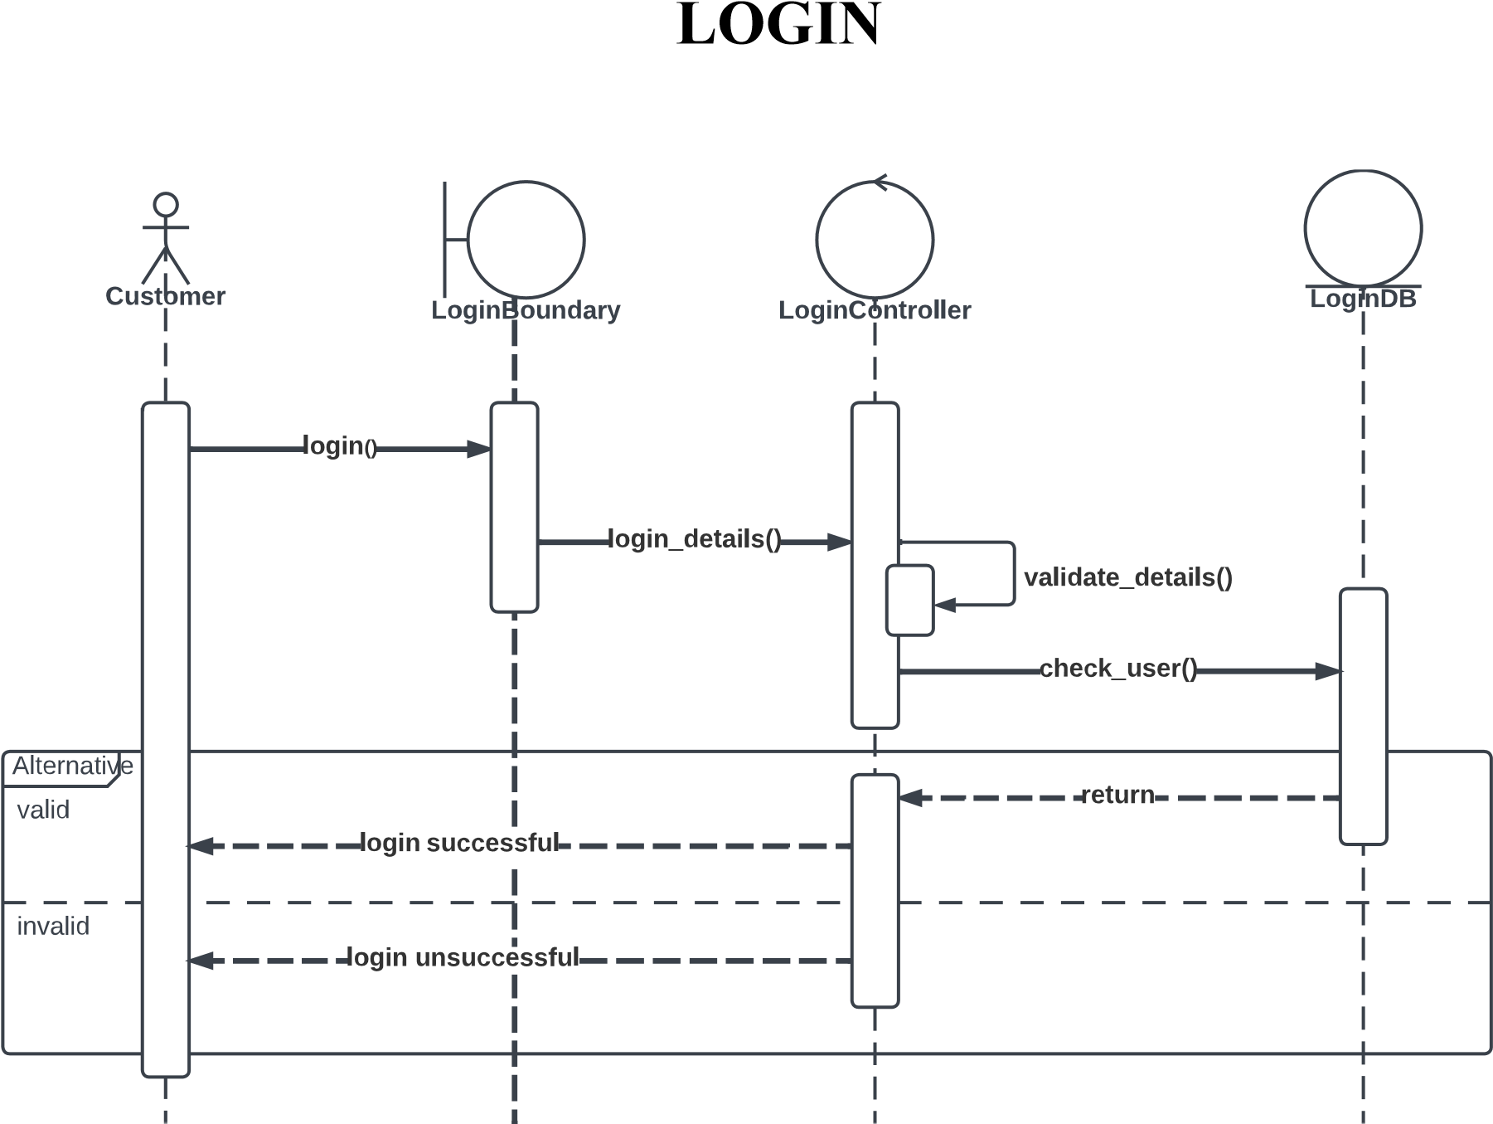

**VIEW SERVICE**

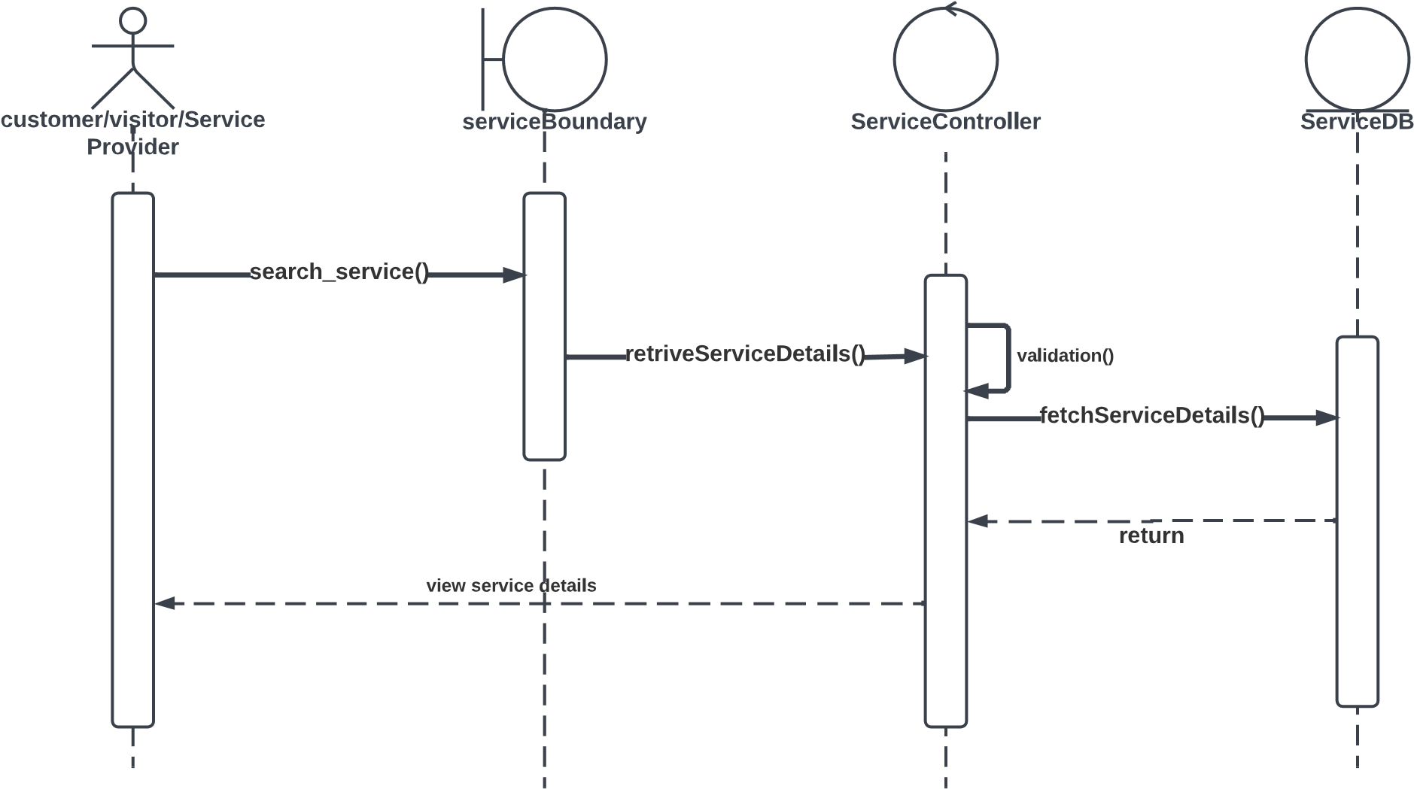

**MANAGE SERVICE**

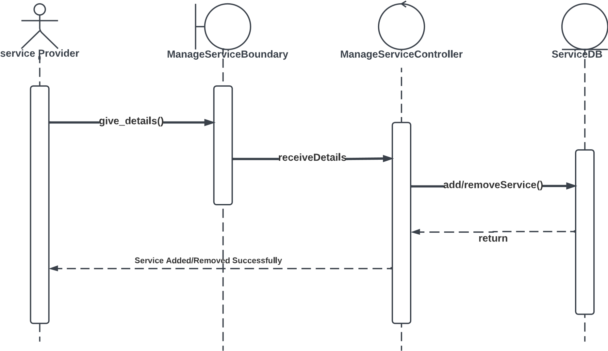

**MANAGE SERVICE CATEGORY**

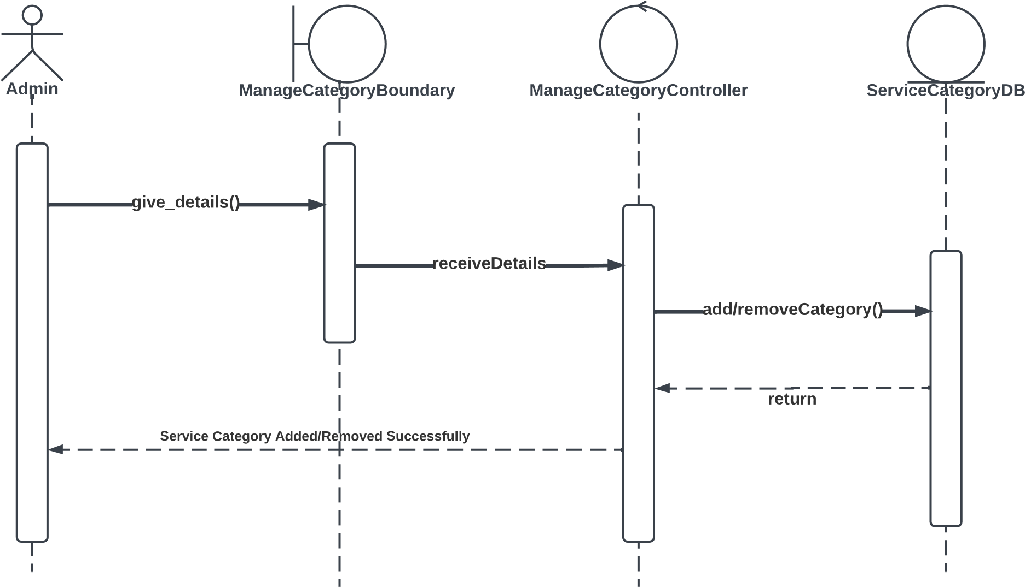

**CART**

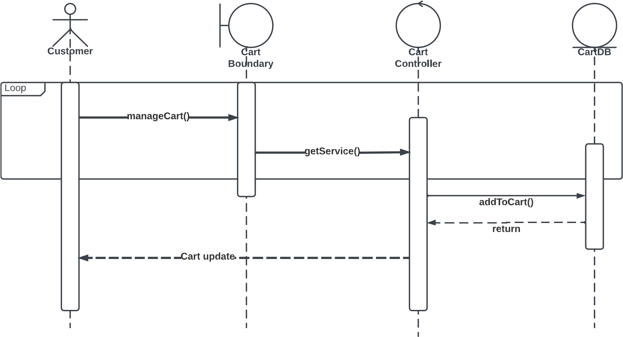

**PLACE ORDER**

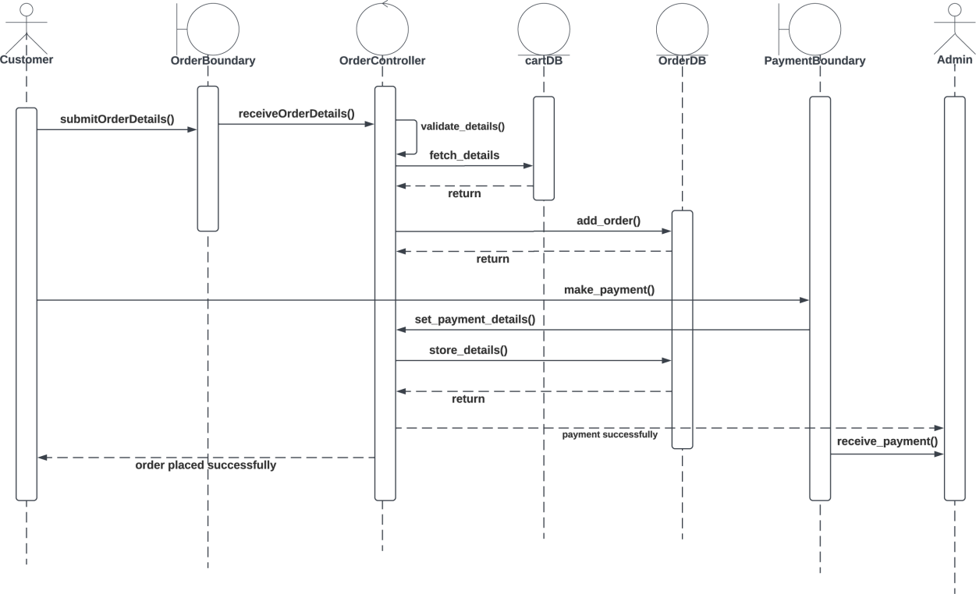

**GIVE FEEDBACK & RATING**

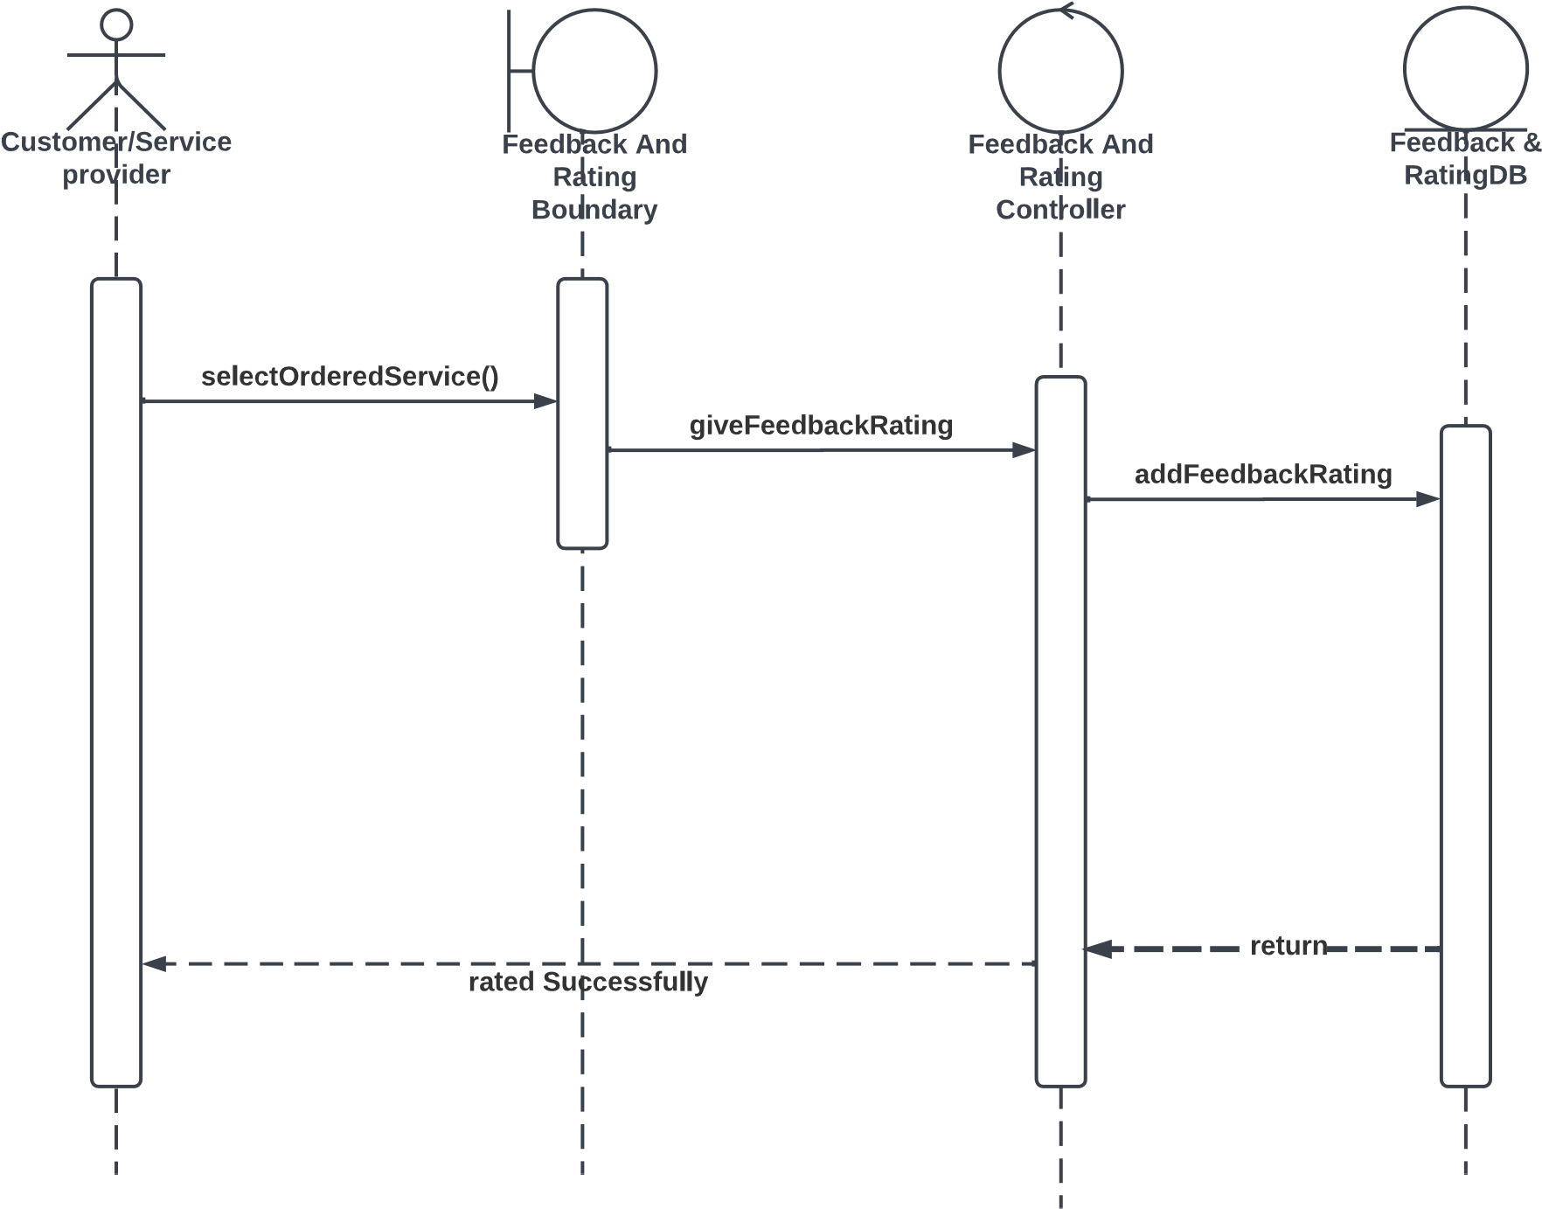

**VIEW FEEDBACK & RATING**

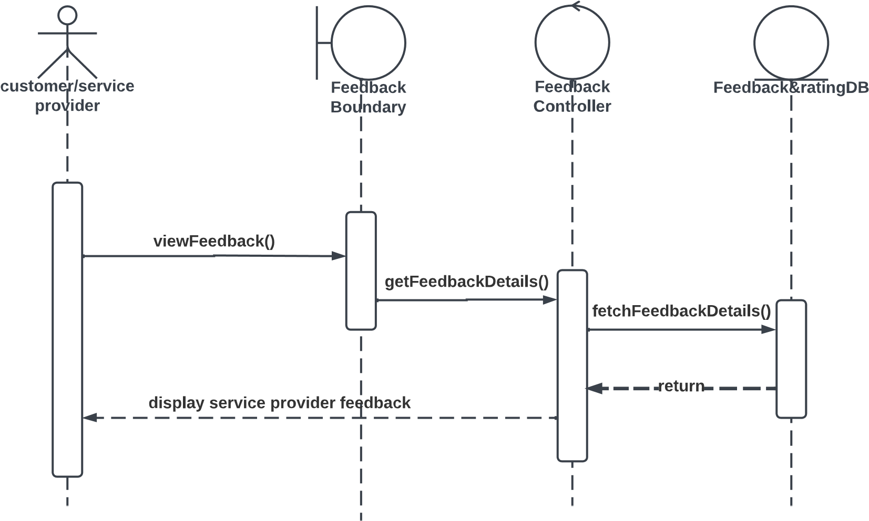

**GENERATE REPORT**

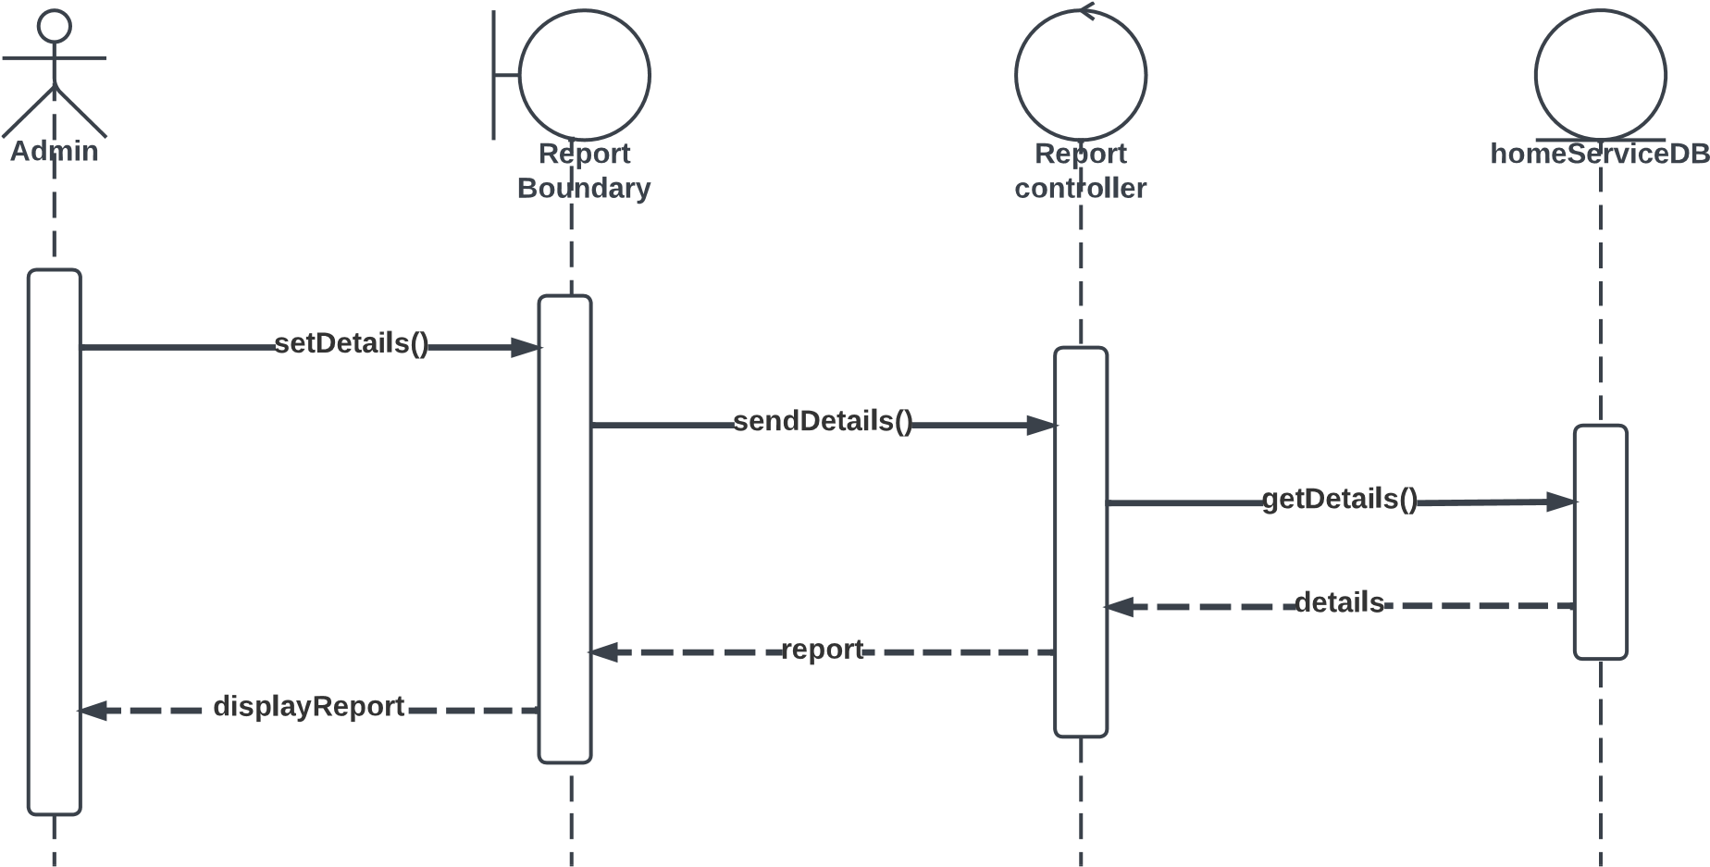

**ACTIVITY DIAGRAM**

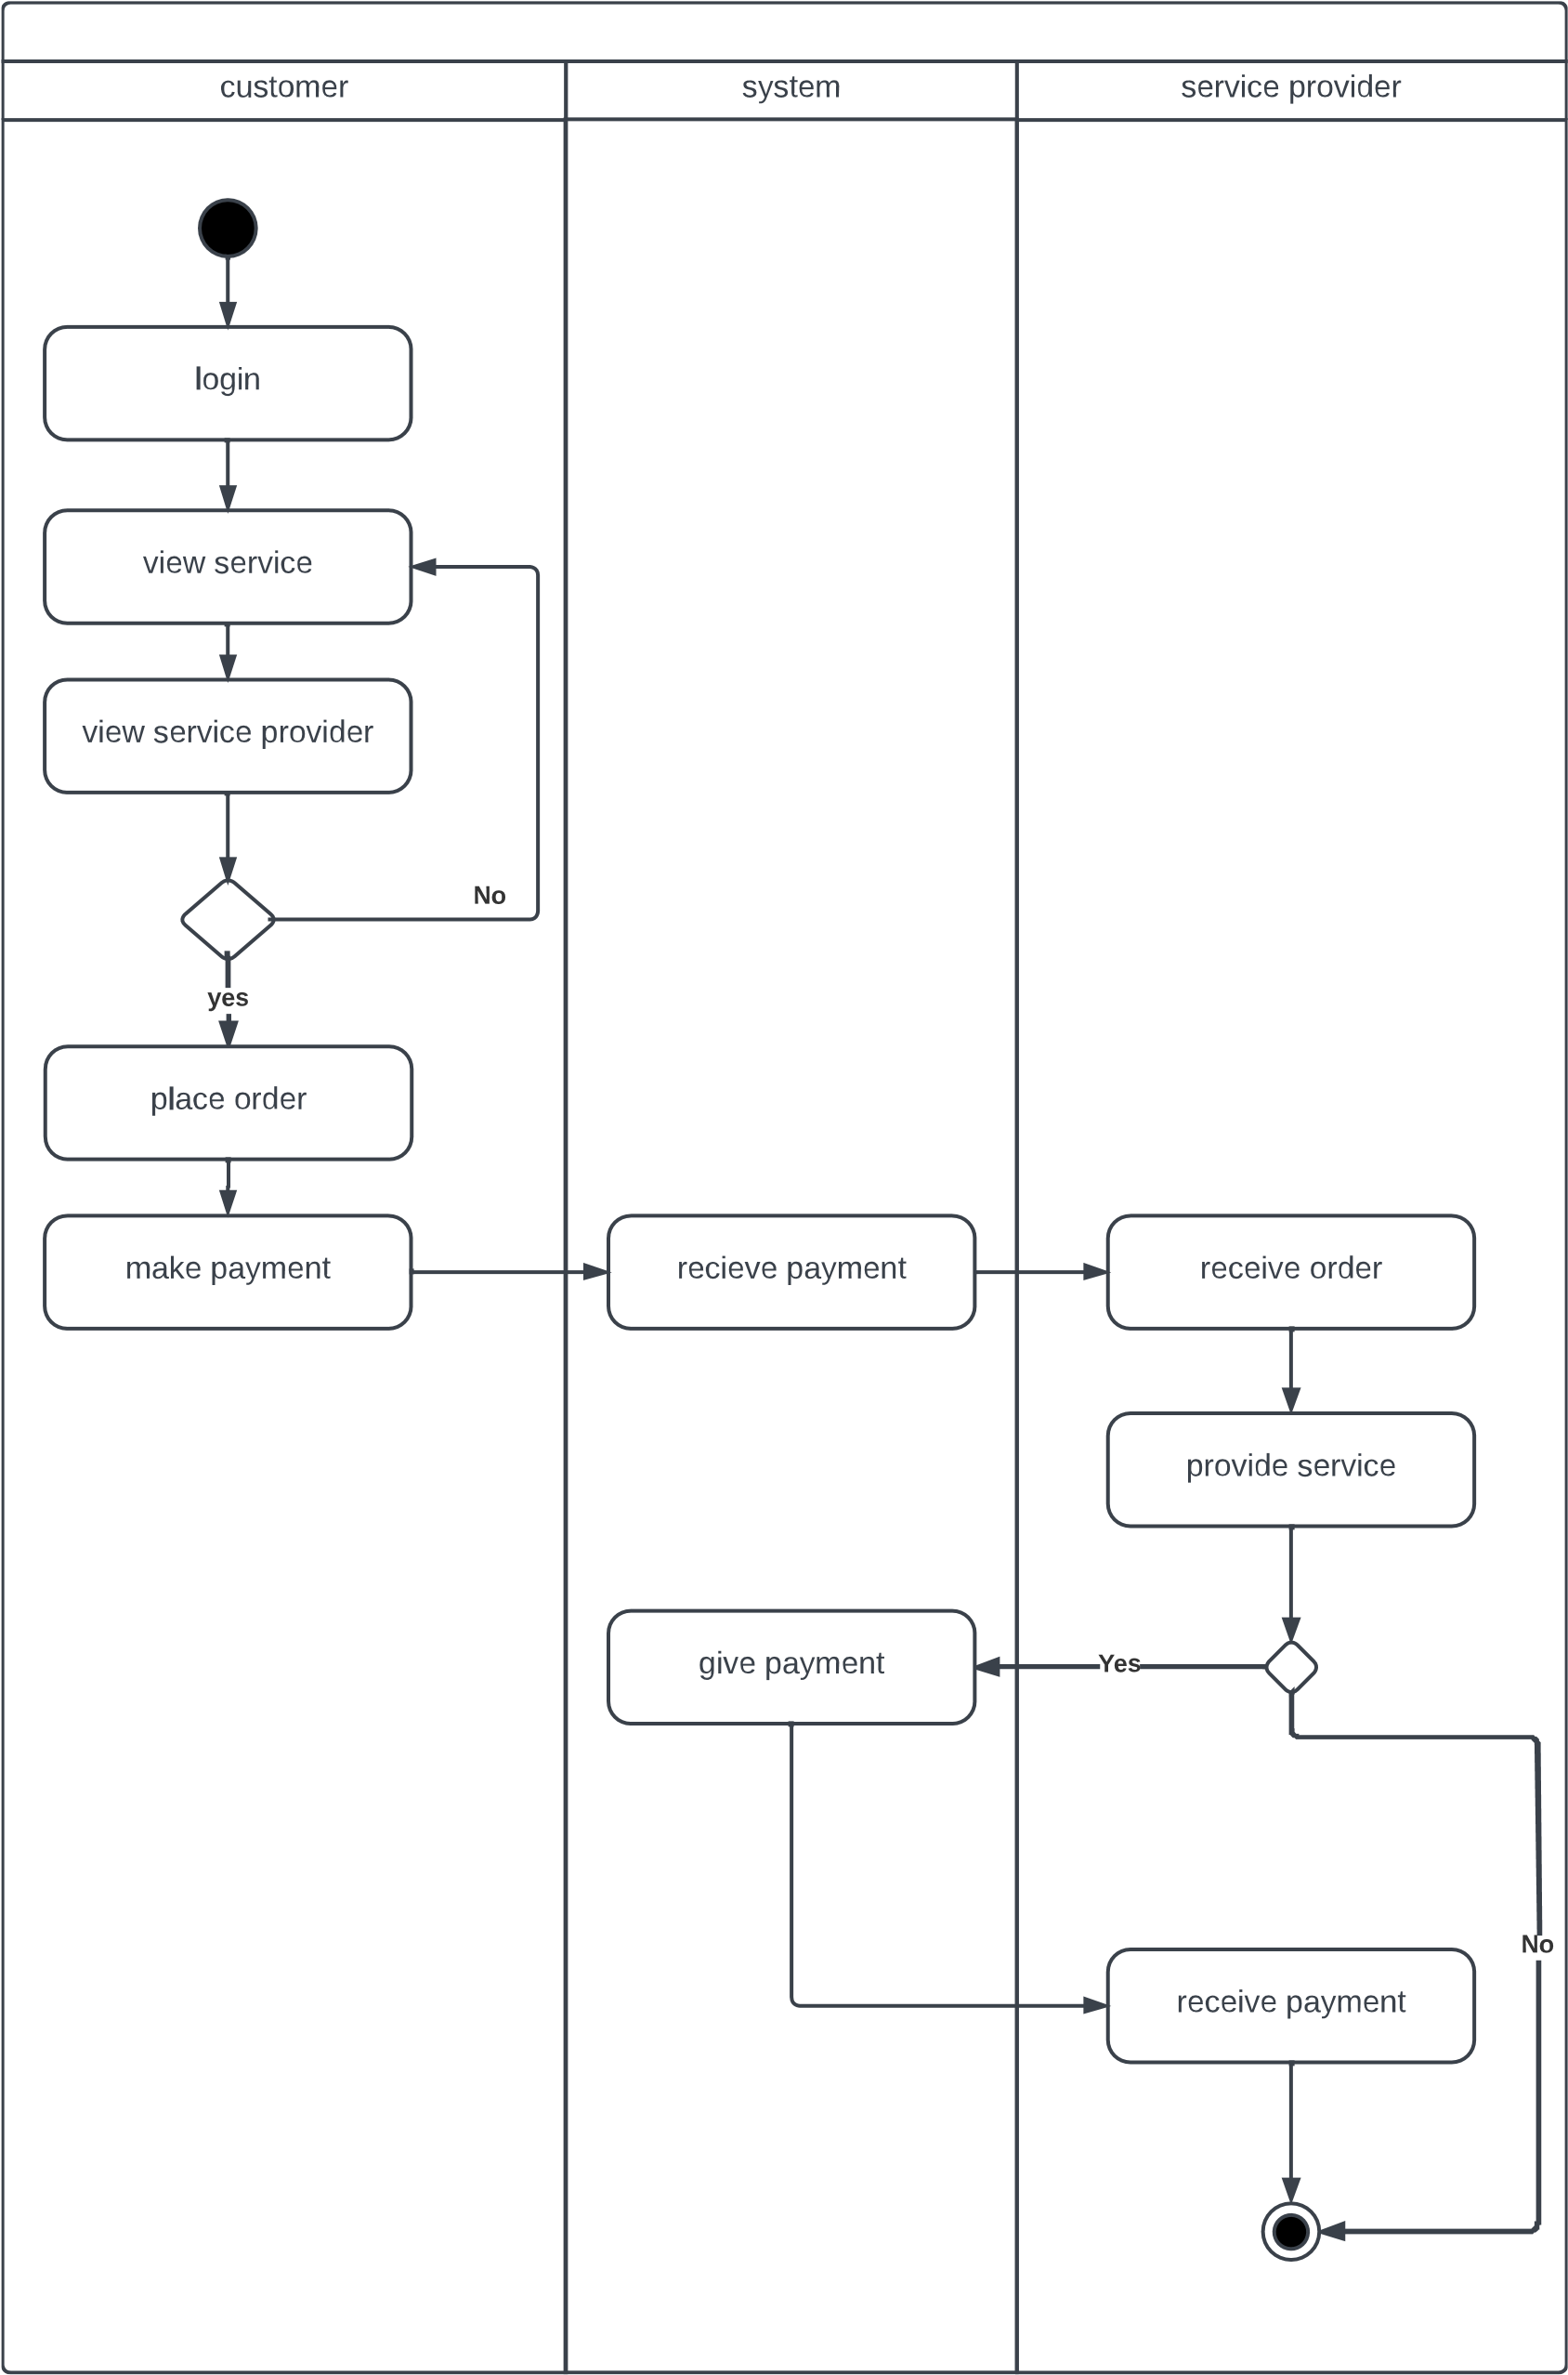

**DFD DIAGRAM**

DFD AT 0 Level:-

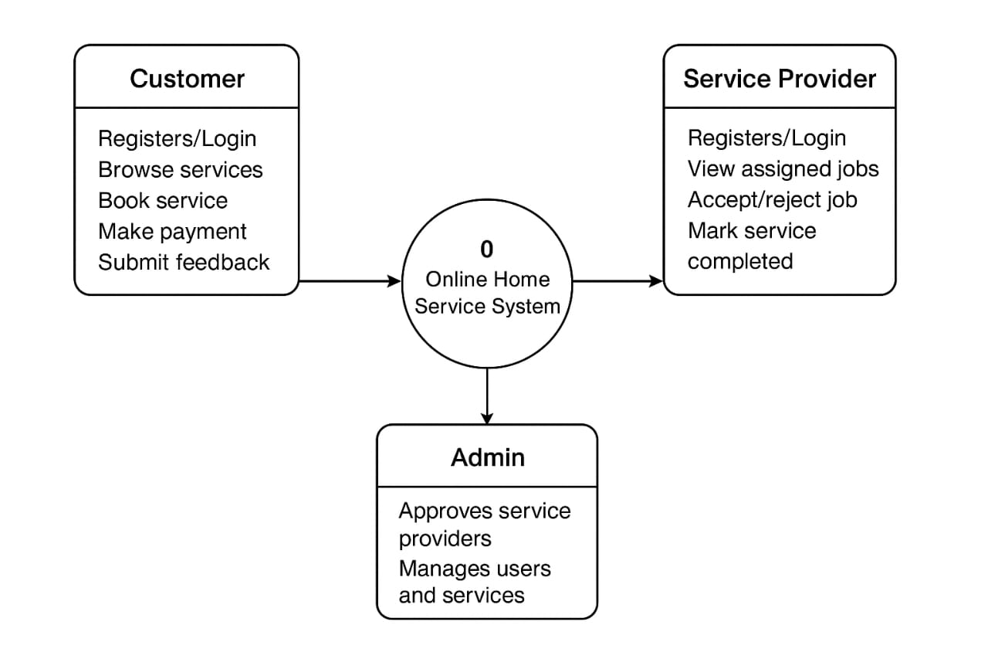

DFD AT 1 LEVEL:-

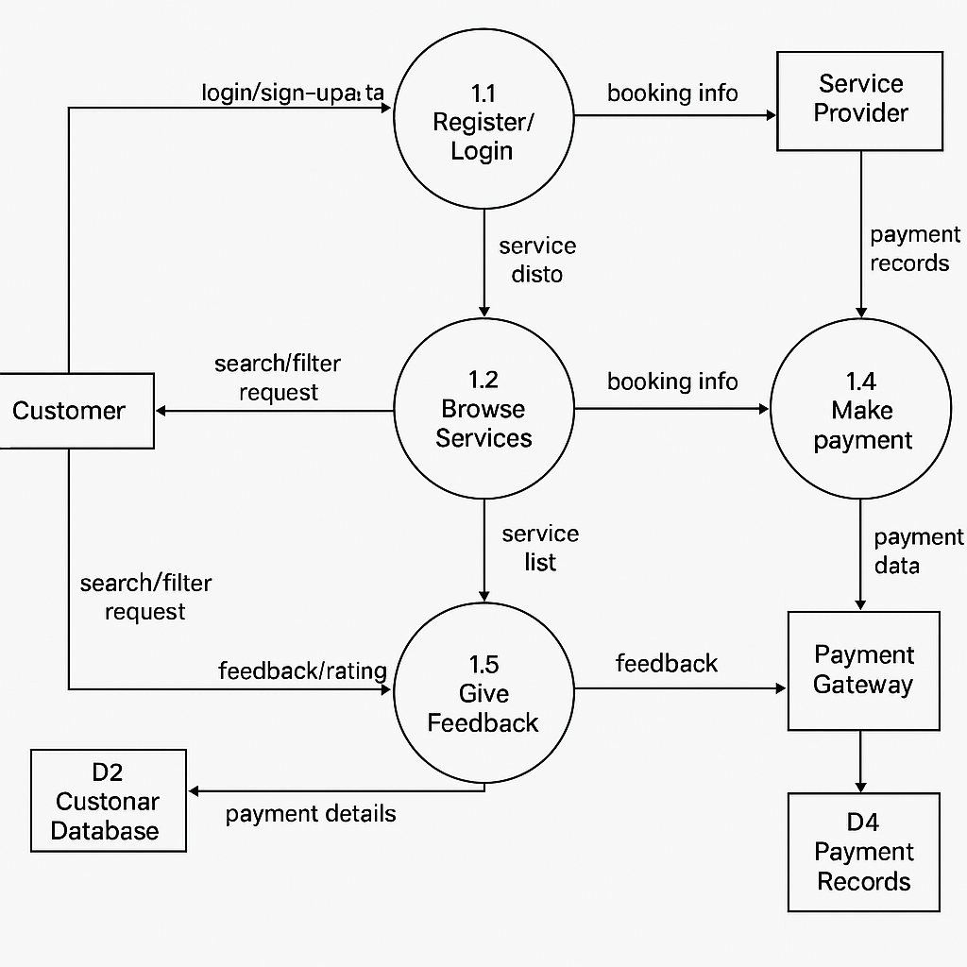

DFD AT 2 LEVEL:-

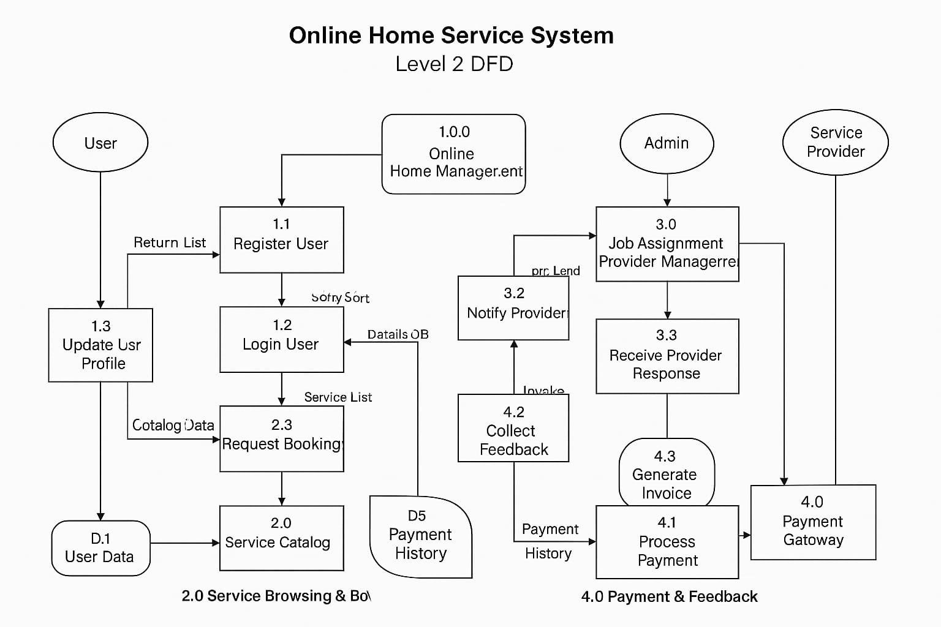

**DATABASE DESIGN**

## Role

|  |  |  |  |
| --- | --- | --- | --- |
| **Field name** | **Data type** | **Constraints** | **Description** |
| Role_id | Integer | Primary key | Id of role |
| Role_name | Varchar(45) | Not null | Name of role |

## Login

|  |  |  |  |
| --- | --- | --- | --- |
| **Field name** | **Data type** | **Contraints** | **Description** |
| Login_id | Integer | Primary key | Id of login |
| User_name | Varchar(45) | Not null | Name of user |
| Password | Varchar(45) | Not null | Password of user |
| Role_id | Integer | Foreign key | Id of role |

**State**

|  |  |  |  |
| --- | --- | --- | --- |
| **Field name** | **Data type** | **Constraints** | **Description** |
| State_id | Integer | Primary key | Id of state |
| State_name | Varchar(45) | Not null | Name of state |

**City**

|  |  |  |  |
| --- | --- | --- | --- |
| **Field name** | **Data type** | **Constraints** | **Description** |
| City_id | Integer | Primary key | Id of city |
| City_name | Varchar(45) | Not null | Name of city |
| State_id | Integer | Foreign key | Id of state |

**Area**

|  |  |  |  |
| --- | --- | --- | --- |
| **Field name** | **Data type** | **Constraints** | **Description** |
| Area_id | Integer | Primary key | Id of area |
| Area_name | Varchar(45) | Not null | Name of area |
| City_id | Integer | Foreign key | Id of city |

## Customer

|  |  |  |  |
| --- | --- | --- | --- |
| **Field name** | **Data type** | **Constraints** | **Description** |
| Customer_id | Integer | Primary key | Id of customer |
| Login_id | Integer | Foreign key | Id of login |
| Area_id | Integer | Foreign key | Id of area |
| Customer_firstname | Varchar(30) | Not null | Customer firstname |
| Customer_lastname | Varchar(30) | Not null | Customer lastname |
| Address | Varchar(50) | Not null | Customer address |
| Phone_no | Integer | Not null | Phone no of customer |
| Email_id | Varchar(45) | Not null | Email of customer |
| Pincode | Interger | Not null | Pincode of  customer |

## Service_provider

|  |  |  |  |
| --- | --- | --- | --- |
| **Field name** | **Data type** | **Constraints** | **Description** |
| ServiceProvider_id | Integer | Primary key | Id of service- provider |
| Service_id | Integer | Foreign key | Id of service |
| Login_id | Integer | Foreign key | Id of login |
| Area_id | Integer | Foreign ley | Name of serviceprovider |
| ServiceProvider_name | Varchar(45) | Not null | Name of serviceprovider |
| Phone_no | Integer | Not null | Phone_no of service provider |
| Address | Varchar(250) | Not null | Address of serviceprovider |
| Email_id | Varhar(45) | Not null | Email of serviceprovider |
| Pincode | Integer | Not null | Pincode of serviceprovider |

## Service_category

|  |  |  |  |
| --- | --- | --- | --- |
| **Field name** | **Data type** | **Constraints** | **Description** |
| ServiceCategory_id | Integer | Primary key | Id of service category |
| ServiceCategory_ name | Varchar(45) | Not null | Name of category |
| ServiceCategory_ datails | Varchar(45) | Not null | Details of category |

## Service

|  |  |  |  |
| --- | --- | --- | --- |
| **Field name** | **Data type** | **Constraints** | **Description** |
| Service_id | Integer | Primary key | Id of service |
| Service_name | Varchar(45) | Not null | Name of service |
| Service_price | Integer | Not null | Price of service |
| ServiceProvide_id | Integer | Foreign key | Id of service-provider |
| Service_availibility | Integer | Not null | Availibiity of service |
| Service_description | Varchar(300) | Not null | Description of service |
| ServiceCategory_id | Integer | Foreign key | Id of service category |
| Service_availability | Integer | Not null | Availability of service |

## Order

|  |  |  |  |
| --- | --- | --- | --- |
| **Field name** | **Data type** | **Constraints** | **Description** |
| Order_id | Integer | Primary key | Id of order |
| serviceProvicer_id | Integer | Foreign key | Id of serviceprovider |
| Customer_id | Integer | Foreign key | Id of customer |
| Order_date | Date | Not null | Date of order |
| Discount | Float | Not null | Order discount |
| Order_status | Varchar(45) | Not null | Order status |
| Total_amount | Integer | Not null | Total amount of order |
| Address | Varchar(100) | Not null | Address of delivery |
| Pincode | Integer | Not null | Pincode of address |

## Order_details

|  |  |  |  |
| --- | --- | --- | --- |
| **Field name** | **Data type** | **Constraints** | **Description** |
| Service_id | Integer | Primary key | Id of service |
| ServiceProvider_id | Integer | Primary key | Id of serviceprovider |
| Order_id | Integer | Foreign key | Id of order |
| Amount | Integer | Not null | Amount of order |
| Order_date | Date | Not null | Date of order |
| Qty | Integer | Not null | Quantity of order |
| Cancellation_date | Date | Not null | Date of cancellation |
| Iscancelled | Integer | Not null | Status of cancellation |

## Service_provider_has_service

|  |  |  |  |
| --- | --- | --- | --- |
| **Field name** | **Data type** | **Constraints** | **Description** |
| ServiceProvider_id | Integer | Primary key | Id of serviceprovider |
| Service_id | Integer | Primary key | Id of service |
| Charges | Integer | Not null | Charges of services |

### Customer_feedback

|  |  |  |  |
| --- | --- | --- | --- |
| **Field name** | **Data type** | **Constraints** | **Description** |
| Customer_id | Integer | Foreign key | Id of customer |
| ServiceProvider_id | Integer | Foreign key | Id of serviceprovider |
| Description | Varchar(45) | Not null | Description of feedback |
| Date | Date | Not null | Date of feedback |

## Service_provider_feedback

|  |  |  |  |
| --- | --- | --- | --- |
| **Field name** | **Data type** | **Constraints** | **Description** |
| Customer_id | Integer | Foreign key | Id of customer |
| ServiceProvider_id | Integer | Foreign key | Id of serviceprovider |
| Description | Varchar(45) | Not null | Description of feedback |
| Date | Date | Not null | Date of feedback |

## Service_provider_rating

|  |  |  |  |
| --- | --- | --- | --- |
| **Field name** | **Data type** | **Constraints** | **Description** |
| Customer_id | Integer | Foreign key | Id of customer |
| ServiceProvider_id | Integer | Foreign key | Id of serviceprovider |
| Rating_value | Integer | Not null | Value of rating |
| Rating_Date | Date | Not null | Date of rating |

## Customer_rating

|  |  |  |  |
| --- | --- | --- | --- |
| **Field name** | **Data type** | **Constraints** | **Description** |
| Customer_id | Integer | Foreign key | Id of customer |
| ServiceProvider_id | Integer | Foreign key | Id of serviceprovider |
| Rating_value | Integer | Not null | Value of rating |
| Rating_Date | Date | Not null | Date of rating |

## Manage_cart

|  |  |  |  |
| --- | --- | --- | --- |
| **Field name** | **Data type** | **Constraints** | **Description** |
| Service_id | Integer | Primary key | Id of service |
| Customer_id | Integer | Primary key | Id of customer |
| Qty | Integer | Not null | Quantity of service |
| Amount | Integer | Not null | Amount of service |
| Service_provider_id | Integer | Foreign key | Id of service provider |

**Payment**

|  |  |  |  |
| --- | --- | --- | --- |
| **Field name** | **Data type** | **Constraints** | **Description** |
| Payment_id | Integer | Primary key | Id of payment |
| Order_id | Integer | Foreign key | Id of order |
| Amount | Integer | Not null | Amount of payment |