Experiment -11
NAME: A. Abhishek Reddy
Rg No:192424192
Course Code: DSA0406
Course Name: Software: Fundamentals of Data Science for Data Processing
11. Scenario: You are a data scientist working for a company that sells products online. You have been tasked with creating a simple plot to show the sales of a product over time.
Question:
1. Write code to create a simple line plot in Python using Matplotlib to predict sales happened in a month?
2. Write code to create a scatter plot in Python using Matplotlib to predict sales happened in a month?
3. Develop a Python program to create a bar plot of the monthly sales data.
Code
1. Line Plot for Monthly Sales (Matplotlib)
import matplotlib.pyplot as plt
days = list(range(1, 31))
sales = [100, 120, 150, 130, 160, 180, 170, 200, 220, 210,
230, 250, 240, 260, 280, 300, 320, 310, 330, 350,
360, 380, 400, 420, 410, 430, 450, 470, 480, 500]
plt.plot(days, sales, marker='o')
plt.title("Daily Sales Trend (Line Plot)")
plt.xlabel("Day of the Month")
plt.ylabel("Sales Amount")
plt.grid(True)
plt.show()
Output:
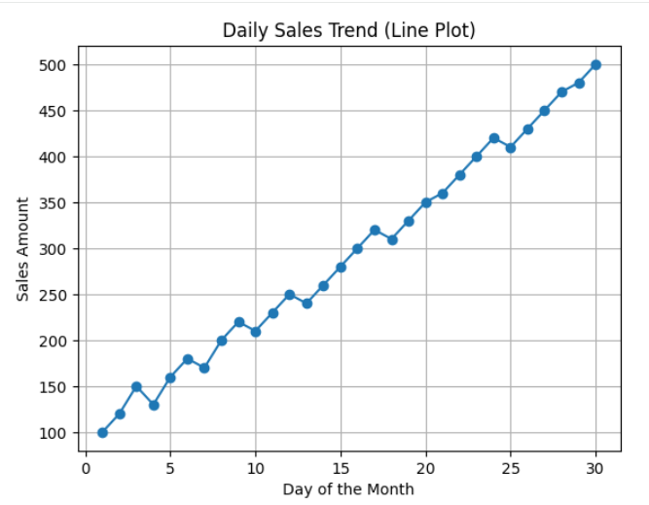
2. Scatter Plot for Monthly Sales (Matplotlib)
import matplotlib.pyplot as plt
days = list(range(1, 31))
sales = [100, 120, 150, 130, 160, 180, 170, 200, 220, 210,
230, 250, 240, 260, 280, 300, 320, 310, 330, 350,
360, 380, 400, 420, 410, 430, 450, 470, 480, 500]
plt.scatter(days, sales)
plt.title("Daily Sales (Scatter Plot)")
plt.xlabel("Day of the Month")
plt.ylabel("Sales Amount")
plt.grid(True)
plt.show()
Output:

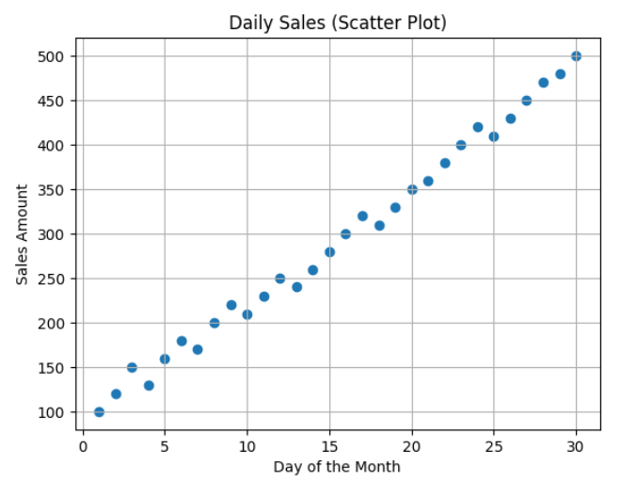
3. Bar Plot of Monthly Sales Data
import matplotlib.pyplot as plt
months = ["Jan", "Feb", "Mar", "Apr", "May", "Jun"]
sales = [5000, 6200, 5800, 7000, 7600, 8000]
plt.bar(months, sales)
plt.title("Monthly Sales Data (Bar Plot)")
plt.xlabel("Months")
plt.ylabel("Sales Amount")
plt.show()
Output:
