Assignment 01 : Basic linux Command

1. man git -> Command to get help about commands

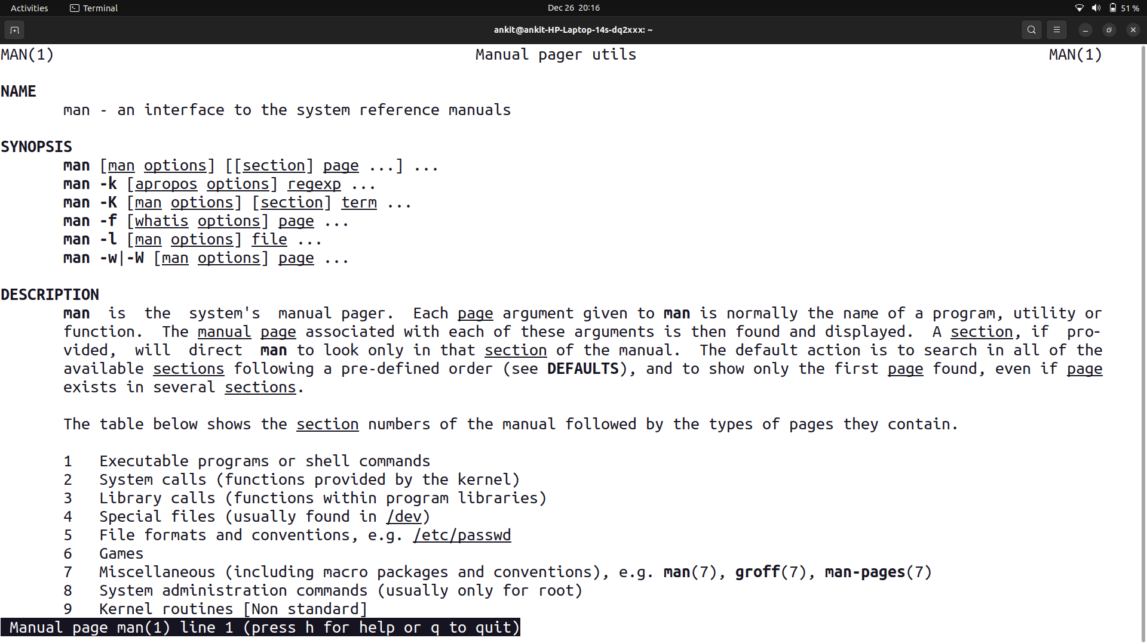
2. uname -> Print System information

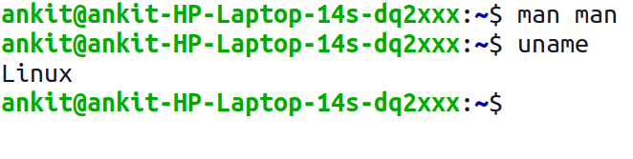

3. pwd ->Print current directory

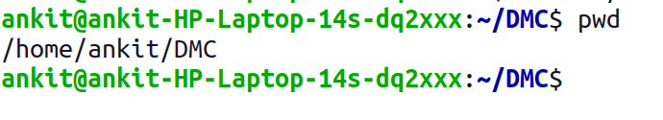
4. hostname -> Print IP address and hostname of the machine

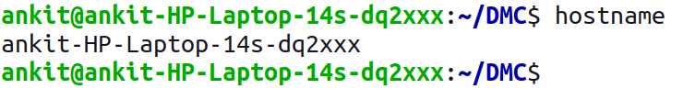

5. date -> Find today’s date
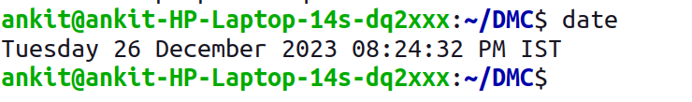

6. cal -> Print calendar for current year

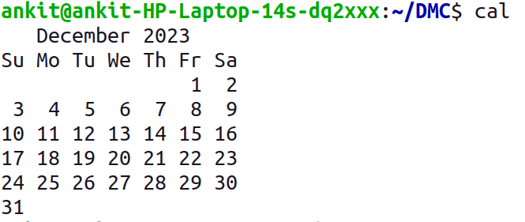

7. ls, dir -> See directory structure

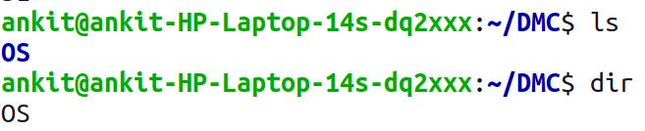

8. cat -> Create file

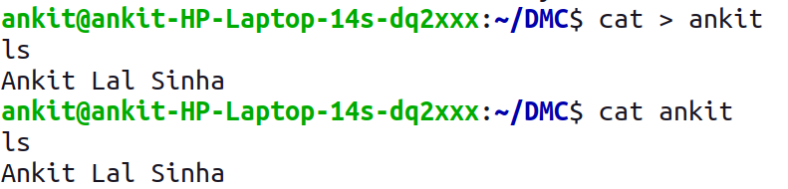

9. cat >> -> Append some text into existing file
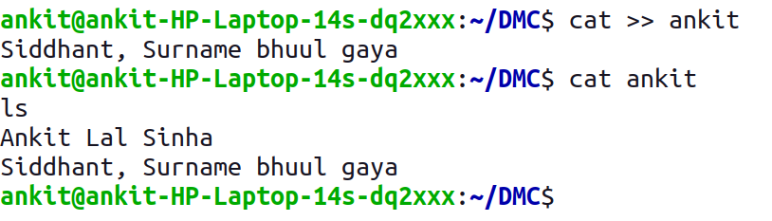

10. cp -> Copy a file, Copy a directory
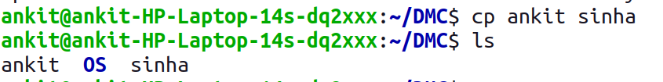

11. mv -> Move the files
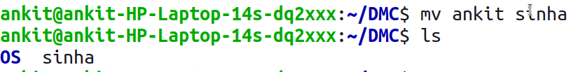

12. mv -> Rename a file
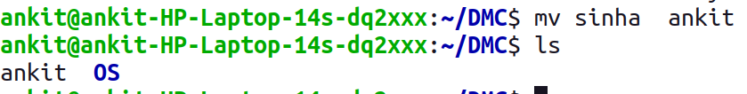

13. tac, rev -> Print the file in reverse order, Reverse each line in the file

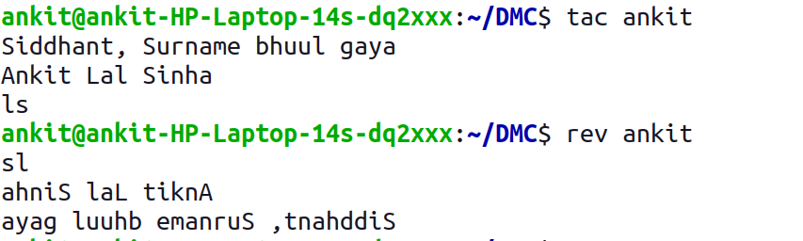

14. wc -> Count the words, characters and lines in a file

15. mkdir -> Create directory

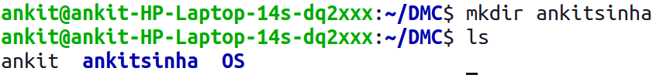
16. cd -> Change current directory

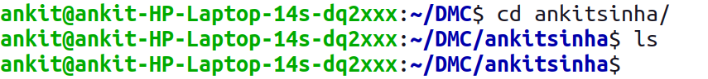
17. rm -> Remove a file, remove a directory ( with -R )
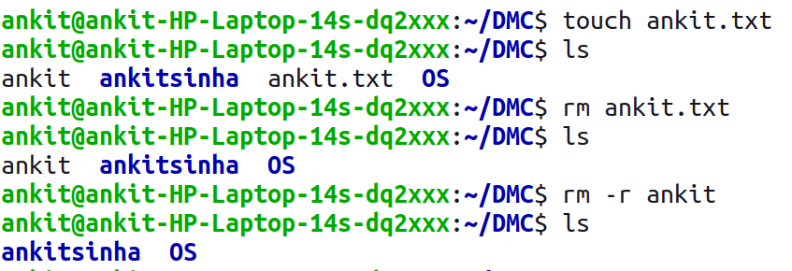

18. rmdir -> remove empty directory

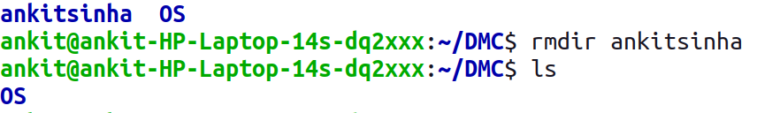
19. touch -> change the modification time , Create Multiple empty files at once

20. sort -> Sort file.

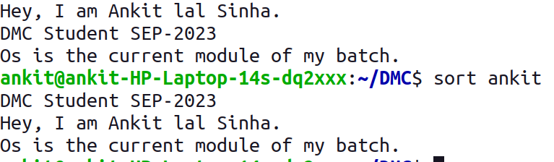

21. uniq -> Avoid repetition in a file.
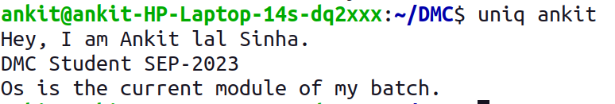

22. head -> Print the specified number of lines from top in the file.

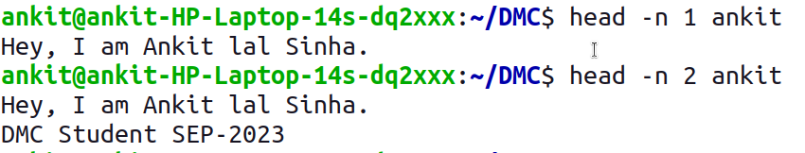

23. tail -> Print the specified number of lines from bottom in the file.

24. factor -> Find the factors of a number

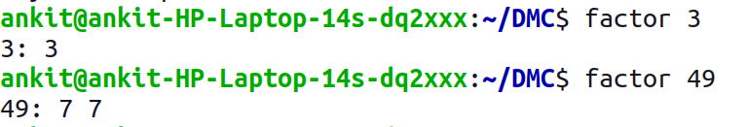

25. alias -> Create command shortcut

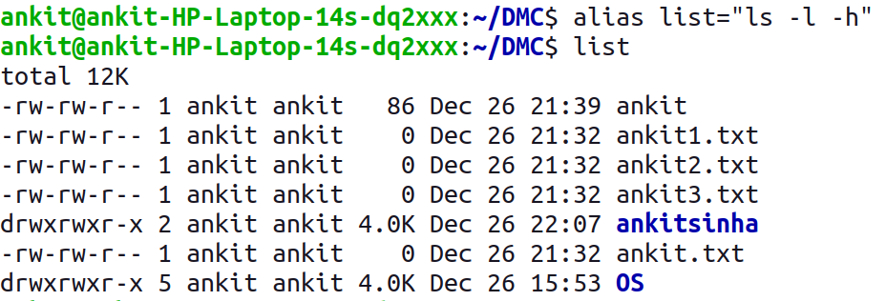

26. unalias -> remove the command shortcut

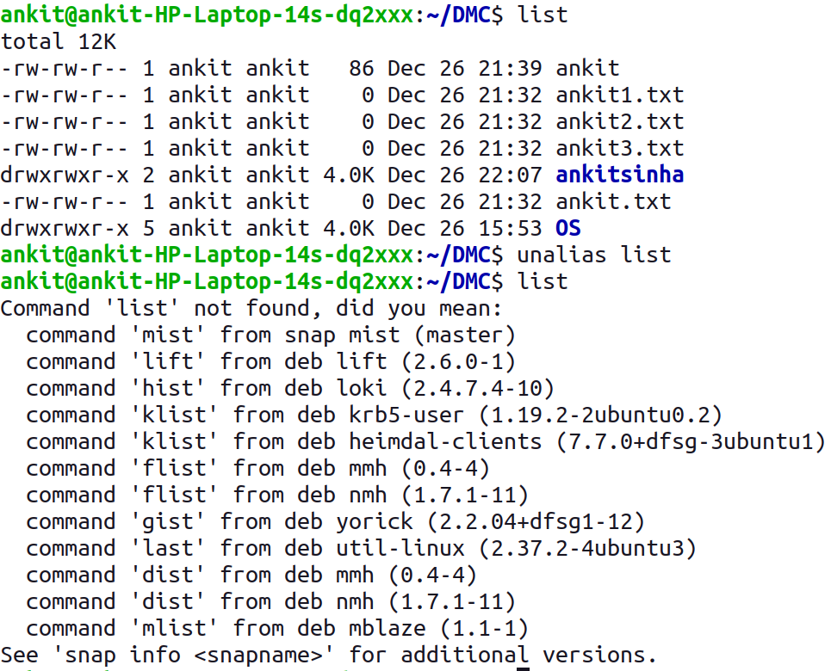

27. echo -> Print environment variables individually

28. ps -> Print current processes

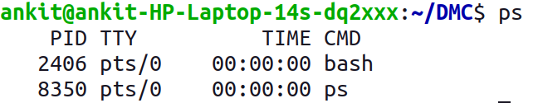
29. kill -> Kill the process

30. env -> Print environment variables

