KEYLOGGER
A PROJECT REPORT

Submitted by

ANKIT PATEL
201260107012

In fulfillment for the award of the degree of

BACHELOR OF ENGINEERING
in
Computer Engineering

Sal Engineering And Technical Institute



Gujarat Technological University , Ahmadabad

[May, 2024]





Sal Engineering And Technical Institute
Ahmedabad - 380060

CERTIFICATE

This is to certify that the project report submitted along with the project entitled KEYLOGGER has been carried out by Patel Ankit under my guidance in fulfillment for the degree of Bachelor of Engineering in Computer Engineering, 8th Semester of Gujarat Technological University, Ahmadabad during the academic year 2023-24.

Prof. Krupa Suthar | Dr. Ajay Upadhyaya
Internal Guide | Head of the CE Department






Sal Engineering And Technical Institute
Ahmedabad - 380060

DECLARATION

We hereby declare that the Internship / Project report submitted along with the Internship /Project entitled KEYLOGGER submitted in fulfillment for the degree of Bachelor of Engineering in Computer Engineering to Gujarat Technological University ,Ahmadabad, is a bonafide record of original project work carried out by me at State Cyber Cell under the supervision of Mr.Nikhil Prajapati and that no part of this report has been directly copied from any students reports or taken from any other source, without providing due reference.

Name of the Student Sign of Student
1 Patel Ankit

Acknowledgement

This project has taken a lot of time and work on my part. However, it would not have been possible without the kind support and cooperation of many individuals and organizations. I'd like to take this opportunity to thank each of you personally.
I owe a lot to "MR.NIKHIL PRAJAPATI" for their guidance and constant supervision, as well as for providing important project specifics. As a way of expressing my gratitude for their steadfast support and assistance throughout our project's preparation, all of my friends and colleagues who started the conversation as well as those who contributed critical review input are being recognized here. Our college's "Sal Engineering And Technical Institute" provided me with all the resources I needed and a welcoming work environment, and for that I am grateful.

-PATEL ANKIT
(201260107012)

Abstract
Keyloggers, often vilified for their association with cyber threats and privacy breaches, possess untapped potential for constructive applications across various domains. This paper aims to elucidate the positive attributes of keyloggers, shedding light on their beneficial roles in contemporary society.
Drawing from diverse fields, including cybersecurity, parental guidance, and accessibility, this abstract underscores keyloggers' multifaceted utility. It delineates how keyloggers, when wielded judiciously, can serve as potent tools for parental monitoring, ensuring children's online safety, and facilitating responsible internet usage. Moreover, within corporate settings, keyloggers emerge as invaluable instruments for employee oversight, bolstering data security and adherence to organizational protocols.
Furthermore, in the realm of data recovery and password retrieval, keyloggers offer indispensable assistance, enabling users to reclaim lost information and regain access to vital accounts. Their utility extends beyond individual domains to encompass broader societal benefits, including user behavior analysis for research and psychological insights.
Ethical considerations remain paramount, emphasizing the importance of lawful and ethical usage to safeguard privacy rights and adhere to regulatory frameworks. By embracing keyloggers' positive potential while navigating ethical frameworks, individuals, organizations, and policymakers can harness their transformative capabilities to foster a safer, more productive digital landscape.

List of Figures
1.1. Organization Chart of State Cyber Cell………………………………………. 10
2.1. Stage of Production…………………………………………………………... 14
4.1. Proposed of keylogger ………………………………………………………. 24
5.1. user case diagram …….……………………………………………………… 29
5.2. System level diagram ……………………………………………………..... 30
6.1. program code ................................................................................................... 31
6.2. program code ................................................................................................... 32
6.3. Implementation.................................................................................................. 32
6.3. output .............................................................................................................. 33

List of Tables
3.7 Project / Internship Effort and Time, Cost Estimation.....................................24

Table of Contents
Abstract ...................................................................................................................... i
Acknowledgement ..................................................................................................... ii
List of Figures ........................................................................................................... iii
List of Table................................................................................................................ iv
- Over view of the Company................................................................................. 1
  - History ................................................................................................................. 1
  - scope of work …………………........................................................................... 1
  - Organization Chart……………………………………………………………….2
- Over view of process being carried out in company ....................................... 3
  - Details Department .............................................................................................. 3
  - List of Technical Specification of Equipment……………………......……........ 3
2.3 Stage of Production............................................... …………………..…………..5
2.4 Explain in details about each stage of production ............................................... 6
- Introduction to Project...................................................................................... 10
  - Project .................…………………………………………………….……...... 10
  - Purpose ................................................................................................................ 10
  - Objective ............................................................................................................. 10
  - Scope (what it can do and can’t do) .................................................................... 11
  - Technology and Literature Review ..................................................................... 12
  - Project Planning .................................................................................................. 13
3.6.1Project Development Approach and Justification .............................................. 13
3.6.2Project Effort and Time, Cost Estimation .......................................................... 14
3.6.3Roles and Responsibilities .......................................................................... 15
3.6.4 Group Dependencies ………………………………………………………15
  - Project Scheduling (Gantt Chart/PERT/Network Chart) ................................... 15
- System Analysis ................................................................................................ 16
  - Study of Current System .................................................................................... 16
  - Problem and Weaknesses of Current System ...................................................... 16
  - Requirements of New System............................................................................. 17
  - System Feasibility .............................................................................................. 18
  - Proposed System ............................................................................................... 19
  - Features of New System...................................................................................... 19
  - List Main Modules Proposed System ................................................................ 20
  - Selection of Approaches and Justification........................................................... 21
- System Design ................................................................................................... 22
  - System Design & Methodology .......................................................................... 22
  - Structure Design ................................................................................................ 35
5.3 Input / Output and Interface Design … ...............................................................19
- Implementation ................................................................................................ 36
  - Implementation Platform / Environment ............................................................. 36
  - Program Specification ......................................................................................... 36
  - Results .................................................................................................................. 37
- Testing ................................................................................................................ 44
  - Testing Plan ...................................................................................................... 44
  - Test Results and Analysis ................................................................................... 45
- Conclusion and Discussion ............................................................................... 46
  - Overall Analysis of Project Viabilities .......... ..................................................... 46
  - Photographs and date of surprise visit by institute mentor...................................
  - Dates of Continuous Evaluation (CE-I and CE-II)...............................................
  - Problem Encountered and Possible Solutions ..................................................... 47
  - Summary of Project work ......................... ......................................................... 48
  - Limitation and Future Enhancement ................................................................... 49
References .............................................................................................................. 51

- Over view of the Company

1.1. History
The history of State Cyber Cells can vary depending on the region and the specific evolution of cybersecurity initiatives within a country or state.
Emergence of Cyber Threats: The need for specialized units to address cybercrimes became apparent with the rise of digital technologies and the internet. As early as the 1990s, cybercrimes such as hacking, malware attacks, and online fraud started to proliferate, highlighting the vulnerability of individuals, businesses, and governments to digital threats.
Formation of Cybercrime Units: In response to the escalating cyber threats, many law enforcement agencies around the world began establishing specialized units dedicated to combating cybercrimes. These units initially focused on basic tasks such as investigating hacking incidents and online fraud.
Expansion of Responsibilities: Over time, the scope of cybercrime units expanded to encompass a broader range of cyber threats, including identity theft, phishing, cyberbullying, and cyberterrorism. As cybercrimes became more sophisticated and diverse, these units evolved to develop expertise in digital forensics, computer science, and cybersecurity.
Legislative Framework: Governments enacted legislation to empower cybercrime units with the legal authority to investigate and prosecute cybercrimes effectively. These laws often included provisions for the preservation of digital evidence, the protection of privacy rights, and the imposition of penalties for cybercriminals.
Integration of Technology: State Cyber Cells leveraged advanced technologies and tools to enhance their capabilities in detecting, preventing, and responding to cyber threats. This includes the use of digital forensics software, cybersecurity analytics, threat intelligence platforms, and collaboration tools.
1.2. scope of work

The scope of work within a State Cyber Cell encompasses a wide range of activities aimed at combating cybercrimes, enhancing cybersecurity measures, and safeguarding digital assets.
Cybercrime Investigation: Conducting investigations into various types of cybercrimes, including hacking, phishing, identity theft, online fraud, cyberbullying, and cyberterrorism. This involves collecting digital evidence, analyzing forensic data, and identifying perpetrators.
Digital Forensics: Utilizing advanced tools and techniques to conduct digital forensics analysis on computers, mobile devices, networks, and other digital storage media. This includes recovering deleted files, examining internet browsing history, and tracing the origin of malicious activities.
Incident Response: Developing and implementing protocols for responding to cybersecurity incidents, such as data breaches, malware infections, and denial-of-service attacks. This involves coordinating with relevant stakeholders, containing the incident, and restoring affected systems and data.
Threat Intelligence: Monitoring and analyzing cyber threats and vulnerabilities to identify emerging trends, tactics, and techniques used by cybercriminals. This includes gathering threat intelligence from various sources, such as security feeds, open-source intelligence, and industry reports.

1.3. Organization Chart

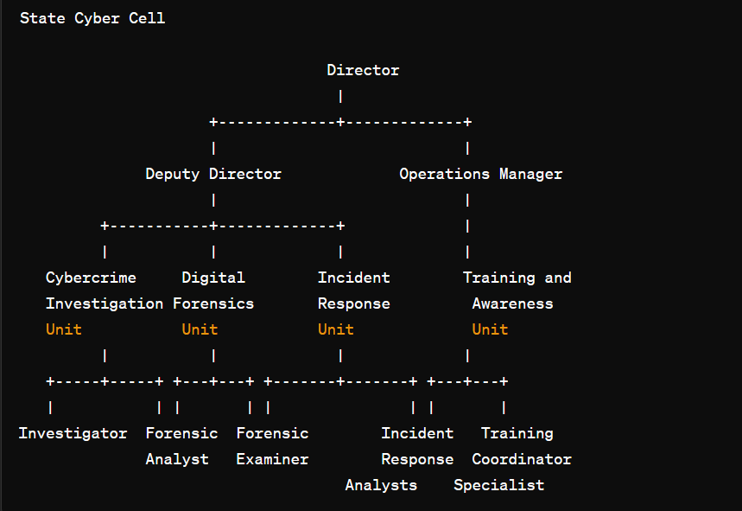
1.1. Organization Chart of State Cyber Cell

2. Overview of Different Department
  - Details of Department

1. Cybercrime Investigation Unit:
- Investigations: Conduct thorough investigations into various cybercrimes, including hacking, phishing, identity theft, online fraud, and cyberbullying.
- Evidence Collection: Gather digital evidence from computers, mobile devices, networks, and other digital storage media using forensic techniques and tools.
- Digital Footprint Analysis: Analyze digital footprints, internet browsing history, communication logs, and metadata to trace the activities of cybercriminals.
- Suspect Identification: Identify and profile suspects involved in cybercrimes through digital forensic analysis and collaboration with other law enforcement agencies.
- Case Management: Manage and document investigative findings, maintain chain of custody for digital evidence, and prepare case reports for prosecution.

2.Digital Forensics Unit:
- Digital Evidence Analysis: Conduct in-depth analysis of digital evidence recovered from computers, mobile devices, and digital storage media using forensic software and techniques.
- Data Recovery: Recover deleted files, encrypted data, and hidden partitions to reconstruct digital artifacts relevant to cybercrime investigations.
- Malware Analysis: Analyze malware samples to identify malicious code, behavior patterns, and indicators of compromise for incident response and threat intelligence purposes.
- Expert Testimony: Provide expert testimony in court proceedings regarding the authenticity and integrity of digital evidence and forensic analysis techniques.
- Research and Development: Stay abreast of advancements in digital forensics technology and techniques, conduct research, and develop tools to enhance forensic capabilities.

3.Incident Response Unit:
- Incident Triage: Receive and prioritize cybersecurity incident reports, assess the severity and impact of incidents, and initiate response actions accordingly.
- Containment and Mitigation: Implement measures to contain and mitigate the impact of cybersecurity incidents, such as isolating affected systems, blocking malicious traffic, and deploying patches or updates.
- Forensic Readiness: Prepare systems and personnel for forensic investigation in the event of a cybersecurity incident, including preserving evidence and maintaining system integrity.
- Coordination: Coordinate incident response efforts with internal stakeholders, external partners, law enforcement agencies, and regulatory bodies to ensure a cohesive and effective response.
- Lessons Learned: Conduct post-incident reviews and analysis to identify lessons learned, improve incident response procedures, and enhance cybersecurity resilience.

4. Training and Awareness Unit:
- Cybersecurity Training: Develop and deliver cybersecurity training programs for law enforcement personnel, government agencies, businesses, and the public on topics such as threat awareness, incident response, digital forensics, and best practices.
- Awareness Campaigns: Organize awareness campaigns, workshops, and seminars to educate stakeholders about cybersecurity risks, trends, and preventive measures.
- Outreach Programs: Collaborate with schools, community organizations, and industry partners to promote cybersecurity awareness and digital literacy among diverse audiences.
- Resource Development: Create educational materials, training modules, and online resources to support cybersecurity training and awareness initiatives.
- Evaluation and Feedback: Assess the effectiveness of training and awareness programs through evaluations, surveys, and feedback mechanisms, and refine content and delivery methods accordingly.

2.2. List of Technical Specification of Equipment

1. Cybercrime Investigation Unit:
Forensic Workstations:
Processor: Intel Core i7 or higher
RAM: 16GB DDR4 or higher
Storage: 1TB SSD or higher
Graphics: Dedicated GPU with at least 4GB VRAM
Operating System: Windows 10 Pro
Forensic Imaging Tools:
Write-Blocked Forensic Imaging Hardware
Forensic Imaging Software (e.g., FTK Imager, EnCase Forensic)
Digital Evidence Storage:
Network Attached Storage (NAS) or Storage Area Network (SAN)
Capacity: Scalable, depending on storage needs
Redundancy: RAID configuration for data redundancy and fault tolerance
Mobile Forensics Kits:
Mobile Forensic Hardware (e.g., Cellebrite UFED)
Mobile Forensic Software (e.g., Oxygen Forensic Detective)
Network Forensics Tools:
Packet Capture Appliances (e.g., Wireshark, tcpdump)
Network Forensic Analysis Software (e.g., NetworkMiner, Security Onion)

2. Digital Forensics Unit:
Forensic Workstations:
Same specifications as Cybercrime Investigation Unit
Forensic Hardware Tools:
Write-Blocked Forensic Imagers
Hardware Write-Blockers (e.g., Tableau, WiebeTech)
Forensic Software Tools:
Forensic Analysis Software (e.g., Autopsy, X-Ways Forensics)
Data Carving Tools (e.g., Scalpel, Foremost)
Registry and Artifact Analysis Tools (e.g., Registry Explorer, Forensic Toolkit)
Forensic Hardware Accessories:
Write-Blockers (e.g., USB write-blockers, SATA write-blockers)
Write-Protected Media Adapters
Mobile Forensics Tools:
Same as Cybercrime Investigation Unit

3.Incident Response Unit:
Incident Response Workstations:
Processor: Intel Core i7 or higher
RAM: 16GB DDR4 or higher
Storage: 512GB SSD or higher
Operating System: Windows 10 Pro or Linux distribution (e.g., Kali Linux)
Incident Response Software Tools:
SIEM (Security Information and Event Management) Platform (e.g., Splunk, ELK Stack)
Endpoint Detection and Response (EDR) Software (e.g., Carbon Black, CrowdStrike)
Incident Response Platform (e.g., FireEye Helix, IBM Resilient)
Malware Analysis Sandbox (e.g., Cuckoo Sandbox, VMRay Analyzer)
Network Security Appliances:
Intrusion Detection System (IDS) or Intrusion Prevention System (IPS)
Firewall Appliances (e.g., Cisco ASA, Palo Alto Networks)
Network Traffic Analysis Tools (e.g., Zeek, Suricata)

4.Training and Awareness Unit:
Training Workstations:
Same specifications as Cybercrime Investigation Unit
Training Software Tools:
Virtual Training Environments (e.g., VMware, VirtualBox)
E-Learning Platforms (e.g., Moodle, Canvas)
Simulation and Gamification Software
Presentation Equipment:
Projectors or Large Displays
Interactive Whiteboards or Smartboards
Audiovisual Equipment (e.g., microphones, speakers)

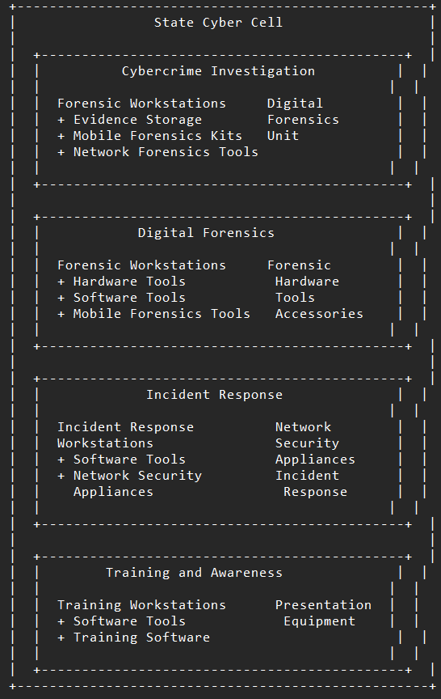
2.3. Stage of Production
2.1. Stage of Production

2.4 Explain in details about each stage of production

Planning and Strategy Development: In this initial stage, the state authorities identify the need for a cyber cell and develop a comprehensive plan and strategy. This includes defining the objectives, scope, and responsibilities of the cyber cell, as well as identifying the required resources, budget, and timeline. Key stakeholders, such as law enforcement agencies, government departments, and private sector partners, are involved in this stage to ensure a collaborative and coordinated approach.

Legal and Policy Framework: The second stage involves establishing a robust legal and policy framework to govern the operations of the cyber cell. This includes drafting and enacting legislation to provide the necessary legal authority for the cyber cell to investigate and prosecute cybercrimes. Additionally, policies and procedures are developed to guide the day-to-day operations of the cyber cell, such as incident response protocols, data handling and protection guidelines, and collaboration mechanisms with other agencies.

Infrastructure and Resource Allocation: In this stage, the necessary infrastructure and resources are allocated to support the operations of the cyber cell. This includes establishing a physical facility, procuring hardware and software tools, and hiring and training personnel. The infrastructure should be designed to ensure the confidentiality, integrity, and availability of data and systems, as well as comply with relevant security standards and best practices.

Capacity Building and Training: The fourth stage involves building the capacity and skills of the cyber cell personnel. This includes providing training on various cybersecurity domains, such as network security, digital forensics, malware analysis, and incident response. Additionally, personnel may receive specialized training on specific tools and techniques used in cyber investigations, such as open-source intelligence (OSINT) gathering, social engineering, and penetration testing.

Operationalization and Deployment: Once the cyber cell is fully established and its personnel are trained, it is operationalized and deployed to carry out its mandate. This involves setting up communication channels with other law enforcement agencies, government departments, and private sector partners to facilitate information sharing and collaboration. The cyber cell may also establish a presence on social media platforms and other online forums to engage with the public and raise awareness about cybersecurity issues.

Monitoring and Evaluation: The final stage involves monitoring and evaluating the performance of the cyber cell to ensure that it is meeting its objectives and delivering value to the state. This includes tracking key performance indicators (KPIs), such as the number of cybercrime cases investigated, the number of arrests made, and the amount of financial losses prevented. Additionally, feedback from stakeholders, such as law enforcement agencies and the private sector, is solicited to identify areas for improvement and inform future planning and strategy development.

- Introduction to Project
3.1. Project / Internship

Key loggers also known as keystroke loggers, may be defined as the recording of the key pressed on a system and saved it to a file, and the that file is accessed by the person using this malware. Key logger can be software or can be hardware. Working: Mainly key-loggers are used to steal password or confidential details such as bank information etc. First key-logger was invented in 1970’s and was a hardware key logger and first software key-logger was developed in 1983.

3.2. Purpose
- Parental Monitoring: Keyloggers can be used by parents to monitor their children's online activities, ensuring their safety and protecting them from potentially harmful content or interactions.
- Employee Monitoring: In a corporate environment, keyloggers can be employed to monitor employee activity on company-owned devices to ensure compliance with company policies and prevent data breaches or unauthorized activities.
- Data Recovery: Keyloggers can help in recovering lost or unsaved data by logging keystrokes, thus enabling users to retrieve accidentally deleted information.
- Password Recovery: In situations where a user has forgotten their password, keyloggers can be used to capture the keystrokes and recover the lost password.
- User Behavior Analysis: Keyloggers can be utilized by researchers and psychologists to analyze user behavior and interaction patterns with software applications or websites.
- Security Testing: Ethical hackers and security professionals often use keyloggers to test the security of systems and identify vulnerabilities that could be exploited by malicious actors. This helps in strengthening the security posture of systems and networks.
- Accessibility: Keyloggers can assist individuals with disabilities who may have difficulty typing or navigating a computer interface by capturing their keystrokes and enabling alternative methods of input or control.
- Law Enforcement: Keyloggers can be used by law enforcement agencies as part of their investigations to gather evidence related to criminal activities such as cybercrime or fraud.

3.3. Objective

- Enhancing Security: Utilize keyloggers to strengthen cybersecurity measures by identifying and addressing vulnerabilities in systems and networks, thereby protecting against unauthorized access, data breaches, and cyber attacks.
- Preventing Cybercrime: Deploy keyloggers as proactive tools for detecting and preventing cybercrimes such as phishing scams, identity theft, and online fraud, thus safeguarding individuals and organizations from financial losses and reputational damage.
- Empowering Parental Guidance: Employ keyloggers as parental monitoring tools to promote child safety online, enabling parents to monitor their children's online activities responsibly and protect them from exposure to inappropriate content and online predators.
- Facilitating Employee Oversight: Implement keyloggers in corporate environments to monitor employee activity on company-owned devices, ensuring compliance with company policies, detecting insider threats, and preventing data breaches and intellectual property theft.
- Supporting Law Enforcement: Utilize keyloggers as investigative tools for law enforcement agencies to gather evidence and track criminal activities, thereby facilitating the prosecution of cybercriminals and ensuring justice for victims of cybercrimes.
- Improving Accessibility: Adapt keyloggers to assist individuals with disabilities by providing alternative methods of input or control, enhancing their ability to access and interact with digital devices and applications, and promoting inclusivity in technology usage.
- Fostering Research and Analysis: Employ keyloggers in research and behavioral analysis studies to gain insights into user behavior, interaction patterns, and software usability, thereby informing the development of user-friendly interfaces and enhancing user experience.
- Encouraging Ethical Hacking: Encourage ethical hackers and cybersecurity professionals to utilize keyloggers for security testing and vulnerability assessment purposes, enabling the identification and remediation of security weaknesses before they can be exploited by malicious actors.
- Promoting Data Recovery: Utilize keyloggers as tools for data recovery and password retrieval, enabling users to recover lost or forgotten information, restore system functionality, and minimize disruptions to productivity and operations.
- Educating and Raising Awareness: Educate individuals, businesses, and organizations about the positive applications of keyloggers, raising awareness about their potential benefits in enhancing cybersecurity, protecting privacy, and promoting responsible digital behavior.

3.4. Scope
  - Keyloggers are not always illegal to install and use:
    - Corporations use them for troubleshooting or monitoring employees.
    - Parents may monitor their children’s activities.
  - The concern arises when malicious actors use keyloggers without owning the device they infect.
  - Unauthorized keyloggers can steal passwords, take screenshots, record web pages, and collect sensitive financial information, sending it to remote servers for criminal purposes.
  - Install reputable antivirus software that detects and removes keyloggers.
  - Be cautious when downloading software or clicking on suspicious links.
  - Regularly update your operating system and applications.
  - Use two-factor authentication to enhance security.

3.5 Technology and Literature Review

- Technology Review:
- Types of Keyloggers: Explore different types of keyloggers, including software-based keyloggers that run as programs on a computer or mobile device, hardware-based keyloggers that are physical devices connected to a computer's keyboard, and kernel-based keyloggers that operate at a lower level in the operating system.
- Functionality: Examine how keyloggers capture keystrokes, including techniques such as hooking into the keyboard input, intercepting system calls, or capturing keystrokes at the hardware level.
- Stealth and Persistence: Investigate methods used by keyloggers to remain undetected by users and security software, such as hiding their processes, encrypting captured data, or evading detection by antivirus programs.
- Data Logging and Transmission: Review how keyloggers store captured keystrokes locally and transmit them to remote servers or attackers, including protocols used for data transmission (e.g., FTP, HTTP, email) and encryption methods to protect intercepted data.

- Literature Review:
- Applications: Explore existing literature on the diverse applications of keyloggers, including legitimate uses such as parental monitoring, employee oversight, data recovery, and cybersecurity testing, as well as malicious uses such as hacking, espionage, and identity theft.
- Implications: Review studies examining the legal, ethical, and privacy implications of keyloggers, including discussions on consent, surveillance, data protection laws, and the balance between security and privacy.
- Detection and Countermeasures: Examine research on techniques for detecting and mitigating keyloggers, including antivirus software, intrusion detection systems, behavior-based detection methods, and security best practices.
- User Perception and Attitudes: Investigate user perceptions and attitudes towards keyloggers, including studies on awareness, concerns about privacy and security, and the impact of keylogger-related incidents on trust in technology.
- Ethical Considerations: Review literature discussing the ethical considerations surrounding the use of keyloggers, including debates on individual privacy rights, corporate monitoring policies, and the responsibility of software developers and vendors.

3.6. Project / Internship Planning
3.6.1 Project / Internship Development Approach and Justification

  - Project Development Approach:

- Needs Assessment: Conduct a thorough needs assessment to identify the specific requirements and objectives of the project. Determine the purpose of implementing keyloggers and define clear goals and outcomes.
- Risk Analysis: Perform a risk analysis to evaluate the potential risks and benefits associated with using keyloggers. Consider legal, ethical, and privacy implications, as well as potential security risks and vulnerabilities.
- Stakeholder Engagement: Engage with stakeholders, including end-users, legal advisors, cybersecurity experts, and ethical review boards, to gather input, address concerns, and ensure alignment with organizational goals and values.
- Ethical Considerations: Develop a comprehensive ethical framework to guide the responsible use of keyloggers. Establish protocols for obtaining informed consent, protecting privacy rights, and ensuring transparency and accountability in data collection and usage.
- Technology Selection: Select appropriate keylogger technology based on project requirements, considering factors such as functionality, compatibility, security features, and regulatory compliance.
- Implementation Planning: Develop a detailed implementation plan outlining the deployment strategy, hardware and software requirements, data storage and encryption protocols, and contingency measures for handling security incidents or breaches.
- Testing and Validation: Conduct rigorous testing and validation of the keylogger system to ensure functionality, reliability, and compliance with legal and ethical standards. Verify that the system operates as intended and does not pose undue risks to users or stakeholders.
- Training and Education: Provide training and education to end-users, administrators, and other stakeholders on the proper use of keyloggers, including security best practices, privacy considerations, and legal compliance requirements.
- Monitoring and Evaluation: Establish mechanisms for ongoing monitoring and evaluation of the keylogger system to assess performance, detect anomalies, and address any issues or concerns that may arise during deployment.
- Continuous Improvement: Implement a process for continuous improvement based on feedback, lessons learned, and evolving technology and regulatory landscape. Regularly review and update policies, procedures, and safeguards to adapt to changing circumstances and mitigate emerging risks.

  - Justification for Keyloggers:

- Security Enhancement: Keyloggers can be justified as security tools for detecting and preventing unauthorized access, data breaches, and cyber attacks. They enable organizations to monitor and analyze user activity to identify suspicious behavior and mitigate security threats proactively.
- Investigative Purposes: Keyloggers can be used for investigative purposes by law enforcement agencies and cybersecurity professionals to gather evidence, track criminal activities, and prosecute cybercriminals. They facilitate digital forensics analysis and help uncover valuable insights into cybercrime incidents.
- Employee Monitoring: In corporate settings, keyloggers can be justified for monitoring employee activity on company-owned devices to ensure compliance with company policies, prevent insider threats, and protect sensitive information and intellectual property.
- Parental Control: Keyloggers can serve as parental monitoring tools to protect children from online dangers, including exposure to inappropriate content, cyberbullying, and online predators. They enable parents to monitor their children's online activities responsibly and intervene when necessary.
- Data Recovery: Keyloggers can be used for data recovery purposes to recover lost or deleted information, passwords, or files. They help individuals and organizations retrieve valuable data and restore system functionality in the event of accidental deletion or system failure.
- Accessibility Assistance: Keyloggers can assist individuals with disabilities by providing alternative methods of input or control, enabling them to access and interact with digital devices and applications more effectively. They promote inclusivity and accessibility in technology usage.

3.6.2. Project Effort and Time, Cost Estimation

- Effort Estimation:
Functional Requirements: Break down the functional requirements of the keylogger, including capturing keystrokes, logging data, encrypting information, and transmitting data to a remote server.
Technical Complexity: Assess the technical complexity of implementing keylogger functionality, considering factors such as operating system compatibility, stealth capabilities, and data encryption methods.
Development Resources: Estimate the number of developers and other resources required for the project based on the size and complexity of the keylogger software.
Testing and Validation: Allocate effort for testing and validation activities, including unit testing, integration testing, and user acceptance testing, to ensure the quality and reliability of the keylogger.

- Time Estimation:
Task Breakdown: Break down the keylogger development tasks into smaller components, such as design, coding, testing, and documentation.
Task Duration: Estimate the duration of each task based on historical data, developer expertise, and the complexity of the work involved.
Dependencies and Constraints: Consider dependencies between tasks and any constraints that may impact the project timeline, such as resource availability and external dependencies.
Buffer Time: Add buffer time to account for unforeseen delays, changes in requirements, or unexpected technical challenges that may arise during the development process.

- Cost Estimation:
Resource Costs: Calculate the cost of development resources, including developer salaries, overhead expenses, and any external contractors or consultants hired for the project.
Tool and Technology Costs: Estimate the cost of software tools, development environments, and third-party libraries or components used in developing the keylogger.
Testing and Validation Costs: Budget for testing and validation activities, including testing tools, infrastructure costs, and any additional resources needed for quality assurance.
Contingency Budget: Set aside a contingency budget to cover unexpected expenses, scope changes, or project risks that may impact the overall cost of the keylogger project.

3.6.3 Roles and Responsibilities

Reviewing ethical considerations and implications of keylogger usage.
Ensuring that user privacy and rights are respected.
Evaluating the ethical implications of data collection and monitoring activities.
Providing guidance on ethical guidelines and best practices.
Addressing ethical concerns raised by stakeholders or team members.

3.6.4 Group Dependencies

Requirements Gathering: Dependency on project initiation for clear project objectives and scope.
Design and Architecture: Dependency on requirements gathering for defined functional and technical requirements.
Testing and Quality Assurance: Dependency on development for completed software features to test.
Deployment Phase Dependencies:
Documentation and Training: Dependency on testing and quality assurance for finalized software features and user guides.
Maintenance and Support: Dependency on deployment for completed deployment and user training.

3.7 Project / Internship Scheduling

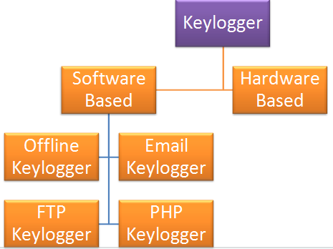

WEEK 1 | Basic Knowlegde About Cyber Security.
WEEK 2 | Tools are use by CID
WEEK 3 | Basic Knowlegde About anti-bullying unit.
WEEK 4 | Digital forensic department tools:- UFAD
WEEK 5 | FALCON TOOL
WEEK 6 | OXYGEN TOOL
WEEK 7 | FTK TOOL
WEEK 8 | OSINT framework
WEEK 9 | MOBSF TOOL
WEEK 10 | Malware Analysis
WEEK 11 | Remnux os
WEEK 12 | Flare vm
3.1 Internship Effort

4. System Analysis
4.1 Study of Current System

- Identify Stakeholders: Determine the key stakeholders involved in the current system, including end-users, administrators, IT support staff, and management.

- Gather Requirements: Collect requirements from stakeholders regarding the need for a keylogger solution. Understand their objectives, pain points, and expectations for monitoring and securing computer activity.

- Assess Current Practices: Evaluate existing practices and tools used for computer monitoring and security. This may include manual monitoring, antivirus software, intrusion detection systems, and employee monitoring tools.

- Review Security Policies: Examine the organization's security policies and procedures related to computer usage, data protection, and privacy. Identify any gaps or areas for improvement in monitoring and enforcing these policies.

- Analyze Technical Infrastructure: Assess the technical infrastructure supporting computer systems, networks, and applications. Evaluate the compatibility of existing hardware and software with potential keylogger solutions.

- Understand Legal and Ethical Considerations: Review applicable laws, regulations, and industry standards related to computer monitoring, data privacy, and employee rights. Ensure that any proposed keylogger solution complies with legal and ethical guidelines.

- Conduct User Interviews and Surveys: Interview end-users and administrators to gather insights into their experiences, challenges, and preferences regarding computer monitoring. Use surveys to collect quantitative data on usage patterns and security concerns.

- Perform Risk Assessment: Identify potential security risks and vulnerabilities in the current system, such as unauthorized access, data breaches, insider threats, and compliance violations. Prioritize risks based on their likelihood and potential impact.

- Document Findings: Document the findings of the current system study, including requirements, practices, policies, infrastructure, legal considerations, user feedback, and risk assessment results. Summarize key insights and observations for use in the next phase of the keylogger project.

4.2 Problem and Weaknesses of keylogger

- Increased Awareness of Security Risks: The presence of keyloggers highlights the potential security risks associated with digital communication and data transmission. This awareness encourages individuals and organizations to adopt better cybersecurity practices and safeguards to protect sensitive information.
- Opportunity for Improved Software Security: The detection of keyloggers prompts software developers and vendors to strengthen security measures and implement robust encryption techniques to protect against unauthorized access and data breaches. This focus on software security benefits all users by enhancing the overall resilience of digital systems.

- Legal and Ethical Discussions: The use of keyloggers sparks important discussions about privacy rights, data protection laws, and ethical considerations surrounding surveillance and monitoring. These discussions lead to greater clarity and transparency in legal frameworks and ethical guidelines, ensuring that keylogger usage is governed by appropriate regulations and standards.

- Empowerment Through Knowledge: Understanding the capabilities and limitations of keyloggers empowers individuals and organizations to make informed decisions about their digital security practices. By educating users about potential threats and vulnerabilities, keyloggers contribute to a more knowledgeable and vigilant digital community.

- Innovation in Detection and Prevention: The presence of keyloggers drives innovation in cybersecurity technologies and techniques for detecting and preventing unauthorized access and data theft. This ongoing development leads to the creation of more advanced security solutions that can effectively mitigate the risks posed by keyloggers and other forms of malware.

- Enhanced Collaboration Among Stakeholders: Addressing the challenges posed by keyloggers requires collaboration among stakeholders from various sectors, including government agencies, industry organizations, and cybersecurity experts. This collaboration fosters the exchange of knowledge, best practices, and resources, ultimately strengthening the collective response to cybersecurity threats.

- Adoption of Proactive Security Measures: The existence of keyloggers encourages individuals and organizations to adopt proactive security measures, such as regular software updates, strong password policies, and multifactor authentication. These measures help mitigate the impact of keyloggers and other cyber threats by reducing the likelihood of successful attacks.

- Promotion of Responsible Use: By highlighting the potential risks and consequences of keylogger usage, individuals and organizations are encouraged to use monitoring technologies responsibly and ethically. This emphasis on responsible use fosters a culture of trust, accountability, and respect for privacy in digital interactions.

4.3 Requirements of Keylogger

Operating System: Windows 7 / Windows 10

IDE : Python

4.4 System Feasibility

- Alignment with Organizational Objectives:
Evaluate whether the keylogger contributes to the overall objectives of the organization, such as enhancing security, improving productivity, or ensuring compliance with regulations.
Consider the specific use cases and benefits that the keylogger can provide in relation to the organization's goals and priorities.

- Technical Feasibility:
Assess whether the keylogger can be implemented using the current technology infrastructure of the organization.
Evaluate compatibility with existing operating systems, applications, and network environments.
Determine if the organization has the technical expertise and resources to develop, deploy, and maintain the keylogger effectively.

- Cost and Schedule Constraints:
Analyze the costs associated with implementing and maintaining the keylogger, including software development, hardware procurement, licensing fees, and ongoing support.
Compare the projected costs with the organization's budget constraints and financial resources.
Determine if the keylogger can be implemented within the specified timeline, taking into account development efforts, testing, deployment, and training.

- Integration with Existing Systems:
Evaluate the feasibility of integrating the keylogger with other systems and applications already in use within the organization.
Assess compatibility with existing security infrastructure, data storage solutions, and reporting tools.
Determine if the keylogger can exchange data and communicate effectively with other systems to provide comprehensive monitoring and reporting capabilities.

- Legal and Ethical Considerations:
Consider legal and regulatory requirements related to monitoring employee activities, data privacy, and consent.
Ensure that the implementation of the keylogger complies with relevant laws and regulations, such as GDPR, HIPAA, or industry-specific standards.
Address ethical considerations regarding privacy, transparency, and trust, and implement safeguards to protect sensitive information and respect individual rights.

- Risk Assessment:
Identify potential risks and challenges associated with implementing the keylogger, such as data breaches, misuse of monitoring data, or resistance from employees.
Develop mitigation strategies to address identified risks and minimize their impact on the success of the keylogger project.

4.5 Proposed System
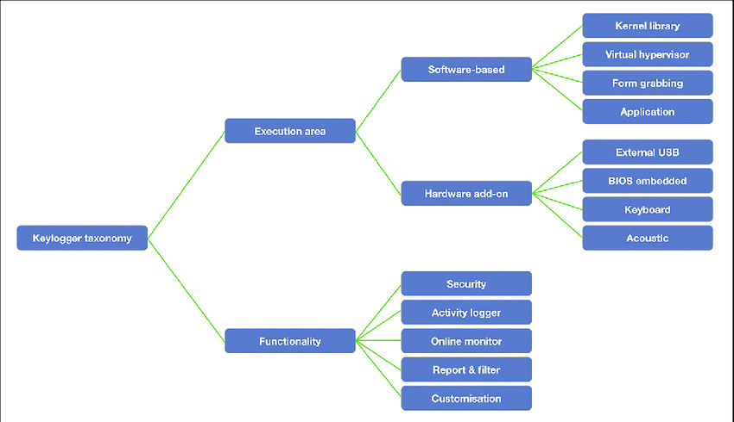
4.1 Proposedof keylogger

4.6 Features of keylogger

- Enhanced Security: Keyloggers can serve as a proactive security measure by monitoring user activity and detecting potential security threats, such as unauthorized access attempts or suspicious behavior.

- Real-time Monitoring: Keyloggers provide the capability to monitor user keystrokes, screen activity, and application usage in real-time, allowing administrators to stay informed about user actions as they occur.

- Comprehensive Logging: Keyloggers can capture a wide range of user interactions, including keystrokes, clipboard activity, website visits, and application usage, providing detailed insights into user behavior.

- Alerts and Notifications: Keyloggers can be configured to generate alerts and notifications in response to predefined triggers or security events, enabling administrators to respond promptly to potential threats or policy violations.

- Remote Access and Control: Some keyloggers offer remote access and control capabilities, allowing administrators to monitor and manage user activity from a centralized location, even across distributed networks.

- Forensic Capabilities: Keyloggers can be valuable tools for forensic investigations, providing a comprehensive audit trail of user activity that can be used to reconstruct events, identify perpetrators, and gather evidence for legal proceedings.

- Customization and Flexibility: Keyloggers often offer customization options and flexible configuration settings, allowing administrators to tailor the monitoring and logging capabilities to meet the specific needs and requirements of their organization.

- User Accountability: By monitoring user activity and enforcing security policies, keyloggers promote accountability among users, discouraging unauthorized behavior and promoting compliance with organizational policies and procedures.

- Parental Guidance: Keyloggers can be used by parents to monitor and supervise their children's online activities, helping to ensure their safety and well-being in the digital environment.

- Productivity Enhancement: In certain contexts, such as employee monitoring, keyloggers can help improve productivity by identifying inefficiencies, bottlenecks, and areas for optimization in workflows and processes.

4.7 List Main Modules

- Keystroke Logging Module:
Captures and logs keystrokes entered by users, including text input, passwords, and commands.

- Screen Capture Module:
Records screenshots of the user's screen at predefined intervals or in response to specific triggers, providing visual evidence of user activity.

4.8 Selection of Hardware

- Hardware Selection:
Choose compatible hardware for effective keystroke capturing.
Opt for reliable storage devices to securely store logged data.

5. System Design
5.1. System Design & Methodology

1.Define System Architecture:
Determine the overall architecture of the keylogger system, including client-server or standalone deployment models.
Specify the components and their interactions, such as the keystroke logger, screen capture module, and data storage.

2.Identify Key Components:
Keystroke Logger: Capture and log keystrokes entered by users.
Screen Capture Module: Record screenshots of the user's screen at predefined intervals.
Data Storage: Store logged data securely, ensuring confidentiality and integrity.
Encryption Module: Encrypt logged data using strong encryption algorithms to protect sensitive information.
Remote Access Interface: Enable remote access for centralized monitoring and management of the keylogger.

3.Design Data Flow and Processing:
Define how data flows through the system, from capturing user activity to storing and accessing logged data.
Specify data processing techniques, such as compression and encryption, to optimize storage and ensure security.
Implement mechanisms for filtering and organizing logged data based on predefined criteria, such as user accounts or time stamps.

4.Incorporate Security Measures:
Implement security features to protect logged data from unauthorized access or tampering.
Use encryption algorithms to encrypt logged data both in transit and at rest.
Enforce access controls and authentication mechanisms to restrict access to the keylogger system.

5.Ensure Covert Operation:
Design the keylogger to operate discreetly, minimizing its visibility to users.
Implement stealth techniques to avoid detection by antivirus software or security scans.
Use obfuscation methods to conceal the presence of the keylogger on the system.

6.Implement Real-Time Monitoring:
Enable real-time monitoring capabilities to capture and log user activity as it occurs.
Design alerting mechanisms to notify administrators of predefined triggers or security events.

7.Integrate Remote Access and Control:
Provide remote access interfaces for administrators to monitor and manage the keylogger from a centralized location.
Implement secure communication protocols to facilitate remote access while maintaining data confidentiality and integrity.

8.Adhere to Legal and Ethical Guidelines:
Ensure that the design and implementation of the keylogger comply with applicable laws and regulations regarding user privacy and data protection.
Respect ethical considerations, such as obtaining informed consent from users and ensuring transparency in monitoring practices.

5.2 Structure Design

Organize the Python script into modular components based on functionality, such as keystroke logging, screenshot capture, database interaction, and reporting.
Ensure clear separation of concerns and maintainability of the codebase.

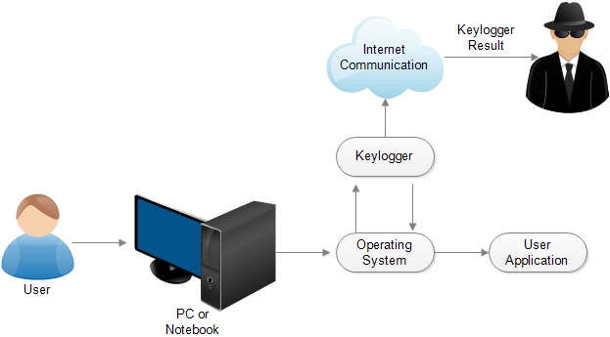

5.1 user case diagram

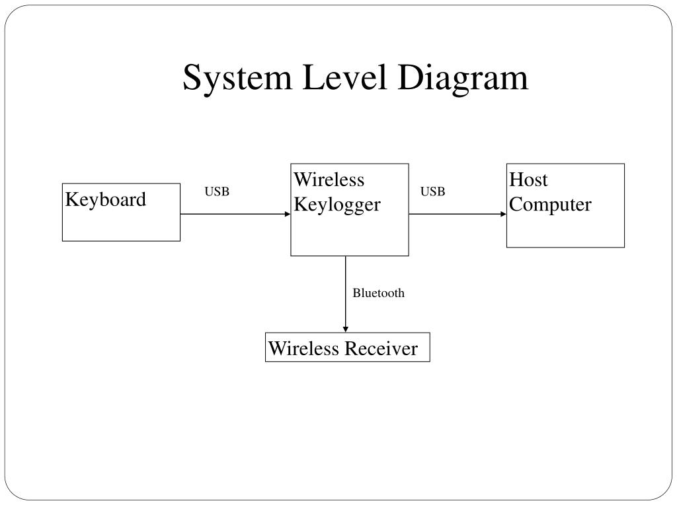
5.2 system level diagram

5.3. Input / Output and Interface Design

- Input:
The script takes an interval (in seconds) as an argument to the Keylogger class constructor. This interval determines how often the script sends the collected data to the Discord webhook.
The script also takes a report method as an argument to the Keylogger class constructor. The report method can be either "webhook" or "file".

- Output:
The script logs keystrokes and mouse clicks and captures screenshots.
The collected data is sent to the Discord webhook every interval seconds.
The data sent to the webhook includes the username of the user, the current date and time, and the log of keystrokes and mouse clicks.
If the log is longer than 2000 characters, the script sends the log as an embed in the Discord message. Otherwise, it sends the log as a plain text message.
If the script captures a screenshot, it sends the screenshot as an attachment to the Discord message.

6. Implementation
6.1 Implementation Platform

- Platform: Any operating system that supports Python.
- Environment: The code can be executed in a Python environment, such as:
Local machine: Run the script directly on a local computer.
Cloud server: Deploy the script on a cloud server (e.g., AWS, Google Cloud) for remote monitoring.
Virtual environment: Utilize virtual environments (e.g., virtualenv, conda) to isolate dependencies and ensure compatibility.

6.2 Technology

- Technology Specification:
Python: Utilizes Python for scripting and interacting with system functionalities.
Discord Webhook: Communicates with Discord's API to send reports.
Pynput: Library used for monitoring keyboard and mouse events.
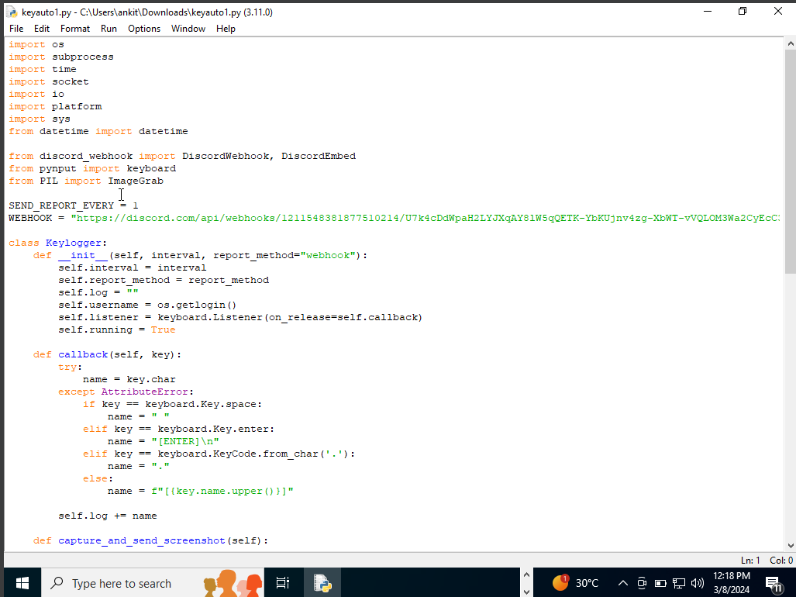
Pillow: Library used for capturing screenshots.
6.1. input code
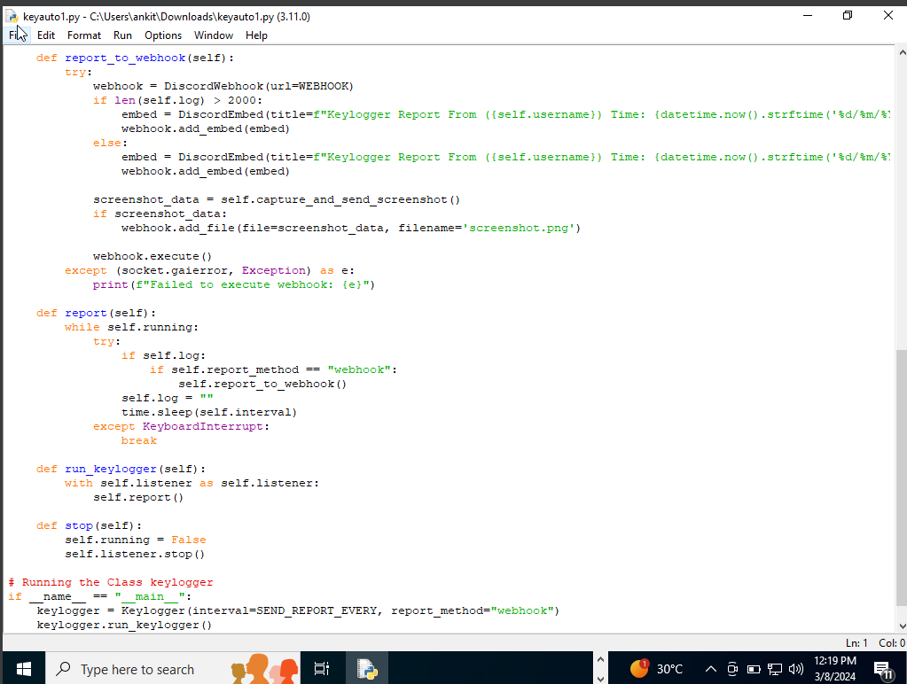
6.2. input code

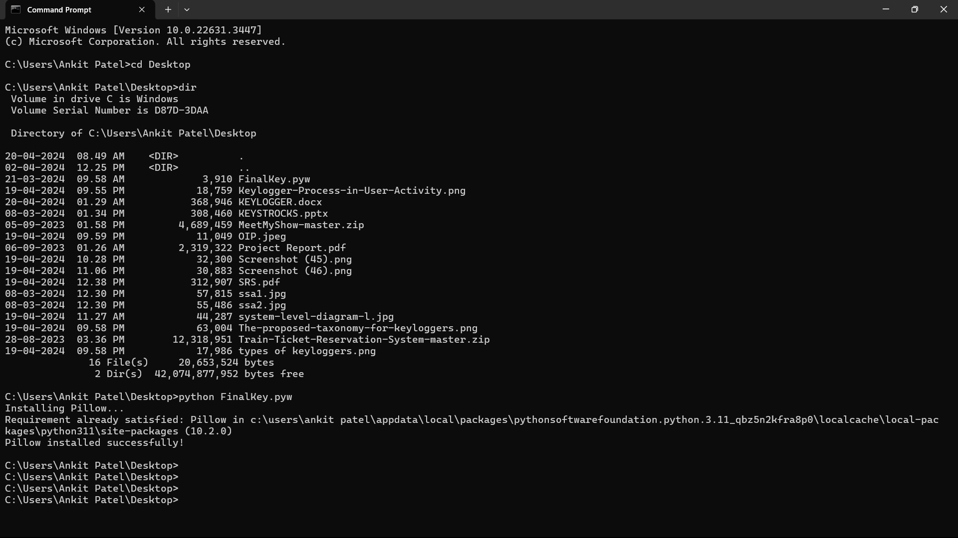
6.3. Implementation

  - Results

Users running this script may not be aware that their activities are being logged and sent to a Discord webhook.
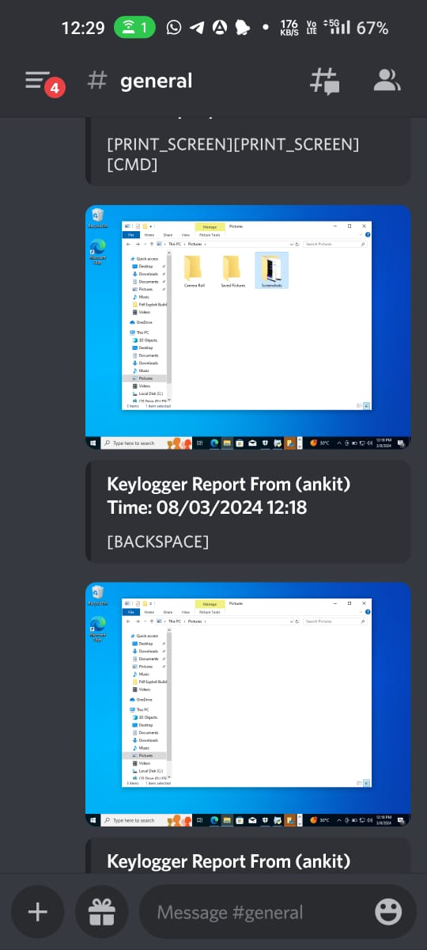
The keylogger operates covertly, making it suitable for monitoring user activity for security or surveillance purposes.

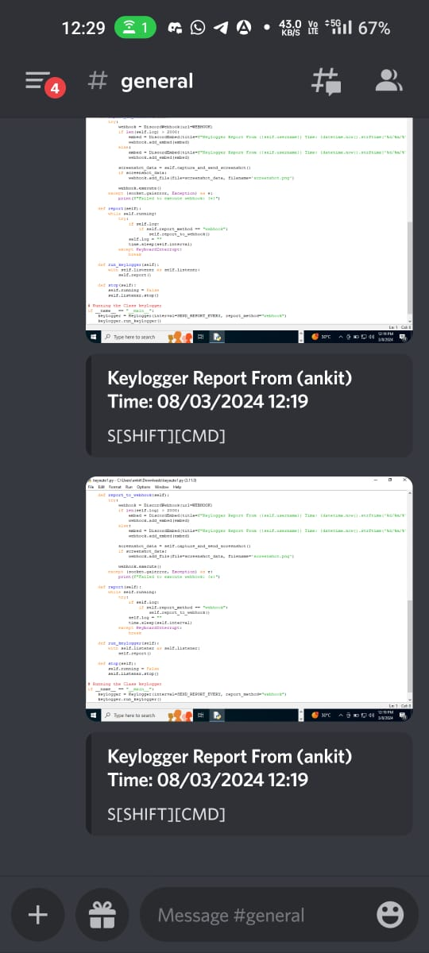
6.3. output

7. Testing
7.1 Testing Plan / Strategy

- Installation and Setup Testing:
Ensure that the required modules (discord_webhook, pynput, Pillow) are installed correctly.
Verify that the script can be executed without errors.

- Keystroke Logging Testing:
Test keystroke logging functionality by typing various characters, including letters, numbers, and special characters.
Verify that special keys like Space, Enter, and function keys are logged correctly.
Test the handling of key combinations (e.g., Ctrl+C, Alt+Tab) to ensure accurate logging.

- Mouse Click Logging Testing:
Test mouse click logging functionality by clicking at different locations on the screen.
Verify that mouse buttons (left, right, middle) are logged correctly.
Test the handling of mouse click events in different applications and contexts.

- Screenshot Capture Testing:
Test screenshot capture functionality by triggering the capture event.
Verify that screenshots are captured accurately and saved in the correct format (PNG).
Test capturing screenshots of different applications and screen resolutions.

- Reporting Testing:
Test the reporting functionality by sending logged data and screenshots to the Discord webhook.
Verify that reports are sent at the specified interval (SEND_REPORT_EVERY).
Test reporting under various network conditions to ensure robustness.

- Error Handling Testing:
Test error handling mechanisms by introducing errors (e.g., network failure, disk full) during execution.
Verify that errors are caught and handled gracefully without crashing the program.
Test recovery mechanisms (if any) after encountering errors.

- Integration Testing:
Test the integration of all components (keystroke logging, mouse click logging, screenshot capture, reporting) to ensure seamless operation.
Verify that the keylogger functions correctly as a unified system.

- Compatibility Testing:
Test the keylogger on different operating systems (Windows, macOS, Linux) to ensure compatibility.
Verify that the keylogger operates consistently across different environments.

- Performance Testing:
Test the performance of the keylogger by running it for an extended period to assess resource usage (CPU, memory).
Verify that the keylogger operates efficiently without significant performance degradation over time.

- Security and Privacy Testing:
Test the keylogger while ensuring that it complies with legal and ethical standards regarding user privacy.
Verify that sensitive information (e.g., passwords, personal data) is not logged or transmitted.

- User Acceptance Testing (UAT):
Involve end-users (if applicable) to test the keylogger in real-world scenarios and gather feedback.
Address any usability issues or concerns raised during UAT.

7.2 Test Results and Analysis

- Functionality:
Keystroke Logging: Verify that the keylogger captures keystrokes accurately, including special keys like Enter and Space.
Mouse Click Logging: Ensure that mouse clicks are detected and trigger screenshot capture appropriately.
Screenshot Capture: Check if the keylogger successfully captures screenshots of the user's screen.
Reporting to Discord: Confirm that the logged data and screenshots are sent to the specified Discord webhook.
- Reliability:
Run the keylogger for an extended period to assess its stability and reliability over time.
Verify that the keylogger continues to function correctly after system restarts or interruptions.
- Potential Issues:
Resource Consumption: Monitor system resource usage (CPU, memory) to ensure that the keylogger does not significantly impact system performance.
Error Handling: Test the keylogger's error handling capabilities by simulating network failures or other exceptions.
Detection: Assess the keylogger's stealthiness and susceptibility to detection by antivirus software or system monitoring tools.
- Analysis:
Functionality: The keylogger successfully captures keystrokes, mouse clicks, and screenshots, and sends them to the Discord webhook.
Reliability: The keylogger appears stable during testing, running continuously without crashes or significant issues.
Potential Issues: Ensure that the keylogger operates covertly and does not raise suspicion or trigger security alerts.

8. Conclusion and Discussion
8.1. Overall Analysis of Internship/Project Viabilities

- The keylogger appears to be viable for capturing keystrokes and mouse clicks on Windows systems.
- The integration with Discord allows for remote monitoring and data exfiltration, making it potentially dangerous if used maliciously.
- However, there are limitations and risks associated with using Discord webhooks for data exfiltration, such as potential detection by security tools and Discord's terms of service regarding abuse of webhooks.
- The code lacks persistence mechanisms, so it would need to be combined with other techniques (e.g., startup scripts, registry modifications) for persistence across system reboots.
- Additionally, the code runs as a standalone script, so it would need to be delivered and executed on the target system through social engineering or other attack vectors.

8.2. Photographs and date of surprise visit by institutement(Optional)

Meeting has not conducted

8.3. Dates of Continuous Evaluation (CE-I and CE-II)
Continuous Evalution-I on 2nd March 2024
Continuous Evalution-II on 20th April 2024

8.4. Problem Encountered and Possible Solutions

- Dependency Installation Failures:
- Problem: If the required modules (discord_webhook, pynput, Pillow) are not installed on the system, the code may fail to execute.
- Solution: Implement more robust error handling for module installation. Provide clearer instructions to the user on how to manually install dependencies if automatic installation fails.

- Limited Reporting Mechanism:
- Problem: The code only supports reporting via a Discord webhook, which may not be suitable for all environments or scenarios.
- Solution: Provide alternative reporting mechanisms such as sending reports via email, uploading logs to an FTP server, or storing data locally for later retrieval.

- Excessive Network Traffic:
- Problem: Sending reports every second to the Discord webhook may result in excessive network traffic, potentially raising suspicion or triggering network security controls.
- Solution: Implement a more configurable reporting interval that allows users to adjust the frequency of report generation based on their specific needs and network constraints.

- Security Risks with Discord Webhooks:
- Problem: Using Discord webhooks for data exfiltration may pose security risks, including detection by security tools and potential violations of Discord's terms of service.
- Solution: Explore alternative communication channels or encryption methods to securely transmit captured data. Consider using encrypted channels or custom-built communication protocols for data transmission.

- Limited Error Handling:
- Problem: The code may fail silently or provide insufficient feedback in case of errors, making it difficult to diagnose and troubleshoot issues.
- Solution: Enhance error handling mechanisms to provide more descriptive error messages, log error details to a file, and implement retry logic for critical operations.

- Potential Detection by Antivirus Software:
- Problem: The use of keylogging techniques and remote reporting mechanisms may trigger alerts from antivirus software, leading to detection and removal of the keylogger.
- Solution: Employ obfuscation techniques to evade signature-based detection by antivirus software. Implement polymorphic code generation or encryption to make the keylogger payload harder to detect.

- Lack of Persistence Mechanisms:
- Problem: The keylogger code does not include persistence mechanisms, meaning it won't run automatically upon system startup or survive system reboots.
- Solution: Develop and integrate persistence mechanisms such as adding the keylogger to startup scripts, creating registry entries, or utilizing scheduled tasks to ensure the keylogger runs persistently on the target system.

8.5. Summary of Project work

- This Python script is a keylogger program that captures keystrokes and mouse clicks, and sends the logged data along with a screenshot to a Discord webhook every specified interval (default is 1 second). The program uses the `pynput` library to capture keystrokes and mouse clicks, the `Pillow` library to capture screenshots, and the `discord_webhook` library to send the data to a Discord webhook.

- The script first checks if the required libraries are installed, and if not, it attempts to install them using pip. It then defines a `Keylogger` class that initializes the keylogger with an interval and a report method (currently only "webhook" is supported). The class has methods for capturing keystrokes and mouse clicks, capturing and sending screenshots, and sending the logged data to the Discord webhook.

- The `run_keylogger` method starts the keylogger and begins capturing keystrokes and mouse clicks, while the `report` method sends the logged data to the Discord webhook every specified interval. The `stop` method stops the keylogger and mouse listener.

- Finally, the script creates an instance of the `Keylogger` class and starts the keylogger. The logged data and screenshots are sent to the Discord webhook specified in the `WEBHOOK` variable.

8.6. Limitation and Future Enhancement

- Limitation
- The keylogger only supports sending data to a Discord webhook, which may not be suitable for all use cases.
- The keylogger uses the pynput library to capture keystrokes and mouse clicks, which is a reliable and well-maintained library with good documentation and support.
- The keylogger uses the Pillow library to capture screenshots, which is a powerful and flexible library for working with images in Python.
- The keylogger uses the discord_webhook library to send the logged data to a Discord webhook, which is a convenient and easy-to-use method for sending data to a remote server.

- Future Enhancements:

- Add support for sending data to other destinations, such as email or a local file, to provide more flexibility and options for the user.
- Add support for capturing special keys and modifier keys to improve the accuracy and completeness of the logged data.
- Add support for capturing text input from password fields and other secure input fields to provide a more comprehensive view of user activity.
- Improve support for systems with multiple input devices by allowing the user to select which device to listen to, providing more control and customization options.
- Add a user interface to allow the user to configure the keylogger settings, such as the interval between reports, the report method, and the webhook URL, making the tool more user-friendly and accessible.
- Implement encryption or other security measures to protect the logged data from unauthorized access, ensuring the privacy and confidentiality of the user's information.

References

- Ethical Hacking - KeyLoggers (GeeksforGeeks): This article provides insights into keyloggers, their types (software and hardware), and their uses. It also discusses protection techniques and features to look for in keylogger software. The post covers both legitimate and illegitimate use cases.

- GitHub Repositories on Keyloggers: GitHub hosts numerous public repositories related to keyloggers. Developers and researchers share code, tools, and resources related to keylogging. You can explore these repositories to learn more.

- Avast Definition of Keyloggers: Avast explains that a keylogger is a type of malicious software that records every keystroke made on a computer. It’s one of the most invasive forms of malware, capturing everything you type. The article emphasizes the importance of protecting against keyloggers.

- Norton Insights on Keyloggers: Norton discusses how keyloggers are commonly spread online via phishing scams, Trojan viruses, and fake websites. The goal is often to obtain victims’ passwords, personal information, and banking details. The article distinguishes between software and hardware keyloggers.

- Fortinet Explanation of Keyloggers: Fortinet defines keyloggers as malware or hardware that tracks and records keystrokes as users type. The captured information is then sent to a hacker via a command-and-control server. The article provides insights into their functioning.

