SHIROMANI GURUDWARA PARBANDHAK COMMITTEE’S
GURU NANAK KHALSA COLLEGE OF
ARTS, SCIENCE AND COMMERCE
MATUNGA, MUMBAI – 400 019

DEPARTMENT OF COMPUTER SCIENCE
A PROJECT WORK ON
“E-DEVICE LEARNING WEB APPLICATION”

SUBMITTED BY:
Ms. ANKITA PANSARE

UNDER THE GUIDENCE OF:
RANDEEP SINGH GHAI

Acknowledgement
All successful completion of the project, looking back my development efforts I found so many people who helped, supported and guided me to complete this project.
I am thankful to principal “Dr.Kiran Mangaonkar” for inspiring me to gather professional knowledge and material. I would sincerely like to thank my guide “Professor Randeep Singh Ghai” for their sincere guidance, timely help and valuable suggestion without which this project would not have been possible. I would also like to thank the head of department “Mr. Jasmeet Ghai” our class teacher “Ms.Bhagyashree Bonde” and staff for their co-operation and help in completion of this project.
Also I thank to all my friends and college hardware person for their appraisal and criticism which has helped me.
Thanking You,
Ankita Pansare

Index

Sr. No. | CONTENTS | Page No.
1. | Introduction | 6
2. | Requirement Specification | 7
3. | Proposed System  Objectives to be Fulfilled  Data Flow(DFD)  Dataflow diagram  UML Diagram  Class Diagram  System flow Diagram  Activity Flow Diagram  Use Case diagram | 8
4. | Analysis Of Result | 16
5. | Design screens/ sys. Implementation | 19
6. | Testing | 36
7. | Advantage | 37
8. | Drawbacks and Limitations | 39
9. | Future Enhancement | 40
10. | Conclusion | 41
11. | References | 42
12. | Gantt chart | 43
13. | Plagiarism Report | 44

1. INTRODUCTION
Now days the necessity of executing things is increasing rapidly in our daily activities. Technology plays a vital role in day-to-day activities. And this in turn made great changes in many work fields and out of them is handling Electronic Device at your work place or at home one that changed lot of colors in their systematic approaches.
This project Online Lost and Found Web application is one in which any one can register themselves and help people to find lost person if any . It is easy searching web site for lost people, Used by any age group of people. This is informative website with user friendly interaction.
In older days it was difficult to find lost person or the person who got found somewhere, we need to take help of cops. But now using this application at your place using your own device you can get information about other people around ur country or world .
This project is aimed at developing a web-based Digital Lost and found System for the people who are finding there relative or friend who got lost somewhere. Some features of this system will be providing information Lost or found people such as name ,where lost/ found , when Lost/ Found , and some description about that respected person.

2.REQUIREMENT SPECIFICATION
HARDWARE AND SOFTWARE
A. SOFTWARE REQUIREMENTS
- Front End : HTML, CSS, JS Query
- Back end : C#,MVC, MySQLi
- SoftwareIDE/ Platform : VisualStudio1015
- Operating System : Windows 10
- Editor : Notepad++, VS Editor

B. HARDWARE REQUIREMENTS
CPU: UMAX(umax-astrapix-pc-102)
Processor Speed: 2.66GHz
Total RAM: 4GB
Hard Disk: 160GB
Keyboard: 85 Keys
Mouse: Logitech Mouse

3. PROPOSED SYSYTEM

To make use of digitalization for finding people, in more efficient way. Using this web application we can have maximum number of contact to find the people who are lost. This application can save our time, as to go to each any every place and One of the aim of the proposed system is to develop digital awareness into society.

3.1 Objectives to be Fulfilled
- Security of data(no one can interrupt data until and unless he create own account to this website . )
- Ensure data accuracy(Person can’t login into site until and unless he get authenticated .)
- Update over the time as technology get update (New model and feature will get added over the time.)
- Provide an innovative, cost efficient and effective way to contribute our help in our society.)

3.2DATA DICTIONARY
This is normally represented as the data about data. It is also termed as metadata some times which gives the data about the data stored in the database.
In our project there are 3 tables included as user table for registeration, Lost table for lost people and found table for found people.
(1)Registaration table (as edltbl)
Field | Type | NULL | Key | Default | Extra
Id | Int(5) | NOT NULL | PRIMARY | TRUE
Email | Varchar(25) | NOT NULL
password | Varchar(25) | NOT NULL

(2)Report Lost table (as edltbl)
Field | Type | NULL | Key | Default | Extra
Id | int | False | PRIMARY | TRUE
Lname | Varchar(50) | False
Lplace | Nchar(10) | False
LdateTime | datetime2(7) | False
LHeight | Float | False
LDisc | Nvarchar(50) | False
LEmailAddress | Varchar(50) | False
LAge | Int | False

(3)Report Found table (as edltbl):

Field | Type | NULL | Key | Default | Extra
Id | Int | False | PRIMARY | TRUE
Fname | Varchar(50) | False
Fplace | Nchar(10) | False
FdateTime | datetime2(7) | False
FHeight | Float | False
FDisc | Nvarchar(50) | False
FEmailAddress | Varchar(50) | False
FAge | Int | False

3.4 DATA FLOW DIAGRAMS (DFD):

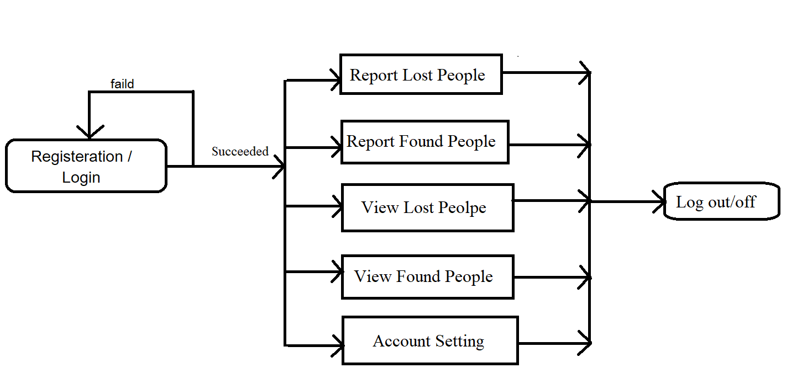

As shown in above data flow diagram..
User Register himself to website and create an account .
After conformation the user can perform multiple activities into application such insert delete or view , data.

  - UML DIIAGRAM
    - Class diagram :

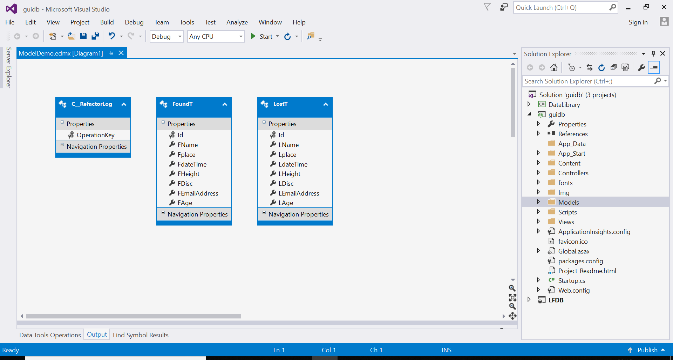

    - System Flow Diagram:

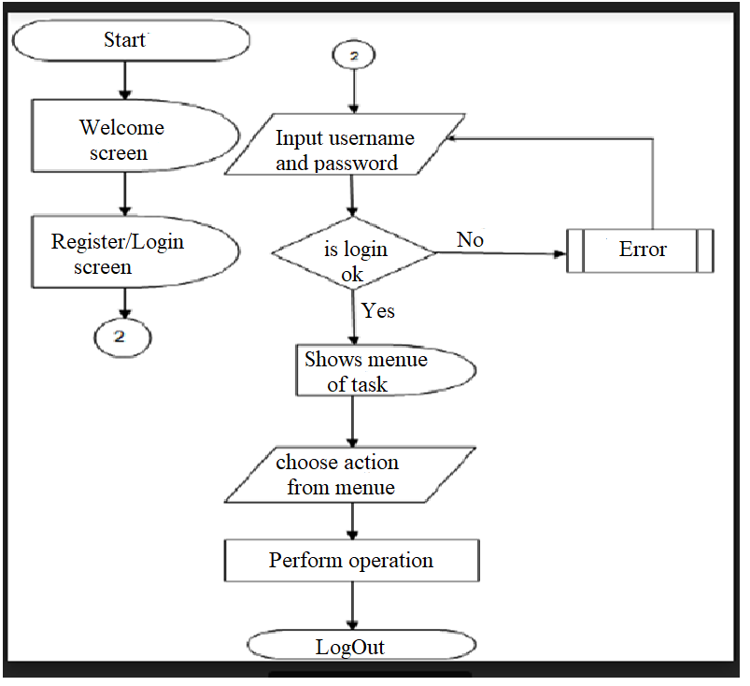

3.5.3 Activity flow diagram:

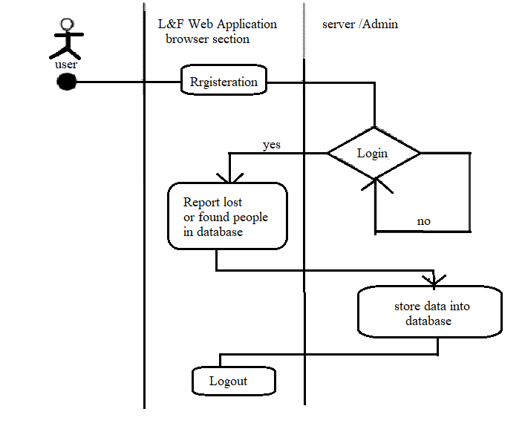

3.5.4 UseCase digram:

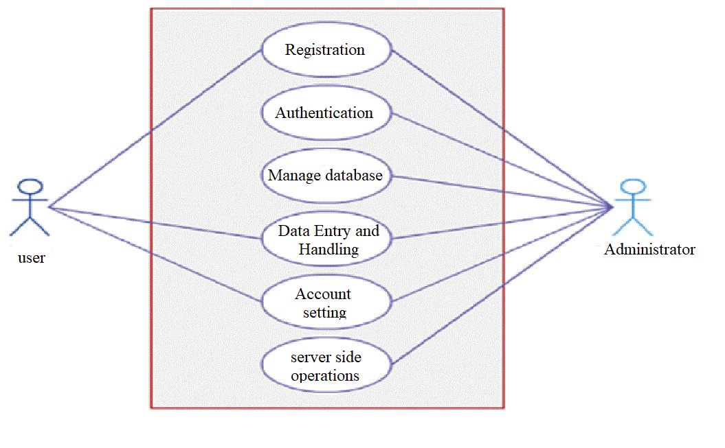

4. Analysis Of Result
Software development lifecycle:
The entire project spanned duration of 4 month. In order to effectively the design and a cost-effective model the Waterfall model was practiced.
General overview of waterfall model:
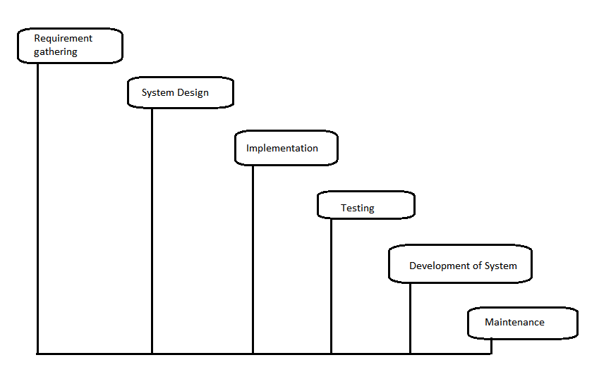
Requirement gathering and Analysis phase:
This phase started at beginning of our project , we had form groups and modularized the project.
- Define and visualize all the objectives clearly ,Gather the requirement and evaluate them .
- Considering technical requirement needed then collect technical specifications of various component required , analysis of language needed.
- Define strategy to avoid risk else define solution to that risk .

Feasibility study:
Feasibility study is made to see the project on completion will serve the purpose of creating site , It lets the developer foresee the future of project and usefulness. A feasibility study of system proposal ia according to its workability to meet their users need and effective use of resource.
The document provide feasibility of project that is being designed and lists various areas were considered very carefully during the feasibility study of this project such as Technical, economics Operational feasibility .Following are some feature:
Technical feasibility:
The system must be evaluated from the technical point of view first. The assessment of this feasibility must be based on outline design of system requirement of system in term of input ,output , program and procedures.
Technical issues raised during the investigation are :
- Existing Technology sufficient for suggested one?
- Can the system expands if it is further developed?
Behavioral study:
- Is there sufficient support for the user?
- Will the proposed system cause harm?
The project should be beneficial because it satisfies the objective when developed and installed. All the behavioral aspects are considered carefully and conclude that the project is behaviorally feasible.

Risk analysis process:
The relative probality of disaster occurring should be determind .items ot consider in determining the probablitiy of specific disaster should include . Potential exposure may be classified as :
- Natural Threats: Internal flooding, external flooding, internal fire External fie, seismic activity, high wind, snow and ice strome ,volcanic eruption ,tornado ,hurricane, epidemic, tidal wave, typhoon.
- Technical Threats: Power failure ,heating ,ventilation ,air conditioning failure , failure of CPU ,failure of software, telecommunication failure, nuclear fallout.
- Human Threat : robbery, bomb threats, war, biological combination, hazardous waste , vehicle crash , airport proximity ,computer crime.
Functional requirement :
Function is define as set of input , the behavior and output. Functional requirement can be calculations ,technical detail, data manipulation, processing and specific functionality is that define ‘What a system is suppose to accomplish . Behavioral requirement describing all the case where the system uses the functional requirement are captured in use case.

Non-functional requirement:
In system engineering and requirement engenering ,a non-functional requirement ia a requirement that specifies criteria that can be used to judge the operating system, rather then specific behavior. This should be contrasted with functional requirement that efine specific behaviouror functions ,The plane for implementing non-functional requiremet detail in system architecture.

5. System Implementation:
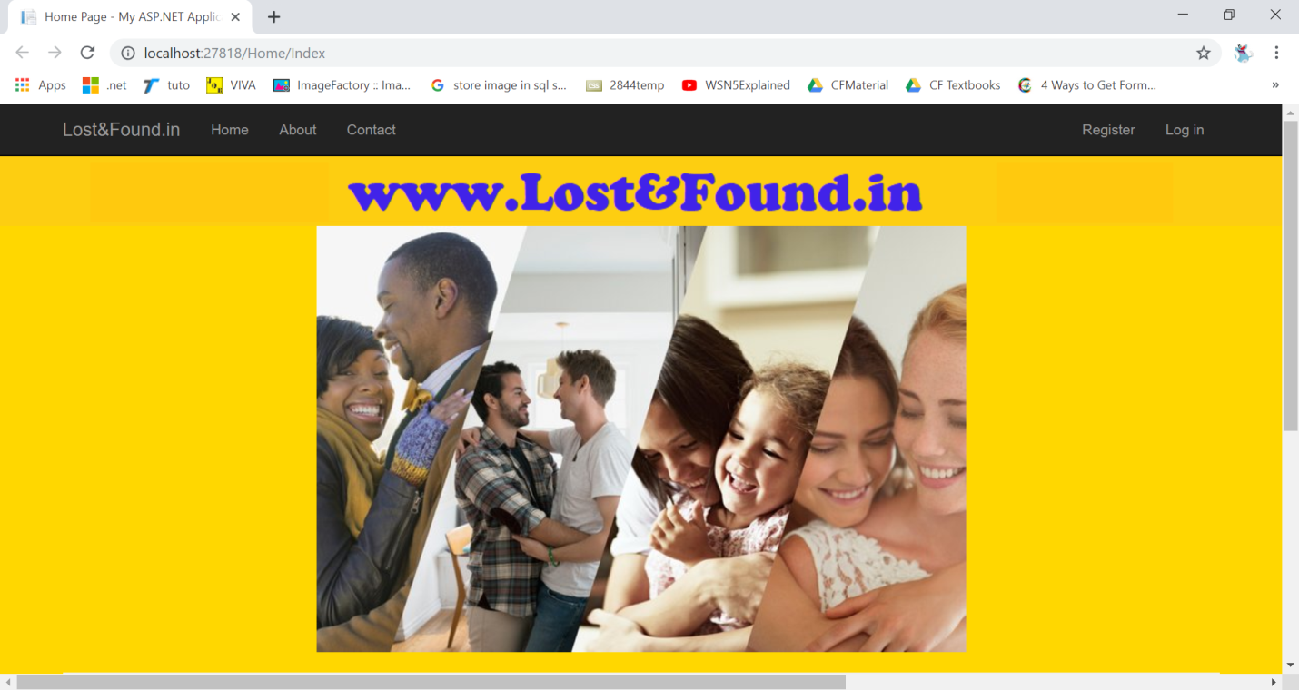

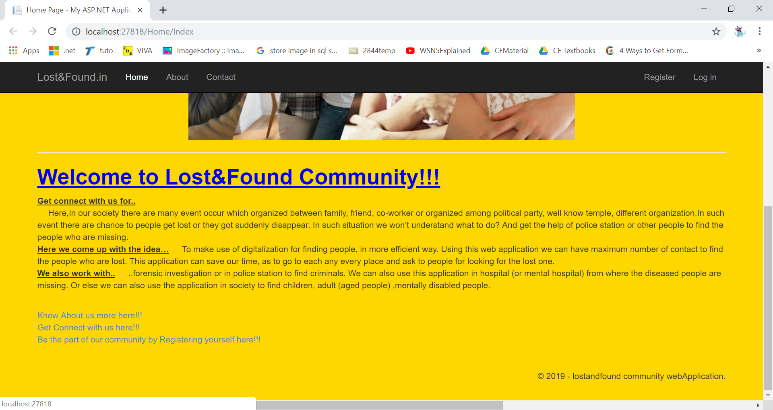

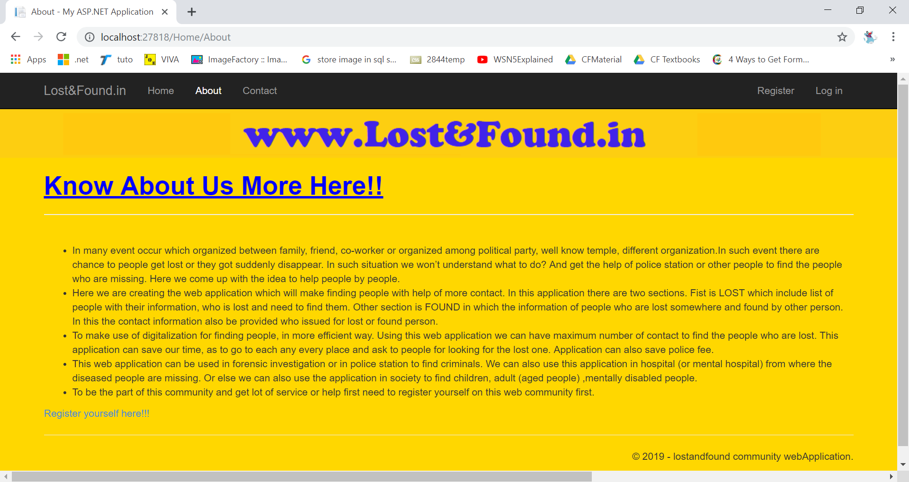

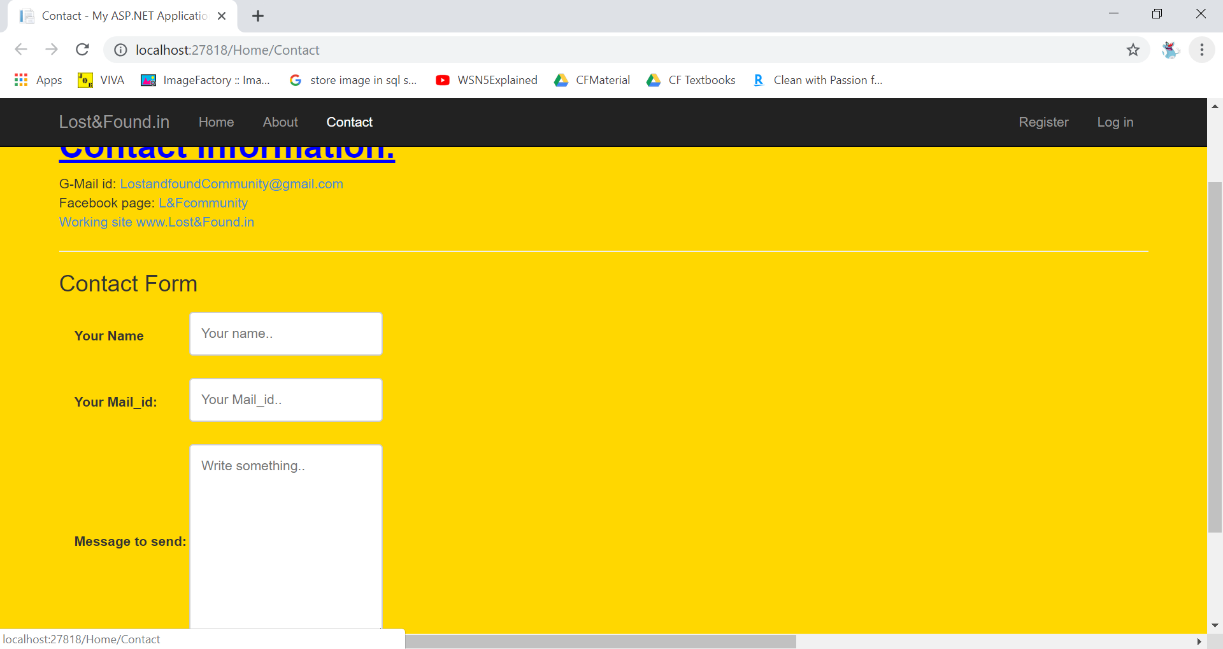

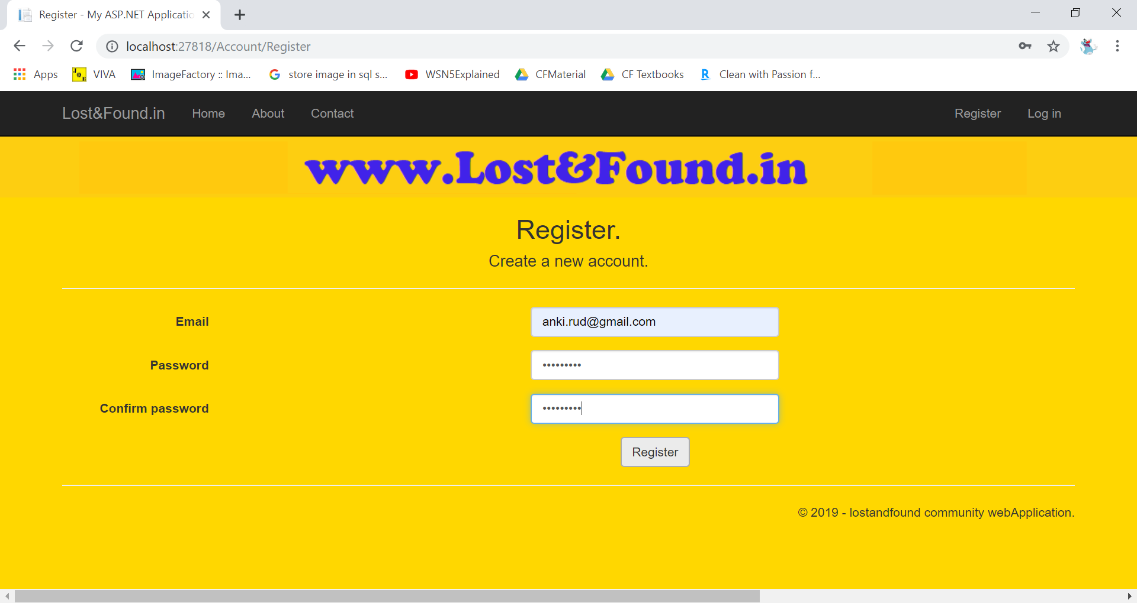

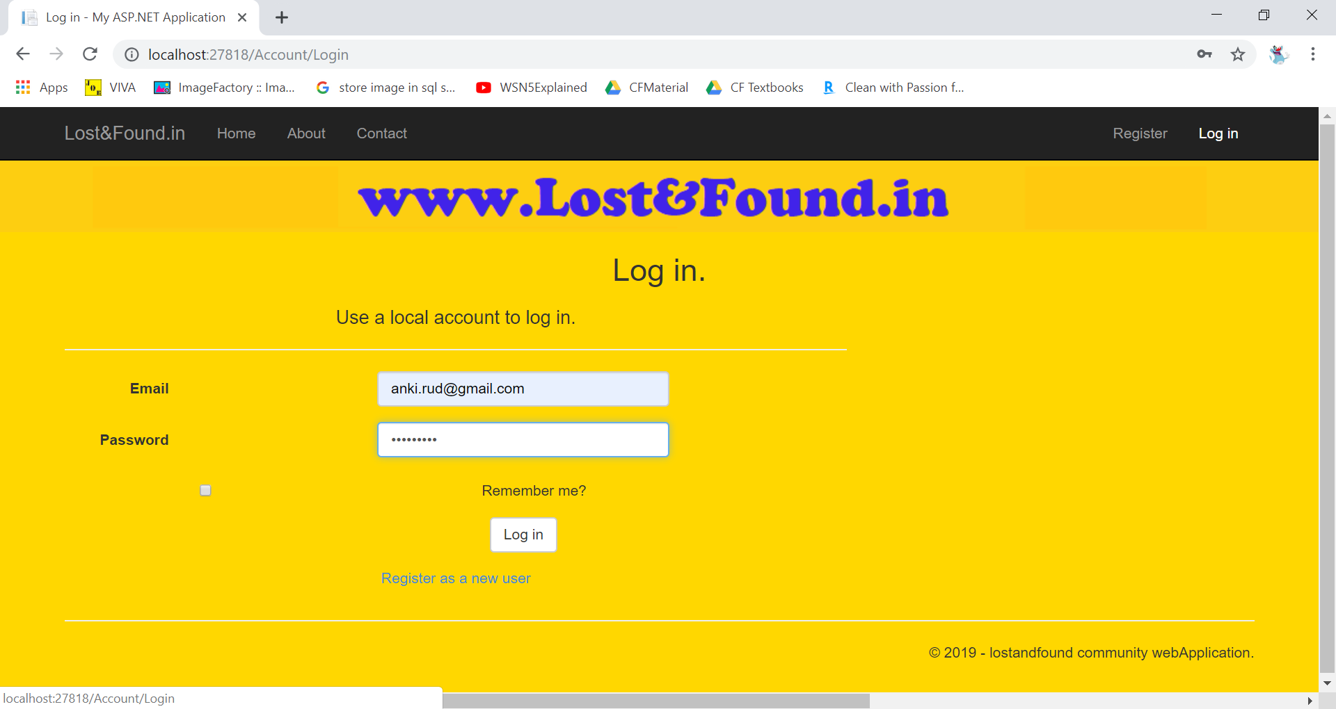

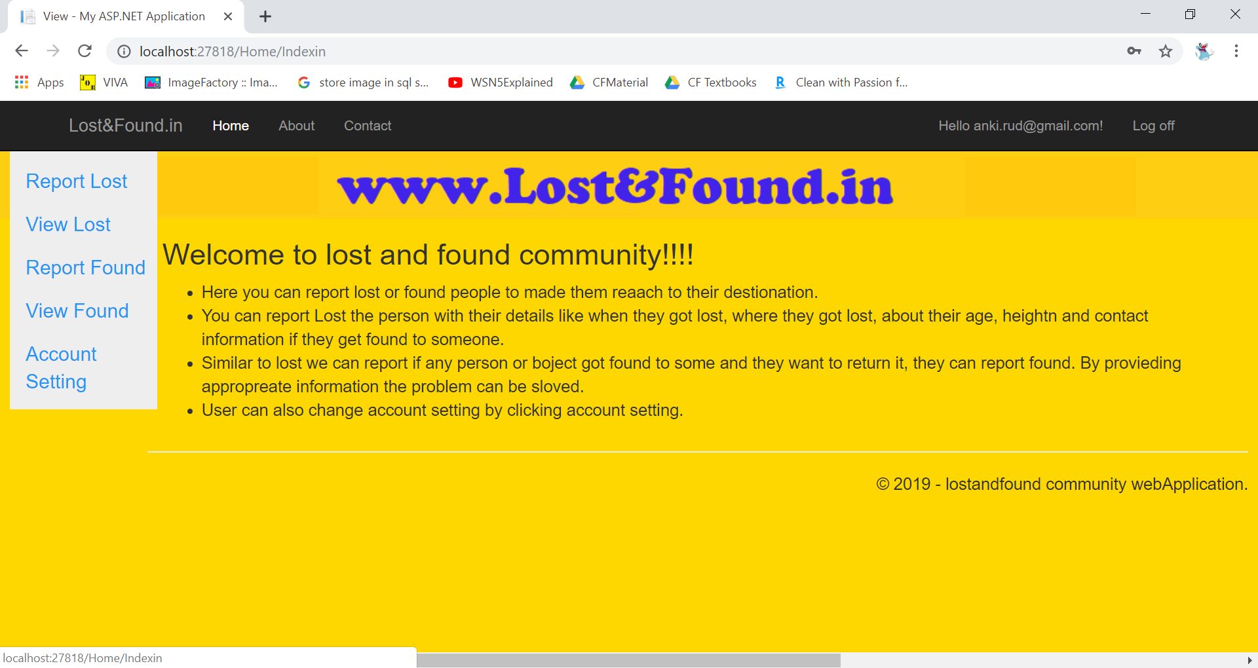

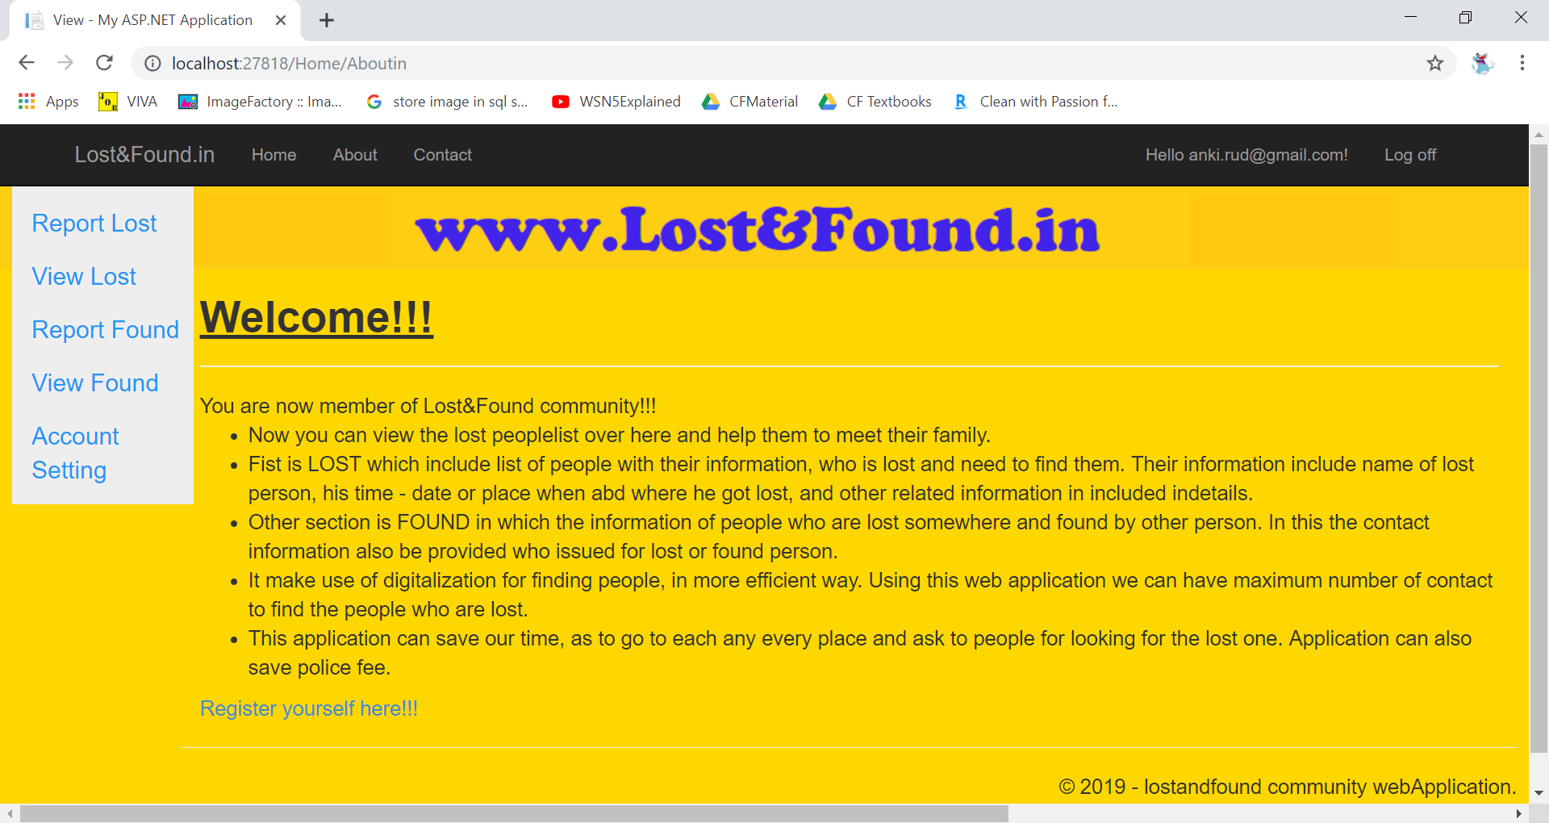

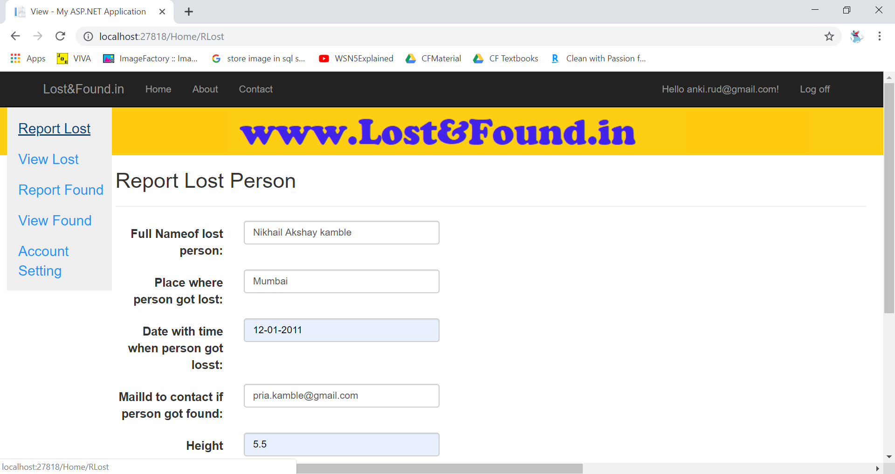

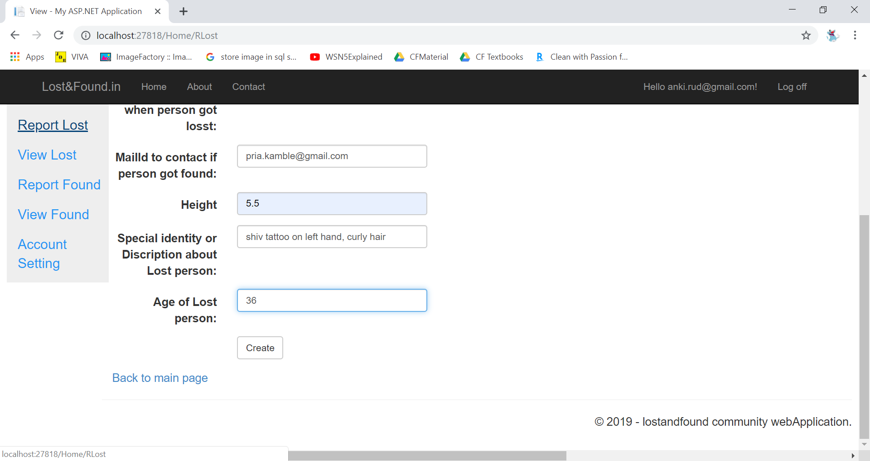

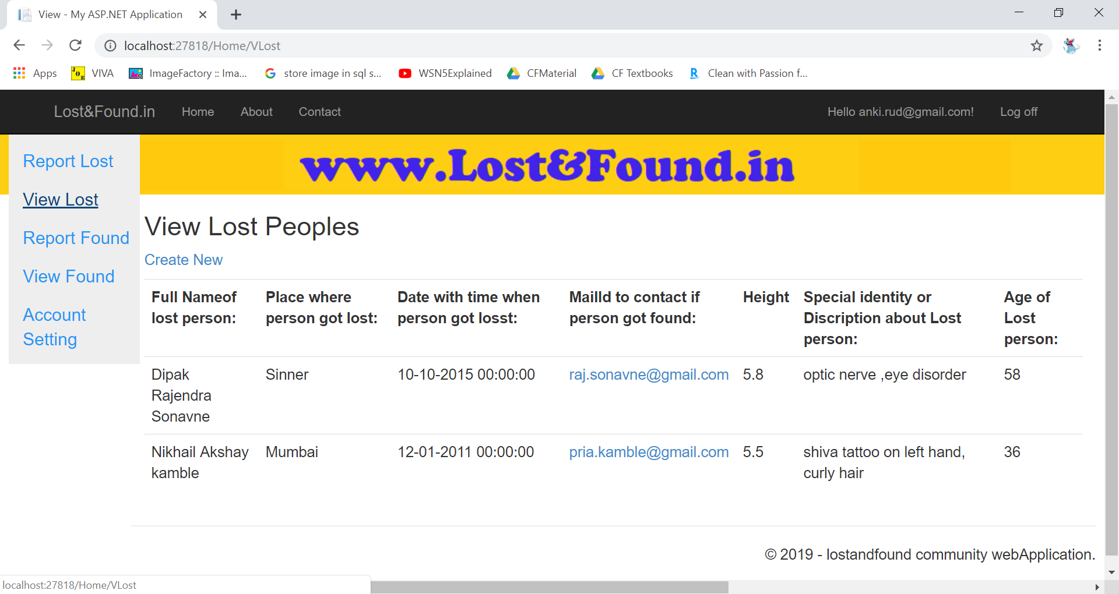

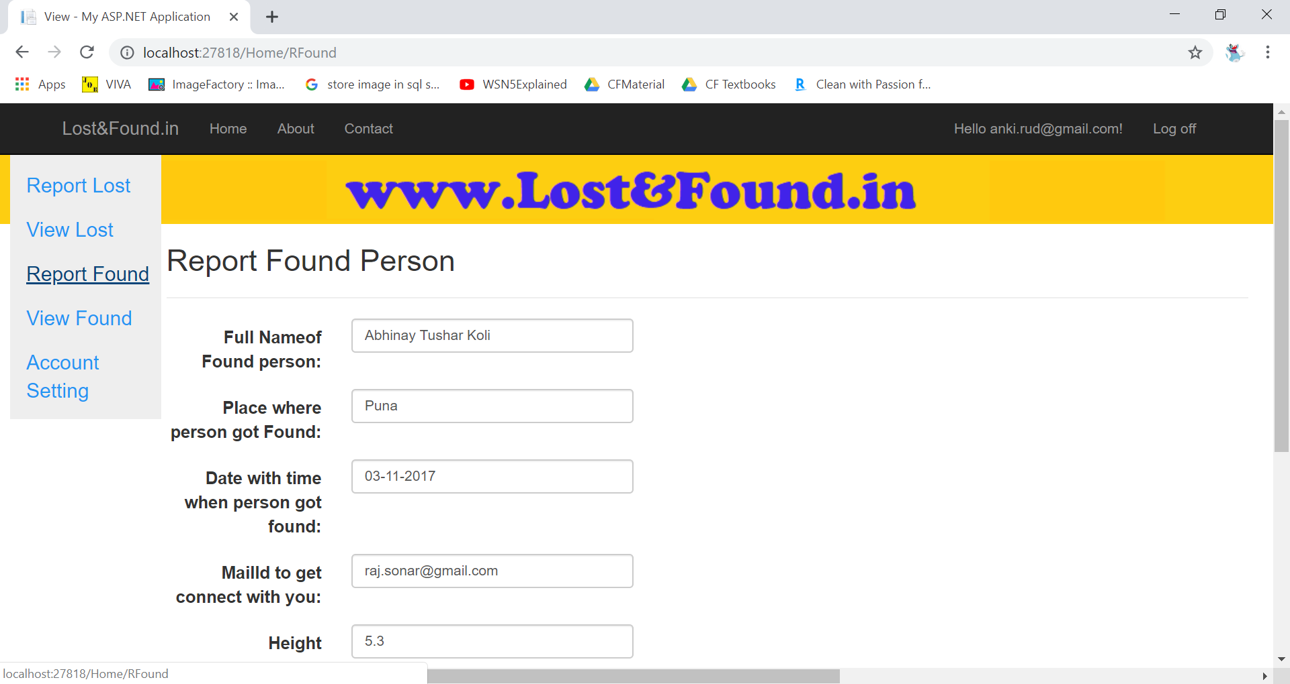

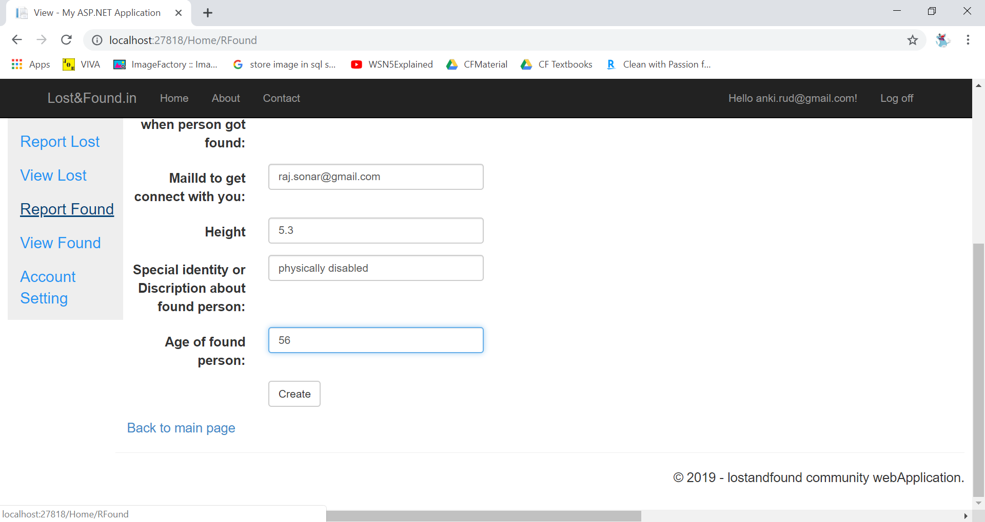

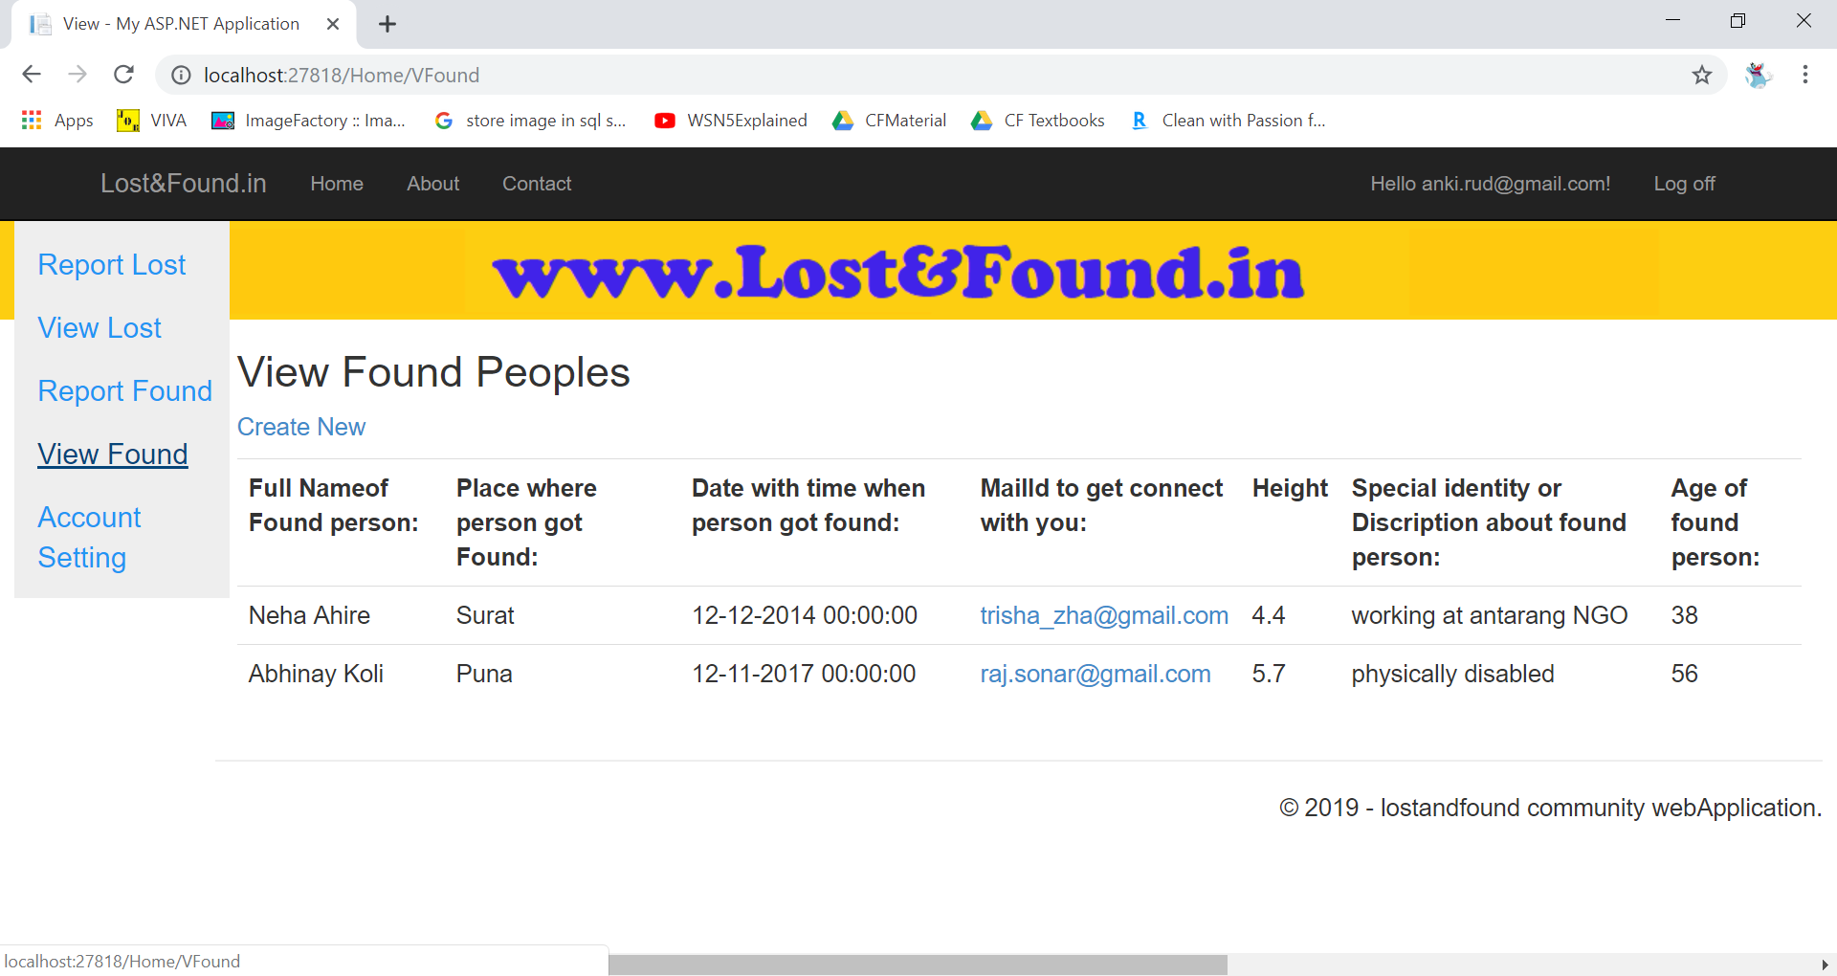

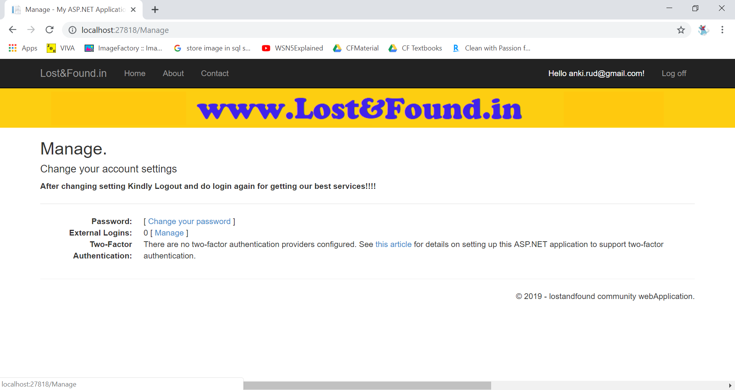

6.TESTING
Testing is a process of executing a program with the interest of finding an error. A good test is one that has high probability of finding the yet undiscovered error. Testing should systematically uncover different classes of errors in a minimum amount of time with a minimum amount of efforts. Two classes of inputs are provided to test the process:
1. A software configuration that includes a software requirement specification, a design specification and source code.
2. A software configuration that includes a test plan and procedure, any testing tool and test cases and their expected results.

Testing is divided into several distinct operations:
1. Unit Testing
2. Integration Testing
3. Validation Testing
4. Recovery Testing
5. Stress Testing
6. Test Data Output

7. ADVANTAGES
- Cost Effective – usually free to use! Not only is it cost but it also minimises time, As it reduce the fees of cops and up down for finding people.
- More Effective – As its future enhancement will going to make most usable application for cops field,detactive field or it can occupy the co-corporate field to find lost objects.
- Reach a Bigger Audience (to the website ) – As this application not have age group restriction , so most of the people will get register to this site. And it can result to having large group of audience group.
- Easy – almost everyone can use online application with very little understanding because it is clear, easy to understand and user-friendly.
- Dynamic Content – posting persons data online and via social media platforms gives you a help to find your knowing one with appropriate content and appealing to finding them to other people. Implementing technology can say a lot about your company and its culture and help attract a any type of candidate.
- Flexibility – the internet gives you much more flexibility with regards to controlling your posts and the applications you receive. If you post in a social media or on our website website or application will helpful to your friends to increase their knowledge.

- Longevity – newspapers or other forms of printed media have a very limited lifetime, dependent on their publishing cycle. Most classified publications have a bi-weekly publishing cycle, meaning that your ad will only be seen for that relatively small amount of time. Online topics for learning posts on the hand will stay live until the author or the website removes it.
- Accessibility – no matter where you are if you have an internet enabled device and connection, then you can do everything using chorm offline facility.
- c – all of the previous advantages, lead to the biggest one of all; a shortened hiring process. Instead of waiting for a group of people or student to build up and then choosing from them, you will be able to access an enormous amount of applicants which will inevitably lead to learning a capable individual sooner.

8. Drawbacks and Limitations
Full authority of project is handled by admin such as observing every post whether it is correctly posted or not, or is there is fake entry done in system, Login user is fully authorized or not, the entered issue should get solve within one week or else to take an serious action will taken, handle data from database and finally to make everyone aware about system update. And these task have to handle by admin until and unless this site get well developed .
User can only enter data he don’t have authority to edit and show proper ownership to his own. This coerce is not certification, because there is increment happen in digital substances and digitalization so it is not possible to fully and perfect use of this site.
So this website is get update on upcoming technology and users feedback.
This web application is not certification facility is one of the drawback.

9. Future Enhancement
We can update Security system for user account.
Give our web site well defined logo.
The main upcoming feature will be insert image and more specific Colum for identification of respective person of lost and found people.
Increase the input information about Lost people and more contact facility so that anyone can contact with them easy efficient way them.
In future, mobile application for this system can also be developed.
Make our site user friendly.
Insert user communication field like massager and rewards for helping people.

10.Conclusion

The purpose of system works on the phenomena of combination of open source software along with hardware with any default browser . Make the youth curious about using digitalization path for different task.
The data sharing increase with help of cloud base application.
System , browsing , social media are used to shear document .
We can access the personal documents by logging in to the application .
In this application we use cloud base storage i.e. cloud database and also we can deploy the application on cloud.

11. References

Reference Sites:
www.google.com
www.w3schools.com
www.youtube.com tutorials
https://www.codeacademy.com

12. Gantt Chart

13. Plagiarism Report:
