Contents

What is OS? 2

Can we use a computer without an OS? 2

Evolution of OS 2

RAM v/s ROM 3

What is RAM: 3

What is ROM: 3

Key Difference 3

Characteristics of RAM 4

Characteristics of ROM 5

Types of RAM 5

Types of ROM 5

Kernal: 5

Task of Kernal: 5

Shell 6

Type of Shell 6

Booting 6

Operating System Overview

# What is OS?

Operating System is a system software that manages computer hardware and software resources and provide a interface to the user to interact.

Example of OS:

* Windows
* MacOS
* Linux (Open Source Software)

# Can we use a computer without an OS?

Ye s we can use a computer without OS but it will be very difficult for a naive user to use the computer, for any simple task user need to write machine level code, that’s very much difficult for any one. For example if we want to print any thing we can just Press **ctrl+P,** but if there is no OS then we need to write machine understandable code.

# Evolution of OS

* Mainframe Computer: In this computer there is no secondary storage, only primary memory was there. In that memory there was User Space and OS Space. In this type of OS Jobs are executed one after another. As there was no Secondary Storage, to get the input from the input was time consuming and that time CPU was idle.
  1. Disadvantage
     + CPU was idle if any program wants input from user.
     + No Secondary memory.
     + Need to load loader and linker many times for similar typed langue programs if they are not in sequence.
* Batch OS: Batch Operating system is one of the important type of operating system. The users who using a batch operating system do not interact with the computer directly. Each user prepares its job on an off-line device like punch cards and submits it to the computer operator. To speed up the processing, jobs with similar needs are batched together and run as a group.
  1. Disadvantage:
     + If one job in a batch is erroneous, then batch will be rejected.
     + There is a lack of interaction between the user and the job.
     + CPU is being often idle, because the speed of the mechanical I/O devices is slower than the CPU.
* Spooling: simultaneous peripheral operations online, in this type of computer there is primary memory as well as secondary memory. But at a time one program sits in the main memory for execution.
  1. Disadvantage:
     + Uniprogramming

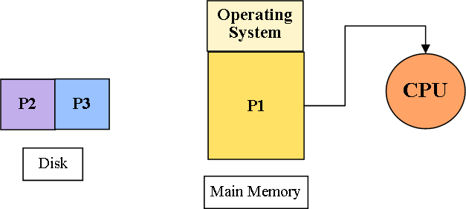

* Multiprogramming: keeping multiple programs inside the main memory at the same time ready for execution. Multiprogramming doesn’t mean running multiple programs at the same time.
* Multitasking: Multiprogramming with round robin scheduling.

# RAM v/s ROM

## What is RAM:

The full form of RAM is Random Access Memory. The information stored in this type of memory is lost when the power supply to the PC or laptop is switched off. The information stored in RAM can be checked with the help of BIOS. It is generally known as the main memory, or temporary memory or cache memory or volatile memory of the computer system.

## What is ROM:

The full form of ROM is a Read-Only Memory. It is a permanent type of memory. Its content are not lost when the power supply is switched off. The computer manufacturer decides the information of ROM, and it is permanently stored at the time of manufacturing, which cannot be overwritten by the user.

## Key Difference

* RAM stands for Random Access Memory while ROM stands for Read-Only Memory
* Data stored in Random Access Memory popularly known by acronym RAM stays there until the computer is running whereas Read Only Memory popularly known by acronym ROM is used mainly in the start-up process of a modern computer
* Important RAM types are 1) DRAM 2)SRAM. SDRAM, and DDR and Important ROM types are 1) EPROM 2) EEPROM, 3) PROM, and 4) Mask ROM,
* RAM is volatile whereas ROM is non-volatile Memory
* The biggest advantage of RAM is that it does not have any moving parts while the biggest advantage of Rom is that it is not lost when power is switched off.
* 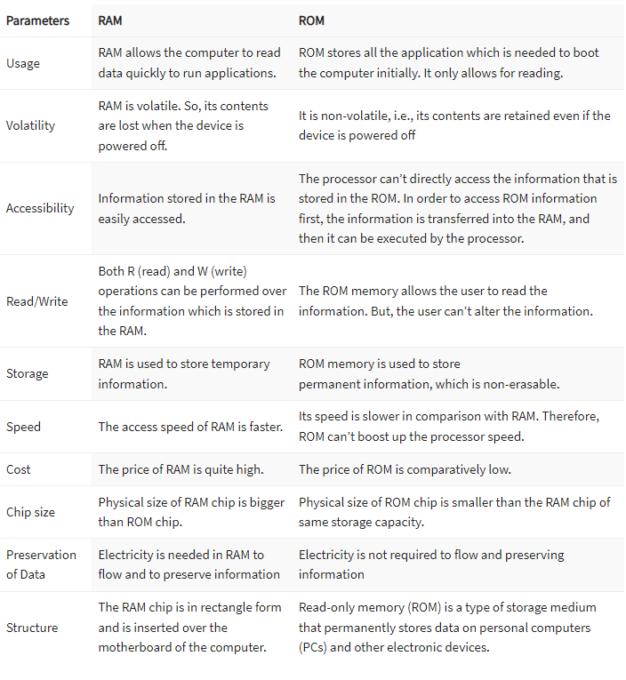

## Characteristics of RAM

* RAM chips are widely used in the normal operations of a computer for starting and loading the operating system and applications.
* Much faster to read from and write
* Data in RAM stays there until the computer is running
* A RAM chip allows you to store multiple gigabytes (GB) of data.
* A 32 bit PC can have a maximum of 4 GB of RAM while a 64 bit PC can have 16 exabytes of RAM

## Characteristics of ROM

* You can write data only once. However, once it is written, you can read it any number of times
* A ROM chip is used mainly in the start-up process of a modern computer
* A ROM, non-volatile memory stores only several megabytes (MB) of data, up to 4 MB or more per chip

## Types of RAM

* DRAM -Dynamic RAM must be continuously refreshed, or otherwise, all contents are lost.
* SRAM – Static RAM is faster, needs less power but is more expensive. However, it does need to be refreshed like DRAM.
* Synchronous Dynamic RAM (SDRAM) – This type of RAM can run at very high clock speeds.
* DDR – Double Data Rate provide synchronous Random Access Memory

## Types of ROM

* EPROM: The full form of EPROM is Erasable Programmable Read-only memory. It stores instructions, but you can erase only by exposing the memory to ultraviolet light.
* PROM: The full form of PROM is Programmable Read-Only memory. This type of ROM is written or programmed using a particular device.
* EEPROM: stands for electrically Erasable Programmable Read-Only Memory. It stores and deletes instructions on a special circuit.
* Mask ROM: is a full form of MROM is a type of read-only memory (ROM) whose contents can be programmed only by an integrated circuit manufacturer.

# Kernal:

Kernel is central component of an operating system that manages operations of computer and hardware. Kernel acts as a bridge between applications and data processing performed at hardware level using inter-process communication and system calls.

Kernel loads first into memory when an operating system is loaded and remains into memory until operating system is shut down again. It is responsible for various tasks such as disk management, task management, and memory management.

## Task of Kernal:

* To establish communication between user level application and hardware.
* To decide state of incoming processes.
* To control disk management.
* To control memory management.
* To control task management

# Shell

* A Shell provides you with an interface to the Unix system. It gathers input from you and executes programs based on that input. When a program finishes executing, it displays that program's output.
* A shell is special user program which provide an interface to user to use operating system services. Shell accept human readable commands from user and convert them into something which kernel can understand. It is a command language interpreter that execute commands read from input devices such as keyboards or from files. The shell gets started when the user logs in or start the terminal.

## Type of Shell

* Bourne shell (sh)
* Korn shell (ksh)
* Bourne Again shell (bash)
* POSIX shell (sh)

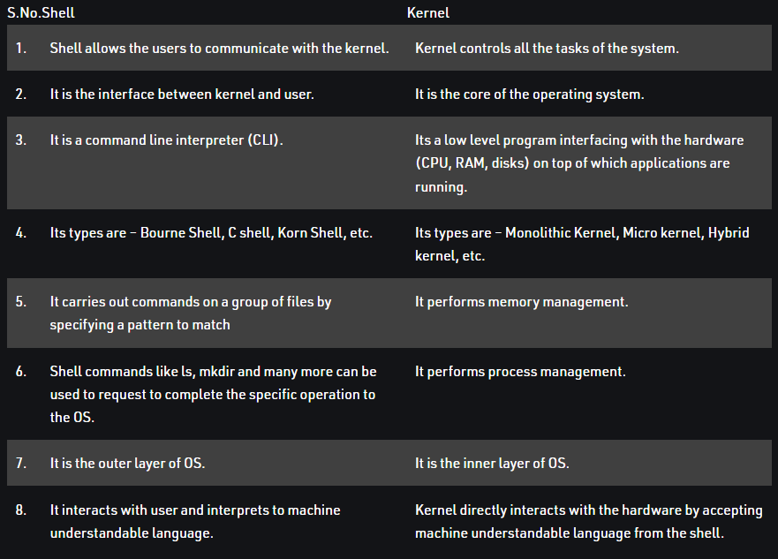

# Booting

Booting is the process of starting a computer. It can be initiated by hardware such as a button press or by a software command. After it is switched on, a CPU has no software in its main memory, so some processes must load software into memory before execution. This may be done by hardware or firmware in the CPU or by a separate processor in the computer system.

# Multiprocessing

In a uni-processor system, only one process executes at a time.

Multiprocessing is the use of two or more CPUs (processors) within a single Computer system. The term also refers to the ability of a system to support more than one processor within a single computer system. Now since there are multiple processors available, multiple processes can be executed at a time

* With the help of multiprocessing, many processes can be executed simultaneously. Say processes P1, P2, P3 and P4 are waiting for execution. Now in a single processor system, firstly one process will execute, then the other, then the other and so on.
* But with multiprocessing, each process can be assigned to a different processor for its execution. If its a dual-core processor (2 processors), two processes can be executed simultaneously and thus will be two times faster, similarly a quad core processor will be four times as fast as a single processor.