Concur App Center Listing Form

Please complete the following form to populate your App Center listing. Email the completed form and graphics to your partner marketing contact for final approval. Please plan for a 1-2 week lead-time to accommodate any edits required. Any requests for updates to your App Center listing require a new form to be submitted, please send to [AppCenterMarketing@concur.com](mailto:AppCenterMarketing@concur.com).

Additionally, any partner collateral materials you would like to include in your App Center listing must be reviewed and pre-approved by Concur prior to posting or distribution. Please send all materials to your partner marketing contact and to [AppCenterMarketing@concur.com](mailto:AppCenterMarketing@concur.com).

**NOTE: All character requirements include spaces.**

|  |
| --- |
| **Listing Language** (What is the language that the following details are written in?) |
| **Listing Type** (User (Apps for Me) or Company (Apps for My Business)) |
| **Listing Name** (Company and/or specific product name.)  *32 characters* |
| **Headline** (Short heading describing the application.)  *64 characters* |
| **Short Description** (Will act as an introduction to your application and entice the reader to learn more. Briefly explain what the integration with Concur does.)  *180 characters* |
| **Long Description** (Longer descriptionof the application and Concur integration. This will appear in the details tab of your application.)  *2048 characters* |
| **Partners Listing URL** (URL to partner website.)  *256 characters* |
| **Datasheet or Collateral URL** (Speaks to the application and Concur integration. Content hosted on partner website.) |
| **Video URL** (Speaks to the application and Concur integration.) |
| **Inquire Lead Report email address** (Only required for Apps for My Business. Lead inquires will be sent to this email address.) |
| **Partner name**  *256 characters* |
| **Partner Support URL** (Partner hosted page that has all of your contact information for product support.) |
| **Partner Contact Phone Number** (Provide a phone number for product support)  *32 characters* |
| **Connect URL** (Only required for Apps for Me. URL for app authorization and sign in/up flow. Provided by development team.) |
| **Connection Workflow** (Only required for Apps for Me.) (Web flow, App Center or Auto Connection) |
| **Mobile Apps Supported** (If applicable)(iOS, Android, Microsoft, Blackberry or Other.) |
| **Keywords** (Used for key word search in the App Center**.** Available in the future and will be helpful if you name and describe your product in a way that drives traffic to your listing.)  *100 characters* |
| **App works with these Concur offerings** (Must choose at least one.)   Expense - Standard  Expense - Professional  Invoice - Standard  Invoice - Professional  Travel - Standard  Travel - Professional  Travel Request - Professional |
| **Regions Available** (Identify which countries your solution is available in by highlighting them below. If your solution is available regionally or globally, please make that note below.)   |  |  |  |  |  | | --- | --- | --- | --- | --- | | **North America**  Anguilla  Antigua And Barbuda  Aruba  Bahamas  Barbados  Bermuda  Canada  Cayman Islands  Cuba  Dominica  Dominican Republic  Grenada  Guadeloupe  Haiti  Jamaica  Martinique  Mexico  Montserrat  Netherlands Antilles  Puerto Rico  Saint Barthélemy  Saint Kitts and Nevis  Saint Lucia  Saint Martin  Saint Pierre and Miquelon  Saint Vincent and the Grenadines  Sao Tome and Principe  Trinidad and Tobago  Turks and Caicos Islands  United States of America  Virgin Islands (British)  Virgin Islands (U.S.) | **Latin America**  Argentina  Bolivia  Brazil  Chile  Colombia  Ecuador  Falkland Islands (Malvinas)  French Guiana  Guyana  Paraguay  Peru  Saint Helena, Ascension and Tristan da Cunha  South Georgia and the South Sandwich islands  Suriname  Uruguay  Venezuela | **Europe, Middle East, & Africa**  Afghanistan  Åland Islands  Albania  Algeria  Andorra  Angola  Armenia  Austria  Azerbaijan  Bahrain  Bailiwick of Guernsey  Belarus  Belgium  Benin  Bosnia and Herzegovina  Botswana  Bulgaria  Burkina Faso  Burundi  Cameroon  Cape Verde  Central African Republic  Chad  Congo, Democratic Republic of  Congo, People's Republic of  Cote D'Ivoire (Ivory Coast)  Croatia  Cyprus  Czech Republic  Denmark  Djibouti  Egypt  Equatorial Guinea  Equatorial guinea  Eritrea  Estonia  Ethiopia  European Union  Faeroe Islands  Finland  France  Gabon  Gambia  Georgia  Germany  Ghana  Gibraltar  Greece  Greenland  Holy see (Vatican city state)  Hungary  Iceland  Iran  Iraq  Ireland  Isle of Man  Israel  Italy  Jersey  Jordan  Kenya  Kuwait  Latvia  Lebanon  Lesotho  Liberia  Libya  Liechtenstein  Lithuania  Luxembourg  Macedonia  Malawi  Mali  Malta  Mauritania  Mauritius  Mayotte  Moldova  Monaco  Montenegro  Morocco  Mozambique  Namibia  Netherlands  Niger  Nigeria  Norway  Oman  Pakistan  Poland  Portugal  Qatar  Romania  Russia  Rwanda  San Marino  Saudi Arabia  Senegal  Serbia  Serbia and Montenegro  Serbia and Montenegro  Seychelles  Sierra Leone  Slovakia  Slovenia  Somalia  South Africa  South Sudan  Spain  Sudan  Svalbard and Jan Mayen  Swaziland  Sweden  Switzerland  Syria  Tanzania  Togo  Tunisia  Turkey  Uganda  Ukraine  United Arab Emirates  United Kingdom  Yemen  Zaire  Zambia  Zimbabwe | **Asia Pacific**  American Samoa  Australia  Bangladesh  Bhutan  British Indian Ocean territory  Brunei Darussalam  Cambodia  Caroline, Mariana, Marshall Is  China  Christmas island  Cocos (keeling) Islands  Comoros  Cook Islands  East Timor  Federated States of Micronesia  Fiji  French Polynesia  French Southern Territories  Guam  Guinea  Guinea-Bissau  Heard and McDonald Islands  Hong Kong  India  Indonesia  Japan  Johnston Island  Kazakhstan  Kiribati  Korea, North (Democratic People's Republic of Korea)  Korea, South (Republic of Korea)  Kyrgyzstan  Laos  Macau  Madagascar  Malaysia  Maldives  Mariana Islands  Marshall Islands  Marshall Islands  Mongolia  Myanmar  Nauru  Nepal  New Caledonia  New Zealand  Niue  Norfolk Island  Northern Mariana Islands  Palau  Palestine  Papua New Guinea  Philippines  Pitcairn  Reunion  Samoa  Singapore  Solomon Islands  Sri Lanka  Taiwan  Tajikistan  Thailand  Timor-Leste  Tokelau  Tonga  Turkmenistan  Tuvalu  USA Minor Outlying Islands  Uzbekistan  Vanuatu  Vietnam  Wallis And Futuna  Western Sahara | **Other**  Antarctica  Bouvet Island | |
| **Industry** (Select an industry if the application is specific to one of the following. If application is NOT industry-specific, do not select an industry below.)   Healthcare and Life Science  Legal  Professional Services |
| **Localization**  Below, you will find a list of Concur-supported languages.  If your application is available in a country where one of the following languages is spoken, please translate your listing into that language.  Use this form, and insert translations for the short description, long description, and insert links to any localized landing pages. For example, if your listing is available in Germany, please translate the listing to German.  *Also, please be sure that all of the assets that your listing links to are also localized, including the inquiry link*.  **Here are several translation companies that Concur has used in the past:**  Lionbridge: <http://www.lionbridge.com/>  MotionPoint: <http://www.motionpoint.com/>  Jonckers: <http://www.jonckers.com/>  We understand that there is a cost associated with localization.  To bring that cost down, consider abbreviating the length of your listing to include only the key points about the integration with Concur and your application.  **Concur-supported languages:**  EN-US / English US  EN-AU / English Australian  EN-GB / English Great Britain  DE / German  FR / French  FR-CA / French Canadian  ES / Spanish  ES-LA / Spanish Latin America  PT-BR / Portuguese Brazil  NL / Dutch  IT / Italian  SV / Swedish  JA / Japan  CS / Czech  DA /  Danish  FI / Finnish  EL /  Greek  LV /  Latvian  LT / Lithuanian  NO /  Norwegian  SK / Slovakian  TR /  Turkish |
| **Please attach images for approval:**  Banner Image: 854x315px, maximum file size 1 MB, jpg or png format  Hero Image: 543x307px, maximum file size 650 KB, jpg or png format  Thumbnail Image: 50x50px, 8px corner radius, maximum file size 10 KB, jpg or png format  Partner Image: (Appears at bottom of details page near partner contact details. Include if different from thumbnail) 50x50px, radius corners (rounded), maximum file size 10 KB, jpg or png format  Product Image: (Print quality product image to be used in future marketing activities.) high resolution file, eps or ai format  Partner Logo: (Print quality logo to be used in future marketing activities.) high resolution, eps or ai format |

**Example App Center Listing**

Summary View

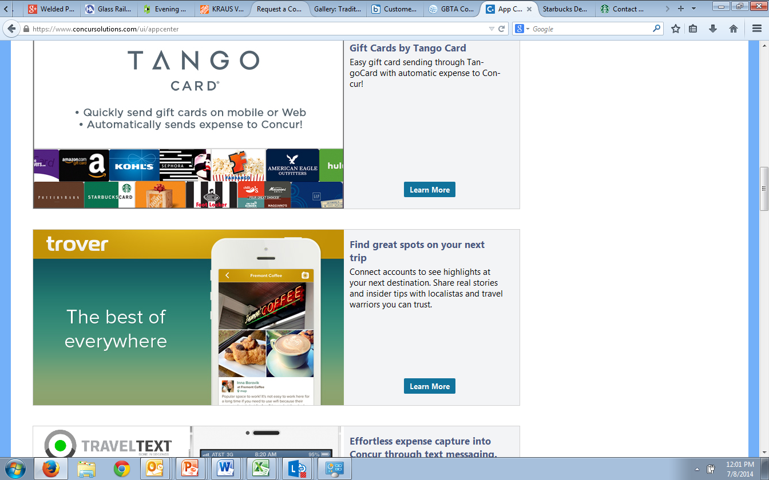

Hero Image

Short Description

Title

Detail View

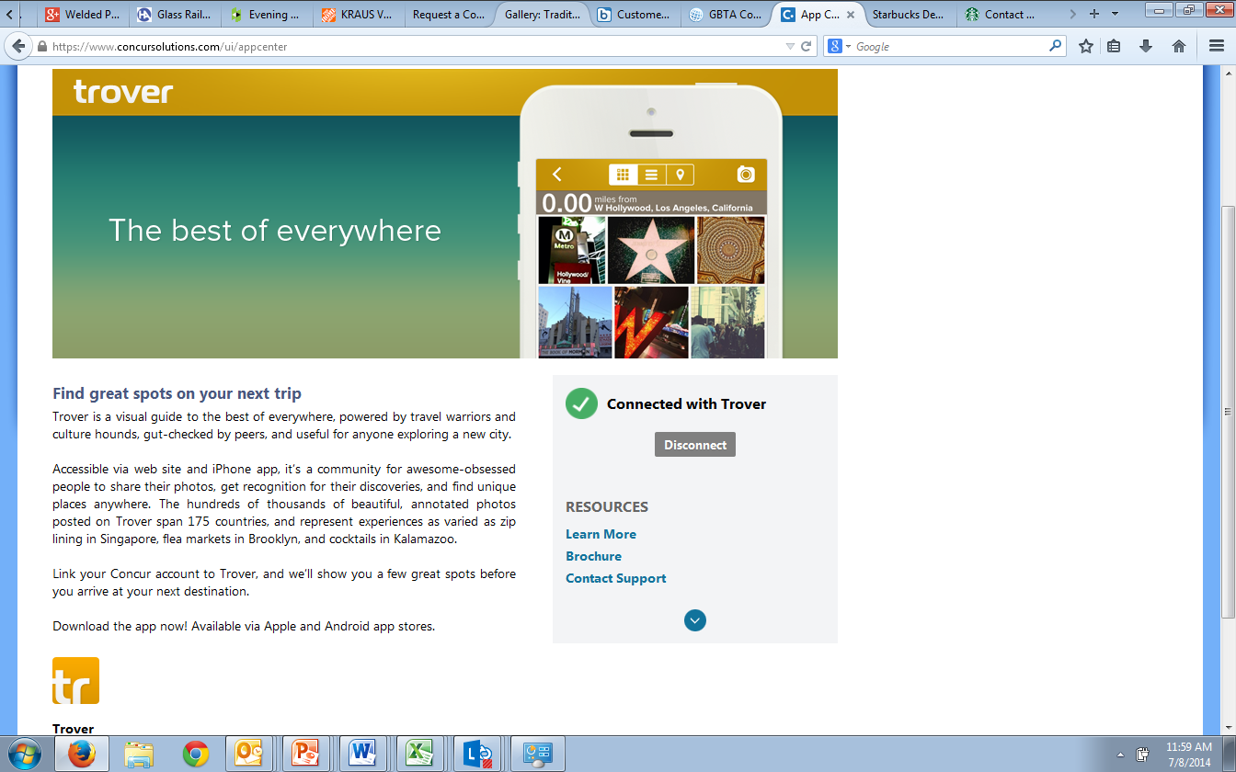

Banner

Support phone number appears here when provided

Company Name

Thumbnail

Website

Long Description

Support website