What is Data- Data is generally a raw format of any information. It may be text information or any rich formatted information.
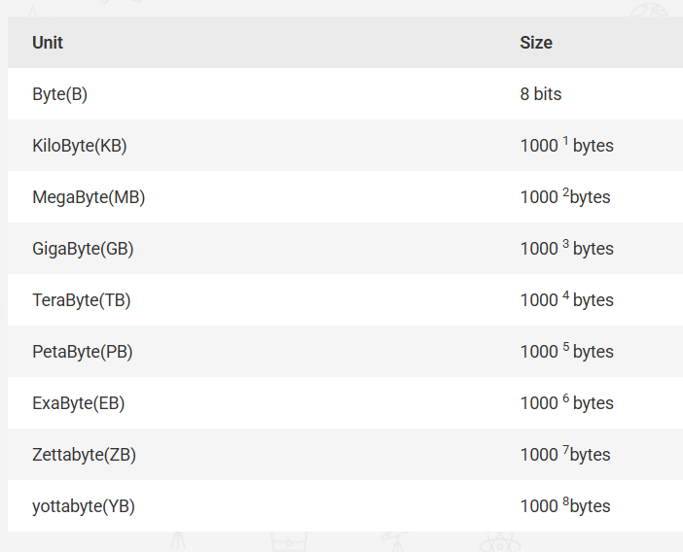

What is Database?
The database is a collection of related data, organized in a structured and meaningful way. Having the data stored in a way that is allowed faster –
- Storage(entry)
- Access
- Update
- Manipulation

The database is a container of multiple tables, views, procedures, functions, triggers, and other database objects. The data is stored in the form of tables and can be queried, updated, and manipulated using SQL cmd.
The DBMS is responsible for managing and maintaining the integrity, security, and consistency of the data in the database.

Databases in early systems
The databases in early systems were stored on tapes, which were read only format, which means once you store data. It is impossible to delete or update or even add any new data on it easily.

What is Database Management System?
The database management system is software that controls all the different manipulation of stored or to be stored data in a database. It allows the creation, update, manipulation, definition of a database. Some examples of DBMS are –
- SQL
- mySQL
- noSQL
- Oracle
- IBM DB2
- PostgreSQL
- MongoDB

A database management system perform the following –
- Database Definition
- Data Updation -Insertion , Update, delete
- Data Retrieval
- Administration -Database Administrator( modification, deletion, updation and creation), Database Manager, Database Editor
- Security

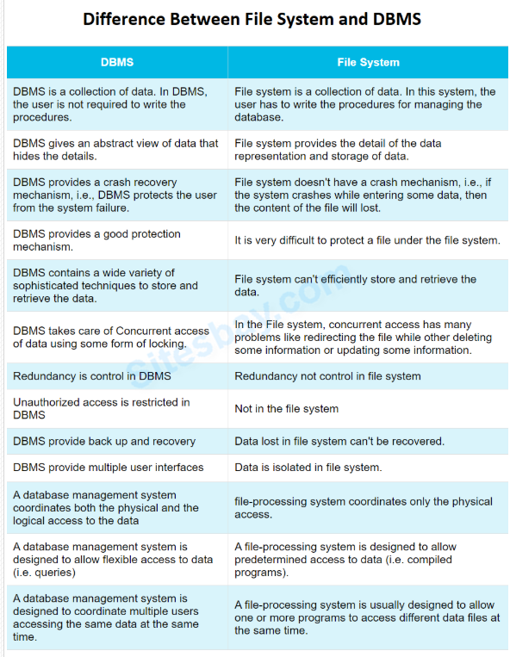

TUPLE
Each tuple represents a complete record of the specific data item, each tuple stores different data with the same structure.

RECORD
Each record represents complete information of the specific data item, each record stores different data with the same structure.

DBMS Architecture (What is Architecture in DBMS)
The following are different types of database architectures, based upon the needs and requirements of the system.
- 1 Tier Architecture
- 2 Tier Architecture
- 3 Tier Architecture
- n Tier Architecture

Single Tier Architecture

In such systems all the required components like – the interface, Middleware, and back-end data, all on one server or platform.
Most of the developers choose such systems as it’s easy and simple. But, it doesn’t provide many tools for the end-users. Thus, it is not suitable for data delivery platforms .

Two Tier Architecture

In such systems, the communication is between the client and server. The client is where the data needs to be delivered to and the server is where data is stored, updated and processed and communication between the two happens.

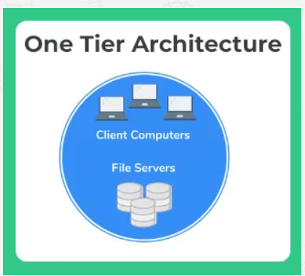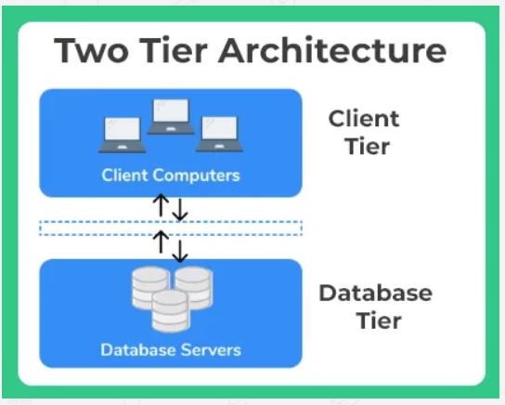

3-Tier Architecture?
3-tier architecture is a client-server software architecture pattern that separates the system into three layers, each with a specific role:

🔷 1. Presentation Tier (Client Layer)
- What it does: User interface (UI) – how users interact with the system.
- Example: Web browser, mobile app, React/Angular frontend.
- Responsibilities:
  - Display data to users
  - Accept user input (e.g., forms, clicks)
  - Send requests to the application tier

🔷 2. Application Tier (Logic Layer / Middle Tier)
- What it does: Processes user requests and applies business logic.
- Example: Backend code (Node.js, Java, Python, .NET), APIs, RESTful services.
- Responsibilities:
  - Business rules (e.g., calculating salary, checking login credentials)
  - Communicates between UI and database
  - Validates and processes data

🔷 3. Data Tier (Database Layer)
- What it does: Stores, retrieves, and manages data.
- Example: MySQL, MongoDB, PostgreSQL, Oracle DB.
- Responsibilities:
  - Persistent data storage
  - Responds to queries from the application tier
  - Ensures data integrity and security, fast retrieval and storing using DSA.
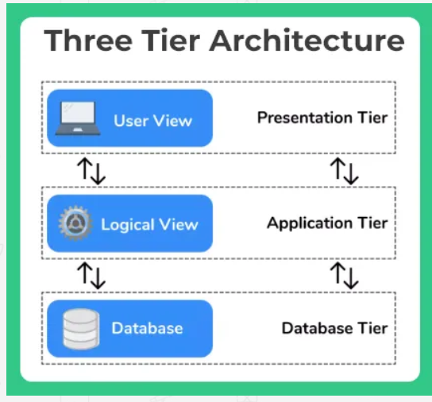

n Tier Architecture
The n tier is more customized format for corporation. Where there are n different divisions of the whole format which are related but independent of one another.

Data Abstraction:

Definition: Data abstraction refers to the hiding of details from users at certain levels, for authentication and security purpose
Any DBMS architecture mainly consists of three levels of
  - Conceptual level
  - Internal level
  - External level

Conceptual level
  - It describes the logical structure of the database
  - Specifies what type of data can be stored in the database by defining the data type and data type signs and constraints like (primary key foreign key )
  - It also specifies the relationship between tables
Example : Create table emp(id num(5) primary key ,name varchar(10));

External level
  - External level describe users view of the database
  - It provides security mechanism i.e. some users can access only a certain portion of data, it depends upon the database administrator which users can access the conceptual level and at what extent

Internal level
  - This is the lowest level of abstraction describes how physical data is stored
  - It provides details about the complex data structures that are used for storage of data
  - Internal level provides indexes and clusters to control and manage the physically stored data in hard disk

Data Independence
These levels of abstraction provide data independence i.e., is all the transactions or changes made at one level are unaffected to other levels
DBMS architecture provides two types of data independence
  - Logical data independence
  - Physical data independence

Logical data independence
Logical data Independence states that external level is completely unaffected are free from any changes that are made at the conceptual level and vice-versa
ex: Adding a new entity in the conceptual level should not affect the external level

Physical data independence
Physical data Independence states that conceptual level is completely unaffected are free from any changes that are made at the internal level and vice-versa
ex: Adding a new entity in the internal level should not affect the conceptual level

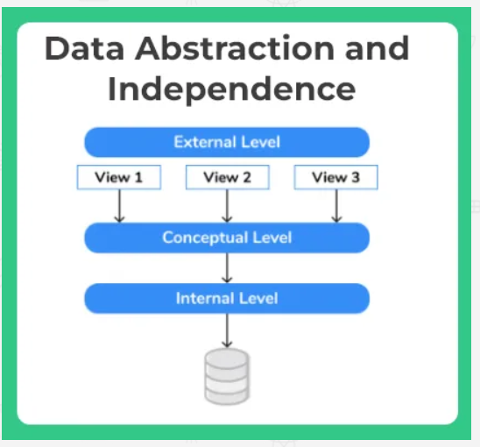

Types of Data Models in DBMS
- Hierarchical database model
- Relational model
- Network model
- Entity-relationship model
- Object-oriented database model
- Document model
- Entity-attribute-value model
- Star schema
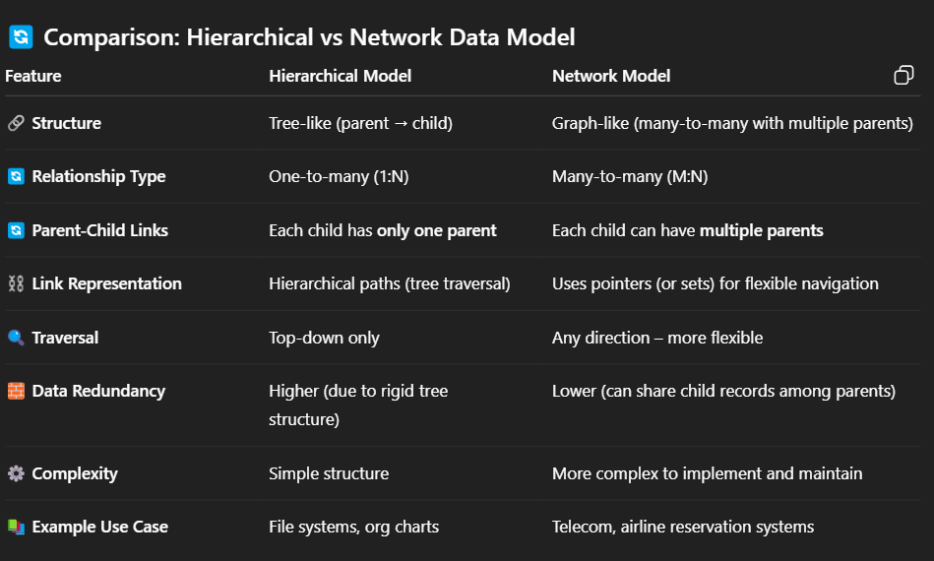
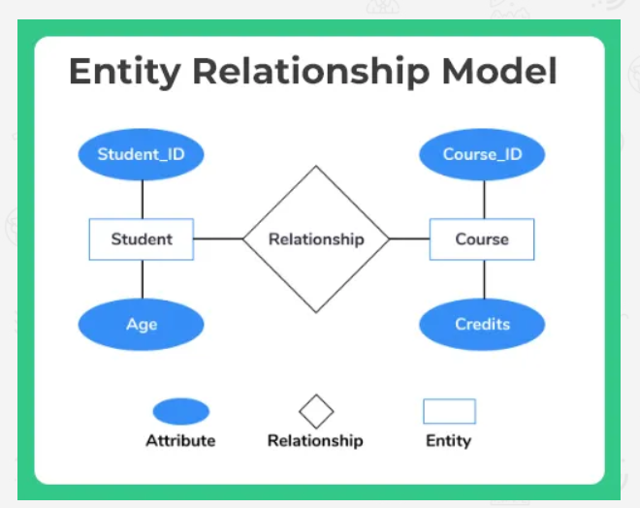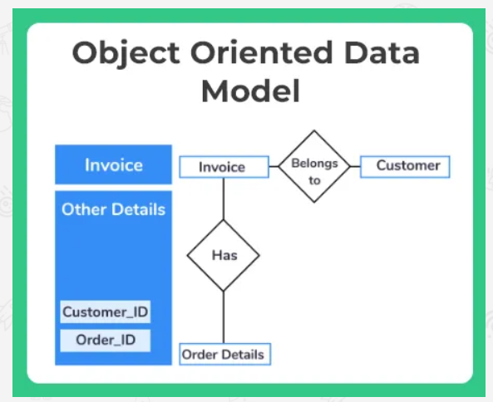

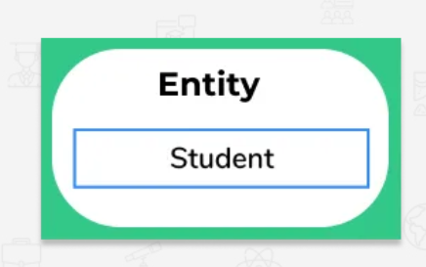

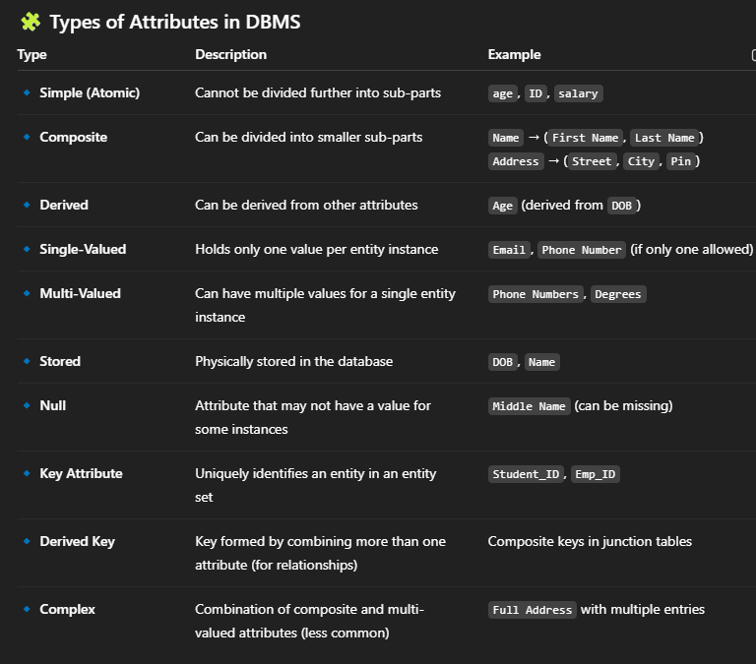

Relationship
The association between different entities that are existing in a database is depicted by relationship. For example, in a university there may be thousands of students, which have enrolled in a few subjects each year.
There are various types of relationships than can exist in a database which are –
  - Unary
  - Binary
  - n-ary
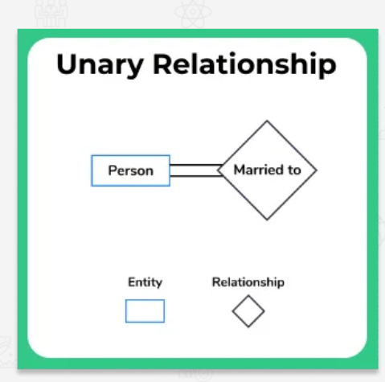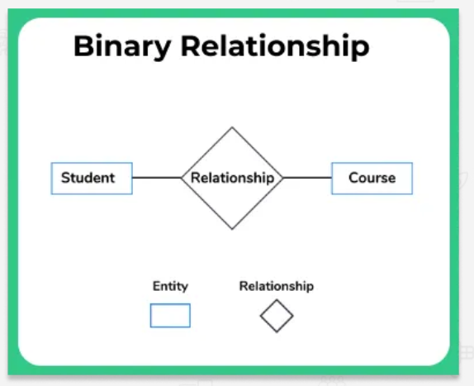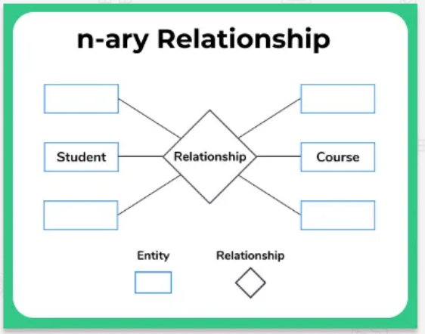
Cardinality
For a given entity sites, the number of entities that can participate in a relationship with another entity set is called cardinality.

One to One
When there is only one entity at a given instance participating in a relationship or association with only one different entity.
For example-Man married woman -At a given time only one man can marry one woman at a given time.

Many to One
When there are multiple entities in a given entity set in relationship with only one entity of another or same entity set.
Example Assuming there is a rule that student can only enrol in 1 course this semester. Many student can enrol in same course.

Many to Many
Imagine there is no restriction in number of courses that can be enrolled in, then.

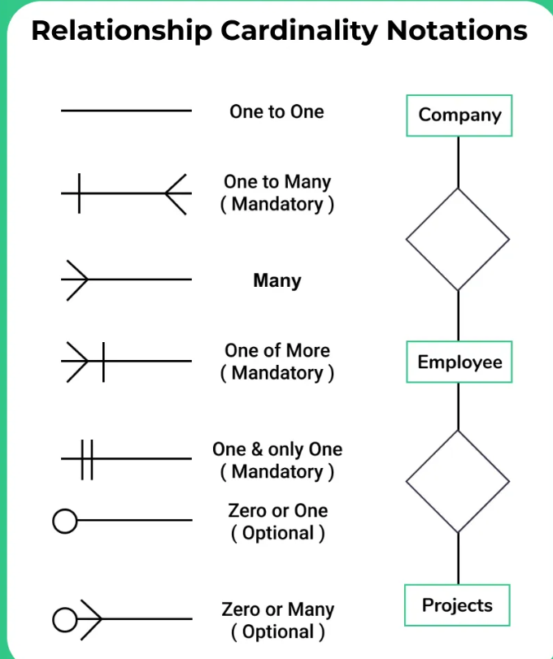
Participation Constraint

Total Participation
All the entities in the entity set must participate in the relationship. For example the university forces, you to necessarily enrol in atleast 1 course, in that case it will be called total participation that student end.

Partial Participation
It is when there maybe cases when some entities may and some entities may not participate in a relationship.
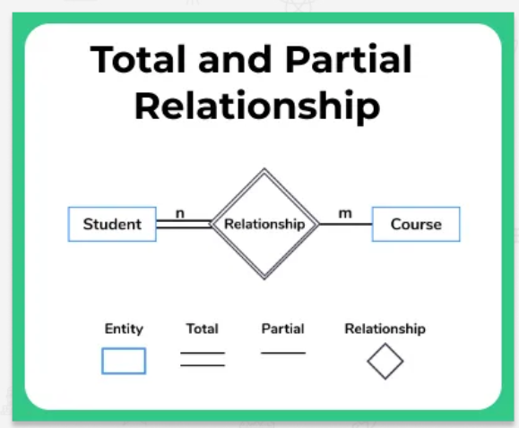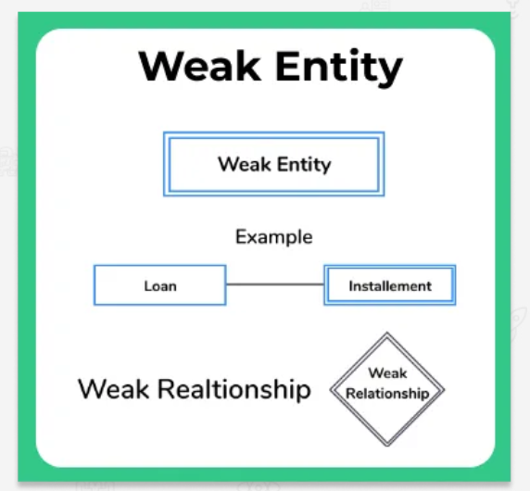

Weak Entity and Weak Relationship
Weak entities are the one which may not have their own attributes and depend on other entity for their existence. For example, the monthly instalment is dependent upon the loan entity and its attributes. The participation for weak entity type is always total.
This is represented by a double rectangle as represented in the image.
Weak relationship which is represented by double diamond connects relationship between a strong entity and a weak entity.
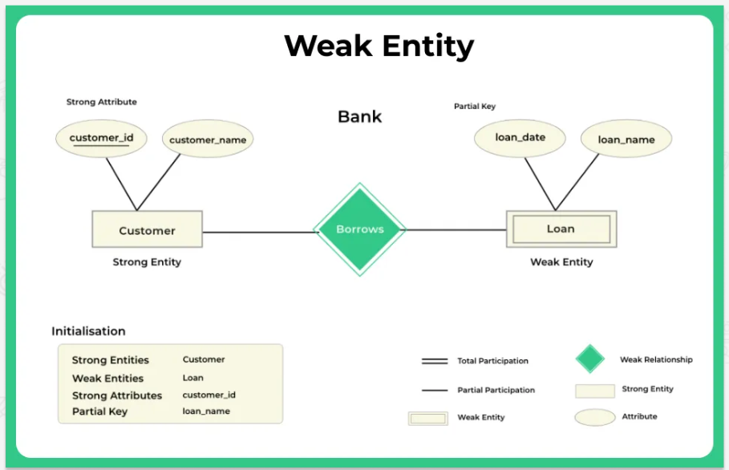

What is the need for Generalization, Specialization and Aggregation in DBMS? Why need?
-With large databases it was realized that the ER model was become a little more complex and inconvenient to use.
Thus by programmers there were some additions in the ER model were suggested to reduce down on the complexity of the program, some new concepts were added are-
- Generalisation
- Specialisation
- Aggregation

Generalization we combine lower level entities to form a higher level entity. Thus its clear that it follows a bottom up approach.
Example – In a bank there are two different types of accounts – Current and Savings, combine to form a super entity Account. It may also be possible that the higher level entity may also combine with further entity to form a one more higher level entity.
Specialization is opposite to that, it follows a top down approach rather.
Example –
Employee may be decomposed to further as current employee entity and ex employee entity.
Aggregation is simply when we would consider two different entities as a single entity together.
Example –
University offering course can be considered a same entity, when viewed from a student entity perspective.
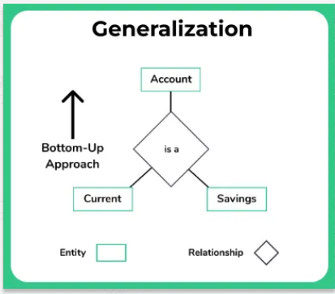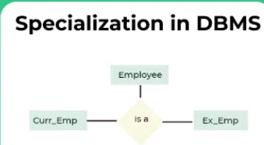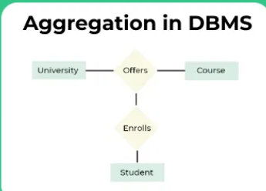

RDBMS

RDBMS?
RDBMS – Relational Database Management System, is a software system or collection of various programs that work together on a relational datamodel database and offer various integrated entities like – Database administration, Data definition, creation, updation etc. Some examples of RDBMS are –
- SQL
- mySQL
- IBM DB2
- Oracle
- Microsoft Access
RDBMS was introduced by E. F. Codd.

Terms used in the relational model

Relation: Representing data in the form of a table consisting of rows and columns and relation both convey the same meaning.

Schema: Schema is nothing but the organization of data in a table i.e in what order the data is logically aligned

Instance: Set of unique values present in the table at present is known as relational instance.

Attribute: An attribute defines the properties of a table that means what type of data that a table is storing ,these are nothing but a view of data in the form of columns
- In the relation student STUD_ID, NAME, PHONE, STATE, STUD_AGE correspond to the attributes of the relation.

Domain : A domain is nothing but the set of possible values that are allowed for a column in a database table.

Tuple :
- It is nothing but the row of the database table
- The student relation is having 4 tuples or rows.

Null values :
- There are certain situations where data may be unknown, missing or undefined which are represented by using this NULL
- A null value is different from zero and any operation on null value will result in null.

Advantages of the relational model
- Data integrity for accuracy and consistency
- No data redundancy
- Access control and integrity in the form of constraints which enables validation before entering and accessing the data
- Provides high security
- Supports to store any types(numbers, characters, date, images, audio, text files )
- Data can be managed and used by several users at a time
- Data can be shared across several platforms.

KEYS
- Keys ensure the data integrity and consistency and helps to access a record uniquely
- The relational Model has the following keys
  - Primary Key
  - Foreign Key
  - Candidate keys are selected from the set of super keys, the only thing that you should remember while selecting candidate keys is, it should not have any redundant attitude( should not contain any column that contains duplicate data.).
  - Alternate Key are columns present in the table which are not selected as primary keys but still, they have all the capabilities to be used as a primary key is called alternate key.
  - super key is a group of single or multiple keys which uniquely identifies rows in a table. A Super key may have additional attributes that are not needed for unique identification.

ER to Relational Model Conversion

Rule-01: For Strong Entity Set With Only Simple Attributes

Rule-02: For Strong Entity Set With Composite Attributes

Rule-03: For Strong Entity Set With Multi Valued Attributes

Rule-04: Translating Relationship Set into a Table

Rule-05: For Binary Relationships With Cardinality Ratios

Rule-06: For Binary Relationship With Both Cardinality Constraints and Participation Constraints

Rule-07: For Binary Relationship With Weak Entity Set

What is Relational Calculus? - it only provides the information about description of the query but not detailed methods on how to do it.

Forms of relational Calculus
- Tuple Relational Calculus (TRC)
- Domain Relational Calculus (DRC)

Tuple Relational Calculus (TRC)

1/
{t | Employee (e) and e.SALARY > 100000}
- Now, this represents results which will be returned as tuple t.
- Predicate here is – Employee (e) and e.SALARY > 100000
- Will return tuples for all the employees which have salary greater than 100000.
2/
Example 2 :
{t| ∃ s ∈ Salary(t.emp_ID = s.emp_ID ∧ s.Salary >= 100000)}

Domain Relational Calculus (DRC)
Example :
{< Fname, Emp_ID > | ∈ Employee ∧ Salary > 10000}
The result here will be returning the Fname and Emp_ID values for all the rows in the employee table where salary is greater than 10000.

FD
In DBMS (Database Management System), Functional Dependency (FD) is a key concept used in relational database design and normalization. It describes a relationship between two sets of attributes in a relation (table).

🔹 What is Functional Dependency?
A Functional Dependency exists when:
If A → B, then A functionally determines B.
This means: if two rows have the same value of A, they must also have the same value of B.
Example:
In a STUDENT table with attributes RollNo, Name, Department:
- RollNo → Name
If you know the RollNo, you can uniquely determine the Name.

🔸 Types of Functional Dependencies

1. Trivial Functional Dependency
- A functional dependency is trivial if the dependent is a subset of the determinant.
- Example: {RollNo, Name} → RollNo is trivial because RollNo is part of the left-hand side.

2. Non-Trivial Functional Dependency
- A functional dependency is non-trivial if the dependent is not a subset of the determinant.
- Example: RollNo → Name is non-trivial because Name is not part of RollNo.

3. Completely Non-Trivial Functional Dependency
- The left-hand side and right-hand side have no common attributes.
- Example: RollNo → Name (if both are completely separate)

4. Partial Functional Dependency
- A non-prime attribute is functionally dependent on part of a candidate key (not the whole).
- Occurs in 2NF violations.
- Example: In a table with {StudentID, CourseID} as primary key:
  - StudentID → StudentName (partial dependency)

5. Full Functional Dependency
- A non-prime attribute is functionally dependent on the whole candidate key, and not on any part of it.
- Required for 2NF.
- Example: {StudentID, CourseID} → Grade

6. Transitive Dependency
- When a non-prime attribute depends on another non-prime attribute through a chain.
- Occurs in 3NF violations.
- Example: StudentID → DeptID and DeptID → DeptName, then:
  - StudentID → DeptName is a transitive dependency.

7. Multivalued Dependency (MVD)
- If A →→ B, then for a single value of A, there can be multiple independent values of B.
- Appears in 4NF.
- Example: A person can have multiple phone numbers and multiple email addresses, but the phone and email are independent.

8. Join Dependency
- A relation R is said to have a join dependency if it can be reconstructed by joining multiple projections of itself.
- Used in 5NF (PJNF).

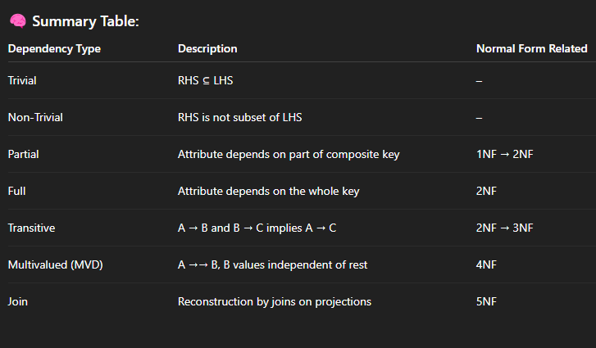

Check for the equivalence of functional dependencies for A relation R (A, B, C, D) having two FD sets S1 = {A->B, B->C, AB->D} and S2= {A->B, B->C, A->C, A->D}
Solution:
- Step 1. Checking whether all FDs of set S1 is present in set S2
  - FD A->B in set S1 is present in set S2.
  - FD B->C in set S1 is also present in set S2.
  - FD AB->D in present in set S1 but not in S2 but we have to check whether we can derive it or not. In set S2, (AB) + = {A, B, C, D}. It means that A,B,C,D can be determined functionally from AB which implies AB->D holds true for set S2
  - As all FDs in set S1 also hold in set S2, S2 ⊃ S1 is true.

- Step 2. Checking whether all FDs of S2 are present in S1
  - FD A->B in set S2 is present in set S1.
  - FD B->C in set S2 is also present in set S1.
  - FD A->C is present in S2 but not in S1 but we have to check whether we can derive it or not. In set S1, (A) + = {A, B, C, D}. It means that A,B,C,D can be determined functionally from A which implies A->C holds true for set S1.
  - FD A->D is present in S2 but not in S1 but we have to check whether we can derive it or not. In set S1, (A) + = {A, B, C, D}. It means that A,B,C,D can be determined functionally from A which implies A->D holds true for set S1.
  - As all FDs in set S2 also hold in set S1, S1 ⊃ S2 is true.

- Step 3. We can conclude that S1=S2 as both S2⊃ S1 and S1⊃ S2 are true. Hence these two FD sets are semantically equivalent.

canonical cover
The canonical cover is defined as a simplified and reduced version of a given functional dependency. As Canonical cover is a compressed version is also called an irreducible set.

Features of Canonical cover
- The canonical cover is free from all irrelevant functional dependencies
- The closure of canonical cover is the same as that of a given set of functional dependency
- The canonical cover is not unique because there may be more than one chemical cover for a given set of functional dependency.

What’s the need for this Canonical cover
Reduces computational time: When a functional dependency is free from useless dependency e then computational time and working with that set becomes very easy.

Problem :
The following functional dependencies hold true for the relational scheme R (W, X, Y, Z) –
X → W
WZ → XY
Y → WXZ
Write the irreducible equivalent for the given set of functional dependencies.
ANS

Solution-
STEP 1: Write all the functional dependencies such that each dependency contains only one attribute on its right side i.e-
X → W
WZ → X
WZ → Y
Y → W
Y → X
Y → Z
STEP 2: Check each functional dependency one by one whether it is essential or not
- For X → W:
Including X → W, (X) + = {X, W}
Ignoring X → W, (X) + = {X}
Now, as the the two results are different, it is concluded that X→W is essential and cannot be eliminated.
- For WZ → X:
Including WZ → X, (WZ) + = {W, X, Y, Z}
Ignoring WZ → X, (WZ) + = {W, X, Y, Z}
Now, as the the two results are same, it is concluded that WZ→X is not essential and can be eliminated.
After eliminating WZ→X ,the resultant set of functional dependencies is :
X → W
WZ → Y
Y → W
Y → X
Y → Z
Now, we will consider this reduced set in further checks.
- For WZ → Y:
Including WZ → Y, (WZ) + = {W, X, Y, Z}
Ignoring WZ → Y, (WZ) + = {W, Z}
Now, as the the two results are different, it is concluded that WZ→Y is essential and cannot be eliminated.
- For Y → W:
Including Y → W, (Y) + = {W, X, Y, Z}
Ignoring Y → W, (Y) + = {W, X, Y, Z}
Now, as the the two results are same, it is concluded that Y→W is not essential and can be eliminated.
After eliminating Y→W,the resultant set of functional dependencies is :
X → W
WZ → Y
Y → X
Y → Z
- For Y → X:
Including Y → X, (Y) + = {W, X, Y, Z}
Ignoring Y → X, (Y) + = {Y, Z}
Now, as the the two results are different, it is concluded that Y→X is essential and cannot be eliminated.
- For Y → Z:
Including Y → Z, (Y) + = {W, X, Y, Z}
Ignoring Y → Z, (Y) + = {W, X, Y}
Now, as the the two results are different, it is concluded that Y→Z is essential and cannot be eliminated.
- From here, our essential functional dependencies are-
X → W
WZ → Y
Y → X
Y → Z

