



RESEARCH PROPOSAL

Scheme applied :- RGEMS

General Purpose Project

TEAM MEMBERS :

Principal Investigator :-

Swati Shukla Mam

**Ankush Bihal 22BCE8692 SCOPE**

**Utkarsh Goel 22BCE8328 SCOPE**

**Ankit Kumar 22BCE9038 SCOPE**

**Rupsa Nanda 22BCE9068 SCOPE**

**Ayushi Jadaun 22BCE8452 SCOPE**

**Kushaj Solanki 22BCE9049 SCOPE**

* First, time application under RGEMS

TITLE :- “SMART SECURITY SYSTEM FOR RESEDENTIAL COMPLEXES”

Proposal Summary :

Keywords : Object detection, coco files, Machine learning, image classification, self-programmed gates, artificial intelligence, Passive Infrared Rays, Microphone module, MQ135 gas and smoke sensor, cyber attack

Working description

The “Smart Security System for Residential Complexes” is a visionary tool comprising of software and hardware components, in place to fully adapt to its environment and thereby, protect the person’s within its range from any kind of direct or indirect attacks. The tool is greatly, made of combinations of various sensors deployed to take care of threats to its owners. It is capable of assessing even gas or chemical attacks and even sense danger from your voice, even if you are not in a position to directly call out for help. The system is taking care of everything inside the residential complex right from a person’s entry from main gate. The pi module camera’s at the main gate records itself the entry of any known person and also captures any unknown persons, random images, while he/she is waiting at the main gate for authenticated entry. Then as the person is inside the premise, on the way to a personal flat and the flat owner has recognized or has already allowed him/her as their guest, only then the flat gates are to be opened. If the person, is instantly admitted by the owner while waiting outside the personal gate, then also he/she can be granted access to enter the personal flat. There are Passive infrared sensors installed right above the entry door of a flat, which is glows light upon any movement, thereby signaling entry of any person. Then, eventually all the sensors are placed at their best fit locations, for maximum utilization of their outputs for safeguarding the members of the flat. Thereby, securing the whole complex with programmed sensors and cameras. The whole of the project is skillfully displaying its readiness and effective working in providing security to the residents and also, at the same time showcasing its social responsibility of environment friendly nature. The whole system works on the theme of “SAVE ELECTRICITY” from the entrance itself, where every part of it is off until the main gate cameras detects any person. So, providing round the clock security from all possible threats.

Diagrams and Flowcharts:-

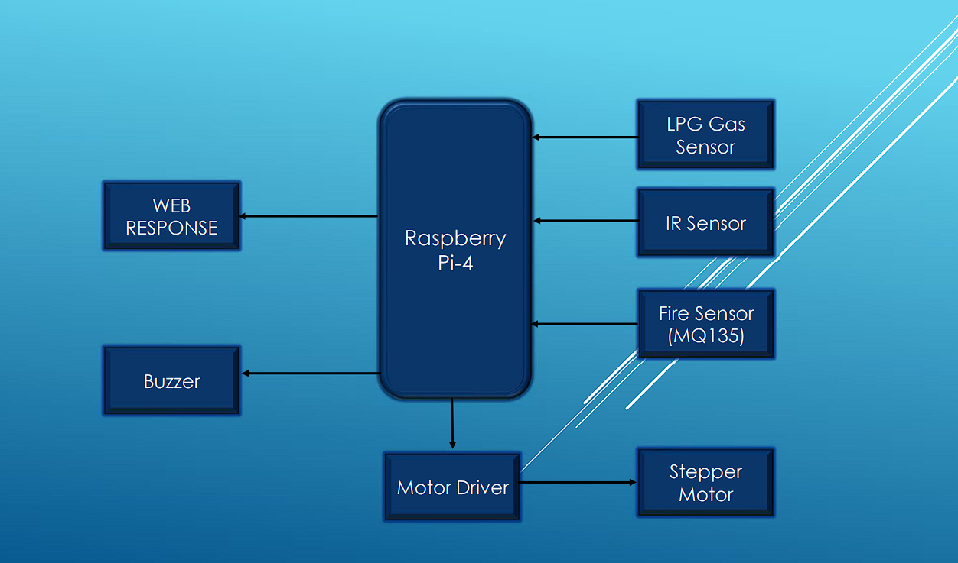

Fig. Schematic diagram depicting the sensors attached around the pi in actual model

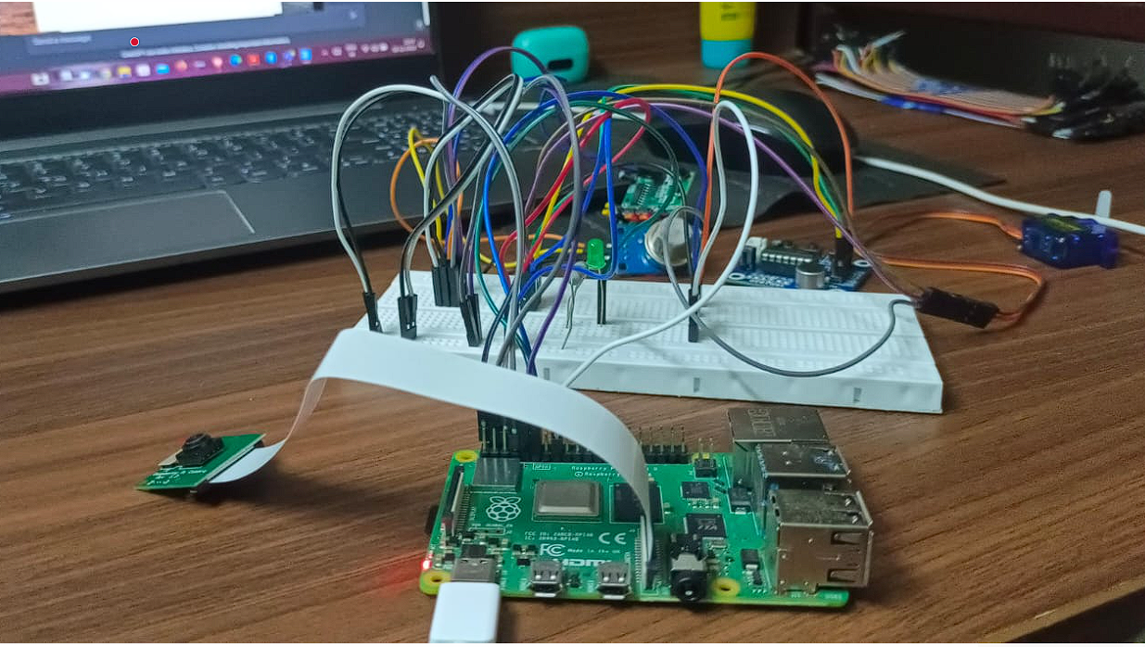

Fig. Raspberry Pi4 with all connections

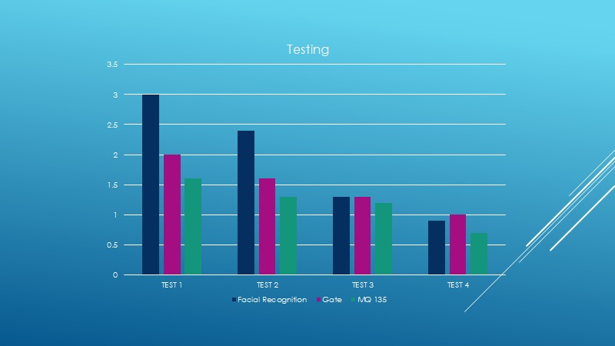

Fig. graph of time taken by respective sensors v/s n number of times

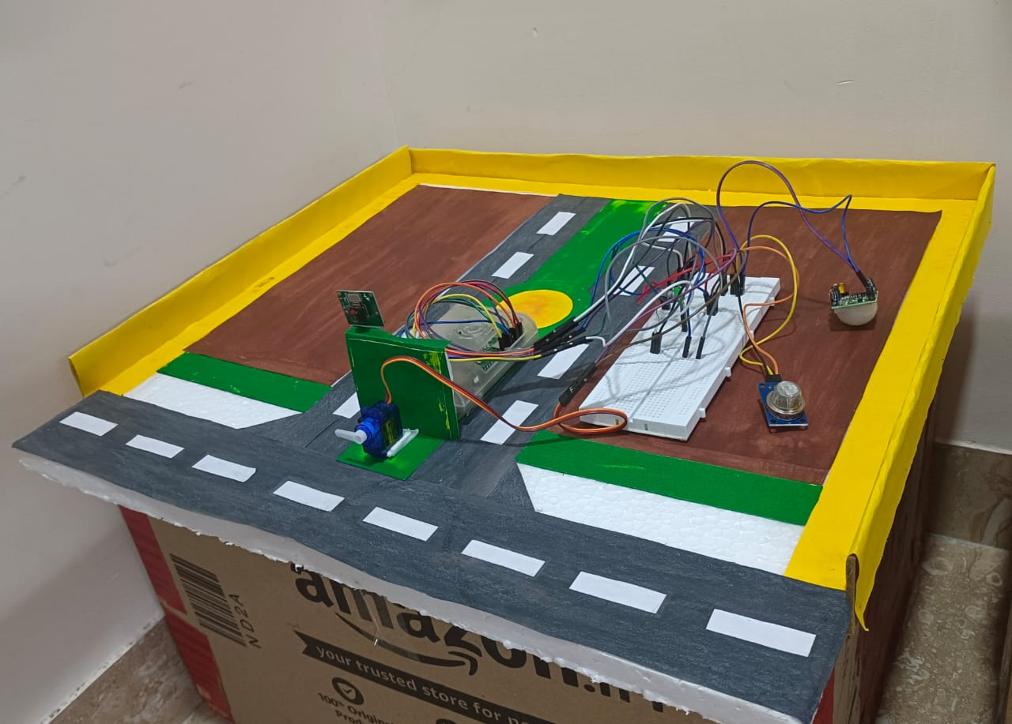

Fig. Prototype Model of the Smart Security System.

Unique features :

* The systems’ operating cost is unimaginably less than the cost of such products in the market.
* Model’s features of securing the owner from any kind of threat be it gas, strangling or direct attack.
* It can be said to be all in one machine as of the various important sensors used in it.
* It can be further, easily enhanced and used in house automation along with security, with minute changes in its programming.
* It is capable of maintaining the records of the entry and exit at the main gate, without any manual assistance.

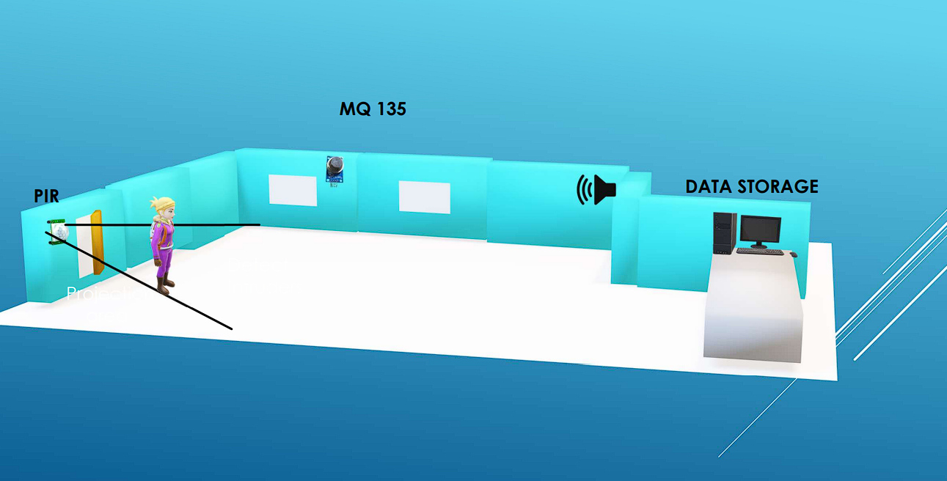

Fig. 3-D model depicting the range and position of all sensors deployed in the room

Origin of the proposal :

This great innovative project was dug out of a rough idea of figuring out ways to use Artificial Intelligence, in securing large residential societies. Further, upon researching the existence of such models, we came across many research papers on this theme, along with some real-use products in the market and then, we set on the journey to know everything about such models, be it their programming languages, software models, authentication machines, the extent of the use of machine learning and artificial intelligence into such systems. We were particular, about making our model very different from the existing ones in terms of user experience, effective readiness of our system, and also cost-efficiency to build the system.

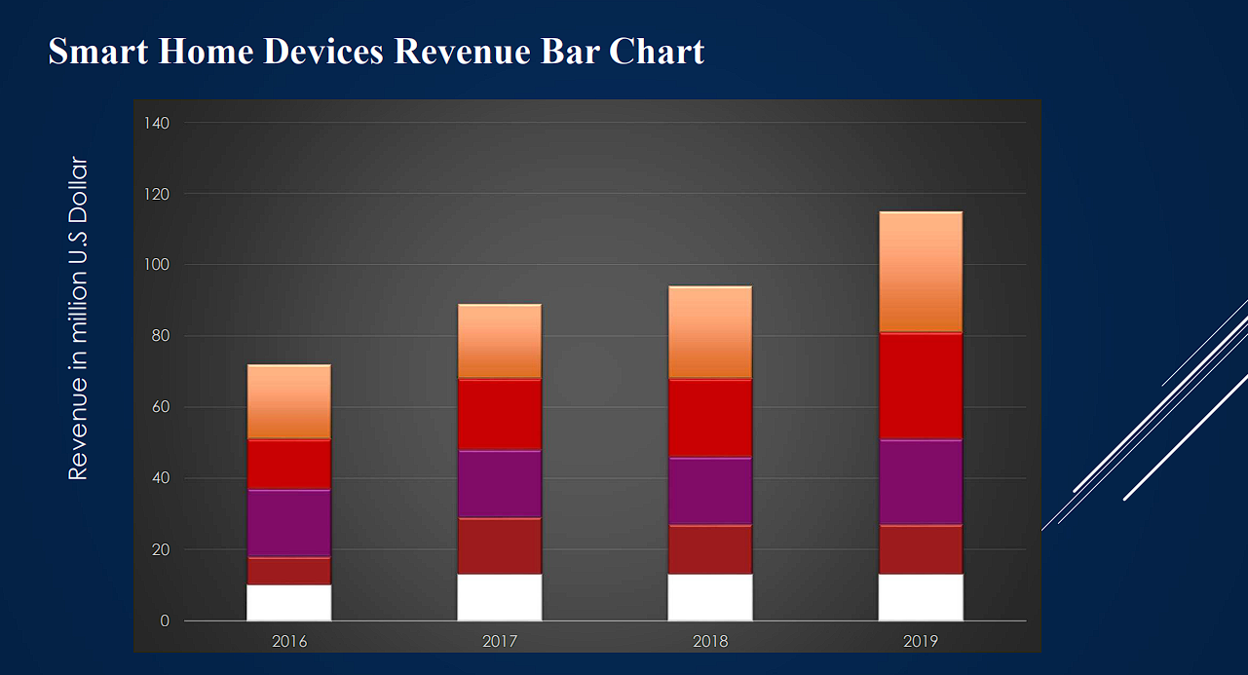

Fig. Bar graph depicting estimated global revenue of companies in this field

Definition of the problem :

Security is a major require of almost everyone in the society. The major challenge is for those with Senior Citizens or infants, as physical security deployment may not always be effective and sure to protect the assigned person. Thus, we came up with the solution of providing security using our system, with full surety to the owners with promise.

The demand for security system with modern technology, is still quite unimaginable for many of us. This greater need of such system made us innovate in this field to meet the supply.

Objectives:

* Secure the owner from any kind of threat perception,
* Systematically, ensuring security in cases of accidents too
* Managing, main gate entry and exit list, with record of unknown persons’ entry along with images of the person while waiting at the main gate
* Ensuring, the theme of sustainable environment by promoting right use of resources
* Providing, immediate medical or police assistance in cases of grieve need, in real time

Review and status of the development and research in the subject :

International References:

Review on Security in Smart Home Development by Rosslin John Robles and Tai hoon kim

Details :

Smart Home is a residence that uses a Home Controller to integrate the residence's various home automation systems. The most popular Home Controllers are those that are connected to a Windows based PC during programming only, and are then left to perform the home control duties on a stand-alone basis. Integrating the home systems allows them to communicate with one another through the home controller, thereby enabling single button and voice control of the various home systems simultaneously, in preprogrammed scenarios or operating modes. Security has been an important issue in the smart home applications. In this paper, they have discussed smart home and security, we also review the tool related to smart home security.

# Design and Implementation of Smart Home Security System by Md. Kamal Hossain and Prodip Biswas.

Details :

It has been seen that the prototype model works without any basic error. So it can be implemented in the practical field. Besides the cost of the project is not too much. Here it has provided utmost security so, it is quite impossible to any burglar to enter the room without concern of owner. If available financial and technical support from the concerned Govt. section and organizations it is found that, then it will be possible to commercialize the proposed lock for the benefit of the people of our country. Some feature has been added to

make the project more efficient. It could be implemented it by GSM based home security system. For this when a burglar enters the room without the concern of owner a sms will be sent to the user. Then it will take precautionary measure. It may be used another technique called biometrics which is more prominent and a recognized means of positive identification. Some new technologies such as fingerprint scanning, retinal scanning and iris scanning, and voiceprint identification also can be inserted. Moreover it could be useful for various sensors such as gas sensor, fire sensor for more improvement of the security of home.

# Enhanced Intelligent Smart Home Control and Security System Based on Deep Learning Model by Olutosin Taiwo,**Absalom E. Ezugwu**,Olaide N. Oyelade, and Mubarak S. Almutairi

Improved convenient living, a healthy lifestyle, comfortability, and home security are areas of interest and development. The elderly, handicapped, and sick need to reduce daily activities that can stress them and negatively impact their health. To end this, a smart home automation system that can facilitate local and global monitoring, control, and safety of the home was developed. This work contributes to the existing research in home automation with the design and development of a multifunctional Android-based mobile application for the smart home automation domain. It has proposed an approach to enhance home security using the CNN deep learning model to classify and detect intruders in the home. The detection is based on the identification of motion in the home environment. Using this method shows that users will have enhanced security of their houses while having minimal disturbance from notifications.

The proposed method intends to eliminate frequent notifications and false notifications in a smart home automation system. The drawback of our proposed method is the detection of multiple movements at a time. The training and classification models were based on the movement of a person at a time.

NATIONAL REFERENCES :

* **"A Smart Security System for Residential Complexes Using Machine Learning"** by researchers at the Indian Institute of Technology Madras. Their paper proposes a smart security system that uses machine learning to identify threats in residential complexes. The system uses cameras to collect data on the activity in a residential complex. This data is then used to train a machine learning model to identify suspicious behavior.
* **"A Smart Security System for Residential Complexes Using IoT"** by researchers at the Indian Institute of Science Bangalore. This paper proposes a smart security system that uses the Internet of Things (IoT) to collect data from a variety of sensors in a residential complex. This data is then used to create a real-time picture of the security situation in the complex.
* **"A Smart Security System for Residential Complexes Using Blockchain"** by researchers at the Indian Institute of Management Ahmedabad. This paper proposes a smart security system that uses blockchain to secure data in residential complexes. The system uses blockchain to create a tamper-proof record of all security events.

These are a few research papers and their work overview on the theme of “Smart Security system for Resedential Complexes”.

Importance :

In current times, the need for smart security system amidst the high vulnerabilities as of rapid growth in technology and innovation is alarming and thereby, calls out a clear need for such efficient and modern solution. Home is regarded to be as comfortable and safe location for anyone, in today’s context, even it is not safe and thus, in-order of such demands, the growth of such devices are rapid. The current market-size of this market is about $4 billion dolars alone, when combined with home automation it is about $55 billion dollar, as per United Nations estimates. Now, the note-worthy aspect of these info is that in this industry there are very few companies working seriously, also there is almost no global market leader from India in this domain. Thus, if we are able to enhance our present model and build up a cost-effficient device, then we can make a remarkable progress.

Work plan methodology :

This research methodology uses, top to bottom approach. Here, we had assumed primarily that there is a need to secure the main entrance of a residential complex, also any building hosting humongous number of people everyday. Then, we gradualy, move up to elevate to theme of round the clock security, for all personal flats. Ensuring this, we could move to home automation part, which is a very exciting arena to invest time. We have in the security, model covered all risks of security that are possible for any attacker.

The basis of model is training machine learning modules to recognize person’s based on saved folders of images to keep record for entry and exit, alongwith monitoring of entry of kind any criminal or anti-social element in your complex or area, and inform the police authorities accordingly for safeguarding the residents. The sensors, placed inside the house have features of initiating warnings in case of their activation upon pre-programmed assesments. The future model, of the project can be build upon this foundation only, using various temperature sensors and RFID techniques for entry into personal flats can be done. It can be also be assessed after conducting surveys around residential socities, for better understanding of improving the working and deployment patterns of some new devices or tools for greater protection alongwith, Home Automation in future scope of this project to make it all rounder for complete and perfect fit for its use case.

Lastly, we also need to assess cyber threats which our model is very vulnerable to. We are to conduct some surveys on possible attacks patterns and finding loopholes in our model to assess and make our system attack proof and proficient to handle our servers in case of any cyber attack.

References :

<https://www.researchgate.net/publication/228416463_A_Review_on_Security_in_Smart_Home_Development>

<https://www.researchgate.net/publication/293173717_Design_and_Implementation_of_Smart_Home_Security_System>

THANK YOU !