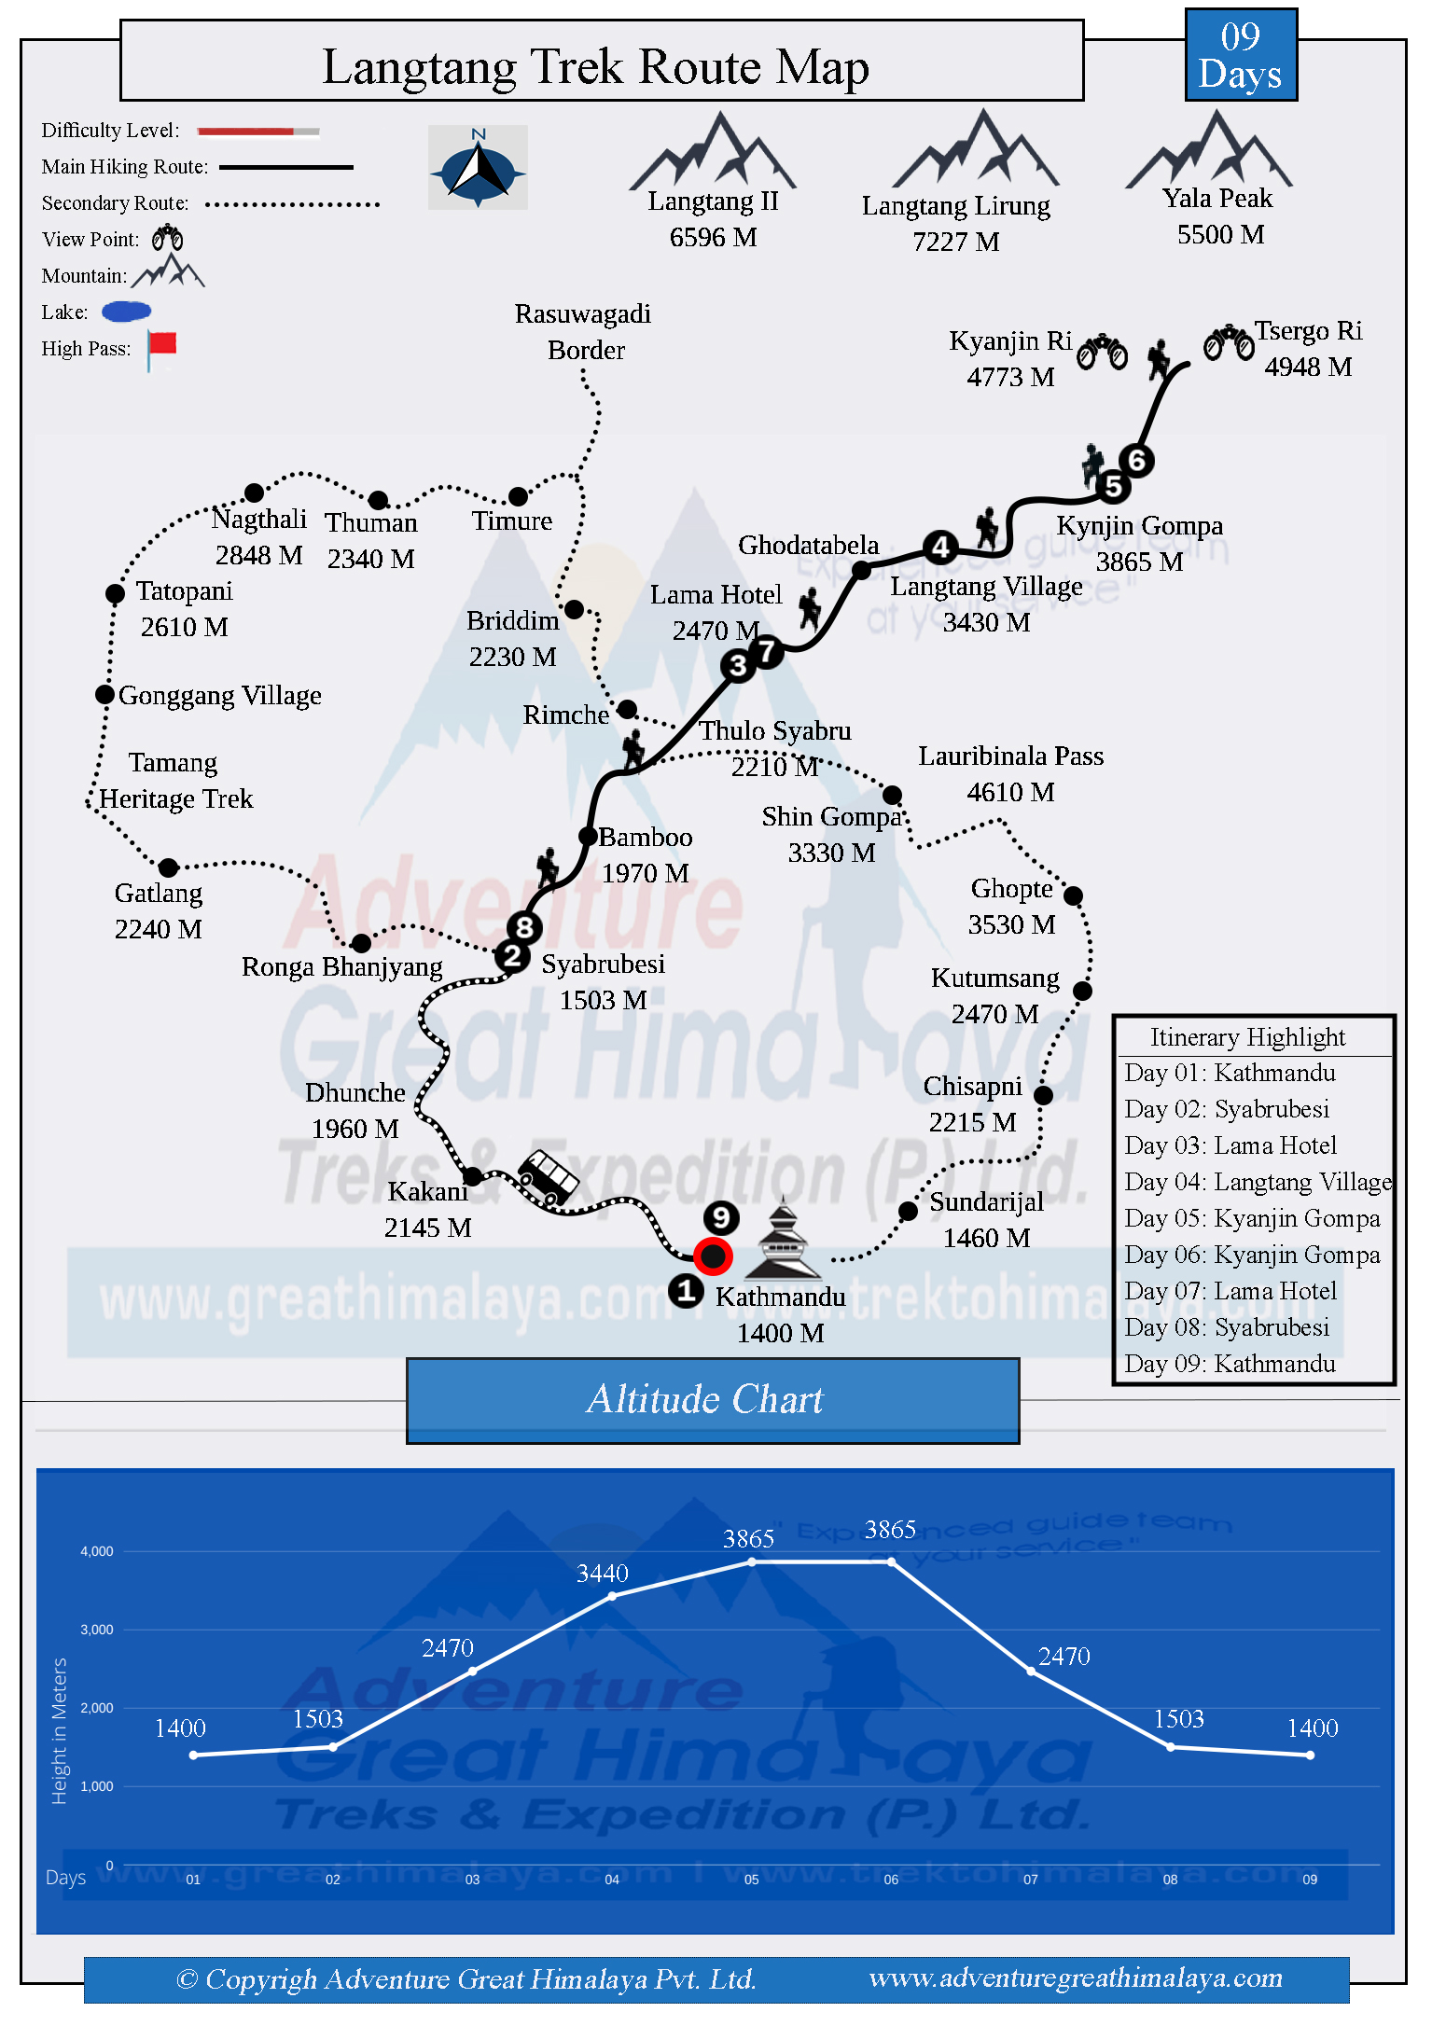

[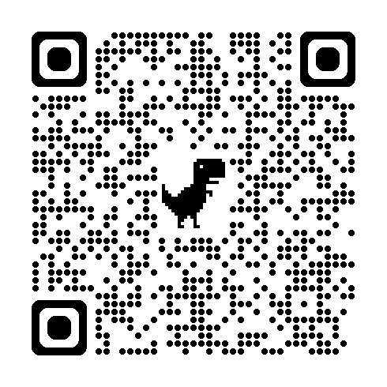](https://www.adventuregreathimalaya.com/wp-content/uploads/Langtang-Trek-Route-Map.jpg)