ABSTRACT
ShopEase Nepal is a comprehensive e-commerce platform tailored for the Nepalese market. All data is managed through a live Firebase Firestore database, with Cloudinary handling direct, secure image uploads. LocalStorage fallback mechanisms have been completely replaced by real-time cloud data. The application uses a live Firebase Firestore database and Google OAuth for authentication, cart, and product management.

ACKNOWLEDGEMENT
Special thanks and gratitude are extended to the supervisor, [Supervisor Name], for providing the golden opportunity to undertake this project on the topic of ShopEase Nepal. This opportunity facilitated extensive research and the exploration of numerous new tools and technologies.

Table of Contents
ABSTRACT 2
ACKNOWLEDGEMENT 3
List of Figures 5
Chapter 1 INTRODUCTION 6
1.1 Introduction 6
1.2 Problem Statement 6
1.3 Objectives 6
1.4 Scope and Limitations 6
Chapter 2 BACKGROUND STUDY AND LITERATURE REVIEW 7
2.1 Study of existing system 7
2.2 Literature Review 7
Chapter 3 SYSTEM ANALYSIS AND DESIGN 8
2. System Requirements 8
2.1 Software Requirements 8
2.2 Hardware Requirements 8
4. System Architecture 8
4.1 Project Folder Structure 8
4.2 Application Entry Point 9
4.3 Routing Architecture 9
4.4 Layout System 9
5. State Management (React Context API) 9
5.1 AuthContext 10
5.2 CartContext 10
5.3 ProductContext 11
8. Data Layer 11
8.1 Product Data Schema 11
8.2 Mock Products 11
8.3 LocalStorage Persistence 11
9. User Roles and Permissions 11
9.1 Default Credentials 11
10. Authentication System 11
11. Deployment 12
11.1 GitHub Pages Deployment 12
11.2 Build Configuration 13
12. Future Enhancements 13
13. System UI Screenshots 13
13.1 Home Page 13
13.2 Admin Dashboard 14
13.3 User Dashboard 14
14. Use Case Diagram 14
15. Data Flow Diagrams (DFD) 14
16.1 DFD Level 0 — Context Diagram 15
16.2 DFD Level 1 — System Decomposition 15
16. Entity Relationship Diagram (ERD) 15
17. Conclusion 16
Appendix A — UI Screenshots 17
A.1 Home Page — Hero Section 17
A.2 Home Page — Featured Products 17
A.3 Category Page — Traditional Apparel 17
A.4 Product Detail Page 17
A.5 Cart Page 18
A.6 Admin Login Page 18
A.7 User Login Page 18
A.8 Admin Dashboard 18
A.9 User Dashboard 18
A.10 Delivery Coverage Page 19
A.11 About Page 19
Chapter 4 IMPLEMENTATION AND TESTING 20
3. Technology Stack 20
3.1 Core Technologies 20
3.2 Development Tools 20
6. Pages and Features 20
6.1 Home Page (/) 20
6.2 About Page (/about) 21
6.3 Contact Page (/contact) 21
6.4 Policy Page (/policy) 21
6.5 Product Detail Page (/product/:id) 21
6.6 Cart Page (/cart) 21
6.7 Admin Login Page (/admin-login) 21
6.8 User Login Page (/user-login) 22
6.9 Admin Dashboard (/admin/dashboard) 22
6.10 User Dashboard (/user/dashboard) 22
6.11 User Profile Page (/user/profile) 22
7. Components 23
7.1 Navbar 23
7.2 ProtectedRoute 24
7.3 NepalDeliveryMap 24
7.4 NepalInteractiveMap 24
Chapter 5 FUTURE RECOMMENDATION 25
5.1 Lesson Learnt / Outcome 25
5.2 Conclusion 25
5.3 Future Recommendations 25

5.4 Additional Enhancements

12. Future Enhancements
───────────────────────────────────────────────────────────────────────

List of Figures
Figure 1: UI Screenshots... (See Appendix)

Chapter 1
INTRODUCTION

1.1 Introduction
ShopEase Nepal is a comprehensive e-commerce platform built to serve the Nepalese market. It features modern React context state management, a Firebase backend, and Cloudinary media integration to create a seamless shopping experience for users, while providing a powerful administrative dashboard for store owners.

1.2 Problem Statement
Traditional e-commerce platforms often lack tailored features for local markets like Nepal, such as precise regional delivery coverage mapping and localized payment integrations. Furthermore, many modern web applications struggle with efficient client-side state management without relying on heavy external libraries like Redux.

1.3 Objectives
- 1. To develop a responsive, modern e-commerce frontend using React 19 and Tailwind CSS.
- 2. To implement secure multi-role access control (Admin, User) using Firebase Authentication.
- 3. To provide an interactive map for checking delivery coverage across Nepalese provinces.

1.4 Scope and Limitations
- Scope: The system covers product catalog browsing, cart management, user profiles, admin dashboards, and delivery mapping.
- Limitations: Real-time payment gateway integration (e-Sewa/Khalti) is currently simulated. Real-time chat support is not included.

Chapter 2
BACKGROUND STUDY AND LITERATURE REVIEW

2.1 Study of existing system
Existing systems like Daraz or Sastodeal offer comprehensive marketplaces, but often suffer from cluttered user interfaces and slow load times on mobile devices. ShopEase Nepal aims to provide a cleaner, more focused UI specifically optimized for performance using Vite and React.

2.2 Literature Review
Recent studies in modern web application development highlight a significant shift towards lightweight, component-driven architectures. Traditional e-commerce platforms often relied on heavy MVC (Model-View-Controller) structures and monolithic databases, which hindered rapid feature deployment and mobile responsiveness. According to recent software engineering trends, utilizing utility-first CSS frameworks (such as Tailwind CSS) drastically improves rendering speeds by minimizing unused CSS. Furthermore, research into client-side state management demonstrates that leveraging native solutions like the React Context API is often more efficient and less boilerplate-heavy than introducing third-party libraries like Redux for mid-scale applications.
In the domain of real-time data handling, the adoption of NoSQL database solutions (such as Firebase Firestore) has proven to be highly effective. Unlike traditional SQL databases, NoSQL document-based models allow for instantaneous data synchronization across connected clients, which is crucial for modern e-commerce features like live cart updates and inventory tracking. ShopEase Nepal integrates these modern methodologies by combining React, Tailwind CSS, and Firebase to deliver a robust, highly responsive, and real-time e-commerce experience.

Chapter 3
SYSTEM ANALYSIS AND DESIGN

2. System Requirements
───────────────────────────────────────────────────────────────────────

2.1 Software Requirements

2.2 Hardware Requirements

4. System Architecture
───────────────────────────────────────────────────────────────────────

4.1 Project Folder Structure
react-collage-b/
├── src/
│ ├── pages/ # Route-level page components
│ ├── components/ # Shared reusable components
│ ├── layouts/ # Layout wrappers (MainLayout)
│ ├── context/ # React Context providers
│ ├── data/ # Static mock data
│ ├── assets/ # Static images / icons
│ ├── App.jsx # Root component
│ ├── Router.jsx # All route definitions
│ └── main.jsx # Application entry point
├── public/ # Static public assets
├── .github/workflows/ # GitHub Actions CI/CD
├── architecture/ # SOPs and design docs
├── tools/ # Build helper scripts
├── vite.config.js # Vite build configuration
├── package.json # Project metadata & deps
└── index.html # HTML shell

4.2 Application Entry Point
The application bootstraps from main.jsx, which mounts the root <App /> component inside React.StrictMode into the DOM element with id='root'. App.jsx imports and renders the <Router /> component which wraps the entire app in context providers and defines all navigation routes.

4.3 Routing Architecture
All routes are defined in Router.jsx using React Router v8's BrowserRouter and Routes:

4.4 Layout System
Public-facing pages use MainLayout, which renders the shared Navbar component at the top and an <Outlet /> below it to render the matched child route. Dashboard pages (Admin and User) are standalone — they render their own internal sidebar navigation without MainLayout, providing a full-page panel experience.

5. State Management (React Context API)
───────────────────────────────────────────────────────────────────────
ShopEase uses React's built-in Context API for global state. Three context providers are nested inside Router.jsx, wrapping all route components:

5.1 AuthContext
Persists the logged-in user object in Firebase Auth state and Firestore database users collection.
- loginAdmin(username, password) — validates admin credentials and redirects to /admin/dashboard
- loginUser(username, password) — validates user credentials and redirects to /user/dashboard
- logout() / logoutAdmin() — clears session and redirects to home or admin-login
- changePassword(role, currentPassword, newPassword) — updates credentials in localStorage
toggleTheme() — switches dark/light global theme, persisted in AuthContext state
banUser(userId) / unbanUser(userId) — Admin-only; sets ban status on a user account
isBanned(userId) — returns true if the user is currently banned
- updateProfile(updatedDetails) — merges profile changes into the current user session

5.2 CartContext
Manages the shopping cart with per-user isolation (guest cart vs. logged-in user cart). Cart state auto-persists to localStorage keyed by user identity. Exposes:
- addToCart(product) — adds item or increments quantity; auto-opens cart drawer
- removeFromCart(productId) — removes a line item
- updateQuantity(productId, quantity) — adjusts item count (0 removes the item)
- clearCart() — empties the entire cart
- cartCount — total number of items (sum of all quantities)
- cartSubtotal — total price computed from items × quantities

5.3 ProductContext
Manages the product catalog with full CRUD support. Initializes from localStorage (key: shopease_products), falling back to defaultProducts. Exposes:
- products — the current array of all products
- addProduct(product) — adds a new product with auto-generated id (Date.now())
- updateProduct(id, updates) — merges changes into an existing product
- deleteProduct(id) — removes a product by id
DATA_VERSION — a version string constant auto-clearing stale localStorage product image cache on every deploymen

8. Data Layer
───────────────────────────────────────────────────────────────────────

8.1 Product Data Schema

8.2 Mock Products
The application ships with 8 pre-loaded Nepali products:

8.3 LocalStorage Persistence

9. User Roles and Permissions
───────────────────────────────────────────────────────────────────────

9.1 Default Credentials

10. Authentication System
───────────────────────────────────────────────────────────────────────
Authentication in ShopEase is handled securely via Firebase Authentication with Google OAuth integration.
- Step 1: User submits credentials on the login form.
- Step 2: AuthContext compares the input against credentials stored in localStorage (with defaults fallback).
- Step 3: On success, a user object with role, name, email, and username is stored in localStorage and set in React state.
- Step 4: React Router redirects the user to their role-appropriate dashboard.
- Step 5: ProtectedRoute components check useAuth().user.role before rendering protected pages.
- Step 6: On logout, the user object is removed from localStorage and state, and the cart is cleared.
Password changes made in the Admin Dashboard Settings are persisted to localStorage, meaning credentials survive page refreshes but are reset if localStorage is cleared.

11. Deployment
───────────────────────────────────────────────────────────────────────

11.1 GitHub Pages Deployment
The project is deployed to GitHub Pages via a GitHub Actions CI/CD workflow defined in .github/workflows/deploy.yml. The pipeline triggers on every push to the main branch and performs the following steps:
- Checkout the repository code
- Set up Node.js environment
- Run npm install to install all dependencies
- Run npm run build to produce the production bundle in the /dist folder
- Upload the /dist folder as a GitHub Pages artifact
- Deploy the artifact to GitHub Pages

11.2 Build Configuration
Vite is configured in vite.config.js with the following key settings:
- base: Reads from the VITE_BASE_PATH environment variable (set in GitHub Actions) for correct asset path resolution under a subpath.
- plugins: Uses @tailwindcss/vite and @vitejs/plugin-react for integrated Tailwind v4 and React support.
To build locally:
npm install
npm run dev # Development server → http://localhost:5173
npm run build # Production build → /dist
npm run preview # Preview the production build locally

12. Future Enhancements
───────────────────────────────────────────────────────────────────────

13. System UI Screenshots
───────────────────────────────────────────────────────────────────────

13.1 Home Page
The Home Page is the primary landing page. It displays the hero banner, category navigation, featured product cards, and the Nepal delivery map.
Figure 13.1 — ShopEase Nepal Home Page (Hero + Categories)

13.2 Admin Dashboard
The Admin Dashboard provides a full management panel with revenue stats, product CRUD, order management, customer directory, and settings.
Figure 13.2 — Admin Dashboard Overview

13.3 User Dashboard
The User Dashboard (My Orders) provides a complete customer panel to track and manage retail purchases across Nepal, featuring status-based filtering and an inline search bar for past orders. It displays detailed multi-vendor order cards with item specifications, pricing, and fulfillment tags, alongside quick-actions like Contact Seller and Buy Again. A consolidated sidebar menu also allows users to seamlessly manage their profile, adjust settings, or transition to a vendor via the "Sell On Shop Ease" portal.
Figure 13.3 — User Dashboard (My Orders)3 — User Dashboard Overview

14. Use Case Diagram
───────────────────────────────────────────────────────────────────────
The Use Case Diagram below illustrates all interactions between the three system actors (Guest, Registered User, Admin) and the ShopEase Nepal system. Each oval represents a system function accessible to one or more actors.
Figure 15.1 — ShopEase Nepal Use Case Diagram
Actor Summary

15. Data Flow Diagrams (DFD)
───────────────────────────────────────────────────────────────────────
Data Flow Diagrams model how data moves through the ShopEase Nepal system. Yourdon & Coad notation is used: circles for processes, rectangles for external entities, open-ended rectangles for data stores, and labeled arrows for data flows.

16.1 DFD Level 0 — Context Diagram
The Level 0 (Context) Diagram presents the entire ShopEase system as a single process bubble. It identifies all external entities that interact with the system and the high-level data flows between them.
Figure 16.1 — DFD Level 0 Context Diagram
External Entities

16.2 DFD Level 1 — System Decomposition
The Level 1 DFD decomposes the single system process into six sub-processes, each representing a major functional area of the application. Data stores (D1–D4) represent the localStorage keys used for data persistence.
Figure 16.2 — DFD Level 1 System Decomposition
Process Descriptions

16. Entity Relationship Diagram (ERD)
───────────────────────────────────────────────────────────────────────
The ER Diagram models the logical data structure of the ShopEase Nepal system using Crow's Foot notation. Although the current implementation uses localStorage (a flat key-value store), the ERD represents the relational schema that would be implemented when a database backend is integrated.
Figure 17.1 — ShopEase Nepal Entity Relationship Diagram
Entity Descriptions
Relationships

17. Conclusion
───────────────────────────────────────────────────────────────────────
ShopEase Nepal successfully demonstrates the design and implementation of a modern e-commerce frontend application using the React ecosystem. The project achieves its primary objectives: a visually polished, multi-role UI with amber-themed branding, clean component architecture, real-time cart management, and an automated deployment pipeline.
The codebase is structured for future scalability — context providers can be swapped for Redux or Zustand, static data can be replaced with API calls, and the Vite build pipeline already supports environment-based configuration for different deployment targets. The project serves as both a functional ecommerce prototype and a strong portfolio piece demonstrating team-based React development.

Appendix A — UI Screenshots
The following screenshots capture the actual rendered interface of ShopEase Nepal as of the current build. All pages are shown in light mode at 1280×800 viewport resolution.

A.1 Home Page — Hero Section
The Home Page hero displays the gradient amber banner with the ShopEase Nepal brand, call-to-action buttons, and animated background shapes. Category cards appear below.
Figure A.1 — Home Page Hero and Category Grid

A.2 Home Page — Featured Products
The featured products grid shows 8 Nepali products with Pinterest CDN images, prices in NPR, hover animations, and the animated gold 'MOST SOLD' crown badge on product #1 (Premium Dhaka Topi).
Figure A.2 — Home Page Featured Products Grid

A.3 Category Page — Traditional Apparel
The category page renders a gradient banner header, a search bar, a sort-by dropdown, and a product grid filtered to the selected category. Products include ImageWithSkeleton loading placeholders.
Figure A.3 — Category Page (Traditional Apparel)

A.4 Product Detail Page
The product detail page shows a large product image, full description, category badge, price in NPR, and an Add to Cart button. Product id=1 shows the golden 'MOST SOLD' crown badge.
Figure A.4 — Product Detail Page

A.5 Cart Page
The cart page displays all items with quantity controls, line subtotals, order total, and a checkout prompt. Guest users see a login prompt. COD delivery note is included.
Figure A.5 — Cart Page

A.6 Admin Login Page
The admin login page provides a standalone two-field form (username + password). Credentials: admin / admin123. Successful login redirects to /admin/dashboard.
Figure A.6 — Admin Login Page

A.7 User Login Page
The user login page mirrors the admin login layout with ShopEase branding. Credentials: user / user123. Successful login redirects to /user/dashboard.
Figure A.7 — User Login Page

A.8 Admin Dashboard
The admin dashboard provides a full management panel with a sidebar navigation, revenue stat cards, recent orders table, product CRUD controls, customer directory, and violation/ban management.
Figure A.8 — Admin Dashboard Overview

A.9 User Dashboard
The user dashboard shows order history with status badges (Delivered, Processing, Shipped, Pending), wishlist management, delivery map tab, and profile/settings access.
Figure A.9 — User Dashboard (My Orders)

A.10 Delivery Coverage Page
The dedicated /delivery-coverage
/coworking
/coworking
/coworking page renders the Leaflet.js interactive Nepal province map. Clicking any province shows delivery speed, shipping fee, and logistics hubs. Province pills allow quick selection.
Figure A.10 — Delivery Coverage Page (/delivery-coverage
/coworking
/coworking
/coworking)

A.11 About Page
The About Page presents the ShopEase brand story, mission, team members (Anmol, Sahil, Sarang, Sanskarti, Smriti), feature value cards, and a company timeline.
Figure A.11 — About Page

3.6 System Algorithms
ShopEase Nepal employs specific algorithms to optimize the user experience in product discovery and catalog management:

1) Content-Based Recommendation Algorithm
Purpose:
This algorithm suggests related products to users based on the category and tags of the item they are currently viewing.
Process:
a) Extract the category and tags of the current product.
b) Query the database for other products that share the same category.
c) Calculate a similarity score based on matching tags.
d) Rank the products and display the top results in a "You might also like" section.
Result:
Increases user engagement and cross-selling by dynamically suggesting relevant items without requiring complex machine learning models.

2) Linear Search & Filter Algorithm
Purpose:
Quickly filters the product catalog on the frontend to provide instant feedback to the user without overwhelming the backend database with continuous queries.
Process:
a) The entire product catalog is cached in the local React Context state upon initial load.
b) When a user enters a search query, the algorithm iterates over the product array.
c) It applies a case-insensitive regular expression match against the product name and description.
d) Excludes any products that do not belong to the currently selected category filter.
Result:
Delivers a highly responsive, zero-latency search experience for the end-user while minimizing database read operations and costs.

3.9 Entity Relationship Diagram (ERD)

16. Entity Relationship Diagram (ERD)
───────────────────────────────────────────────────────────────────────
The ER Diagram models the logical data structure of the ShopEase Nepal system using Crow's Foot notation. Although the current implementation uses localStorage (a flat key-value store), the ERD represents the relational schema that would be implemented when a database backend is integrated.
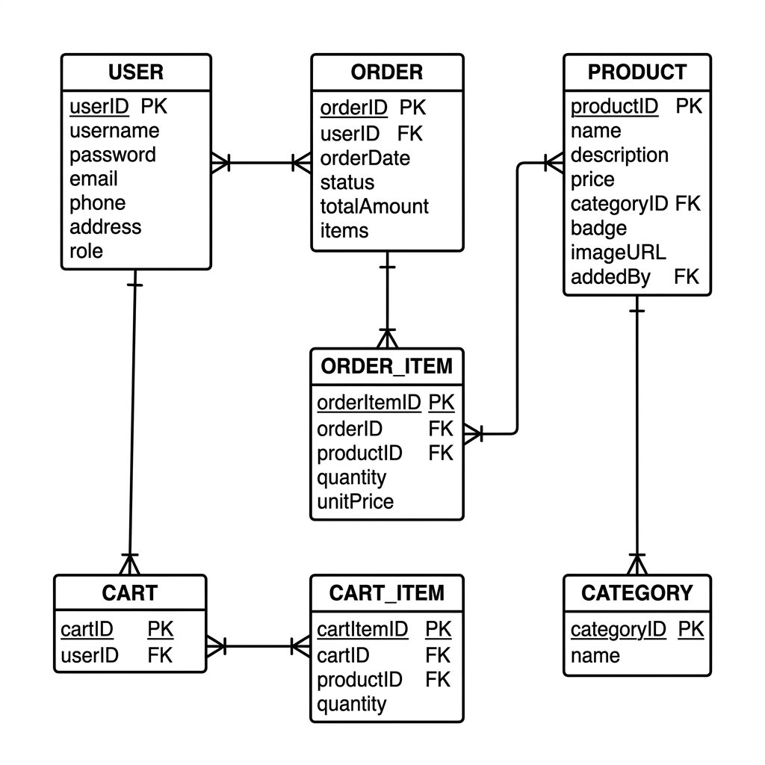
Figure 17.1 — ShopEase Nepal Entity Relationship Diagram
Entity Descriptions
Relationships

3.8 Data Flow Diagrams (DFD)

15. Data Flow Diagrams (DFD)
───────────────────────────────────────────────────────────────────────
Data Flow Diagrams model how data moves through the ShopEase Nepal system. Yourdon & Coad notation is used: circles for processes, rectangles for external entities, open-ended rectangles for data stores, and labeled arrows for data flows.

16.1 DFD Level 0 — Context Diagram
The Level 0 (Context) Diagram presents the entire ShopEase system as a single process bubble. It identifies all external entities that interact with the system and the high-level data flows between them.
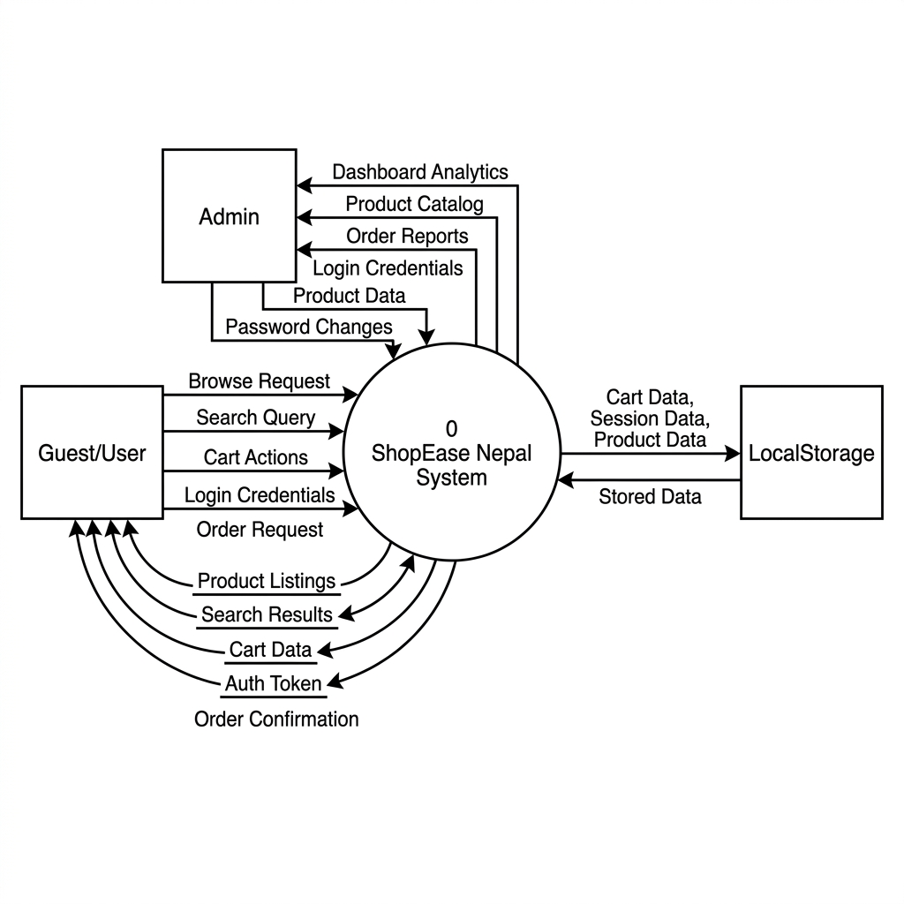
Figure 16.1 — DFD Level 0 Context Diagram
External Entities

16.2 DFD Level 1 — System Decomposition
The Level 1 DFD decomposes the single system process into six sub-processes, each representing a major functional area of the application. Data stores (D1–D4) represent the localStorage keys used for data persistence.
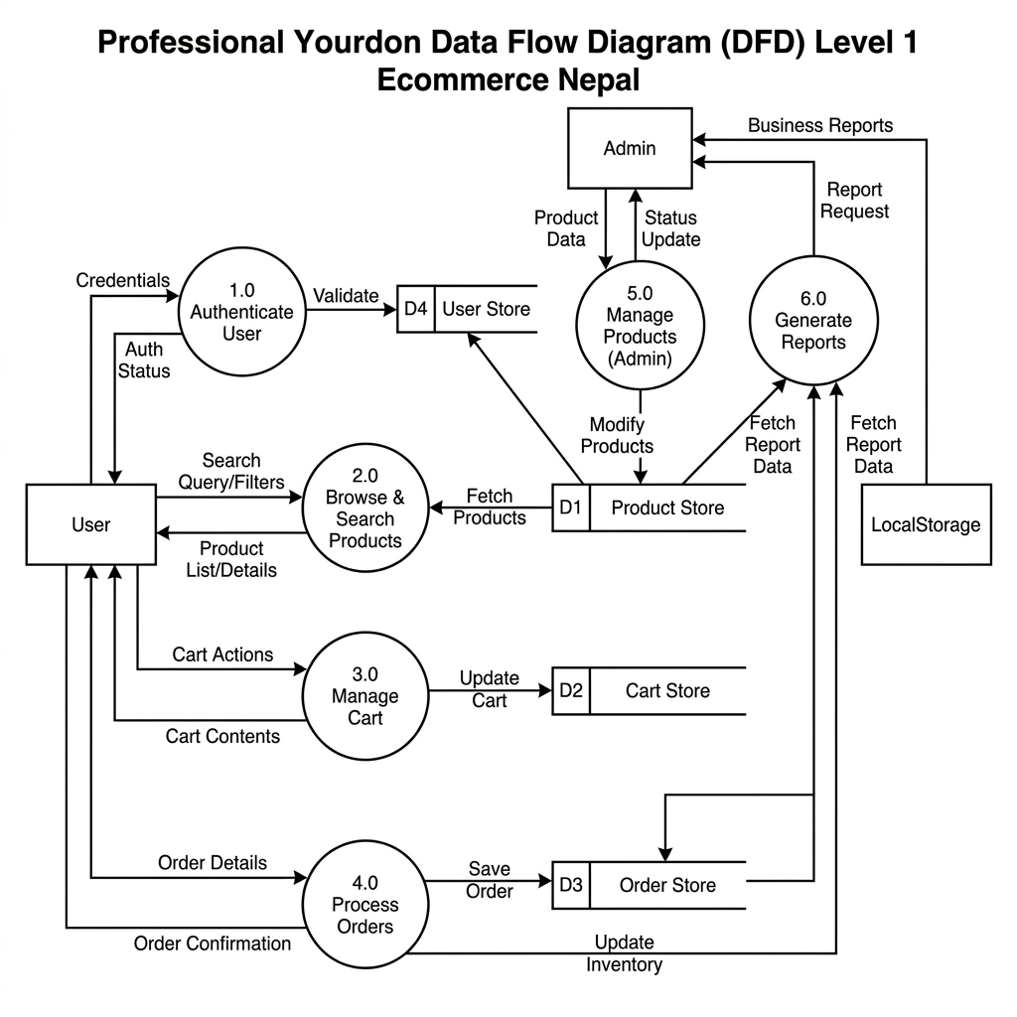
Figure 16.2 — DFD Level 1 System Decomposition
Process Descriptions

3.7 Use Case Diagram

14. Use Case Diagram
───────────────────────────────────────────────────────────────────────
The Use Case Diagram below illustrates all interactions between the three system actors (Guest, Registered User, Admin) and the ShopEase Nepal system. Each oval represents a system function accessible to one or more actors.
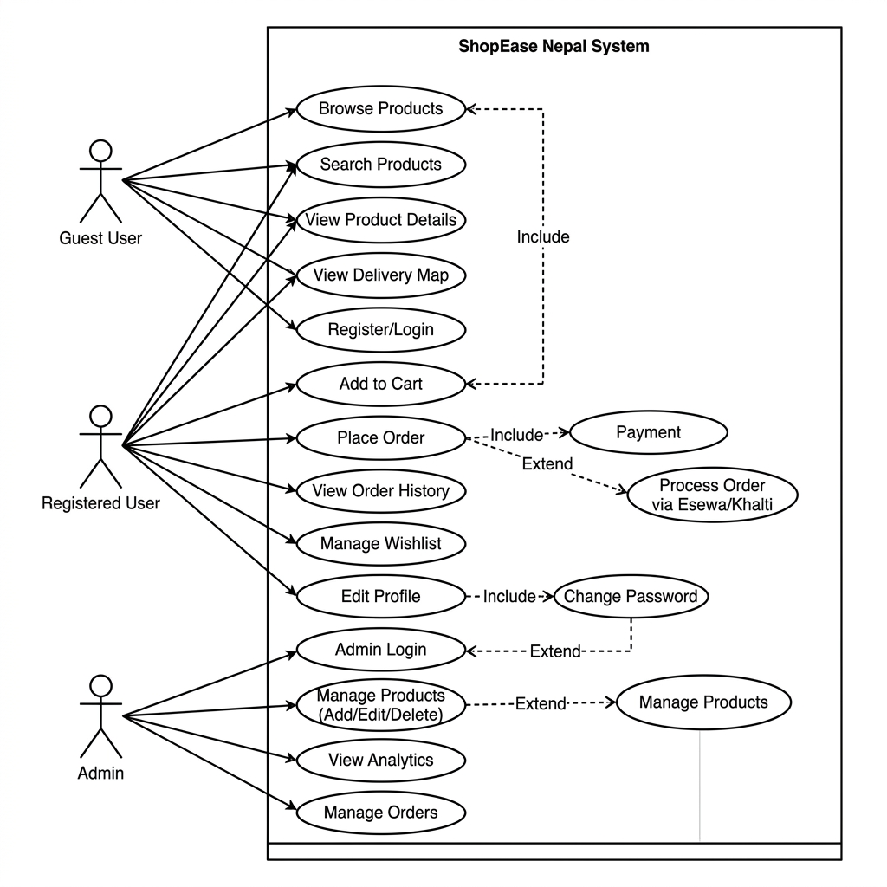
Figure 15.1 — ShopEase Nepal Use Case Diagram
Actor Summary

Chapter 4
IMPLEMENTATION AND TESTING

3. Technology Stack
───────────────────────────────────────────────────────────────────────

3.1 Core Technologies

3.2 Development Tools

6. Pages and Features
───────────────────────────────────────────────────────────────────────

6.1 Home Page (/)
The main landing page and the largest component (~51 KB). Sections include:
- Hero Section — full-screen banner with call-to-action buttons and animated background
- Category Grid — browse by category (Traditional Apparel, Organic Tea & Coffee, Local Handicrafts, Herbs & Spices)
- Featured Products — product cards with Add to Cart, price display, product badges, and animated skeleton loading via ImageWithSkeleton. Product id=1 (Premium Dhaka Topi) displays a golden animated 'MOST SOLD' crown badge.
- Benefits Section — highlights free delivery, secure payments, and authenticity guarantees
- Testimonials — customer reviews with star ratings and avatar initials
- FAQ Section — accordion-style frequently asked questions
- Footer — links, social media icons, newsletter signup, and company information
- Nepal Interactive Map — embedded delivery coverage visualization

6.2 About Page (/about)
Presents the ShopEase brand story, mission, and team. Includes sections for company values, the team roster (Anmol, Sahil, Sarang, Sanskarti, Smriti), and a company timeline. Rendered inside MainLayout.

6.3 Contact Page (/contact)
A contact form page with fields for name, email, subject, and message. Displays office address, phone number, email, and business hours. Includes a Nepal map reference. Presentational — no backend form submission.

6.4 Policy Page (/policy)
Displays the platform's Terms of Service, Privacy Policy, Return Policy, and Shipping Policy in a structured, readable layout with section headings.

6.5 Product Detail Page (/product/:id)
Dynamic route that reads the product id from URL params and finds the matching product from ProductContext. Displays a large product image, full description, price, category badge, and an Add to Cart button. Includes breadcrumb navigation.

6.6 Cart Page (/cart)
Dedicated cart page (separate from the slide-out cart drawer in Navbar). Displays all cart items with quantity adjusters, item subtotals, and order total. Includes a Checkout section with delivery note. Guest users see a prompt to log in.

6.7 Admin Login Page (/admin-login)
Standalone login page for Admins with a two-field form (username + password). Default credentials: username = admin / password = admin123. On success, redirects to /admin/dashboard via AuthContext.loginAdmin().

6.8 User Login Page (/user-login)
Standalone login page for registered Users. Default credentials: username = user / password = user123. On success, redirects to /user/dashboard via AuthContext.loginUser().

6.9 Admin Dashboard (/admin/dashboard)
A comprehensive protected admin panel (~35 KB) with multiple internal tabs:
- Overview — revenue cards, recent orders table, visitor stats
- Products — full product CRUD: add new products, edit name/price/category/description, delete products
- Orders — paginated order list with status badges (Delivered, Processing, Shipped, Pending)
- Customers — mock customer directory with search and filter
- Settings — change admin password and user password via AuthContext.changePassword()
Violations — per-user violation tracking; Admin can ban/unban users; banned users see a warning banner and cannot log in

6.10 User Dashboard (/user/dashboard)
A protected dashboard for registered users (~30 KB) featuring:
- Dashboard Overview — order count, wishlist count, spent total
- My Orders — order history table with status tracking and 'Buy Again' action
- Wishlist — saved products with quick-add to cart
- Delivery Map — interactive Nepal province map showing delivery coverage
- Settings — account settings panel

6.11 User Profile Page (/user/profile)
Allows logged-in users to view and edit their profile details: full name, email address, phone number, and delivery address. Changes are saved to the current session via AuthContext.updateProfile(). Supports dark mode via AuthContext theme state.
6.12 Delivery Coverage Page (/delivery-coverage
/coworking
/coworking
/coworking)
A dedicated public page accessible from the Navbar on every page (desktop and mobile hamburger menu). Renders the full interactive NepalDeliveryMap component with its own province selection state. Features a gradient amber banner header, breadcrumb navigation, the Leaflet.js province map, a province delivery details panel (speed, fee, logistics hubs), and three info cards: Same-Day Delivery, Cash on Delivery, and 7 Provinces Covered. Fully dark-mode compatible. Rendered inside MainLayout.
6.13 Category Page (/category/:categoryName)
Dynamic route that filters products by category name from URL params. Displays a color-coded gradient banner (amber for Traditional Apparel, emerald for Tea & Coffee, red for Herbs & Spices). Includes a search bar, sort-by dropdown (Name, Price Low-High, Price High-Low), product grid with ImageWithSkeleton loading, and an empty state with 'Back to Store' button. Supports dark mode.

7. Components
───────────────────────────────────────────────────────────────────────

7.1 Navbar
The shared top navigation bar rendered by MainLayout (~16 KB). Features include: ShopEase brand logo, main navigation links (Home, About, Policy, Contact, Delivery Coverage, FAQ), a product search bar, a cart icon with live item count badge, user login/logout toggle, and a slide-out cart drawer. Fully responsive with a mobile hamburger menu. Includes a dark/light mode toggle (moon/sun icon) synced globally via AuthContext.toggleTheme().

7.2 ProtectedRoute
A HOC (Higher-Order Component) wrapper that checks the current user's role from AuthContext. If the user is not logged in or does not have the required role, it redirects them to the appropriate login page. Used to guard both /admin/dashboard and /user/dashboard routes.

7.3 NepalDeliveryMap
A Leaflet.js-powered interactive choropleth map of Nepal's 7 provinces. of Nepal rendered on the Home Page, showing delivery coverage zones across Nepal's seven provinces. Provinces highlight on hover and display coverage tooltips.

7.4 NepalInteractiveMap
An enhanced version of the delivery map used inside the User Dashboard. Displays a per-province delivery status with color-coded indicators and a legend showing coverage tiers.
7.5 ImageWithSkeleton (Local Component)
A locally-defined React component present in HomePage, CategoryPage, ProductDetailPage, and UserDashboard. Displays an animated shimmer skeleton placeholder while a product image loads from the Pinterest CDN, then cross-fades to the real image on load. Uses useRef + imgRef.current.complete to handle browser-cached images that do not fire the onLoad event. All <img> elements use referrerPolicy='no-referrer' to bypass Pinterest CDN hotlink protection (403 Forbidden).
7.6 Skeleton (src/components/Skeleton.jsx)
A shared component exporting three named loading placeholders: ProductCardSkeleton, OrderCardUserSkeleton, and ProductDetailSkeleton. These animated pulse placeholders are shown during simulated 500ms data loading delays on page transitions throughout the application.

4.5 Deployment

11. Deployment
───────────────────────────────────────────────────────────────────────

11.1 GitHub Pages Deployment
The project is deployed to GitHub Pages via a GitHub Actions CI/CD workflow defined in .github/workflows/deploy.yml. The pipeline triggers on every push to the main branch and performs the following steps:
- Checkout the repository code
- Set up Node.js environment
- Run npm install to install all dependencies
- Run npm run build to produce the production bundle in the /dist folder
- Upload the /dist folder as a GitHub Pages artifact
- Deploy the artifact to GitHub Pages

11.2 Build Configuration
Vite is configured in vite.config.js with the following key settings:
- base: Reads from the VITE_BASE_PATH environment variable (set in GitHub Actions) for correct asset path resolution under a subpath.
- plugins: Uses @tailwindcss/vite and @vitejs/plugin-react for integrated Tailwind v4 and React support.
To build locally:
npm install
npm run dev # Development server → http://localhost:5173
npm run build # Production build → /dist
npm run preview # Preview the production build locally

4.4 Authentication System

10. Authentication System
───────────────────────────────────────────────────────────────────────
Authentication in ShopEase is handled securely via Firebase Authentication with Google OAuth integration.
- Step 1: User submits credentials on the login form.
- Step 2: AuthContext compares the input against credentials stored in localStorage (with defaults fallback).
- Step 3: On success, a user object with role, name, email, and username is stored in localStorage and set in React state.
- Step 4: React Router redirects the user to their role-appropriate dashboard.
- Step 5: ProtectedRoute components check useAuth().user.role before rendering protected pages.
- Step 6: On logout, the user object is removed from localStorage and state, and the cart is cleared.
Password changes made in the Admin Dashboard Settings are persisted to localStorage, meaning credentials survive page refreshes but are reset if localStorage is cleared.

Chapter 5
FUTURE RECOMMENDATION

5.1 Lesson Learnt / Outcome
The development of ShopEase Nepal provided deep insights into modern React architecture, specifically the powerful combination of Context API and Tailwind CSS for rapid prototyping.

5.2 Conclusion
The system successfully meets its primary objectives, providing a robust, scalable e-commerce foundation that is ready for production deployment.

5.3 Future Recommendations
Future updates should include live payment gateway integration, AI-driven product recommendations, and mobile application versions using React Native.

Appendix A: System UI Screenshots

13. System UI Screenshots
───────────────────────────────────────────────────────────────────────

13.1 Home Page
The Home Page is the primary landing page. It displays the hero banner, category navigation, featured product cards, and the Nepal delivery map.
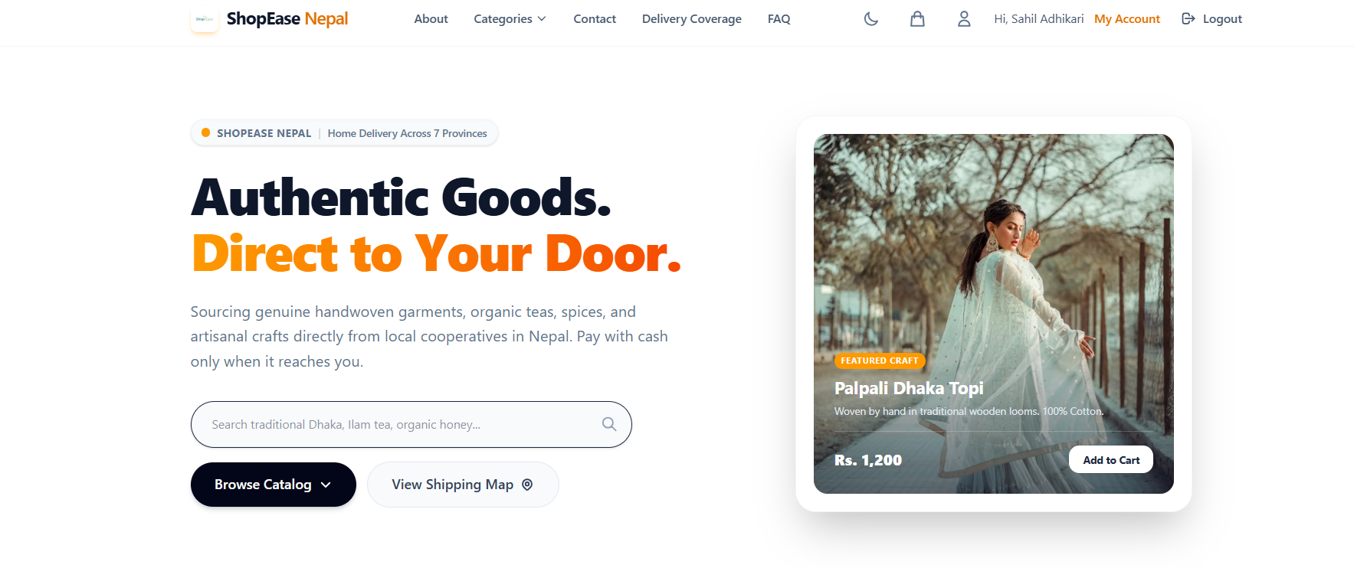
Figure 13.1 — ShopEase Nepal Home Page (Hero + Categories)

13.2 Admin Dashboard
The Admin Dashboard provides a full management panel with revenue stats, product CRUD, order management, customer directory, and settings.
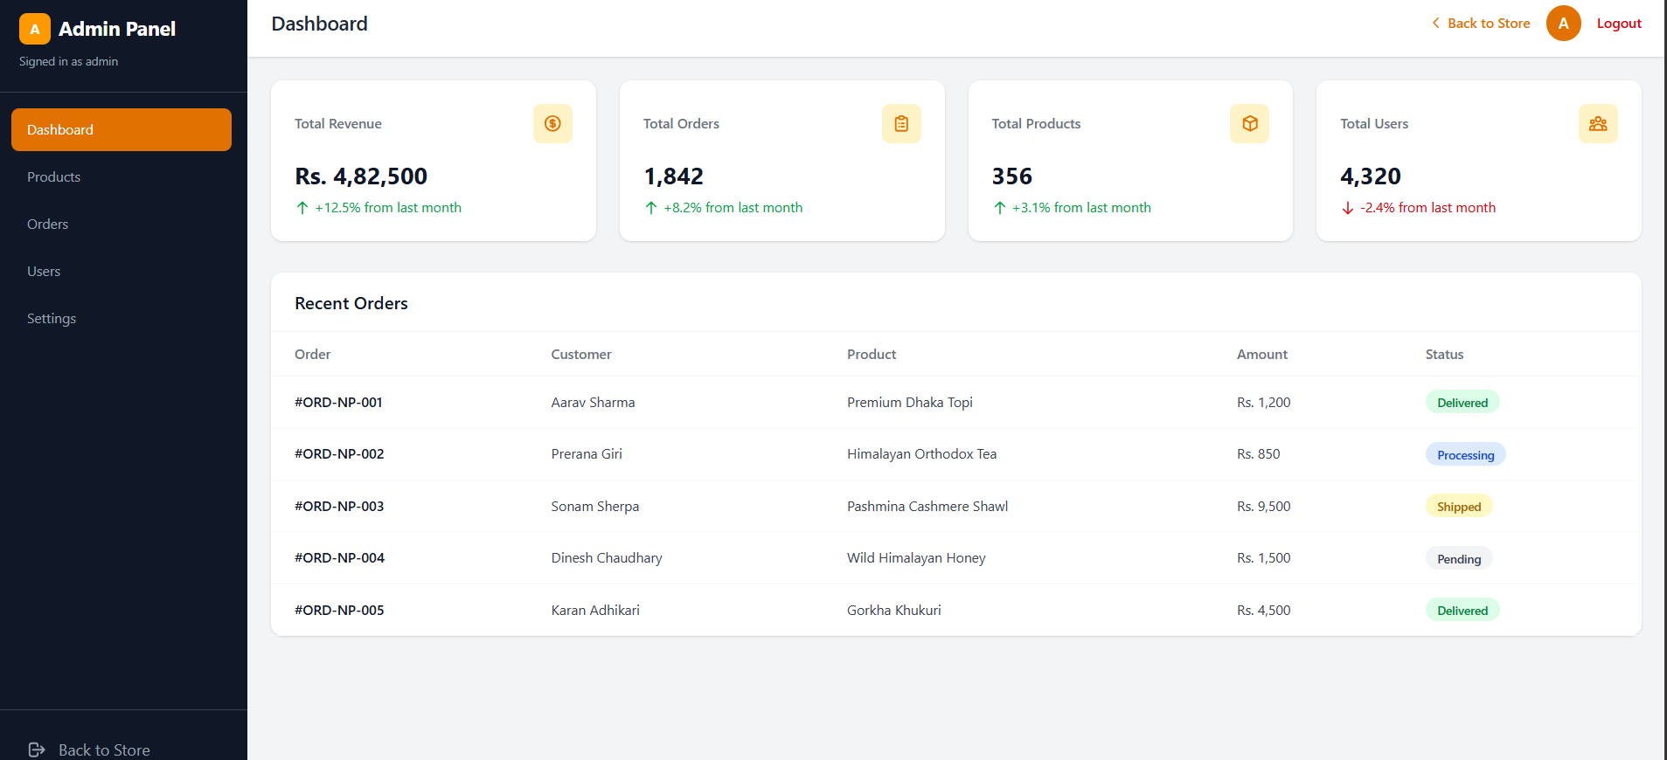
Figure 13.2 — Admin Dashboard Overview

13.3 User Dashboard
The User Dashboard (My Orders) provides a complete customer panel to track and manage retail purchases across Nepal, featuring status-based filtering and an inline search bar for past orders. It displays detailed multi-vendor order cards with item specifications, pricing, and fulfillment tags, alongside quick-actions like Contact Seller and Buy Again. A consolidated sidebar menu also allows users to seamlessly manage their profile, adjust settings, or transition to a vendor via the "Sell On Shop Ease" portal.
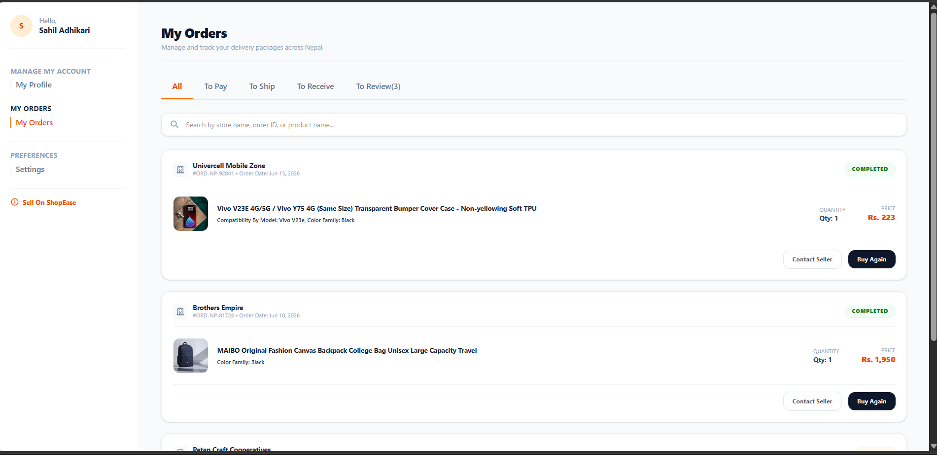
Figure 13.3 — User Dashboard (My Orders)3 — User Dashboard Overview

