Anmol Chhetri
Butwal, Nepal | +977 9748809637
ambassador.anmol@nicnepal.org
https:// www.linkedin.com/in/anmolchhetri

Date: February 17, 2026

To,
The Hostmaster
Mercantile Communications Pvt. Ltd.
Durbar Marg, Kathmandu
Nepal

Subject: Request for Registration of anmol.info.np

Dear Sir/Madam,

I am writing to kindly request the registration of the domain anmol.info.np for my personal website. As required for .np domain registration, I have attached a copy of my citizenship for verification.

The domain name corresponds to my full legal name, making it suitable for personal use under the .com.np category. I intend to use this domain to host my personal website, which will help me present my professional profile, portfolio, and future projects. I understand the guidelines for .np domain registration and have ensured that all required information and documents are complete

I would sincerely appreciate your kind approval of my request. Thank you very much for your time and kind consideration.

Sincerely,
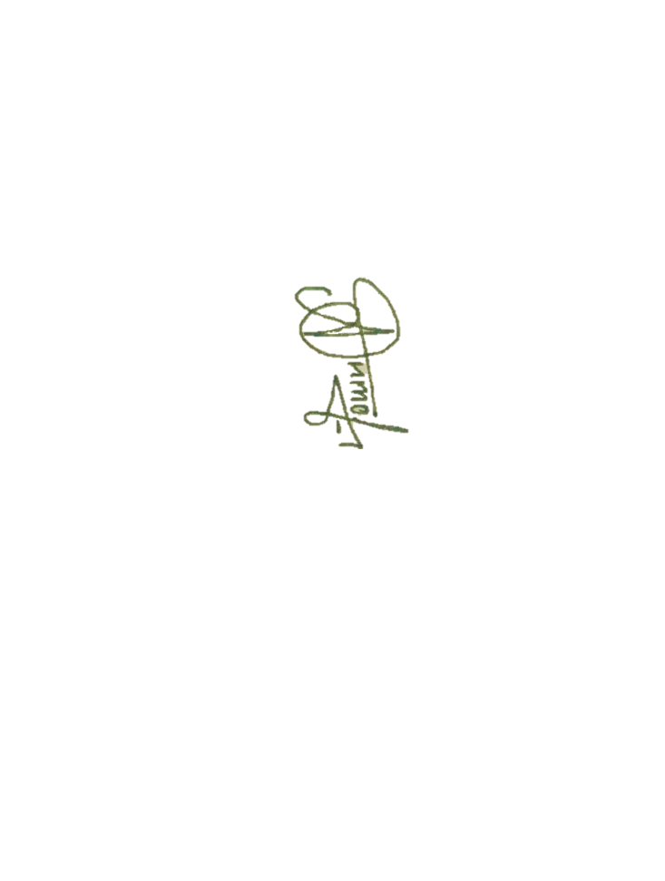
Anmol Chhetri

