Department of Artificial Intelligence and Machine Learning
 | Test -1 –Scheme and Solution | Max. Marks: 50+10
Semester: V | UG | Duration: 1 $\frac{1}{2}$ Hrs + ½ Hr
Course Title: Artificial Neural Networks and Deep Learning |  | Course Code: AI253IA
Part A
Sl No | Questions | M | BT | CO
 | A perceptron has weights $w_{1}=0.4, w_{2}=and -0.2, b=0.1$. For input $x_{1}=1, x_{2}=0$, compute the net input and output (step activation).  0.5 and 1 | 1 | 3 | 1
 | Compute the output of a sigmoid neuron if $net=0.8$.  0.6900 | 1 | 2 | 1
 | The learning rate (η) is a positive scalar that scales weight updates during training (how big a step we take in parameter space).  If η is too large training may diverge or oscillate; if too small convergence is very | 1 | 2 | 2
 | 0.5,1.05, 2.10 | 2 | 4 | 2
 | Can learn nonlinearly separable functions (hidden layers let them combine features to solve problems single-layer perceptrons cannot, e.g., XOR).Can approximate complex mappings (universal approximation for continuous functions) and learn hierarchical features. | 2 | 3 | 1
 | 11 | 2 | 3 | 1
 | Sequential (online): update weights after each training example — faster immediate updates, introduces noise that can help escape local minima.  Batch: accumulate errors/gradients over the whole training set and update weights once per epoch — smoother, more stable gradient estimate but needs more memory and slower per-epoch updates. | 1 | 2 | 2

Part B
Sl No | Questions | M | BT | CO
1a. | 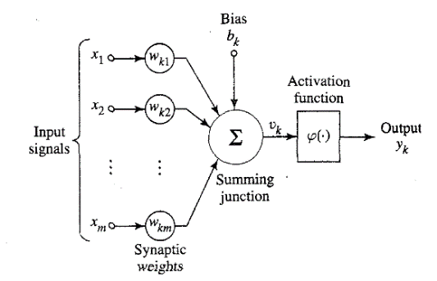 - 2M, Explanation -2M | 04 | 2 | 1
1b. | Bias (b) Net Input Sigmoid Output Observation  0.1 0.7 0.668 Normal activation -3M  0.5 1.1 0.750 Higher bias → higher output-3M | 06 | 3 | 1
2a. | Learning Rule Basic Principle Weight Update Formula (Conceptual) Type of Learning Key Features Practical Example  Hebbian Learning “Neurons that fire together, wire together.” — strengthens connections between simultaneously active neurons. Δw = η·x·y (where x = input, y = output) Unsupervised Reinforces correlations between inputs and outputs; no error or teacher signal. Associative memory (e.g., pattern storage in Hopfield networks).  Competitive Learning Neurons compete; only one (winner) neuron updates its weights toward the input (Winner-Takes-All). Only winning neuron’s weights updated: Δw = η·(x − w) Unsupervised Promotes specialization — neurons become tuned to different input patterns or clusters. Clustering / Self-Organizing Maps (Kohonen networks)  Error-Correction Learning Adjusts weights to minimize the difference (error) between desired and actual outputs. Δw = η·(d − y)·x Supervised Uses a teacher signal; aims to reduce prediction error; basis for backpropagation. Perceptron / MLP training for classification or regression | 05 | 3 | 2
2b | Quantity Expression Value  Output (y) ( w^T x ) −0.7  Error (e) ( d - y ) 3.7  Updated Weights ( w + η e x ) [0.685, −0.23] | 05 | 4 | 2
3 | Explain the Perceptron Learning Algorithm with its update rule and convergence theorem. Why does the perceptron fail for non-linearly separable problems?
4 | 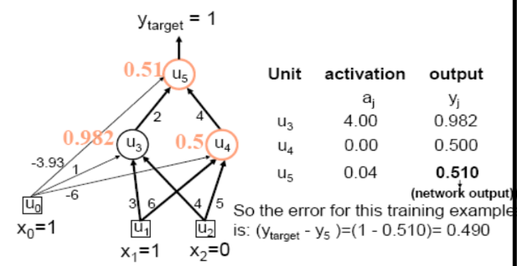  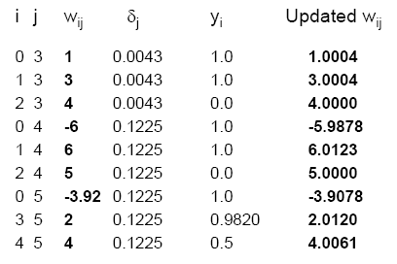  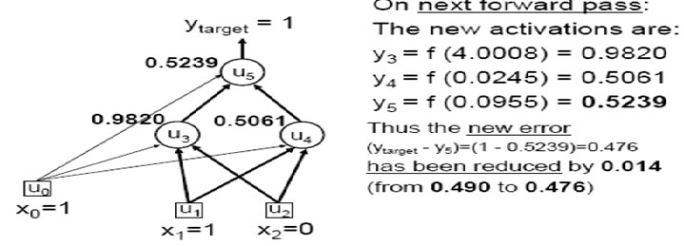 | 14 | 4 | 3
5 | 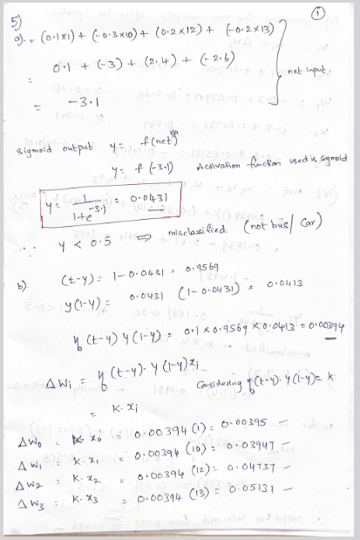  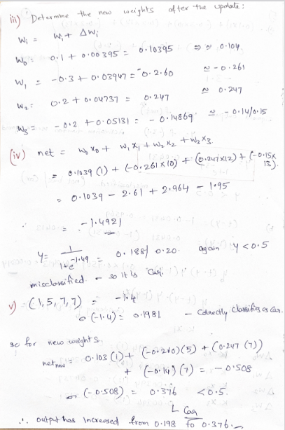 | 10 | 4 | 2
M-Marks, BT-Blooms Taxonomy Levels, CO-Course Outcomes
Marks Distribution | Particulars | CO1 | CO2 | CO3 | CO4 | CO5 | L1 | L2 | L3 | L4 | L5 | L6
 | Max Marks CIE | 16 | 30 | 14 | - | - | - | 13 | 16 | 31 | - | -

