**SEVAK**

1. **Team Name** – SEVAK  
   **Team Leader’ name** – Mr. A.Shanmuka Sai  
   **Team Leader’ email id** – [shanmuk398@gmail.com](mailto:shanmuk398@gmail.com)
2. **Solution Brief Overview** –

Our idea is about, In the COVID 19 pandemic situation, the people with sensitive health issue may face some adverse issues if they don’t get to know the situation of their case which may be dangerous to their life, as in case of this pandemic there is a great issue of mobility. To help them, a mobile CHATBOT application is proposed, so the patient can contact the case specialist and letting him know about the symptoms they can get to know the severity of the case, which avoids panicking among them which may degrade their condition more to avoid this kind of situations through an app, we can connect the user to the near doctor who is specialized in a particular case.

To develop the proposed CHATBOT application, IBM services like Watson Assistant, Slack app, and HERE location services are used. IBM Watson Assistant is used to build, train, and deploy conversational interactions. The proposed CHATBOT plays a vital role in helping people with sensitive health cases.

1. **Working Model** - <https://youtu.be/W6yYTXl2VxQ>
2. **Solution description**-

To implement, the idea, IBM services like Watson Assistant, Slack app, and in addition external source HERE location services are used to develop an application for people with sensitive health issues. Here we have created a CHATBOT that is used to provide communication between User and the Case Specialist(Doctor). The conversion process is like if the user type HELLO then it responds like Hi, the NIRDESHI CHATBOT replies how can I help you. if the user needs Doctor Appointment, the user can text, I need Doctor Appointment then it responds Select case category. so in this CHATBOT where the response is given according to the intents, entities and dialogues which are imported in the chat-bot. so this is how the communication process goes on in the chat-bot. Firstly we have to Log in to an IBM cloud then by creating a Watson Assistant, imported intents i.e input given by the user, entities nothing but output given by the CHATBOT and then go to the dialog by adding nodes in that and the CHATBOT is ready for the communication between user and Case specialist. After that Preview the link to copy and run the application. Through this proposed application the user can get to know the severity of their case and can know whether they should visit the hospital for a physical appointment or simple medication can regulate their health. This application is easy to operate as it uses the chat-bot. It also simple to get the info of their case severity by letting the doctor know about their symptoms. It can also get to know the tests to be done to know the severity of the case

1. **Solution Architecture-**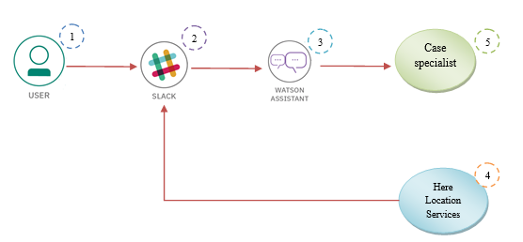

In the solution architecture, IBM services like Watson Assistant, Slack App, and HERE location services are used to develop CHATBOT to help families of front line warriors.

* 1. Watson Assistant uses natural language understanding and machine learning to extract entities and intents of the user question.
  2. The Slack Application calls Watson Assistant hosted in IBM Cloud.
  3. It communicates with the user for specifying the details like case category, patient details, location details.
  4. Location services connected with slack identifies the case specialist near to the user
  5. The available case specialist’s details like the location of his/her hospital and mobile number are allocated to the user

1. **IBM Cloud Services/Systems** – The List of IBM Services used in this solution
   1. IBM Watson Assistant
   2. Slack Application
   3. HERE Location Services