**Program 1**

**Aim: Write a python program to perform arithmetic operation of two integers.**

**Source Code:**

"""

Created on Tue Feb 6 09:16:43 2024

@author: it2117

"""

a=int(input("Enter a value: "))

b=int(input("Enter b value: "))

c=a+b

d=a-b

e=a*b

f=a/b

g=a%b

print("Addition is: ",c)

print("subraction is: ",d)

print("Multiplication is: ",e)

print("Division is: ",f)

print("Modulodivision is: ",g)

**OUTPUT:**

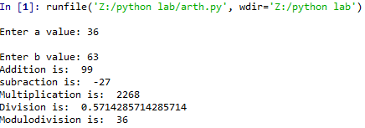

**Program-2**

**Aim: Write a python program to print the biggest number among the three numbers.**

**Source Code:**

"""

Created on Tue Feb 6 09:34:05 2024

@author: it2117

"""

a=int(input("Enter a value: "))

b=int(input("Enter b value: "))

c=int(input("Enter c value: "))

if a>b and a>c:

print("{} is big".format(a))

elif b>a and b>c:

print("{} is big".format(b))

else:

print("{} is big".format(c))

**Output:**

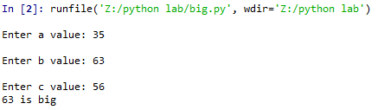

**Program-3(Natural numbers)**

**Aim: Write a python program to print first 10 natural numbers.**

**Source Code:**

"""

Created on Tue Feb 6 09:45:10 2024

@author: it2117

"""

i=1

print("10 Natural numbers are")

while(i<=10):

print(i,end=" ")

i=i+1

**Output:**



**Program-4(Multiplication table)**

**Aim: Write a python program to print multiplication table for first 10 numbers.**

**Source Code:**

"""

Created on Tue Feb 6 09:50:18 2024

@author: it2117

"""

n=int(input("Enter n value"))

i=1

print("multiplication table of {} is".format(n))

while(i<=10):

print("{}*{}={}".format(n,i,n*i))

i=i+1

**Output:**

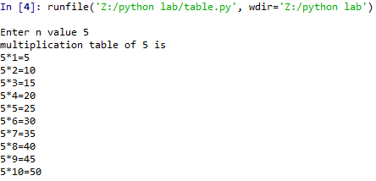

**Program-5(Factorial)**

**Aim: Write a python program to find a factorial of a number.**

**Source Code:**

"""

Created on Tue Feb 6 09:55:18 2024

@author: it2117

"""

n=int(input("Enter n value"))

fact=1

i=1

print("Factorial of {} is".format(n))

while i<=n:

fact=fact*i

i=i+1

print(fact)

**Output:**

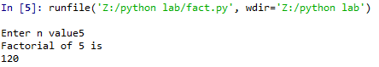

**Program-6(Prime)**

**Aim: Write a python program to check whether the given number is prime or not.**

**Source Code:**

"""

Created on Tue Feb 13 07:36:57 2024

@author: it2117

"""

n=int(input("Enter a value for n: "))

count=0

i=1

while i<=n:

if(n%i==0):

count=count+1

i=i+1

if count==2:

print("{} is prime".format(n))

else:

print("{} not a prime".format(n))

**Output:**

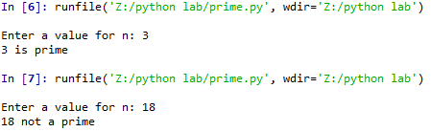

**Program-7(Fibonacci)**

**Aim: Write a python program to generate Fibonacci series up to n terms.**

**Source Code:**

"""

Created on Tue Feb 13 07:42:25 2024

@author: it2117

"""

n=int(input("Enter a value for n: "))

a,b=0,1

result=[0]

for i in range(n-1):

result.append(b)

a,b=b,a+b

print("result is: ",result)

**Output:**

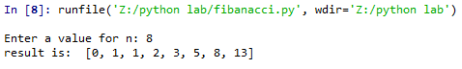

**Program-8(List)**

**Aim: Write a python program to ask the user to enter a list of integers separated by spaces then convert this into a list of integers but square of each element, Finally print the list.**

**Source Code:**

"""

Created on Tue Feb 13 07:59:13 2024

@author: it2117

"""

list=[ ]

n=input("Enter list of integers separated by spaces: ")

s=n.split(" ")

print(s)

for i in s:

j=int(i)

list.append(j*j)

print(list)

**Output:**

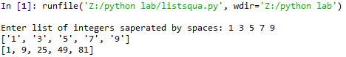

**Program-9(Ascending order)**

**Aim: Write a python program to ask the user to enter list of strings separated by spaces and convert this into a list of characters split the list in ascending order and eliminate repeated one.**

**Source Code:**

"""

Created on Tue Feb 13 08:07:51 2024

@author: it2111

"""

n=input("enter any string:")

n.split(" ")

l=list(n)

print("before sorting the list",l)

l.sort()

print("after sorting the list:",l)

k=set(l)

a=list(k)

print("after eliminating the duplicates",a)

**Output:**

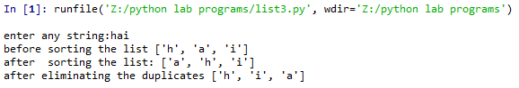

**Program-10(Descending order)**

**Aim: Write a python program to ask the user to enter list of strings separated by spaces and convert this into a list of characters split the list in descending order and eliminate repeated one.**

**Source Code:**

"""

Created on Tue Feb 13 08:16:41 2024

@author: it2117

"""

n=input("Enter list of strings saperated by spaces: ")

l=n.split(" ")

print("Before sorting the list is: ",l)

l.sort(reverse=True)

print("After sorting the list is: ",l)

**Output:**

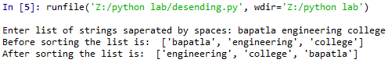

**Program-11(Tuples)**

**Aim: Write a python program to ask the user to enter the list of integers separated by spaces convert this into a list of integers but square each element. Store the integer in a tuple, put this into a list and print the list.**

**Source Code:**

"""

Created on Tue Feb 13 09:22:53 2024

@author: it2117

"""

list=[ ]

n=input("Enter list of integers saperated by spaces: ")

s=n.split(" ")

print("Integers after spliting are: ",(s))

for i in s:

j=int(i)

list.append((j,j*j))

print("Squares in a tuple are: ",list)

**Output:**

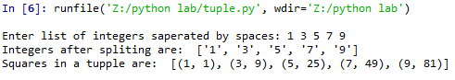

**Program-12(Dictionary)**

**Aim: Write a python program to ask the user for a list of integers separated by spaces for each integer, store the string version as the key and the square of the integer value as the value in a dictionary. Print the resulting dictionary.**

**Source Code:**

"""

Created on Tue Feb 20 07:46:13 2024

@author: it2117

"""

l=input("Enter list of integers separated by spaces: ")

list=l.split(" ")

d={}

for i in list:

d[i]=int(i)*int(i)

print("The dictionary is: ",d)

**Output:**



**Program-13**

**Aim: Write a python program to read 5 student registration number, percentage and append them into dictionary then display it.**

**Source Code:**

"""

Created on Tue Feb 20 07:35:18 2024

@author: it2117

"""

i=1

d={}

n=int(input("Enter how many students you want to read: "))

for i in range(0,n):

print("Enter {} student regno,name: ".format(i+1))

r=input()

m=input()

d[r]=m

print("The given student details: ",d)

**Output:**

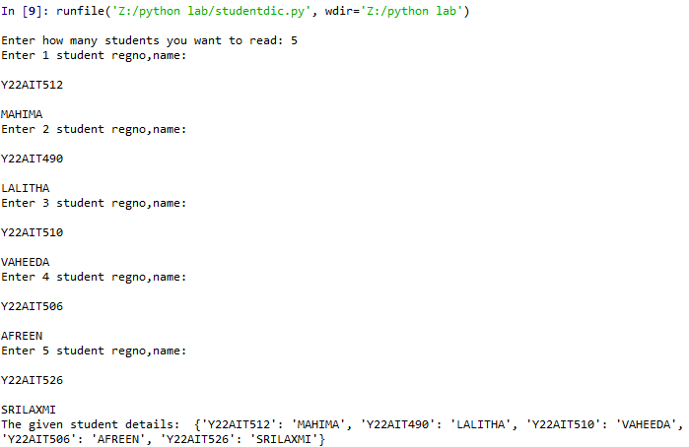

**Program-14(Strings)**

**Aim: Write a python program to ask user to enter a string, convert this to lower case count the no. of occurrences of each character in the string then print the result in sorted order of the characters.**

**Source Code:**

"""

Created on Tue Feb 27 07:38:18 2024

@author: it2117

"""

d={}

s=input("Enter a string: ").lower()

for i in s:

if i in d:

d[i]+=1

else:

d[i]=1

for i in sorted(d):

print("Sorted order is: ",i,d[i])

**Output:**

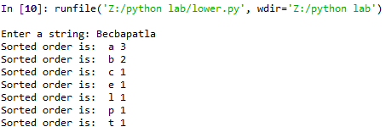

**Program-15**

**Aim: Write a python program to read a string from keyboard then print the following:**

**i) Without 1st character. ii) String without last character.**

**iii) String in reverse. iv) Every alternate character of a string starting from the list.**

**Source Code:**

"""

Created on Tue Feb 20 07:51:07 2024

@author: it2117

"""

name=input("Enter a string: ")

print(name[1: ])

print(name[ :-1])

print(name[ ::-1])

print(name[ ::2])

**Output:**

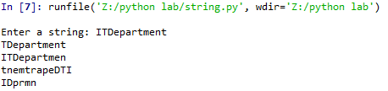

**Program-16**

**Aim: Write a python program to ask the user to enter two integers, one each line say x and y. if x is larger than y print “first” store the value w of x in a variable highest. If y is larger than x print “second” ,store the value of y in variable highest. If they are equal print “same”. Store either as the highest finally print the square the highest.**

**Source Code:**

"""

Created on Tue Feb 20 08:47:32 2024

@author: it2117

"""

x=int(input("Enter a value for x: "))

y=int(input("Enter a value for y: "))

if x>y:

print("First")

highest=x

elif y>x:

print("Second")

highest=y

else:

print("same")

highest=x

print("Highest value is: ",highest)

print("Square of highest is: ", highest*highest)

**Output:**

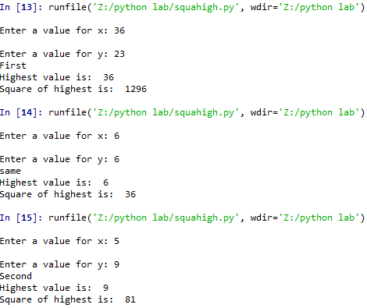

**Program-17(Palindrome)**

**Aim: Write a python program to read a string from keyboard and check whether the string is palindrome or not.**

**Source Code:**

"""

Created on Tue Feb 20 09:09:53 2024

@author: it2117

"""

n=input("Enter a string: ")

print("The given string is: ",n)

r=n[ ::-1]

if n==r:

print("The string is palindrome")

else:

print("The string is not a palindrome")

**Output:**

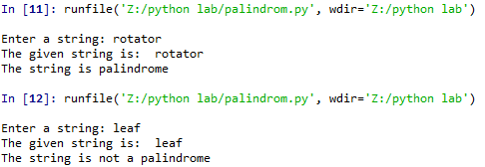

**Program-18:**

**Aim: Write a python program to find the pattern “the” in the given string or not.**

**Source Code:**

"""

Created on Tue Feb 27 07:51:06 2024

@author: it2117

"""

import re

while True:

str=input("Enter a string: ")

key=input("Enter a key to search: ")

if re.search(key,str):

print("Pattern is found in the given string")

else:

print("Pattern is not found in the given string")

c=input("Do u want to continue:y/n ")

if c=='n' or c=='N':

break

**Output:**

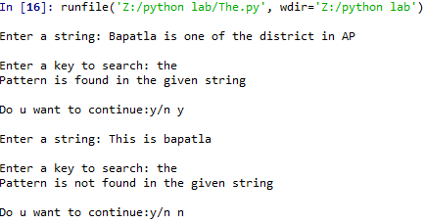

**Program-19**

**Aim: Write a python program to replace all the occurrences 5 with five.**

**Source Code:**

"""

Created on Tue Feb 27 07:59:35 2024

@author: it2117

"""

import re

while True:

str=input("Ente a string: ")

r=re.sub('5','five',str)

print(r)

c=input("Do you want to continue: y/n ")

if c=='n' or c=='N':

break

**Output:**

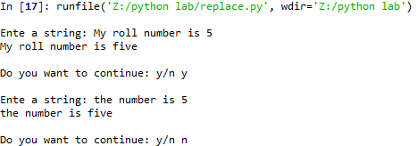

**Program-20**

**Aim: Write a python program for a given list of strings. Filter all the strings that do not contain ‘e’**

**Source Code:**

"""

Created on Tue Feb 27 09:00:24 2024

@author: it2117

"""

import re

l=input("Enter list of strings saperated by spaces: ")

s=l.split(" ")

print(s)

a=[]

for i in s:

if re.search('e',i):

continue

else:

a.append(i)

print("Filtered list is: ",a)

**Output:**

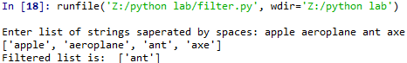

**Program-21**

**Aim: Write a python program for a given list of strings. Filter all the strings that start with alphabet ‘a’.**

**Source Code:**

"""

Created on Tue Feb 27 09:10:29 2024

@author: it2117

"""

import re

s=input("Enter list of strings: ")

l=s.split(" ")

print(l)

a=[]

for i in l:

if re.search('^a',i):

a.append(i)

else:

continue

print("After sorting the list is: ",a)

**Output:**

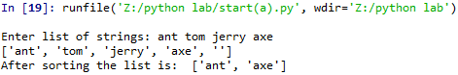

**Program-22**

**Aim: Write a python program to find all integers in a given string then display their sum.**

**Source Code:**

"""

Created on Tue Feb 27 09:14:40 2024

@author: it2117

"""

import re

str=input("Enter a string: ")

l=re.findall('\d',str)

print(l)

sum=0

for i in l:

sum=sum+int(i)

print("Sum is ",sum)

**Output:**

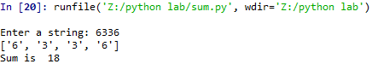

**Program-22**

**Aim: Write a python program to check whether a string contains only certain set of characters a-z A-Z 0-9**

**Source Code:**

"""

Created on Tue Mar 5 07:35:16 2024

@author: it2117

"""

import re

str=input("Enter list of strings: ")

l1=str.split(" ")

l=[]

print(l1)

for i in l1:

if re.match('[A-Za-z0-9]+$',i):

l.append(i)

else:

continue

print("List after filtering is: ",l)

**Output:**

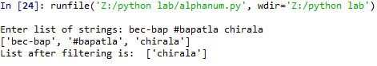

**Program-23**

**Aim: Write a python program that matches has ‘a’ followed by 0 or more b’s.**

**Source Code:**

"""

Created on Tue Mar 5 07:48:07 2024

@author: it2117

"""

import re

s=input("enter list of strings separated by spaces:")

l1=s.split(" ")

a=[]

print(l1)

for i in l1:

if re.search("a(b*)",i):

l1.append(i)

else:

continue

print("list after filtering:",a)

**Output:**

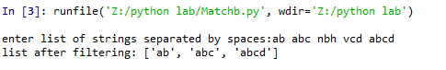

**Program-24**

**Aim: Write a python program to find whether the string should contain an alphabet ‘a’ or not.**

**Source Code:**

"""

Created on Tue Mar 5 07:57:41 2024

@author: it2117

"""

import re

str=input("Enter a strings: ")

if re.search('a',str):

print("a is found",str)

else:

print("a is not found")

**Output:**

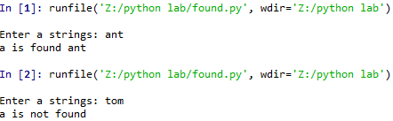

**Program-25**

**Aim: Write a python program that matches ‘a’ that has a followed by 3b’s.**

**Source Code:**

"""

Created on Tue Mar 5 08:19:25 2024

@author: it2117

"""

import re

str=input("Enter list of strings saperated by spaces: ")

l1=str.split(" ")

a=[]

print(l1)

for i in l1:

if re.match('ab{3}',i):

a.append(i)

else:

continue

print("List after filtering is: ",a)

**Output:**

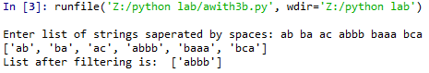

**Program-26(Upercase)**

**Aim: Write a python program to convert the given string into upper case.**

**Source Code:**

"""

Created on Tue Mar 5 09:30:57 2024

@author: it2117

"""

name =input("enter a string:")

print (name.upper())

**Output:**



**Program-27**

**Aim: Write a python program that matches a string that has started with ‘a’ and end with ‘e’.**

**Source Code:**

"""

Created on Tue Mar 12 07:35:12 2024

@author: it2117

"""

import re

a=[]

n=input("enter a string:")

s=n.split(" ")

for i in s:

if re.search('^a',i)and re.search('e$',i):

a.append(i)

else:

continue

print("filtered list",a)

**Output:**

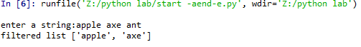

**Program-28**

**Aim: Write a python program that matches a string that starts with uppercase letters that are followed by any number of lowercase letters.**

**Source Code:**

"""

Created on Tue Mar 12 08:48:54 2024

@author: it2117

"""

import re

str=input("Enter list of strings saperated by spaces: ")

l1=str.split(" ")

a=[]

print(l1)

for i in l1:

if re.match('^[A-Z][a-z]*$',i):

a.append(i)

else:

continue

print("List after filtering is: ",a)

**Output:**

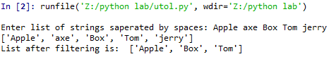

**Program-29**

**Aim: Write a python program to find all 3 or 4 or 5 characters words.**

**Source Code:**

"""

Created on Tue Mar 12 08:53:45 2024

@author: it2117

"""

import re

l1=[]

s=input("Enter list of strings separated by spaces:")

l=s.split(" ")

for i in l:

if re.findall("^\w{3,5}$",i):

l1.append(i)

else:

continue

**Output:**

print("list after filtering:",l1) 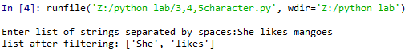

**Program-30**

**Aim: Write a python program that matches a word containing a letter‘s’.**

**Source Code:**

"""

Created on Tue Mar 12 09:03:57 2024

@author: it2117

"""

import re

l1=[]

str=input("enter strings separated by spaces:")

l=str.split()

for i in l:

if re.search("s",i) :

l1.append(i)

else:

continue

print("list after filtering:",l1)

**Output:**

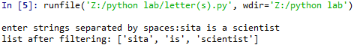

**Program-31(Date Time)**

**Aim: Write a python program to print current date and time.**

**Source Code:**

"""

Created on Tue Mar 12 09:26:33 2024

@author: it2117

"""

from datetime import datetime

print(datetime.now())

**Output:**



**Program-32**

**Aim: Write a python program to read a date from keyboard and convert into date format.**

**Source Code:**

"""

Created on Tue Mar 19 08:08:42 2024

@author: it2117

"""

from datetime import datetime

s=input("Enter any date(dd/mm/yyyy): ")

d=datetime.strptime(s,"%d/%m/%Y")

print(d.day,":",d.month,":",d.year,":")

print(type(d))

**Output:**

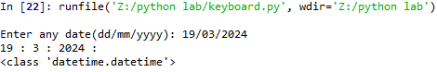

**Program-33**

**Aim: Write a python program to convert given date to date format in different ways.**

**Source Code:**

"""

Created on Tue Mar 19 08:38:42 2024

@author: it2117

"""

from datetime import datetime

s=input("Enter any date(dd/mm/yyyy): ")

d=datetime.strptime(s,"%d/%m/%Y")

print(d.day,"/",d.month,"/",d.year)

d1=datetime.strftime(d,"%A-%B-%Y")

print(d1)

d2=datetime.strftime(d,"%a:%b:%y")

print(d2)

**Output:**

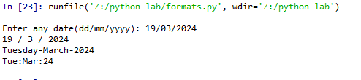

**Program-34**

**Aim: Write a python program to add 5 days to the given date.**

**Source Code:**

"""

Created on Tue Mar 19 09:00:43 2024

@author: it2117

"""

from datetime import datetime,timedelta

s=input("Enter any date(dd/mm/yyyy): ")

d=datetime.strptime(s,"%d/%m/%Y")

print("Given date: ",d.date())

d+=timedelta(days=5)

print("After five days: ",d.date())

**Output:**

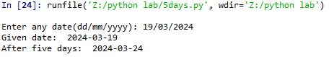

**Program-35**

**Aim: Write a python program to print yesterday, today, tomorrow.**

**Source Code:**

"""

Created on Tue Apr 23 07:35:40 2024 4:18 2024

@author: it2117

"""

from datetime import datetime,timedelta

d=datetime.now()

print("today date:",d.date())

t=d+timedelta(1)

print(" tomorrow date :",t.date())

y=d-timedelta(1)

print("yesterday date:",y.date())

**Output:**

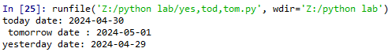

**Program-36**

**Aim: Write a python program to print 5 dates from the given date.**

**Source Code:**

"""

Created on Tue Apr 23 08:00:04 2024

@author: it2117

"""

from datetime import datetime,timedelta

s=input("Enter any date(dd:mm:yyyy):")

d=datetime.strptime(s,"%d:%m:%Y")

d1=d.date()

print("Given date:",d1)

for i in range(5):

d1+=timedelta(days=1)

print(d1)

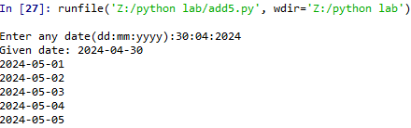

**Program-37(User define module)**

**Aim: Write a python program to demonstrate user define module.**

**Source Code:**

"""

Created on Tue Apr 23 09:26:01 2024

@author: it2117

"""

def add(a,b):

c=a+b

return c

def sub(a,b):

c=a-b

return c

def mul(a,b):

c=a*b

return c

import arithmetic

a=int(input("Enter a value"))

b=int(input("Enter b value"))

print("Addition is",arithmetic.add(a,b))

print("Subtraction is",arithmetic.sub(a,b))

print("multiplication is",arithmetic.mul(a,b))

**Output:**

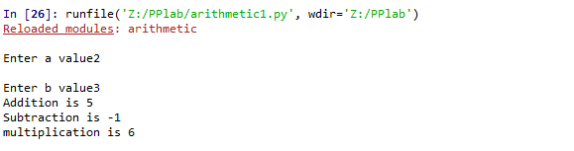

**Program-38(Files)**

**Aim: Write a python program to create bec.txt file and create some content to it.**

**Source Code:**

"""

Created on Tue Apr 30 08:11:15 2024

@author: it2117

"""

s="BEC BAPATLA AUTONOMOUS"

f=open("bec.txt","w")

f.write(s)

**Output:**



**Program-39**

**Aim: Write a python program to create a new file name cec.txt and write 5 lines of content to it and display.**

**Source Code:**

"""

Created on Fri May 6 01:45:30 2024

@author: it2117

"""

try:

f=open("bec.txt","w")

for i in range(5):

print("Enter {} content".format(i+1))

s=input()

f.write(s)

f.write(" ")

finally:

f.close()

try:

f=open("bec.txt","r")

l=f.readlines()

print(l)

finally:

f.close()

**Output:**

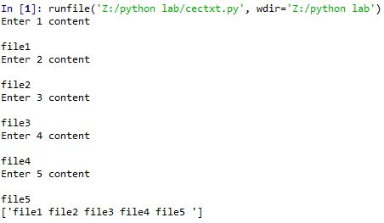

**Program-40(constructors)**

**Aim: Write a python program to demonstrate constructor.**

**Source Code:**

"""

Created on Sat May 6 01:55:15 2024

@author: it2117

"""

class Employee:

def __init__(self,name,id):

self.id=id

self.name=name

def display(self):

print("ID {} Name: {} ".format(self.id,self.name))

emp1=Employee("Mahima",117)

emp2=Employee("Lalitha",95)

emp1.display()

emp2.display()

**Output:**



**Program-41**

**Aim: Write a python program to demonstrate non parameterised constructor.**

**Source Code:**

"""

Created on Sat Jun 15 12:32:57 2024

@author: it2117

"""

class Student:

def __init__(self):

print("This is non parameterised constrctor")

def show(self,name):

print("Hello",name)

ob=Student()

ob.show("Mahima")

**Output:**



**Program-41**

**Aim: Write a python program to demonstrate default constructor.**

**Source Code:**

"""

Created on Sat Jun 15 12:38:07 2024

@author: it2117

"""

class Student:

roll_num = 117

name = "Joseph"

def display(self):

print(self.roll_num,self.name)

st = Student()

st.display()

**Output:**



**Program-43(Class-Object)**

**Aim: Write a python program to demonstrate class and object.**

**Source Code:**

"""

Created on Tue Jun 15 12:47:14 2024

@author: it2117

"""

class Emp:

def __init__(self,name,no):

self.ename=name

self.eno=no

def display(self):

print("Employee name: ",self.ename)

print("Employee number: ",self.eno)

emp=Emp("Mahi",117)

emp.display()

**Output:**



**Program-44(Exceptions)**

**Aim: Write a python program to demonstrate invalid syntax.**

**Source Code:**

"""

Created on Sat Jun 15 12:50:15 2024

@author: it2117

"""

string="Python Exceptions"

for s in string:

if(s!=0:

print(s)

**Output:**



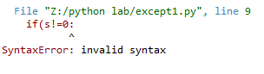**Program-45**

**Aim: Write a python program to demonstrate Name error exception.**

**Source Code:**

# -*- coding: utf-8 -*-

"""

Created on Sat Jun 15 12:55:06 2024

@author: it2117

"""

string="Python Exceptions"

for s in string:

if(s!=o):

print(s)

**Output:**





**Program-46(Functions)**

**Aim: Write a Python program to demonstrate functions in python**

**Source Code:**

"""

Created on Fri Jun 21 12:33:25 2024

@author: it2117

"""

def add(a,b):

c=a+b

print("Addition is:",c)

add(5,10)

**Output:**



**Program-47**

**Aim: Write a Python program to demonstrate positional arguments in functions.**

**Source Code:**

"""

Created on Fri Jun 21 12:40:53 2024

@author: it2117

"""

def add_number(a,b):

sum=a+b

print('Sum:',sum)

add_number(2,3)

**Output:**



**Program-48**

**Aim: Write a Python program to demonstrate function argument with default values in python.**

**Source Code:**

"""

Created on Fri Jun 21 12:47:20 2024

@author: it2117

"""

def add_number(a=7,b=8):

sum=a+b

print('Sum:',sum)

add_number(2,3)

def add_number(b=7,c=8):

sum=b+c

print('Sum:',sum)

add_number(5,3)

**Program-49**

**Aim: Write a Python program to demonstrate python keyword argument in functions in python.**

**Source Code:**

"""

Created on Tue Jun 21 12:51:05 2024

@author: it2117

"""

def display_info(first_name,last_name):

print('First Name',first_name)

print('Last Name',last_name)

display_info(last_name='Cartman',first_name='Eric')

**Output:**



**Program-50**

**Aim: Write a Python program to demonstrate python function with arbitary arguments.**

**Source Code:**

"""

Created on Fri Jun 21 12:54:33 2024

@author: it2117

"""

def add(*args):

sum=0

for i in args:

sum+=i

print('Sum:',sum)

add(2,3,5,6,7)

add(2,3,4,5,6,7,8)

add(2,3)

**Output:**



**Program 51**

**Aim: Write a menu driven Python program to implement Student Management System for the following:**

**a) Insert Student Record b) Display Student Record**

**c) Search Student Record d) Delete Student Record**

**e) Update Student Record Source Code:**

d={}

while True:

print("\n 1.Insert student record\n 2.Display student record\n 3.Search student record\n 4.Delete student record\n 5.Update student record\n 6.exit\n")

ch=int(input("Enter your choice:")) if(ch==1):

r=input("Enter student registration number") p=float(input("Enter student percentage")) d[r]=p

print("Record is inserted successfully") elif(ch==2):

print("List of students",d) elif(ch==3):

r1=input("Enter registration number that you want to search") if r1 in d:

print("Record is found",r1,d[r1]) else:

print("Record is not found") elif(ch==4):

k=input("Enter student registration number that you want to delete") if k in d:

del d[k]

print("Record is deleted successfully") else:

print("Record is not found") elif(ch==5):

r2=input("Enter registration number that you want to update") if r2 in d:

p1=float(input("Enter updated percentage")) d[r2]=p1

print("Record is updated successfully") elif(ch==6):

break else:

print("Enter Invalid choice")

**Output:**

