**Program-1**

**Aim:Write a python program to perform all arithmetic operations on two integers**

**Source Code:**

“””

Created on Tue Feb 6 08:01:30 2024

@author: it2111

"""

a=int(input("enter a value"))

b=int(input("enter b value"))

c=a+b

d=a-b

e=a*b

f=a/b

g=a%b

print("Addition is",c)

print("Subtraction is",d)

print("multiplication is",e)

print("division is",f)

print("modulo division is",g)

**Output:**



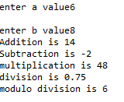

**Program-2**

**Aim:Write a python program to print biggest among three given numbers**

**Source Code:**

"""

Created on Tue Feb 6 08:37:58 2024

@author: it2111

"""

a=int(input("enter a value"))

b=int(input("enter b value"))

c=int(input("enter c value"))

if a>b and a>c:

print("{} is big".format(a))

elif b>a and b>c:

print("{} is big".format(b))

else:

print("{} is big".format(c))

**Output:**



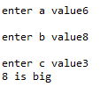

**Program-3**

**Aim: Write a python program to print first 10 natural numbers**

**Source Code:**

"""

Created on Tue Feb 6 09:05:54 2024

@author: it2111

"""

i=1

print("first ten natural numbers are")

while i<=10:

print(i,end=" ")

i=i+1

**Output:**





**Program-4**

**4) Write a python program to find factorial of agiven number**

**Source Code:**

"""

Created on Tue Feb 6 09:16:18 2024

@author: it2111

"""

n=int(input("enter n value"))

fact=1

print("factorial of given number is")

i=1

while i<=n:

fact=fact*i

i=i+1

print(fact)

Output:





**Program-5**

**5) Write a python program to print multiplication table of a given number**

**Source Code:**

"""

Created on Tue Feb 6 09:22:34 2024

@author: it2111

"""

n=int(input("enter n value"))

i=1

print("multiplicaton of {} if".format(n))

while i<=10:

print("{}*{}={}".format(n,i,n*i))

i=i+1

**Output:**

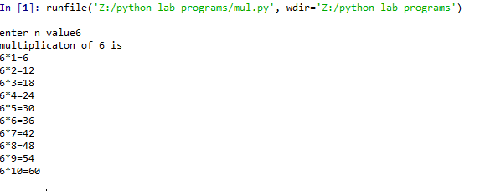

**Program-6**

**6) Write a python program to check whether the given number is prime or not**

**Source Code**:

"""

Created on Tue Feb 6 09:48:42 2024

@author: it2111

"""

n=int(input("enter n value"))

i=1

count=0

while i<=n:

if n%i==0:

count=count+1

i=i+1

if count==2:

print("{} is prime number".format(n))

else:

print("{} is not prime number".format(n))

**Output:**







**Program-7**

**7) Write a python program to generate Fibonacci series upto n terms**

**Source Code:**

"""

Created on Tue Feb 13 07:36:49 2024

@author: it2111

"""

n=int(input("enter n value"))

a,b=0,1

result=[0]

for i in range(n-1):

result.append(b)

a,b=b,a+b

print(result)

**Output:**





**Program-8**

**8) Write a python program to ask the user to enter a list of integers separated by spaces then convert this into a list of integers but square each element,finally print the list**

**Source Code:**

"""

Created on Tue Feb 13 07:44:13 2024

@author: it2111

"""

list=[]

n=input("enter list of integers separeted by spaces:")

s=n.split(" ")

print("list of integers are:",s)

for i in s:

j=int(i)

list.append(j*j)

print("list of integer squares are:",list)

**Output:**





**Program-9**

**9) Write a python program to ask the user to enter the list of integers separated by spaces then convert this into a list of integers but square each element , store the integer and its square in a tuple,put this into a list , print the list**

**Source Code:**

"""

Created on Tue Feb 13 08:25:45 2024

@author: it2111

"""

list=[]

n=input("enter list of integers separeted by spaces")

s=n.split(" ")

print(" the list is",s)

for i in s:

j=int(i)

list.append((j,j*j))

print("integeres and squares are")

print(list)

**Output:**





**Program-10**

**10 ) Write a python program to create a list of strings from keyboard then print after sorting them in descending order**

**Source Code:**

"""

Created on Tue Feb 13 09:22:04 2024

@author: it2111

"""

n=input("enter list of strings:")

l=n.split(" ")

print("Before sorting the list is:",l)

l.sort(reverse=True)

print(" after sorting the list is:",l)

**Output:**





**Program-11**

**11) Write a python program to ask the user to enter a string from keyboard and convert this into a list of characters , sort this list in ascending order and now eliminate any repeated values**

**Source Code:**

"""

Created on Tue Feb 13 07:59:13 2024

@author: it2111

"""

n=input("enter any string:")

n.split(" ")

l=list(n)

print("before sorting the list",l)

l.sort()

print("after sorting the list:",l)

k=set(l)

a=list(k)

print("after eliminating the duplicates",a)

**Output:**



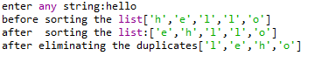

**Program-12**

**12) Write a python program to read a string from keyboard and check whether it is palindrome or not**

**Source Code:**

"""

Created on Tue Feb 20 08:25:06 2024

@author: it2111

"""

n=input("enter a string from keyboard:")

print("string is:",n)

r=n[::-1]

if n==r:

print("String is palindrome")

else:

print("String is not palindrome")

**Output:**







**Program-13**

**13) Write a python program to read a string from keyboard then print the following**

**i) Without first character**

**ii) Without last character**

**iii )String in reverse**

**iv) Every alternate character of the string**

**Source Code:**

""

Created on Tue Feb 20 08:43:38 2024

@author: it2111

"""

name=input("Enter a string:")

print("The taken string is:",name)

print("String without first character is:",name[1:])

print("String without last character is:",name[:-1])

print("Reverse of string is:",name[::-1])

print("Alternate characters of a string:",name[::2])

**Output:**



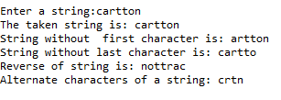

**Program-14**

**14) Write a python program to read n students (regNo,Name) and append them into dictionary and print it**

**Source Code:**

"""

Created on Tue Feb 20 09:07:21 2024

@author: it2111

"""

d={}

n=int(input("Enter how many students you want to read:"))

for i in range(0,n):

print("Enter {} student regno and name:".format(i+1))

r=input()

m=input()

d[r]=m

print("The student details are:",d)

**Output:**



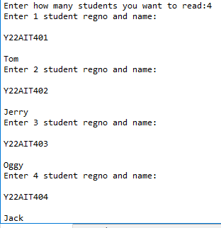

The student details are: {'Y22AIT401': 'Tom', 'Y22AIT402': 'Jerry', 'Y22AIT403': 'Oggy', 'Y22AIT404':

'Jack'}

**Program-15**

**15) Write a python program to ask the user for a list of integers separated by spaces .For each integer store a string version as the key and the square of the integer value as the value in a dictionary,Print the resulting dictionary**

**Source Code:**

"""

Created on Tue Feb 20 09:02:28 2024

@author: it2111

"""

l=input("Enter list of integers separeted by spaces:")

list=l.split(" ")

d={}

for i in list:

d[i]=int(i)*int(i)

print("The dictionary is:",d)

**Output:**





**Program-16**

**16) Write a python program to ask the user to enter a string,convert this to lower case. Count the number of occurrences of each character in the string(use a dictionary).Print the result in sorted order of the characters**

**Source Code:**

"""

Created on Tue Feb 20 09:10:42 2024

@author: it2111

"""

s=input("Enter a string:")

S=s.lower()

d={}

for i in S:

if i in d:

d[i]+=1

else:

d[i]=1

for i in sorted(d):

print("Dictionary:",i,d[i])

**Output:**



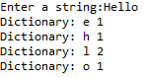

**Program-17**

**17) Write a python program to ask the user to enter two integers,one on each line say x and y . If x is larger then y print “first” store the value of x in a variable highest . If y is larger then x print “second” store the value of y in a variable highest.Finally ,print the square of highest**

**Source Code:**

"""

Created on Tue Feb 27 07:41:16 2024

@author: it2111

"""

x=int(input("Enter x value:"))

y=int(input("Enter y value:"))

if x>y:

print("First")

highest=x

elif y>x:

print("Second")

highest=y

else:

print("Same")

highest=x

print("highest value",highest)

print("square of highest:",highest*highest)

**Output:**



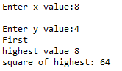

**Program-18**

**18) Write apython program to use a while loop to generate the numbers from 1 to 10. If a number divisible by 3 is found , print ***. If a number divisible by 5 is found , print ***** . Otherwise just print the number**

**SourceCode:**

"""

Created on Tue Feb 27 07:49:04 2024

@author: it2111

"""

i=1

while i<=10:

if i%3==0:

print("***")

elif i%5==0:

print("*****")

else:

print(i)

i+=1

**Output:**



### 

**Program-19**

**19) Write a python program to find the pattern ‘the’ in the given string or not**

**Source Code:**

"""

Created on Tue Mar 5 07:47:31 2024

@author: it2111

"""

import re

str=input("Enter any string:")

if re.search('the',str):

print("pattern is found in the given string")

else:

print("pattern is not found in the given string")

**Output:**







**Program-20**

**20) Write a python program to replace all the occurrence of ‘5’ with ‘five’**

**Source Code:**

"""

Created on Tue Mar 5 07:51:09 2024

@author: it2111

"""

import re

str=input("Enter any string:")

r=re.sub('5','five',str)

print("After replacing:",r)

**Output:**

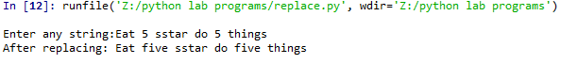

**Program-21**

**21) Write a python program to replace 5 with five in first occurrence**

**SourceCode:**

"""

Created on Tue Mar 5 08:11:09 2024

@author: it2111

"""

import re

str=input("Enter any string:")

r=re.sub('5','five',str,count=1)

print("After replacing first occurence:",r)

**Output:**

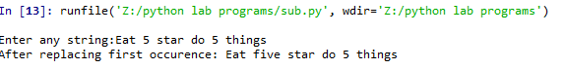

**Program-22**

**22) Write a python program to find whether a string contains ‘a’ or not**

**Source Code:**

"""

Created on Tue Mar 5 07:57:04 2024

@author: it2111

"""

import re

str=input("enter any string:")

if re.search('a',str):

print(" string contain 'a'")

else:

print("string does not contain 'a' ")

**Output:**

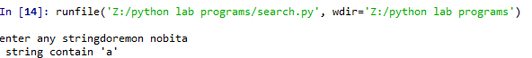

**Program-23**

**23) Write a python program for a given list of strings,filter that do not contain ‘e’**

**Source Code:**

"""

Created on Tue Mar 5 08:00:26 2024

@author: it2111

"""

import re

a=[]

n=input("Enter any string:")

l=n.split(" ")

print(l)

for i in l:

if re.search('e',i):

continue

else:

a.append(i)

print("The filtered list is:",a)

Output:

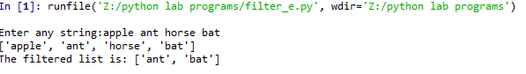

**Program-24**

**24) Write a python program to find all integers in a given sring then display the sum**

**Source Code:**

"""

Created on Tue Mar 5 08:12:23 2024

@author: it2111

"""

import re

str=input("enter any string")

l=re.findall('\d',str)

sum=0

for i in l:

sum=sum+int(i)

print("The sum of integers in a string is:",sum)

**Output:**

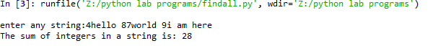

**Program-25**

**25) Write a python program for a given list of strings,filter all the strings that starts with alphabet ‘a’**

**Source Code:**

"""

Created on Tue Mar 5 08:18:29 2024

@author: it2111

"""

import re

str=input("Enter any string:")

a=[]

l=str.split(" ")

for i in l:

if re.search('^a',i):

a.append(i)

else:

continue

print("The strings that start with 'a':",a)

**Output:**

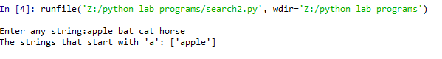

**Program-26**

**26) Write a python program for a list of strings filter all the strings that end with ‘e’**

**Source Code:**

"""

Created on Tue Mar 5 08:22:51 2024

@author: it2111

"""

import re

a=[]

str=input("Enter any string:")

l=str.split(" ")

print(l)

for i in l:

if re.search('e$',i):

a.append(i)

else:

continue

print("the filtered strings are:",a)

**Output:**

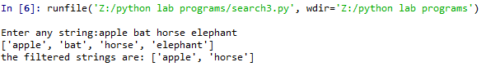

**Program-27**

**27) Write a python program for all strings , filter all strings that starts with ‘a’ and ends with ‘e’**

**Source Code:**

"""

Created on Tue Mar 5 08:28:07 2024

@author: it2111

"""

import re

a=[]

str=input("Enter any string:")

l=str.split(" ")

print(l)

for i in l:

if re.search( '^a',i) and re.search('e$',i):

a.append(i)

else:

continue

print("the filtered strings are:",a)

**Output:**

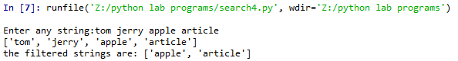

**Program-28**

**28) Write a python program to check whether a string contains set of characters a-z A-Z 0-9**

**Source Code:**

"""

Created on Tue Mar 5 08:31:36 2024

@author: it2111

"""

import re

l1=[]

str=input("Enter alist of strings separeted by spaces:")

l=str.split(" ")

for i in l:

if re.match('[a-zA-Z0-9]+$',i):

l1.append(i)

else:

continue

print("List after filtering:",l1)

**Output:**

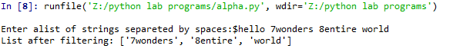

**Program-29**

**29) Write a python program that matches has ‘a’ followed by 0 or B’s**

**Source Code:**

"""

Created on Tue Mar 5 08:36:35 2024

@author: it2111

"""

import re

l1=[]

str=input("Enter alist of strings separeted by spaces:")

l=str.split(" ")

print("given list is:",l)

for i in l:

if re.search('a(b*)',i):

l1.append(i)

else:

continue

print("List after filtering:",l1)

**Output:**

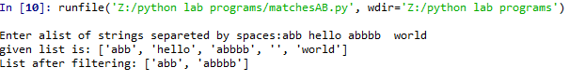

**Program-30**

**30)Write a python program to print current date and time**

**Source Code:**

"""

Created on Tue Mar 5 09:50:05 2024

@author: it2111

"""

import datetime

print(datetime.datetime.now())

**Output:**



**Program-31**

**31) Write a python program to create a mapping from 3 characters month name to month number . Ask the user for 3 characters month code lower or upper mix . Print the month number corresponding to the month the user entered**

**Source Code:**

"""

Created on Tue Mar 5 09:52:45 2024

@author: it2111

"""

m={'jan':1,'feb':2,'mar':3,'apr':4,'may':5,'jun':6,'jul':7,'aug':8,'sep':9,'oct':10,'nov':11,'dec':12}

s=input("Enter month name:")

print("month number corresponding to name is {}".format(m[s]))

**Output:**

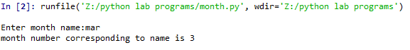

**Program-32**

**32)Write a python program to perform following operations on student management system**

**i)Create ii)Display iii)Search iv)delete v)update**

**Source Code:**

"""

Created on Sat Apr 20 14:54:05 2024

@author: it2111

"""

d={}

while True:

print("1.insert student record\n2.display student record\n3.search student record\n4.delete student record\n5.update student record\n6.exit")

ch=int(input("enter your choice: "))

if(ch==1):

r=input("enter student regdno: ")

p=float(input("enter student percentage: "))

d[r]=p

print("record is inserted successfully")

elif(ch==2):

print("student records are:{}".format(d))

elif(ch==3):

r1=input("enter regdno of student you want to search: ")

if(r1 in d):

print("record is found",r1,d[r1])

else:

print("record not found")

elif(ch==4):

k=input("enter student regdno that you want to delete: ")

if(k in d):

del d[k]

print("record is removed successfully")

print("after deletion: ",d)

else:

print("record not found,enter valid regdno")

elif(ch==5):

r2=input("enter regdno that you want to update: ")

if(r2 in d):

p1=float(input("enter updated percentage: "))

d[r2]=p1

print("record is updated successfully: ",d)

elif(ch==6):

break

else:

print("invalid choice")

**Output:**

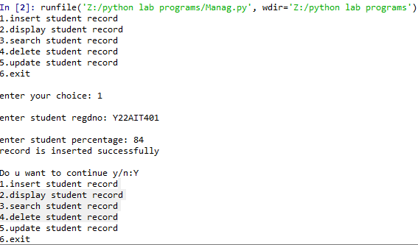

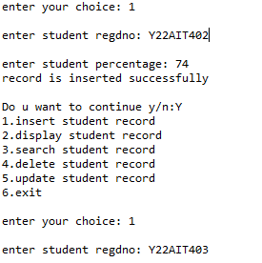

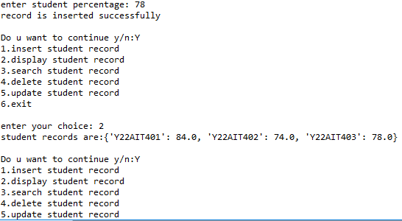

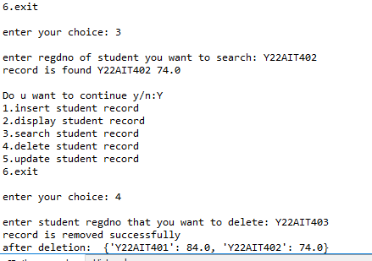



**Program-33**

**33) Write a python program to read a date from keyboard and convert it into date format**

**Source Code:**

"""

Created on Tue Mar 12 07:30:05 2024

@author: it2111

"""

from datetime import datetime

s=input("Enter any date(dd:mm:yyyy):")

d=datetime.strptime(s,"%d:%m:%Y")

print(d.day ,":",d.month,":",d.year)

**Output:**

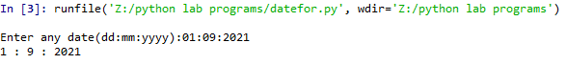

**Program -34**

**34) Write a python program to convert given data to date format in different**

**ways**

**Source Code:**

"""

Created on Tue Mar 12 07:34:30 2024

@author: it2111

"""

from datetime import datetime

s=input("Enter any date(dd:mm:yyyy):")

d=datetime.strptime(s,"%d:%m:%Y")

print(d.date())

d1=datetime.strftime(d,"%A-%B-%Y")

print("the date format is:",d1)

**Output:**

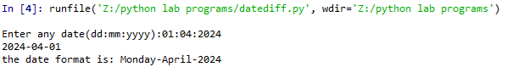

**Program-35**

**35) Write a python program to add 5 days to the given date**

**Source Code:**

"""

Created on Tue Mar 12 07:38:12 2024

@author: it2111

"""

from datetime import datetime,timedelta

s=input("Enter any date(dd/mm/yyyy):")

d=datetime.strptime(s,"%d/%m/%Y")

print("Given date is:",d.date())

d+=timedelta(days=5)

print("After adding 5 days the date is:",d.date())

**Output:**

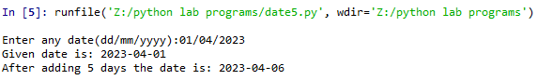

**program-36**

**36) Write a python program to print yesterday today and tomorrow**

**Source Code:**

"""

Created on Tue Mar 12 07:44:38 2024

@author: it2111

"""

from datetime import datetime,timedelta

d=datetime.now()

print("Today date :",d.date())

t=d+timedelta(1)

print("Tomorrow date:",t.date())

y=d-timedelta(1)

print("Yesterday date:",y.date())

**Output:**

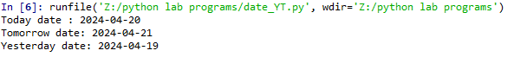

**Program-37**

**37) Write a python program to print 5 days after the given date**

**Source Code:**

"""

Created on Tue Mar 12 07:49:43 2024

@author: it2111

"""

from datetime import datetime,timedelta

s=input("Enter any date(dd/mm/yyyy):")

d=datetime.strptime(s,"%d/%m/%Y")

d1=d.date()

print("Given date:",d1)

print("The five days are:")

for i in range(5):

d1+=timedelta(days=1)

print(d1)

**Output:**

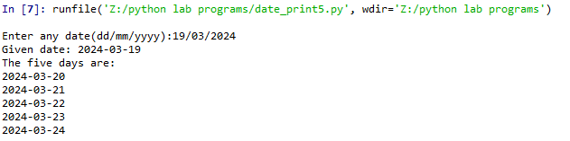

**Program-38**

**38) Write a python program that mathes ‘a’ that has ‘a’ followed by 3b’s**

**Source Code**:

"""

Created on Sat Apr 20 15:25:32 2024

@author: it2111

"""

import re

a=[]

n=input("Enter any list of strings:")

l=n.split(" ")

for i in l:

if re.search("ab{3}",i):

a.append(i)

else:

continue

print("The filtered string is:",a)

**Output:**



**Program-39**

**39) Write a python program that matches a string has an ‘a’ followed by exactly 2 to 3b’s**

**Source Code:**

"""

Created on Sat Apr 20 15:30:40 2024

@author: it2111

"""

import re

a=[]

n=input("Enter any list of strings:")

l=n.split(" ")

for i in l:

if re.search("ab{2,3}",i):

a.append(i)

else:

continue

print("The filtered string is:",a)

**Output:**

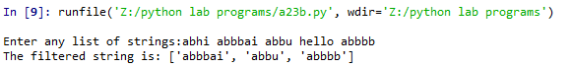

**Program-40**

**40) Write a python program that string that starts with one upper case letter followed by any lower case letters**

**Source Code:**

"""

Created on Sat Apr 20 15:34:13 2024

@author: it2111

"""

import re

a=[]

n=input("Enter any list of strings:")

l=n.split(" ")

for i in l:

if re.search("^[A-Z][a-z]*$",i):

a.append(i)

else:

continue

print("The filtered string is:",a)

**Output:**

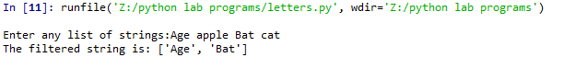

**Program-41**

**41) Write a python program that matches a word containing a letter ‘s’**

**Source Code:**

"""

Created on Sat Apr 20 15:40:24 2024

@author: it2111

"""

import re

a=[]

n=input("Enter any list of strings:")

l=n.split(" ")

for i in l:

if re.search("s",i):

a.append(i)

else:

continue

print("The filtered string is:",a)

**Output:**

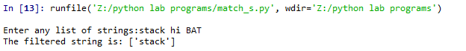

**Program-42**

**42) Write a python program to remove all punctuation marks in a given paragraph**

**Source Code:**

"""

Created on Sat Apr 20 15:43:33 2024

@author: it2111

"""

import re

a=[]

n=input("Enter any paragraph:")

print("Before filtering:",n)

a=re.sub("[;:?!]"," ",n)

print("After filtering:",a)

**Output:**

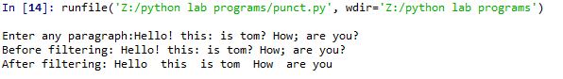

**Program-43**

**43) Write a python program that which removes multiple spaces from s tring**

**Source Code:**

"""

Created on Mon Apr 22 16:15:54 2024

@author: it2111

"""

import re

str=input("Enter any string:")

print("Before removing multiple spaces",str)

r=re.sub("\s+"," ",str)

print("After removing multiple spaces:",r)

**Output:**

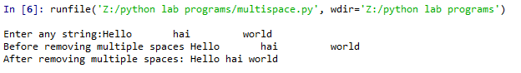

**Program-44**

**44) Write a python program to display the current year**

**Source Code:**

"""

Created on Tue Apr 23 07:36:42 2024

@author: it2111

"""

from datetime import datetime

s=datetime.now()

d=datetime.strftime(s,"%Y")

print("Current year is:",d)

**Output:**



**Program-45**

**45) Write a python program to display current month of year**

**Source Code:**

"""

Created on Tue Apr 23 07:32:03 2024

@author: it2111

"""

from datetime import datetime

s=datetime.now()

d=datetime.strftime(s,"%B")

print("Current month of the year is:",d)

**Output:**

**,**

**Program -46**

**46) Write a python program to create new file named bec.txt and write some content to it**

**Source Code:**

**Output:**

"""

Created on Fri Jun 10 02:55:44 2024

@author: it2111

"""

s="Bec Bapatla Engineering College Autonomous"

f=open("bec.txt","w")

f.write(s)

f.close()

**Output:**

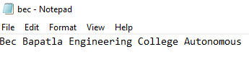

**Program-47**

**47) Write a python program to create a new file named cec.txt and write five lines of content**

**to it and display them**

**Source code:**

"""

Created on Fri Jun 10 02:34:45 2024

@author: it2111

"""

try:

f=open("cec.txt","w")

for i in range(5):

print("Enter {} line".format(i+1))

s=input()

f.write(s)

f.write(" ")

finally:

f.close()

try:

f=open("cec.txt","r")

l=f.readlines()

print(l)

finally:

f.close()

**Output:**

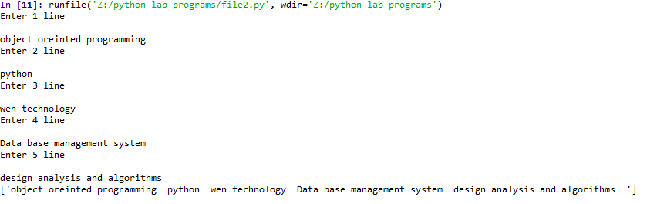

**Program -48**

**48) Write a python program that demonstrates the concept of class and object**

**Source code:**

# -*- coding: utf-8 -*-

"""

Created on Fri Jun 14 10:09:43 2024

@author: it2111

"""

class Student:

def __init__(self,name,no):

self.sname=name

self.sno=no

def dis(self):

print("Student name: ",self.sname)

print("Student roll-number: ",self.sno)

student=Student("noble",91)

student.dis()

**Output:**



**Program -49**

**49) Write a python program to demonstrate inheritance**

**Source Code:**

“""

Created on Fri Jun 14 09:59:32 2024

@author: it2111

"""

class vehicle:

def __init__(self):

self.wheels=4

self.color="blue"

def speed(self):

print("vechile speed upto 20km/h")

class Car(vehicle):

def __init__(self):

self.wheels=4

self.color="red"

def dis(self):

print("No.of wheels",self.wheels,"color=",self.color)

ob=Car()

ob.dis()

ob.speed()

**Output:**



**Program -50**

**50) Write a python program to demonstrate polymorphism with class methods**

**Source Code:**

"""

Created on Fri Jun 14 09:54:49 2024

@author: it2111

"""

class India():

def capital(self):

print("new delhi is the capital of India")

def lang(self):

print("Hindi is the most widely spoken lang in India")

def type(self):

print("India is developing country")

class USA():

def capital(self):

print("washington,D.C is the capital of USA")

def lang(self):

print("english is the primary language of USA")

def type(self):

print("USA is a developed country")

obj_ind=India()

obj_usa=USA()

for country in(obj_ind,obj_usa):

country.capital()

country.lang()

country.type()

**Output:**

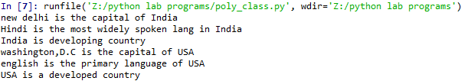

**Program- 51**

**51) Write a python program to demonstrate polymorphism with inheritance**

**Source Code:**

"""

Created on Fri Jun 14 09:46:16 2024

@author: it2111

"""

class Bird:

def intro(self):

print("There are many types of birds")

def flight(self):

print("Most of the birds can fly but some cannot")

class Sparrow(Bird):

def flight(self):

print("sparrows can fly")

class Ostrich(Bird):

def flight(self):

print("ostriches cannot fly")

obj_bird=Bird()

obj_spr=Sparrow()

obj_ost=Ostrich()

obj_bird.intro()

obj_bird.flight()

obj_spr.intro()

obj_spr.flight()

obj_ost.intro()

obj_ost.flight()

**Output:**

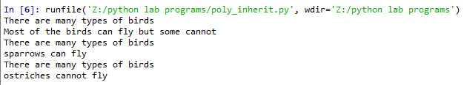

**Program -52**

**52)Write a python program to create a tuple and add some items to it**

**Source Code:**

"""

Created on Fri Jun 14 09:41:33 2024

@author: it2111

"""

t=()

n=int(input("Enter how many values you want to append: "))

for i in range(n):

print("Enter {} value:".format(i))

v=int(input())

t=t+(v,)

print("Elements in the tuple are:",t)

**Output:**

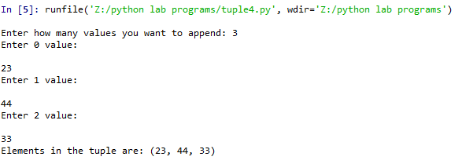

**Program-53**

**53)Write a python program to print specific values from a tuple**

**Source Code:**

"""

Created on Fri Jun 14 08:27:09 2024

@author: it2111

"""

t=input("Enter a string: ")

print("String from index upto last:",t[2:])

print("String from index 2 to 3:",t[1:4])

**Output:**

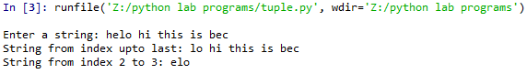

**Program- 54**

**Aim: Write a python program to implement following polygons using polymorphism.**

**1.Triange 2.rhombus 3.pentagon 4.hexagon**

**Source Code:**

"""

Created on Thu Jun 13 06:36:10 2024

@author: it2111

"""

import math

class Polygon:

def no_of_sides(self):

return 0

def area(self):

return 0

def perimeter(self):

return 0

class Triangle(Polygon):

def no_of_sides(self):

print("No.of sides for triangle is 3")

def area(self):

base=int(input("enter base:"))

height=int(input("enter height:"))

Area=1/2*base*height

print(Area)

def perimeter(self):

a=int(input("enter a value:"))

b=int(input("enter b value:"))

c=int(input("enter c value:"))

if a+b>c:

perimeter=a+b+c

print(perimeter)

else:

print("Invalid Triangle")

class Rhombus(Polygon):

def no_of_sides(self):

print("No.of sides for rhombous is 4")

def area(self):

p=int(input("enter p value:"))

q=int(input("enter q value:"))

Area=p*q/2

print(Area)

def perimeter(self):

a=int(input("enter a value:"))

perimeter=4*a

print(perimeter)

class Pentagon(Polygon):

def no_of_sides(self):

print("No.of sides for 'pentagon is 5")

def area(self):

a=int(input("enter a value:"))

area=1/4*math.sqrt(5*(5+2*math.sqrt(5)))*a*2

print(area)

def perimeter(self):

a=int(input("enetr a value:"))

perimeter=5*a

print(perimeter)

class Hexagon(Polygon):

def no_of_sides(self):

print("No.of sides for hexagon is 6")

def area(self):

a=int(input("enter a value:"))

area=(3 * math. sqrt(3) * (a ** 2)) / 2.

print(area)

def perimeter(self):

a=int(input("enter a value:"))

perimeter=6*a

print(perimeter)

while True:

print("\n 1.Triangle\n 2.rhombous\n 3.pentagon\n 4.hexagon\n 5.exit")

ch=int(input("enter your choice:"))

if ch==1:

while True:

tri=Triangle()

print("\n 1.sides\n 2.area\n 3.perimeter")

c=int(input("enter your choice:"))

if c==1:

tri.no_of_sides()

elif c==2:

tri.area()

elif c==3:

tri.perimeter()

else:

print("Invalid choice")

c1=input("Do you want to continue y/n")

if c1=='Y' or c1=='y':

continue

else:

break

elif ch==2:

while True:

rho=Rhombus()

print("\n 1.sides\n 2.area\n 3.perimeter")

cc=int(input("enter your choice:"))

if cc==1:

rho.no_of_sides()

elif cc==2:

rho.area()

elif cc==3:

rho.perimeter()

else:

print("Invalid choice")

cc1=input("Do you want to continue y/n")

if cc1=='Y' or cc1=='y':

continue

else:

break

elif ch==3:

while True:

pent=Pentagon()

print("\n 1.sides\n 2.area\n 3.perimeter")

ccc=int(input("enter your choice:"))

if ccc==1:

pent.no_of_sides()

elif ccc==2:

pent.area()

elif ccc==3:

pent.perimeter()

else:

print("Invalid choice")

ccc1=input("Do you want to continue y/n")

if ccc1=='Y' or ccc1=='y':

continue

else:

break

elif ch==4:

while True:

hexa=Hexagon()

print("\n 1.sides\n 2.area\n 3.perimeter")

cc=int(input("enter your choice:"))

if cc==1:

hexa.no_of_sides()

elif cc==2:

hexa.area()

elif cc==3:

hexa.perimeter()

else:

print("Invalid choice")

cc1=input("Do you want to continue y/n")

if cc1=='Y' or cc1=='y':

continue

else:

break

elif ch==5:

break

else:

print("Invalid choice")

c=input("Do you want to continue(y/n):")

if c=='n' or c=='N':

break

**Output:**

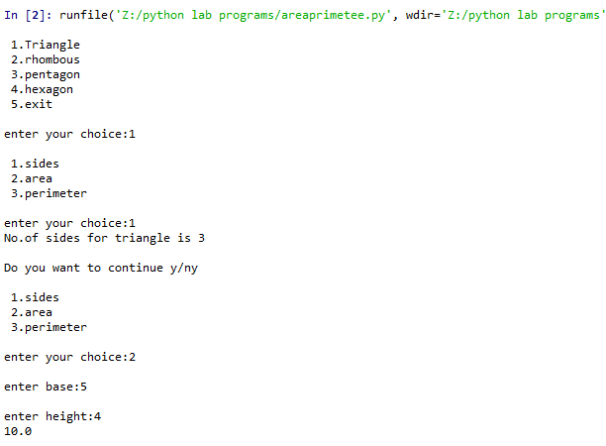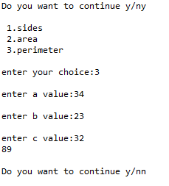

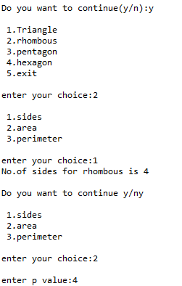

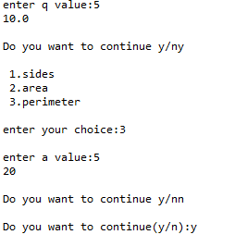

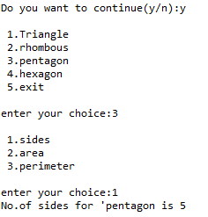

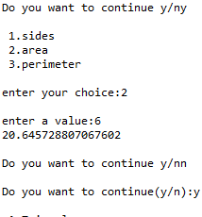

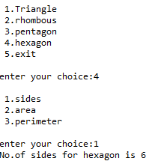

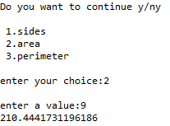

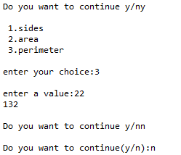

**Program-55**

**55) Write a python program to demonastrate functions using positional arguments**

**Source Code:**

# -*- coding: utf-8 -*-

"""

Created on Fri Jun 14 12:24:42 2024

@author: it2111

"""

def add_numbers(a,b):

sum=a+b

print("Sum:",sum)

add_numbers(2,3)

**Output:**



**Program-56**

**56) Write a python program demonstrate functions using default values**

**Source Code:**

"""

Created on Fri Jun 14 12:26:18 2024

@author: it2111

"""

def add_numbers(a=5,b=7,c=11):

sum=a+b+c

return sum

#print("Sum is :",sum)

print("sum with positonal arguments:",add_numbers(2,3,6))

print("Sum with default arguments:",add_numbers())



**Program-57**

**57) Write a python program to demonastrate using keyword arguments**

**Source Code:**

"""

Created on Fri Jun 14 12:33:07 2024

@author: it2111

"""

def display_info(first_name,last_name):

print("firs name:",first_name)

print("Lastname is:",last_name)

display_info(last_name="Cartman",first_name="Eric")

**Output:**



**Program-58**

**58) Write a python program to demonastrate using arbitary arguments**

**Source Code:**

# -*- coding: utf-8 -*-

"""

Created on Fri Jun 14 12:43:30 2024

@author: it2111

""

def add_numbers(*args):

total = 0

for num in args:

total += num

return total

result = add_numbers(1, 2, 3, 4, 5)

print(result)

**Output:**

