10/5

Color Map

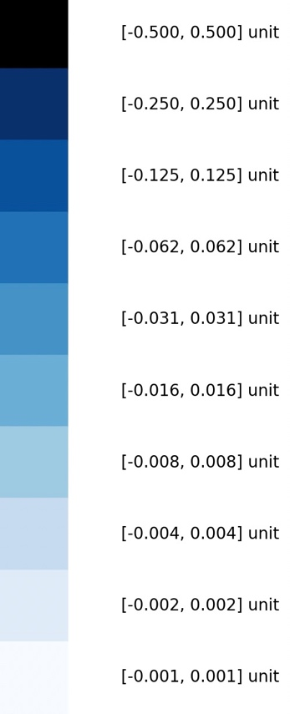

House K-D Tree Visualizations with the above Gradient Color Map

Tools for Building R-Tree Visualizations

Matplotlib 3D

<https://www.geeksforgeeks.org/three-dimensional-plotting-in-python-using-matplotlib/>

10/13

First try of building a R-Tree visualization

