WishGI: Lightweight Static Global Illumination Baking via Spherical Harmonics Fitting
JUNKE ZHU, University of Science and Technology of China and Tencent Technology, China ZEHAN WU, Tencent Technology, China
QIXING ZHANG, University of Science and Technology of China, China CHENG LIAO∗ , Tencent Technology, China
ZHANGJIN HUANG∗ , University of Science and Technology of China, China
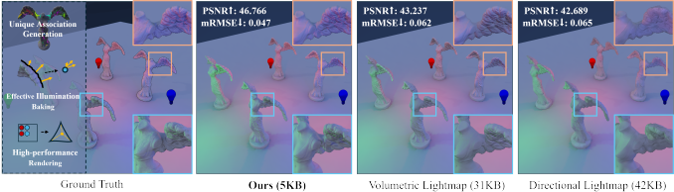

arXiv:2506.01288v1 c s.GR 2 Jun 2025[]
Fig. 1. We present a novel method for static global illumination baking tailored for low-end platforms. Our work significantly reduces memory usage and ensures high runtime eficiency, while avoiding additional render passes, making it highly compatible with forward rendering. This method enables high-quality static global illumination on low-end devices, demonstrating clear advantages over mainstream industry methods.

Global illumination combines direct and indirect lighting to create realis- tic lighting efects, bringing virtual scenes closer to reality. Static global illumination is a crucial component of virtual scene rendering, leveraging precomputation and baking techniques to significantly reduce runtime com- putational costs. Unfortunately, many existing works prioritize visual quality by relying on extensive texture storage and massive pixel-level texture sam- pling, leading to large performance overhead. In this paper, we introduce an illumination reconstruction method that efectively reduces sampling in fragment shader and avoids additional render passes, making it well-suited for low-end platforms. To achieve high-quality global illumination with reduced memory usage, we adopt a spherical harmonics fitting approach for baking efective illumination information and propose an inverse probe distribution method that generates unique probe associations for each mesh. This association, which can be generated offline in the local space, ensures consistent lighting quality across all instances ofthe same mesh. As a conse- quence, our method delivers highly competitive lighting efects while using
* Corresponding authors.
Authors’Contact Information: Junke Zhu, junkezhu@mail.ustc.edu.cn, University of Science and Technology of China and Tencent Technology, China; Zehan Wu, zehanwu@tencent.com, Tencent Technology, China, zehanwu@tencent.com;Qixing Zhang, qixing@ustc.edu.cn, University of Science and Technology of China, China, qixing@ustc.edu.cn;Cheng Liao, chengliao@tencent.com, Tencent Technology, China, chengliao@tencent.com;Zhangjin Huang, zhuang@ustc.edu.cn, University of Science and Technology of China, China, zhuang@ustc.edu.cn.
This work is licensed under a Creative Commons Attribution 4.0 International License. ⑥ 2025 Copyright held by the owner/author(s).
ACM 1557-7368/2025/8-ART
https://doi.org/10.1145/3730935

only approximately 5% of the memory required by mainstream industry techniques.
CCS Concepts: • Computing methodologies → Rendering.
Additional Key Words and Phrases: static global illumination, low-end plat- form, spherical harmonic, probe distribution
ACM Reference Format:
Junke Zhu, Zehan Wu, Qixing Zhang, Cheng Liao, and Zhangjin Huang.
2025. WishGI: Lightweight Static Global Illumination Baking via Spherical Harmonics Fitting. ACM Trans. Graph. 44, 4 (August 2025), 12pages. https: //doi.org/10.1145/3730935

1 Introduction
Global illumination (GI) refers to the process of simulating all light interactions within a scene, including both direct and indirect light- ing [Ritschel et al. 2012]. High-quality global illumination tech- niques can make virtual scenes more realistic, providing users with an enhanced experience. In most video games, static objects make up the majority of the scene. By leveraging precomputation and baking techniques, runtime computational costs can be significantly reduced. Therefore, static global illumination baking techniques [Diolatzis et al. 2022; Li et al. 2023; Rainer et al. 2022] have attracted a great deal of attention.
Among various static global illumination techniques, we focus on methods tailored for low-end platforms. Due to hardware lim- itations, these platforms often face a great challenge of memory and performance. Existing probe-based works[Games 2024c; Guo

ACM Trans. Graph., Vol. 44, No. 4, Article . Publication date: August 2025.

2 • Junke Zhu, Zehan Wu, Qixing Zhang, Cheng Liao, and Zhangjin Huang

et al. 2022; Michal Iwanicki and Shirley 2024; Song and Funkhouser 2019] require storing a large number of spherical harmonics in the scene and rely on massive pixel-level interpolation during render- ing, posing significant challenges to low-end platforms in terms of storage and runtime performance. Epic Games [Games 2024a] just distributes probes on the surface of objects and reduces runtime overhead through per-component interpolation, making it feasi- ble for mobile platforms. However, its lighting quality deteriorates when applied to structurally complex objects. Sloan et al. [Sloan and Silvennoinen 2018] calculate illumination based on the surface of the object and simplify the storage into light intensity and dominant light direction, which becomes the most widely adopted methods in industry. However, it introduces visual imperfections in low-end platforms due to limited precision and compression artifacts. More- over, the gaps caused by the use of UV mapping result in wasted memory space.
In this paper, we introduce a novel illumination reconstruction method, which supports Level of Detail (LOD), efectively reduces sampling in fragment shader and avoids additional render passes. Therefore, this method is well-suited for forward rendering (a ren- dering technique widely used in Tile-based Deferred Rendering GPUs). To achieve high-quality global illumination with minimal memory usage, we adopt a spherical harmonics fitting approach that efficiently bakes efective illumination information to ensure accuracy. Since existing probe-based works typically place fixed probes in the scene leading to redundancy in spherical harmonics when applied to baking static objects, we propose an inverse probe distribution method that generates unique probe associations for each mesh in local space through optimization. This association, which can be generated offline, ensures consistent lighting quality across all instances of the same mesh. We demonstrate our work through illumination quality and performance statistics.
The major contributions of this work are as follows.
• We propose an illumination reconstruction method that ef- fectively reduces sampling in fragment shader and avoids additional render passes, ensuring exceptional runtime per- formance.
• We propose an illumination baking method that bakes ef- fective lighting information via spherical harmonics fitting, improving the utilization of efective information and achiev- ing higher precision.
• We propose an inverse probe distribution method that gen- erates unique probe associations for each mesh in the local space to reduce spherical harmonics redundancy. This associ- ation can be generated offline and ensures consistent lighting quality across all instances ofthe same mesh.

2 RELATED WORK
Hemispherical illumination. The illumination of objects in the real world usually varies with changes in surface normals. To achieve detailed lighting efects, illumination information must be recorded in the hemispherical space defined by the geometric normals. Thus, spherical harmonics (SH) have been adopted as a medium for repre- senting illumination since earlier works [Chen and Liu 2008; Good and Taylor 2005]. Sloan et al. [2002] also introduced the SH-based

concept of precomputed radiance transfer, and subsequent works [Li et al. 2019; Rainer et al. 2022; Sloan et al. 2005] achieved re- markable visual results. However, this technology is far from be- ing supported on low-end platforms due to its significant mem- ory requirements. Simpler representations, such as AHD (Ambi- ent/Highlight/Direction) [Iwanicki 2013; Iwanicki and Sloan 2017b; Lazarov 2011], significantly reduce storage requirements compared to SH, but AHD’s nonlinear nature makes linear interpolation of individual components mathematically inaccurate. Environment cube-based representations [Gilabert and Stefanov 2012; Hooker 2016; Iwanicki and Sloan 2017a] also provide a good way to repre- sent illumination by storing limited surface data and interpolating to compute colors for arbitrary directions, but they still lag behind spherical harmonics in terms of quality.
Our work adopts spherical harmonics to encode hemispherical il- lumination information at diferent sample points, preserving more lighting details. Their linearity ensures the feasibility and accuracy of surface interpolation, making the entire baking process diferen- tiable and facilitating subsequent optimization.
Global illumination baking. 2D lightmap is one of the most com- monly used methods for storing precomputed lighting. Research in this area includes parameterization [Liu et al. 2008], packing and compression [Knodt et al. 2023; ?], and seam handling [Liu et al. 2017; Ray et al. 2010]. Sloan and Silvennoinen [2018] proposed Directional Lightmap, which stores lighting intensity and the direc- tion of the strongest incoming light. While lightmaps strike a good balance between visual quality and runtime performance, visual imperfections are often introduced on low-end platforms due to limited resolution and compression artifacts. Moreover, the gaps caused by the use of UV mapping result in wasted memory usage. Xing et al. [2024] attempted to store incoming radiance information in point clouds, yet this approach still incurred considerable storage demands, posing challenges for complex scenes. The lightweight probe-based method Indirect Light Caching [Games 2024a] is a common solution on mobile platforms, performing per-component spherical harmonic interpolation. However, this approach often re- sults in poor lighting quality for large objects or those with complex structures.
The other probe-based works typically require pixel-level sam- pling for rendering.Cupisz [2012] interpolated values through tetra- hedral vertices; Volumetric Lightmap [Games 2024c], implemented by Epic Games, performs trilinear interpolation per pixel using nine 3D textures; Majercik et al. [2019] sample each probe in the eight- probe cage using the surface normal in world space to calculate the pixel color, etc. The large amount of pixel-level sampling place a sig- nificant burden on fragment shader, posing a considerable challenge for low-end platforms. Meanwhile, these works typically require storing large amounts of data to ensure the accuracy of spherical harmonics. Other recent works introducing neural network into scene representation [Granskog et al. 2020; Rodriguez-Pardo et al. 2023; Sitzmann et al. 2020] can achieve good visual efects, but it is not feasible for low-end devices due to both memory usage and runtime efficiency.
Probe distribution. Probes can be defined in various forms. In the field of illumination baking, probes are viewed as Spherical

ACM Trans. Graph., Vol. 44, No. 4, Article . Publication date: August 2025.

WishGI: Lightweight Static Global Illumination Baking via Spherical Harmonics Fitting • 3

Harmonics (SH) expansions [Sloan et al. 2002]. The probe distri- bution strategy is a crucial part of SH-based techniques. Poorly placed probes can lead to interpolation artifacts, such as light leak- age. Probe positions can be determined either manually [Cupisz 2012] or automatically [Iwanicki and Sloan 2017b; Valient 2014]. Michal Iwanicki and Shirley [2024] combined light field information with pre-trained neural networks to distribute the probes, aiming to reduce light leakage. Existing works typically distribute probes by analyzing the lighting conditions of the scene, which often results in spherical harmonics redundancy. Moreover, a reasonable probe distribution must be explored before each baking process.
On the other hand,Currius et al. [2020] define probes as Spherical Gaussians, treating probe distribution as an optimization problem. Recently, a series of works [Kerbl et al. 2023; Lu et al. 2024; You et al. 2024] based on Spherical Gaussians optimization have achieved remarkable results in novel view synthesis. Approaching probe distribution as an optimization task and performing an inverse probe distribution often yields better results with fewer probes. But performing the optimization for the entire scene before baking leads to lengthy lighting build times due to the vast amount of scene information (geometric & lighting data), making it impractical. In this paper, we perform an inverse probe distribution in the local space for each mesh, which can be conducted offline once after mesh import. This information is then embedded into the mesh, avoiding the need for probe distribution before light baking.

3 METHOD

3.1 Problem and formulation
Problem statement. Our work based on probes (Spherical Harmon- ics) aims to achieve high-quality static global illumination baking with extremely low memory usage. During illumination reconstruc- tion, our method should achieve excellent runtime performance, supporting low-end platforms, such as mobile devices. To preserve rich lighting details even after normal map perturbations, we need to bake illumination information for the hemispherical space Ω corresponding to the geometric normal, as shown in Figure 2.
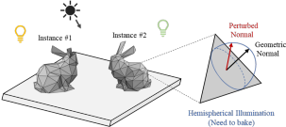
Fig. 2. Normal maps perturb the geometric normals in tangent space, and illumination is calculated based on the perturbed normals. Thus, hemispher- ical illumination is the target we aim to bake. Additionally, since multiple instances of the same model can exist in a scene, operations in the local space must be applicable to all instances.

Formulation. The input data is a triangular mesh within a scene, composed of vertices v1, v2, . . . , vNo . We assume the existence of an

integrable function f : S → R3 that maps each point on the surface S ofthe mesh to its corresponding hemispherical space illumination.
In addition to designing a high-performance illumination recon-
struction scheme that supports low-end platforms, the key question
is how to design an efficient light baking method that uses minimal
storage to achieve high-quality static global illumination. Thus, the
problem can be formulated as an optimization problem, aiming to
tion fˆ(S) and the actual illumination f (S) across the entire surfaceS:Equation (1) Optimization Objective
minimize the diference between the reconstructed global illumina-
min_A loss = ∫_S || L̂(A; p) − L(p) ||² dp
Extended form:
min_A ∫_S ∫_Ω || L̂(A; p, d) − L(p, d) ||² dd dp
where fˆ is the reconstructed illumination with the association pa- rameters 贝 . Eloss is the loss function that measures the similarity between the reconstructed and actual illumination. 贝 represents the result of probe distribution in our work generated in local space for each mesh, specifically the association between vertices and probes through their indices and weights.
Challenges. First, previous works [Cupisz 2012; Games 2024c] based on spherical harmonics perform massive texture sampling within the fragment shader, resulting in significant runtime over- head that is unacceptable for low-end platforms. We need to design a diferentiable illumination reconstruction model that achieves high- quality global illumination while maintaining exceptional runtime efficiency. Second, probe-based methods typically require substan- tial memory usage and often sufer from visual issues such as light leakage and ringing artifacts [Sloan 2008]. Our approach should minimize memory consumption while ensuring visual fidelity. Third, reuse of meshes is very common in practical scenarios. The associa- tion parameters 贝 generated in local space for each mesh should deliver consistent and reliable results across diferent instances of the same mesh. In this way, the association can be constructed offline and embedded within the mesh, avoiding exploring probe distribution in the scene before light building.

3.2 High-performance illumination reconstruction
Existing approaches [Diolatzis et al. 2022; Games 2024c; Zhan et al. 2021] leverage probes (Spherical Harmonics, SH) to store spherical lighting information, achieving excellent illumination efects. How- ever, these methods place a significant load on the fragment shader due to massive pixel-level sampling, which poses performance chal- lenges on low-end platforms. To address the limitation, we propose a vertex-based illumination model that reconstructs illumination us- ing minimal computation, ensuring excellent runtime performance. Additionally, we encode the coefficients to reduce the number of samples while seamlessly supporting Level of Detail(LOD).
Illumination reconstruction function. We treat multiple sets of spherical harmonics (Probes) as higher-dimensional basis functions. The spherical harmonic values at each vertex, denoted as SHvi , are represented as a linear combination of the probes SHi. The association parameters 贝 directly record the relationship between vertices and probes in the form of indices j, k, ..., n and weights wj, wK, ..., wn :
SHvi = wjSHj + wKSHK + ... + wnSHn. (2)

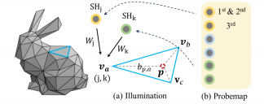
Fig. 3. (a) Retrieve values from the probemap using indices and weights, then decode and combine for illumination calculation. (b) All probe data for the scene is stored seamlessly in a single probemap.

For each point p ∈ S, its spherical harmonic values are inter- polated using the barycentric coordinates b = (bp,a, bp,b, bp,c) of the three vertices va , vb , vc of its containing triangle. In this way, as shown in Figure 3(a), we define the illumination reconstruction formula for point p as:
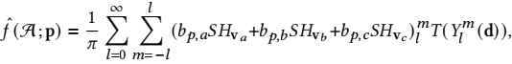
(3)
where ylm (d) represents a spherical harmonics basis function for a given degree l and order m, evaluated at the direction d, and T performs the convolution of a SH with the circularly symmetric function [Sloan 2008].
The formula above enables efficient illumination reconstruction with minimal computational complexity and places more emphasis on the vertex compared to other works [Games 2024c; Majercik et al. 2019]. Moreover, this computation can be performed directly in the base pass without any additional render pass, making it per- fectly suited for forward rendering and well adapted to Tiled-Based Deferred Rendering (TBDR) on mobile chips.
Coeﬁcients encoding & storage. Humans are generally more sensi- tive to the color channel with the highest brightness [Wallace 1991]. Therefore, we store the maximum absolute value among the three color channels of the spherical harmonic coefficients as a multi- plier, using one byte to ensure accuracy. The other coefficients are normalized using this value, allowing us to uniformly control the precision of the spherical harmonic coefficients. Considering that most hardware platforms support high-precision texture formats like R32G32B32A32, we use twelve 10-bits to store the coefficients of the first- and second-order spherical harmonics, while the third- order coefficients are stored using fifteen 8-bits, as shown in Figure 4.
Note that we only need a single multiplication operation to decode the data. This further optimizes the sampling frequency, enabling support for Level of Detail (LOD): distant objects use second-order spherical harmonics with a single texture sample, while closer ob- jects utilize third-order spherical harmonics requiring two texture samples. Additionally, as shown in Figure 3(b), our approach elimi- nates both the gaps in texture [Sloan and Silvennoinen 2018] and the requirement to store multiple textures [Games 2024c;Sloan et al. 2002]. All probe data for the entire scene can be seamlessly stored

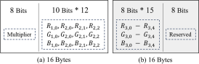
Fig. 4. (a) The first pixel (16 bytes) stores the Multiplier and the coeficients for the first and second orders. (b) The second pixel (16 bytes) stores the coeficients for the third order, leaving 8 bits reserved.

in a single probemap in our work, supporting maximum instance draw and reducing draw call overhead.

3.3 Efective illumination baking
Now, we proceed to bake the illumination information into probes. The baked information will be output through the aforementioned reconstruction function. Since we focus exclusively on the illumina- tion of static objects, unlike existing methods [Games 2024c; Guo et al. 2022], we do not need to bake the complete environmental lighting. Instead, our goal is the precise illumination representation of the object’s surface. Therefore, we only fit the illumination infor- mation along the efective directions of valid sampling points on the surface S. For the illumination across the entire hemisphere, we pri- oritize ensuring accuracy in the direction of the mesh’s normal. Thus, we define the weight for each direction as w (d) = max(0, cos(d, n)), where d is the spherical sampling direction and n is the surface normal. We define the loss function E light as follows:
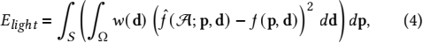
where f (p, d) is the actual illumination of a valid direction d at
sample point p, and fˆ(A;p, d) is the reconstructed illumination
based on the association parameters A.
Considering that global illumination is typically low-frequency and smooth, we introduce a regularization term to ensure visual smoothness. The pixel value is calculated from the vertices using barycentric coordinates in Eqn. (3). Therefore, we only need to constrain the gradient along the geometric normal direction n of the vertices v to ensure smoothness:
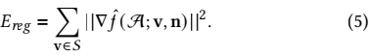
based approach to compute ∇fˆ, which focuses on the gradients of
Inspired by Kavan et al. [Kavan et al. 2011], we adopt the edge-
adjacent triangles in a butterfly-shaped configuration. The calcula-
tion formula is as follows:
(6)
where (t, u) represents a pair of adjacent triangles, at and au are
and Fi is a sparse matrix that FiL = ∇fi. For simplicity, we will use
areas of the triangles, L is the matrix of vertex illumination values
the diference matrix D to represent √at + au (Ft - Fu).
Since the association parameters A of the mesh to be baked are determined in this section, we use the weight matrix W to represent

the association between the vertices and probes. We further express the regularization term Ereg as:
Ereg = | |D · Y′ · W · SH| |2, (7)
where Y′ is the spherical harmonic basis at the vertices after apply- ing the convolution function T [Sloan 2008].
Our final loss function combines the lighting loss and the regu- larization term and the final optimization objective is defined as:
Note that this optimization objective is diferentiable with respect to SH, we can find its global minimum by solving ∂E loss/∂SH = 0, which finally reduces to:
( (w · T (Y) · B · W)T (w · T (Y) · B · W) + λ ( (Y′W)TDTD(Y′W) ) ) SH
= (w · T (Y) · B · W)T · (w · I) (9)
where matrix B represents the barycentric coordinates, matrix I is the actual illumination in the efective directions of valid points, and SH is the matrix of all spherical harmonic coefficients (probe data), which is the target we are solving for. The problem of baking illumination information into probes is successfully reformulated as a classic linear regression problem. Detailed derivation can be found in the supplementary.
In this way, we can efficiently complete the illumination baking. Unlike previous works that compute spherical harmonic coefficients through SH projection [Ramamoorthi and Hanrahan 2001] using uniform sampling in all directions, our method prioritizes the ac- curacy of illumination in the efective directions of valid points, as shown in Figure 5. This approach maximizes the utilization of efec- tive illumination information while ensuring that irrelevant data do not impact the precision of hemispherical illumination within the normal space.

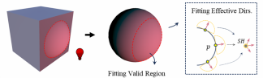
Fig. 5. We fit the values for efective directions of valid sample points, allowing invalid regions or directions to take arbitrary values to ensure the precision.

3.4 Inverse probe distribution
Now, let us perform the object-level probe distribution. Unlike con- ventional probe-based works [Games 2024a,c; Sloan et al. 2002] treating probes as entities in the space, probes in our work serve solely as spherical harmonics for transferring illumination, without including any other information such as position, due to the direct association between vertices and probes. Given that a single mesh model has limited geometric details and the probes are solely re- lated to the mesh rather than the entire scene, we treat the probe

distribution as an optimization problem for the association A in local space.
Loss function. Due to object reuse in a scene is common, we aim for all instances of the same mesh shared the unique association parameters A can achieve consistent and high-quality results. The loss of evaluating the parameters A is defined as:
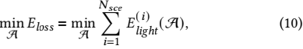
where Nsce scenarios with diferent lighting conditions are con- structed to evaluate the quality.
Geometric prior. Light leakage is a common issue in probe-based methods. To mitigate this problem, we initialize probes based on geometric priors, which shortens optimization time as well. To adapt to our pipeline and ensure efficient illumination reconstruction, we utilize classical machine learning techniques rather than neural processes.
We first apply a K-Medoids clustering method [Lloyd 1982] on the valid sample points:
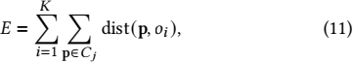
where E is the total cost, representing the sum of distances between each sample point p and its associated medoid oi. K denotes the number of medoids. cj is the cluster of points associated with the jth medoid. This approach positions cluster centers on the mesh surface, enabling efficient distance computation through sampled point connectivity as follows. This clustering occurs as a one-time operation during mesh import, with probes initialized based on the medoids.
Inspired by Iwanicki et al. [Michal Iwanicki and Shirley 2024], we combined the heuristic-based approach of A* [Hart et al. 1968] with the exhaustive search nature of Dijkstra’s algorithm to refine the distance metric. If two sample points are mutually visible, the Euclidean distance will be the distance between them. If they are not visible, they are considered disconnected. This process then con- structs a graph connecting all the sample points. Finally, the distance between two non-visible points is calculated using a pathfinding algorithm among the sample points as shown in Figure 6(c). In this way, we appropriately increased the distance for occluded sample points while maintaining continuity.
After clustering, we calculate the distances to the nearest n medoids (Probes) for each sample point, invert these distances, and normal- ize them to obtain the weights wo1 , wo2 , . . . , won . These weights are then transferred to the vertices using barycentric coordinates:
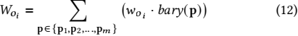
where p1, p2 . . . pm are the sample points within one triangle, woi is the weight of a vertex for probe oi , wo i is the normalized weight of a sample point p for probe oi and bary(p) means the barycentric coordinate at point p. Each vertex needs to be assigned the top n probes with the highest weights as geometric priors to avoid visual discontinuities in Figure 7(a) when the mesh triangles are dense.

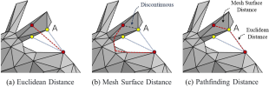
Fig. 6. Red sampling points are not mutually visible. (a) Euclidean distance results in close sampling points, making separation dificult and causing light leakage; (b) Mesh surface distance causes discontinuities at the bound- ary between visible and non-visible points (point A); (c) Visible points use Euclidean distance for graph construction, non-visible points use pathfind- ing to increase occluded point distance, ensuring smooth transitions.

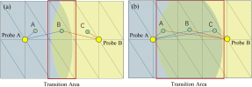
Fig. 7. (a) Each sampling point is associated only with the nearest probe, resulting in transition area existing only in the edge triangles, which would lead to visual artifacts, especially when the mesh triangles are dense. (b) As each sampling point is associated with more probes, the transition area becomes larger, resulting in smoother outcomes.

Optimization. Now, we have preliminarily initialized the associa- tion parameters 贝 between vertices and probes based on geometric prior. We can still use the weight matrix W to represent the associa- tions, but now W is the objective that we need to optimize.
We construct a standard scene with complex lighting, place the mesh into it, and simulate its illumination fitting under various complex scenarios by rotating the mesh. Essentially, this process en- codes geometric information through lighting. The comprehensive loss defined in Eqn. (10) is then calculated. This loss is diferentiable with respect to the matrix W, allowing us to further optimize it using gradient descent. In this way, we efectively mitigate light leakage and reduce the ringing artifacts of spherical harmonics.
Note that our work in this section is conducted entirely in local space after model import, efectively reducing probe redundancy, and ensuring consistent, high-quality results across all instances of the mesh. Meanwhile, the association can be generated offline and embedded into the mesh, avoiding the need to explore probe distribution in the scene.

4 IMPLEMENTATION DETAILS
Sampling density. We use the Blue Noise Sampling method [Chen et al. 2012] to perform uniform sampling on the surface of the mesh. We tested diferent sampling point densities and some of the results are shown in Figure 8. Ultimately, we set 100 points per square meter as our standard.
Probe associations per vertex. We associate each sampling point with the two probes. Thus, each vertex is associated with two probes.

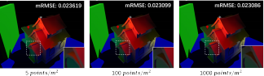
Fig. 8. Visual artifacts are noticeable at lower sampling densities. Beyond 100 points/m2 , further increasing the density yields limited improvements.

The association data for each vertex is stored as indices and weights in R8G8B8A8 format, with 8 bits allocated for the probe index and another 8 bits for the weight. Based on our tests, 256 probes are sufficient to represent even the most complex objects, with most requiring fewer than 30 probes for high-precision representation. The weights and indices are stored by replacing the memory allo- cated for UV2 at each vertex, introducing no additional memory overhead.
Empirical parameter setup. During illumination baking, we set the smoothness regularization weight λ to 0.1. We performed spherical sampling with 960 directions, fitting the illumination for efective directions that are on the same side as the surface normal. In the probe distribution, we built our code framework using LibTorch and employed the Adam optimizer with a learning rate decayed from 0.01 to 0.001, running for 400 iterations. To reduce the computational overhead during iterations, the probe distribution optimization used spherical sampling with 120 directions, fitting illumination for ef- fective directions with angles less than 30 degrees relative to the surface normal.
Baking process time. Our work consists of two main components during the production process: probe distribution and light baking. We provide the timing details of our current implementation for reference. The time can vary significantly depending on the specific implementation and hardware setup. First, the time required for probe distribution for each mesh is typically within 2 minutes. Since this is a one-time task performed in the local space after mesh import, it does not afect the production process. Second, the baking time we recorded for scenarios as shown in Table 1. The baking time of our work is comparable to that of the Directional Lightmap [Games 2024b] (the official implementation in Unreal Engine). Note that both of the aforementioned tasks are part of the production process and are conducted offline. The runtime performance of our work will be detailed in Section 5.

Table 1. The baking time obtained from a single PC equipped with an i9- 10980XE CPU, an RTX 3090 GPU, and 128 GB of RAM.
Sun Temple
Small Scene
Large Scene
Egypt

Lightmap | 16mins | 19mins | 13mins | 80mins
Ours | 21mins | 25mins | 19mins | 107mins

5 RESULTS
The implementation of this work was developed on Unreal Engine 4.27. We first demonstrate the efectiveness of our method on indi- vidual objects, followed by results of entire scenes. Next, we provide performance evaluations of our method on mobile devices.

5.1 Illumination quality evaluation
Ground truth. We performed high-density sampling on the mesh surface S and recorded the radiance values obtained from ray trac- ing for each sample point using third-order spherical harmonics, serving as the numerical ground truth for quantitative analysis. The visual reference ground truth is computed based on the directions perturbed by the normal map.
Using this ground truth as a standard reference, we compare our work with the current mainstream methods, Directional Lightmaps (Lightmap) [Sloan and Silvennoinen 2018] and Volumetric Lightmaps (VLM) [Games 2024c], which share the same source data.
Evaluation metrics. We defined a multi-directional RMSE (mRMSE) to assess the results. This metric evaluates the quality of hemispher- ical illumination within the hemisphere defined by the geometric normal, thereby assessing the lighting quality after perturbations caused by normal maps. The calculation formula is as follows:
mRMSE = 丨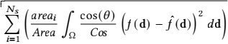 (13)
where Ns is the number of sampling points, 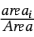 and 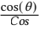 respec-
angles, f (d) and fˆ(d) are the ground truth and the illumination
tively represent the normalizations over the area and hemispherical
reconstructed. Lower mRMSE values indicate higher accuracy in
the global illumination baking. The details can be found in the
supplementary.
Note that we directly compare the diferences between the re- constructed values and the numerical ground truth, rather than evaluating the final rendered image. This metric transcends spe- cific image spaces, allowing for a comprehensive evaluation across the entire object. Additionally, it eliminates the influence of other rendering factors, enabling a more precise and efficient comparison.
Results of single mesh. We tested various individual models with diferent complexities and types under complex lighting conditions. The quantitative results are presented in Table 2, while the corre- sponding visual efects are shown in Figure 14.
Results of entire scene. We applied our work to entire scenes (all static objects). We present a visual comparison with mainstream industry methods in Figure 15.

5.2 Performance evaluation
Directional Lightmap (Lightmap) [Sloan and Silvennoinen 2018] achieves top-tier runtime performance among existing methods due to its reliance solely on UV coordinates for texture lookups. Using Snapdragon Profiler, we tested our approach in the Sun Temple scene (Table 3) and measured frame rates on four mobile devices (Table 4) in a large game map (2km × 2km). By comparison, our method alleviates the burden on the fragment shader, performing efficiently on low-end platforms.

Table 2. Quantitative Results of mRMSE. Tests were conducted on models of varying complexity under complex lighting, comparing our work (Probes: 20, 30) with 6x6 ASTC-compressed Directional Lightmap (Resolutions: 64, 128, 256) and two diferent VLM densities (Mesh-surrounding probe counts only, with memory usage shown in parentheses in the table). All memory usage in the table is measured in kilobytes (KB).

mRMSE↓  Mesh | Mem. | Lightmap |  |  | VLM |  | Ours
 | 2.67KB | 10.68KB | 42.72KB | - | - | 0.63KB | 0.94KB
Befreiung 0.045 |  | 0.041 | 0.039 0.041(2.0KB) |  | 0.032(10KB) 0.027 |  | 0.025
Bunny | 0.047 | 0.046 | 0.045 | 0.043(2.0KB) | 0.034(16KB) | 0.031 | 0.029
Watchtower | 0.055 | 0.038 | 0.030 | 0.044(4.0KB) | 0.041(9KB) | 0.041 | 0.039
Statue | 0.033 | 0.031 | 0.029 | 0.027(6.6KB) | 0.021(16KB) | 0.021 | 0.021
Townhall | 0.052 | 0.040 | 0.034 | 0.072(3.1KB) | 0.047(9KB) | 0.038 | 0.036
Guard | 0.072 | 0.058 | 0.047 | 0.060(4.0KB) | 0.047(9KB) | 0.053 | 0.050
Wall | 0.035 | 0.035 | 0.034 | 0.049(2.3KB) | 0.053(15KB) | 0.035 | 0.031
Angle | 0.041 | 0.035 | 0.034 | 0.032(3.8KB) | 0.027(9KB) | 0.021 | 0.020
AVG. ↓ | 0.048 | 0.041 | 0.037 | 0.046(3.5KB) | 0.038(12KB) | 0.033 | 0.031
Table 3. The performance statistics on Samsung Galaxy S21 with the Qual- comm Snapdragon 888 and Adreno 660 GPU. We analyzed the number of texture samples for each vertex (V.) and fragment (F.), as well as the shading time consumption ratio for vertices and fragments. We efectively reduced the workload on the fragment shader, achieving ideal results in memory read bandwidth (BW.) per frame (Frm.) and basepass (B.) time.

 | Tex. Samps. ↓ |  | Shading % |  | Mem. Read BW. ↓  Mem./Frm. (MB) | B. Time ↓  Time (ms)
 | Tex./V. | Tex./F. | V.(%) | F.(%)
VLM 0.613 |  | 12.20 1.91 |  | 98.09 43.2 6.83
Lightmap | 0.657 | 5.14 | 3.31 | 96.69 | 43.1 | 5.12
Ours (LOD 1) | 1.239 | 3.08 | 5.22 | 94.78 | 42.7 | 4.95
Ours (LOD 0) | 1.315 | 3.08 | 6.34 | 93.66 | 42.7 | 5.66
Table 4. The performance test on mobile platforms. For each device, the frame rate (FPS) represents the average value across multiple identical units. Our work achieves performance comparable to that of the Lightmap, enabling good support for low-end devices.
GalaxyS9+ Avg. ↑
FindX3Pro
Pixel6Pro
Mi 6

Lightmap | 55.96 | 18.70 | 51.36 | 15.03 | 35.26
Ours | 55.67 | 16.46 | 52.36 | 22.13 | 36.65

5.3 Ablation study

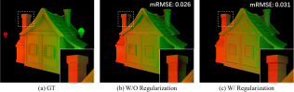
Fig. 9. The Impact of Gradient Regularization (Forge with 40 probes, 1.25 KB). Without regularization (b), lower loss results in noticeable unsmooth visual artifacts.
Gradient regularization. We validated the impact of the regular- ization term in Eqn. (7). As shown in Figure 9, the baking method without the regularization term focuses solely on the numerical

accuracy of the illumination, disregarding visual smoothness. While the error is numerically lower without regularization, it introduces noticeable visual artifacts.
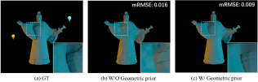
Fig. 10. The Impact of Geometric Prior (Statue with 50 probes, 1.56KB). Without geometric prior (b), light leakage remains an issue after 5000 epochs. By initializing probes with the geometric prior and then optimizing (c), satisfactory associations are achieved in just 400 epochs.
Geometric prior. We show the impact of the geometric prior men- tioned in Section 3.4 in Figure 10. By initializing probes with geo- metric priors and further optimizing through gradient descent, light leakage is efectively reduced, and the optimization time is signifi- cantly shortened. This result also demonstrates the efectiveness of our probe distribution strategy.

5.4 Discussion and limitations
No UV mapping requirement. Our work relies on geometric vertices, removing the need for UV mapping. Traditional workflows require precise, non-overlapping UV maps, which consume storage, waste memory due to gaps, and are time-intensive to create. Our approach saves both storage space and production time related to UV mapping.
Time of Day support. Our work enables straightforward imple- mentation of Time of Day (TOD) efects by interpolating between probemaps, as shown in Figure 11. This process can be efficiently conducted in the compute shader for the entire scene (or a large region in current use) due to its small texture size, ensuring that it does not impose any burden or shader complexity on per object drawing. For example, we achieved global illumination for the en- tire scene’s day-night cycle by interpolating among 8 probemaps (corresponding to 8 diferent time points), as shown in Figure 12.
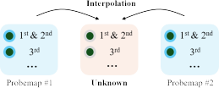
Fig. 11. The probemap at a given moment is derived through interpolation between the known probemaps of adjacent time points.
Visual quality across different meshes. The visual quality of our method is determined by the number of probes and the vertex den- sity of the mesh. Unlike existing approaches, our method performs better on complex models with denser meshes. For extremely sim- ple meshes, higher accuracy can be achieved by applying simple

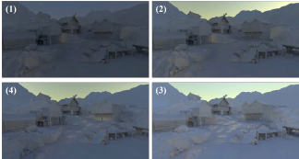
Fig. 12. Time of the Day in LightingTutorial Scene. Our work requires only 4MB of memory (0.5MB × 8) to realize the day-night global illumination efect. In contrast, the traditional lightmap method requires 18MB of mem- ory usage for a single time point at comparable quality.

subdivision operations to increase mesh density, but this will also increase the geometric memory usage. In our engineering practice, models satisfying the vertex density criteria constitute more than 95% of the scene and using traditional methods for extremely simple meshes is a better choice. For meshes that do not require reuse or are highly complex, we can opt for targeted optimization, such as distributing probes based on the actual lighting environment. This will efectively reduce the number of light probes while improving lighting quality.
Dynamic objects. Our work mainly focuses on static objects. For dynamic objects in mobile games, which are often augmented with supplementary lighting, the reliance on global illumination (GI) is less critical compared to static objects. Simpler GI solutions are typi- cally more suitable for low-end platforms, such as Indirect Lighting Cache (ILC), which conduct an interpolation for the whole compo- nent. As for extending our work to dynamic objects, we consider interpolating SH values from the surrounding environment to be a viable approach.
Potential LOD popping. Given that visual requirements on low-end platforms are generally less stringent, and the impact of global illu- mination (GI) transitions is less pronounced than that of mesh level of detail (LOD) changes, our work simply applies probe distribution to each level of the mesh, which may lead to potential popping phenomena. We consider simplifying the probe distribution from LOD0 to be a valuable task, as it can save optimization time and ensure smoother transitions. We will investigate this further in the future.
High-frequency detail limitation. Due to the constraints of spheri- cal harmonics (SH) and the vertex-probe structure, it is difficult for our work to represent high-frequency details such as sharp shadows. We explored using a lightweight neural network to address this is- sue but found it challenging to balance performance and quality. Considering that this limitation is not critical for low-end platforms, we did not conduct further exploration and leave this problem for future work.

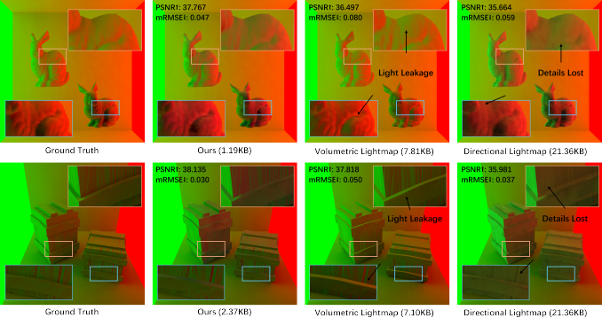
Fig. 13. The results of multiple objects in a Cornell Box with the left and right walls as emissive light sources. Our work efectively reduces light leakage and preserves more details. Compared to PSNR, mRMSE is more sensitive to light leakage due to the hemispherical lighting information of the whole object.
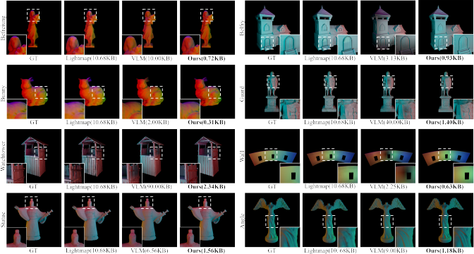
Fig. 14. The results of single mesh. Each mesh was exposed to over three light sources. Our work was tested on various types of models with diferent characteristics, such as polygon count and the presence of occlusions, consistently achieving satisfactory global illumination with minimal memory usage.

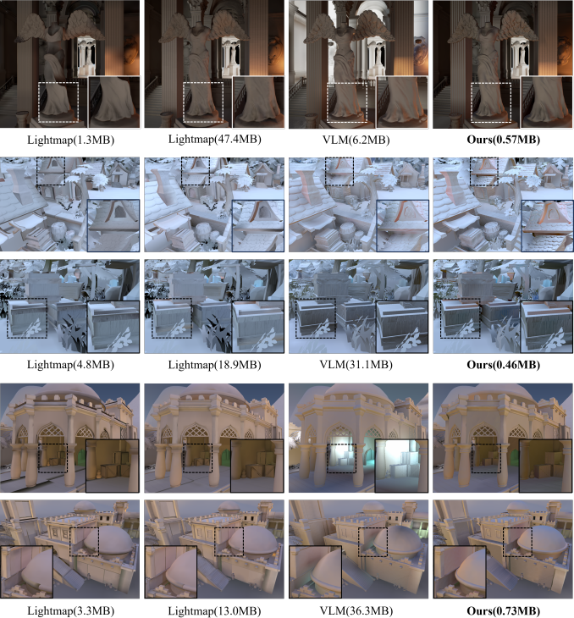

Fig. 15. The results of entire scenes. We conducted tests in Unreal Engine’s Sun Temple, Summer HandPainted Environment, and Stylized Egypt. Compared to other mainstream methods, our work achieves fully usable visual efects with minimal memory usage.

6 CONCLUSION
In this paper, we present a new static global illumination solution tailored for low-end platforms. We introduce a novel illumination baking model that achieves high-precision fitting for efective illumi- nation and formulate probe distribution as an optimization problem, enabling inverse probe placement in local space. Thanks to our efficient illumination reconstruction method and fitting strategy, our method achieves high performance while maintaining precision and supporting Level of Detail (LOD). Moreover, it delivers highly competitive lighting efects with an extremely low memory usage and efectively reduces sampling in fragment shader. This makes our work highly suitable for addressing the static global illumination requirements of low-end platforms.
The demand for high-quality virtual scenes on mobile devices is rapidly increasing. However, most existing works focus on PC plat- forms, aiming for higher-quality lighting efects, leaving very lim- ited options for low-end platforms. Therefore, designing pipelines around high performance and low memory usage is both valuable and challenging. We hope our work can inspire further exploration in the lightweight optimization.

Acknowledgments
We thank the reviewers for the valuable comments. We thank the Activision Research, whose previous work greatly inspired us. This work was supported in part by the National Key R&D Program of China (No. 2022YFB3303400).

References
Hao Chen and Xinguo Liu. 2008. Lighting and material of Halo 3. In ACM SIGGRAPH 2008 Games. 1–22.
Zhonggui Chen, Zhan Yuan, Yi-King Choi, Ligang Liu, and Wenping Wang. 2012. Variational Blue Noise Sampling. IEEE Transactions on Visualization and Computer Graphics 18, 10 (2012), 1784–1796.
Robert Cupisz. 2012. Light Probe Interpolation Using Tetrahedral Tessellations. In Game Developers Conference.
Roc R Currius, Dan Dolonius, Ulf Assarsson, and Erik Sintorn. 2020. Spherical gaussian light-field textures for fast precomputed global illumination. In Computer Graphics Forum, Vol. 39. Wiley Online Library, 133–146.
Stavros Diolatzis, Julien Philip, and George Drettakis. 2022. Active exploration for neural global illumination of variable scenes. ACM Transactions on Graphics (TOG)
41, 5 (2022), 1–18.
Epic Games. 2024a. Indirect Lighting Cache in Unreal Engine. https: //dev.epicgames.com/documentation/en-us/unreal-engine/indirect-lighting- cache-in-unreal-engine. Accessed: December 24, 2024.
Epic Games. 2024b. Understanding Lightmapping in Unreal Engine.
https://dev.epicgames.com/documentation/en-us/unreal-engine/understanding-
lightmapping-in-unreal-engine. Accessed: December 24, 2024.
Epic Games. 2024c. Volumetric Lightmaps in Unreal Engine. https://dev.epicgames.com/ documentation/en-us/unreal-engine/volumetric-lightmaps-in-unreal-engine. Ac- cessed: December 24, 2024.
Mickael Gilabert and Nikolay Stefanov. 2012. Deferred Radiance Transfer Volumes. In Game Developers Conference.
Otavio Good and Zachary Taylor. 2005. Optimized photon tracing using spherical harmonic light maps. In ACM SIGGRAPH 2005 Sketches. 53–es.
Jonathan Granskog, Fabrice Rousselle, Marios Papas, and Jan Novák. 2020. Composi- tional neural scene representations for shading inference. ACM Trans. Graph. 39, 4, Article 135 (Aug. 2020), 13 pages.
Jie Guo, Zijing Zong, Yadong Song, Xihao Fu, Chengzhi Tao, Yanwen Guo, and Ling-Qi Yan. 2022. Efficient Light Probes for Real-Time Global Illumination. ACM Trans. Graph. 41, 6, Article 202 (Nov. 2022), 14 pages.
Peter E. Hart, Nils J. Nilsson, and Bertram Raphael. 1968. A Formal Basis for the Heuristic Determination of Minimum Cost Paths. IEEE Transactions on Systems Science and Cybernetics 4, 2 (1968), 100–107.
John T Hooker. 2016. Volumetric global illumination at Treyarch. Advances in Real-Time Rendering (2016).

Michal Iwanicki. 2013. Lighting technology of the last of us. In ACM SIGGRAPH 2013 Talks.
Michał Iwanicki and Peter-Pike Sloan. 2017a. Ambient Dice. In Eurographics Symposium on Rendering.
Michał Iwanicki and Peter-Pike Sloan. 2017b. Precomputed lighting in Call of Duty: Infinite Warfare. SIGGRAPH Advances in Real-Time Rendering in Games course (2017).
Ladislav Kavan, Adam W Bargteil, and P-P Sloan. 2011. Least squares vertex baking. In Computer Graphics Forum, Vol. 30. Wiley Online Library, 1319–1326.
Bernhard Kerbl, Georgios Kopanas, Thomas Leimkühler, and George Drettakis. 2023. 3d gaussian splatting for real-time radiance field rendering. ACM Trans. Graph. 42, 4 (2023), 139–1.
Julian Knodt, Zherong Pan, Kui Wu, and Xifeng Gao. 2023. Joint UV Optimization and Texture Baking. ACM Trans. Graph. 43, 1, Article 2 (Sept. 2023), 20 pages. https://doi.org/10.1145/3617683
Dimitar Lazarov. 2011. Physically-based lighting in call of duty: Black ops. SIGGRAPH Advances in Real-Time Rendering in Games course (2011).
Yue Li, Pablo Wiedemann, and Kenny Mitchell. 2019. Deep Precomputed Radiance Transfer for Deformable Objects. Proc. ACM Comput. Graph. Interact. Tech. 2, 1, Article 3 (June 2019), 16 pages. https://doi.org/10.1145/3320284
Zhengqin Li, Li Yu, Mikhail Okunev, Manmohan Chandraker, and Zhao Dong. 2023. Spatiotemporally consistent hdr indoor lighting estimation. ACM Transactions on Graphics 42, 3 (2023), 1–15.
Ligang Liu, Lei Zhang, Yin Xu, Craig Gotsman, and Steven J Gortler. 2008. A local/global approach to mesh parameterization. In Computer graphics forum, Vol. 27. Wiley Online Library, 1495–1504.
Songrun Liu, Zachary Ferguson, Alec Jacobson, and Yotam I Gingold. 2017. Seamless: seam erasure and seam-aware decoupling of shape from mesh resolution. ACM Transactions on Graphics (TOG) 36, 6 (2017), 216:1–216:15.
S. Lloyd. 1982. Least squares quantization in PCM. IEEE Transactions on Information Theory 28, 2 (1982), 129–137.
Tao Lu, MulinYu, Linning Xu, Yuanbo Xiangli, Limin Wang, Dahua Lin, and Bo Dai. 2024. Scafold-gs: Structured 3d gaussians for view-adaptive rendering. In Proceedings of the IEEE/CVF Conference on Computer Vision and Pattern Recognition. 20654–20664. Zander Majercik, Jean-Philippe Guertin, Derek Nowrouzezahrai, and Morgan McGuire.
2019. Dynamic difuse global illumination with ray-traced irradiance fields. Journal of Computer Graphics Techniques 8, 2 (2019).
Air Silvennoinen Michal Iwanicki, Peter-pike Sloan and Peter Shirley. 2024. Neural Light Grid. SIGGRAPH 2024 Course.
Gilles Rainer, Adrien Bousseau, Tobias Ritschel, and George Drettakis. 2022. Neural precomputed radiance transfer. In Computer graphics forum, Vol. 41. Wiley Online Library, 365–378.
Ravi Ramamoorthi and Pat Hanrahan. 2001. An efficient representation for irradi- ance environment maps. In Proceedings of the 28th Annual Conference on Computer Graphics and Interactive Techniques (SIGGRAPH ’01). Association for Computing Machinery, New York, NY, USA, 497–500.
Nicolas Ray, Vincent Nivoliers, Sylvain Lefebvre, and Bruno Lévy. 2010. Invisible seams. In Computer Graphics Forum, Vol. 29. Wiley Online Library, 1489–1496.
Tobias Ritschel, Carsten Dachsbacher, Thorsten Grosch, and Jan Kautz. 2012. The State ofthe Art in Interactive Global Illumination. Comput. Graph. Forum 31, 1 (Feb. 2012), 160–188.
Carlos Rodriguez-Pardo, Javier Fabre, Elena Garces, and Jorge Lopez-Moreno. 2023. NEnv: Neural Environment Maps for Global Illumination. In Computer Graphics Forum, Vol. 42. Wiley Online Library, e14883.
Vincent Sitzmann, Michael Zollhöfer, and Gordon Wetzstein. 2020. Scene Represen- tation Networks: Continuous 3D-Structure-Aware Neural Scene Representations.
arXiv:1906.01618 [cs.CV] https://arxiv.org/abs/1906.01618
Peter-Pike Sloan. 2008. Stupid spherical harmonics (sh) tricks. In Game developers conference, Vol. 9. 42.
Peter-Pike Sloan, Jan Kautz, and John Snyder. 2002. Precomputed radiance transfer for real-time rendering in dynamic, low-frequency lighting environments. ACM Trans. Graph. 21, 3 (July 2002), 527–536. https://doi.org/10.1145/566654.566612
Peter-Pike Sloan, Ben Luna, and John Snyder. 2005. Local, deformable precomputed radiance transfer. ACM Transactions on Graphics (TOG) 24, 3 (2005), 1216–1224.
Peter-Pike Sloan and Ari Silvennoinen. 2018. Directional lightmap encoding insights. In SIGGRAPH Asia 2018 Technical Briefs (Tokyo, Japan) (SA ’18). Association for Computing Machinery, New York, NY, USA, Article 12, 3 pages.
Shuran Song and Thomas Funkhouser. 2019. Neural illumination: Lighting prediction for indoor environments. In Proceedings of the IEEE/CVF Conference on Computer Vision and Pattern Recognition. 6918–6926.
Michal Valient. 2014. Taking Killzone: Shadow Fall Image Quality into the Next Gener- ation. In Game Developers Conference.
Gregory K Wallace. 1991. The JPEG still picture compression standard. Commun. ACM 34, 4 (1991), 30–44.
Youxin Xing, Gaole Pan, Xiang Chen, Ji Wu, Lu Wang, and Beibei Wang. 2024. Real- time all-frequency global illumination with radiance caching. Computational Visual

Media 10, 5 (2024), 923–936. https://doi.org/10.1007/s41095-023-0367-z
Zinuo You, Geiger andreas, and Anpei Chen. 2024. NeLF-Pro: Neural Light Field Probes for Multi-Scale Novel View Synthesis. In 2024 IEEE/CVF Conference on Computer Vision and Pattern Recognition (CVPR). 19833–19843.

Fangneng Zhan, Changgong Zhang, Yingchen Yu, Yuan Chang, Shijian Lu, Feiying Ma, and Xuansong Xie. 2021. Emlight: Lighting estimation via spherical distribution approximation. In Proceedings of the AAAI Conference on Artificial Intelligence, Vol. 35. 3287–3295.

