# LAB1: Develop a Java program that prints all real solutions to the quadratic equation ax2+bx+c = 0. Read in a, b, c and use the quadratic formula. If the discriminate b2- 4ac is negative, display a message stating that there are no real solutions.

ANS:

import java.util.Scanner;

public class RootsOfQuadraticEquation { public static void main(String args[]){

double secondRoot = 0, firstRoot = 0; Scanner sc = new Scanner(System.in); System.out.println("Enter the value of a ::"); double a = sc.nextDouble();

System.out.println("Enter the value of b ::"); double b = sc.nextDouble();

System.out.println("Enter the value of c ::"); double c = sc.nextDouble();

double determinant = (b*b)-(4*a*c); double sqrt = Math.sqrt(determinant);

if(determinant>0){

firstRoot = (-b + sqrt)/(2*a); secondRoot = (-b - sqrt)/(2*a);

System.out.printf("Roots are Real and Distinct: %.4f and %.4f",firstRoot,secondRoot);

}else if(determinant == 0){

System.out.printf("Roots are Real and Equal: %.4f and %.4f",firstRoot,secondRoot);

}

else if(determinant<0){

System.out.println("Roots are complex and imaginary");

}

}

}

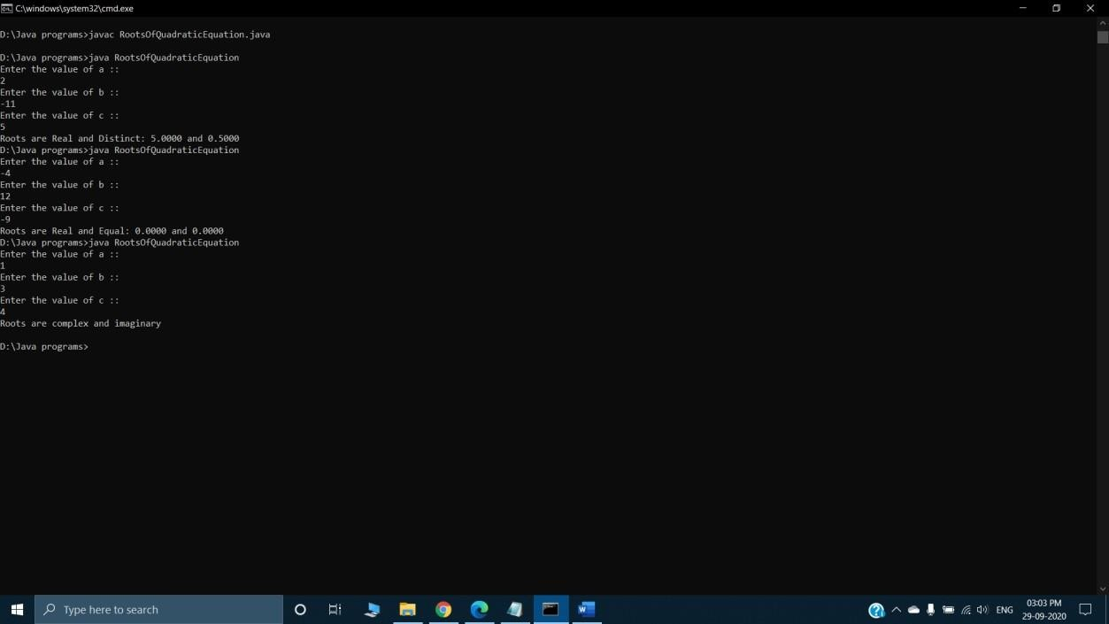

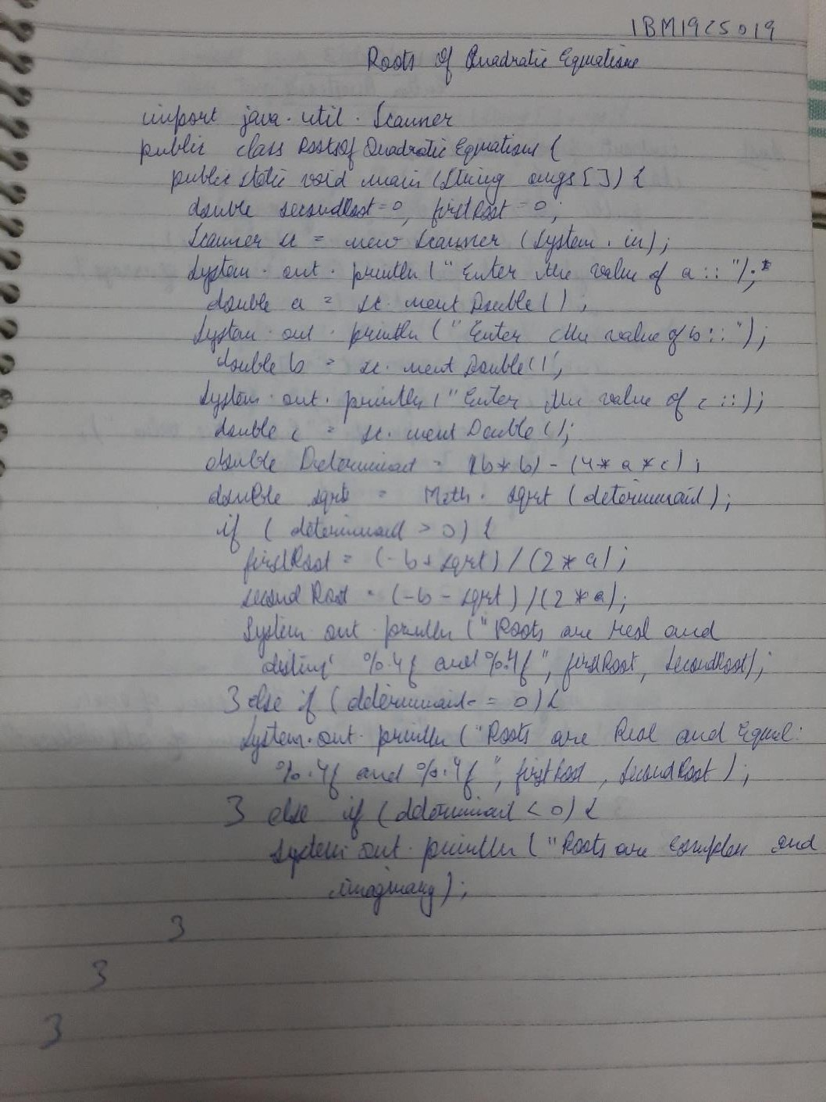

# LAB2: Develop a Java program to create a class Student with members usn, name, an array credits and an array marks. Include methods to accept and display details and a method to calculate SGPA of a student.

ANS:

import java.util.Scanner; class Student{

int i,n,res1=0,res2=0; double res;

String usn; String name; int credits[]; double marks[]; int gp[];

void getdata(){

Scanner sc=new Scanner(System.in); System.out.println("Enter the number of subjects"); n=sc.nextInt();

credits=new int[n]; marks=new double[n]; gp=new int[n];

System.out.println("Enter your usn no:"); usn=sc.next();

System.out.println("Enter your name:"); name=sc.next();

for(i=0;i<n;i++){

System.out.println("Enter your credits for subject:"); credits[i]=sc.nextInt();

System.out.println("Enter your marks out of 100 in subject:"); marks[i]=sc.nextDouble();

}

}

void printdata(){ System.out.println("Student details:"); System.out.println("USN:"+usn); System.out.println("Name:"+name); for(i=0;i<n;i++){

System.out.println("your credits for subject:"+credits[i]); System.out.println("your marks out of 100 in subject:"+marks[i]);

}

}

void sgpa(){ for(i=0;i<n;i++){

if(marks[i]<=100 && marks[i]>=90) gp[i]=10;

else if(marks[i]>=80) gp[i]=9;

else if(marks[i]>=70) gp[i]=8;

else if(marks[i]>=60) gp[i]=7;

else if(marks[i]>=50) gp[i]=6;

else if(marks[i]>=40) gp[i]=4;

else if(marks[i]<40) gp[i]=0;

}

for(i=0;i<n;i++) res1+=credits[i];

for(i=0;i<n;i++){ res2+=(credits[i]*gp[i]);

}

//res=(double)(res2/res1); System.out.println("SGPA:"+(double)res2/res1);

}

}

class Testj{

public static void main(String[] args) { Student stu=new Student(); stu.getdata();

stu.printdata(); stu.sgpa();

}

}



:ñ

O

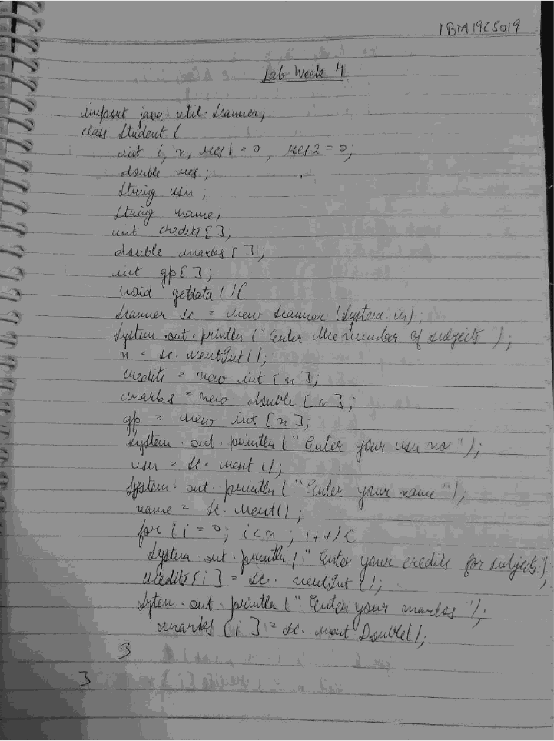

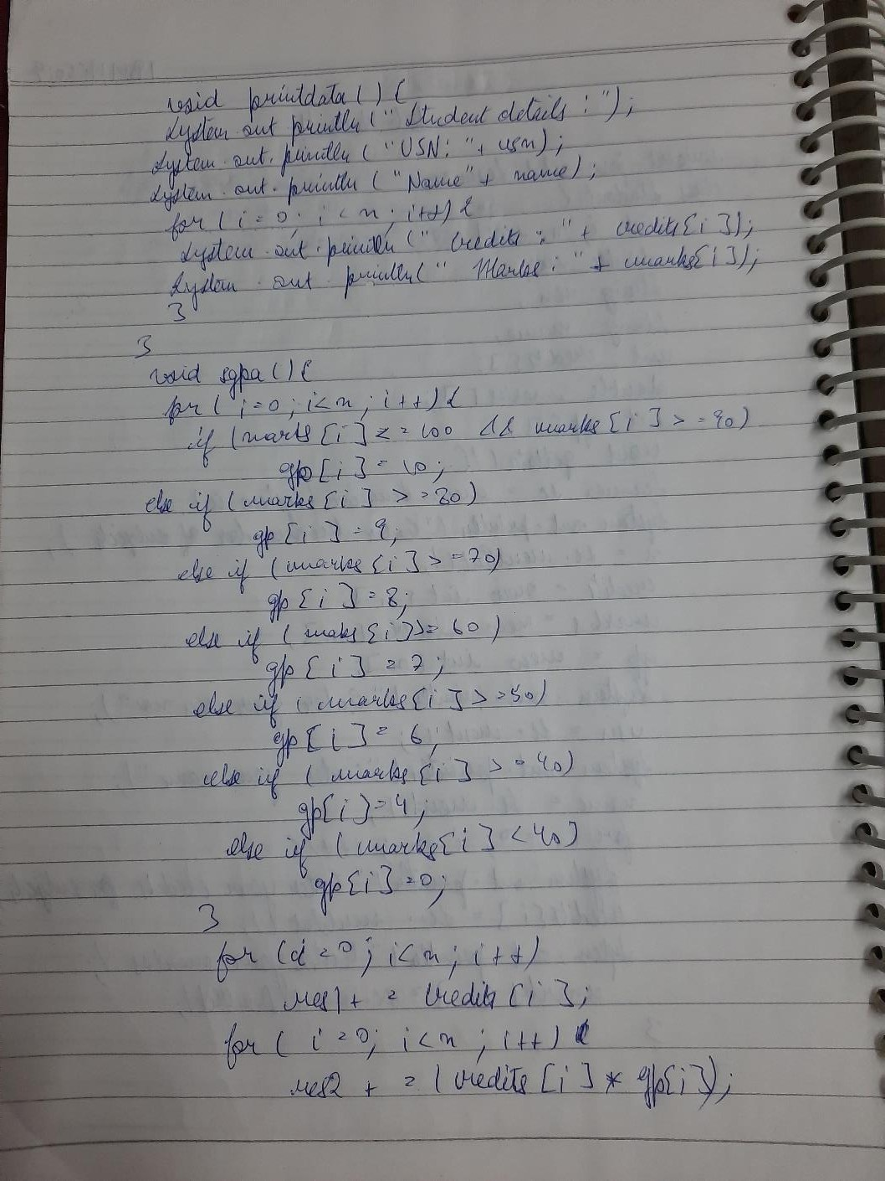

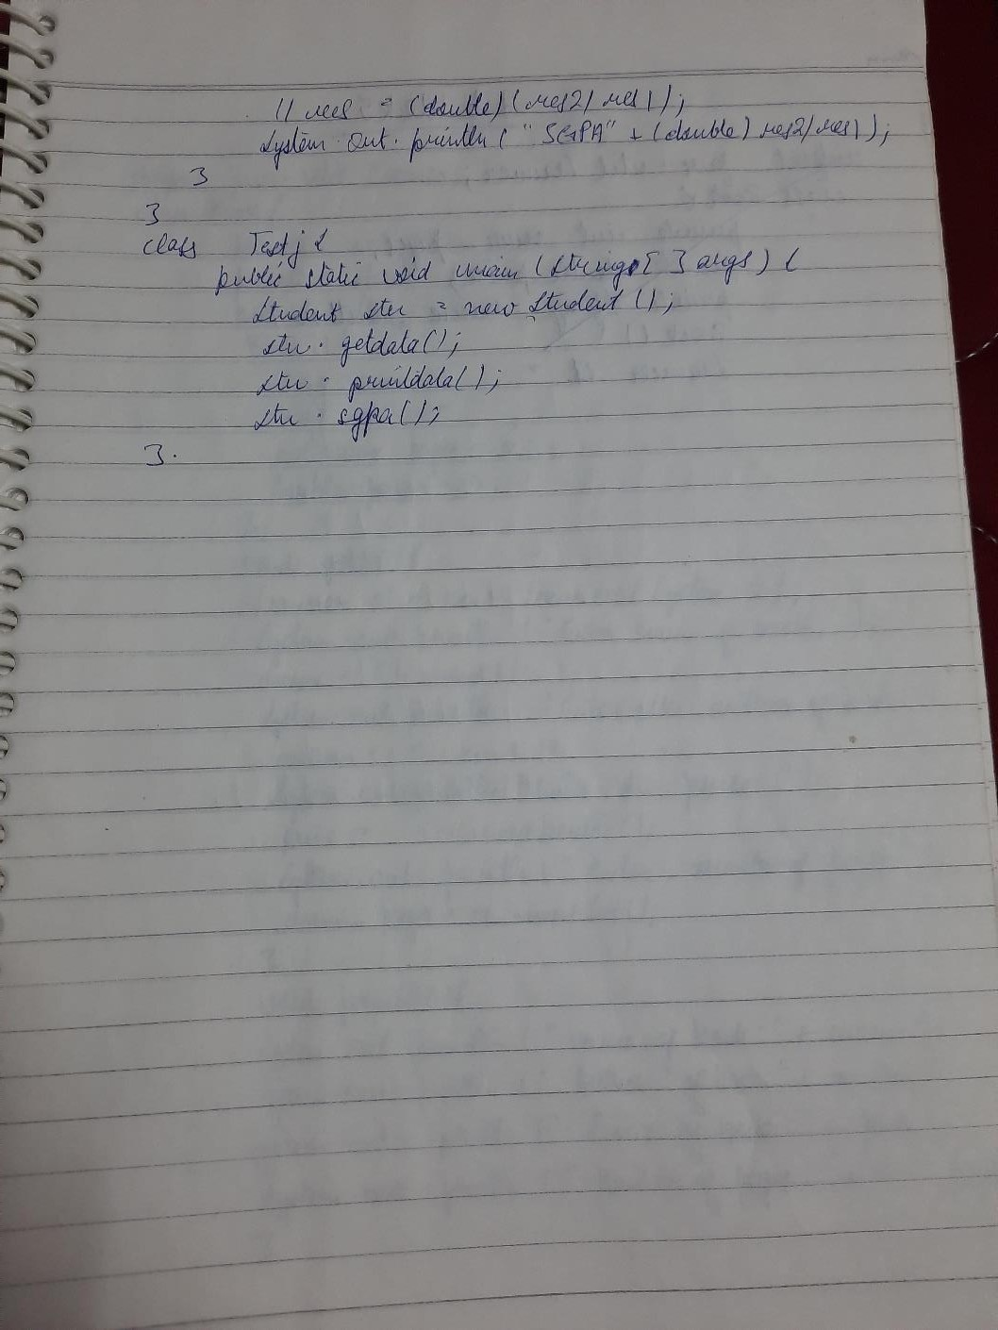

# LAB3: Create a class Book which contains four members: name, author, price, num_pages. Include a constructor to set the values for the members. Include methods to set and get the details of the objects. Include a toString( ) method that could display the complete details of the book. Develop a Java program to create n book objects.

ANS:

import java.util.Scanner; class Book{

private int num_pages;

private double price; private String name,author;

Book(){

String name=""; String author=""; double price=0; int num_pages=0;

}

void getd(){

Scanner s1=new Scanner(System.in); System.out.println("Enter the name of book:"); name=s1.next();

System.out.println("Enter the author of book:"); author=s1.next();

System.out.println("Enter the price of book:"); price=s1.nextDouble();

System.out.println("Enter the number pages in book:"); num_pages=s1.nextInt();

}

void printd(){

System.out.println("Name of book:"+name); System.out.println("Author of book:"+author); System.out.println("Price of book:"+price); System.out.println("Number of pages in book:"+num_pages);

}

public String toString(){

return name+" "+author+" "+price+" "+num_pages;

}

}

class Testj{

public static void main(String[] args) { int i,num;

Scanner s2=new Scanner(System.in); System.out.println("Enter the number of books"); num=s2.nextInt();

Book[] bk=new Book[num]; for(i=0;i<num;i++){

bk[i]=new Book();

bk[i].getd();

}

for(i=0;i<num;i++) bk[i].printd(); for(i=0;i<num;i++)

System.out.println(bk[i]);

}

}

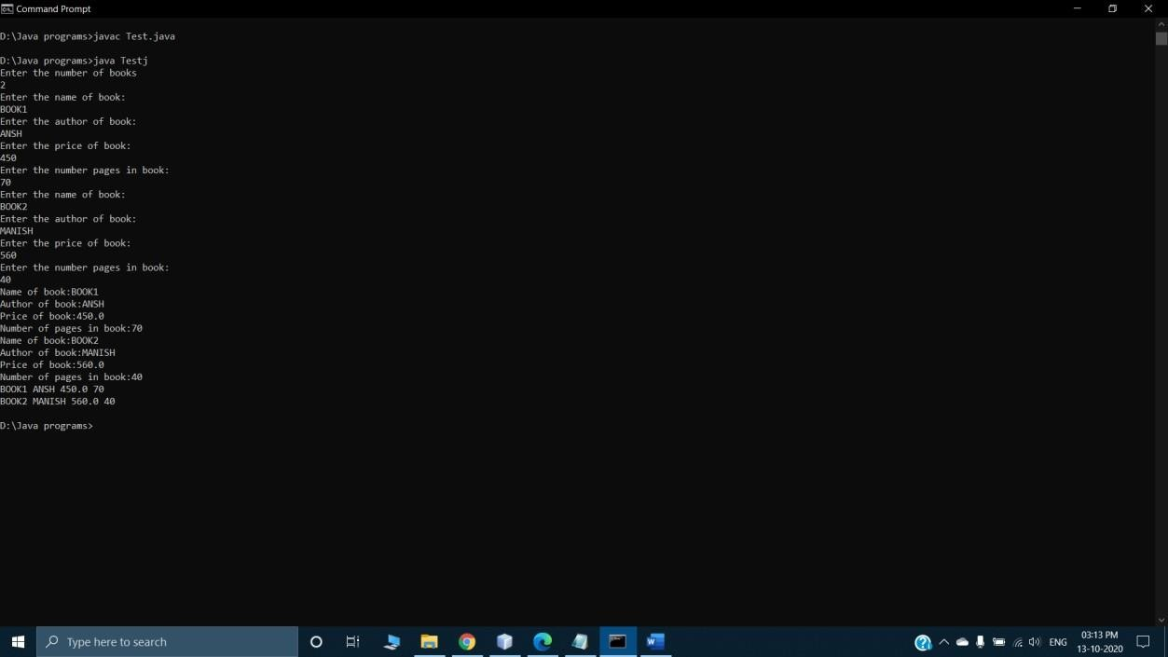

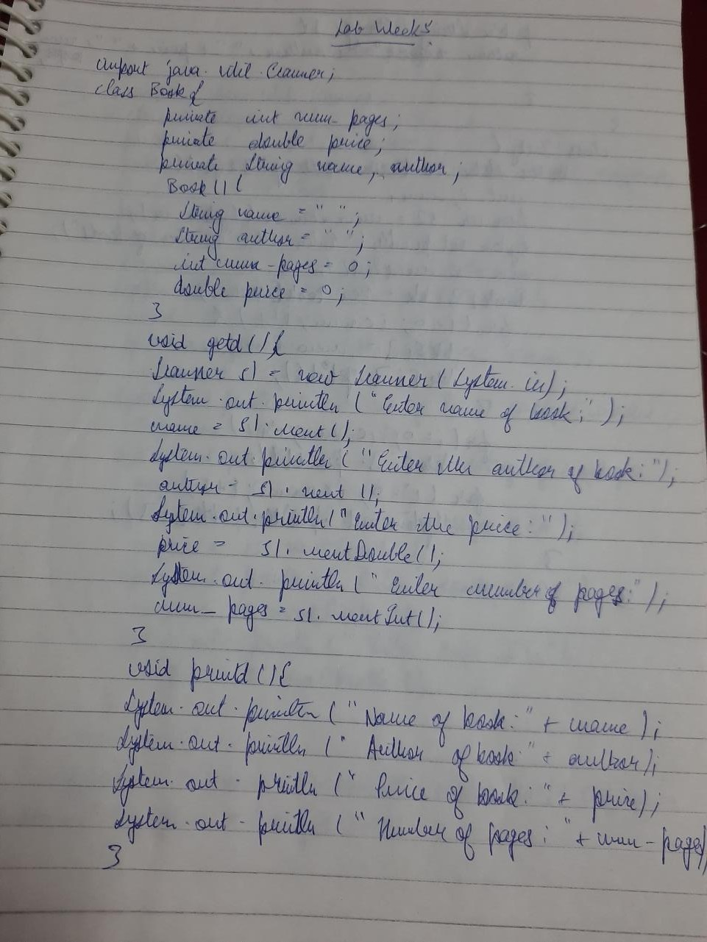

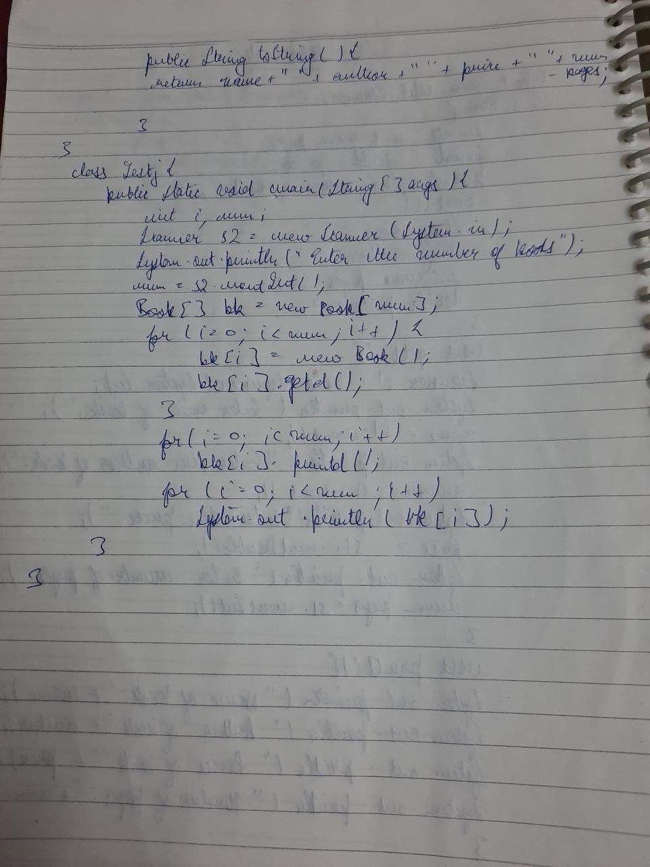

# LAB 4: Develop a Java program to create an abstract class named Shape that contains two integers and an empty method named printArea( ). Provide three classes named Rectangle, Triangle and Circle such that each one of the classes extends the class Shape. Each oneof the classes contain only the method printArea( ) that prints the area of the given shape.

ANS :

ANS 4:-

import java.util.Scanner; abstract class shape{

int a;

int b;

abstract void printArea();

}

class rectangle extends shape{ Scanner sc=new Scanner(System.in); void printArea(){

System.out.println("Enter the length of rectangle:"); a=sc.nextInt();

System.out.println("Enter the breadth of rectangle:"); b=sc.nextInt();

System.out.println("Area:"+a*b);

}

}

class triangle extends shape{

Scanner sc=new Scanner(System.in); void printArea(){

System.out.println("Enter the base of triangle:"); a=sc.nextInt();

System.out.println("Enter the height of triangle:"); b=sc.nextInt(); System.out.println("Area:"+(a*b)/2);

}

}

class circle extends shape{ double res;

Scanner sc=new Scanner(System.in); void printArea(){

System.out.println("Enter the radius of circle:"); a=sc.nextInt();

res=(double)3.14*(a*a); System.out.println("Area:"+res);

}

}

class Testj{

public static void main(String args[]){ rectangle r=new rectangle(); triangle t=new triangle();

circle c=new circle(); r.printArea(); t.printArea(); c.printArea();

}

}

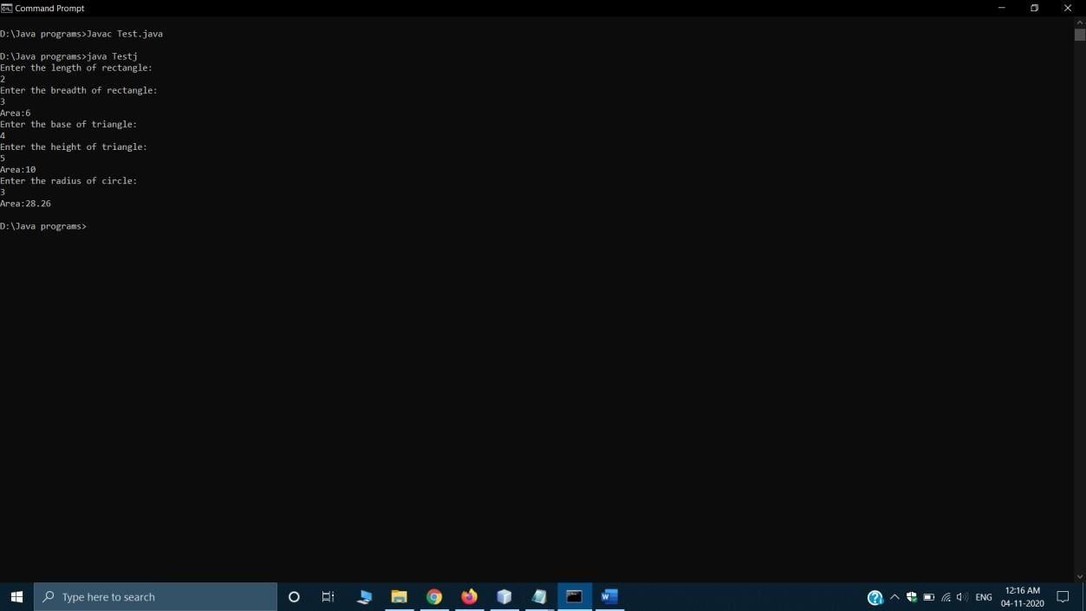

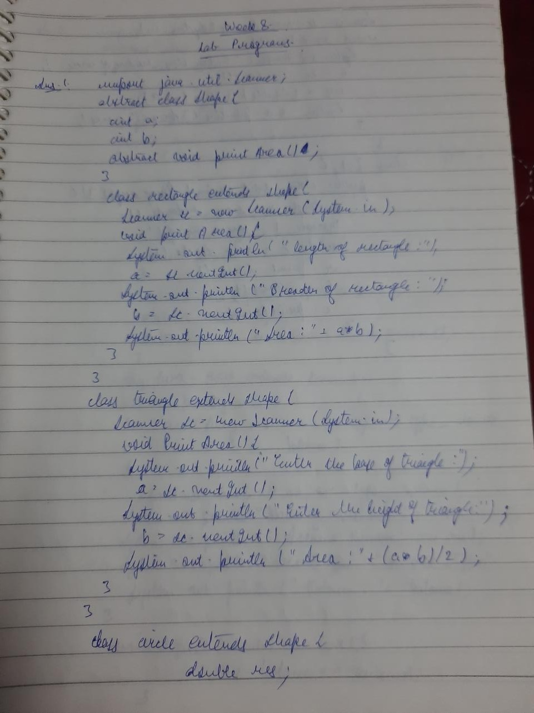

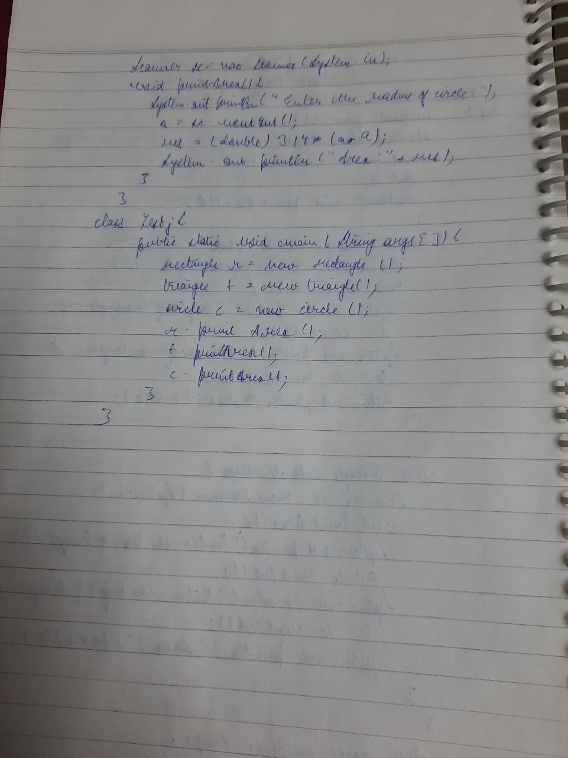

# LAB 5: Develop a Java program to create a class Bank that maintains two kinds of account for its customers, one called savings account and the other current account. The savings account provides compound interest and withdrawal facilities but no cheque book facility. The current account provides cheque book facility but no interest. Current account holders should also maintain a minimum balance and if the balance falls below this level, a service charge is imposed.Create a class Account that stores customer name, account number and type of account. From this derive the classes Curr-acct and Sav-acct to make them more specific to their requirements. Include thenecessary methods in order to achieve the following tasks:

* Accept deposit from customer and update the balance.•Display the balance.
* Compute and deposit interest
* Permit withdrawal and update the balance
* Check for the minimum balance, impose penalty if necessary and update the balance.

Ans:

import java.util.Scanner; abstract class Account

{

String cust_name; String acc_no; String acc_type; double balance;

double min_bal = 1000.0;

Account (String cust_name, String acc_no,String acc_type,double balance) { this.cust_name=cust_name;

this.acc_no=acc_no;

this.acc_type=acc_type; this.balance=balance;

}

abstract void deposit(double amount); abstract void display();

abstract void withdrawal(double amount);

}

class Curr_acct extends Account

{

double penalty=100.0;

Curr_acct(String cust_name, String acc_no,String acc_type,double balance)

{

super(cust_name,acc_no,acc_type,balance); System.out.println("Name of the customer: "+cust_name); System.out.println("Account Number accno: "+acc_no); System.out.println("Account type: "+acc_type); System.out.println("Balance: "+balance);

}

void deposit(double amount)

{

this.balance+= amount;

}

void withdrawal(double amount)

{

this.balance-=amount; if(this.balance<min_bal)

imposepenalty();

System.out.println("The current balance is "+balance);

}

void imposepenalty()

{

this.balance=this.balance-penalty;

System.out.println("The current balance is insufficient,penalty imposted = 100Rs");

}

void display()

{

System.out.println("Balance is: " + this.balance);

}

}

class Sav_acct extends Account

{

Sav_acct(String cust_name,String acc_no,String acc_type,double balance)

{

super(cust_name,acc_no,acc_type,balance); System.out.println("Name of the customer: "+cust_name); System.out.println("Account Number accno: "+acc_no); System.out.println("Account type: "+acc_type); System.out.println("Balance: "+balance);

}

void deposit(double amount)

{

this.balance = this.balance+amount; System.out.println("UPDATED BALANCE:"+this.balance);

}

void interest()

{

int rate=10,time=1;

float ci=(float)(this.balance*Math.pow(1+rate/100.0,time)-this.balance); System.out.println("The interest amount added to balance is "+ci); this.balance=this.balance+ci;

System.out.println("UPDATED BALANCE:"+this.balance);

}

void withdrawal(double amount)

{

this.balance=this.balance-amount; System.out.println("UPDATED BALANCE:"+this.balance);

}

void display()

{

System.out.println("Balance:" +this.balance);

}

}

class Testj{

public static void main(String[] args) { Scanner sc = new Scanner(System.in); double amount;

int flag = 0; while(flag == 0){

System.out.println("Enter the type of Account:\n1:Current account\n2:Savings account\n3:Exit");

int choice=sc.nextInt(); switch(choice){

case 1:

System.out.println("\nCurrent account:\n"); System.out.println("Enter the name of account holder"); String name1=sc.next();

System.out.println("Enter the account number"); String a_no1=sc.next(); System.out.println("Enter the balance amount"); double balance_am1=sc.nextDouble();

Curr_acct c = new Curr_acct(name1,a_no1,"current",balance_am1); int flag1 = 0;

while( flag1 == 0)

{

System.out.println("Enter your choice\n1:Deposit amount\n2:Display Balance\n3:Withdraw\n4:Exit");

int choice1= sc.nextInt(); switch (choice1)

{

case 1:

System.out.println("Enter amount to be deposited:"); amount = sc.nextDouble();

c.deposit(amount); break;

case 2:

c.display(); break; case 3:

System.out.println("Enter amount you want to withdraw:");

amount = sc.nextDouble(); c.withdrawal(amount); break;

default: flag1 = 1;

}

}

break;

case 2:

System.out.println("\nSavings account:\n"); System.out.println("Enter the name of account holder"); String name2=sc.next();

System.out.println("Enter the account number"); String a_no2=sc.next(); System.out.println("Enter the balance amount"); double balance_am2=sc.nextDouble();

Sav_acct s = new Sav_acct(name2,a_no2,"Savings",balance_am2); int flag2 = 0;

while(flag2 == 0)

{

System.out.println("Enter your choice\n1:Deposit amount\n2:Display Balance and Interest\n3:Withdraw\n4:Exit");

int choice2 = sc.nextInt(); switch (choice2)

{

case 1:System.out.println("Enter amount to be deposited:"); amount = sc.nextDouble();

s.deposit(amount); break;

case 2:

s.display(); s.interest (); break; case 3:

System.out.println("Enter amount you want to withdraw:"); amount = sc.nextDouble(); s.withdrawal(amoun

t); break; defaul

t: flag2

=1;

}

}

break; default:flag

=1;

}

}

}

}

