Percentage_of_ship by Ship Mode

0.454332141440… (45.43%)

0.23219111780751042 (23.22%)

0.2277490871… (22.77%)

0.08572765359577521 (8.57%)

**Ship Mode**

Standard Class

Second Class

First Class

Same Day



Data

Off

Suggest a type

**+**

**Add data**

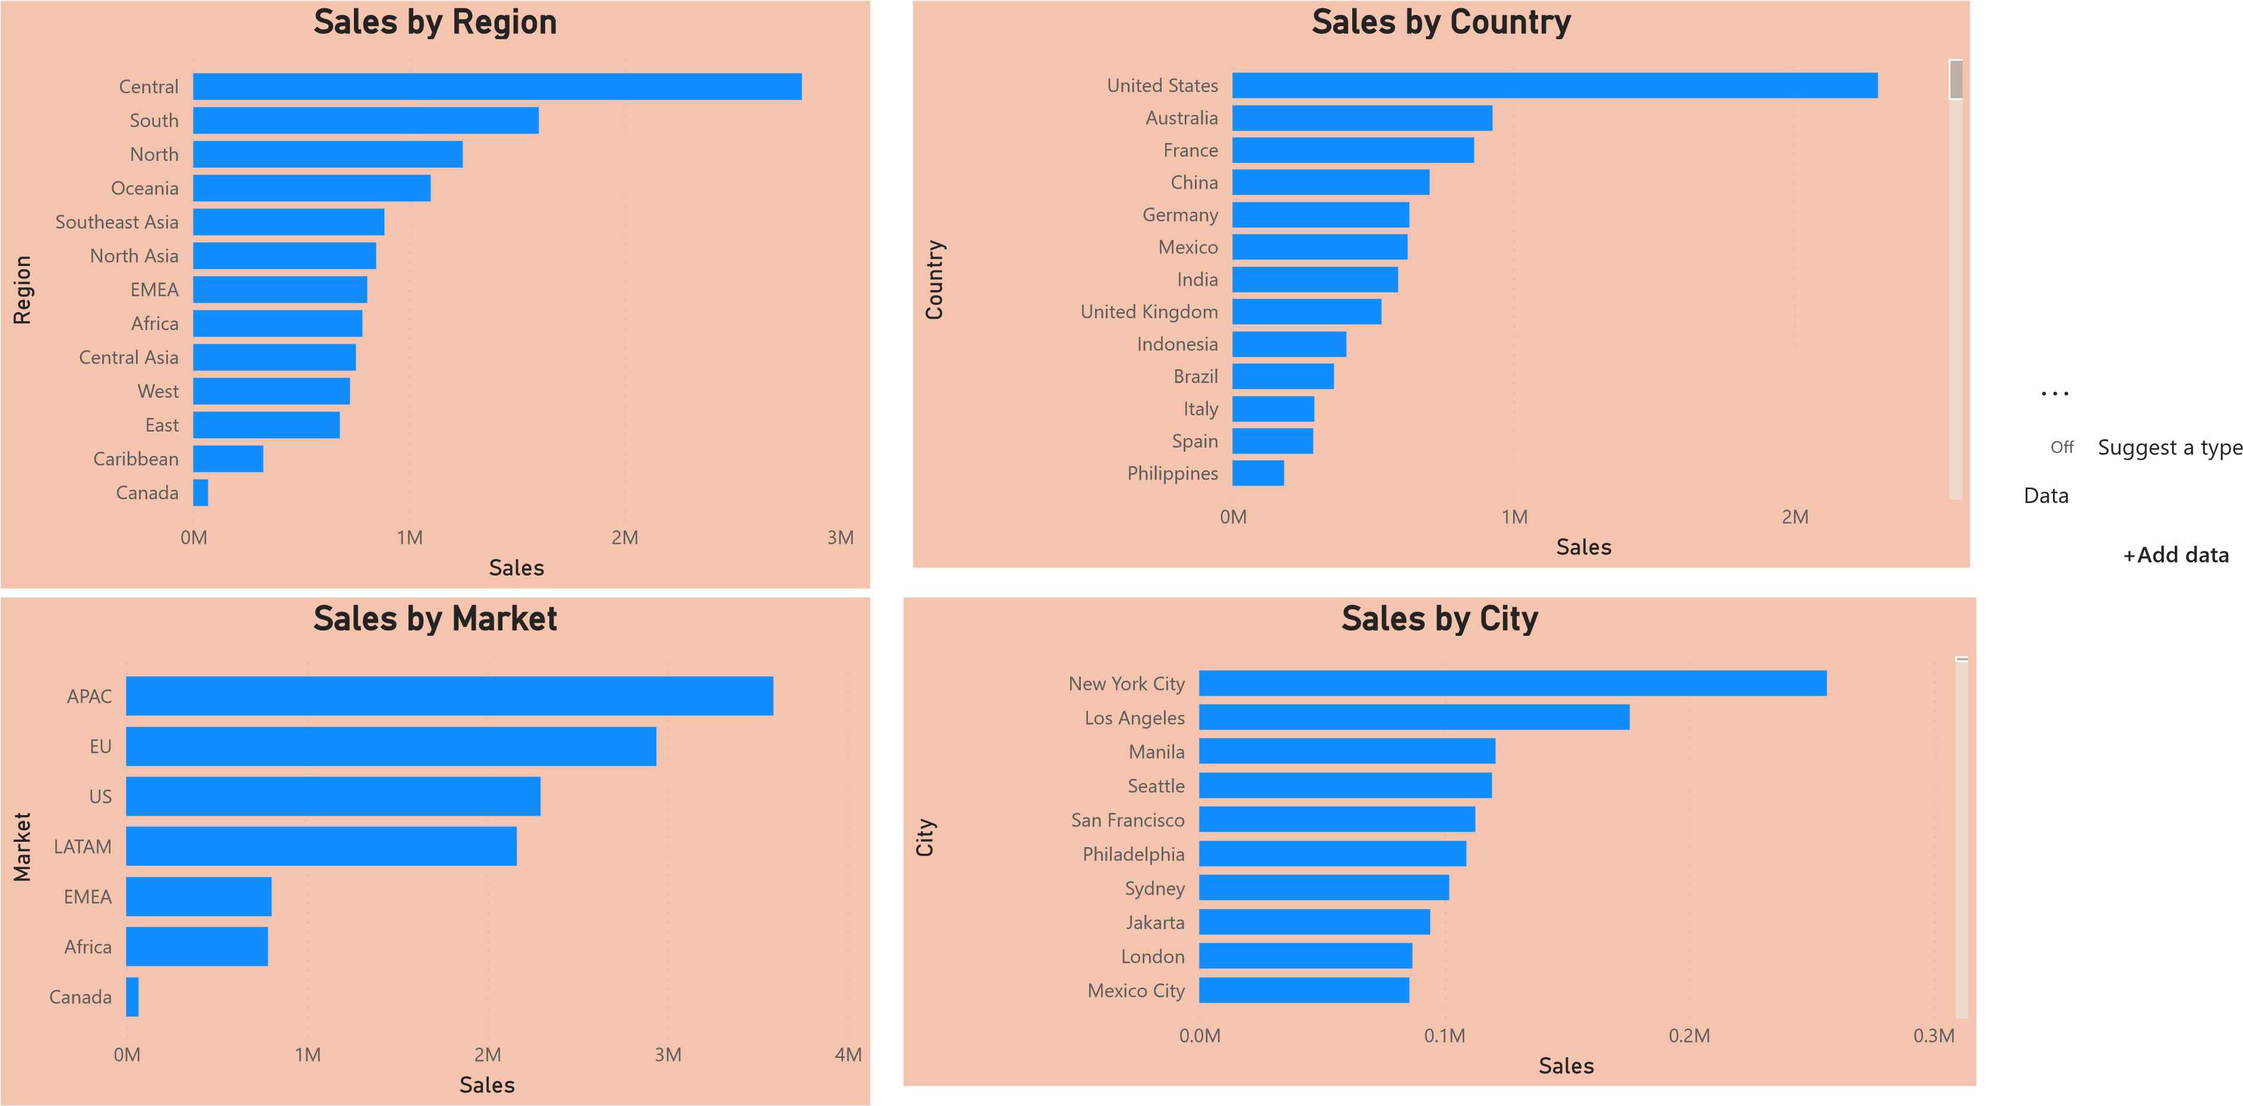

|  |  |  |  |  |  |  |  |
| --- | --- | --- | --- | --- | --- | --- | --- |
|  | |  |  |  |  |  |  | | --- | --- | --- | --- | --- | --- | | Percentage ship by shipmode   |  | | --- | | Ship Mode Percentage_of_ship   | | Standard Class 0.45 | | Second Class 0.23 | | First Class 0.23 | | Same Day 0.09 |   **Total 1.00** | |



Off Suggest a type

Data

**+Add data**

