Game Design Document

Fill up the following document

1. Write the title of your project.

**Escape Zoe !!**

1. What is the goal of the game?

**Reach the earth safely without exceeding the time limit and without colliding with any of the obstacles/allienspaceships.**

1. Write a brief story of your game.

**You're stuck inside the rocket somewhere in the space. You need to reach earth asap cuz you've limited time. In between your path, there will be allien spaceships and other obstacles moving in the space(Avoid them). Grab the chest crates/diamonds and reach earth**.

1. Which are the playing characters of this game?

* Playing characters are the ones who respond to the user based on the input from the user.
* Cars, monkeys, dinos, wizards, etc., are the playing characters in the game.

|  |  |  |
| --- | --- | --- |
| Number | Character Name | What can this character do? |
| 1 | **Zoe** | **Can Move left, right, up and down** |
| 2 |  |  |
| 3 |  |  |
| 4 |  |  |
| 5 |  |  |
| 6 |  |  |
| 7 |  |  |
| 8 |  |  |

1. Which are the Non-Playing Characters of this game?

* Non-Playing characters are the ones that don't have an action or behavior when the user interacts with the game.
* Hurdles, stones, bananas, coins, etc., are non-playing characters in the game.

|  |  |  |
| --- | --- | --- |
| Number | Character Name | What can this character do? |
| 1 | **Allien Spaceships** | **Can move up and down** |
| 2 | **Asteriods** | **Can move up and down** |
| 3 |  |  |
| 4 |  |  |
| 5 |  |  |
| 6 |  |  |
| 7 |  |  |
| 8 |  |  |

Draw your imagination of this game. What does this game look like?

* Draw the game either on your computer or on paper.
* Add images of the game scenes to show each of the playing and non-playing characters at least once.

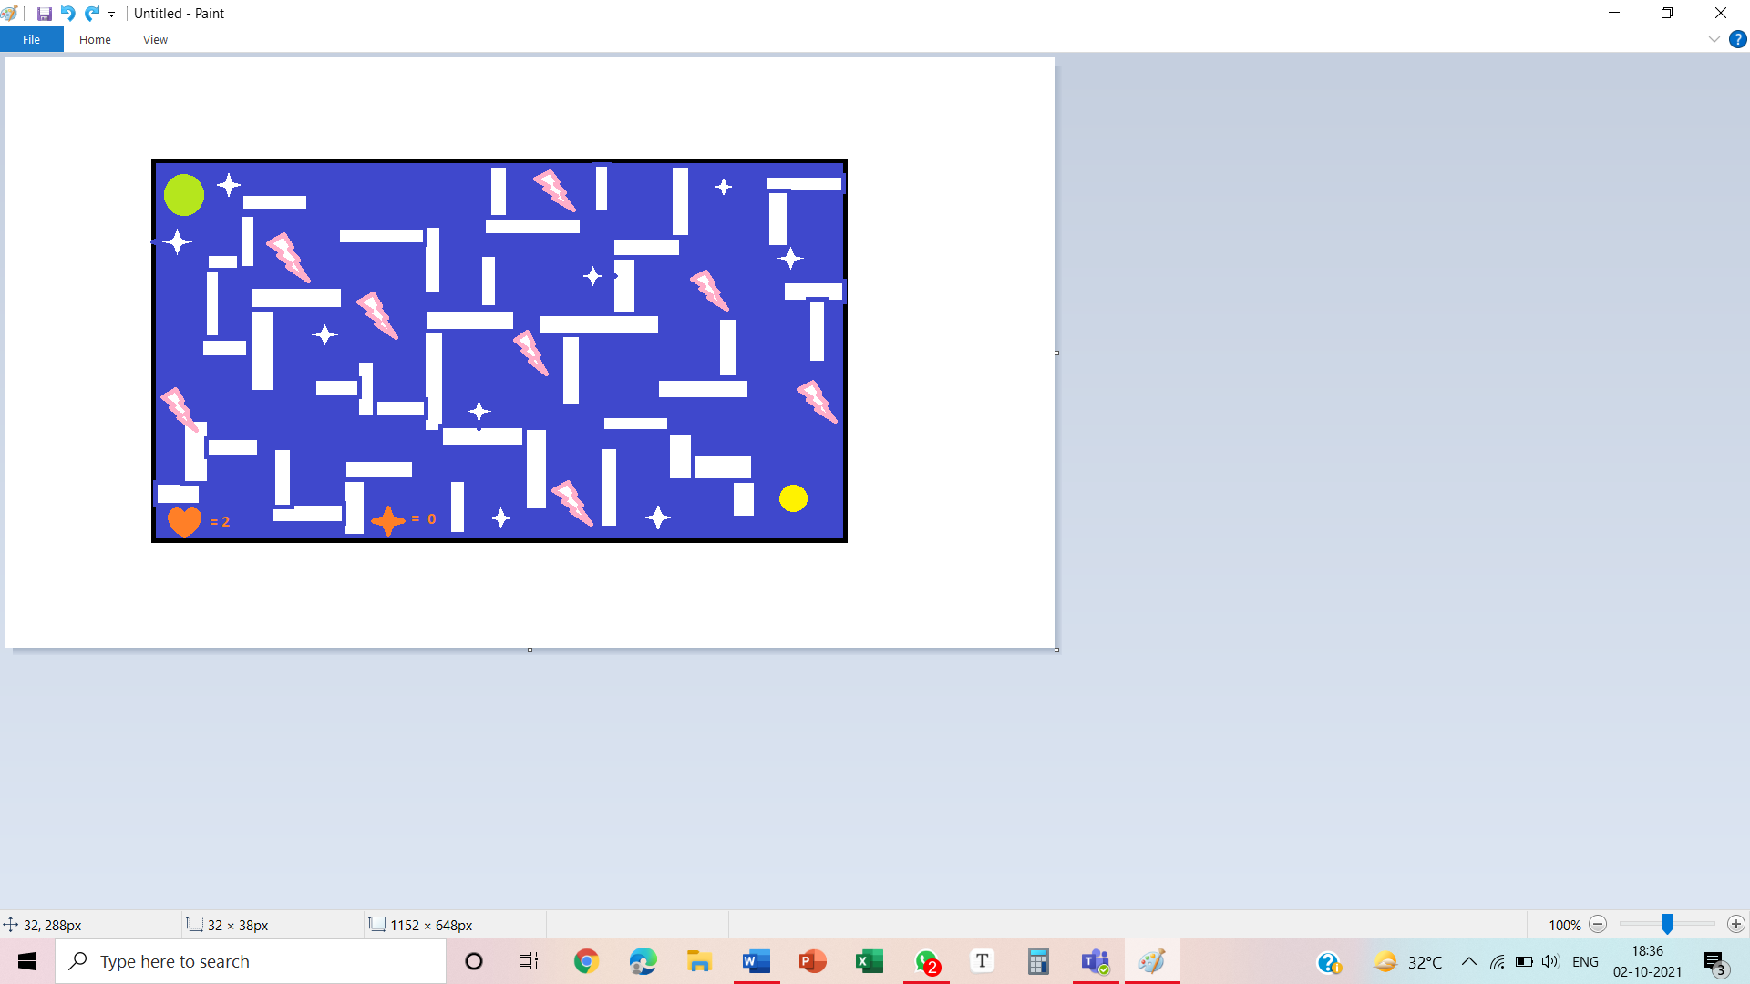

**Over here in this picture, the yellow circle represent Zoe, the green circle represents the earth, the star shape icons represent the diamonds, the symbol with pink boundary represents the obstacles. (Note- This is a roughly drawn figure).**

How do you plan to make your game engaging?

**Adding levels will make my game more fascinating. I can also add a choice in between the characters. For example, right now I’ve decided to have a rocket (named as Zoe) as my playing character but if the player wants a different character(like any human being or maybe a dog as well because dogs have also been to space).**

**Secondly, I can also update the theme of my game in the upcoming versions of the game like “Instead of space you’re stuck on a island. You need to destroy the pirate ships and collect the pieces of map and then join it and find the route to your place. So ya, I think this can make my game more engaging.**