**WELCOME**

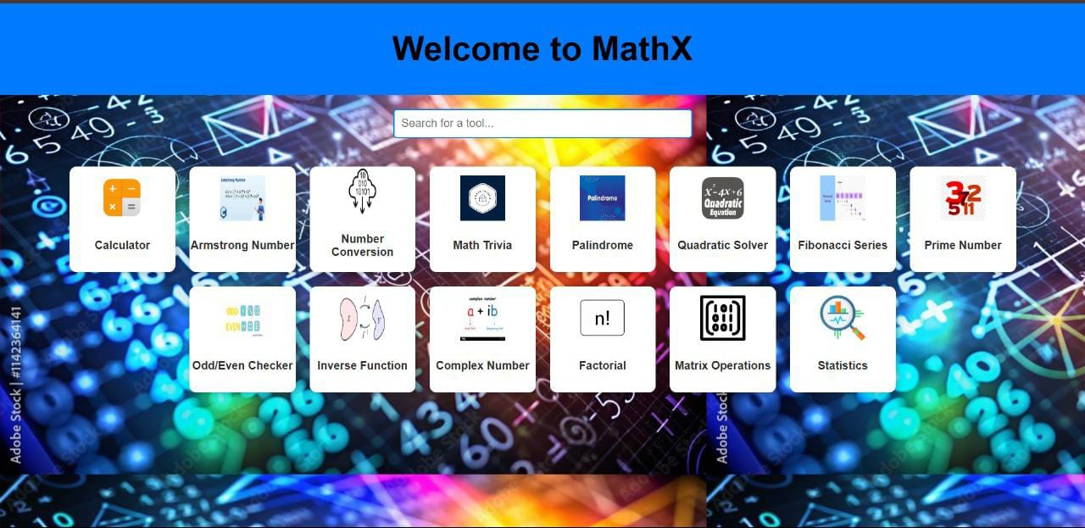**TO THE MATHEMATICS PROJECT**

**Details of all members**

* Team Leader -: **Anshika**

Email -: [**anshdwi21@gmail.com**](mailto:anshdwi21@gmail.com)

Deployed at: **https://github.com/ANSHIKApyr**

**Members name -:**

* Name -: **Prashant**

Email -: [**prashantdudhal11@gmail.com**](mailto:prashantdudhal11@gmail.com)

* Name -: **Nikita**

Email -: **dhamalnikita02@gmail.com**

* Name -: **Sravan**

Email -: **sravangaraga1379@gmail.com**

* Name -: **Kajal**

Email-: **kajalsanjaychavhan2222@gmail.com**

* **USE CASES OF PROJECT**

**1.Educational Platform**

* **Helps students learn mathematical concepts like Fibonacci series,**

**Armstrong numbers, prime numbers, etc.**

* **Provides interactive explanations with examples.**
* **Can include quizzes and exercises to test knowledge.**

**2.Mathematical Calculators**

* **Allows users to calculate Fibonacci series, factorials,**

**and prime numbers dynamically.**

* **Provides step-by-step solutions for complex calculations.**

**3.Reference Tool For Programmers**

* **Useful for programmers who need quick access**

**to mathematical algorithms.**

* **Can include code snippets for implementing these**

**concepts in different programming languages**

* Features of the project
* Project Overview
* **MathX is a web-based tool that provides various mathematical utilities, including number checks, calculations, and problem-solving functions. The project aims to help students, teachers, and enthusiasts by offering a user-friendly interface for mathematical computations.**
* Technologies Used
* **Frontend: HTML, CSS, JavaScript**
* **Styling: CSS for UI design**
* **Logic Implementation: JavaScript**
* Features and Functionality
* **Each tool is implemented as a separate module and allows users to perform mathematical operations efficiently. Below is a description of each tool**:
* Calculator
* **A basic arithmetic calculator that supports addition, subtraction, multiplication, and division.**
* **Performs basic arithmetic operations: addition, subtraction, multiplication, and division.**
* **Can handle decimal and integer calculations.**
* **Advanced versions may support trigonometry, logarithms, and percentages.**
* Armstrong Number Checker
* **Checks whether a given number is an Armstrong number (a number that is equal to the sum of its digits each raised to the power of the number of digits).**
* **Checks whether a number is an Armstrong (Narcissistic) number.**
* **Works for different digit-length numbers (3-digit, 4-digit, etc.).**
* **Provides step-by-step calculation for verification.**
* Number Conversion
* **Converts numbers between different bases (binary, decimal, octal, hexadecimal).**
* **Converts numbers between different bases: Binary, Decimal, Octal, and Hexadecimal.**
* **Supports real-time conversion.**
* **Displays conversion steps for learning purposes.**
* Math Trivia
* **Displays interesting mathematical facts dynamically with animations.**
* **Provides interesting and lesser-known facts about mathematics.**
* **Covers historical discoveries and modern applications.**
* **Engaging and interactive for learning.**
* Palindrome Checker
* **Checks if a given number or word is a palindrome (reads the same forward and backward).**
* **Identifies whether a given number or word is a palindrome.**
* **Works with both numeric and alphabetic inputs.**
* **Can handle case sensitivity and spaces.**
* Quadratic Equation Solver
* **Solves quadratic equations of the form ax² + bx + c = 0 using the quadratic formula.**
* **Solves quadratic equations of the form ax² + bx + c = 0.**
* **Uses the quadratic formula to find roots.**
* **Supports real and complex roots.**
* Fibonacci Series Generator
* **Generates the Fibonacci series up to a given number.**
* **Generates Fibonacci sequence up to a given number or term.**
* **Provides both iterative and recursive solutions.**
* **Can visualize the series in graphical form.**
* Prime Number Checker
* **Checks if a given number is prime.**
* **Determines if a number is prime or not.**
* **Can generate a list of prime numbers up to a given limit.**
* **Uses efficient algorithms for large numbers.**
* Odd/Even Checker
* **Checks whether a given number is odd or even.**
* **Identifies whether a given number is odd or even.**
* **Works for positive and negative integers.**
* **Simple and fast computation.**
* Inverse Function
* **Calculates the inverse of a function (if applicable).**
* **Finds the inverse of a given function (if it exists).**
* **Supports algebraic functions.**
* **Provides graphical representation of function inversion.**
* Complex Number Operations
* **Performs addition, subtraction, multiplication, and division of complex numbers.**
* **Performs operations on complex numbers (addition, subtraction, multiplication, division).**
* **Converts between polar and rectangular forms.**
* **Useful in engineering and physics applications.**
* Factorial Calculator
* **Computes the factorial of a given number (n!).**
* **Supports large values with efficient computation.**
* **Provides applications in permutations and probability.**
* Matrix Operations
* **Performs addition, subtraction, and multiplication of matrices.**
* **Supports matrix addition, subtraction, and multiplication.**
* **Computes determinants and inverses.**
* **Useful in linear algebra and computer graphics.**
* Statistics Calculator
* **Performs basic statistical calculations (mean, median, mode, standard deviation).**
* **Computes mean, median, mode, variance, and standard deviation.**
* **Can analize datasets and generate statistical reports.**
* **Useful in data science and analytics.**
* Future scope of mathematical website
* Advanced Mathematical Concepts

**Expand beyond basic calculations to include calculus, linear algebra, and probability**

**Implement features like matrix operations, differentiation, and integration.**

* Real-World Applications

**Include finance-related math, such as interest calculation, investment growth, etc.**

**Provide statistical analysis tools for researchers and students.**

* Community & Collaboration

**Add a discussion forum for users to discuss math related topics.**

**Allow user to submit and share their own math problem s and solutions.**