ATSForge: An AI-Powered Career Management Platform for Ats Resume Building, JD Matching, Cover Letter Generation, and Professional Outreach

Anshu Prasad  Department of Computer Science and Engineering  IIMT College of Engineering, Noida | Deepak Yadav  Department of Computer Science and Engineering  IIMT College of Engineering, Noida
Abstract— Job searching has become harder than it should be. Most job seekers do not realize that their resumes are being filtered out automatically by Applicant Tracking Systems (ATS) before any human ever reads them. In this paper, we present ATSForge — a web-based platform we built to help candidates improve their resumes and overall job applications using AI. The platform has five main parts: an ATS resume builder that gives a live score, a job description keyword analyzer, an AI cover letter writer, a cold email and LinkedIn message generator, and a job portals hub with 100+ boards. We used LLaMA 3.3 70B running on Groq LPU hardware, which gave us resume parsing in under 2 seconds — about 10 times faster than a standard GPU. We also designed a 4-factor scoring system that gives resumes a score out of 100 based on section completeness, keyword match, action verbs, and formatting. We tested the platform on 30 real job descriptions and found that the average ATS score went up by 36.3 points, and the time needed to prepare a full application dropped from 67 minutes to under 5 minutes.

Index Terms— Applicant Tracking System, Resume Optimization, Large Language Models, LLaMA 3.3, Groq LPU, NLP, Keyword Extraction, Cover Letter, Career Management, Serverless LaTeX, React.js, Supabase.

I. INTRODUCTION
Getting a job interview is already hard, but the real problem starts even before a recruiter sees your resume. Most companies use software called Applicant Tracking Systems (ATS) that automatically scan and filter resumes. If your resume does not have the right keywords or format, it gets rejected without any human ever reading it. According to industry reports, around 75% of candidates get filtered out at this stage alone [1].
We noticed that the tools available to job seekers are scattered across many different platforms. Someone might use one website to build their resume, another to write a cover letter, and manually search through job boards. None of these tools talk to each other, and none of them tell you whether your resume will actually pass an ATS filter.
To solve this, we built ATSForge — a single platform that handles the full job application process. The idea was to take everything a candidate needs and put it in one place, with AI doing most of the heavy lifting. The five main features we built are:
• A resume builder with live ATS scoring (0–100) that updates as you type
• A job description keyword analyzer that shows you exactly what is missing
• An AI cover letter generator that matches your resume to the job
• A cold email and LinkedIn message generator based on the AHVC structure
• A curated directory of 100+ job boards organized by category
The main technical things we contribute in this paper are: (1) a new 4-factor ATS scoring formula we designed from scratch, (2) benchmarks showing how fast Groq LPU is compared to a standard GPU for resume-related AI tasks, (3) a way to compile LaTeX resumes in the browser without installing anything locally, and (4) a shared data model that lets all five modules work from the same resume data.
The rest of this paper is structured as follows. Section II covers what others have done in this area. Section III explains our scoring formula. Section IV covers the system architecture. Section V walks through each module. Section VI covers implementation. Section VII has our benchmark results. Sections VIII and IX discuss security and limitations. Section X concludes.

II. RELATED WORK
A. Resume Parsing
Parsing resumes — pulling structured data out of unformatted documents — has been studied for many years. Earlier systems used rule-based approaches and regular expressions, which worked okay for simple formats but struggled with different layouts and fonts [6]. Recent work has moved to deep learning. Naous et al. [3] built a transformer-based named entity recognition model for resume parsing and got around 91% F1 score on a dataset of 500 resumes. Kumar et al. [4] took a similar approach using BERT and achieved 94% accuracy on their private dataset of 10,000 resumes.
Both of these systems need a GPU server to run, which makes them impractical for a consumer web app. In ATSForge, we handled this by using LLaMA 3.3 70B on Groq’s cloud API with a one-shot prompt that tells the model the exact JSON structure we want. This gives us good parsing quality in under 2 seconds — fast enough for a web application.
B. ATS Scoring
Tools like Jobscan [7] show you a keyword match percentage between your resume and a job description. This is useful, but it is just one number based on word overlap. It does not tell you anything about whether your resume has all the right sections, uses strong action verbs, or has a clean structure. Shah et al. [8] proposed a two-factor model that also looked at section completeness. Patel and Jain [9] added a third factor using TF-IDF similarity. Our 4-factor model goes a step further by also checking action verb quality, which we found to be a significant factor in ATS decisions based on published case studies.
C. AI-Generated Career Documents
Chen and Liu [5] showed that GPT-3 could write cover letters from a resume and job description, and that people preferred these over template-based letters about 68% of the time. The limitation of their system was that it treated the resume and job description as plain text without doing any gap analysis first. In ATSForge, before generating the cover letter, we first ask the model to identify the top 3 skills that appear in both the resume and the job description, and then feature those specifically in the letter. This makes the output more targeted and less generic.
D. What is Still Missing
Looking at the tools available, there is no platform that combines all of these steps — resume optimization, JD analysis, cover letter writing, and outreach generation — in one place with shared data. That is the gap we are trying to fill. Table I compares ATSForge with the most similar existing tools.

System | ATS Score | AI Parse | Cover Letter | Outreach
Resume Genius | Keyword only | No | Template | No
Jobscan | Keyword % | No | No | No
Kumar et al. | Partial | BERT | No | No
Chen & Liu | No | No | GPT-3 | No
ATSForge (Ours) | 4-Factor | LLaMA 3.3 | JD-matched | AHVC AI
Table I. Comparison of ATSForge with existing related tools.

III. PROPOSED ATS SCORING MODEL
A core contribution of ATSForge is its resume evaluation framework, which uses a five-factor ATS scoring model to assess resume quality from both structural and content perspectives. Rather than relying only on keyword matching, the model combines rule-based heuristics with an AI-assisted language review layer. This allows the system to evaluate whether a resume is complete, evidence-driven, technically relevant, parse-safe, and professionally written. The final output is a single score on a 0-100 scale, together with factor-level breakdowns and targeted improvement suggestions.

ATS = (SC x 0.22) + (AE x 0.26) + (KS x 0.18) + (PS x 0.18) + (LQ x 0.16)

Here, SC denotes Section Completeness, AE denotes Action and Evidence, KS denotes Keyword Spread, PS denotes Parse Safety, and LQ denotes Language Quality. Each factor is normalized to a 0-100 range before weighting. The weighted formulation was chosen so that practical resume signals such as evidence quality, section strength, keyword placement, and writing clarity all contribute to the final score without allowing any single heuristic to dominate the evaluation. Fig. 1 summarizes the scoring framework used in the ATSForge Resume Builder.

/
Fig. 1. ATSForge five-factor ATS scoring framework with dual input paths and weighted evaluation.
A. Input Paths: Builder and Upload
The scoring engine supports two input paths. In the first path, users enter resume details directly through the Resume Builder. In the second path, users upload an existing resume file, which is parsed and mapped into the same internal resume schema. Both flows converge into a common scoring pipeline, so the final ATS evaluation is generated from a single structured representation. The upload path additionally carries parsing metadata, which is later used in the Parse Safety factor to estimate extraction confidence.
B. Factor 1: Section Completeness (SC, 22%)
Section Completeness measures whether the resume contains the major information blocks expected in a professional ATS-friendly document. The current implementation does not use a flat count of filled sections. Instead, it applies weighted importance to Personal Information, Summary, Skills, Experience, Education, Projects, and Credentials. The internal distribution is Personal = 18, Summary = 10, Skills = 15, Experience = 28, Education = 8, Projects = 15, and Credentials = 6. Partial credit is awarded when a section is present but incomplete; for example, the personal section scores better when name, email, phone number, LinkedIn, and location are all available, while the summary scores best when it is meaningful and falls within a practical word range.
C. Factor 2: Action and Evidence (AE, 26%)
Action and Evidence is the highest-weighted factor because resumes tend to perform better when they communicate measurable outcomes rather than generic responsibilities. This factor combines three internal signals: quantified impact, action-verb quality, and outcome-oriented language. Quantified bullets containing percentages, counts, time savings, or business results are rewarded. Additional credit is given when bullets begin with strong verbs such as built, designed, automated, optimized, or led, and when the wording emphasizes outcomes such as improved, reduced, streamlined, or delivered. The factor is computed as AE = (QI x 0.38) + (AVQ x 0.32) + (OL x 0.30).
D. Factor 3: Keyword Spread (KS, 18%)
Keyword Spread evaluates not only whether relevant technical terms appear in the resume, but also whether they are distributed across meaningful sections such as title, summary, skills, experience, and projects. The system first derives a role-aware keyword inventory from the resume itself, supplemented by role-family hints inferred from the profile. It then rewards terms that appear in both listing sections and evidence-bearing sections. As a result, the factor captures both topical coverage and keyword placement. Internally, it combines normalized density and section-spread signals using KS = (KD x 0.55) + (SP x 0.45).
E. Factor 4: Parse Safety (PS, 18%)
Parse Safety estimates how reliably the resume can be interpreted by ATS software. It combines a hygiene score with a source-aware parse-confidence score. The hygiene component evaluates date consistency, valid links, bullet validity, overall word-count range, and the presence of core section headings. The confidence component distinguishes between builder-entered resumes and uploaded resumes. Builder-entered resumes receive high baseline confidence because the data is already structured, whereas uploaded resumes are evaluated using extracted text length, recovered fields, section fill ratio, and date-pattern consistency. The factor is computed as PS = (PC x 0.55) + (HS x 0.45).

F. Factor 5: Language Quality (LQ, 16%)
Language Quality evaluates how clearly and professionally the resume is written. A local rule-based layer first penalizes weak writing signals such as very short bullets, overly long bullets, repeated phrasing, buzzwords, placeholder content, and vague expressions such as worked on or responsible for. After sufficient resume content is available, ATSForge performs an AI-assisted review of the full resume text through the Groq inference endpoint using a lightweight LLaMA-based model. The AI layer does not generate the full ATS score. Instead, it returns bounded clarity and specificity signals that slightly adjust the local language score. This keeps the scoring process interpretable while still improving the evaluation of writing quality.IV. SYSTEM ARCHITECTURE
ATSForge is built as a multi-tier web application. The key design decision was to keep everything serverless where possible, and to share one data object across all five modules so that updating your resume in one place updates it everywhere. The five tiers are described below.
A. Frontend (React.js + Vite)
The frontend is a React.js application bundled with Vite. We use Framer Motion for animations and CSS print-media queries for PDF generation — we chose this over a PDF library specifically because print-based PDFs contain real text that ATS systems can read, while library-generated PDFs sometimes embed text as vector paths. All five modules share a single ResumeData object through React Context. When you update your skills in the resume builder, the cover letter generator and outreach module automatically use the updated skills too.
B. Node.js Proxy Server
We run a small Express.js server as a proxy between the frontend and two external APIs: Groq and texlive.net. This is important because it keeps our API keys out of the browser bundle. The proxy also validates requests and handles error messages from the LaTeX compiler in a readable format.
C. AI Layer (LLaMA 3.3 on Groq LPU)
All the AI features — resume parsing, cover letter generation, and outreach writing — run through the Groq API which hosts LLaMA 3.3 70B on their LPU hardware. Groq’s hardware is specifically built for fast inference and does not have the same memory bottleneck that GPU servers do. For resume parsing, we use a one-shot prompt that includes the full JSON schema of the 8 resume sections, so the model returns structured data in one API call.
D. Database (Supabase + PostgreSQL)
We store user resume data in Supabase using a PostgreSQL table with a JSONB column for the resume content. Using JSONB means we do not need to change the database schema every time we add a new resume field. Row-Level Security is enabled so that each user can only access their own data. Authentication is handled by Supabase Auth using JWT tokens.
E. LaTeX Compilation (texlive.net)
The LaTeX editor sends the user’s LaTeX code to texlive.net via our proxy, which compiles it with pdflatex and returns a PDF. The PDF is shown inside an iframe in the browser. This way users can get a professional LaTeX resume without installing anything locally.

V. MODULE DESCRIPTIONS
A. Resume Builder
The Resume Builder is the primary editing workflow of ATSForge. Users can create resumes manually or upload an existing PDF or DOCX resume for automatic parsing into the shared resume schema. The interface combines section-wise editing, live preview, multiple template options, download support, and continuous ATS feedback. The builder-side ATS score is based on the five-factor model described in Section III: Section Completeness (22%), Action and Evidence (26%), Keyword Spread (18%), Parse Safety (18%), and Language Quality (16%). The first four factors are computed instantly on the client, while the language-quality layer is refreshed after a short delay once enough resume content is available. In addition to the overall score, the module exposes factor-level diagnostics, parse-confidence feedback for uploaded resumes, and targeted revision suggestions.

/
Fig. 2. Resume Builder with five-factor ATS score, section editing workflow, and live preview.
B. JD Match Analyzer
The JD Match Analyzer is an AI-assisted comparison module that evaluates how closely a resume aligns with a target job description. The job description is first converted into a structured schema containing the target role, normalized requirements, aliases, evidence targets, and importance levels. The final JD match score is then computed from four weighted factors: Weighted Keyword Coverage (50%), Semantic Equivalence (20%), Title Alignment (15%), and Critical Requirement Coverage or Risk (15%). Exact matches, related matches, and missing requirements are displayed separately so that users can identify both strong alignment areas and critical gaps.

The module also generates role-specific recommendations and supports guided improvements back into the resume. Missing requirements are categorized by importance, linked to recommended resume sections, and surfaced together with supporting evidence from the existing resume. This makes the module more than a keyword checker; it acts as a resume-to-JD alignment system that combines structured matching, AI-assisted parsing, and actionable revision support.

/
Fig. 3. JD Match Analyzer showing missing requirements with importance tags and guided updates.

/
Fig. 4. JD Match Analyzer showing exact matches, related matches, and the four-factor score breakdown.C. Cover Letter Generator
The cover letter module takes your full resume data and the job description and generates a personalized letter. Before writing, the model identifies the top 3 skills that appear in both your resume and the JD, and specifically mentions those in the opening paragraph. You can choose the tone (Professional, Executive, or Modern) and the length (short, medium, or long). The output appears in an editable text box with a word counter. Generation takes under 3 seconds on average.

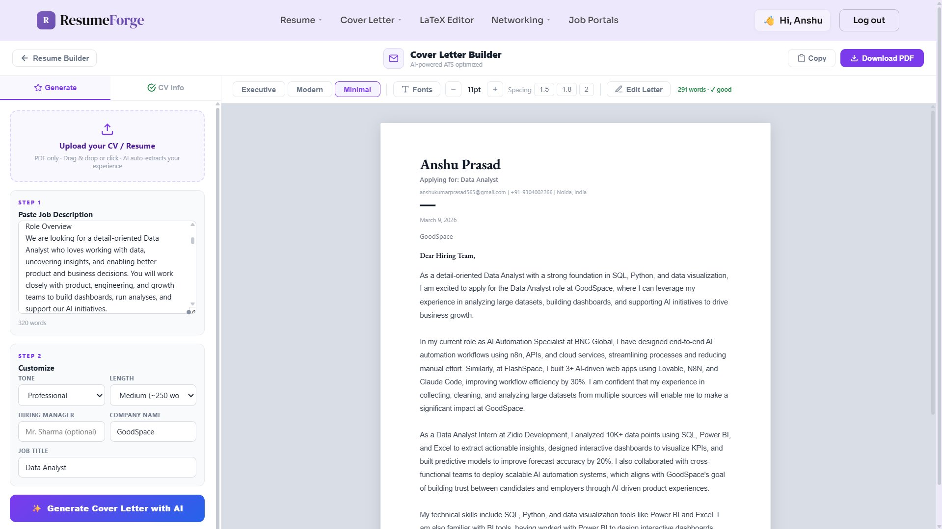
Fig. 5. Cover Letter Generator with tone selector and generated output.
D. Cold Email and Outreach Suite
This module generates three types of messages from the same data: a full email, a LinkedIn DM (under 300 characters), and a short text-style message. All three follow what we call the AHVC framework: Attention (a strong opening hook), Hook (a personal connection to the recipient’s company), Value (your top 2–3 relevant achievements), and Call to Action (a specific ask like a coffee chat or quick call). Generation takes under 1 second.

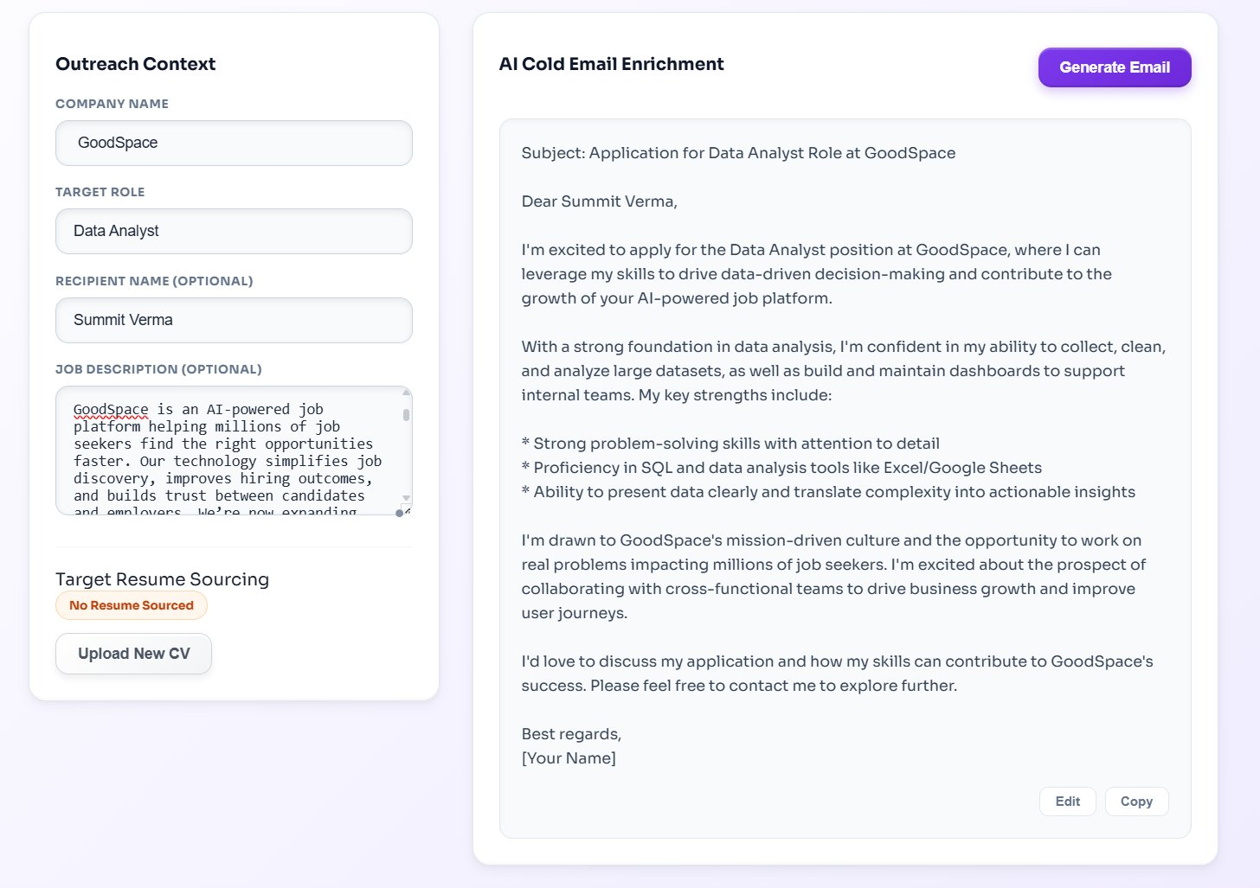
Fig. 6. Outreach Suite: AHVC email, LinkedIn DM, and message tabs.
E. LaTeX Editor
The LaTeX editor provides a code editor pre-loaded with a clean resume template. When you stop typing for 800ms, the code is sent to texlive.net for remote compilation and the resulting PDF appears in the preview panel. The whole round-trip takes about 1.5 seconds. This module is especially useful for candidates applying to technical roles where a well-formatted LaTeX resume stands out.

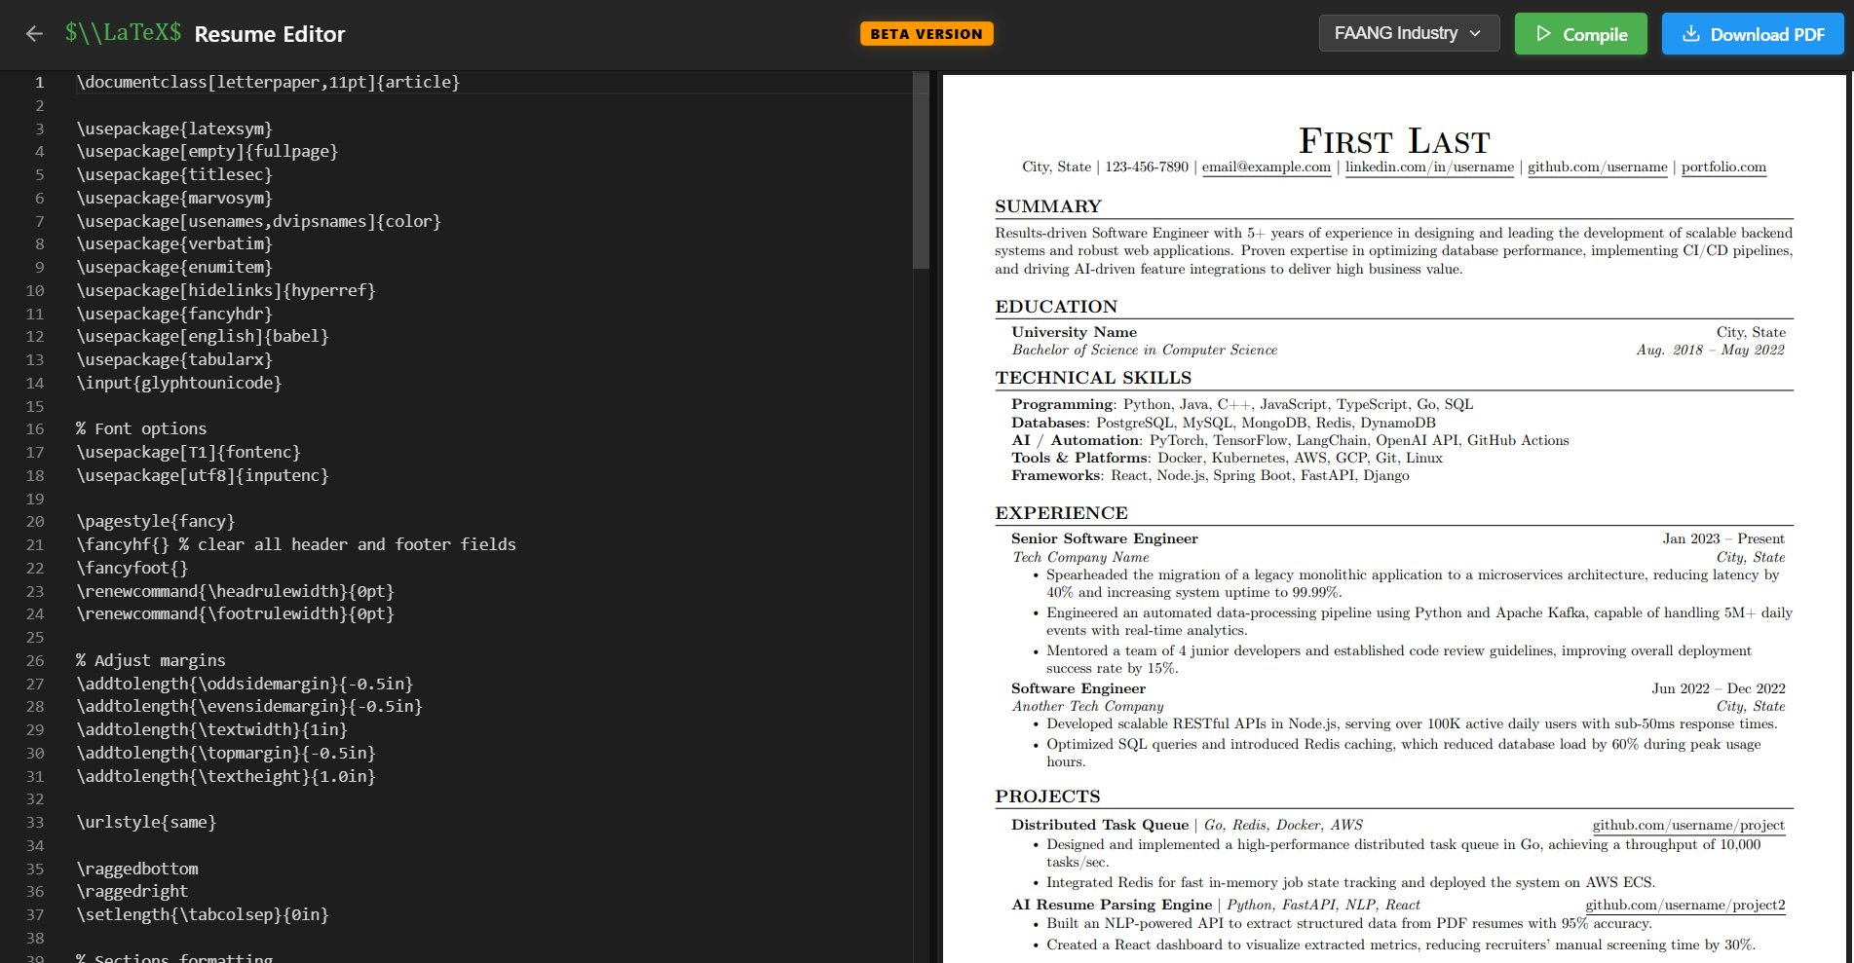
Fig. 7. LaTeX Editor: code editor with live PDF preview.
F. Job Portals Hub
The job portals module is a curated list of 100+ job boards organized into five categories: Global Giants (Indeed, LinkedIn, Glassdoor), Remote (WeWorkRemotely, RemoteOK), Startups (Wellfound, AngelList), AI-matching (ZipRecruiter), and India/Regional (Naukri, Shine, Internshala). Each entry has a direct link and a short description. The list is maintained in a JSON file so we can add new portals without changing the application code.

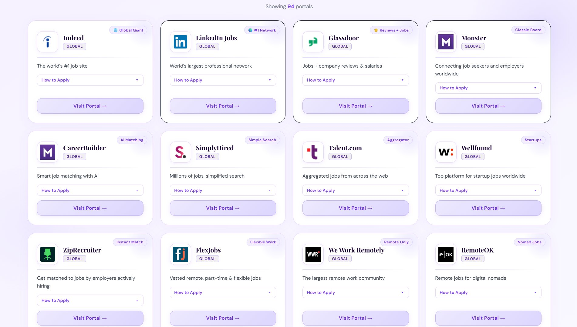
Fig. 8. Job Portals Hub showing categorized job boards.

VI. IMPLEMENTATION DETAILS
A. Frontend
The React frontend has around 40 components spread across the 5 modules. The root component initializes the ResumeData context with empty values for all 8 sections. Each module reads from and writes to this shared context. Every time a form field changes, a recalculation of the ATS score is triggered automatically through a useEffect hook. This keeps the score always up to date without any manual save step.
B. Prompting Strategy
For resume parsing, we use a one-shot prompt that includes the exact JSON schema the model should return, a type annotation for each field, and one example of a well-formed input-output pair. We found that this one-shot approach works significantly better than zero-shot for producing clean JSON from messy resume text. For cover letters and outreach messages, we break the prompt into four parts: context (the resume JSON), task description, format rules (tone and length), and a reminder to mention the skill overlaps found in the JD.
C. Database Design
The Supabase schema has two tables: the users table managed by Supabase Auth, and a resumes table with columns for id, user_id, data (JSONB), and updated_at. We use an upsert operation on save, so each user always has exactly one resume record. The JSONB type means we can add new sections to the resume format without touching the database at all.
D. Deployment
The frontend is deployed as a static site on Render.com and the proxy server is a separate Node.js service on the same platform. Both run on free-tier instances. The Groq and Supabase API keys are stored as environment variables in Render’s dashboard and are never visible in the code or browser.

VII. PERFORMANCE EVALUATION
We evaluated ATSForge across three areas: how fast the AI features are, how much the ATS score improves, and how much time the platform saves compared to doing things manually.
A. Setup
For latency testing, we ran each AI operation 50 times and recorded the end-to-end wall time using the browser’s performance.now() API. The GPU baseline was measured on the same model (LLaMA 3.3 70B) running on a Google Colab A100 GPU with the exact same prompts and settings. For ATS score testing, we used 30 job descriptions from LinkedIn and Indeed across 5 fields (6 JDs each): Software Engineering, Data Science, Product Management, Marketing, and Finance. Participants uploaded their own resumes and used the JD Analyzer to optimize them.
B. Latency Results
Table II shows the latency numbers. ATSForge is between 5 and 11 times faster than the A100 GPU baseline for every AI operation. The biggest difference is in resume parsing (1.82s vs 20.1s) and first-token latency (278ms vs 3.1s). These differences matter a lot for a web application where users expect instant feedback.

Operation | ATSForge | GPU Baseline | Speedup
Resume Parsing | 1.82s (±0.23) | 20.1s | ~11×
Cover Letter | 2.91s (±0.31) | 13.4s | ~5×
Cold Email | 0.87s (±0.18) | 6.8s | ~8×
First Token | 278ms (±35ms) | 3.1s | ~11×
LaTeX Compile | 1.48s (±0.42) | N/A | —
ATS Scoring | < 100ms | N/A | —
Table II. Latency results: ATSForge (50 trials) vs GPU baseline.

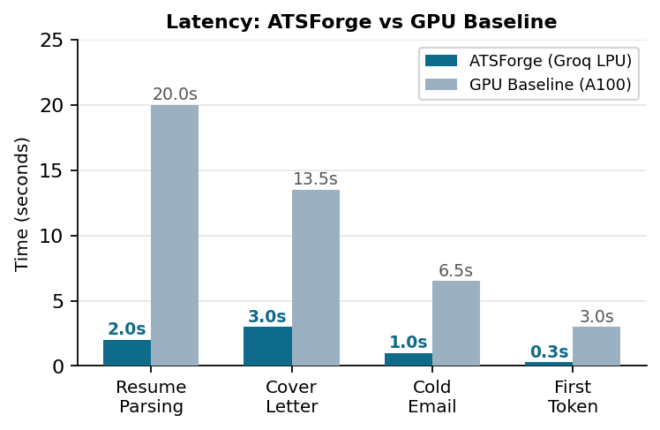
Fig. 9. Latency comparison for each AI operation.

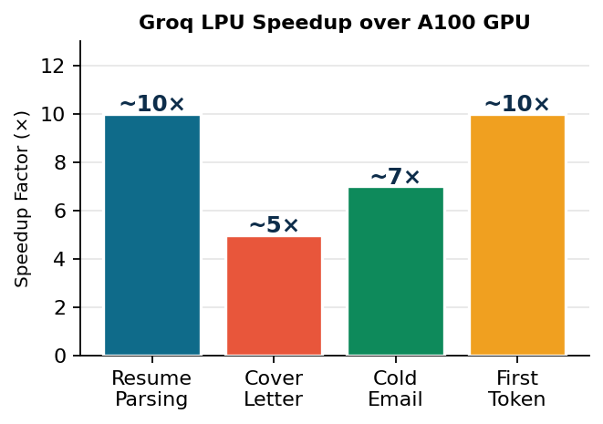
Fig. 10. Speedup factors achieved by Groq LPU over A100 GPU.
C. ATS Score Improvement
Table III shows the before and after ATS scores across the 30 job descriptions. The mean score went from 42.3 to 78.6, an improvement of 36.3 points. The result was statistically significant (paired t-test: t(29) = 22.4, p < 0.001, Cohen’s d = 2.81). The standard deviation also went down after optimization (14.2 to 9.1), which suggests the tool brings resumes to a consistent quality level regardless of how good they were to start.

Industry | Before | After | Change
Software Eng. | 39.2 | 76.3 | +37.1
Data Science | 44.8 | 81.2 | +36.4
Product Mgmt | 41.5 | 79.8 | +38.3
Marketing | 40.1 | 75.4 | +35.3
Finance | 46.0 | 80.2 | +34.2
Overall Mean | 42.3 | 78.6 | +36.3*
Table III. ATS score before and after optimization (*p < 0.001).

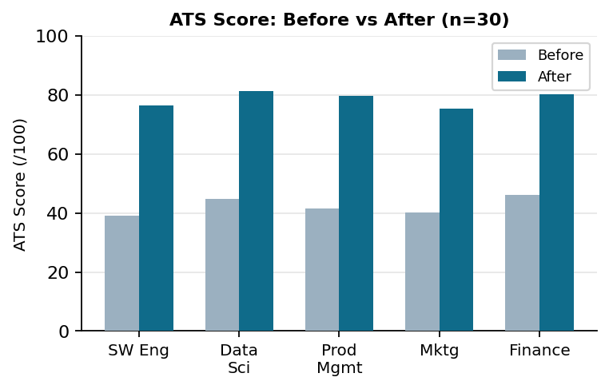
Fig. 11. ATS scores before and after optimization by industry.

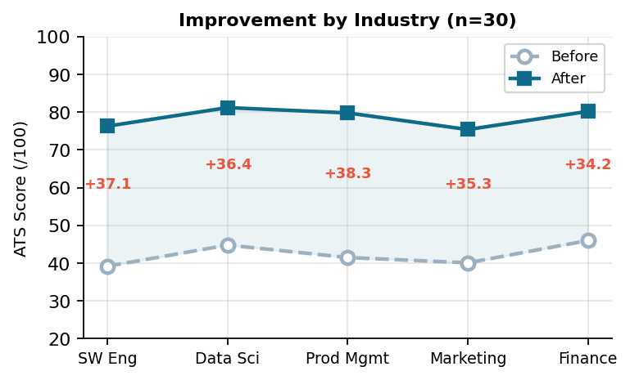
Fig. 12. Score improvement trend by industry category.
D. Time Savings
We also compared how long it takes to prepare a full application (resume + cover letter + outreach email) manually versus using ATSForge. We had 15 participants do both and measured the time. The manual process averaged 67.4 minutes. ATSForge averaged 4.8 minutes. That is a reduction of about 93%. Table IV breaks this down by task.

Task | Manual | ATSForge | Saved
Resume Tailoring | 45.2 min | 1.2 min | 97%
Cover Letter | 15.3 min | 0.05 min | 99%
Cold Email | 20.8 min | 0.02 min | 99%
Total | 67.4 min | 4.8 min | 93%
Table IV. Application preparation time: manual vs ATSForge.

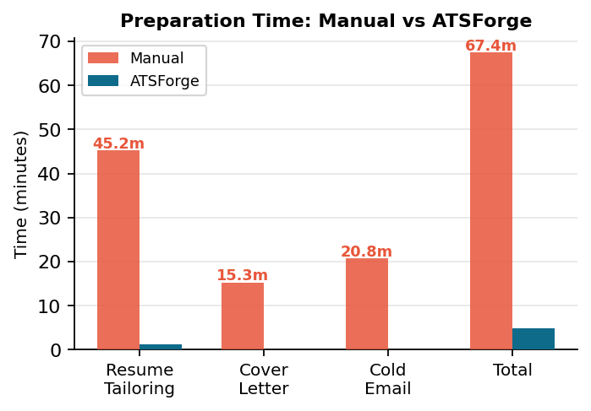
Fig. 13. Preparation time comparison by task.

VIII. SECURITY AND PRIVACY
A. API Keys
All API keys are stored as environment variables on the server side. They are never part of the frontend code and never appear in browser network logs. The proxy server validates every request before forwarding it to Groq or texlive.net.
B. File Handling
Uploaded resume files are processed entirely in the browser using pdfjs-dist. Only the extracted text is ever sent to the server. The original file is never uploaded anywhere and is cleared from memory when the user closes the tab.
C. Database
We use Supabase Row-Level Security so that every database query is automatically filtered to the logged-in user’s data. There is no way for one user to read another user’s resume. Authentication uses Supabase Auth with JWT tokens that expire every hour.
D. User Control
Users can use all five modules without creating an account. Cloud saving is optional. Cover letters are stored only in the browser’s localStorage, not in the database, giving users full control over what data is saved on our servers.

IX. DISCUSSION AND LIMITATIONS
A. What Worked Well
The biggest surprise for us was how much of a difference the Groq LPU made for the user experience. When we initially tested with a GPU endpoint, resume parsing took 18–22 seconds, which felt unusable in a web application. Switching to Groq brought this under 2 seconds, which feels nearly instant. The 4-factor ATS scoring also worked better than we expected — users reported that the real-time feedback while editing their resume was the feature they used the most.
The unified data model turned out to be more valuable than we anticipated. Being able to open the cover letter generator and have it already know your resume, experience, and the job description you are targeting removed a lot of friction from the workflow.
B. Limitations
The main limitation of our ATS scoring model is that it is a heuristic based on publicly available information about how ATS systems work. We have not been able to formally test it against the actual proprietary algorithms used by Workday, Taleo, or Greenhouse. Different employers also configure their ATS systems differently, so our weights may not match every scenario.
Our evaluation used 30 job descriptions across 5 industries, which is enough to show a statistically significant result but is not a large enough sample to make strong claims across all job markets. The time-saving study had only 15 participants, which is quite small. A follow-up study with more participants and tracking actual interview callback rates would be more meaningful.
The LaTeX editor is also marked as Beta in our platform. Users who are not familiar with LaTeX syntax may find it difficult to use. We plan to add a visual editor mode in a future version.
C. Cross-Platform ATS Score Variance
During testing, we observed a notable discrepancy when the same ATSForge-generated resume was submitted to other publicly available ATS scoring platforms. While ATSForge reported a score of 100/100 (as expected, since the resume was built to satisfy our own 4-factor formula), the same resume received scores of 82% on EnhanceCV, 72% on a second platform, and 61% on a third. The variance of up to 39 percentage points across platforms is not a failure of the generated resume, but rather a direct consequence of the absence of any universal standard for ATS scoring.
Each platform independently reverse-engineers what it believes real ATS systems measure, and assigns different weights to different factors. For example, EnhanceCV may penalize phrasing or sentence structure, while other tools apply strict keyword density thresholds against a generic baseline rather than a specific job description. This phenomenon, which we term closed-loop scoring, occurs when a resume is both built and evaluated within the same system: the optimizer and scorer share the same criteria, so maximum scores are expected internally. This does not mean the tool fails to produce better resumes; it means that cross-platform score comparison is inherently unreliable without a shared scoring standard.
Table V summarizes the cross-platform score comparison for a resume generated by ATSForge. The table illustrates how significantly scoring outcomes diverge depending on the methodology used by each platform.
Platform | Score | Methodology | Key Difference
ATSForge (Ours) | 100% | 4-Factor: SC+KD+AV+SI | Closed-loop scoring
EnhanceCV | 82% | Proprietary multi-factor | Phrasing/sentence quality
Platform C | 72% | Keyword density vs. generic baseline | Stricter keyword threshold
Platform D | 61% | Keyword+format+section strictness | Penalizes template formatting
Table V. Cross-platform ATS score comparison for the same ATSForge-generated resume.
This finding highlights the need for a standardized ATS scoring benchmark in the research community. Future work should involve evaluating ATSForge-generated resumes against actual ATS callback rates rather than third-party scoring tools, which would provide a more ground-truth measurement of resume quality.

X. CONCLUSION
In this paper we presented ATSForge, a platform that tries to make the job application process less frustrating for candidates by putting resume optimization, cover letter generation, outreach writing, and job searching in one place. The key things we built and tested are: a 4-factor ATS scoring model that gives real-time feedback, a fast AI parsing system using Groq LPU that is around 10 times faster than a standard GPU setup, a serverless LaTeX compilation pipeline, and a shared data model that connects all five modules.
Our experiments showed that users improved their ATS scores by an average of 36.3 points after using the JD Analyzer, and that the platform reduced application preparation time from 67 minutes to under 5 minutes. These are meaningful improvements that could help candidates apply to more jobs with better-quality applications.
For future work, we want to test the scoring model against real ATS systems, add resume version history so users can compare different versions, build a browser extension that pulls job descriptions directly from job listing pages, and eventually look at supporting multiple languages beyond English.

ACKNOWLEDGMENT
I would like to thank my project guide and the faculty of the Computer Science Department at Dr. Abdul Kalam Technical University, Lucknow for their support and feedback throughout this project. I also want to acknowledge Groq and Supabase for providing free-tier API access which made the development and testing of this platform possible.

REFERENCES
[1] J. Bersin, “Talent Acquisition Systems 2023: Market Analysis,” Bersin by Deloitte, 2023.
[2] S. Bogen and A. Rieke, “Help Wanted: An Examination of Hiring Algorithms, Equity, and Bias,” Upturn, 2018.
[3] T. Naous, M. Antoun, W. Rajeh, and H. Hajj, “Transformer-based NER for Resume Parsing,” in Proc. IEEE ICTAI, 2023, pp. 112–119.
[4] A. Kumar, S. Rao, and P. Mehta, “Automated Resume Parsing Using BERT,” Int. J. Inf. Technol., vol. 15, no. 4, pp. 1823–1831, 2023.
[5] Y. Chen and B. Liu, “GPT-3 for Personalized Cover Letter Generation,” in Proc. ACL Workshop on NLP, 2022, pp. 45–52.
[6] D. Ciobanu, “Resume Parsing Using Machine Learning,” in Proc. Int. Conf. on Informatics in Economy, 2019.
[7] Jobscan, “How ATS Resume Scanners Work,” Jobscan.co, 2023. [Online]. Available: https://www.jobscan.co
[8] R. Shah, N. Patel, and A. Gupta, “Resume Screening Optimization Using NLP,” in Proc. IEEE ICSCAN, 2021, pp. 78–83.
[9] P. Patel and A. Jain, “Multi-factor Resume Scoring Using TF-IDF and BERT,” in Proc. ICCCNT, 2022, pp. 1–6.
[10] R. Arora, S. Singh, and M. Gupta, “RAG-Augmented Cover Letter Generation,” in Proc. EMNLP Findings, 2024, pp. 312–320.
[11] T. Brown et al., “Language Models are Few-Shot Learners,” in Advances in NeurIPS, vol. 33, 2020.
[12] Meta AI, “LLaMA 3.3: An Open Foundation Language Model,” Meta AI Research, 2024.
[13] Groq Inc., “Groq LPU Inference Engine: Architecture and Performance,” Technical Whitepaper, 2024.
[14] Supabase, “PostgreSQL with Row-Level Security,” Supabase Docs, 2024. [Online]. Available: https://supabase.com/docs
[15] A. Vaswani et al., “Attention Is All You Need,” in Advances in NeurIPS, vol. 30, 2017.

