**LAB - 4**

**KMEANS CLUSTERING**

**PRIYANSHU SHARMA**

**15BCE1282**

**CODE**

import pandas as pd

data = pd.read_csv('C:/Users/PRIYANSHU SHARMA/Desktop/PRIYANSHU/6 STUDY/6 SEMSTER/MACHINE LEARNING/LAB/breast.csv')

data.head()

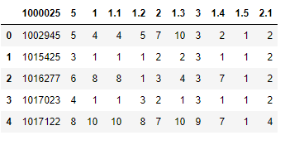

colnames=['ID', 'RADIUS', 'TEXTURE', 'PERIMETER', 'AREA', 'SMOOTHNESS', 'COMPACTNESS', 'CONCAVITY', 'CONCAVE', 'SYMMETRY', 'FRACTAL']

data = pd.read_csv('C:/Users/PRIYANSHU SHARMA/Desktop/PRIYANSHU/6 STUDY/6 SEMSTER/MACHINE LEARNING/LAB/breast.csv', names=colnames, header=None)

data.head()

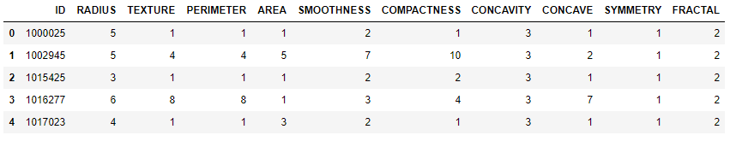

import matplotlib.pyplot as plt

import seaborn as sb

sb.pairplot(data,vars=colnames,hue='FRACTAL')

X, y = data.iloc[:, [2, 6]].values, data['FRACTAL']

from sklearn.preprocessing import StandardScaler

sc=StandardScaler()

X_std=sc.fit_transform(X)

X_std

plt.scatter(X_std[:,0],X_std[:,1],c='blue',marker='o')

plt.grid()

plt.show()

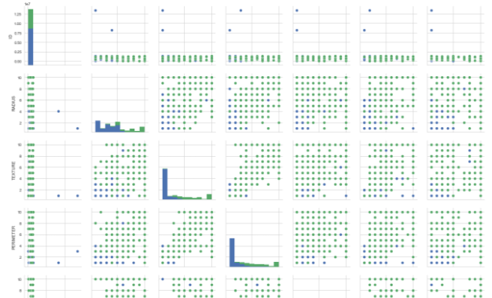

from sklearn.cluster import KMeans

km = KMeans(n_clusters=2,init='random',n_init=100,max_iter=30,tol=1e-04,random_state=0)

y_km = km.fit_predict(X_std)

plt.scatter(X_std[y_km==0,0],X_std[y_km ==0,1],c='lightgreen',marker='s',label='cluster 1')

plt.scatter(X_std[y_km ==1,0],X_std[y_km ==1,1],c='orange',marker='o',label='cluster 2')

plt.scatter(km.cluster_centers_[:,0],km.cluster_centers_[:,1],marker='*',c='red',label='centroids')

plt.legend(bbox_to_anchor=(1, 1),

bbox_transform=plt.gcf().transFigure)

plt.grid()

plt.show()

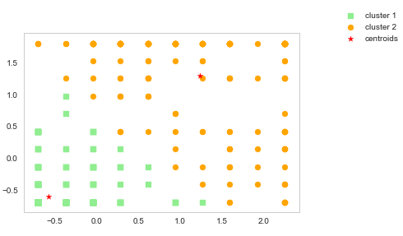

print('Distortion: %.2f' % km.inertia_)



distortions = []

for i in range(1, 11):

km = KMeans(n_clusters=i,init='k-means++',n_init=10,max_iter=300,random_state=0)

km.fit(X)

distortions.append(km.inertia_)

plt.plot(range(1,11), distortions, marker='o')

plt.xlabel('Number of clusters')

plt.ylabel('Distortion')

plt.show()

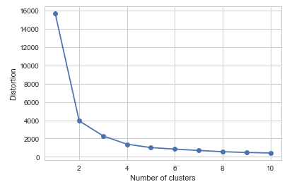

from matplotlib import cm

from sklearn.metrics import silhouette_samples

import numpy as np

cluster_labels = np.unique(y_km)

n_clusters = cluster_labels.shape[0]

silhouette_vals = silhouette_samples(X_std,y_km,metric='euclidean')

y_ax_lower, y_ax_upper = 0, 0

yticks = []

for i, c in enumerate(cluster_labels):

c_silhouette_vals = silhouette_vals[y_km == c]

c_silhouette_vals.sort()

y_ax_upper += len(c_silhouette_vals)

color = cm.jet(i / n_clusters)

plt.barh(range(y_ax_lower, y_ax_upper),

c_silhouette_vals,

height=1.0,

edgecolor='none',

color=color)

yticks.append((y_ax_lower + y_ax_upper) / 2)

y_ax_lower += len(c_silhouette_vals)

silhouette_avg = np.mean(silhouette_vals)

plt.axvline(silhouette_avg,color="red",linestyle="--")

plt.yticks(yticks, cluster_labels + 1)

plt.ylabel('Cluster')

plt.xlabel('Silhouette coefficient')

plt.show()

