**LAB - 3**

**MACHINE LEARNING**

**PRIYANSHU SHARMA**

**15BCE1282**

**LOGISTIC REGRESSION**

**CODE**

#logistic regression

import matplotlib.pyplot as plt

import pandas as pd

import numpy as np

data = pd.read_csv('C:/Users/PRIYANSHU SHARMA/Desktop/PRIYANSHU/6 STUDY/6 SEMSTER/MACHINE LEARNING/LAB/breast.csv')

data.head()

colnames=['ID', 'RADIUS', 'TEXTURE', 'PERIMETER', 'AREA', 'SMOOTHNESS', 'COMPACTNESS', 'CONCAVITY', 'CONCAVE', 'SYMMETRY', 'FRACTAL']

data = pd.read_csv('C:/Users/PRIYANSHU SHARMA/Desktop/PRIYANSHU/6 STUDY/6 SEMSTER/MACHINE LEARNING/LAB/breast.csv', names=colnames, header=None)

data.head()

print(data.columns)

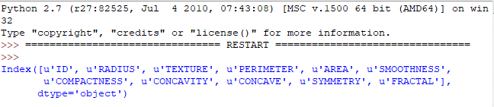

data.describe()

def sigmoid(z):

return 1.0 / (1.0 + np.exp(-z))

z = np.arange(-7, 7, 0.1)

phi_z = sigmoid(z)

plt.plot(z, phi_z)

plt.axvline(0.0, color='k')

plt.axhspan(0.0, 1.0, facecolor='1.0', alpha=1.0, ls='dotted')

plt.axhline(y=0.5, ls='dotted', color='k')

plt.yticks([0.0, 0.5, 1.0])

plt.ylim(-0.1, 1.1)

plt.xlabel('z')

plt.ylabel('$\phi (z)$')

plt.show()

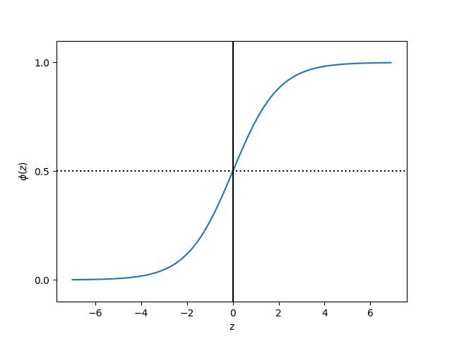

from sklearn.cross_validation import train_test_split

X = data.iloc[0:, [1,5]].values

X

X_train,X_test,Y_train,Y_test = train_test_split(X,data['FRACTAL'], test_size=0.3, random_state=0)

col=['COMPACTNESS','SMOOTHNESS']

#For visualization

from matplotlib.colors import ListedColormap

def plot_decision_regions(X, y, classifier,test_idx=None, resolution=0.02):

# setup marker generator and color map

markers = ('s', 'x', 'o', '^', 'v')

colors = ('green', 'red', 'lightgreen', 'gray', 'cyan')

cmap = ListedColormap(colors[:len(np.unique(y))])

# plot the decision surface

x1_min, x1_max = X[:, 0].min() - 1, X[:, 0].max() + 1

x2_min, x2_max = X[:, 1].min() - 1, X[:, 1].max() + 1

xx1, xx2 = np.meshgrid(np.arange(x1_min, x1_max, resolution),

np.arange(x2_min, x2_max, resolution))

Z = classifier.predict(np.array([xx1.ravel(), xx2.ravel()]).T)

Z = Z.reshape(xx1.shape)

plt.contourf(xx1, xx2, Z, alpha=0.4, cmap=cmap)

plt.xlim(xx1.min(), xx1.max())

plt.ylim(xx2.min(), xx2.max())

# plot class samples

for idx, cl in enumerate(np.unique(y)):

plt.scatter(x=X[y == cl, 0], y=X[y == cl, 1],

alpha=0.8, c=cmap(idx),

marker=markers[idx], label='Benign' if cl == 2 else 'Malignant')

from sklearn.linear_model import LogisticRegression

from sklearn.preprocessing import StandardScaler

import numpy as np

sc = StandardScaler()

sc.fit(X_train)

X_train_std = sc.transform(X_train)

X_test_std = sc.transform(X_test)

lr = LogisticRegression(C=1000.0, random_state=0)

lr.fit(X_train_std, Y_train)

print("Accuracy on the training set: %.3f" % lr.score(X_train,Y_train))

print("Accuracy on the testing set: %.3f" % lr.score(X_test,Y_test))

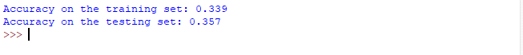

X_combined_std = np.vstack((X_train_std, X_test_std))

y_combined = np.hstack((Y_train, Y_test))

plot_decision_regions(X_combined_std,y_combined, classifier=lr)

plt.xlabel('COMPAPCTNESS')

plt.ylabel('SMOOTHNESS')

plt.legend(loc='upper left')

plt.show()

**OUTPUT**

