**LAB - 4**

**MACHINE LEARNING**

**PRIYANSHU SHARMA**

**15BCE1282**

**SINGLE LAYER PERCEPTRON**

**CODE**

#SINGLE LAYER PERCEPTRON

import pandas as pd

import sklearn

import matplotlib.pyplot as plt

import numpy as np

from scipy.special import expit

import sys

class NeuralNetMLP(object):

def __init__(self, n_output, n_features, n_hidden=30,

l1=0.0, l2=0.0, epochs=500, eta=0.001,

alpha=0.0, decrease_const=0.0, shuffle=True,

minibatches=1, random_state=None):

np.random.seed(random_state)

self.n_output = n_output

self.n_features = n_features

self.n_hidden = n_hidden

self.w1, self.w2 = self._initialize_weights()

self.l1 = l1

self.l2 = l2

self.epochs = epochs

self.eta = eta

self.alpha = alpha

self.decrease_const = decrease_const

self.shuffle = shuffle

self.minibatches = minibatches

def _encode_labels(self, y, k):

onehot = np.zeros((k, y.shape[0]))

for idx, val in enumerate(y):

onehot[val, idx] = 1.0

return onehot

def _initialize_weights(self):

w1 = np.random.uniform(-1.0, 1.0,

size=self.n_hidden*(self.n_features + 1))

w1 = w1.reshape(self.n_hidden, self.n_features + 1)

w2 = np.random.uniform(-1.0, 1.0,

size=self.n_output*(self.n_hidden + 1))

w2 = w2.reshape(self.n_output, self.n_hidden + 1)

return w1, w2

def _sigmoid(self, z):

# expit is equivalent to 1.0/(1.0 + np.exp(-z))

return expit(z)

def _sigmoid_gradient(self, z):

sg = self._sigmoid(z)

return sg * (1 - sg)

def _add_bias_unit(self, X, how='column'):

if how == 'column':

X_new = np.ones((X.shape[0], X.shape[1]+1))

X_new[:, 1:] = X

elif how == 'row':

X_new = np.ones((X.shape[0]+1, X.shape[1]))

X_new[1:, :] = X

else:

raise AttributeError('`how` must be `column` or `row`')

return X_new

def _feedforward(self, X, w1, w2):

a1 = self._add_bias_unit(X, how='column')

z2 = w1.dot(a1.T)

a2 = self._sigmoid(z2)

a2 = self._add_bias_unit(a2, how='row')

z3 = w2.dot(a2)

a3 = self._sigmoid(z3)

return a1, z2, a2, z3, a3

def _L2_reg(self, lambda_, w1, w2):

return (lambda_/2.0) * (np.sum(w1[:, 1:] ** 2) + np.sum(w2[:, 1:] ** 2))

def _L1_reg(self, lambda_, w1, w2):

return (lambda_/2.0) * (np.abs(w1[:, 1:]).sum() + np.abs(w2[:, 1:]).sum())

def _get_cost(self, y_enc, output, w1, w2):

term1 = -y_enc * (np.log(output))

term2 = (1 - y_enc) * np.log(1 - output)

cost = np.sum(term1 - term2)

L1_term = self._L1_reg(self.l1, w1, w2)

L2_term = self._L2_reg(self.l2, w1, w2)

cost = cost + L1_term + L2_term

return cost

def _get_gradient(self, a1, a2, a3, z2, y_enc, w1, w2):

# backpropagation

sigma3 = a3 - y_enc

z2 = self._add_bias_unit(z2, how='row')

sigma2 = w2.T.dot(sigma3) * self._sigmoid_gradient(z2)

sigma2 = sigma2[1:, :]

grad1 = sigma2.dot(a1)

grad2 = sigma3.dot(a2.T)

# regularize

grad1[:, 1:] += (w1[:, 1:] * (self.l1 + self.l2))

grad2[:, 1:] += (w2[:, 1:] * (self.l1 + self.l2))

return grad1, grad2

def predict(self, X):

a1, z2, a2, z3, a3 = self._feedforward(X, self.w1, self.w2)

y_pred = np.argmax(z3, axis=0)

return y_pred

def fit(self, X, y, print_progress=False):

self.cost_ = []

X_data, y_data = X.copy(), y.copy()

y_enc = self._encode_labels(y, self.n_output)

delta_w1_prev = np.zeros(self.w1.shape)

delta_w2_prev = np.zeros(self.w2.shape)

for i in range(self.epochs):

# adaptive learning rate

self.eta /= (1 + self.decrease_const*i)

if print_progress:

sys.stderr.write(

'\rEpoch: %d/%d' % (i+1, self.epochs))

sys.stderr.flush()

if self.shuffle:

idx = np.random.permutation(y_data.shape[0])

X_data, y_data = X_data[idx], y_data[idx]

mini = np.array_split(range(

y_data.shape[0]), self.minibatches)

for idx in mini:

# feedforward

a1, z2, a2, z3, a3 = self._feedforward(

X[idx], self.w1, self.w2)

cost = self._get_cost(y_enc=y_enc[:, idx],

output=a3,

w1=self.w1,

w2=self.w2)

self.cost_.append(cost)

# compute gradient via backpropagation

grad1, grad2 = self._get_gradient(a1=a1, a2=a2,

a3=a3, z2=z2,

y_enc=y_enc[:, idx],

w1=self.w1,

w2=self.w2)

# update weights

delta_w1, delta_w2 = self.eta * grad1, self.eta * grad2

self.w1 -= (delta_w1 + (self.alpha * delta_w1_prev))

self.w2 -= (delta_w2 + (self.alpha * delta_w2_prev))

delta_w1_prev, delta_w2_prev = delta_w1, delta_w2

return self

data = pd.read_csv('C:/Users/PRIYANSHU SHARMA/Desktop/PRIYANSHU/6 STUDY/6 SEMSTER/MACHINE LEARNING/LAB/breast.csv')

data.head()

colnames=['ID', 'RADIUS', 'TEXTURE', 'PERIMETER', 'AREA', 'SMOOTHNESS', 'COMPACTNESS', 'CONCAVITY', 'CONCAVE', 'SYMMETRY', 'FRACTAL']

data = pd.read_csv('C:/Users/PRIYANSHU SHARMA/Desktop/PRIYANSHU/6 STUDY/6 SEMSTER/MACHINE LEARNING/LAB/breast.csv', names=colnames, header=None)

data.head()

print(data.columns)

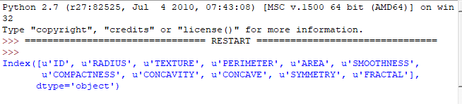

data.describe()

from sklearn.cross_validation import train_test_split

X = data.iloc[0:, [1,2,3,4,5,6,7]].values

X_train,X_test,Y_train,Y_test = train_test_split(X,data['FRACTAL'], test_size=0.3, random_state=0)

nn = NeuralNetMLP(n_output=10,

n_features=X_train.shape[1],

n_hidden=25,

l2=0.1,

l1=0.0,

epochs=1000,

eta=0.001,

alpha=0.001,

decrease_const=0.00001,

shuffle=True,

minibatches=50,

random_state=1)

nn.fit(X_train, Y_train, print_progress=True)

plt.plot(range(len(nn.cost_)), nn.cost_)

plt.ylim([0, 100])

plt.ylabel('Cost')

plt.xlabel('Epochs * 50')

plt.tight_layout()

plt.show()

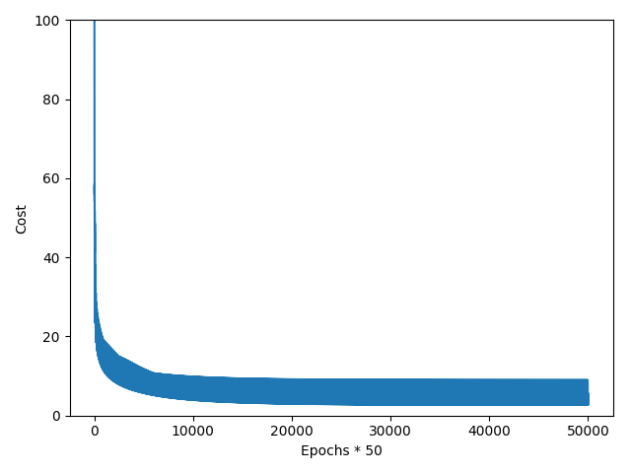

batches = np.array_split(range(len(nn.cost_)), 1000)

cost_ary = np.array(nn.cost_)

cost_avgs = [np.mean(cost_ary[i]) for i in batches]

plt.plot(range(len(cost_avgs)),

cost_avgs,

color='red')

plt.ylim([0, 100])

plt.ylabel('Cost')

plt.xlabel('Epochs')

plt.tight_layout()

plt.show()

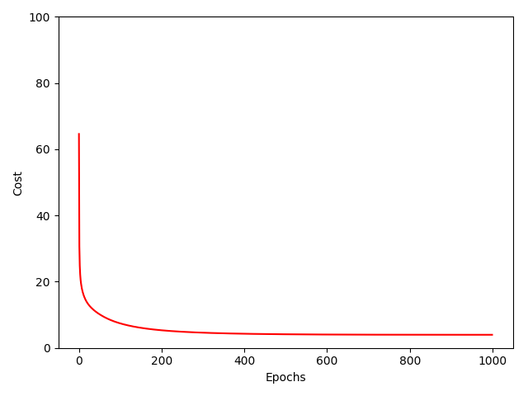

Y_train_pred = nn.predict(X_train)

acc = np.sum(Y_train == Y_train_pred, axis=0) / X_train.shape[0]

print('Training accuracy: %.2f%%' % (acc * 100))

Y_test_pred = nn.predict(X_test)

acc = np.sum(Y_test == Y_test_pred, axis=0) / X_test.shape[0]

print('Testing accuracy: %.2f%%' % (acc * 100))

