**PROJECT REVIEW - 1**

**EMBEDDED SYSTEM AND DESIGN**

**PRIYANSHU SHARMA**

**15BCE1282**

**TITLE - “LINE FOLLOWING ROBOT WITH OBSTACLE AVOIDANCE SYSTEM”**

**MODULES AND THEIR DESCRIPTION**

1. **ARDUINO UNO**

Arduino Uno is an ATmega 328p Micro-controller based prototyping board. It is an open source electronic prototyping platform that can be used with various sensors and actuators. Arduino Uno has 14 digital I/O pins out of which 6 pins are used in this project.

1. **HC-SR04 (ULTRASONIC SENSOR)**

It is an Ultrasonic Range Finder Sensor. It is a non-contact based distance measurement system and can measure distance of 2cm to 4m.

1. **L293D (MOTOR DRIVER)**

It is a motor driver which can provide bi-directional drive current for two motors.

1. **SERVO MOTOR**

The Tower Pro SG90 is a simple Servo Motor which can rotate 90 degrees in each direction (approximately 180 degrees in total).

1. **JUMPER WIRES (MALE TO MALE, FEMALE TO FEMALE, MALE TO FEMALE**
2. **POWER SOURCES**

5V power bank or 5V battery pack (I used a phone charger power bank I had already)

1. **SOFTWARE**

Ardunio IDE is requires in order to used the Arduino Uno.

1. **IR RECEIVER AND RECEIVER**

**METHODOLOGY**

**Step 1 :** Get to know Arduino and electronics basics

**Step 2:** Connect ultrasonic sensor to detect obstacle

**2.1:** Connect the circuit as shown below

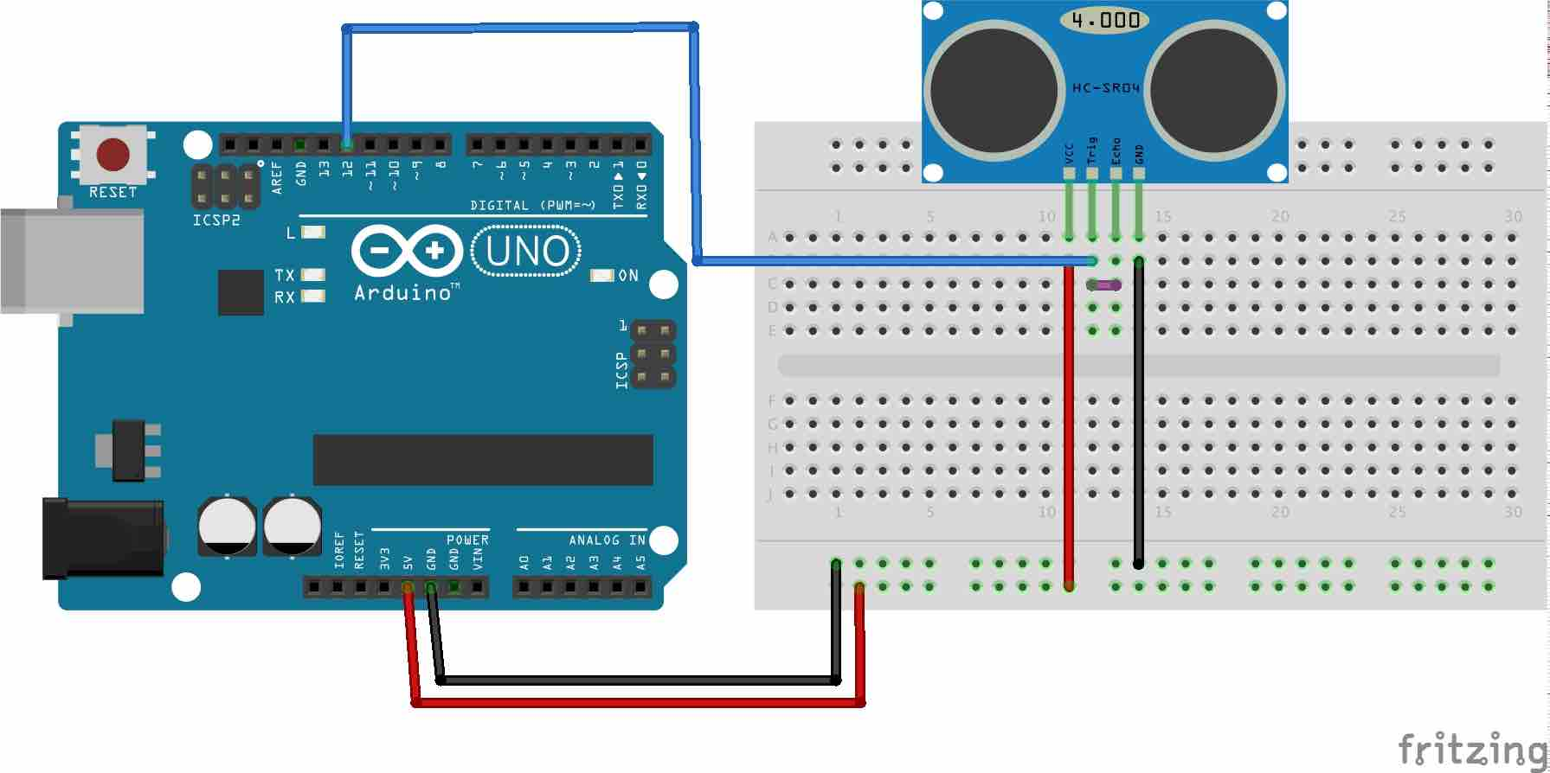

**2.2:** Add New Ping library to read distance.

**2.3:** Upload the code to Arduino

**2.4:** Test the distance measured by sensor

**Step 3:** Assemble the robot chassis and test the motors & wheels

**Step 4:** Program L293D motor driver to control the wheels

**4.1:** Connect the L293D motor to Arduino

**4.2:** Test the wheel movement control

**Step 5:** Integrate sensor input to control the bot movement

**Step 6:** Test it in the field

**CIRCUIT DIAGRAM**

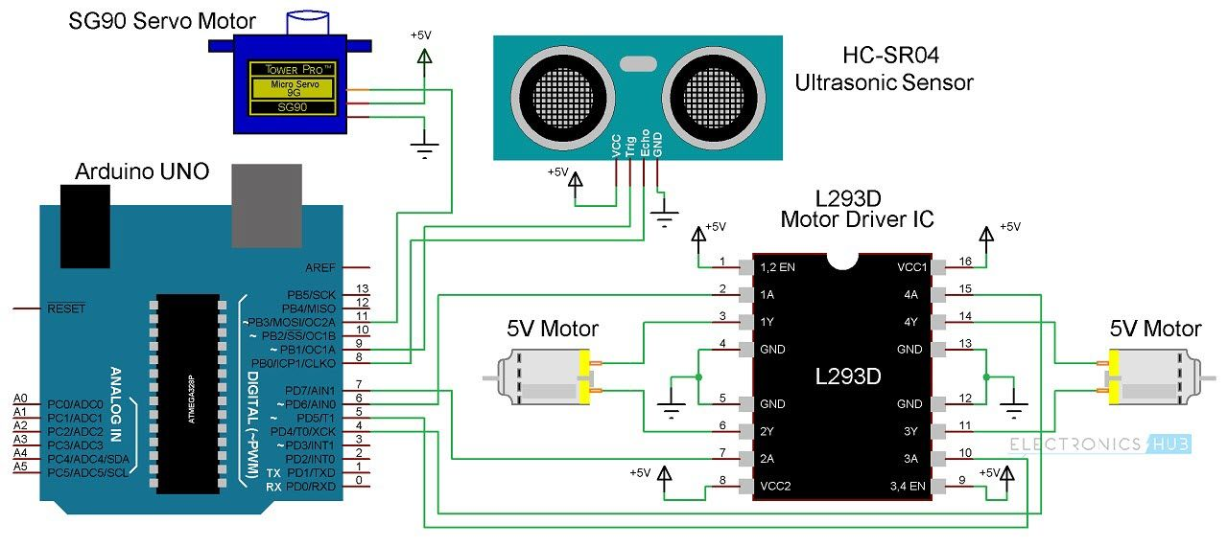

**EXPECTED RESULT**

Our robot can able to follow the line using the IR sensors and if our ultrasonic sensor sense any obstacle its path they it should able to follow the other path also.