LAB-4
Combiner and Salary based calculation with conditions

PRIYANSHU SHARMA
15BCE1282

CODE

Question-1

Try the word count program with combiner class.

CODE

import java.io.IOException;

import java.util.*;

import org.apache.hadoop.fs.Path;

import org.apache.hadoop.conf.*;

import org.apache.hadoop.io.*;

import org.apache.hadoop.mapreduce.*;

import org.apache.hadoop.mapreduce.lib.output.*; import org.apache.hadoop.mapreduce.lib.input.*; public class WordCount2{

public static class Map extends Mapper<LongWritable,Text,Text,IntWritable> {

private final static IntWritable one = new IntWritable(1); private Text word=new Text();

public void map(LongWritable key,Text value, Context context) throws IOException,InterruptedException{

String[] line= value.toString().split(" "); for(String lines:line)

{

context.write(new Text(lines),one);

}

}

}

public static class Reduce extends Reducer<Text,IntWritable,Text,IntWritable>{ public void reduce (Text key,Iterable<IntWritable> values, Context

context) throws IOException,InterruptedException{ int sum=0;

for(IntWritable val:values){

sum+=val.get();

}

context.write(key, new IntWritable(sum));

}

}

public static void main(String[] args) throws Exception{ Configuration conf= new Configuration();
Job job = new Job(conf,"wordcount"); job.setJarByClass(WordCount2.class); job.setOutputKeyClass(Text.class); job.setOutputValueClass(IntWritable.class); job.setMapperClass(Map.class); job.setReducerClass(Reduce.class); job.setCombinerClass(Reduce.class); job.setInputFormatClass(TextInputFormat.class); job.setOutputFormatClass(TextOutputFormat.class); FileInputFormat.addInputPath(job,new Path(args[0])); FileOutputFormat.setOutputPath(job,new Path(args[1])); job.waitForCompletion(true); }}

OUTPUT

When combiner is used
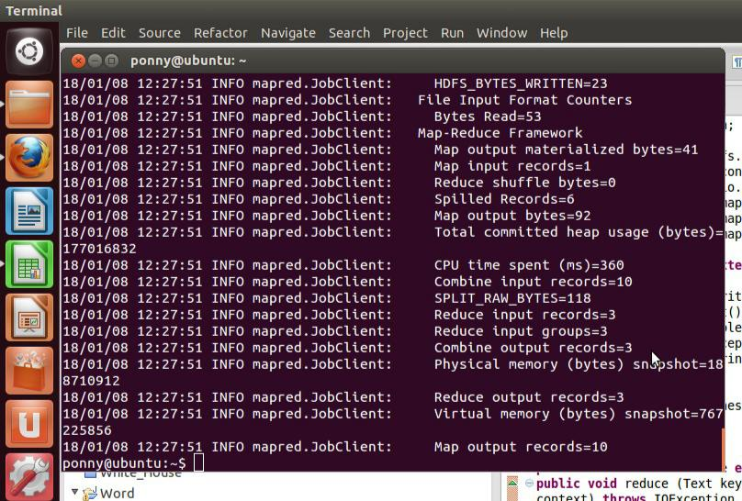
When combiner is not used we see 0 combine input records
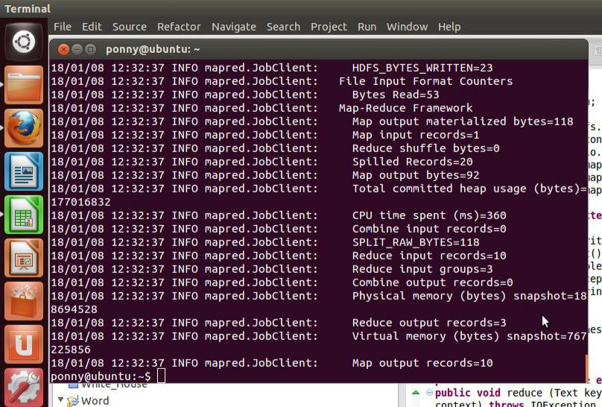

Question-2

Write map-reduce programming with the salary details > 100000 and display the total number of records satisfying the conditions. The output in HDFS should be country name, years of experience and salary

CODE

import java.io.IOException;

import java.util.*;

import org.apache.hadoop.fs.Path;

import org.apache.hadoop.conf.*;

import org.apache.hadoop.io.*;

import org.apache.hadoop.mapreduce.*;

import org.apache.hadoop.mapreduce.lib.output.*; import org.apache.hadoop.mapreduce.lib.input.*; public class salary{

public static class Map extends Mapper<LongWritable,Text,Text,IntWritable>

{

private final static IntWritable one = new IntWritable(1);
private Text word=new Text();

Text w= new Text("");

Text counter= new Text("Total count");

int c=0;

IntWritable val;

public void map(LongWritable key,Text value, Context context) throws IOException,InterruptedException{

String[] line= value.toString().split(",");

int i=Integer.parseInt(line[1]);

if(i>100000))

{

context.write(new Text(line[3]+","+line[0]),new IntWritable(i)); val=new IntWritable(i);

w=new Text(line[3]+","+line[0]);

c=c+1;

}

}

protected void cleanup(Context context) throws

IOException, InterruptedException {

context.write(w,val);

context.write(counter,new IntWritable(c));

}

}

public static void main(String[] args) throws Exception{ Configuration conf= new Configuration();

Job job = new Job(conf,"wordcount"); job.setJarByClass(salary.class); job.setOutputKeyClass(Text.class); job.setOutputValueClass(IntWritable.class); job.setMapperClass(Map.class); job.setCombinerClass(Reduce.class); job.setInputFormatClass(TextInputFormat.class); job.setOutputFormatClass(TextOutputFormat.class); FileInputFormat.addInputPath(job,new Path(args[0])); FileOutputFormat.setOutputPath(job,new Path(args[1])); job.waitForCompletion(true); }}

OUTPUT
