LAB-3
Maximum Frequency and Total Number of Words

PRIYANSHU SHARMA
15BCE1282

CODE

import java.io.*;

import java.util.*;

import org.apache.hadoop.fs.Path;

import org.apache.hadoop.io.*;

import org.apache.hadoop.conf.*;

import org.apache.hadoop.mapreduce.*;

import org.apache.hadoop.mapreduce.lib.input.*; import org.apache.hadoop.mapreduce.lib.output.*; public class WordCount2 {

public static class Map extends Mapper<LongWritable,Text,Text,IntWritable>

{

private final static IntWritable one=new IntWritable(1); private Text word=new Text();

public void map(LongWritable key,Text value,Context

context)throws

IOException,InterruptedException

{

String[] line=value.toString().split(" "); for(String lines:line) {

context.write(new Text(lines),one);

}

}

}

public static class Reduce extends Reducer<Text,IntWritable,Text,IntWritable>

{

int max =0,total=0;

Text maxWord = new Text();

Text Total=new Text("Total Count");

public void reduce(Text key,Iterable<IntWritable>

values,Context

context)throws IOException,InterruptedException

{

int sum=0;

for(IntWritable val:values)

{

sum+=val.get();

}
total+=sum;

if(sum > max)

{

max = sum;

maxWord.set(key);

}

}

protected void cleanup(Context context) throws IOException, InterruptedException {

context.write(maxWord, new IntWritable(max)); context.write(Total,new IntWritable(total));

}

}

public static void main(String[] args) throws Exception {

Configuration conf=new Configuration(); Job job=new Job(conf,"wordcount"); job.setJarByClass(WordCount2.class); job.setOutputKeyClass(Text.class); job.setOutputValueClass(IntWritable.class); job.setMapperClass(Map.class); job.setReducerClass(Reduce.class); job.setInputFormatClass(TextInputFormat.class); job.setOutputFormatClass(TextOutputFormat.class); FileInputFormat.addInputPath(job,new Path(args[0])); FileOutputFormat.setOutputPath(job,new Path(args[1])); job.waitForCompletion(true);

}

}

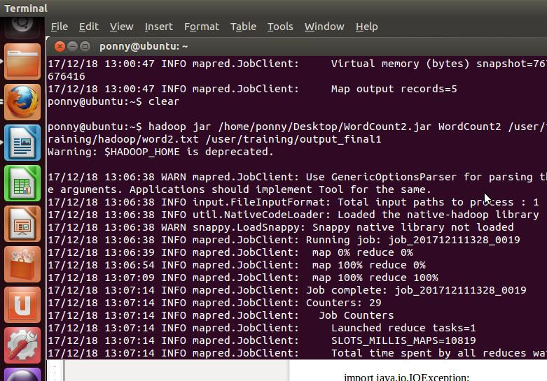
OUTPUT
