PROJECT REPORT
Titanic Survival Prediction using Logistic Regression

Name: Anshul Singh Jadon
Roll No.: 2301920100064
Branch: CSE (4th Year)
Submitted To: Mr. Anant Verma

1. Introduction
The Titanic disaster is one of the most well-known events used in machine learning to study binary classification problems. In this project, a Logistic Regression model is developed to predict whether a passenger survived based on information such as age, gender, passenger class, family members, fare, and port of embarkation.
The project follows the complete machine learning process, including understanding the dataset, performing exploratory data analysis (EDA), preprocessing the data, training the Logistic Regression model, evaluating its performance, and drawing meaningful insights from the results. The main objective is to identify the factors that influenced passenger survival and build a model that can accurately predict survival.

2. Problem Statement
The objective of this project is to build a Logistic Regression model that predicts whether a Titanic passenger survived or not using passenger information such as age, gender, passenger class, family members, fare, and port of embarkation. The model helps identify the factors that had the greatest impact on passenger survival.
The target variable used in this project is:
- Survived = 0 → Passenger did not survive
- Survived = 1 → Passenger survived
Since the target variable has only two possible outcomes (survived or not survived), Logistic Regression is an appropriate algorithm for this prediction task. It is simple, effective, and helps understand how different features influence the survival of passengers.

3. Dataset Description
The dataset used in this project is the Titanic dataset, which contains passenger information such as age, gender, passenger class, fare, family members, and port of embarkation. These features are used to predict whether a passenger survived the disaster.

3.1 Data Cleaning Findings
- 19 Before training the model, the dataset was cleaned and prepared for analysis.
- Unnecessary columns containing only zero values were removed.
- The target column was renamed to Survived for better readability.
- Rows with invalid or placeholder survival values were removed to ensure accurate model training.
- The features Sex, Pclass, and Embarked were already available in numerical form.
- Missing values in the Embarked column were handled before model training.

3.2 Feature Summary
Feature | Type | Description
Passengerid | Numerical (ID) | Unique passenger identifier
Age | Numerical | Passenger age in years
Fare | Numerical | Ticket fare paid
Sex | Categorical | 0 = Male, 1 = Female
SibSp | Numerical | Number of siblings/spouses aboard
Parch | Numerical | Number of parents/children aboard
Pclass | Categorical | Ticket class: 1, 2, or 3
Embarked | Categorical | Port of embarkation (coded 0/1/2)
Survived | Target | 0 = Did not survive, 1 = Survived

4. Exploratory Data Analysis
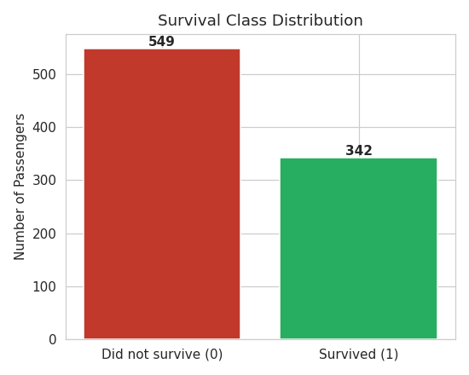
Figure 1. Survival class distribution.

4.1 Correlation Analysis
The correlation heatmap below shows Sex as the feature most strongly correlated with Survived (positive), and Pclass as strongly negatively correlated (higher class number = lower survival).
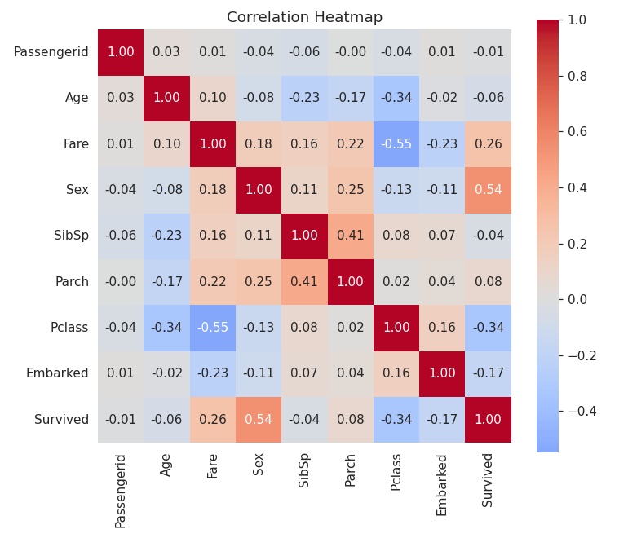
Figure 2. Correlation heatmap of numeric/encoded features.

4.2 Distributions and Outliers
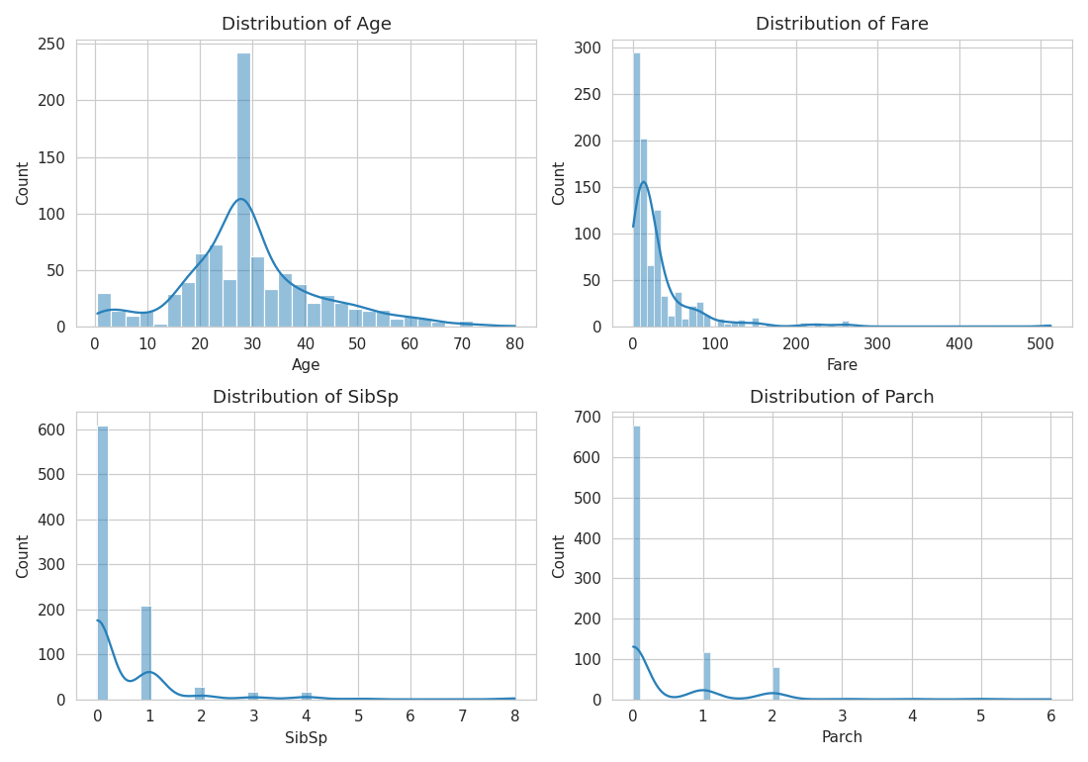
Figure 3. Histograms of numerical features.
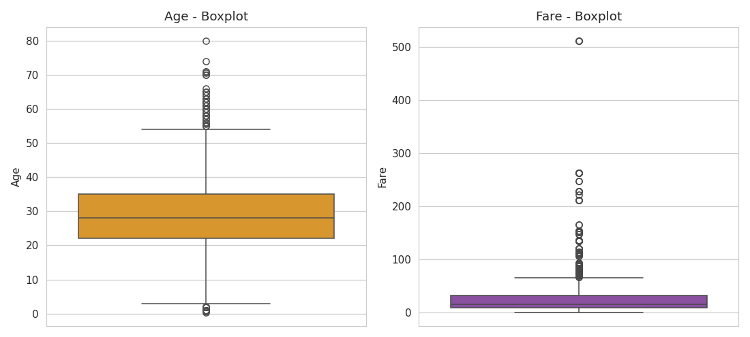
Figure 4. Boxplots of Age and Fare showing outliers.

4.3 Survival by Category
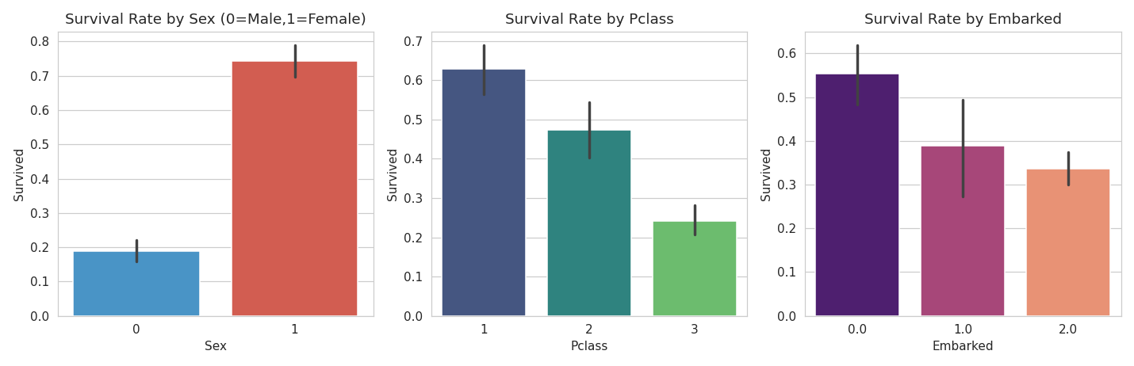
Figure 5. Survival rate by Sex, Pclass, and Embarked.

4.4 Pairplot
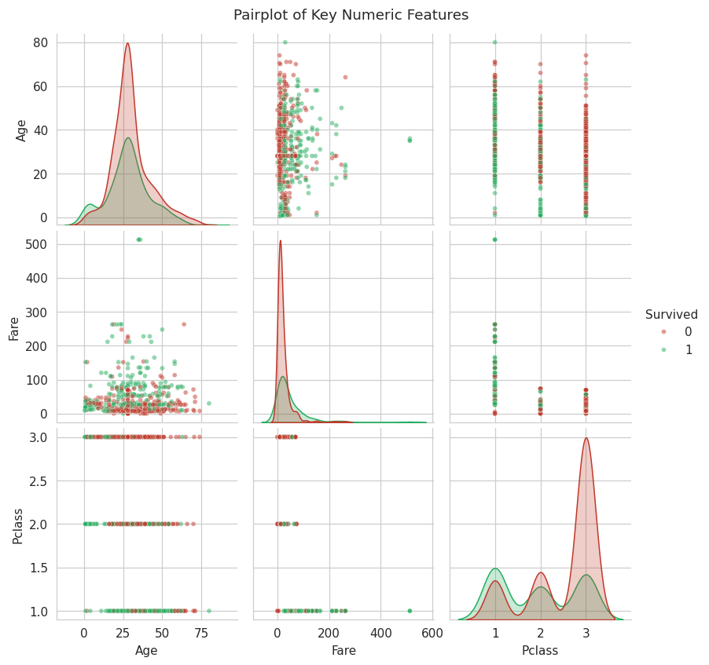
Figure 6. Pairwise relationships between Age, Fare, and Pclass, colored by survival.

4.5 EDA Observations
- Sex is the feature most highly correlated with survival.
- The dataset is moderately imbalanced (approximately 62/38 split), which is factored into metric choice later.
- Sex, Pclass, and Fare are the most visually and statistically useful predictors; Age and family-size features (SibSp, Parch) add smaller but non-trivial signal.

5. Data Preprocessing
Before training the Logistic Regression model, the dataset was preprocessed to improve its quality and prepare it for modeling.
- Missing Values: Missing values in the Embarked column were filled using the most frequent value (mode).
- Encoding: Categorical features were converted into numerical format using one-hot encoding, while the Sex feature was already in binary form.
- Feature Scaling: Numerical features were standardized using StandardScaler so that all features have a similar scale.
- Train-Test Split: The dataset was divided into 80% training data and 20% testing data to evaluate the model's performance on unseen data.

6. Model Building
A Logistic Regression classifier (scikit-learn, max_iter=1000) was trained on the scaled training features.

6.1 Model Coefficients
Feature | Coefficient
Sex | 1.2653
Pclass_3 | -1.0707
Age | -0.4939
Pclass_2 | -0.3744
SibSp | -0.261
Embarked_2.0 | -0.187
Fare | 0.1239
Embarked_1.0 | 0.0794
Parch | -0.0696
Intercept: -0.6588
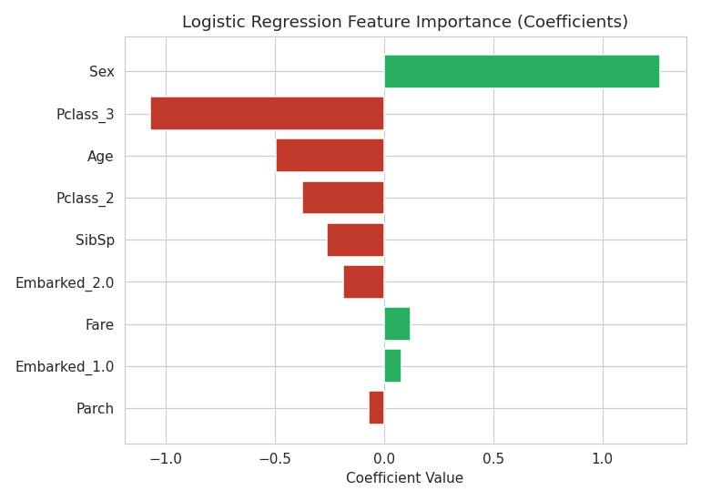
Figure 7. Feature importance ranked by absolute coefficient magnitude.

7. Model Evaluation
Metric | Value
Accuracy | 0.8045
Precision | 0.7931
Recall | 0.6667
F1 Score | 0.7244
ROC-AUC | 0.8423
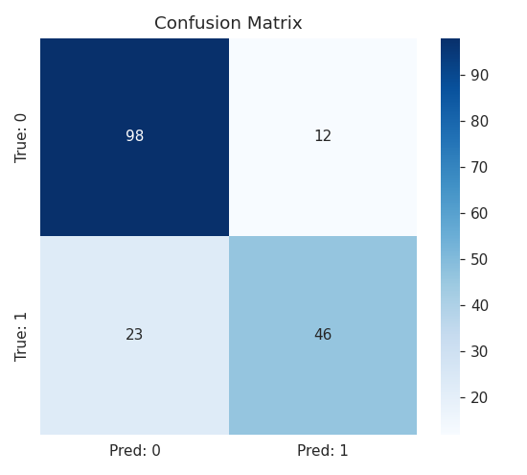
Figure 8. Confusion matrix on the held-out test set.
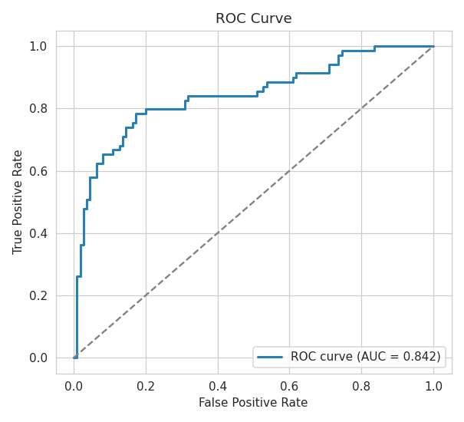
Figure 9. ROC curve.

8. Hyperparameter Tuning

Metric | Baseline Model | Tuned Model
Accuracy | 0.8045 | 0.8045
Precision | 0.7931 | 0.7931
Recall | 0.6667 | 0.6667
F1 Score | 0.7244 | 0.7244
In this case, the default Logistic Regression settings were already close to the cross-validated optimum, so tuning produced the same test-set performance while confirming, via grid search, that the chosen regularization strength and penalty type are well-justified rather than arbitrary.

9. Business Insights

1. Which factors most influenced passenger survival?
The most important factors affecting survival were gender (Sex), passenger class (Pclass), and age. These features had the greatest impact on the model's predictions.

2. Did passenger class affect survival probability?
Yes. Passengers traveling in first class had a higher chance of survival than those in second and third class. Survival rates decreased as the passenger class moved from first to third.

3. Did gender significantly impact survival?
Yes. Gender was the strongest predictor of survival. Female passengers had a much higher survival rate than male passengers.

4. What role did age play?
Age also influenced survival. Younger passengers, especially children, had a better chance of surviving than older passengers.

5. Which feature was the strongest predictor?
Among all the features, Sex was the strongest predictor of passenger survival.

6. Recommendations for improving passenger safety

Ensure equal access to lifeboats for passengers in all classes.

Give priority to children and other vulnerable passengers during emergencies.

Conduct regular safety drills and provide clear emergency instructions.

Use predictive models to support emergency planning and improve passenger safety.

