Course Title: Artificial Intelligence and Deep learning
Course Code: 24CS312PC310
Year/Sem: III/1
Date: 20/08/26
Name: M.ANSIKA
Roll No:2403A51092
Batch:04
ASSIGNMENT – 5
Kaggle Dataset Link: https://www.kaggle.com/c/cifar-10
1.Load and preprocess the CIFAR-10 dataset/example.
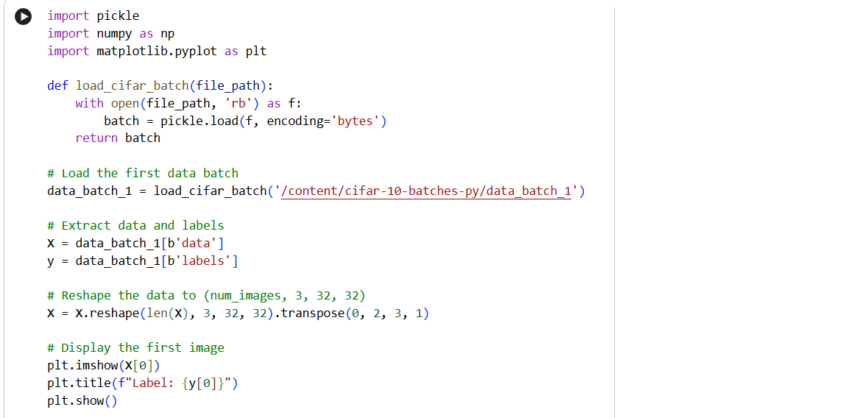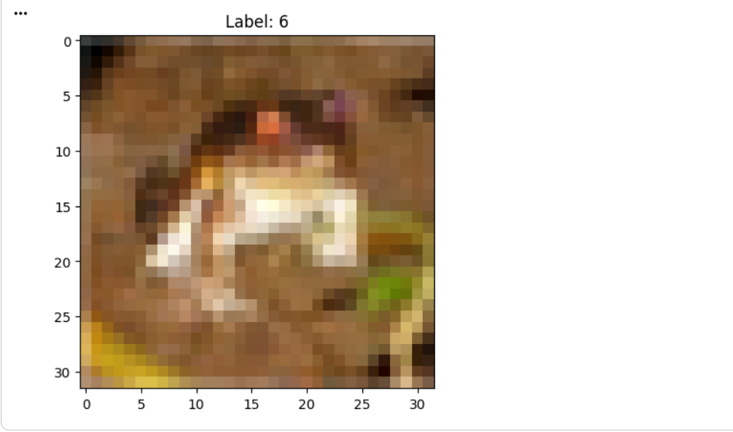
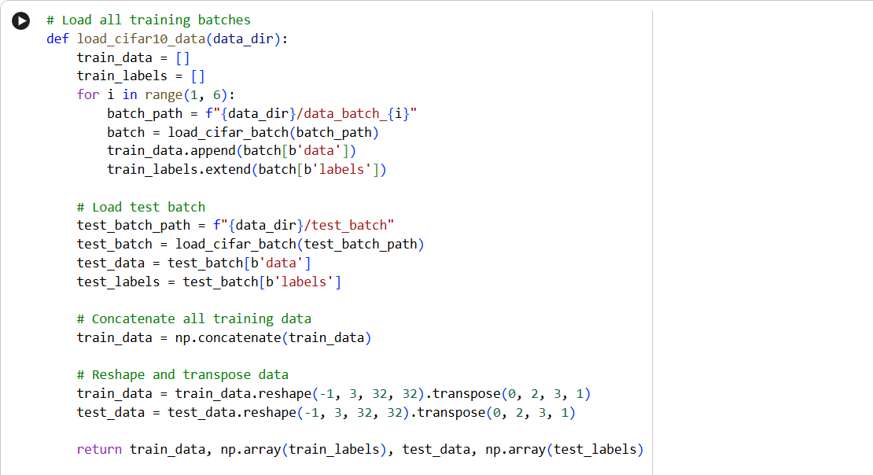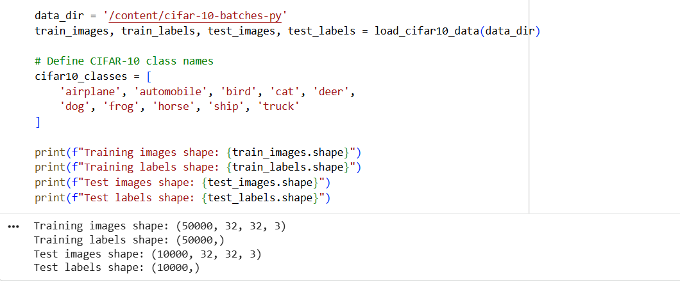

2.Build the required PyTorch model/program.

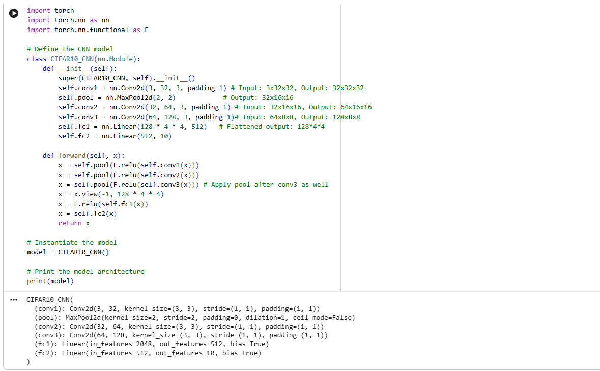

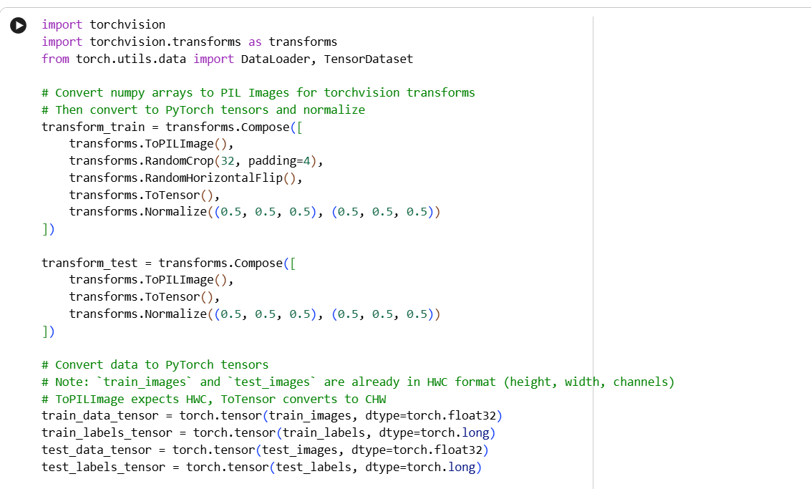

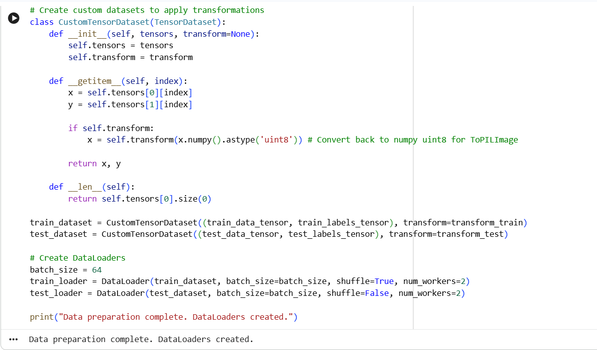

3. Train/execute the model.

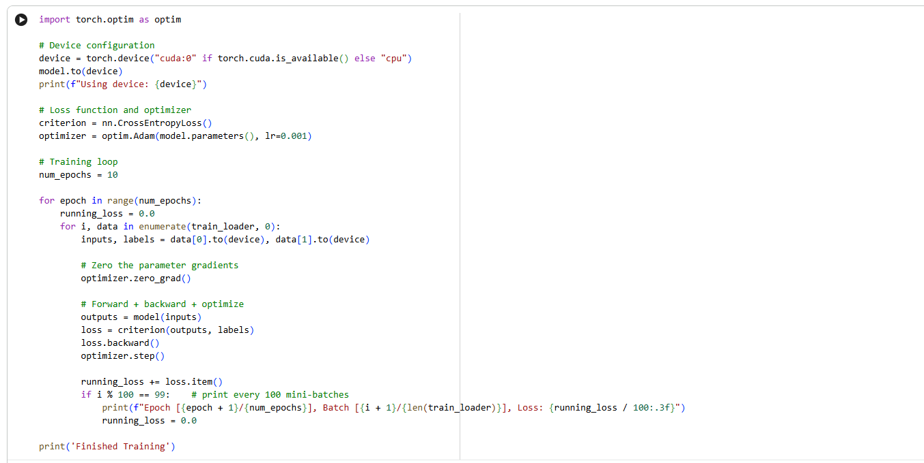

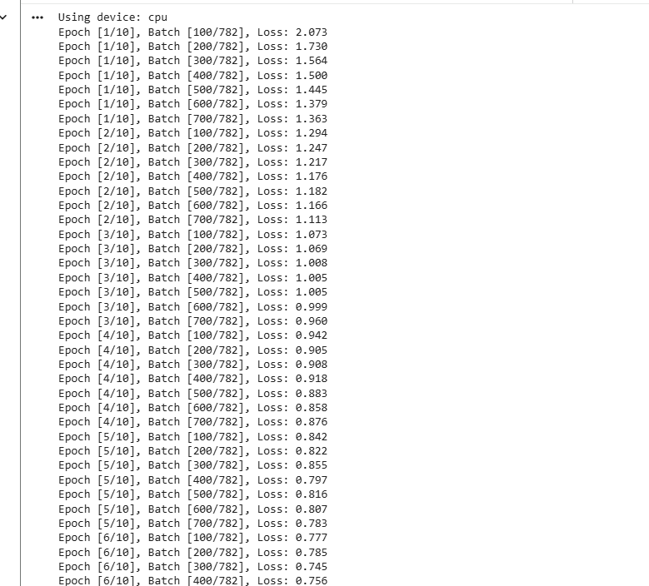

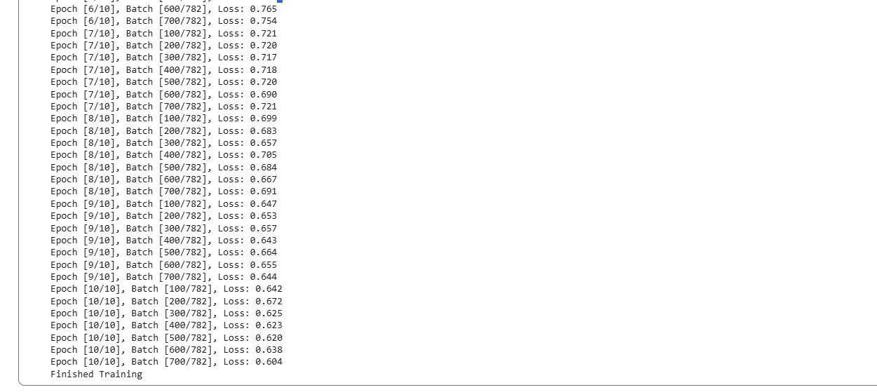

4. Evaluate the suitable metrics.
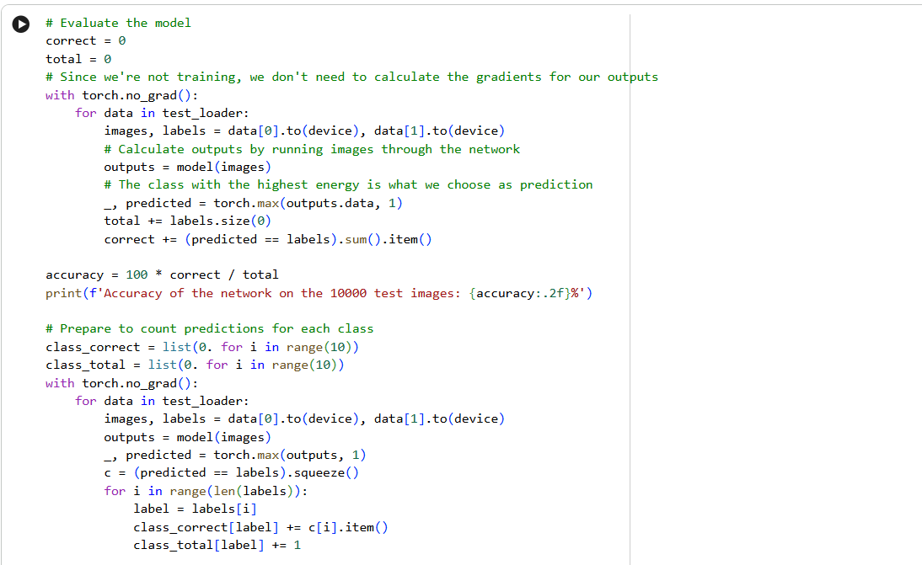

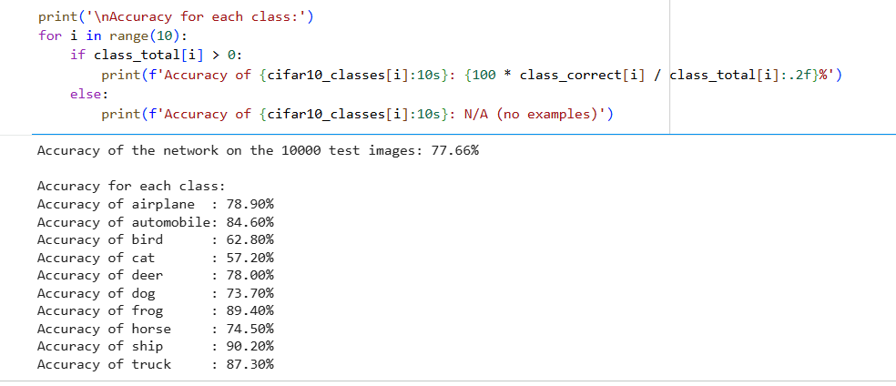

5.Visualise results using plots where applicable.

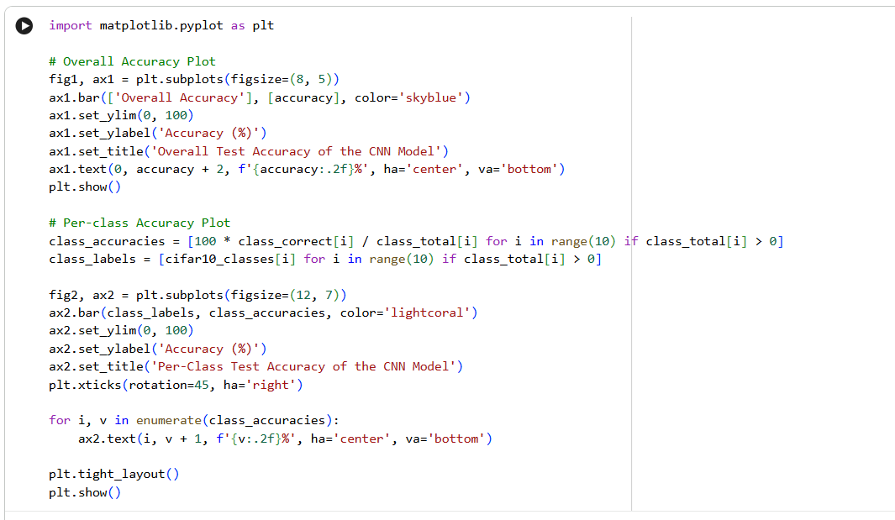

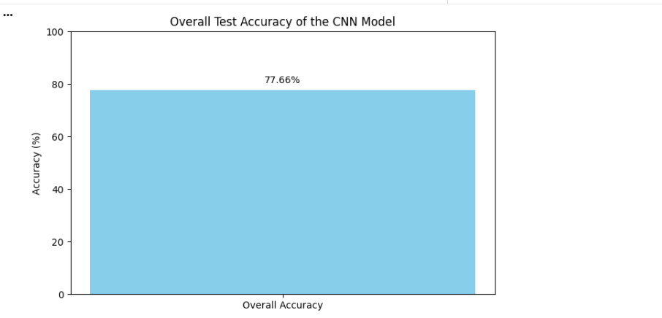

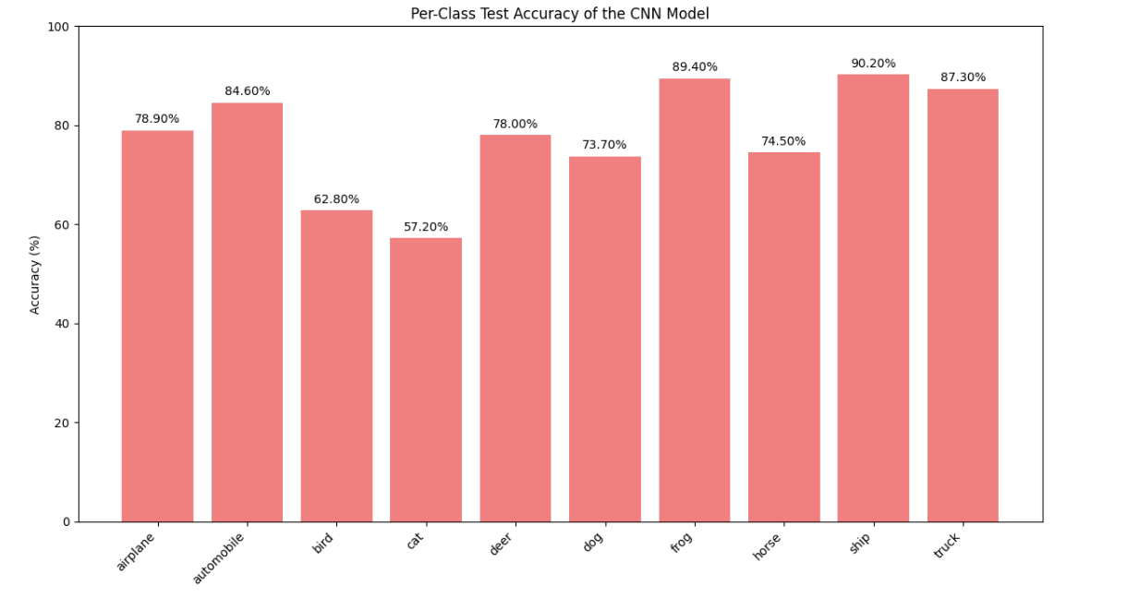

6.Write a brief conclusion comparing observations.

Based on the evaluation, the CNN model achieved an overall accuracy of 77.66% on the CIFAR-10 test dataset. This overall score provides a general sense of the model's effectiveness, but a deeper dive into the per-class accuracies reveals more nuanced insights into its performance characteristics.
Looking at the individual class accuracies, the model demonstrated strong performance on categories such as 'ship' (90.20%), 'frog' (89.40%), and 'truck' (87.30%). This suggests that the features learned by the CNN are particularly effective at distinguishing these objects, possibly due to their more distinct shapes, textures, or contexts within the dataset.

