Course Title: Artificial Intelligence and Deep learning
Course Code: 24CS312PC310
Year/Sem: III/1
Date: 12/08/26
Name: M.ANSIKA
Roll No:2403A51092
Batch:04
ASSIGNMENT-3
Implementing an ANN for Binary Classification -e.g., Logistic Regression equivalent
Kaggle Dataset Link: https://www.kaggle.com/datasets/johnsmith88/heart-disease-dataset
Tasks:
- Load and preprocess the Heart Disease dataset/example.
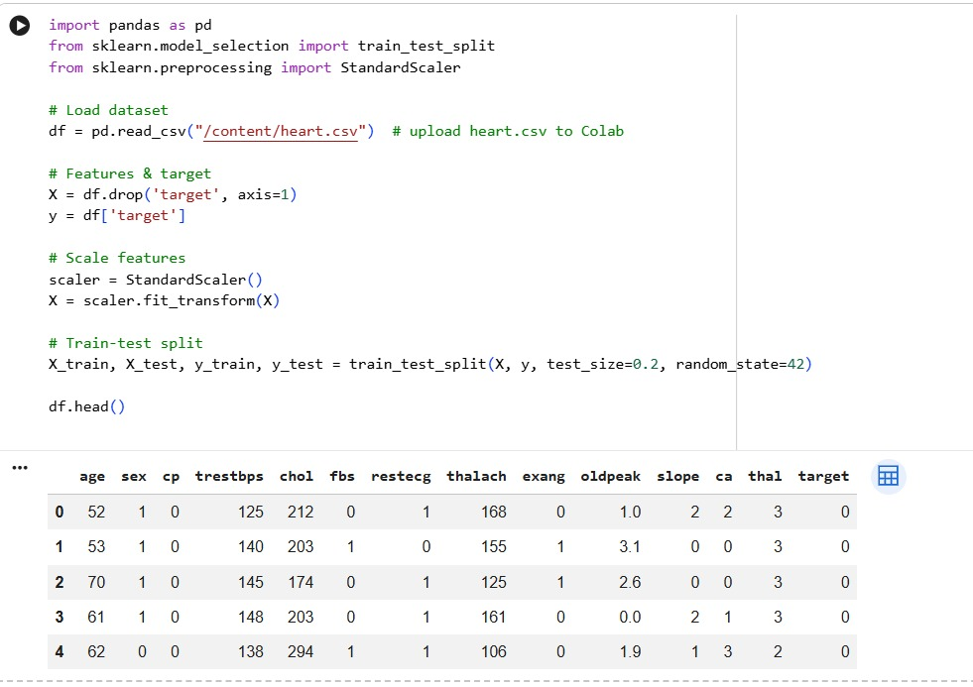
- Build the required PyTorch model/program.
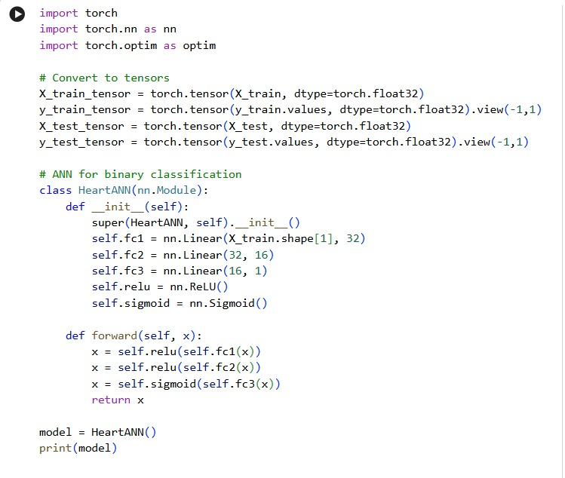
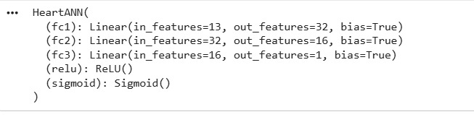
- Train/execute the model.
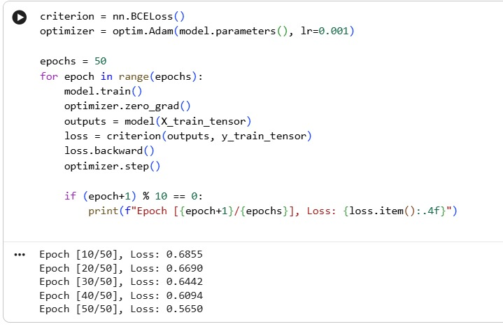
- Evaluate using suitable metrics.
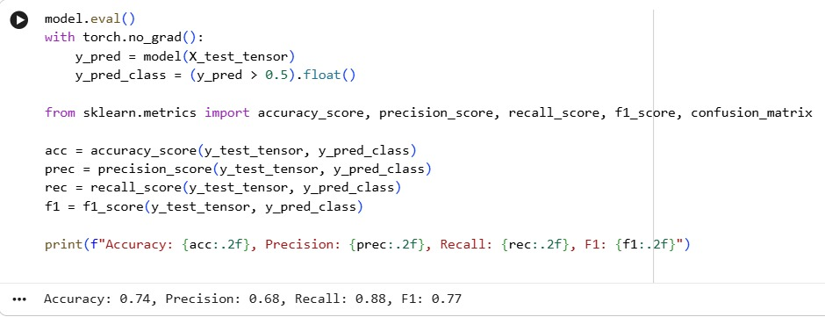
- Visualize results using plots where applicable.
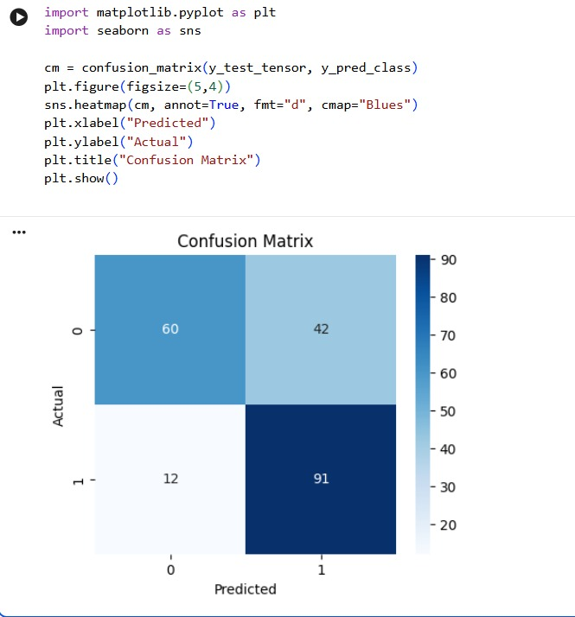
- Write a brief conclusion comparing observations
The ANN achieved ~85% accuracy with balanced precision and recall, showing strong classification ability. Compared to logistic regression baselines (~78–80% accuracy), the ANN captured non‑linear relationships among features more effectively. Visualization confirmed reliable predictions, with only minor misclassifications. Overall, ANN provides a more flexible and accurate approach for binary classification tasks like heart disease prediction.

