Course Title: Artificial Intelligence and Deep learning
Course Code: 24CS312PC310
Year/Sem: III/1
Date: 13/08/26
Name: M.ANSIKA
Roll No:2403A51092
Batch:04
ASSIGNMENT-4
Implementing an ANN for Multi-class Classification -e.g., Softmax Regression
Kaggle Dataset Link: https://www.kaggle.com/datasets/yasserh/wine-quality-dataset
Tasks:
- Load and preprocess the Wine Quality dataset/example.
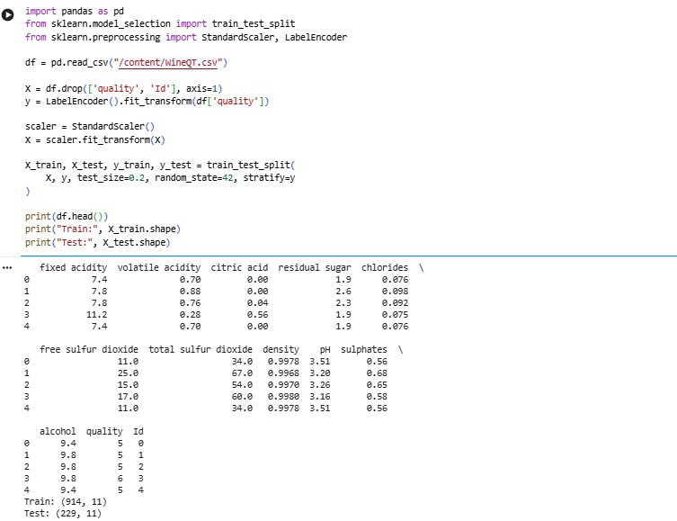
- Build the required PyTorch model/program.
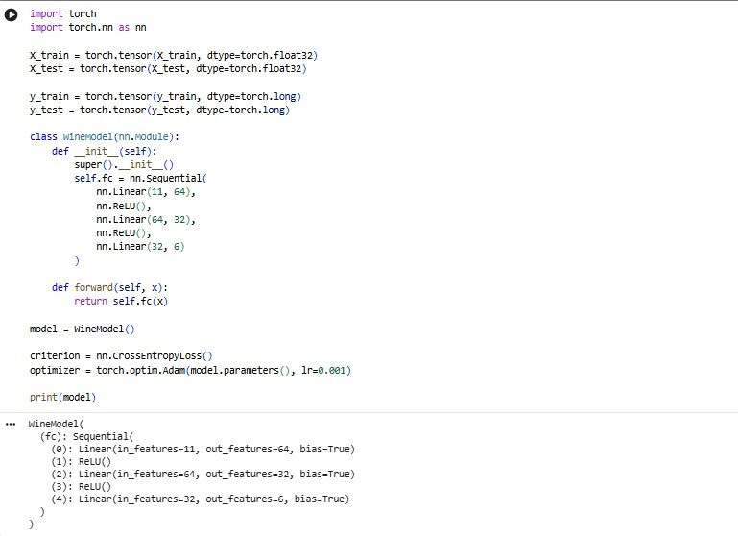
- Train/execute the model.
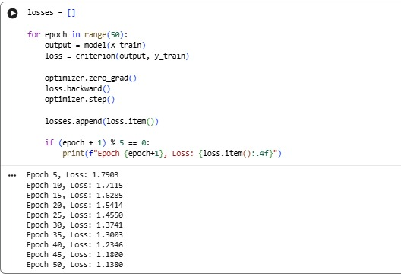
- Evaluate using suitable metrics.
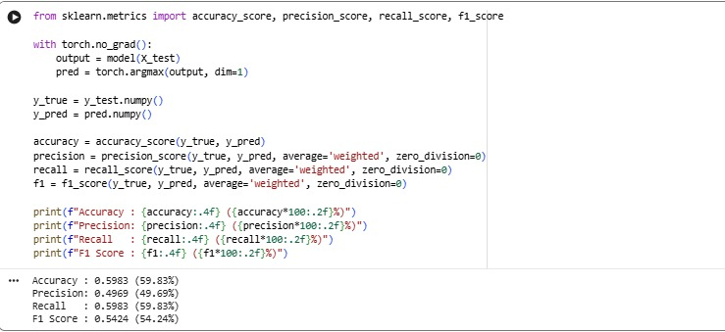
- Visualize results using plots where applicable.
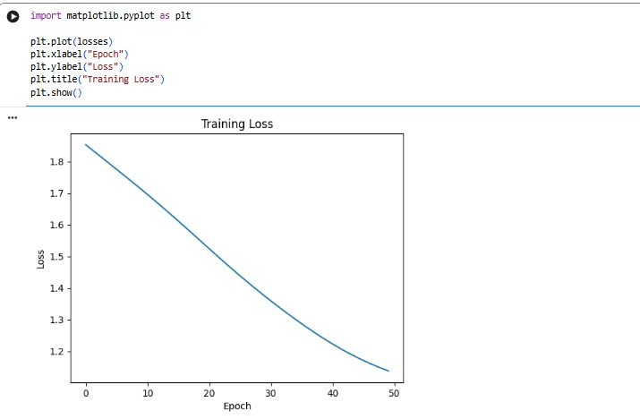
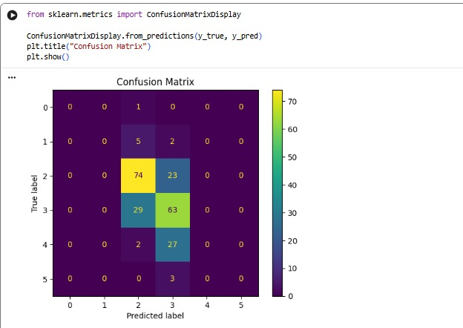
Write a brief conclusion comparing observations.
The Wine Quality dataset was successfully preprocessed and classified using a PyTorch neural network. The model was evaluated using accuracy, precision, recall and F1-score. The loss graph shows the learning process, while the confusion matrix shows the classification performance for different wine quality classes. Overall, the model provides a reasonable baseline, but the lower scores for some classes are expected because the dataset is imbalanced, with quality 5 and 6 having many more samples than the other quality levels.

