**Title Page**

**Authors:** Elena Belskaya, Maxim Zolotarev, Artëm Sozontov

**Title:** Changes in ground beetle assemblages (Coleoptera, Carabidae) along an industrial pollution gradient in the Southern Urals

**Affiliation:** Institute of Plant and Animal Ecology, Ural Branch, Russian Academy of Sciences, Eighth March Street 202, Yekaterinburg 620144, Russia

**Corresponding Author:** Elena Belskaya

**Email address:** belskaya@ipae.uran.ru

**ORCID** 0000-0002-3284-8829

# Abstract

Industrial pollution can negatively affect individual ground beetles and their populations; however, effects at the community level remain poorly understood. Existing data regarding changes in structural and functional parameters of ground beetle assemblages in response to pollution are inconsistent. The study analyzes changes in ground beetle assemblages along the pollution gradient caused by emissions from the Karabash Copper Smelter (KCS) to examine the dynamics of functional (abundance) and structural (species richness and diversity) indices. Surveys were conducted in 2009 and 2014 across ten birch forest sites with background, moderate, high, and extreme pollution. The study evaluated the composition and structure of ground beetle assemblages along with their abundance and diversity. Two hypotheses were tested: (1) abundance and diversity decline at high pollution levels; (2) structural and functional indices respond in a similar way. The dynamics of all examined indices were best described with segmented regression. The structural and functional indices of ground beetle assemblages decreased in the heavily polluted area. The breakpoint after which species richness decreased was found at a distance of 10 km from the facility, while the breakpoint for diversity was at a distance of 7 km, and that of abundance at 5 km. At high pollution shifts in ground beetle assemblages occurred along with changes in species composition and ecological traits of dominant species. Alterations in all indices were consistent across years with varying weather conditions. Ground beetle larvae were found throughout the entire gradient, with the exception of the extremely polluted site. The absence of larvae in this area suggests that local reproduction is impossible; all individuals likely migrated from nearby areas.

**Keywords:** Cu smelter; Heavy metals; Biodiversity; Abundance; Structure

# 1. Introduction

Airborne industrial pollution is one of the main forms of anthropogenic pressure on ecosystems. Toxicants such as SO2, fluorine compounds, and heavy metals found in industrial emissions negatively affect the abundance and diversity of terrestrial arthropods (Kozlov and Zvereva, 2011). Identifying the responses of this group of invertebrates to industrial pollution is essential for understanding and predicting changes in ecosystem structure and function (Zvereva and Kozlov, 2010).

Ground beetles are widely used as bioindicators of anthropogenic impacts due to their high abundance and species diversity, well-studied biology and ecology, close association with habitat conditions, and ease of evaluation (Rainio and Niemelä, 2003; Avgın and Luff, 2010). Their responses to industrial pollution have been relatively well studied at the individual and population levels (e.g. Bayley et al., 1995; Kramarz and Laskowski, 1997; Stone et al., 2001; Łagisz et al., 2002; Mozdzer et al., 2003; Migula et al., 2004; Lagisz, 2008; Bednarska et al., 2009; Talarico et al., 2014; Sowa and Skalski, 2019). However, studies at the level of the entire taxocene remain scarce (Avgın and Luff, 2010), despite their particular importance for assessing the effects of toxicants on biota (Zvereva and Kozlov, 2010).

Vicinities of metallurgical plants provide good opportunities for studying the responses of ground beetle assemblages to pollution, especially areas around non-ferrous enterprises, due to the combined effects of SO2 and heavy metals (Vorobeichik and Kozlov, 2012). In the vicinity of such facilities, sites can be found with varying degrees of pollution and vegetation degradation, ranging up to industrial barrens—an extreme manifestation of ecosystem disruption (Kozlov and Zvereva, 2007). Studies in ground beetle responses to emissions from non-ferrous metallurgy plants have been mainly conducted in Western Europe and North America (Read et al., 1987; Strojan, 1975, cited from Bengtsson and Tranvik, 1989; Skalski et al., 2010, 2011, 2015; Babin-Fenske and Anand, 2011). In contrast, the central and eastern regions of Eurasia remain underexplored, with only a few studies conducted near the Middle Ural Copper Smelter, located in the southern taiga subzone (Ermakov, 2004; Belskaya and Zinoviev, 2007; Zolotarev and Belskaya, 2012).

The Karabash Copper Smelter (KCS) is another major source of air pollution, emitting SO2, heavy metals, and arsenic. Located on the border between Europe and Asia in the Southern Urals, it lies within a subzone of pine-birch forests, a transitional zone between the southern taiga and forest-steppe. Pollutants are dispersed predominantly to the northeast, following the prevailing wind direction (Purvis et al., 2006). Heavy metal concentrations in the soil decline to background levels at distances of 30–40 km from the smelter (Frontasyeva et al., 2004; Kozlov et al., 2009). The KCS is among the most thoroughly studied emission sources in terms of the number of investigations and the range of biota components analyzed for pollution responses (Vorobeichik, 2004; Kozlov et al., 2009). However, data on ground-dwelling invertebrates, including ground beetles, are lacking.

Field studies of how ground-dwelling arthropods respond to environmental factors commonly use activity density to estimate their abundance. Temperature is the primary driver of changes in activity density (Kaspari et al., 2022). To separate the effects of pollution from those of other factors, particularly weather, it is therefore essential to conduct multi-year observations under different temperature conditions.

The aim of current study is to examine changes in ground beetle assemblages along the pollution gradient from the KCS, with a comparison of functional (abundance) and structural (species richness, composition and diversity) indices.

Studies on ground beetle responses to pollution from metallurgical plant emissions have reported decreases in abundance, species richness, and diversity (Bengtsson and Tranvik, 1989; Ermakov, 2004; Gongalsky et al., 2007; Skalski et al., 2010; Babin-Fenske and Anand, 2011; Zolotarev and Belskaya, 2012; Skalski et al., 2015), although the negative effects of pollution are not always confirmed (Oliveriusová, 1983; Read et al, 1987; Skalski et al., 2011). Responses of abundance and diversity to industrial pollution may either coincide (Gongalsky et al., 2007; Skalski et al., 2010) or diverge (Read et al, 1987; Babin-Fenske and Anand, 2011). The following hypotheses were tested:

- Ground beetle abundance and diversity decrease at high pollution levels near the KCS;

- Responses of structural and functional indices of ground beetle assemblages to pollution coincide.

# 2. Materials and methods

## 2.1. Study area

The study area is situated in the pre–forest–steppe pine–birch forest subzone at the eastern slope of the Southern Urals. The research was conducted in the vicinity of the Karabash Copper Smelter (CJSC Karabashmed), which has been operating since 1910. This facility is situated in Karabash, approximately 90 km northwest of the Chelyabinsk regional center. The main pollutants include sulfur, carbon, and nitrogen oxides, along with polymetallic dust containing Cu, Pb, Cd, Zn, and As (Kozlov et al., 2009; Smorkalov and Vorobeichik, 2022). Atmospheric pollutant emissions peaked during the 1970s–1980s, reaching approximately 160 to 400 thousand tons annually (Kozlov et al., 2009). Due to the extreme levels of air pollution, Karabash was recognized as one of the most polluted cities in the world (Kozlov et al., 2009). Emissions declined considerably between 1990 and 1998, falling below 40 thousand tons per year. However, a slight increase followed between 2000 and 2003, with annual emissions rising to around 100 thousand tons. Since 2004, a new phase of emission reduction has been observed, driven by advancements in production methods (Kozlov et al., 2009; Kalabin and Moiseenko, 2011). In 2009, when annual emissions had decreased to 16 thousand tons, Karabash was removed from the list of Russian cities with the highest levels of atmospheric pollution (Department of Rospotrebnadzor in Chelyabinsk oblast, 2010). Nevertheless, during the period of data collection, soil contamination and vegetation degradation in the vicinity of the smelter remained substantial (Mikryukov and Dulya, 2017; Smorkalov and Vorobeichik, 2022; Belskaya et al., 2019).

Two transects were established to the south and north of the KCS, with five sampling sites selected along each (Fig. 1). Except for the site nearest to the smelter, all were located in secondary deciduous forest areas, predominantly composed of *Betula pendula* Roth, which had replaced the pine forest. The site located at a distance of 1 km from the KCS, at the foot of Mount Zolotaya, lies within an industrial barren. Based on heavy metal concentrations in the topsoil and the condition of the vegetation, four distinct pollution zones were identified. The background zone exhibited metal concentrations corresponding to regional baseline (sites at distances of 32, 27, and 26 km from the smelter, Fig. S1a); the buffer zone represented moderate pollution (sites at distances of 18, 12, 11, and 9 km from the KCS, Fig. S1b); the impact zone represented high pollution (sites at distances of 5 and 4 km from the KCS, Fig. S1c); while the industrial barren zone represented extreme pollution (site at distance of 1 km from the KCS, Fig. S1d). The background and buffer zones are characterized by a well-developed tree layer, the presence of undergrowth, neutral soil pH, and a litter layer thickness of 1–4 cm (Usoltsev et al., 2012; Belskaya et al., 2019; Smorkalov and Vorobeichik, 2022). As the distance to the KCS decreases, there is a shift in plant community composition—from forb-dominated associations in the background zone to forb-grass associations in the buffer zone—accompanied by a slight decline in phytomass, forest stand productivity, and projective cover of the herbaceous layer. In the impact zone, the acidity and thickness of the litter layer increase, while forest stand productivity declines further; undergrowth and the herbaceous layer are nearly absent. In the industrial barren, litter layer is completely absent, and the soil is heavily eroded. Scattered low trees occur only in ravines, and sparse patches of grasses are confined to ravines and mountain slope.

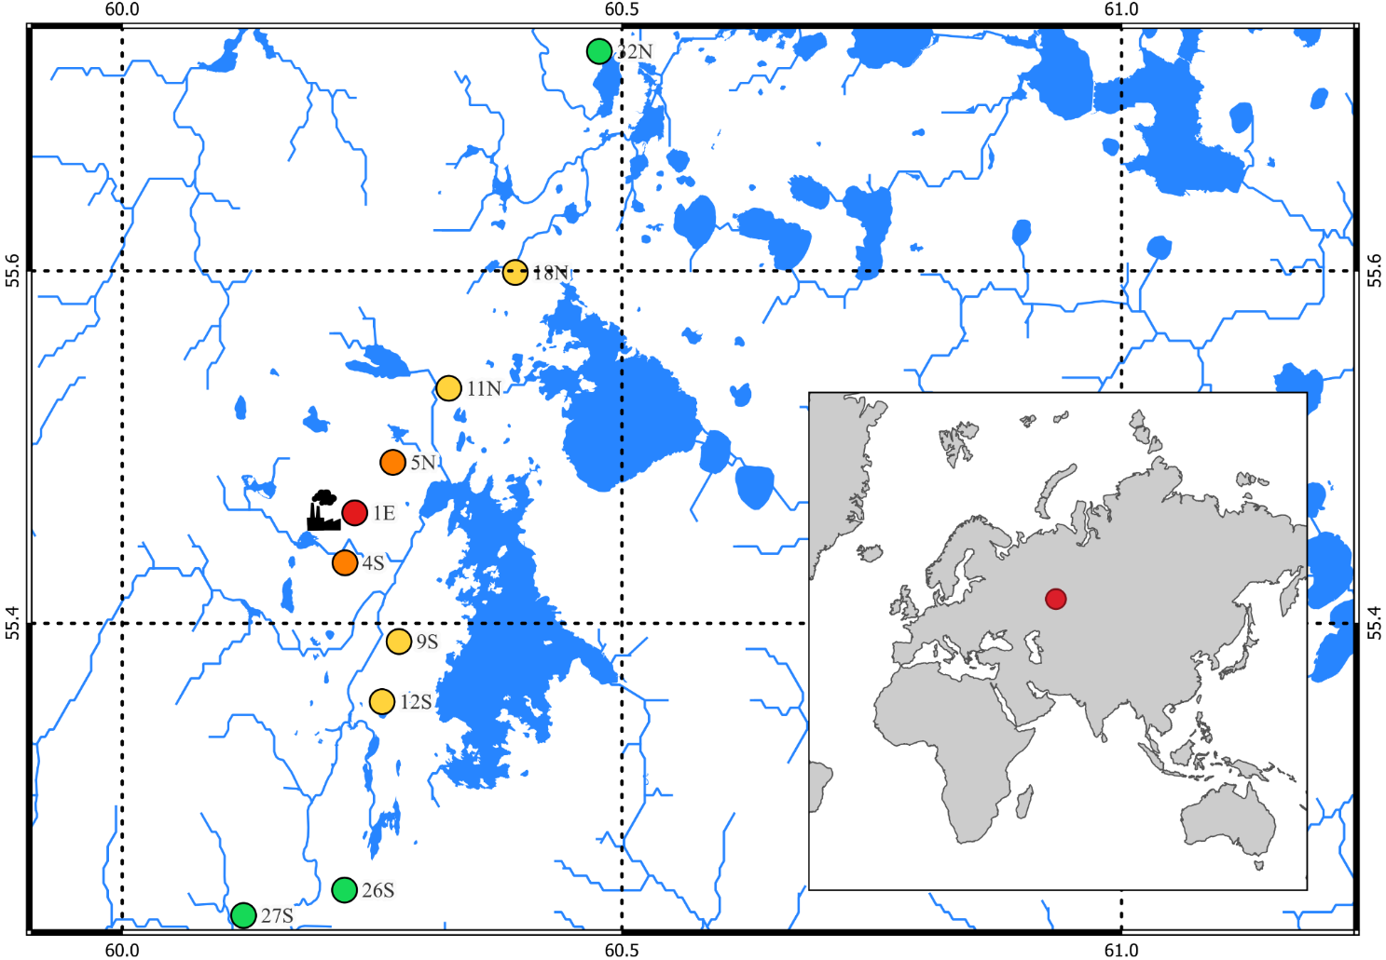

Fig. 1. Map of the study area. Dots represent sites; numbers in site names indicate distance from the smelter, and letters denote direction (N—north, S—south, E—east). The black pictogram marks the location of the KCS. Pollution levels are color-coded: green—background (background zone); yellow—moderate (buffer zone); orange—high (impact zone); red—extreme (industrial barren). Blue lines indicate the hydrographic network. The inset shows the study area.

## 

## 2.2. Sampling

Ground beetles were sampled using pitfall traps, which consisted of plastic cups with a neck diameter of 9 cm filled with 3% acetic acid as a preservative. Each site included three sampling plots (SPs), each measuring 10×10 m and spaced 70–100 m apart. On each SP, five traps were installed in a linear arrangement with 3 m intervals for five days exposure. Sampling was conducted twice per season (Table 1) to evaluate the activity of species with different phenology (spring-summer and autumn). To determine the temporal repeatability of pollution effects, ground beetles were sampled in 2009 and 2014, years with similar emission levels but contrasting weather conditions. From May to August, air temperatures in both years were close to the long-term average (1984–2014) (Table 1); however, 2014 was notably more humid. Weather conditions during the sampling rounds varied between the years: 2009 was warmer in early summer, while 2014 was warmer in late summer. Precipitation levels in early summer were similar; however, in late summer of 2009, precipitation was five times higher compared to 2014.

Table 1

Weather conditions during the study years as recorded by the Zlatoust meteorological station, Russia (WMO_ID 28630).

*Values in parentheses indicate the 95% confidence interval;

** June 5–10, 2009; June 3–8, 2014 August 26–31, 2009; August 18–23, 2014.

|  |  |  |  |  |  |
| --- | --- | --- | --- | --- | --- |
| Month, period | | Average monthly temperature, °C | | Total precipitation, mm | |
| 2009 | 2014 | 2009 | 2014 |
| May | | 10.4 | 13.3 | 28.9 | 62.8 |
| June | | 16.2 | 15.1 | 33.2 | 110 |
| July | | 15.0 | 12.8 | 120.8 | 197.9 |
| August | | 13.7 | 16.7 | 123.7 | 38.0 |
| May—August | | 13.8 | 14.5 | 306.6 | 408.7 |
| * May—August (1984-2014 mean) | | 14.3 (13.8–14.7) | | 336.7 (305.7–367.6) | |
| ** Sampling round | early summer | 19.1 | 14.8 | 6.9 | 5.4 |
| late summer | 16.8 | 20.5 | 19.2 | 3.8 |

A total of 6,325 ground beetle specimens representing 58 different species were collected over the two-year study period (Tables S1, S2). Species identification was carried out under laboratory conditions using identification keys for adult beetles (Kryzhanovskii, 1965) and reference collections from the Museum of the Institute of Plant and Animal Ecology, Ural Branch of the Russian Academy of Sciences. Larvae collected in 2009 were identified by Professor K.V. Makarov, PhD (Moscow Pedagogical State University).

## 

## 2.3. Data processing and statistical analyses

Data processing and statistical analysis were conducted separately for each study year. The SPs served as replicates. Activity density per 100 trap-days was used as a measure of abundance and was summed across both sampling rounds. The distance from the KCS was used as an index of toxic load, based on two considerations: (1) the life cycle of ground beetles occurs in close contact with the soil, and (2) the concentration of pollutants in the soil is strongly negatively correlated with the distance from the KCS (Koroteeva et al., 2015). Sites located to the north and south of the KCS were combined into a single distance series, as the spatial distribution of pollutants in the forest litter layer was similar along both transects (Smorkalov and Vorobeichik, 2011).

Species richness was assessed using the number of species observed (*S*) and the interpolated number per 100 individuals (*S'*) (Gotelli and Colwell, 2001; Chao et al., 2014; Hsieh et al., 2016), while species diversity was evaluated using the Shannon index (*H'*). Species accounting for at least 5% of the total abundance were classified as dominant. Four models were considered to describe the dependence of abundance, species richness, and the diversity of ground beetles on the distance from the pollution source: linear, segmented, polynomial, and logarithmic. The model with the lowest Akaike Information Criterion (AIC) was selected and used for further analysis. The significance of differences between model parameters across years was evaluated based on the overlap of confidence intervals (CIs), with CI limits calculated as the standard error multiplied by 2. Differences were considered significant when the CI limits did not overlap.

When analyzing species composition, assemblage structure, and rarefaction curves, the categorical predictor "zone" was used instead of the continuous predictor "distance from the KCS, km". Ordination of assemblages based on the activity density of species was carried out using Bray-Curtis distance and principal coordinate analysis (PCoA) in the ape v. 5.8 package (Paradis and Schliep, 2019). Bray-Curtis distance matrices were calculated using the vegan v. 2.6 package (Oksanen et al., 2022). The significance of the effects of zone and year was assessed using PERMANOVA (999 iterations) (Anderson, 2001).

Data transformation and visualization were performed using the tidyverse v. 2.0 package (Wickham et al., 2019). Calculations were conducted in the R v. 4.3.3 programming environment (R Core Team, 2024).

# 

# 3. Results

## 3.1. Changes in the abundance and diversity of ground beetles along the pollution gradient

The dependence of ground beetle abundance, species richness, and diversity on the distance from the KCS was nonlinear (Fig. S1, Table S3). Among the four models considered, the segmented model provided the best fit for all indices, as indicated by the lowest AIC. The trajectories of change in abundance, species richness, and diversity followed a similar pattern (Fig. 2): these metrics remained relatively stable in the background and buffer zones but declined sharply in the polluted area compared to the background level (Table 2). The differences between the indices were associated with the location of the breakpoint relative to the distance from the KCS.

Ground beetle abundance varied across the background, buffer, and impact zones of the pollution gradient. The highest numbers of individuals were recorded at the site 26S in both years, whereas the lowest numbers were sampled at the site 5N (Table S1, S2). At the site 4S, the number of individuals ranged from 152 to 206 across years. A sharp decline in abundance occurred approximately at a distance of 1 km from the KCS (Fig. 2A). The breakpoint of the function was located at a distance of 4-5 km from theKCS (Table 2).

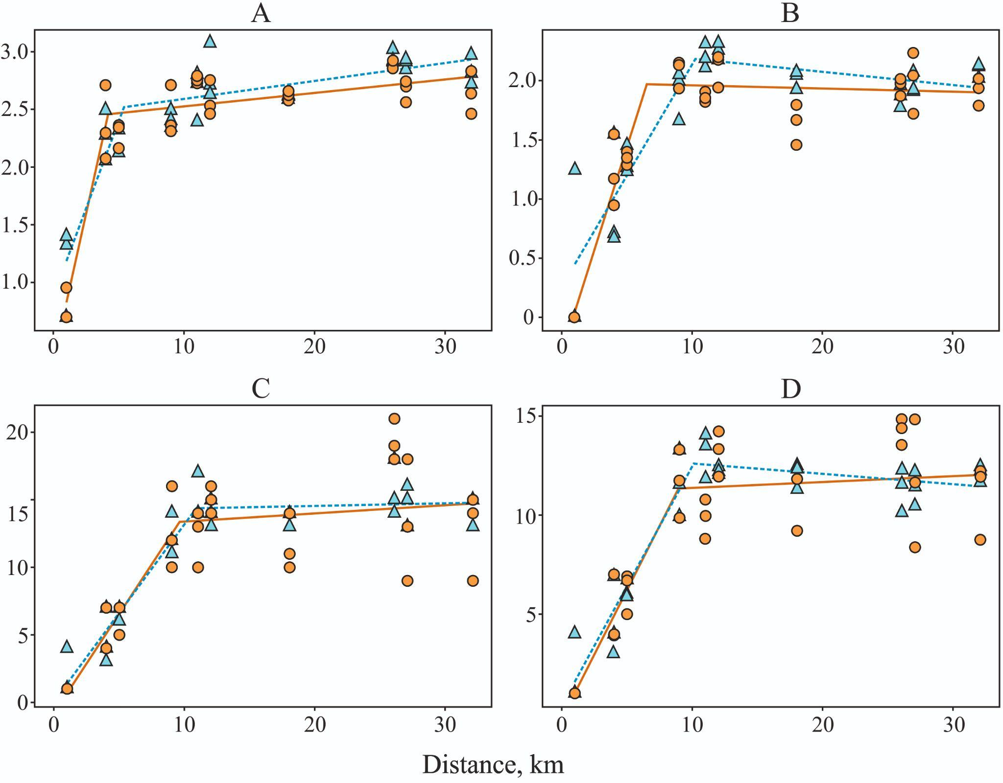

Fig. 2. Dependence of ground beetle abundance (log10 individuals per 10 trap-days) (A), Shannon diversity (B), species richness observed (C) and interpolated per 100 individuals (D) on the distance to the KCS. Parameter values are shown for each SP, with orange representing 2009 and blue representing 2014.

Table 2. Parameters of the segmented regression describing the dependence of ground beetle diversity and abundance on the distance from the KCS.

* Slope coefficient of the segment from the breakpoint to the plant,

** Significant differences between years. Calculation methods are detailed in subsection *2.3.*

|  |  |  |
| --- | --- | --- |
| Model parameters | Coefficient±SE | |
| 2009 | 2014 |
| Abundance (log10 individuals per 10 trap-days) | | |
| *Slope | 0.511±0.058 (0.395; 0.627) | 0.303±0.041  (0.221; 0.385) |
| breakpoint, km | 4.192±0.272  (3.648; 4.736) | 5.409±0.487  (4.435; 6.383) |
| Species richness (observed) | | |
| Slope | 1.475±0.332  (0.811; 2.139) | 1.313±0.147  (1.019; 1.607) |
| breakpoint, km | 9.588±1.523  (6.542; 12.634) | 10.867±0.882  (9.104; 12.631) |
| Species richness (interpolated species richness per 100 individuals) | | |
| Slope | 1.304±0.442  (0.420; 2.188) | 1.216±0.115  (0.986; 1.446) |
| breakpoint, km | 8.921±1.991  (4.939; 12.903) | 10.086±0.656  (8.774; 11.398) |
| Shannon index | | |
| Slope | 0.348±0.045  (0.258; 0.438) | 0.187±0.028  (0.131; 0.243) |
| breakpoint, km | 6.518±0.479  (5.56; 7.476) | 10.266±1.028**  (8.21; 12.321) |

Species richness remained relatively stable at distances ranging from 32 to 10 km from the KCS (Fig. 2C, 2D, Table 2). Closer to the smelter, the number of species decreased from 18 to 1 in 2009 and from 15 to 4 in 2014 (Tables S1, S2).

In 2009, ground beetle diversity remained consistent along the gradient sections ranging from 32 to 6.5 km from the KCS, followed by a sharp decline (Fig. 2B, Table 2). In 2014, in the diversity slightly increased between sites at 32 and 10 km of the gradient. As the distance to the KCS decreased further, diversity declined, reaching its lowest point at a distance of 1 km from the smelter.

Slope coefficients of the segmented regression equations remained consistent across all years for all examined I indices (Table 2). Significant variations between years were found only for the breakpoint, beyond which diversity declined. This breakpoint was located much closer to the KCS in 2009 compared to its position in 2014 (Fig. 2B, Table 2).

## 3.2. Ground beetle species composition in pollution zones

Over a span of two years, 40 species were identified in the background zone, 36 species in the buffer zone, 16 species in the impact zone, and 4 species at the industrial barren. The background and buffer zones showed similarity not only in observed but also in interpolated number of species (Fig. 3). The species composition was also similar, sharing 27 common species. Differences were mainly related to singleton and rare species. The ecological traits of dominant species also coincided (Table S4). These were exclusively zoophages from the genera *Pterostichus*, *Carabus*, and *Synuchus* *vivalis* (Table 3), with *Pterostichus oblongopunctatus* as the most abundant species. Larger species exhibited high relative abundance in both zones, while species typical for open habitats were absent.

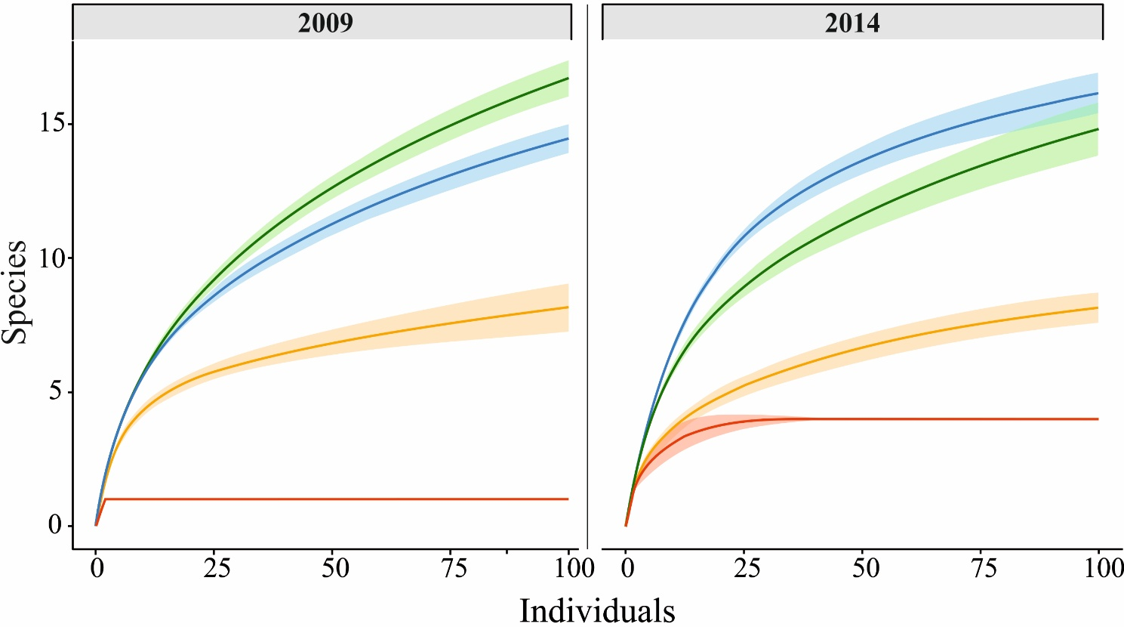

Fig. 3. Dependence of the number of ground beetle species on the sample size in different pollution zones, calculated using the rarefaction method. Pollution zones are indicated as follows: background—green, buffer—blue, impact—orange and industrial barren—red. Confidence intervals were determined by bootstrapping with 999 iterations.

Table 3. Composition of dominants (proportion of individuals in total abundance, %) across pollution zones (industrial barren is excluded due to exceedingly low species richness and abundance of ground beetles).

|  |  |  |  |  |  |  |
| --- | --- | --- | --- | --- | --- | --- |
| Species | Pollution zone | | | | | |
| background | | buffer | | impact | |
| 2009 | 2014 | 2009 | 2014 | 2009 | 2014 |
| *Pterostichus oblongopunctatus* | 34.3 | 25.7 | 21.7 | 23.2 | 27.4 | 13.9 |
| *Pterostichus. melanarius* | 11.7 | 14.4 | 26.9 | 11.2 | 0 | 0 |
| *Carabus granulatus* | 14.4 | 7.7 | 12.6 | 5.5 | 0 | 0 |
| *Pterostichus uralensis* | 12.9 | 17.8 | 5.0 | 5.0 | 0 | 0 |
| *Pterostichus niger* | 3.3 | 11.9 | 1.1 | 6.2 | 0 | 0 |
| *Pterostichus magus* | 3.4 | 6.2 | 10.8 | 6.7 | 0 | 0 |
| *Carabus cancellatus* | 0.4 | 1.0 | 8.7 | 10.7 | 0 | 0 |
| *Pterostichus mannerheimi* | 3.1 | 3.9 | 1.9 | 7.7 | 0 | 0 |
| *Synuchus vivalis* | 0.2 | 1.4 | 0.2 | 6.0 | 0 | 0 |
| *Amara brunnea* | 1.2 | 0.4 | 0.2 | 0.4 | 35.8 | 54.1 |
| *Amara communis* | 2.9 | 0.3 | 2.1 | 2.5 | 7.1 | 17.2 |
| *Calathus micropterus* | 0.8 | 1.6 | 1.9 | 6.9 | 9.0 | 3.0 |
| *Poecilus versicolor* | 0 | 0 | 0 | 0 | 15.4 | 1.7 |

Species richness in the impact zone was considerably lower compared to the background and buffer zones (Fig. 3). Species composition also changed. Near the KCS, only 8 species were shared with the background zone and 6 species were common with the buffer zone. The species lists differed not only in the number of single and rare species. In the impact zone, changes in the composition of dominant species and their ecological traits were observed (Table 3, Table S4). The abundance of *P. oblongopunctatus* near the KCS decreased by 4.3 times (in 2009) and 10.9 times (in 2014) compared to the background zone (Table S1, S2), leading it to become a subdominant species. The impact zone was dominated by smaller-sized species of the genus Amara which are mixo-phytophages . . Large zoophages were absent, replaced by medium-sized (*Poecilus versicolor*) and small (*Calathus micropterus*) zoophages. *Poecilus versicolor*, favoring open habitats, appeared among the dominant species.

Only four species were recorded at the industrial barren: the small zoophages *Bembidion lampros* and *Microlestes minutulus*, and medium-sized ground beetles *Harpalus affinis* and *H. smaragdinus*, both belonging to the mixed-feeding guild (Table S4). The latter two species were found exclusively at the industrial barren (Table S1, S2). All species recorded at the barren had the ability to fly.

## 

## 3.3. Changes in the structure of assemblages

The structure of ground beetle assemblages depended on the pollution level. Results of the PERMANOVA test showed that the effect of zone explained 52% of the overall variance (*R2*=0.52, *F*=21.2, *p*=0.001), while the effect of year accounted for only 2% (*R2*=0.02, *F*=2.1, *p*=0.054). Pollution-related changes in the assemblage structure differed between study years, as evidenced by a considerable interaction between zone and year (*R2*=0.05, *F*=2.1, *p*=0.008). Assemblages in the background and buffer zones demonstrated the highest similarity. Ordination showed minimal distances between centroids in both years, with substantial overlap of confidence ellipses (Fig. 4). Variations of assemblage structure across the zones were comparable to those observed among sites within zone (Table 4). Notably, ground beetle assemblages underwent considerable changes in heavily polluted forest areas. The centroids of the impact and background zones, as well as those of the impact and buffer zones, were markedly separated in both years, with no overlap of confidence ellipses (Fig. 4). Differences between the background and impact zones exceeded within-zone plot differences by factors of 1.4–2.2, while differences between the buffer and impact zones exceeded them by factors of 1.5–2.1 (Fig. 4). Variability among SPs within the impact zone was lower in 2014 compared to 2009 (Fig. 4). The industrial barren differed substantially from the background, buffer, and impact zones in terms of species composition and ground beetle abundance.

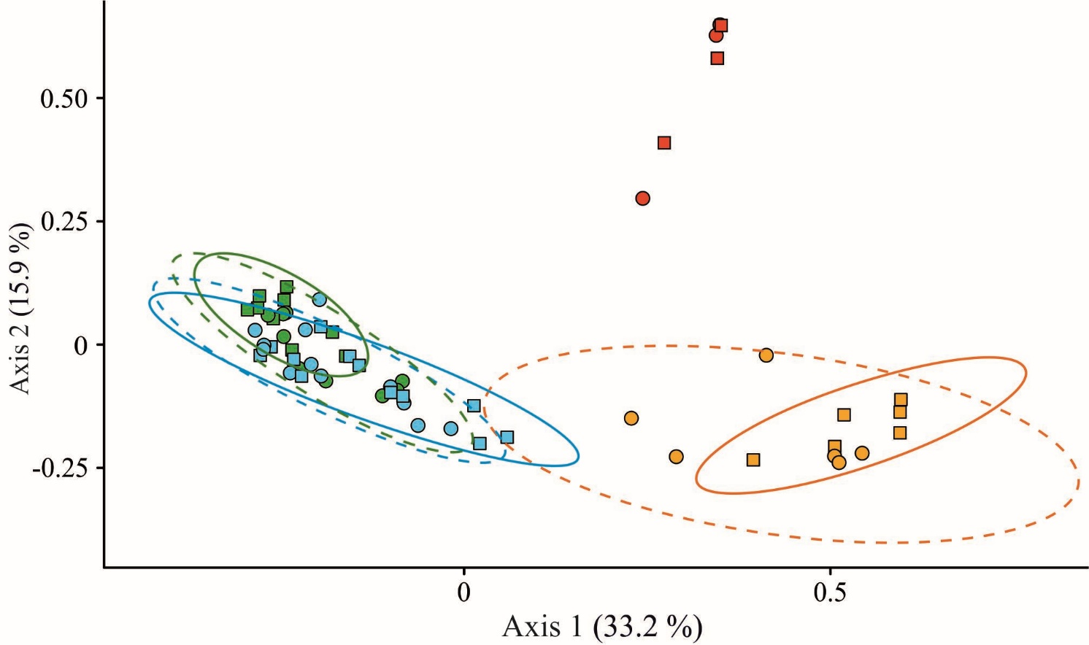

Fig. 4. Ordination of ground beetle assemblages across pollution zones (colored as in Figure 3). Ellipses represent confidence intervals ( dashed lines and circle—2009, and solid lines and squares—2014). Calculation methods are detailed in subsection *2.3*.

Table 4. Within-group (gray cells) and between-group (uncolored cells) Bray-Curtis distances. Intragroup distances represent differences among sample plots within the polluted zone, whereas between-group distances reflect differences across zones. Calculation methods are detailed in subsection *2.3*.

|  |  |  |  |  |  |  |  |  |  |
| --- | --- | --- | --- | --- | --- | --- | --- | --- | --- |
| Pollution zone | year | industrial barren | | impact | | buffer | | background | |
| 2014 | 2009 | 2014 | 2009 | 2014 | 2009 | 2014 | 2009 |
| background | 2009 | 1 | 1 | 0.86 | 0.81 | 0.57 | 0.53 | 0.47 | 0.45 |
| 2014 | 1 | 1 | 0.92 | 0.87 | 0.6 | 0.57 | 0.43 |  |
| buffer | 2009 | 1 | 1 | 0.87 | 0.83 | 0.52 | 0.46 |  |  |
| 2014 | 1 | 1 | 0.86 | 0.81 | 0.52 |  |  |  |
| impact | 2009 | 1 | 1 | 0.5 | 0.56 |  |  |  |  |
| 2014 | 0.98 | 0.98 | 0.41 |  |  |  |  |  |
| industrial barren | 2009 | 0.76 | 0.78 |  |  |  |  |  |  |
| 2014 | 0.72 |  |  |  |  |  |  |  |

In addition to adult ground beetles, larvae of the 1st to 3rd instars of *A*. *brunnea, A. praetermissa, Carabus glabratus, C. granulatus, Curtonotus aulicus,* and *P. niger* were collected using pitfall traps in the background zone; larvae of *Amara sp., C. granulatus, Poecilus sp.,* and *P. niger* were present in the buffer zone; while only *A. brunnea* larvae were found in the impact zone (Table S1). No larvae of ground beetles were found in the industrial barren. Larvae were present during both sampling rounds in both the background and buffer zones, whereas in the impact zone they were collected exclusively in late summer.

# 

# 4. Discussion

## 

## 4.1. Changes in structural and functional indices of assemblages along the pollution gradient

A segmented model was selected to describe and analyze changes in structural and functional indices along the pollution gradient. This model yielded the lowest AIC among the four models considered. In addition, the segmented model enables the incorporation of nonlinear dependencies and facilitates the identification of the breakpoint in the trend of parameter changes.

In this study, all examined indices changed slightly in the background and buffer zones but declined sharply as they approached the smelter. Species richness decreased first, followed by the Shannon index, while abundance was reduced to a lesser extent. Changes in structural and functional indices of ground beetle assemblages along the pollution gradient were consistent across both years, despite differences in weather conditions during the sampling rounds. This indicates the stability of the pollution effect over time and suggests that this effect exceeds that of the weather.

Experimental studies have shown that a reduction in species diversity leads to a decline in the abundance or biomass of trophic groups, regardless of whether they are producers, herbivores, detritivores, or predators (Cardinale et al., 2006). However, minor losses of biodiversity do not noticeably affect ecosystem functions, whereas larger losses accelerate the rate of changes (Cardinale et al., 2012). In essence, a decline in biodiversity indices precedes functional transformations. Such changes were observed in ground beetle assemblages under industrial pollution from KCS. The relationship between biodiversity and ecosystem functioning is diverse and complex. Numerous hypotheses exist concerning the mechanisms underlying this relationship (Naeem et al., 2001). Following current recommendations (Cardinale et al., 2011), discussion of potential mechanisms maintaining ground beetle abundance during the initial stages of species richness decline is omitted. Only the observed differences in response thresholds of structural and functional indices of this group to industrial pollution are reported.

## 

## 4.2. Changes in the species composition of assemblages

It was found that the composition and ratio of dominant ground beetle species shifted in the heavily polluted KCS area when compared to areas with background and moderate pollution. The decline in the abundance of *P. oblongopunctatus* in the impact zone may be attributed to a reduction in the reproductive capacity of its populations. Thus, the proportion of reproductive females of *P. oblongopunctatus*, as well as the number of eggs per reproductive female near the Middle Ural copper smelter (Revda, Russia), were lower than those recorded in the background area (Belskaya, 2008). Decreased reproduction could result from the direct toxic effect of heavy metals. Elevated concentrations of heavy metals in the soil of ground beetle habitats were associated with a reduction in the number of eggs laid by females of *P. oblongopunctatus* and a decrease in the number of F1 imagoes produced per female of the parental generation (Łagisz et al., 2002). Furthermore, heavy metals in the food delayed development of *P. oblongopunctatus* larvae and increased mortality (Mozdzer et al., 2003). Other potential causes of larval mortality of this species include limited food availability and, consequently, increased cannibalism (Heessen and Brunsting, 1981). Previous studies reported the disappearance of worms belonging to the families *Lumbricidae* and *Enchytraeidae* from the soil contaminated by the KCS, along with a decline in both the abundance and biomass of millipedes and insects, which are key food resources for ground beetles (Sadykov et al., 1992). We are not aware of more recent studies on soil invertebrates in this region.At the same time, high heavy metal litter concentrations near the KCS which have been documented at the time of this study (Mikryukov and Dulya, 2017) indicate persistent toxicity to soil invertebrates.

The reduction in food availability could also affect other ground beetles, particularly larger species. Their vital functions require a substantial amount of energy (Grüm, 1980). Therefore, it is crucial for larger species to obtain food with lower energy costs, which is partly achieved by feeding on larger prey (Wheater, 1988). This may explain why annelids and mollusks constitute a substantial part of the diet of large ground beetles, particularly females (Sergeeva and Gryuntal, 1990; Symondson et al., 1996; Hatteland et al., 2011; Jelaska et al., 2014). A notable decline in the abundance of annelids and mollusks, resulting in their complete disappearance near non-ferrous metallurgy plants (Sadykov et al., 1992; Koneva, 1995; Nahmani et al., 2003; Nesterkov, 2013; Vorobeichik et. al, 2019), is one potential cause of the notable decline in the abundance of large ground beetles. Other factors contributing to the decline of large-bodied species in harsh environments include their high sensitivity to changes in habitat conditions due to small population sizes, low fecundity, and prolonged larval development (Kotze and O’Hara, 2003).

Ground beetles inhabiting the soil surface and litter layer are strongly dependent on environmental parameters such as vegetation composition and structure, soil composition and moisture, litter layer thickness, and the extent of moss cover on the ​​soil. This relationship is evident regardless of the study scale, whether regional (Niemelä et al., 1988; Walsh et al., 1993; Ings and Hartley, 1999; Jukes et al., 2001; Alalykina and Tselishcheva, 2005; Yanahan and Taylor, 2014) or local (Koivula et al., 1999; Antvogel and Bonn, 2001; Magura et al., 2004; Antsiferov, 2018). Approaching the KCS, changes were observed in the habitat characteristics of ground beetles. Along with the increasing concentrations of heavy metals, the acidity, thickness, and moisture of the litter layer increased, whereas the height and density of the forest stand, species richness, and projective cover of the field layer declined (Chernenkova and Stepanov, 1992; Smorkalov and Vorobeichik, 2011; Usoltsev et al., 2012; Mikryukov and Dulya, 2017; Belskaya et al., 2019). The emergence of ground beetle species with mixed diet and a species preferring open habitats among the dominants in the impact zone likely reflects an indirect effect of pollution. The presence of *Amara* larvae at a distance of 4-5 km from the KCS indicates that these ground beetles are capable of successful reproduction even in heavily polluted areas and, consequently, can sustain populations under such conditions. Ground beetles of the genus *Amara* are justifiably recognized as indicators of severely contaminated soils (Skalski et al., 2011). Nearly all species disappeared from the industrial barren, with the exception a few well-flying ones of small to medium size. An increased proportion of ecologically flexible, highly mobile species with smaller individuals is also a common feature under other forms of anthropogenic impact on ecosystems, such as urbanization, land use type (Hahs et al., 2023; Martínez-Núñez et al., 2024), and recreation (Grandchamp et al., 2000).

To accurately characterize the structure of ground beetle assemblages, it is essential to evaluate the ratio of resident and migratory species, distinguished based on their demographic spectra (Matalin and Makarov, 2011). At this stage, it is not possible to determine the exact number of such species across areas with varying levels of pollution. However, the presence of larvae at different developmental stages confirms that at least six species are capable of reproduction in the background zone, four species in the buffer zone, and one species in the impact zone. Extremely low abundance of ground beetles, high ability to fly, and the absence of larvae at the industrial barren suggest that the species recorded in this area are sporadic, while the habitat itself functions as a “transit” zone (Makarov and Matalin, 2009; Matalin and Makarov, 2011).

# 

# 5. Conclusion

In summary, the hypothesis regarding the decline in abundance and diversity of ground beetle assemblages under high levels of emissions from the KCS was confirmed. In heavily polluted sites, a reduction in the number of ground beetles, a restructuring of ground beetle assemblages, and a decrease in their diversity were observed. Only ecologically flexible and highly mobile species, primarily those of medium and small body sizes, were recorded in the industrial barren. The second hypothesis—that responses of structural and functional indices of ground beetle assemblages to pollution coincide—was not supported. Reductions in abundance and diversity along the industrial pollution gradient, in comparison to the background level, occurred at different distances from the KCS. Structural indices responded first: the threshold for a sharp decline in species richness was observed at a distance of 10 km from the smelter, while diversity declined at a distance of 7 km. Functional indices were more conservative (i.e. changed at higher pollution), with abundance showing a notable decrease only at a distance of 5 km from the KCS.

Changes in the activity density and species richness of ground beetle assemblages in the heavily polluted area near the KCS were consistent across years with differing weather conditions during the ground beetles’ activity period.

The presence of larvae in pitfall traps indicates that, at a distance of 4-5 km from the KCS, at least some ground beetle species are capable of completing their full ontogenetic cycle. In contrast, the extremely low abundance, the presence of only flying species, and the absence of larvae in the industrial barren suggest that current conditions are unsuitable for the existence of sustainable populations, and all individuals recorded in this area migrated here from adjacent areas.

Given the ongoing reduction in industrial emissions from the KCS, these findings may serve as a baseline for future studies on the recovery of ground beetle assemblages in polluted areas.

# CRediT authorship contribution statement

**E. A. Belskaya, M. P. Zolotarev**: Sampling and processing. **E. A. Belskaya**: Species identification, Data processing, Writing—original draft. **A.N. Sozontov**: Data processing and Visualization. **M. P. Zolotarev**: Visualization. **E. A. Belskaya, M. P. Zolotarev,** **A.N. Sozontov:** Conceptualization, Writing—review and editing.

**Declaration of competing interest**

Authors declare that they have no known competing financial interests or personal relationships that could have appeared to influence the work reported in this paper.

# 

# Acknowledgements

The planning of the study, as well as the collection and laboratory processing of materials, was partially supported by the Russian Foundation for Basic Research (RFBR) [grant number 08-04-91766].

The authors are grateful to K.V. Makarov, PhD, and A.V. Matalin, PhD, for their assistance with larval identification and consultations on the identification of adult ground beetles and their ecological traits. The authors also thank E.L. Vorobeichik, and E.A. Belskii, for their valuable comments during the preparation of the manuscript.

# Appendix A. Supplementary data

Supplementary data to this article can be found online at https: …

# Data availability

The script and raw data are available in a public repository at: <https://github.com/ANSozontov/Karabash_2025>.

The authors declare that there is no conflict of interest.

# References

1. Alalykina, N.M., Tselishcheva, L.G., 2005. The fauna of ground beetles (Coleoptera, Carabidae) of the Kirov region and the possible use of data in assessing ecological status of territory. Vestnic Ivstituta biologyi Comi NC UroRAN. 2, 16–21 (in Russian).
2. Anderson, M.J., 2001. A new method for non-parametric multivariate analysis of variance. Austral Ecol. 26, 32–46. https://doi.org/10.1111/j.1442-9993.2001.01070.pp.x.
3. Antsiferov, A.L., 2018. The spatial heterogeneity of ground beetle community (Coleoptera, Carabidae) on one-year-old felling area. EEJ. 17 (6), 403–413. https:// doi. org/10.15298/euroasentj.17.6.04
4. Antvogel, H., Bonn, A., 2001. Environmental parameters and microspatial distribution of insects: a case study of carabids in an alluvial forest. Ecography. 24, 470–482. https://doi.org/10.1111/j.1600-0587.2001.tb00482.x
5. Avgın, S.S., Luff, M.L., 2010. Ground beetles (Coleoptera: Carabidae) as bioindicators of human impact. Mun. Ent. Zool. 5 (1), 209–215. https://www.researchgate.net/publication/267417321.
6. Babin-Fenske, J., Anand, M., 2011. Patterns of insect communities along a stress gradient following decommissioning of a Cu-Ni smelter. Environ. Pollut. 159 (10), 3036–3043. https://doi.org/10.1016/j.envpol.2011.04.011
7. Bayley, M., Baatrup, E., Heimbach, U., Bjerregaard, P., 1995. Elevated copper levels during larval development cause altered locomotor behavior in the adult carabid beetle *Pterostichus cupreus* L. (Coleoptera, Carabidae). Ecotox. Environ. Safe. 32, 166–170. https://doi.org/10.1006/eesa.1995.1098.
8. Bednarska, A.J., Portka I., Kramarz P. E., Laskowski R., 2009. Combined effect of environmental pollutants (nickel, chlorpyrifos) and temperature on the ground beetle, *Pterostichus oblonggopunctatus* (Coleoptera: Carabidae). Environ. Toxicol. Chem. 28 (4), 864–872. https://doi.org/10.1897/08-286R.1.
9. Belskaya, E., Gilev, A., Trubina, M., Belskii, E., 2019. Diversity of ants (Hymenoptera, Formicidae) along a heavy metal pollution gradient: Evidence of a hump-shaped effect. Ecol. Indic. 106, 105447. https://doi.org/10.1016/j.ecolind.2019.105447.
10. Belskaya, E.A., 2008. Breeding peculiarities of *Pterostichus oblongopunctatus* (Coleoptera, Carabidae) under the conditions industrial pollution in: Problems of Soil Zoology. Soil Communities from Structure to Functions: XV All-Russian Conference on Soil Zoology. Scientific Publications Association KMK, Moscow, 259–261 (in Russian).
11. Belskaya, E.A., Zinoviev, E.V., 2007. Structure of the complexes of carabid beetles (Coleoptera, Carabidae) in natural and industry-disturbed forest ecosystems in the south-west Sverdlovsk region. Contemp. Probl. Ecol. 4, 533–543 (in Russian).
12. Bengtsson, G., Tranvik, L., 1989. Critical metal concentrations for forest soil invertebrates. Water Air Soil Poll. 47, 381–417. https://link.springer.com/article/10.1007/BF00279332.
13. Cardinale, B. J., Duffy, J. E. , Gonzalez, A., Hooper, D. U., Perrings, C., Venail, P., Narwani, A., Mace, G. M., Tilman, D., Wardle, D. A., Kinzig, A. P., Daily, G.C., Loreau, M., Grace ,J. B., Larigauderie, A., Srivastava, D. S., Naeem, S., 2012. Biodiversity loss and its impact on humanity. Nature. 486, 59–67. https://doi.org/10.1038/nature11148.
14. Cardinale, B. J., Matulich, K.L., Hooper, D. U., Byrnes, J.E., Duffy, J. E. , Gamfeldt, L., Balvanera, P., O'Connor, M.I., Gonzalez, A., 2011. The functional role of producer diversity in ecosystems. Am.J. Bot. 98, 572–592. https://doi.org/10.3732/ajb.1000364.
15. Cardinale, B.J., Srivastava, D.S., Duffy, J.E., Wright, J.P., Downing, A.L., Sankaran, M., Jouseau, C., 2006. Effects of biodiversity on the functioning of trophic groups and ecosystems Nature. 443, 989–992. https://doi.org/10.1038/nature05202.
16. Chao, A., Gotelli, N.J., Hsieh, T.C., Sander, E.L., Ma, K.H., Colwell, R.K., Ellison, A.M., 2014. Rarefaction and extrapolation with Hill numbers: a framework for sampling and estimation in species diversity studies. Ecol. Monogr., 84, 45–67, https://doi.org/10.1890/13-0133.1.
17. Chernenkova, T.V., Stepanov, A.M. Changes in phytocenotic parameters, 1992, in Stepanov A.M. (Ed.), Comprehensive environmental assessment of technogenic impact on ecosystems of the southern taiga. CFEP, Moscow, pp. 46–82 (in Russian).
18. Department of Rospotrebnadzor in Chelyabinsk oblast. 2009. State report «On the sanitary and epidemiological welfare of the population of the Chelyabinsk oblast in 2009». Chelyabinsk.
19. Ermakov, A.I., 2004. Structural changes in the carabid fauna of forest ecosystems under a toxic impact. Russ. J. Ecol. 6, 403–408. https://doi.org/10.1023/B:RUSE.0000046977.30889.a1.
20. Gongalsky, K.B., Filimonova, Zh.V., Pokarzhevskii, A.D., Butovsky, R.O., 2007. Differences in responses of herpetobionts and geobionts to impact from the Kosogorsky metallurgical plant (Tula Region, Russia). Russ. J. Ecol. 38, 52–57. https://doi.org/10.1134/S1067413607010092.
21. Gotelli, N.J., Colwell, R.K., 2001. Quantifying biodiversity: procedures and pitfalls in the measurement and comparison of species richness. Ecol. Lett. 4, 379–391. https://doi.org/10.1046/j.1461-0248.2001.00230.x.
22. Grandchamp, A-C., Niemelä, J, Kotze, D.J., 2000. The effects of trampling on assemblages of ground beetles (Coleoptera, Carabidae) in urban forests in Helsinki, Finland. Urban Ecosyst. 4, 21–332. https://doi.org/10.1023/A:1015707916116.
23. Grüm, L., 1980. Methods of approximate estimation of energy flow through carabid populations. Ekol. Pol. 28 (1), 129–149.
24. Hahs, A.K.; Fournier, B.; Aronson, M.F.J.; Nilon, C.H.; Herrera-Montes, A.; Salisbury, A.B.; Threlfall, C.G.; Rega-Brodsky, C.C.; Lepczyk, C.A.; La Sorte, F.A.; et al., 2023. Urbanisation generates multiple trait syndromes for terrestrial animal taxa worldwide. Nat. Commun. 14, 4751. https://doi.org/10.1038/s41467-023-39746-1.
25. Heessen, H.J.L., Brunsting, A.M.H., 1981. Mortality of larvae of *Pterostichus oblongopunctatus* (Fabricius) Col., Carabidae and *Philonthus decorus* (Gravenhorst) (Col., Staphylinidae). Netherlands J. Zool. 31 (4), 729–745.
26. Hsieh, T.C., Ma, K.H., Chao, A. 2016. iNEXT: An R package for rarefaction and extrapolation of species diversity (Hill numbers). Methods Ecol. Evol., 7, 1451–1456, https://doi.org/10.1111/2041-210X.12613.
27. Ings, T.C., Hartley, S.E., 1999. The effect of habitat structure on carabid communities during the regeneration of a native Scottish forest. Forest Ecol. Manag. 119, 123–136.
28. Jelaska, L. Š., Jurasović, J., Brown, D.S., Vaughan, I. P., Symondson, W.O.C., 2014. Molecular field analysis of trophic relationships in soil-dwelling invertebrates to identify mercury, lead and cadmium transmission through forest ecosystems. Mol. Ecol. 23, 3755–3766. https://doi.org/10.1111/mec.12566.
29. Jukes, M.R., Peace, A.J., Ferris, R., 2001. Carabid beetle communities associated with coniferous plantations in Britain: the influence of site, ground vegetation and stand structure. Forest Ecol. Manag. 148 (1–3), 271–286. https://doi.org/10.1016/S0378-1127(00)00530-2.
30. Kalabin, G. V., Moiseenko, T. I., 2011. Ecodynamics of technogenic provinces of mining industries: from degradation to restoration. Doklady Earth Sciences. 437 (3), 398–403, (in Rassian).
31. Kaspari, M., Weiser, M. D., Marshall, K. E., Miller, M., Siler, C., de Beurs, K., 2022. Activity density at a continental scale: What drives invertebrate biomass moving across the soil surface? Ecology. 103(1), e03542. https://doi.org/10.1002/ecy.3542.
32. Koivula, M., Punttila, P., Haila, Y., Nicnielii, J., 1999. Leaf litter and the small-scale distribution of carabid beetles (Coleoptera, Carabidae) in the boreal forest. Ecography. 22, 424-435.
33. Koneva, G.G., 1995. Changes in soil mesofauna, in: Sychev, V.V. (Ed.), Impact of metallurgical production on forest ecosystems of the Kola Peninsula / BIN AN SSSR, SPb, pp. 136–146 (in Russian).
34. Koroteeva, E.V., Veselkin, D.V., Kuyantseva, N.B., Mumber, A.G., Chashchina, O.E., 2015. Accumulation of heavy metals in the different betula pendula roth organs near the Karabash copper smelter. Agrochemistry. 3, 88–96 (in Russian).
35. Kotze, D.J., O’Hara, R.B., 2003. Species decline – but why? Explanations of carabid beetle (Coleoptera, Carabidae) declines in Europe. Oecologia. 135 (1), 138–148. https://doi.org/10.1007/s00442-002-1174-3.
36. Kozlov, M.V., Zvereva, E.L., 2007. Industrial barrens: extreme habitats created by non-ferrous metallurgy. Rev. Environ. Sci. Biotechnol. 6, 231–259. https://doi.org/10.1007/s11157-006-9117-9.
37. Kozlov, M.V., Zvereva, E.L., 2011. A second life for old data: Global patterns in pollution ecology revealed from published observational studies. Environ. Pollut. 159, 1067–1075. http://dx.doi.org/10.1016/j.envpol.2010.10.028.
38. Kozlov, M.V., Zvereva, E.L., Zverev, V.E., 2009. Impacts of point polluters on terrestrial biota. Springer, Berlin etc.
39. Kramarz, P., Laskowski, R., 1997. Effect of Zinc Contamination on Life History Parameters of a Ground Beetle, Poecilus cupreus. Bull. Environ. Contam. Toxicol. 59, 525–530.
40. Kryzhanovskii, O.L., 1965. Family Carabidae – Ground beetles, in: Bey-Bienko, G.Ya. (Ed.), Opredelitel’ nasekomykh evropeiskoi chasti SSSR (Identification of Insects of the European Part of the USSR), Moscow, Leningrad, v. 2, pp. 29–77, (in Rassian).
41. Lagisz, M., 2008. Changes in morphology of the ground beetle *Pterostichus oblongopunctatus* F. (Coleoptera; Carabidae) from vicinities of a zinc and lead smelter. Environ. Toxicol. Chem. 27(8), 1744–1747. https://doi.org/10.1897/07-661.1.
42. Łagisz, M., Kramarz, P., Laskowski, R., Tobor, M., 2002. Population parameters of the beetle *Pterostichus oblongopunctatus* F. from metal contaminated and reference areas. Bull. Environ. Contam. Toxicol. 69, 243–249. https://doi.org/10.1007/s00128-002-0053-2.
43. Magura, T., Tóthmérész, B., Elek, Z., 2004. Effects of leaf-litter addition on carabid beetles in a non-native Norway spruce plantation. Acta Zool. Acad. Sci. H. 50 (1), 9–23.
44. Makarov, K.V., Matalin, A.V., 2009. Ground-beetle communities in the Lake Elton region, southern Russia: a case study of a local fauna (Coleoptera, Carabidae), in: Babenko et al (Eds), Species and Communities in Extreme Environments. Pensoft Publ. & KMK, Sofia; Moscow, pp. 357–384.
45. Martínez-Núñez, С., Gossner, M.M., Maurer, C., Neff, F., Obrist, M.K., Moretti, M., Bollmann, K., Herzog, F., Knop, E., Luka, H., Cahenzli, F., Albrecht, M., 2024. Land-use change in the past 40 years explains shifts in arthropod community traits. J. Anim. Ecol. https://doi.org/10.1111/1365-2656.14062.
46. Matalin, A.V., Makarov, K.B. 2011. Using demographic data to better interpret pitfall trap catches. ZooKeys. 100, 223–254, https://doi.org/10.3897/zookeys.100.1530.
47. Migula, P., Laszczyca, P., Augustyniak, M., Wilczek, G., Rozpędek, K., Kafel, A.,Wołoszyn, M. 2004. Antioxidative defence enzymes in beetles from a metal pollution gradient. Biologia. 59 (.5), 645–654.
48. Mikryukov, V.S., Dulya, O.V. 2017. Contamination-induced transformation of bacterial and fungal communities in spruce-fir and birch forest litter. Appl. Soil Ecol.114, 111–122. http://dx.doi.org/10.1016/j.apsoil.2017.03.003.
49. Mozdzer, J.T., Kramarz P., Piśkiewicz A., Niklińska M., 2003. Effects of cadmium and zinc on larval growth and survival in the ground beetle, *Pterostichus oblongopunctatus*. Environ. Int., 28, 737–742, https://doi.org/10.1016/S0160-4120(02)00107-1.
50. Naeem, S., Loreau, M., Inchausti, P., 2002. Biodiversity and ecosystem functioning: the emergence of a synthetic ecological framework, in: Loreau, M., Naeem, S., Inchausti P. (Eds), Biodiversity and ecosystem functioning: synthesis and perspectives. Oxford University Press, New York, pp. 3-11.
51. Nahmani, J., Lavelle, P., Lapied, E., van Oort, F., 2003. Effects of heavy metal soil pollution on earthworm communities in the north of France. Pedobiologia. 47 (5–6), 663–669. https://doi.org/10.1078/0031-4056-00243.
52. Nesterkov, A.V., 2013. Reaction of mollusk population to emissions from the Middle Ural copper smelter. Contemp. Probl. Ecol. 6 (6), 667–673. https://doi.org./10.1134/S1995425513060085.
53. Niemelä, J., Haila, Y., Halme, E., Lahti, T., Pajunen, T, Punttila, P., 1988. The distribution of carabid beetles in fragments of old coniferous taiga and adjacent managed forest. Ann. Zool. Fenn. 25, 107–119.
54. Oksanen, J., Simpson, G.L., Blanchet, J., et al. 2022. Vegan: Community Ecology Package (Version 2.6-4). [R Package Software]. https://doi.org/10.32614/CRAN.package.vegan.
55. Oliveriusová, L., 1983. The impact of industrial emissions on the state of some groups of arthropods. Ecologya. 4, 74–77 (in Russian).
56. Paradis, E., Schliep, K. 2019. Ape 5.0: An environment for modern phylogenetics and evolutionary analyses in R. Bioinformatics. 35, 526–528. https://doi.org/10.1093/bioinformatics/bty633.
57. R Core Team. 2024. R: A Language and Environment for Statistical Computing. (Version 4.3) [Software]. Vienna, Austria: R Foundation for Statistical Computing. https://www. R-project.org.
58. Rainio, J., Niemelä, J., 2003. Ground beetles (Coleoptera: Carabidae) as bioindicators. Biodivers. Conserv. 12, 487–506. https://doi.org/10.1023/A:1022412617568.
59. Read, H.J., Wheater, C. P., Martin, M. H., 1987. Aspects of the ecology of Carabidae (Coleoptera) from woodlands polluted by heavy metals. Environ. Poll. 48 (1), 61–76.
60. Sadykov, O.F., Nekrasova, L.S., Seredyuk, S.D., Khanislamova, G.M. 1992. Change in biocenotic parameters, in Stepanov A.M. (Ed.), Comprehensive environmental assessment of technogenic impact on ecosystems of the southern taiga. CFEP, Moscow, pp. 46–82 (in Russian).
61. Sergeeva, E.K., Gryuntal, S.Yu., 1990. Relationships of ground beetles of the genus *Pterostichus* with food resources. Russ. J. Zool. 69 (3), 32–41 (in Russian).
62. Skalski, T., Gargasz, K., Laskowski, R., 2011. Does of mixed diffuse pollution degrease ground beetle diversity? Baltic J. Coleopterol. 11.(1), 1-15.
63. Skalski, T., Kędzior, R., Kolbe D., Knutelski, S., 2015. Different responses of epigeic beetles to heavy metal contamination depending on functional traits at the family level. Baltic J. Coleopterol. 15 (2), 81–90.
64. Skalski, T., Ston, D., Kramarz, P., Laskowski, R., 2010. Ground beetle community responses to heavy metal contamination. Baltic J. Coleopterol. 10 (1), 1407–8619.
65. Smorkalov, I. A., Vorobeichik, E. L., 2022. Does long‑term industrial pollution affect the fine and coarse root mass in forests? Preliminary investigation of two copper smelter contaminated areas. Water Air Soil Pollut. 233, 55. https://doi.org/10.1007/s11270-022-05512-0.
66. Smorkalov, I.A., Vorobeichik, E.L., 2011. Soil respiration of forest ecosystems in gradients of environmental pollution by emissions from copper smelters. Russ. J. Ecol. 6, 429–435. https://doi.org/ 10.1134/S1067413611060166.
67. Sowa, G., Skalski, T., 2019. Effects of chronic metal exposure on the morphology of beetles species representing different ecological niches. B. Environ. Contam. Tox. 102, 191–197. https://doi.org/10.1007/s00128-018-02532-7.
68. Stone, D., Jepson, P., Kramarz, P., Laskowski, R., 2001. Time to death response in carabid beetles exposed to multiple stressors along a gradient of heavy metal pollution. Environ. Pollut. 113, 239–244. https://doi.org/10.1016/S0269-7491(00)00134-2.
69. Symondson, W.O.C., Glen, D.M., Wiltshire, C.W., Langdon, C.J., Liddell, J.E., 1996. Effects of cultivation techniques and methods of straw disposal on predation by *Pterostichus melanarius* (Coleoptera: Carabidae) upon slugs (Gastropoda: Pulmonata) in an arable field. J. Appl. Ecol. 33 (4), 741–753. https://doi.org/10.2307/2404945.
70. Talarico, F., Brandmayr, P., Giulianini, P.G., Ietto, F., Naccarato, A., Perrotta, E., Tagarelli, A., Giglio, A., 2014. Effects of metal pollution on survival and physiological responses in *Carabus* (*Chaetocarabus*) *lefebvrei* (Coleoptera, Carabidae). Eur. J. Soil Biol. 61, 80–89. http://www.elsevier.com/locate/ejsobi.
71. Usoltsev, V.A , Vorobeichik, E.L., Bergman, I.E. Biological productivity of Ural forests under conditions of air pollutions: an investigation of a system of regularities, USFEU, Yekaterinburg (in Russian).
72. Vorobeichik, E.L., 2002. Changes in the spatial structure of the destruction process under the conditions of atmospheric pollution of forest ecosystems. Biol. Bull. 29 (3), 300–310, https://doi.org/10.1023/A:1015446917235.
73. Vorobeichik, E.L., 2004. Ecology of impact regions: a perspective for fundamental research, in: Zhuykova, T.V. (Ed.), Scientific notes, NTSPA, Nizhny Tagil, 6–45.
74. Vorobeichik, E.L., Ermakov, A. I., Grebennikov, M. E., 2019. Initial stages of recovery of soil macrofauna communities after reduction of emissions from a copper smelter. Russ. J. Ecol. 50 (2), 133–148. https://doi.org/ 10.1134/S1067413619020115.
75. Vorobeichik, E.L., Kozlov, M.V., 2012. Impact of point polluters on terrestrial ecosystems: methodology of research, experimental design, and typical errors. Russ. J. Ecol. 2, 83–91. https://doi.org./10.1134/S1067413612020166.
76. Walsh, P. J., Day, K. R., Leather, S. R., Smith, A., 1993. The influence of soil type and pine species on the carabid community of a plantation forest with a history of pine beauty moth infestation. Forestry. 66, 135–146. https://doi.org/10.1093/forestry/66.2.135.
77. Wheater, C.P., 1988. Predator-prey size relationships in some Pterostichini (Coleoptera, Carabidae). Col. Bul. 4 (3), 237–240.
78. Wickham, H., Averick, M., Bryan, J., et al., 2019. Welcome to the tidyverse. J. Open Source Software. 4(43), 1686. https://doi.org/10.21105/joss.01686.
79. Yanahan, A.D., Taylor, S.J., 2014. Vegetative communities as indicators of ground beetle (Coleoptera: Carabidae) diversity. Biodivers. Conserv. 23, 1591–1609. https://doi.org/10.1007/s10531-014-0688-4.
80. Zolotarev, M.P., Belskaya, E.A., 2012. Effects of industrial pollution and habitat characteristics on epigeic invertebrate abundance. Euroasian Entomological J. 11 (1), 19–28.
81. Zvereva, E.L., Kozlov, M.V., 2010. Responses of terrestrial arthropods to air pollution: a meta-analysis. Environ. Sci. Pollut. Res. 17, 297–311. https://doi.org/10.1007/s11356-009-0138-0.