Program # 1
Create a simple HTML webpage for your CV to showcase the use of text formatting. Image embedding, tables, Lists and links within a page and link to another web page

PROGRAM CODE:

CV.html
<!DOCTYPE html>
<html lang="en">
<head>
<meta charset="utf-8" />
<meta name="viewport" content="width=device-width, initial-scale=1" />
<title>Resume</title>
<style>
:root{
font-family: 'Inter', system-ui, -apple-system, 'Segoe UI', Roboto, 'Helvetica Neue', Arial;
}
body {
background: #f7f9fc; margin: 24px;
color: #0b1220;
}
.container {
max-width: 900px;

margin: 0 auto;
}
.card {
background: #ffffff; border-radius: 12px;
box-shadow: 0 6px 24px rgba(15,22,40,0.06); padding: 28px;
overflow: hidden;
}
.header { display: flex; gap: 20px;
align-items: center;
}
.avatar { width: 96px; height: 96px;
border-radius: 12px;
background: linear-gradient(135deg,#0f62fe,#6f8cff); display: flex;
align-items: center; justify-content: center; color: white;
font-weight: 700; font-size: 28px;
}

h1 { margin: 0;
font-size: 26px;
}
.sub {
margin-top: 6px;
}
.two-col { display: grid;
grid-template-columns: 1fr 320px; gap: 24px;
margin-top: 20px;
}
.section {
margin-bottom: 20px;
}
.section h2 { font-size: 18px;
margin: 0 0 10px 0;
color: #111827;
}
.bullets {
margin: 8px 0 0 18px;
}
.skill { display: flex;

justify-content: space-between; align-items: center;
margin: 8px 0;
}
.skill .bar { height: 8px;
background: #e6eefc; border-radius: 999px; flex: 1;
margin-left: 12px; overflow: hidden;
}
.skill .bar > span { display: block; height: 100%;
border-radius: 999px; background: #0f62fe;
}
table {
width: 100%; border-style: solid;
}
th, td {
border: 1px solid #ddd; padding: 8px;
text-align: center;

}
.navbar {
background-color: #2c3e50; overflow: hidden;
display: flex; flex-wrap: wrap;
justify-content: center;
}
.navbar a { color: #ecf0f1;
padding: 14px 15px; text-decoration: none;
text-transform: uppercase; font-weight: bold;
transition: background-color 0.3s;
}
.navbar a:hover { background-color: #0f62fe;;
}
.image-shadow { width: 200px; border-radius: 2px;
box-shadow: 0 3px 5px rgba(0, 0, 0, 0.2);
}
</style>
</head>

<body>
<div class="container">
<div class="card">
<div class="navbar">
<a href="#profile">Profile</a>
<a href="#education">Education</a>
<a href="#projects">Projects</a>
<a href="#certifications">Certifications</a>
<a href="#skills">Skills</a>
<a href="#languages">Languages</a>
<a href="#interests">Interests</a>
</div><br>
<div class="header">
<div class="avatar"><img class="image- shadow"src="pic.jpeg"height="100px"width="100px"></div>
<div>
<h1>Anas Raju</h1>
<div class="sub">
GitHub: <a href="https://github.com/ANAS- RK">https://github.com/ANAS-RK</a> •
LinkedIn: <a href="https://www.linkedin.com/in/anas-raju- 7a228a280/">https://www.linkedin.com/in/anas-raju-7a228a280/</a><br>
anasraju009@gmail.com • +91 6238306391
</div>
</div>
</div>
<div class="two-col">

<div>
<section id="profile" class="section">
<h2>Profile</h2>
<ul class="bullets">
<li>DOB: 09/08/2004</li>
<li>Sex: Male</li>
<li>Address: Konnamparambil(H), Meempara P.O, Meempara, 682308, Puthencruz, Ernakulam, Kerala, India</li>
</ul>
</section>
<section id="education" class="section">
<h2>Education</h2>
<table>
<thead>
<tr>
<th>Year</th>
<th>Qualifications</th>
<th>Institution</th>
<th>Percentage/CGPA</th>
</tr>
</thead>
<tbody>
<tr>
<td>2022-2025</td>
<td>BCA</td>
<td>Baselios Poulose II Catholicose College</td>

<td>7.67 CGPA</td>
</tr>
<tr>
<td>2020-2022</td>
<td>Higher Secondary</td>
<td>Parama Bhattara Kendriya Vidyalayam</td>
<td>86.4%</td>
</tr>
<tr>
<td>2019-2020</td>
<td>Tenth</td>
<td>Parama Bhattara Kendriya Vidyalayam</td>
<td>83%</td>
</tr>
</tbody>
</table>
</section>
<section id="projects" class="section">
<h2>Projects</h2>
<strong>Disaster Management</strong> — A disaster management system involves structured planning and response strategies for minimizing disaster impacts.<br><br>
<strong>Vehicle Parking Management System</strong> — A system that manages parking efficiently, integrating policies and real-time data.
</section>
<section id="certifications" class="section">
<h2>Certifications</h2>

<ul class="bullets">
<li>Software Testing (4 Weeks NPTEL Course, IIT Kharagpur, Sep 2023)</li>
<li>Joy of Computing using Python (12 Weeks NPTEL Course, IIT Madras, Apr 2024)</li>
</ul>
</section>
</div>
<div>
<section id="skills" class="section">
<h2>Skills</h2>
<div class="skill"><div>C</div><div class="bar"><span style="width:90%"></span></div></div>
<div class="skill"><div>C++</div><div class="bar"><span style="width:90%"></span></div></div>
<div class="skill"><div>Python</div><div class="bar"><span style="width:90%"></span></div></div>
<div class="skill"><div>Java</div><div class="bar"><span style="width:80%"></span></div></div>
<div class="skill"><div>HTML, PHP</div><div class="bar"><span style="width:90%"></span></div></div>
</section>
<section id="languages" class="section">
<h2>Languages</h2>
<div>English • Malayalam</div>
</section>
<section id="interests" class="section">
<h2>Interests</h2>

<div>Football • Music • Cricket</div>
</section>
</div>
</div>
</div>
</div>
</body>
</html>

Output:
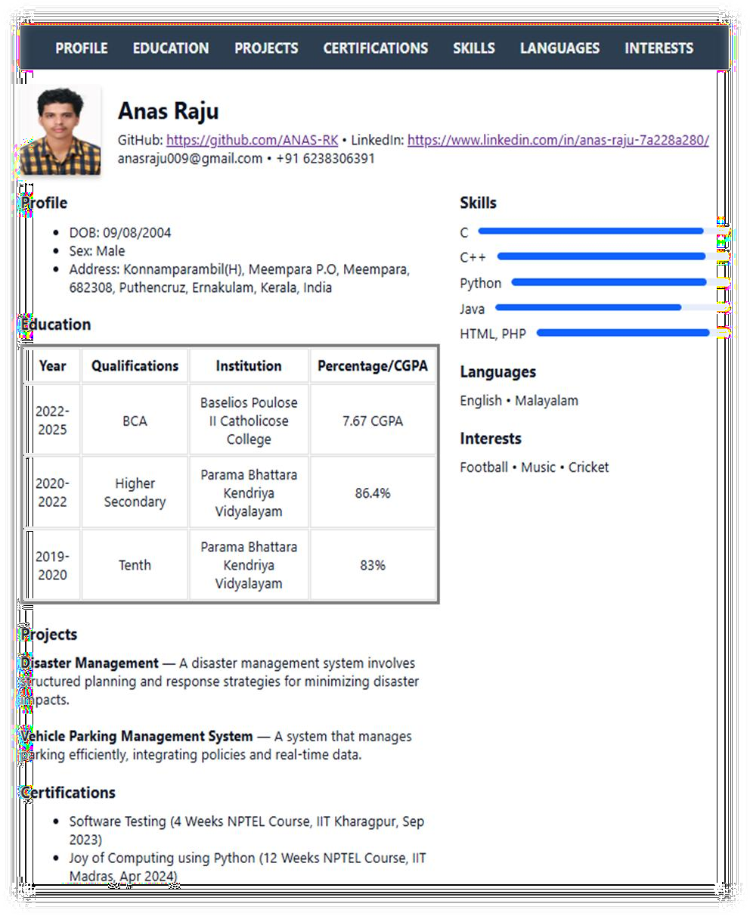

Program # 2
Create a web page of two parts, Part 1: MCA student registration form Part 2: Webpage of the college.
Use frames and various form elements to create the webpage

PROGRAM CODE:

index.html
<!DOCTYPE html>
<html>
<head>
<title>MCA Registration & College Page</title>
</head>
<frameset cols="50%,50%">
<frame src="form.html" name="formFrame">
<frame src="college.html" name="collegeFrame">
</frameset>
</html>

college.html
<!DOCTYPE html>
<html>
<head>
<title>College</title>
<style> body {
font-family: 'Times New Roman', Times, serif; background: #eef6f9;
padding: 20px;
}
header {

text-align: center; padding: 10px; background: #f1072a; color: white;
border-radius: 10px;
}
nav {
margin: 20px 0; text-align: center;
}
nav a {
margin: 0 15px;
text-decoration: none; color:#f1072a;
font-weight: bold;
}
section { background: white; padding: 15px; border-radius: 10px;
box-shadow: 0 0 10px #aaa;
}
footer {
text-align: center; margin-top: 20px; font-size: 12px;

color: #555;
}
</style>
</head>
<body>
<header>
<h1>Muthoot Institute of Technology and Science</h1>
<p>Excellence in Education</p>
</header>
<nav>
<a href="#Home">Home</a>
<a href="#About">About</a>
<a href="#Departments">Departments</a>
<a href="#Contact">Contact</a>
</nav>
<section id="Home">
<h2>Welcome to Muthoot Institute of Technology and Science</h2>
<p> Muthoot Institute of Technology and Science College offers
a postgraduate programs and Btech programmes including Btech,Mtech, MCA, MBA.
Our mission is to provide quality education and prepare students for successful careers.</p>
</section><br>
<section id="About">
<h2>About Us</h2>
<p>Established in 2010, Muthoot Institute of Technology and Science has been at the forefront of technical education.

Our campus is equipped with state-of-the-art facilities and a dedicated faculty committed to student success.</p>
</section><br>
<section id="Departments">
<h2>Our Departments</h2>
<ul>
<li>Computer Science and Engineering</li>
<li>Electronics and Communication Engineering</li>
<li>Mechanical Engineering</li>
<li>Civil Engineering</li>
<li>Business Administration (MBA)</li>
<li>Computer Applications (MCA)</li>
<li>Electrical and Electronics Engineering</li>
</ul>
</section><br>
<section id="Contact">
<h2>Contact Us</h2>
<p><strong>Address:</strong> Muthoot Institute of Technology and Science Varikoli P.O,<br>Puthencruz- 682308</p>
<p><strong>Email:</strong> info@mgits.ac.in<br> For placement related queries, pc@mgits.ac.in</p>
<p><strong>Phone:</strong> 0484-2732111,<br>0484-2732100</p>
</section>
<footer>
&copy; 2025 Muthoot Institute of Technology and Science. All Rights Reserved.
</footer></body></html>

form.html
<!DOCTYPE html>
<html>
<head>
<title>MCA Student Registration</title>
<style> body {
font-family: 'Times New Roman', Times, serif; background: #f0f4f9;
padding: 20px;
}
h2 {
text-align: center; color: #f1072a;
}
form {
background: white; padding: 20px; border-radius: 10px;
box-shadow: 0px 0px 10px #aaa;
}
label {
display: block; margin-top: 10px; font-weight: bold;
}

input[type="text"],input[type="email"],input[type="date"],input[type="submi t"],select, textarea {
width: 95%; padding: 8px; margin-top: 5px;
border: 1px solid #ccc; border-radius: 5px;
}
input[type="submit"], input[type="reset"] { width: 45%;
margin-top: 15px; background: #2c3e50; color: white;
border: none;
}
input[type="reset"] { background: #e74c3c;
}
</style>
</head>
<body>
<h2>MCA Student Registration Form</h2>
<form>
<label>Full Name:</label>
<input type="text" name="name" required>
<label>Gender:</label>

<input type="radio" name="gender" value="Male"> Male
<input type="radio" name="gender" value="Female"> Female
<input type="radio" name="gender" value="Other"> Other
<label>Date of Birth:</label>
<input type="date" name="dob">
<label>Email:</label>
<input type="email" name="email" required>
<label>Contact Number:</label>
<input type="text" name="phone">
<label>Address:</label>
<textarea name="address" rows="3"></textarea>
<label>Course (Select):</label>
<select name="course">
<option value="MCA">MCA</option>
<option value="MBA">MBA</option>
<option value="MSc">Mtech</option>
<option value="Btech">Btech</option>
</select>
<label>Upload Photo:</label>
<input type="file" name="photo">
<div style="display:flex; justify-content:space-between;">
<input type="submit" value="Register">
<input type="reset" value="Clear">
</div>
</form>
</body></html>

Output:
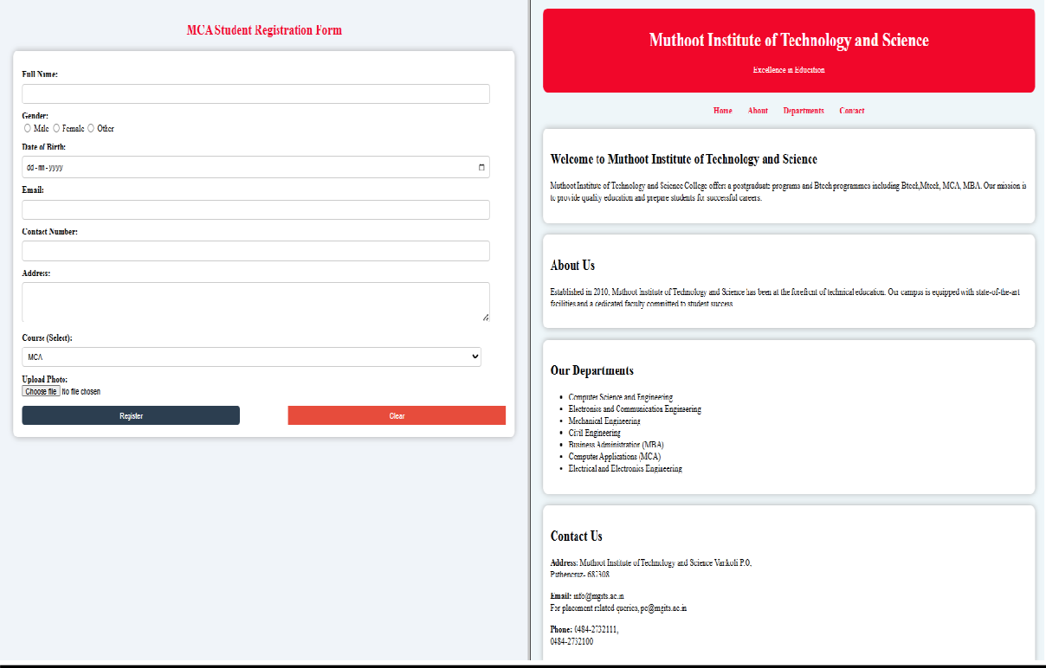

Program # 3
Create a webpage about your hometown and its tourist attractions using Html, and External, Internal, and inline CSS.
The following elements should be included in the webpage.
- Html text formatting
- Links to Wikipedia pages for further references
- External, Internal, and Inline CSS
- CSS should include font colour, positioning, background colours, text alignment etc.
- Images of the hometown and its attractions.
- Usage of div elements for styling

PROGRAM CODE:

hometown.html
<!DOCTYPE html>
<html lang="en">
<head>
<meta charset="utf-8" />
<meta name="viewport" content="width=device-width, initial-scale=1" />
<title>My Beautiful Hometown</title>
<link href="https://fonts.googleapis.com/css2?family=Inter:wght@300;400;600;800& display=swap" rel="stylesheet">
<link rel="stylesheet" href="style(home).css">
<Style>
.c{min-height:60vh; display:flex;
align-items:center; padding:40px;

gap:40px
}
.c-left{flex:1
}
h1{font-size:48px; margin:12px 0 12px
}
p.lead{color:#6b7280; max-width:60%
}
.cta{margin-top:18px
}
.btn{background:#2b8aef; color:white; padding:12px 18px; border-radius:10px; text-decoration:none; font-weight:700;
box-shadow:0 8px 18px rgba(43,138,239,0.18)
}
.c-right{flex:1;display:grid;
grid-template-columns:repeat(2,1fr); gap:12px
}
.card{background:#ffffff; border-radius:14px;

padding:12px;
box-shadow:0 8px 24px rgba(15,23,42,0.06); overflow:hidden
}
.card img{width:100%; height:180px;
object-fit:cover; border-radius:10px
}
.container{padding:0 40px 80px
}
.grid{display:grid;
grid-template-columns:repeat(3,1fr); gap:18px;
margin-top:24px
}
.place{background:linear-gradient(180deg,#ffffff,#fbfdff); padding:18px;
border-radius:12px; min-height:220px; display:flex;
flex-direction:column
}
.place h3{margin:8px 0 4px}
.place p{color:#6b7280; flex:1}

</style>
</head>
<body>
<header>
<nav>
<a href="#about">About</a>
<a href="#places">Places</a>
<a href="#gallery">Gallery</a>
<a href="#languages">Languages</a>
<a href="#location">Location</a>
</nav>
</header>
<section id="gallery" class="c container">
<div class="c-left">
<h1>Discover the quiet magic of our hometown</h1>
<p class="lead"></p>
<div class="cta"><a class="btn" href="#places">Explore Top Sights</a></div>
</div>
<div class="c-right">
<div class="card">
<img src="kodakuthi.jpg">
<div style="margin-top:10px;font-weight:700">Kodakuthi</div>
<div style="color:#6b7280;font-size:13px">Free to roam around.</div>
</div>
<div class="card">

<img src="home.jpg">
<div style="margin-top:10px;font-weight:700">Paddy Field</div>
<div style="color:#6b7280;font-size:13px">Sunset viewpoint.</div>
</div>
<div class="card">
<img src="hom2.jpeg">
<div style="margin-top:10px;font-weight:700">Pallikka Kavu Temple</div>
<div style="color:#6b7280;font-size:13px">Feel the village freshness.</div>
</div>
<div class="card">
<img src="home3.jpg">
<div style="margin-top:10px;font-weight:700">Neeramukal Church</div>
<div style="color:#6b7280;font-size:13px">A peaceful retreat.</div>
</div>
</section>
<div class="container">
<section id="about">
<h2>About the Town</h2>
<p style="color:#6b7280;max-width:70%">
Meempara is a small Village/hamlet in Vadavucode Block in Ernakulam District of Kerala State, India. It comes under Aikkaranadu
South Poothrikka Panchayath. It belongs to Central Kerala Division .
It is located 24 KM towards East from District head quarters Kakkanad. 8 KM from Vadavucode Puthencruz.
200 KM from State capital Thiruvananthapuram

Meempara Pin code is 682308 and postal head office is Puthencruz.
Maneed( 5 KM ),Ramamangalam ( 6 KM ),Chottanikkara( 7 KM
),Edakkattuvayal( 9 KM ),Pampakuda( 9 KM )
are the nearby Villages to Meempara.Meempara is surrounded by Mulanthuruthy Block towards west,Pampakuda Block towards East,
Vyttila Block towards west,Muvattupuzha,Perumbavoor,Kochi are the near by Cities to Meempara.</p>
</section><br>
<section id="languages">
<h2>Demographics of Meempara</h2>
<p style="color:#6b7280;max-width:70%">Malayalam is the Local Language here.</p>
</section><br>
<section id="location">
<h2>Location</h2>
<p style="color:#6b7280;max-width:70%">
<a href="https://maps.app.goo.gl/Vuh4Vcr6AVEMZtfy5">
<img src="icon.png" alt="Map Icon" style="width:32px;height:32px;border:0;">9.9583° N, 76.4429° E
</a>
</p><br>
<section id="places" style="margin-top:22px">
<h2>Top Places to Visit</h2>
<div class="grid">
<div class="place">
<h3>Pallikka Kavu Temple</h3>
<p class="muted">A small temple with a nostalgic charm.<br><br>

<iframe src="https://www.google.com/maps/embed?pb=!1m18!1m12!1m3!1d125789.34 06297416!2d76.36599814989113!3d9.857339486050405!2m3!1f0!2f0!3f0!3m
2!1i1024!2i768!4f13.1!3m3!1m2!1s0x3b08756edca7df9d%3A0xf22da4151b08
278f!2sPallikkakavu%20Temple!5e0!3m2!1sen!2sin!4v1759164320287!5m2!1 sen!2sin"
width="400" height="300" style="border:0;" allowfullscreen="" loading="lazy" referrerpolicy="no-referrer-when-downgrade"></iframe>
</p>
</div>
<div class="place">
<h3>Pallikka Kavu chira</h3>
<p class="muted">Jump to the serene waters for a refreshing dip.
<br><br><iframe src="https://www.google.com/maps/embed?pb=!1m18!1m12!1m3!1d125789.34 06297416!2d76.36599814989113!3d9.857339486050405!2m3!1f0!2f0!3f0!3m
2!1i1024!2i768!4f13.1!3m3!1m2!1s0x3b08756edca7df9d%3A0xf22da4151b08
278f!2sPallikkakavu%20Temple!5e0!3m2!1sen!2sin!4v1759164320287!5m2!1 sen!2sin"
width="400" height="300" style="border:0;" allowfullscreen="" loading="lazy" referrerpolicy="no-referrer-when-downgrade"></iframe>
</p>
</div>
<div class="place">
<h3>Kodakuthi Chapel</h3>
<p class="muted">Gathering of locals for prayer and reflection.
<br><br>
<iframe src="https://www.google.com/maps/embed?pb=!1m18!1m12!1m3!1d3929.8380 329234483!2d76.44082457479283!3d9.947430690155361!2m3!1f0!2f0!3f0!3
m2!1i1024!2i768!4f13.1!3m3!1m2!1s0x3b08756fe01adebb%3A0x5f73ad6b59

a7821c!2sKudakuthi%20Chapel!5e0!3m2!1sen!2sin!4v1759164043532!5m2!1s en!2sin"
width="400" height="300" style="border:0;" allowfullscreen="" loading="lazy" referrerpolicy="no-referrer-when-downgrade">
</iframe>
</p>
</div>
<div class="place">
<h3>Neeramukal Church</h3>
<p class="muted">Peaceful atmosphere and beautiful architecture.
<br><br><iframe src="https://www.google.com/maps/embed?pb=!1m18!1m12!1m3!1d3929.9561 26656646!2d76.44354087479272!3d9.937608590164643!2m3!1f0!2f0!3f0!3m
2!1i1024!2i768!4f13.1!3m3!1m2!1s0x3b08757813f25d93%3A0xe35f35efac72
3fa1!2sSt.%20Peter&#39;s%20%26%20St.%20Paul&#39;s%20Jacobite%20Sy rian%20Cathedral%2C%20Neeramukal!5e0!3m2!1sen!2sin!4v1759164190064! 5m2!1sen!2sin"
width="400" height="300" style="border:0;" allowfullscreen=""
loading="lazy" referrerpolicy="no-referrer-when- downgrade"></iframe>
</p>
</div>
</div>
</body>
</html>

style(home).css
body{margin:0;background:linear-gradient(180deg,#f3f7fb 0%,#f7fafc 100%);

color:#0f172a;
font-family:'Times New Roman', Times, serif;
}
header{display:flex; align-items:center;
justify-content:space-between; padding:20px 40px
}
nav a{margin-left:18px; text-decoration:none; color:#6b7280;
font-weight:600
}

Output:
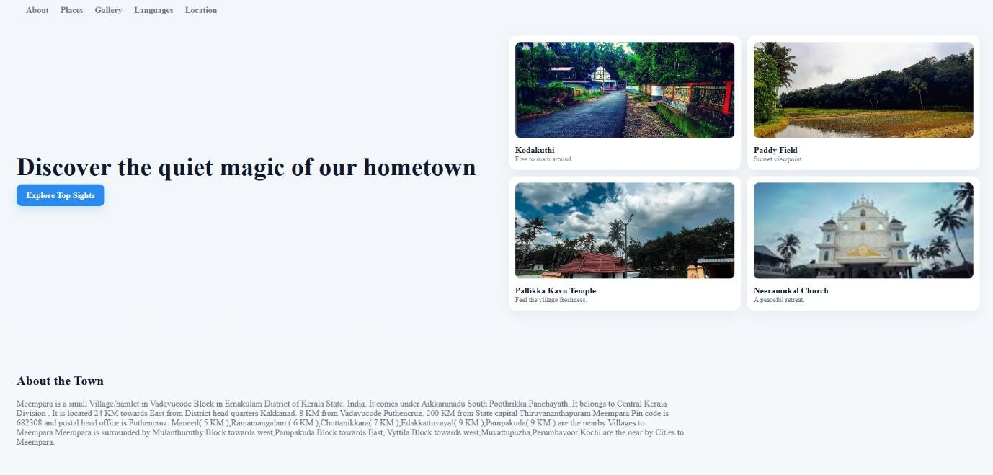

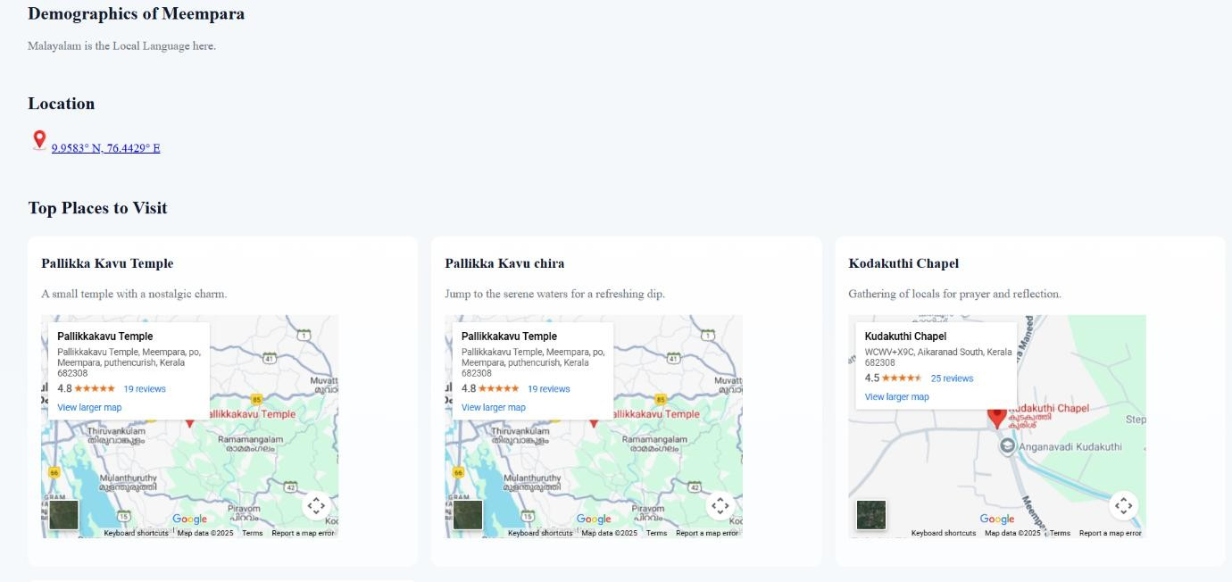

Program # 4
Create MITS college Website with the help of frames, style sheets, background colours, images, tables, and lists. Create multiple webpages which are easily navigable by hyperlinks. Apply style sheets as well as floating, mixed, and navigation frames to design the webpages.

PROGRAM CODE:

mits.html
<!DOCTYPE html>
<html lang="en">
<head>
<meta charset="UTF-8">
<meta name="viewport" content="width=device-width, initial-scale=1.0">
<title>College site</title>
<style> body::before { margin: 0;
font-family:'Times New Roman', Times, serif; color: #333;
content: ""; position: fixed; top: 0;
left: 0;
width: 100%;
height: 100%;
background: url('muthoot.jpeg') no-repeat center center; background-size: cover;

opacity: 0.2;
z-index: -1;
}
header {
background: #f90101; color: #fff;
padding: 20px 0; text-align: center;
}
nav { background:#f90101; padding: 10px;
text-align: center;
}
nav a { color: #fff;
text-decoration: none; margin: 0 15px;
font-weight: bold;
}
nav a:hover {
text-decoration: underline;
}
section { padding: 40px; margin: 0;

margin-top: 5px; border-radius: 8px;
}
footer { background:#f90101; color: #fff;
text-align: center; padding: 15px; margin-top: 5px;
}
.course-container { display: flex;
justify-content: space-between; gap: 40px;
margin-top: 20px;
}
.course-list { flex: 1; padding: 20px;
border-radius: 8px;
}
.course-list h3 { margin-top: 0; color:#f90101;
}
#login-frame {

position: absolute;
top: 800px; /* below header */ right: -100px; /* right side gap */ width: 500px;
height: 280px; border: none; border-radius: 10px; z-index: 999;
}
#message-frame { position: absolute;
top: 800px; /* below header */ right: 300px; /* right side gap */ width: 500px;
height: 280px; border: none; border-radius: 10px; z-index: 999;
}
</style>
</head>
<body>
<header>
<h1>Muthoot Institute Of Technology And Science</h1>
<p>Excellence in Education Since 2013</p>
</header>

<nav>
<a href="mits.html">Home</a>
<a href="#about">About</a>
<a href="#courses">Courses</a>
<a href="mits(admission).html">Admission</a>
<a href="#message-frame">Message</a>
<a href="#contact">Contact</a>
<a href="#login-frame">Login</a>
<a href="#message-frame">Message</a>
</nav>
<section id="about">
<h2>About Us</h2>
<p><b>Muthoot Institute of Technology and Science (MITS)</b> is
<b>promoted by Muthoot M. George</b>.
MITS is a self financing technical institution offering postgraduate and undergraduate engineering programmes,
situated in the industrial suburb of Kochi, close to the Smart City and Info Park, approximately 15 kms from
Vytilla Junction towards Muvattupuzha on the Cochin Madurai National Highway.
The promoters with their commanding presence in the domains of Financial Services, Hospitality, Healthcare,
Renewable Energy and Information Technology, are committed to building MITS as a centre of excellence,
focusing purely on merit. This “temple of learning” will provide to the students, state-of-the-art infrastructure,
highly qualified and proficient teachers from various faculty of engineering and allied streams,

embedded in a conducive environment where focus will be on their harmonious development.</p>
</section>
<section id="courses">
<h2>Our Courses</h2>
<div class="course-container">
<div class="course-list">
<h2>B-TECH Courses Offered</h2>
<ul>
<li>Computer Engineering (CS)</li>
<li>Artificial Intelligence & Data Science (AI & DS)</li>
<li>Artificial Intelligence (AI)</li>
<li>Computer Science & Engineering(CSE)</li>
<li>Cyber Security</li>
<li>Electronics & Communication Engineering (ECE)</li>
<li>Electrical & Electronics Engineering (EEE)</li>
<li>Civil Engineering (CE)</li>
<li>Mechanical Engineering (ME)</li>
</ul>
</div>
<div class="course-list">
<h2>M-TECH Courses Offered</h2>
<ul>
<li>Artificial Intelligence & Data Science (AI & DS)</li>
<li>Cyber Security</li>
</ul>

</div>
<div class="course-list">
<h2>Other Courses Offered</h2>
<ul>
<li>MBA</li>
<li>MCA</li>
</ul>
</div>
</div>
</section>
<section id="contact">
<h2>Contact Us</h2>
<p><strong>Address:</strong> Muthoot Institute of Technology and Science Varikoli P.O,<br>Puthencruz- 682308</p>
<p><strong>Email:</strong> info@mgits.ac.in<br> For placement related queries, pc@mgits.ac.in</p>
<p><strong>Phone:</strong> 0484-2732111,<br>0484-2732100</p>
</section>
<!-- Floating Login Frame -->
<iframe src="login.html" id="login-frame"scrolling="no"></iframe>
<iframe src="message.html" id="message-frame"scrolling="no"></iframe>
<footer>
<p>&copy; 2025 Muthoot Institute of Technology and Science</p>
</footer>
</body>
</html>

mits(admission).html
<!DOCTYPE html>
<html lang="en">
<head>
<link rel="stylesheet" href="style.css">
<meta charset="UTF-8">
<title>Admission</title>
<style> table {
width: 100%; border-style: solid;
}
th, td {
border: 1px solid #ddd; padding: 8px;
text-align: center;
}
#admission-form { max-width: 10000px; margin: 0px; padding: 20px; border-radius: 8px;
font-family: Arial, sans-serif;
}
#admission-form h2 { text-align: center;

color: #f90101; margin-bottom: 25px;
}
.form-row { display: flex; gap: 20px;
margin-bottom: 15px; flex-wrap: wrap;
}
.form-group {
flex: 1 1 45%; /* two columns */ display: flex;
flex-direction: column;
}
label {
font-weight: bold; margin-bottom: 5px;
}
input, select { padding: 8px; border-radius: 5px;
border: 1px solid #ccc; box-sizing: border-box;
}
.submit-btn {
background-color: #f90101;

color: #fff; border: none; padding: 12px;
border-radius: 5px; cursor: pointer; width: 100%;
font-size: 16px;
}
.submit-btn:hover { background-color: #c70000;
}
</style>
</head>
<body>
<header>
<h1>Muthoot Institute Of Technology And Science</h1>
<p>Excellence in Education Since 2013</p>
</header>
<nav>
<a href="mits.html">Home</a>
<a href="mits.html#about">About</a>
<a href="mits.html#courses">Courses</a>
<a href="mits(admission).html#seats">Admission</a>
<a href="mits.html#message-frame">Message</a>
<a href="mits.html#contact">Contact</a>
<a href="mits.html#login-frame">Login</a>

</nav>
<section id="admission-form">
<h2>Admission Registration Form</h2>
<form>
<div class="form-row">
<div class="form-group">
<label for="fullname">Full Name:</label>
<input type="text" id="fullname" name="fullname" placeholder="Enter full name" required>
</div>
<div class="form-group">
<label for="dob">Date of Birth:</label>
<input type="date" id="dob" name="dob" required>
</div>
</div>
<div class="form-row">
<div class="form-group">
<label for="gender">Gender:</label>
<select id="gender" name="gender" required>
<option value="">Select</option>
<option value="male">Male</option>
<option value="female">Female</option>
<option value="other">Other</option>
</select>
</div>
<div class="form-group">

<label for="email">Email:</label>
<input type="email" id="email" name="email" placeholder="Enter email" required>
</div>
</div>
<div class="form-row">
<div class="form-group">
<label for="phone">Phone Number:</label>
<input type="tel" id="phone" name="phone" placeholder="Enter phone number" required>
</div>
<div class="form-group">
<label for="course">Course Applying For:</label>
<select id="course" name="course" required>
<option value="">Select</option>
<option value="btech-cse">B.Tech - CSE</option>
<option value="btech-ece">B.Tech - ECE</option>
<option value="btech-eee">B.Tech - EEE</option>
<option value="btech-ce">B.Tech - CE</option>
<option value="btech-me">B.Tech - ME</option>
<option value="mtech-ais">M.Tech - AI & DS</option>
<option value="mtech-cyber">M.Tech - Cyber Security</option>
<option value="mba">MBA</option>
<option value="mca">MCA</option>
</select>
</div>
</div>

<div class="form-row">
<div class="form-group">
<label for="qualification">Highest Qualification:</label>
<input type="text" id="qualification" name="qualification" placeholder="Enter qualification" required>
</div>
<div class="form-group">
<label for="percentage">Percentage / CGPA:</label>
<input type="text" id="percentage" name="percentage" placeholder="Enter percentage/CGPA" required>
</div>
</div>
<div class="form-row">
<div class="form-group">
<label for="city">City:</label>
<input type="text" id="city" name="city" placeholder="City" required>
</div>
<div class="form-group">
<label for="state">State:</label>
<input type="text" id="state" name="state" placeholder="State" required>
</div>
</div>
<div class="form-row">
<div class="form-group">
<label for="pincode">Pincode:</label>
<input type="text" id="pincode" name="pincode" placeholder="Pincode" required>

</div>
<div class="form-group">
<label for="address">Address:</label>
<input type="text" id="address" name="address" placeholder="Full address" required>
</div>
</div>
<div class="form-row">
<input type="submit" value="Submit Registration" class="submit-btn">
</div>
</form>
</section>
<section id="seats">
<table>
<thead>
<tr>
<th>Course</th>
<th>Duration</th>
<th>No. of Seats</th>
<th>Eligibility</th>
</tr>
</thead>
<tbody>
<tr>
<td>B.Tech - Computer Science & Engineering (CSE)</td>
<td>4 Years</td>

<td>60</td>
<td>10,+2 Science</td>
</tr>
<tr>
<td>B.Tech - Artificial Intelligence (AI)</td>
<td>4 Years</td>
<td>30</td>
<td>10,+2 Science</td>
</tr>
<tr>
<td>B.Tech - Artificial Intelligence and Data Science (AI & DS)</td>
<td>4 Years</td>
<td>30</td>
<td>10,+2 Science</td>
</tr>
<tr>
<td>B.Tech - Cyber Security</td>
<td>4 Years</td>
<td>30</td>
<td>10,+2 Science</td>
</tr>
<td>B.Tech - Electronics & Communication Engineering (ECE)</td>
<td>4 Years</td>
<td>60</td>
<td>10,+2 Science</td>
</tr>

<tr>
<td>B.Tech - Electrical & Electronics Engineering (EEE)</td>
<td>4 Years</td>
<td>60</td>
<td>10,+2 Science</td>
</tr>
<tr>
<td>B.Tech - Civil Engineering (CE)</td>
<td>4 Years</td>
<td>60</td>
<td>10,+2 Science </td>
</tr>
<tr>
<td>B.Tech - Mechanical Engineering (ME)</td>
<td>4 Years</td>
<td>60</td>
<td>10,+2 Science</td>
</tr>
<tr>
<td>M.Tech - Artificial Intelligence & Data Science</td>
<td>2 Years</td>
<td>18</td>
<td>B.Tech in relevant field</td>
</tr>
<tr>
<td>M.Tech - Cyber Security</td>

<td>2 Years</td>
<td>18</td>
<td>B.Tech in relevant field</td>
</tr>
<tr>
<td>MBA</td>
<td>2 Years</td>
<td>60</td>
<td>Graduation in any discipline</td>
</tr>
<tr>
<td>MCA</td>
<td>2 Years</td>
<td>60</td>
<td>B.Sc/BCA/B.Tech</td>
</tr>
</tbody>
</table>
</section>
<!-- Footer -->
<footer>
<p>&copy; 2025 Muthoot Institute of Technology and Science</p>
</footer>
</body>
</html>

message.html
<!DOCTYPE html>
<html lang="en">
<head>
<meta charset="UTF-8">
<meta name="viewport" content="width=device-width, initial-scale=1.0">
<title>login</title>
<style>
section { background: #fff; padding: 30px; border-radius: 10px;
box-shadow: 0 4px 10px rgba(0,0,0,0.2); width: 300px;
text-align: center;
}
#form {
max-width: 10000px; margin: 0px; padding: 20px; border-radius: 8px;
font-family: Arial, sans-serif;
}

#form h2 {
text-align: center;

color:#f90101; margin-bottom: 25px;
}
.submit-btn {
background-color: #f90101; color: #fff;
border: none; padding: 12px; border-radius: 5px; cursor: pointer; font-size: 16px;
}
.submit-btn:hover { background-color: #e67575;
}
</style>
</head>
<body>
<section id="form">
<h2>Message Us</h2>
<form>
<textarea name="message" rows="4" cols="30" placeholder="Your message here..." required></textarea><br><br>
<input type="submit" value="Send" class="submit-btn">
</form>
</body></html>

login.html
<!DOCTYPE html>
<html lang="en">
<head>
<meta charset="UTF-8">
<meta name="viewport" content="width=device-width, initial-scale=1.0">
<title>login</title>
<style>
section { background: #f90101; padding: 30px;
border-radius: 10px;
box-shadow: 0 4px 10px rgba(0,0,0,0.2); width: 300px;
text-align: center;
}
#admission-form { max-width: 10000px; margin: 0px; padding: 20px; border-radius: 8px;
font-family: Arial, sans-serif;
}
#admission-form h2 { text-align: center; color:#fff;

margin-bottom: 25px;
}
.submit-btn { background-color:#fff; color: #f90101; border: none;
padding: 12px; border-radius: 5px; cursor: pointer; font-size: 16px;
}
.submit-btn:hover { background-color: #e67575;
}
</style>
</head>
<body>
<!-- Page Content -->
<section id="admission-form">
<h2>Login</h2>
<form>
<input type="email" name="email" placeholder="Email" required><br><br>
<input type="password" name="pass" placeholder="Password" required><br><br>
<input type="submit" value="Login" class="submit-btn">
</form></body></html>

style.css body::before { margin: 0;
font-family:'Times New Roman', Times, serif; color: #333;
content: "";
position: fixed; /* stays behind content even on scroll */ top: 0;
left: 0;
width: 100%;
height: 100%;
background: url('muthoot.jpeg') no-repeat center center; background-size: cover;
opacity: 0.2; /* adjust opacity to make content readable */ z-index: -1; /* behind everything */
}
header {
background: #f90101;; color: #fff;
padding: 20px 0; text-align: center;
}
nav { background:#f90101;; padding: 10px;
text-align: center;

}
nav a { color: #fff;
text-decoration: none; margin: 0 15px;
font-weight: bold;
}
nav a:hover {
text-decoration: underline;
}
section { padding: 40px;
max-width: 10000px; margin: auto;
margin-top: 5px; border-radius: 8px;
}
footer { background:#f90101;; color: #fff;
text-align: center; padding: 15px; margin-top: 5px;
}
.course-container { display: flex;

justify-content: space-between; gap: 40px;
margin-top: 20px;
}
.course-list { flex: 1; padding: 20px;
border-radius: 8px;
}
.course-list h3 { margin-top: 0; color:#f90101;;
}

Output:


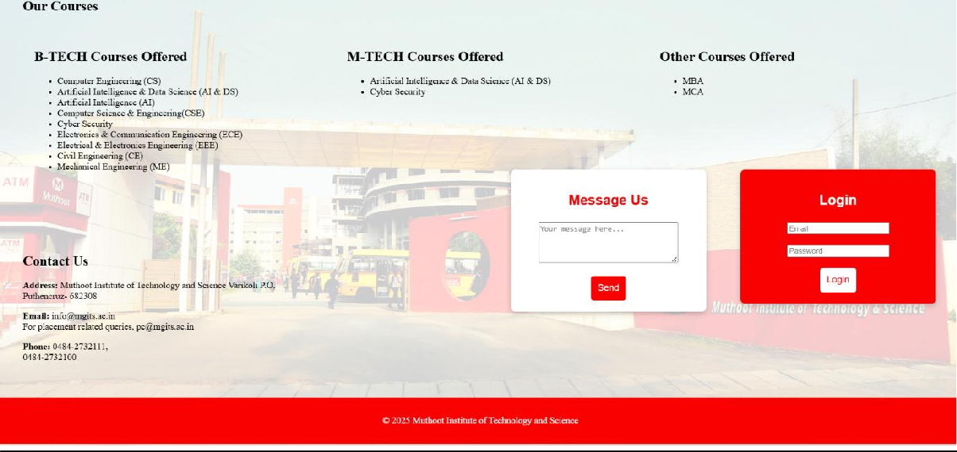

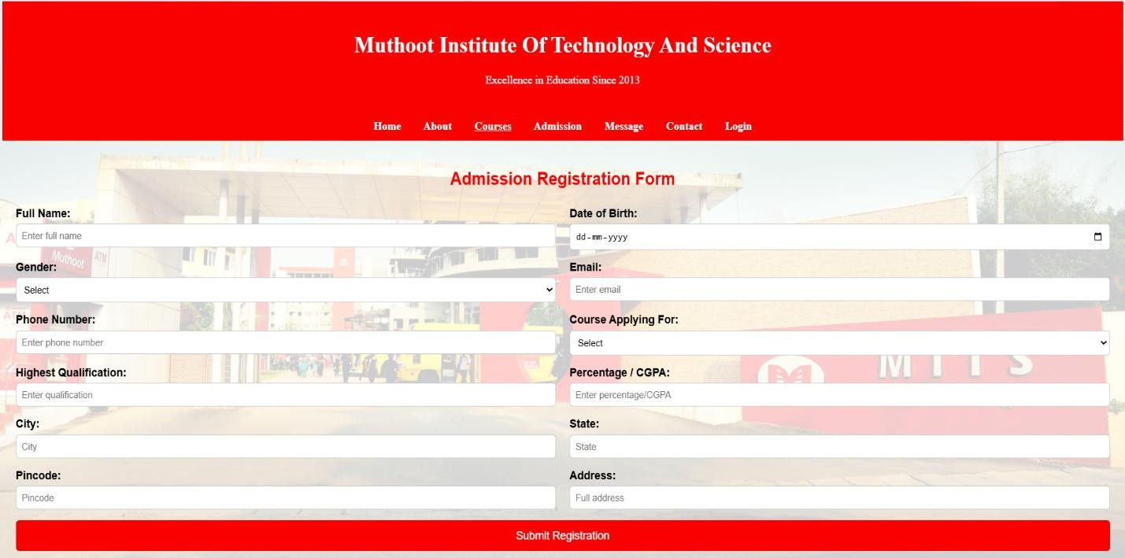

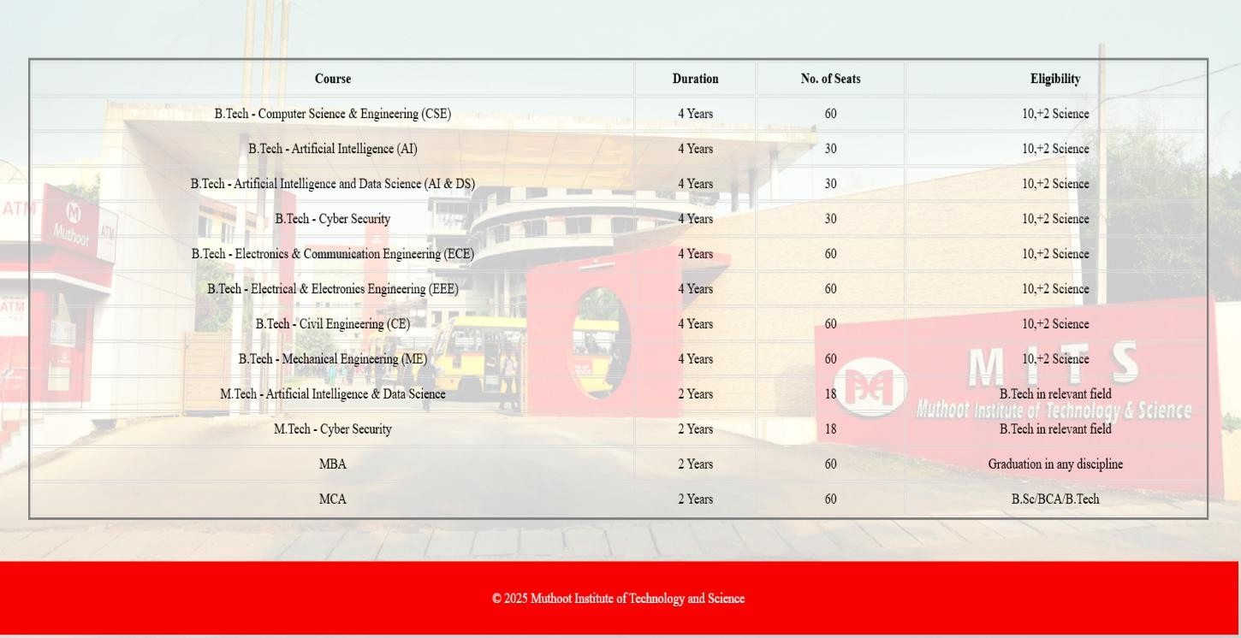

Program # 5
Apply positioning methods of elements on a webpage with div elements and their corresponding classes using two external stylesheets. Compare the output with absolute, and relative positioning of div elements.
.

PROGRAM CODE:

div(style).html
<!DOCTYPE html>
<html lang="en">
<head>
<meta charset="UTF-8">
<title>Positioning Example</title>
<link rel="stylesheet" href="style1.css">
<link rel="stylesheet" href="style2.css">
</head>
<body>
<h2>Positioning with div elements</h2>
<div class="relative-box">
<p>Relative Positioned Box</p>
</div>
<div class="absolute-box">
<p>Absolute Positioned Box</p>
</div>
<div class="normal-box">
<p>Normal Flow Box</p>
</div>
</body></html>

style1.css
/* General Styling */ body {
font-family: Arial, sans-serif; background: #f4f4f9; padding: 20px;
}
h2 {
text-align: center; color: #333;
}
/* Base box style */ div {
width: 200px; height: 100px;
border: 2px solid #444; margin: 20px; padding: 10px;
text-align: center;
}

style2.css
/* Relative positioning */
.relative-box { position: relative; left: 50px;

top: 20px; background: #cce7ff;
}
/* Absolute positioning */
.absolute-box { position: absolute; left: 200px;
top: 150px; background: #ffcccc;
}
/* Normal flow */
.normal-box {
position: static; /* default */ background: #ccffcc;
}

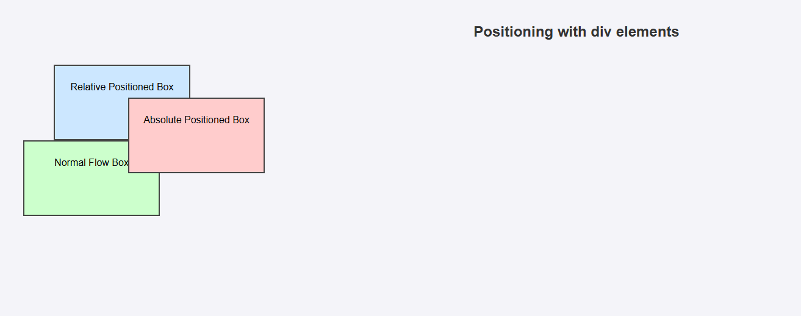
Output:
Program # 6
Create a HTML page to explain the use of various predefined functions in a string and math
object in java script.

PROGRAM CODE:

javascript_function.html
<!DOCTYPE html>
<body>
<h3>String Functions</h3>
<p id="s1"></p>
<p id="s2"></p>
<p id="s3"></p>
<p id="s4"></p>
<p id="s5"></p>
<p id="s6"></p>
<p id="s7"></p>
<head>
<script>
let txt = "Hello, World!"; let len=txt.length;
let part = txt.slice(5,13); let sub=txt.substr(5,6);
let newtxt=txt.replace("World","Universe");

let u=txt.toUpperCase(); let s=txt.toLowerCase();
let txt2=", Hello Everyone!"; let c=txt.concat(" ",txt2);
document.getElementById("s1").innerHTML = "Length: " + len; document.getElementById("s2").innerHTML = "Sliced: " + part; document.getElementById("s3").innerHTML = "Substr: " + sub; document.getElementById("s4").innerHTML = "Replaced: " + newtxt; document.getElementById("s5").innerHTML = "Uppercase: " + u; document.getElementById("s6").innerHTML = "Lowercase: " + s; document.getElementById("s7").innerHTML = "Concatenated: " + c; let m1 = Math.round(4.6);
let m2 = Math.pow(2,3); let m3 = Math.sqrt(49); let m4 = Math.abs(-25);
let m5 = Math.max(4,8,2,10); let m6 = Math.random();
let m7 = Math.min(4,8,2,10); let m8 = Math.floor(4.7);
let m9 = Math.ceil(4.2); let m10 = Math.PI;
let m11 = Math.sign(10); let m12 = Math.sign(-5); let m13 = Math.sign(0); let m14 = Math.log(10);
document.write("<h3>Math Functions</h3>");

document.write("Round(4.6): " + m1 + "<br><br>"); document.write("Power(2,3): " + m2 + "<br><br>"); document.write("Square Root(49): " + m3 + "<br><br>"); document.write("Absolute(-25): " + m4 + "<br><br>"); document.write("Maximum(4,8,2,10): " + m5 + "<br><br>"); document.write("Random: " + m6 + "<br><br>"); document.write("Minimum(4,8,2,10): " + m7 + "<br><br>"); document.write("Floor(4.7): " + m8 + "<br><br>"); document.write("Ceil(4.2): " + m9 + "<br><br>"); document.write("Value of PI: " + m10 + "<br><br>"); document.write("Sign(10): " + m11 + "<br><br>"); document.write("Sign(-5): " + m12 + "<br><br>"); document.write("Sign(0): " + m13 + "<br><br>"); document.write("Natural Logarithm of 10: " + m14 + "<br><br>");
</script>
</head>
</body>

Output:
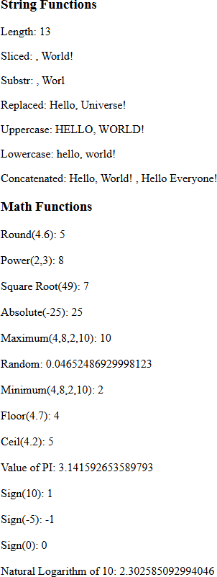

Program # 7
Generate the calendar using JavaScript code by getting the year from the user.

PROGRAM CODE:

Calender.html
<!DOCTYPE html>
<html>
<head>
<style> table {
border-collapse: collapse;
}
td, th {
border: 1px solid black; padding: 3px;
text-align: center;
}
th {
font-weight: bold; background-color: #E6E6E6;
}
</style>
<title>Calendar in JS</title>
</head>
<body>
<h2><center>CALENDAR</center></h2><br>

Year: <input id="y" type="number" name="year"><br/><br/> Month: <input id="m" type="number" name="month"><br/><br/>
<input type="button" value="Generate" onclick="createCalendar()"> <br><br>
<div id="cal"></div>
<script>
function createCalendar() {
var year = document.getElementById("y").value; var month = document.getElementById("m").value; if ( month < 1 || month > 12) {
alert("Please enter a valid year or month (1–12)."); return;
}
let mon = month - 1;
let d = new Date(year, mon); let table =
'<table><tr><th>SUN</th><th>MON</th><th>TUE</th><th>WED</th><th> THU</th><th>FRI</th><th>SAT</th></tr><tr>';
for (let i = 0; i < d.getDay(); i++) { table += '<td></td>';
}
while (d.getMonth() === mon) {
table += '<td>' + d.getDate() + '</td>'; if (d.getDay() === 6) {
table += '</tr><tr>';
}
d.setDate(d.getDate() + 1);
}

if (d.getDay() !== 0) {
for (let i = d.getDay(); i < 7; i++) { table += '<td></td>';
}
}
table += '</tr></table>'; document.getElementById("cal").innerHTML = table;
}
</script>
</body>
</html>

Output:

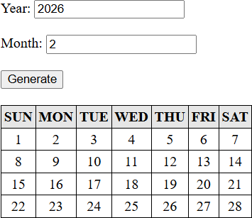

Program # 8
Create a program using the JavaScript Event Listener to add multiple events on the same button.

PROGRAM CODE:

event_handlers.html
<!DOCTYPE html>
<body>
<button id="btn">Try it</button>
<p id="demo"></p>
<script>
var x = document.getElementById("btn"); x.addEventListener("mouseover", mouseOver); x.addEventListener("click", mouseClick); x.addEventListener("mouseout", mouseOut); x.addEventListener("dblclick", doubleClick); x.addEventListener("mousedown", MouseDown); x.addEventListener("mouseup", MouseUp); x.addEventListener("focus", Focus); x.addEventListener("blur", Blur);
function mouseOver() {
document.getElementById("demo").innerHTML += "Moused over!<br>";
}
function mouseClick() {
document.getElementById("demo").innerHTML += "Mouse clicked!<br>";
}

function mouseOut() {
document.getElementById("demo").innerHTML += "Mouse out!<br>";
}
function doubleClick() {
document.getElementById("demo").innerHTML += "Mouse double clicked!<br>";
}
function MouseDown() {
document.getElementById("demo").innerHTML += "Mouse button down!<br>";
}
function MouseUp() {
document.getElementById("demo").innerHTML += "Mouse button up!<br>";
}
function Focus() {
document.getElementById("demo").innerHTML += "Button focused!<br>";
}
function Blur() {
document.getElementById("demo").innerHTML += "Button lost focus!<br>";
}
</script>
</body>

Output:
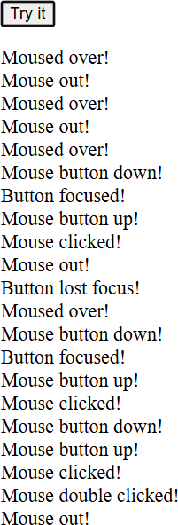

Program # 9
Develop a JavaScript Event Handling mechanism to change the background colour of an HTML page.

PROGRAM CODE:

Event_colorchange.html
<!DOCTYPE html>
<head>
<style> body {
text-align: center;
}
</style>
</head>
<body>
<p>Click anywhere to change the background color!</p>
<script>
function getRandomColor() {
const colors = ['#f00', '#0f0', '#00f', '#ff0', '#0ff', '#f0f'];
const randomColor = colors[Math.floor(Math.random() * colors.length)]; return randomColor;
}
document.addEventListener("click", () => { document.body.style.backgroundColor = getRandomColor();
});
</script>

Program # 10
Create an HTML page to display a new image and text when the mouse comes over the existing content in the page using JavaScript Event Handling mechanism.

PROGRAM CODE:

event_imagechange.html
<!DOCTYPE html>
<head>
<style> #container { width: 300px; height: 200px;
position: relative; margin: 20px auto;
}
#img1{
display: block;
}
#img2{
display: none;
}
</style>
</head>
<body>
<p>Make mouse over on image !...</p>
<div id='container'>

<img id="img1" src="image1.jpg">
<p id="p1">iam michael.</p>
<img id="img2" src="image2.png">
<p id="p2" style="display: none;">iam johnnny.</p>
</div>
<script>
const content = document.getElementById('container'); const image1 = document.getElementById('img1'); const image2 = document.getElementById('img2'); const para1 = document.getElementById('p1');
const para2 = document.getElementById('p2'); content.addEventListener('mouseover', () => { image1.style.display = 'none'; image2.style.display = 'block'; para1.style.display = 'none'; para2.style.display = 'block';
});
content.addEventListener('mouseout', () => { image2.style.display = 'none'; image1.style.display = 'block'; para2.style.display = 'none'; para1.style.display = 'block';
});
</script>
</body>
</html>

Program # 11
Create a HTML registration form and validate the form using JavaScript code. The validation should include the following:
- Name validation/Mandatory field validation
- password validation
- Email validation
- Mobile number validation

PROGRAM CODE:

formvalidate.html
<!DOCTYPE html>
<html lang="en">
<head>
<meta charset="UTF-8">
<meta name="viewport" content="width=device-width, initial-scale=1.0">
<title>Form</title>
<link href="https://cdn.jsdelivr.net/npm/bootstrap@5.3.3/dist/css/bootstrap.min.css" rel="stylesheet">

</head>
<body>
<section>
<div class="container-fluid">
<div class="row">
<div class="col-md-12">
<div class="head">
<h1 class="text-center text-primary">Form Validation</h1>
</div>
</div>
</div>

<div class="row">
<div class="col-md-12">
<div class="formm">
<form id="myform" action="" method="POST" onsubmit=" return myFormValidate()">
<input type="text" class="form-control my-3" placeholder="Enter Your Name" name="name" id="name" required>
<input type="email" class="form-control my-3" placeholder="Enter Your Email" name="email" id="email">
<input type="text" class="form-control my-3" placeholder="Enter Your Phone No" name="phone" id="phone" maxlength="10" minlength="10" >
<input type="password" class="form-control my-3" placeholder="Enter Your Password" name="password" id="password" required>
<center><button type="submit" class="btn btn-primary text-center" id="submitBtn"
>Submit</button></center>

</form>
</div>
</div>
</div>
</div>

</section>

<script>
function myFormValidate(){
let name=document.getElementById("name").value; let email=document.getElementById("email").value; let phone=document.getElementById("phone").value;
let password = document.getElementById("password").value; if(name=="" || email=="" || phone==""){

alert("All fields are required"); return false;

}
let emailPattern=/^[a-zA-Z0-9._%+-]+@[a-zA-Z0-9.-]+\.[a-zA-Z]{2,}$/; if(!emailPattern.test(email)){
alert("Please enter a valid email address"); return false;
}
let phonePattern=/^[0-9]{10}$/; if(!phonePattern.test(phone)){
alert("Please enter a valid 10-digit phone number"); return false;
}
let passwordPattern = /^(?=.*[a-z])(?=.*[A-Z])(?=.*\d)(?=.*[@$!%*?&])[A-Za- z\d@$!%*?&]{8,}$/;
if (!passwordPattern.test(password)) {
alert("Password must be at least 8 characters long, include an uppercase letter, a lowercase letter, a number, and a special character.");
return false;
}
}
</script>
<!-- Bootstrap JS Bundle (includes Popper) -->
<script src="https://cdn.jsdelivr.net/npm/bootstrap@5.3.3/dist/js/bootstrap.bundle.min.js"></script>
</body>
</body>
</html>

Program # 12
Design and develop a complete online exam using Html, CSS and JavaScript. Minimum 4-5 questions should be in the online exam, and the results should be displayed on completion.

PROGRAM CODE:

exam.html
<!DOCTYPE html>
<style> body {
margin: 0; height: 150vh; display: flex;
justify-content: center; align-items: center;
background: linear-gradient(135deg, #d9e4f5, #f7f7f7); font-family: Arial, sans-serif;
}
.quiz-container { background: white; width: 600px; padding: 30px; border-radius: 15px;
box-shadow: 0 0 15px rgba(0,0,0,0.2);
}
h2 {
text-align: center;

margin-bottom: 25px; color: #333;
}
.question {
margin-bottom: 20px;
}
.question p {
font-weight: bold; margin-bottom: 10px;
}
label {
display: block; margin-bottom: 6px; cursor: pointer;
}
input[type="radio"] { margin-right: 8px;
}
button {
width: 100%;
background-color: #4CAF50; color: white;
border: none; padding: 12px; font-size: 16px; border-radius: 8px;

cursor: pointer;
}
button:hover {
background-color: #45a049;
}
#result {
text-align: center; font-weight: bold; margin-top: 20px; color: #333;
}
</style>
</head>
<body>
<div class="quiz-container">
<h2>Quiz</h2>
<form id="quizForm">
<div class="question">
<p>1. What does HTML stand for?</p>
<label><input type="radio" name="q1" value="a"> HyperText Markup Language</label>
<label><input type="radio" name="q1" value="b"> HighText Machine Language</label>
<label><input type="radio" name="q1" value="c"> HyperTool Multi Language</label>
</div>

<div class="question">
<p>2. Which tag is used to insert a line break in HTML?</p>
<label><input type="radio" name="q2" value="a">&lt;br&gt;</label>
<label><input type="radio" name="q2" value="b">&lt;break&gt;</label>
<label><input type="radio" name="q2" value="c">&lt;lb&gt;</label>
</div>
<div class="question">
<p>3. Inside which HTML element do we put JavaScript code?</p>
<label><input type="radio" name="q3" value="a">&lt;script&gt;</label>
<label><input type="radio" name="q3" value="b">&lt;javascript&gt;</label>
<label><input type="radio" name="q3" value="c">&lt;js&gt;</label>
</div>
<div class="question">
<p>4. Which attribute is used to provide an alternative text for an image?</p>
<label><input type="radio" name="q4" value="a"> alt </label>
<label><input type="radio" name="q4" value="b"> title </label>
<label><input type="radio" name="q4" value="c"> src </label>
</div>
<div class="question">
<p>5. Which of the following is the correct way to write a JavaScript array?</p>
<label><input type="radio" name="q5" value="a"> var colors = [ "red", "green", "blue" ]</label>

<label><input type="radio" name="q5" value="b"> var colors = "red", "green", "blue"</label>
<label><input type="radio" name="q5" value="c"> var colors = ( "red", "green", "blue" )</label>
</div>
<div class="question">
<p>6. Which event occurs when a user clicks on an HTML element?</p>
<label><input type="radio" name="q6" value="a"> onmouseover
</label>
<label><input type="radio" name="q6" value="b"> onclick </label>
<label><input type="radio" name="q6" value="c"> onchange </label>
</div>
<div class="question">
<p>7. How do you write "Hello World" in an alert box?</p>
<label><input type="radio" name="q7" value="a"> alert("Hello World"); </label>
<label><input type="radio" name="q7" value="b"> msg("Hello World"); </label>
<label><input type="radio" name="q7" value="c"> alertBox("Hello World"); </label>
</div>
<button type="button" onclick="checkAnswers()">Submit</button>
<div id="result"></div>
</form>
</div>
<script>
function checkAnswers() {

if (document.getElementById("quizForm").q1.value =='' || document.getElementById("quizForm").q2.value =='' || document.getElementById("quizForm").q3.value =='' || document.getElementById("quizForm").q4.value =='' || document.getElementById("quizForm").q5.value =='' || document.getElementById("quizForm").q6.value =='' || document.getElementById("quizForm").q7.value =='')
{
alert("Please answer all questions before submitting."); return;
}
var correct = { q1: "a",
q2: "a",
q3: "a",
q4: "a",
q5: "a",
q6: "b",
q7: "a"
};
var answers={
q1: document.getElementById("quizForm").q1.value, q2: document.getElementById("quizForm").q2.value, q3: document.getElementById("quizForm").q3.value, q4: document.getElementById("quizForm").q4.value, q5: document.getElementById("quizForm").q5.value,

q6: document.getElementById("quizForm").q6.value, q7: document.getElementById("quizForm").q7.value
};
var score = 0; var total = 7;
var form = document.forms["quizForm"]; for (var i in correct) {
if (answers[i] === correct[i]) { score++;
}
}
alert(document.getElementById("result").innerHTML =
`You scored ${score} out of ${total}`);
}
</script>
</body>
</html>

Program # 13
Build a PHP code to store name of students in an array and display it using print_r function. Sort and display the same using asort & arsort functions.

PROGRAM CODE:
Arrayphp.php
<?php
$names = array("Alex","Danny","John","George","Mike"); echo "Original Array: <br>";
print_r($names); echo "<br><br>"; asort($names);
echo "Sorted Array: <br>"; print_r($names);
echo "<br><br>"; arsort($names);
echo "Reverse Sorted Array: <br>"; print_r($names);
?>

Output:

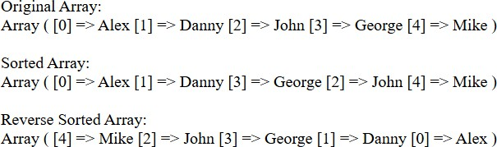

Program # 14
Build a PHP code to store name of Indian Cricket players in an array and display the same in HTML table.

PROGRAM CODE:
Crickerarray.php
<!DOCTYPE html>
<html lang="en">
<body>
<?php
$cricket_players = array("Sachin Tendulkar", "Virat Kohli", "MS Dhoni", "Rohit Sharma");
$count = 1;?>
<table border="1">
<tr> <th> SI_NO </th> <th> PLAYERS NAME </th> </tr>
<?php foreach ($cricket_players as $player) {?>
<tr> <td> <?php echo $count; ?> </td> <td> <?php echo $player; ?> </td>
</tr> <?php
$count++;
}
?>
</body>
</html>

Output:
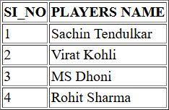

Program # 15
Design a registration form in HTML, and do necessary server side validations using PHP.

PROGRAM CODE:
Formvalidate.php
<!DOCTYPE html>
<html>
<body>
<?php
$name = $email = $password = $mob = "";
$error = "";
if ($_SERVER["REQUEST_METHOD"] == "POST") {
$name = trim($_POST["name"]);
$email = trim($_POST["email"]);
$password = trim($_POST["password"]);
$mob = trim($_POST["mob"]);
if (empty($name) || empty($email) || empty($password) || empty($mob)) {
$error = "All fields must be filled out";
}
elseif (!preg_match("/^[a-zA-Z ]+$/", $name)) {
$error = "Name must contain only letters";
}
elseif (!filter_var($email, FILTER_VALIDATE_EMAIL)) {
$error = "Please enter a valid e-mail address";
}

elseif (strlen($password) < 6) {
$error = "Password must be at least 6 characters long";
}
elseif (!preg_match("/^[0-9]{10}$/", $mob)) {
$error = "Please enter a valid 10-digit mobile number";
}
else {
$error = "Registration successfully submitted";
}
}
?>
<center>
<?php if (!empty($error)){?>
<div style="color:red; font-size:20px; margin-bottom:20px;">
<?php echo $error; ?>
</div>
<?php }?>
<form style="padding: 250px;" method="POST" action="<?php echo
$_SERVER["PHP_SELF"];?>">
<input type="text" name="name" placeholder="Name" value="<?php echo htmlspecialchars($name); ?>" style="width:300px; height:35px;"><br><br>
<input type="email" name="email" placeholder="Email" value="<?php echo htmlspecialchars($email); ?>" style="width:300px; height:35px;"><br><br>

<input type="password" name="password" placeholder="Password" value="<?php echo htmlspecialchars($password); ?>" style="width:300px; height:35px;"><br><br>

<input type="text" name="mob" placeholder="Mob.No" value="<?php echo htmlspecialchars($mob); ?>" style="width:300px; height:35px;"><br><br>

<input type="submit" value="Register" style="width:300px; height:35px;">
</form>
</center>
</body>
</html>

Output:

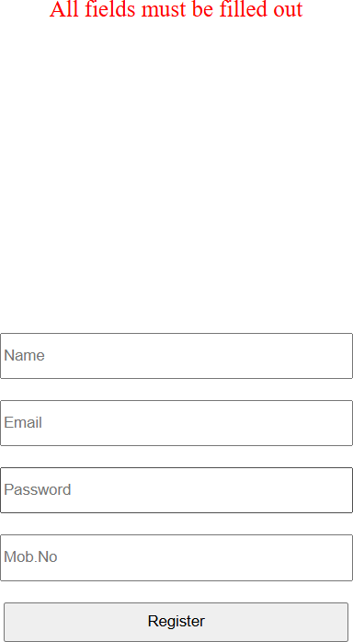
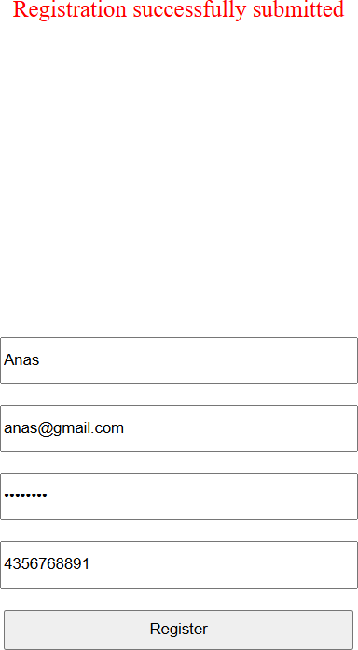

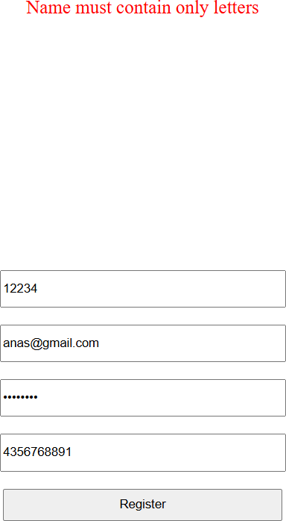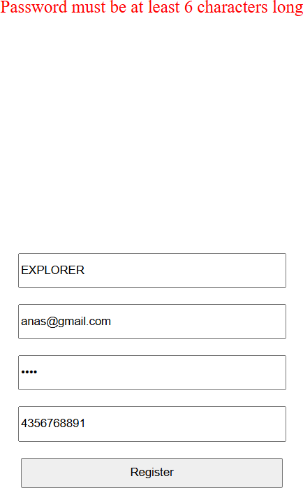

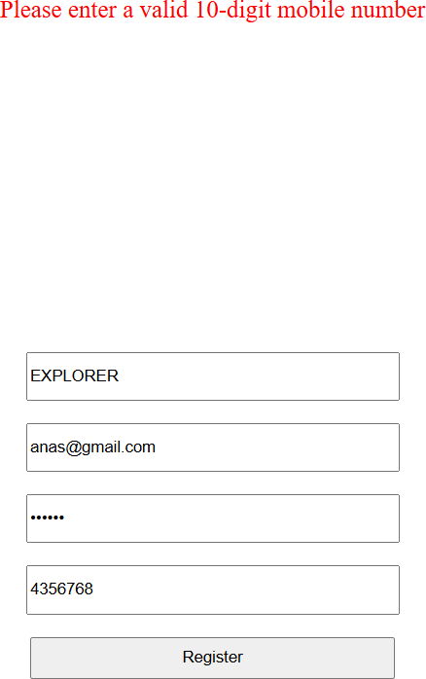

Program # 16
Develop a user-friendly electricity bill calculator using HTML and PHP. Collect the consumer data, and the units used, through an input form. Based on the given tariff, calculate the consumer bill amount.

Tariff:
Rate of electricity for 1-100 units: Rs.5/unit
Rate of electricity from 101 units to 200 units: Rs. 7.5/unit Rate of electricity from 201 units: Rs.10/unit.

PROGRAM CODE:
Electricity.php
<!DOCTYPE html>
<html>
<body>
<?php
$name = $meter = $units = "";
$result = "";
if ($_SERVER["REQUEST_METHOD"] == "POST") {
$name = trim($_POST["name"]);
$meter = trim($_POST["meter"]);
$units = trim($_POST["units"]);
if (empty($name) || empty($meter) || empty($units)) {
$result = "<span style='color:red;'>All fields are required.</span>";
}
elseif (!is_numeric($units) || $units < 0) {
$result = "<span style='color:red;'>Units must be a valid positive number.</span>";
}

else {
if ($units <= 100) {
$bill = $units * 5;
}
elseif ($units <= 200) {
$bill = (100 * 5) + (($units - 100) * 7.5);
}
else {
$bill = (100 * 5) + (100 * 7.5) + (($units - 200) * 10);
}
$result = "
<h2 style='color:green;'>Bill Details</h2>
<p><b>Consumer Name:</b> $name</p>
<p><b>Meter Number:</b> $meter</p>
<p><b>Total Units Used:</b> $units</p>
<p><b>Total Bill Amount:</b> ₹$bill</p>";
}
}
?>
<center>
<h1>Electricity Bill Calculator</h1>
<div style="margin:20px; font-size:18px;">
<?php echo $result; ?>
</div>
<form method="POST" action="">
<input type="text" name="name" placeholder="Enter Consumer Name"

value="<?php echo htmlspecialchars($name); ?>" style="width:300px; height:35px;"><br><br>
<input type="text" name="meter" placeholder="Enter Meter Number" value="<?php echo htmlspecialchars($meter); ?>" style="width:300px; height:35px;"><br><br>
<input type="number" name="units" placeholder="Enter Units Used" value="<?php echo htmlspecialchars($units); ?>" style="width:300px; height:35px;"><br><br>
<input type="submit" value="Calculate Bill" style="width:300px; height:35px;">
</form>
</center>
</body>
</html>

Output:
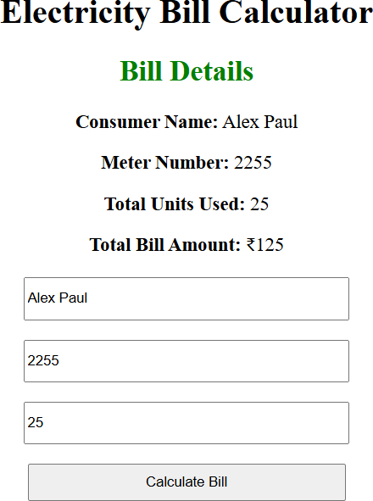

Program # 17
Develop a PHP program to connect to a database and retrieve data from a table and show the details in a neat format.

PROGRAM CODE:

Studentdetails.php
<!DOCTYPE html>
<head>
<style>
table {
font-family: Arial, sans-serif; border-collapse: collapse; width: 80%;
margin: auto; text-align: center;
}
</style>
</head>
<body>
<h2><center>Student Records</center></h2>
<?php
$conn = mysqli_connect('localhost','root','','college'); if (!$conn) {

die("Connection failed: " . mysqli_connect_error());
}
$sql = "SELECT rollno, name, age, course FROM students";
$result = mysqli_query($conn, $sql); if (mysqli_num_rows($result) > 0) {?>
<table class="table" border='1'>
<tr>
<th>Roll No</th>
<th>Name</th>
<th>Age</th>
<th>Course</th>
</tr>
<?php
while($row = mysqli_fetch_assoc($result))
{?>
<tr>
<td><?php echo $row['rollno']; ?></td>
<td><?php echo $row['name']; ?></td>
<td><?php echo $row['age']; ?></td>
<td><?php echo $row['course']; ?></td>
</tr>
<?php
}?>
</table>
<?php
}

else
{
echo "No records found";
}
mysqli_close($conn);
?>
</body>
</html>

Output:
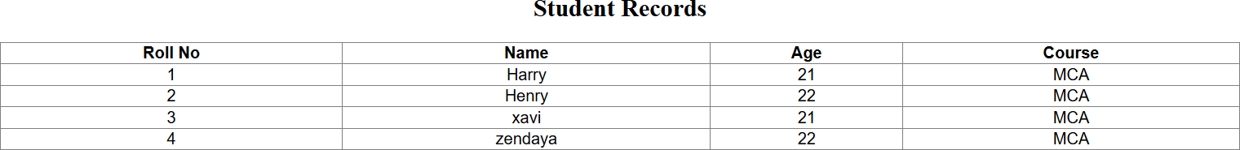

Program # 18
Develop an application in PHP and MySQL, to accept book details viz. Book id, title, authors, edition and publisher from an HTML form in a web page and save the records in a MySQL database on submission. The program also should include a search function given the author's name, and display the search results.

PROGRAM CODE:
Book.php
<!DOCTYPE html>
<html lang="en">
<head>
<meta charset="UTF-8">
<title>Book Database</title>
<style>
body {
font-family: Arial, sans-serif; background: #f4f7fa; margin: 0;
padding: 20px;
}
h2 {
text-align: center; color: #333;
}
.container { width: 50%; margin: auto;

background: #fff; padding: 20px; border-radius: 8px;
box-shadow: 0 0 10px rgba(0,0,0,0.1); margin-bottom: 30px;
}
label {
font-weight: bold;
}
input[type="text"], input[type="number"] {
width: 95%; padding: 10px;
margin: 8px 0 15px 0; border: 1px solid #ccc; border-radius: 5px;
}
input[type="submit"] { background: #007bff; border: none; padding: 10px 20px; color: white;
border-radius: 5px; cursor: pointer;
}

input[type="submit"]:hover { background: #0056b3;
}
table {
width: 80%; margin: auto;
border-collapse: collapse; background: white;
box-shadow: 0 0 10px rgba(0,0,0,0.1);
}
table, th, td {
border: 1px solid #ccc; padding: 12px;
text-align: center;
}

th {
background: #007bff; color: white;
}
</style>
</head>
<body>
<h2>Add Book Details</h2>
<div class="container">
<form action="program18.php" method="post">

<label>Book ID:</label>
<input type="text" name="id" required="">
<label>Title:</label>
<input type="text" name="name"required="">
<label>Authors:</label>
<input type="text" name="auth"required="">
<label>Edition:</label>
<input type="number" name="edition"required="">
<label>Publisher:</label>
<input type="text" name="publisher"required="">
<input type="submit" name="submit" value="Submit">
</form>
</div>
<h2>Search Book</h2>
<div class="container">
<form action="program18.php" method="post">
<label>Book ID:</label>
<input type="text" name="bookid"required="">
<input type="submit" name="search" value="Search">
</form>
</div>
<?php
$conn = mysqli_connect('localhost','root','', 'college'); if (!$conn) {
die("Connection failed: " . mysqli_connect_error());
}

if (isset($_POST['submit']))
{
$id=$_POST['id'];
$name=$_POST['name'];
$auth=$_POST['auth'];
$edition=$_POST['edition'];
$publisher=$_POST['publisher'];

$sql = "INSERT INTO books VALUES ('$id', '$name', '$auth', '$edition', '$publisher')";
mysqli_query($conn, $sql);
}
if (isset($_POST['search']))
{
$id=$_POST['bookid'];
$sql = "SELECT * FROM books where book_id='$id'";
$result = mysqli_query($conn, $sql); if (mysqli_num_rows($result) > 0) {
?>
<table class="table" border='1'>
<tr>
<th>Book ID</th>
<th>Title</th>
<th>Authors</th>
<th>Edition</th>
<th>Publisher</th>

</tr>
<?php
while( $row = mysqli_fetch_assoc($result))
{?>
<tr>
<td><?php echo $row['book_id']; ?></td>
<td><?php echo $row['book_title']; ?></td>
<td><?php echo $row['book_author']; ?></td>
<td><?php echo $row['book_edition']; ?></td>
<td><?php echo $row['publisher']; ?></td>
</tr>
<?php
}
}
else
{
echo "No records found";
}
}
?>
</body>
</html>

Output:
