**SAVEETHA SCHOOL OF ENGINEERING**

**CSA1142-OBJECT ORIENTED ANALYSIS AND DESIGN**

**QUESTION 14: E-COMMERCE**

**USE CASE**

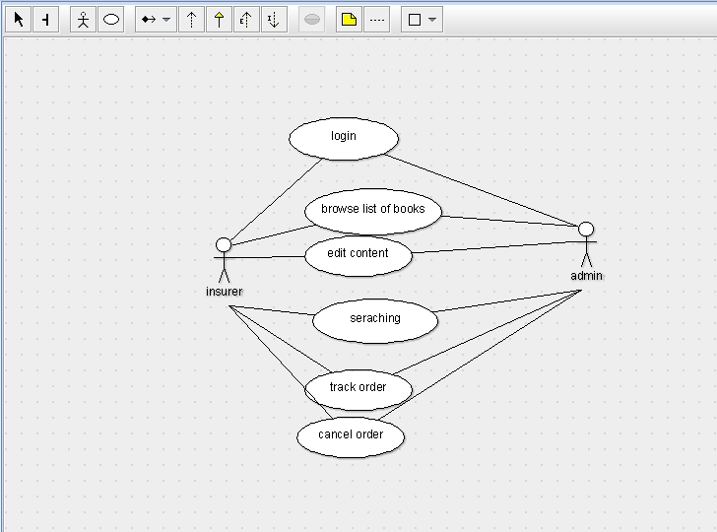

STATE DIAGRAM

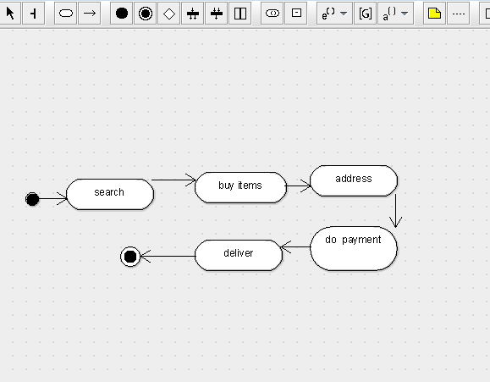

SEQUENCE DIAGRAM

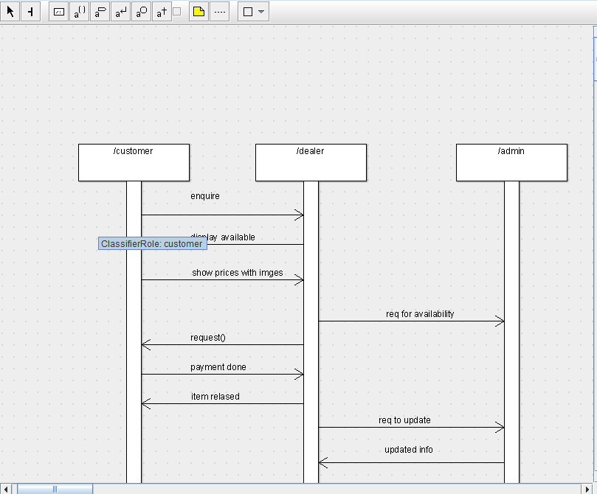

DEPLOYMENT DIAGRAM

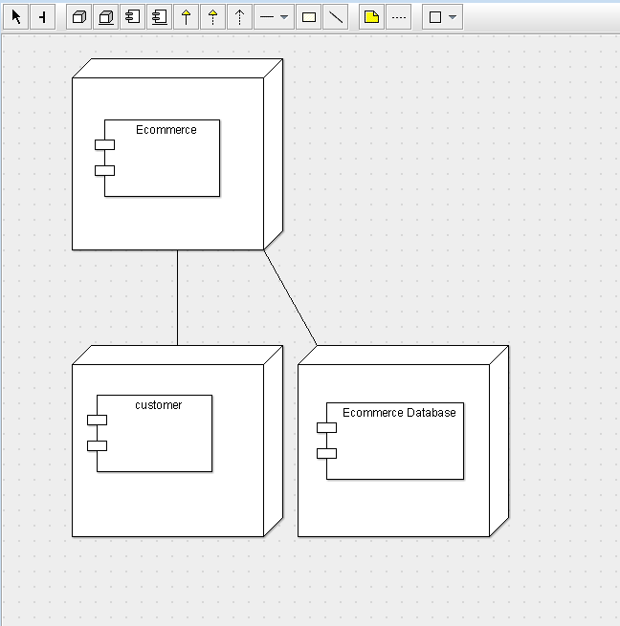

COMPONENT DIAGRAM

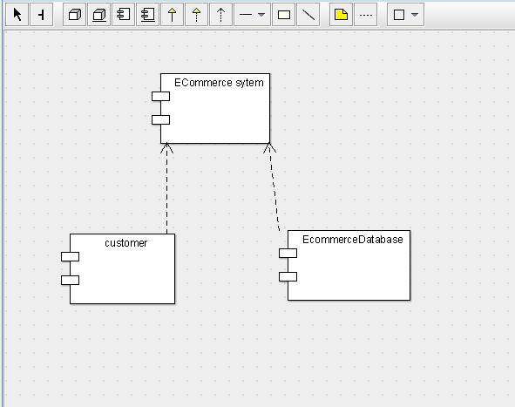

COLLABORATION DIAGRAM

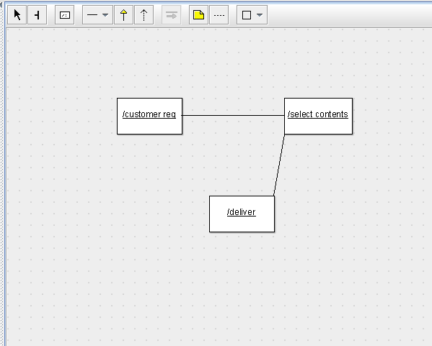

CLASS DIAGRAM

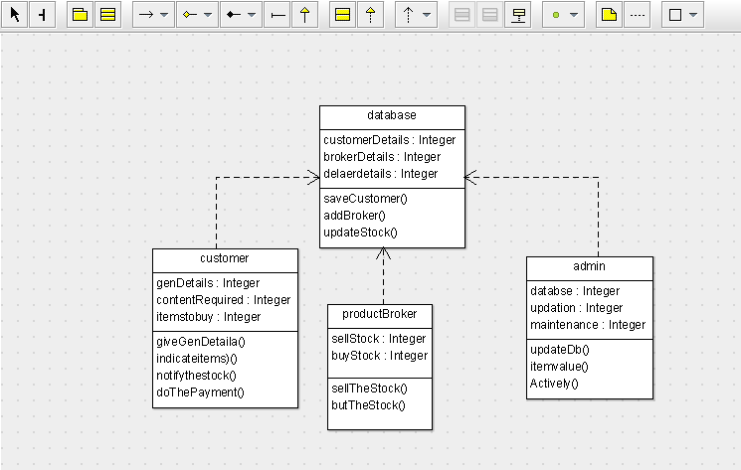

ACTIVITY DIAGRAM

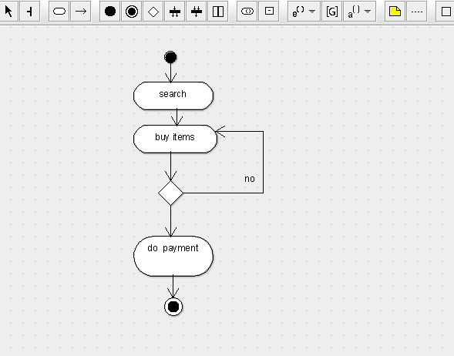

SKELETON CODE;

public class productBroker {

  public Integer sellStock;

  public Integer buyStock;

  public void sellTheStock() {

  }

  public void butTheStock() {

  }

}

public class customer {

  public Integer genDetails;

  public Integer contentRequired;

  public Integer itemstobuy;

  public void giveGenDetaila() {

  }

  public void indicateitems)() {

  }

  public void notifythestock() {

  }

  public void doThePayment() {

  }

}

public class database {

  public Integer customerDetails;

  public Integer brokerDetails;

  public Integer delaerdetails;

  public void saveCustomer() {

  }

  public void addBroker() {

  }

  public void updateStock() {

  }

}

public class admin {

  public Integer databse;

  public Integer updation;

  public Integer maintenance;

  public void updateDb() {

  }

  public void itemvalue() {

  }

  public void Actively() {

  }

}