**SAVEETHA SCHOOL OF ENGINEERING**

**CSA1142-OBJECT ORIENTED ANALYSIS AND DESIGN**

**QUESTION 6: F-TICKET BOOKING**

**USE CASE**

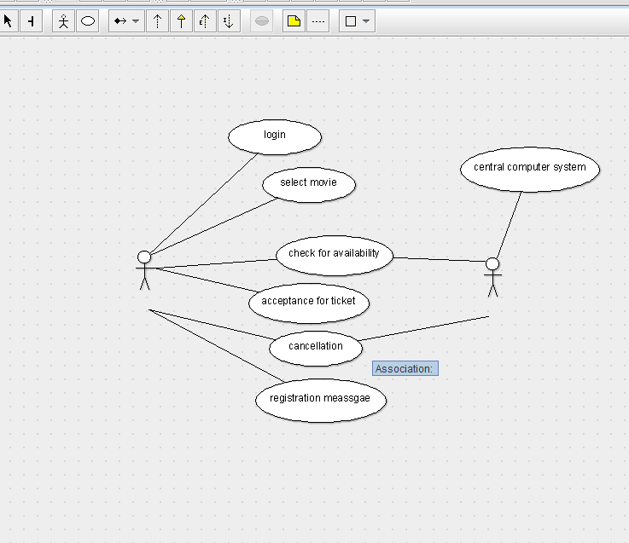

STATE DIAGRAM

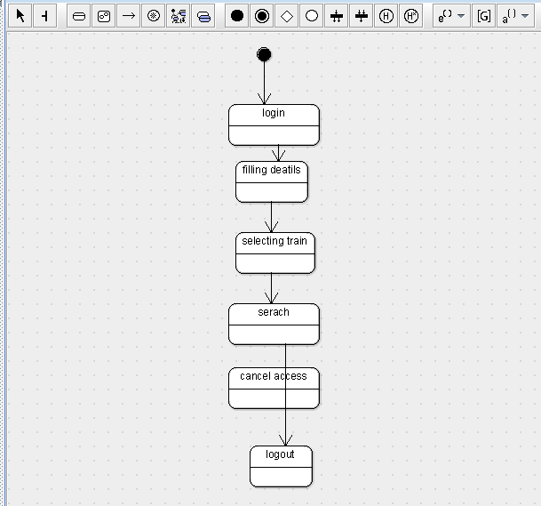

SEQUENCE DIAGRAM

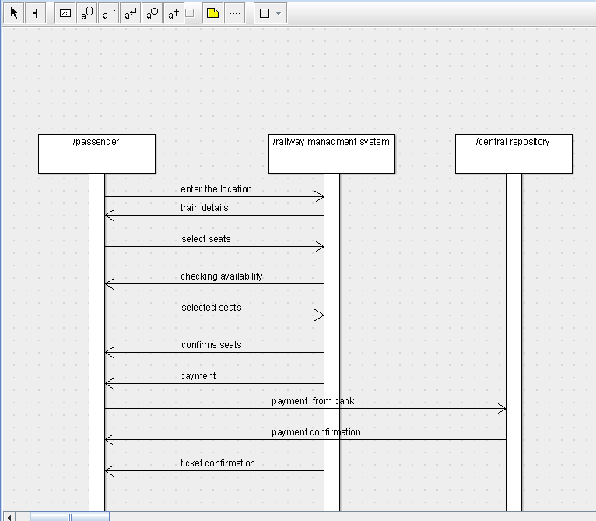

DEPLOYMENT DIAGRAM

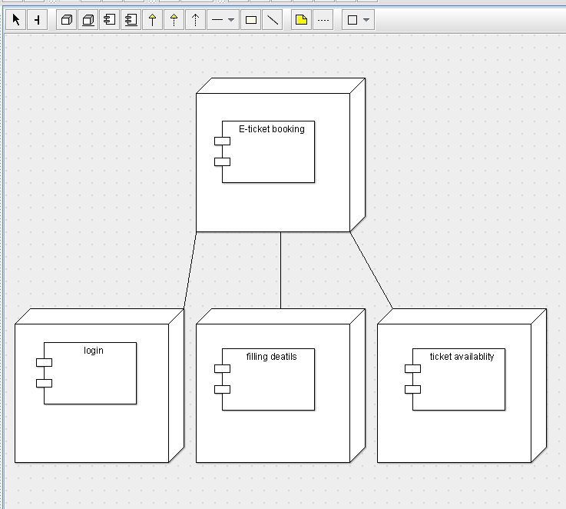

COMPONENT DIAGRAM

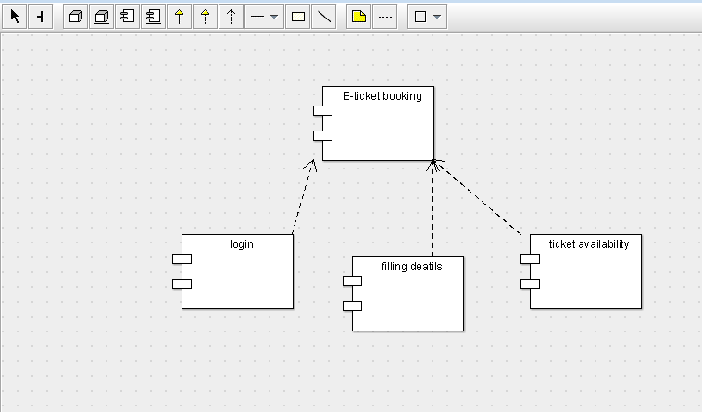

COLLABORATION DIAGRAM

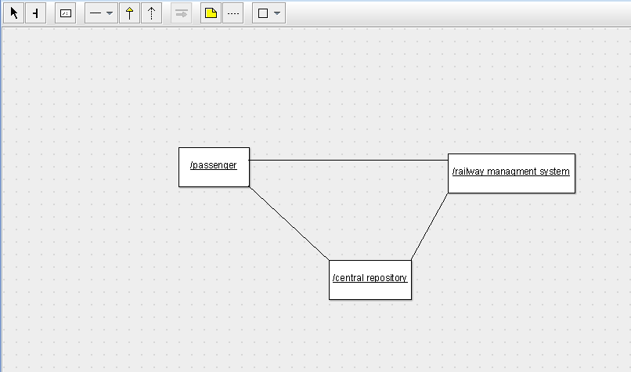

CLASS DIAGRAM

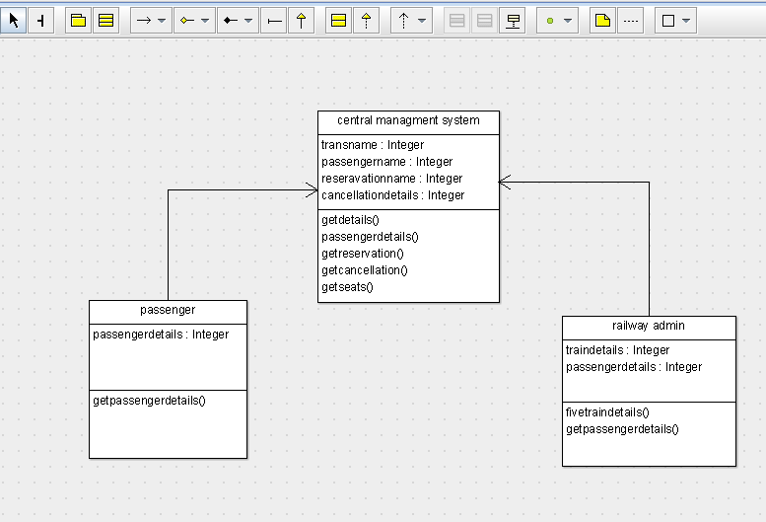

ACTIVITY DIAGRAM

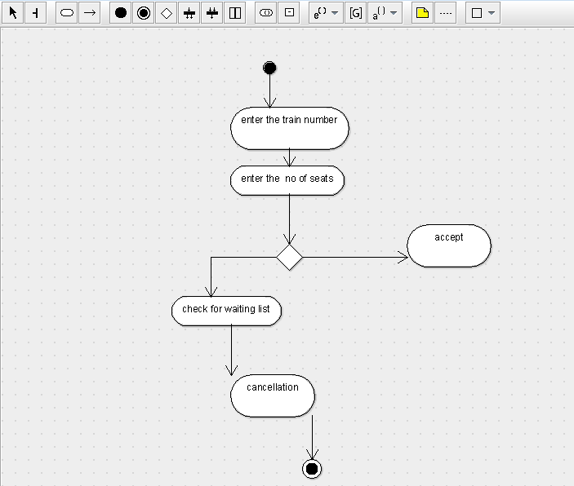

SKELETON CODE:

public class central managment system {

public Integer transname;

public Integer passengername;

public Integer reseravationname;

public Integer cancellationdetails;

public void getdetails() {

}

public void passengerdetails() {

}

public void getreservation() {

}

public void getcancellation() {

}

public void getseats() {

}

}

import java.util.Vector;

public class passenger {

public Integer passengerdetails;

public Vector mycentral managment system;

public void getpassengerdetails() {

}

}

import java.util.Vector;

public class railway admin {

public Integer traindetails;

public Integer passengerdetails;

public Vector mycentral managment system;

public void fivetraindetails() {

}

public void getpassengerdetails() {

}

}