**SAVEETHA SCHOOL OF ENGINEERING**

**CSA1142-OBJECT ORIENTED ANALYSIS AND DESIGN**

QUESTION NO-1: PASSPORT MANAGEMNENT SYSTEM

**USE CASE DIGRAM**

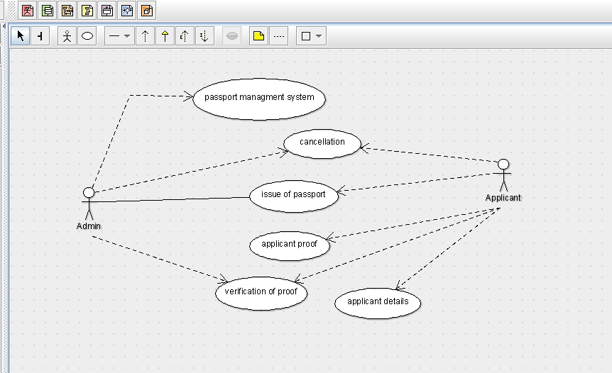

**CLASS DIGRAM**

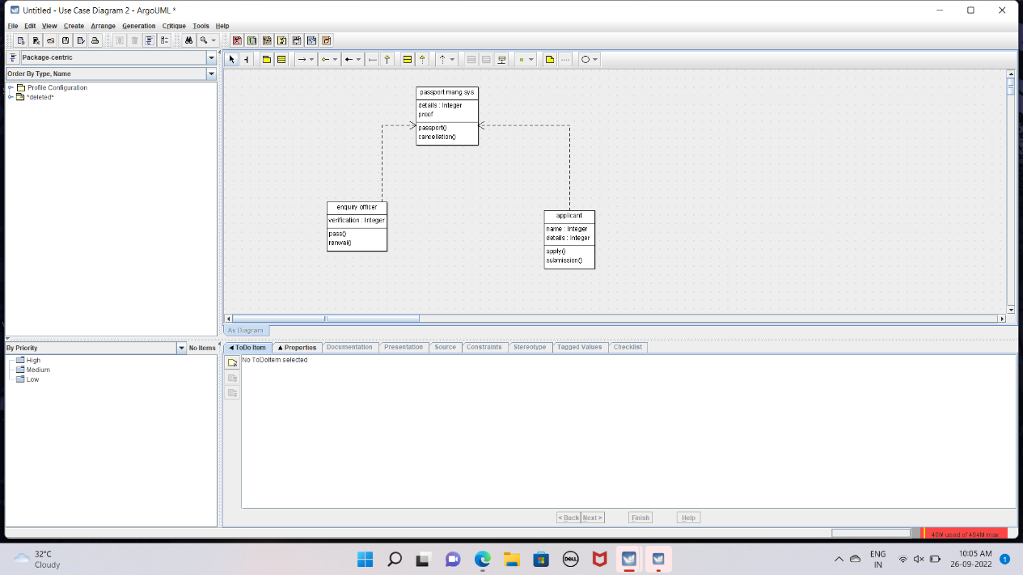

STATE DIGRAM

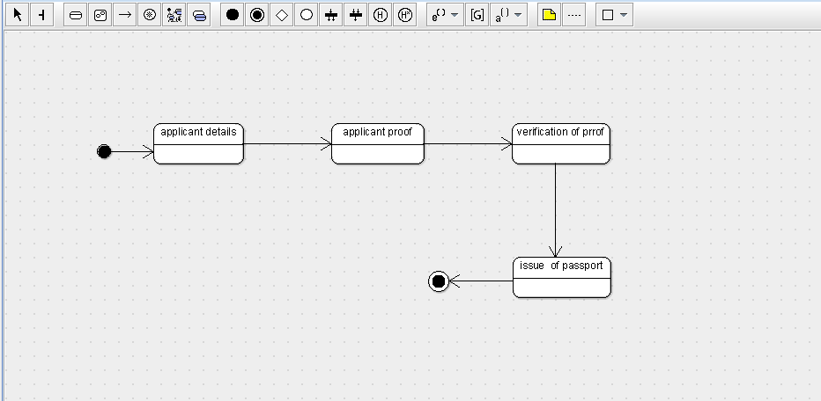

SEQUENCE DIGRAM

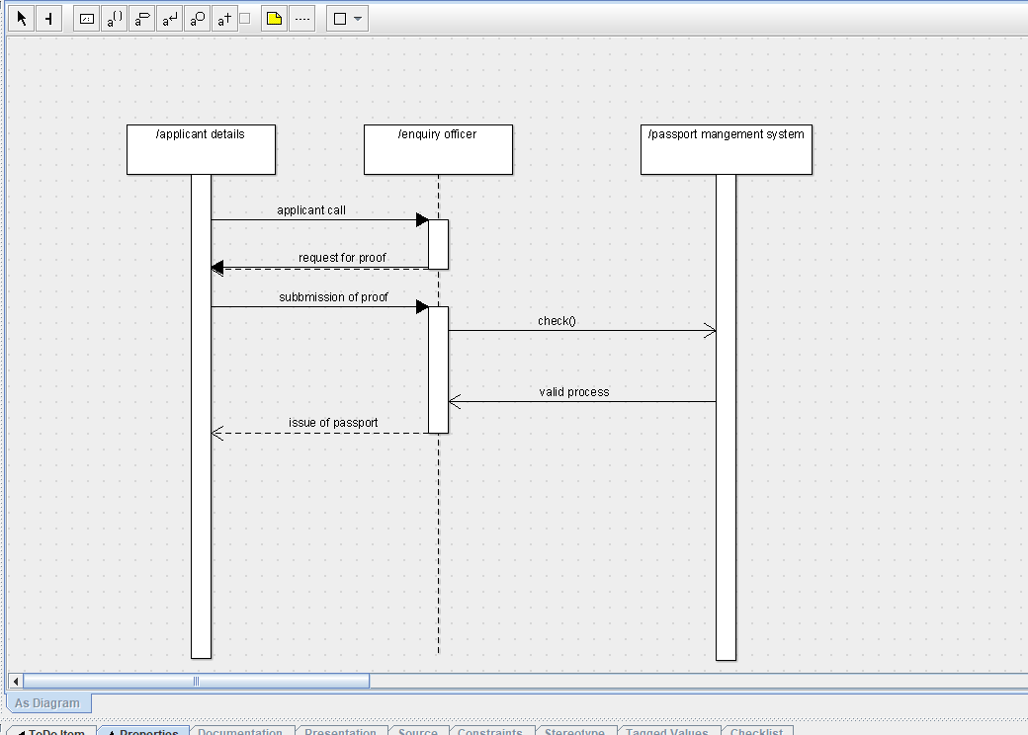

DEPLOYMENT DIGRAM

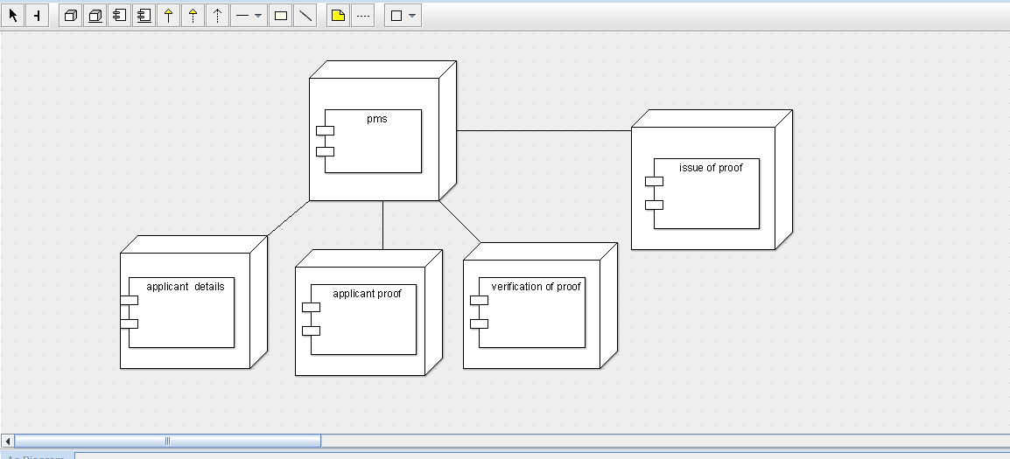

COMPONENT DIGRAM

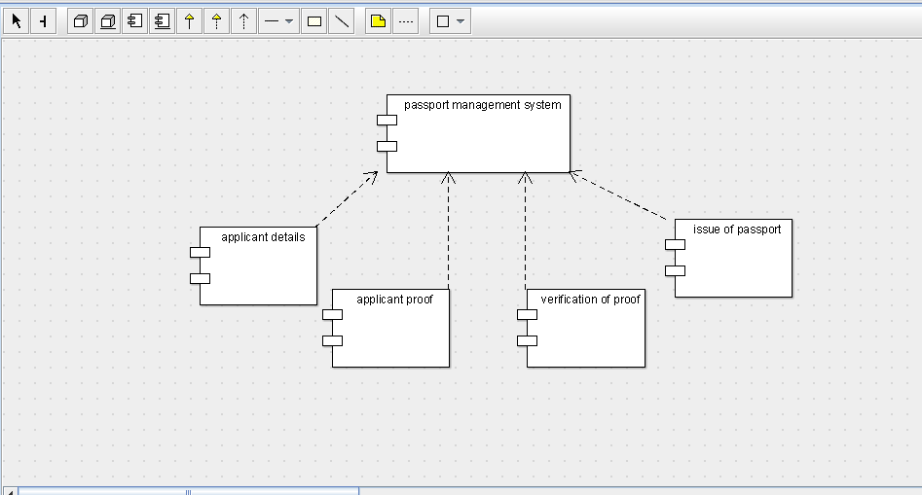

PACKAGE DIGRAM

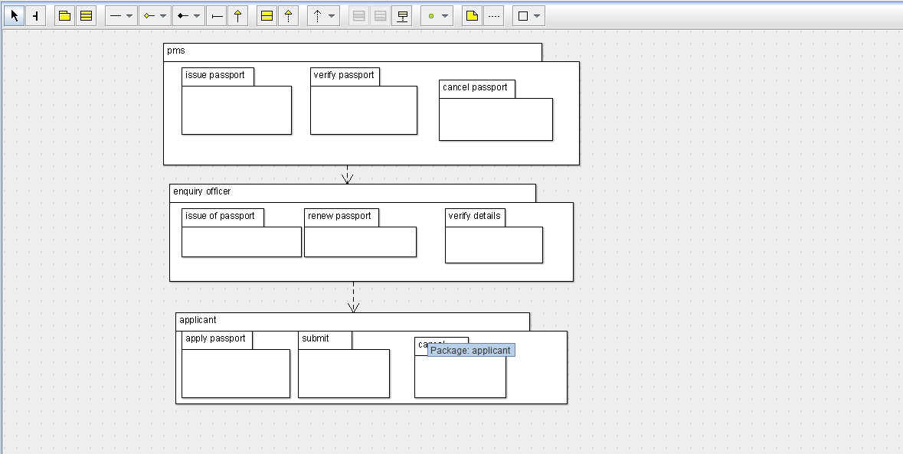

COLLABRATION DIGRAM

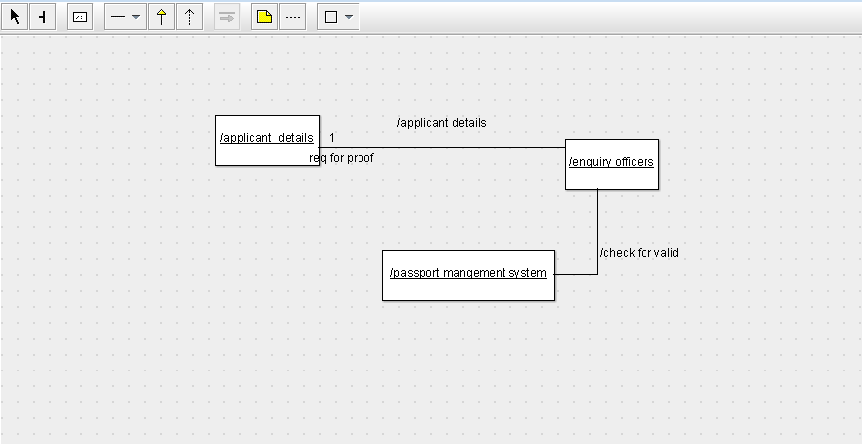

ACTIVITY DIGRAM

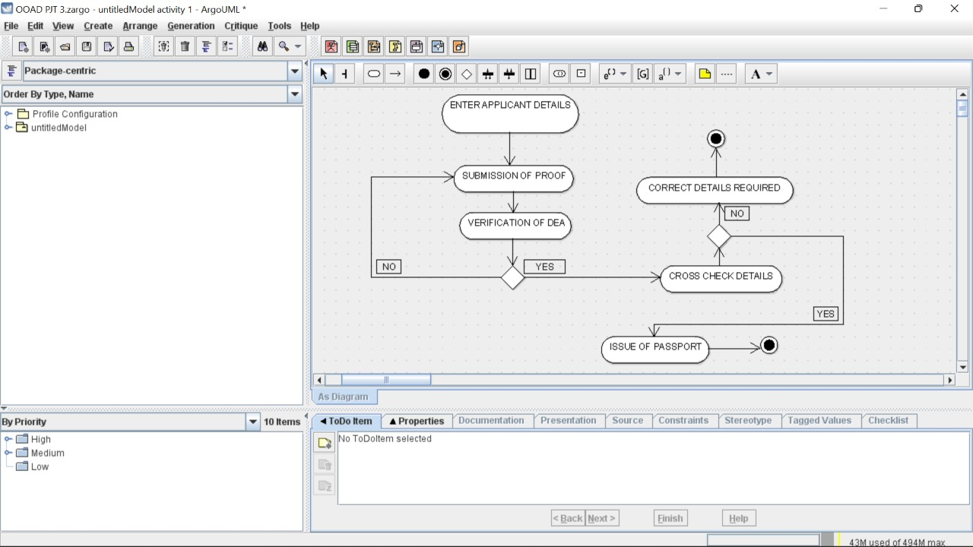

SKELETON CODE:

APPLICANT public class APPLICANT {

public Integer NAME;

private Integer DETAILS;

private void APPLY() {

}

private void SUBMISSION() {

}

}

public class ENQUIRY OFFICERS {

private VERIFICATIONS DETAILS;

private void ISSUE() {

}

private void RENUAL() {

}

}

public class PASSPORT MANAGE SYSTEM {

private Integer DETAILS;

public Integer PROOF;

private void PASSPORT() {

}

private void VERIFICATION() {

}

public void CANCELLATION() {

}

}