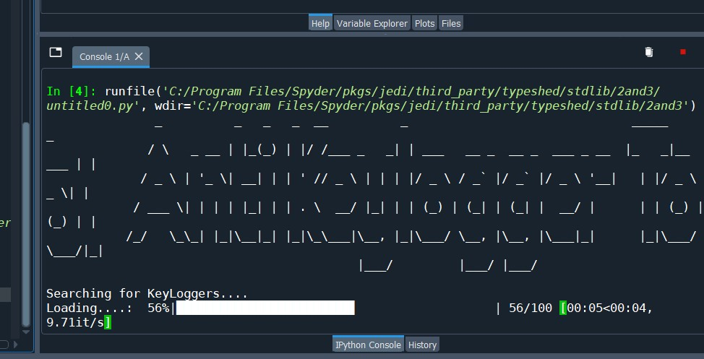

If there is no keylogger it would not show anything