**Exercise 1: Ranking and Window Functions**

Goal: Use ROW_NUMBER(), RANK(), DENSE_RANK(), OVER(), and PARTITION BY.

Scenario:

Find the top 3 most expensive products in each category using different ranking functions.

Steps:

1. Use ROW_NUMBER() to assign a unique rank within each category.

2. Use RANK() and DENSE_RANK() to compare how ties are handled.

3. Use PARTITION BY Category and ORDER BY Price DESC.

**1. Use ROW_NUMBER() to assign a unique rank within each category.**

SELECT

Category,

ProductName,

Price,

ROW_NUMBER() OVER (PARTITION BY Category ORDER BY Price DESC) AS RowNum

FROM Products;

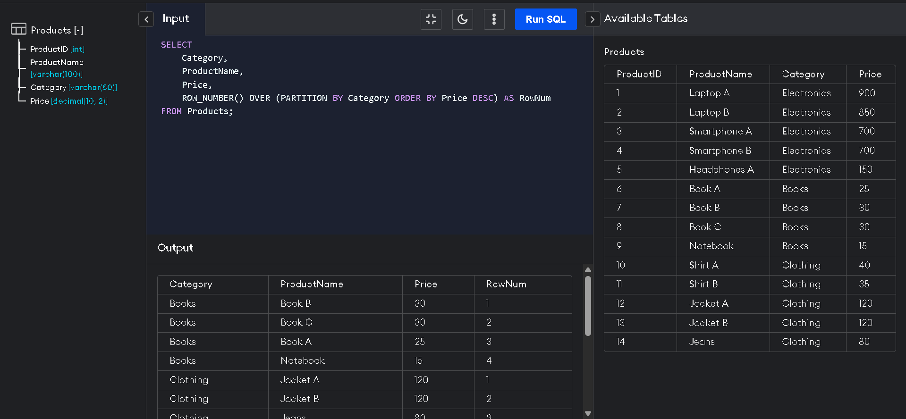

**2. Use RANK() and DENSE_RANK() to compare how ties are handled.**

SELECT

Category,

ProductName,

Price,

RANK() OVER (PARTITION BY Category ORDER BY Price DESC) AS RankNum

FROM Products;

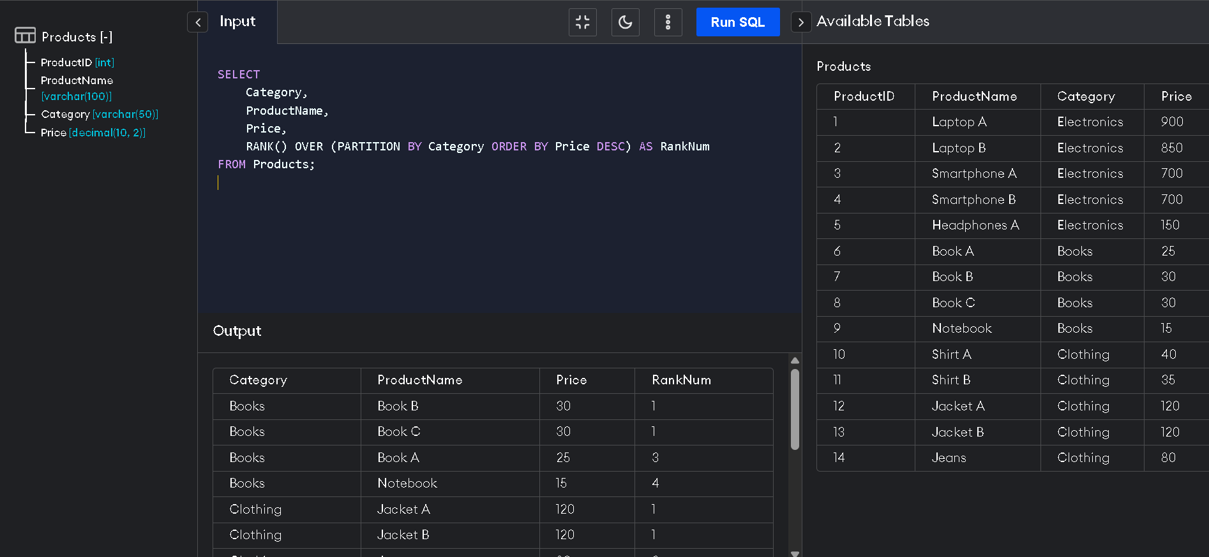

**3. Use PARTITION BY Category and ORDER BY Price DESC.**

SELECT

Category,

ProductName,

Price,

DENSE_RANK() OVER (PARTITION BY Category ORDER BY Price DESC) AS DenseRankNum

FROM Products;

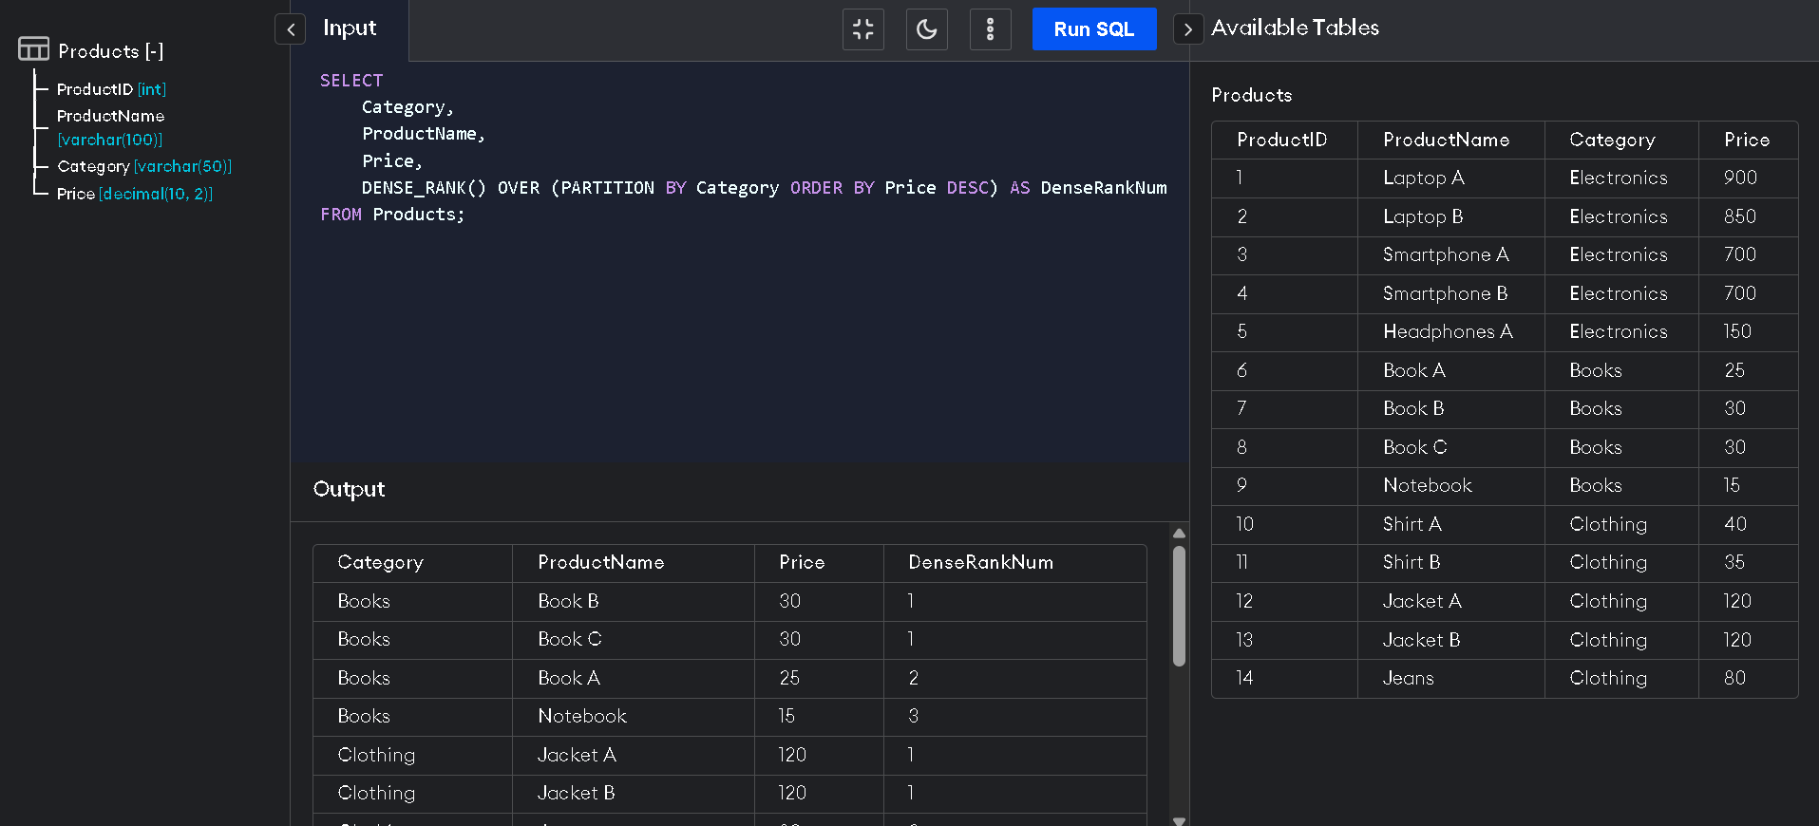

**Top 3 Most Expensive Products per Category**

WITH Ranked AS (

SELECT *,

ROW_NUMBER() OVER (PARTITION BY Category ORDER BY Price DESC) AS RowNum

FROM Products

)

SELECT *

FROM Ranked

WHERE RowNum <= 3;

