- Create a new React Application with the name “myfirstreact”, Run the application to print “welcome to the first session of React” as heading of that page.
App.js

function App() {
return (
<h1>Welcome to the first session of React !!!</h1>

);
}

export default App;

OUTPUT

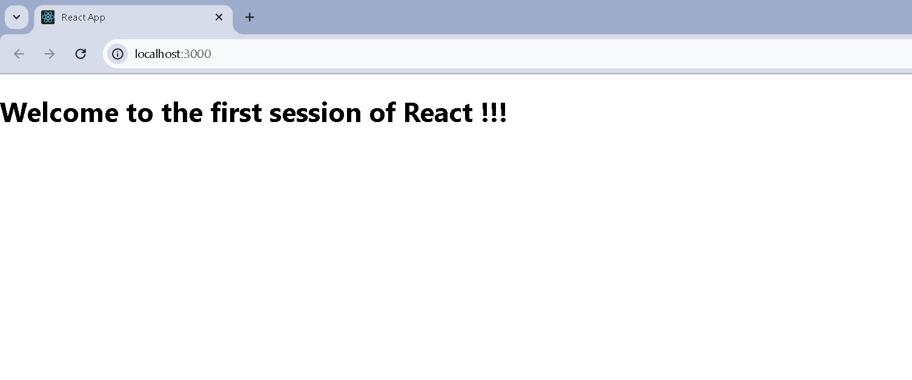

2.Create a react app for Student Management Portal named StudentApp and create a component named Home which will display the Message “Welcome to the Home page of Student Management Portal”. Create another component named About and display the Message “Welcome to the About page of the Student Management Portal”. Create a third component named Contact and display the Message “Welcome to the Contact page of the Student Management Portal”. Call all the three components.

App.js

import React from 'react';
import { BrowserRouter as Router, Routes, Route, Link } from 'react-router-dom';
import Home from './Home';
import About from './About';
import Contact from './Contact';

function App() {
return (
<Router>
<div>
<h1>Student Management Portal</h1>
<nav>
<ul>
<li><Link to="/">Home</Link></li>
<li><Link to="/about">About</Link></li>
<li><Link to="/contact">Contact</Link></li>
</ul>
</nav>

<Routes>
<Route path="/" element={<Home />} />
<Route path="/about" element={<About />} />
<Route path="/contact" element={<Contact />} />
</Routes>
</div>
</Router>
);
}

export default App;

Home.js

import React from 'react';

function Home() {
return <h2>Welcome to the Home page of Student Management Portal</h2>;
}

export default Home;

About.js

import React from 'react';

function About() {
return <h2>Welcome to the About page of the Student Management Portal</h2>;
}

export default About;

Contact.js

import React from 'react';

function Contact() {
return <h2>Welcome to the Contact page of the Student Management Portal</h2>;
}

export default Contact;

OUTPUT

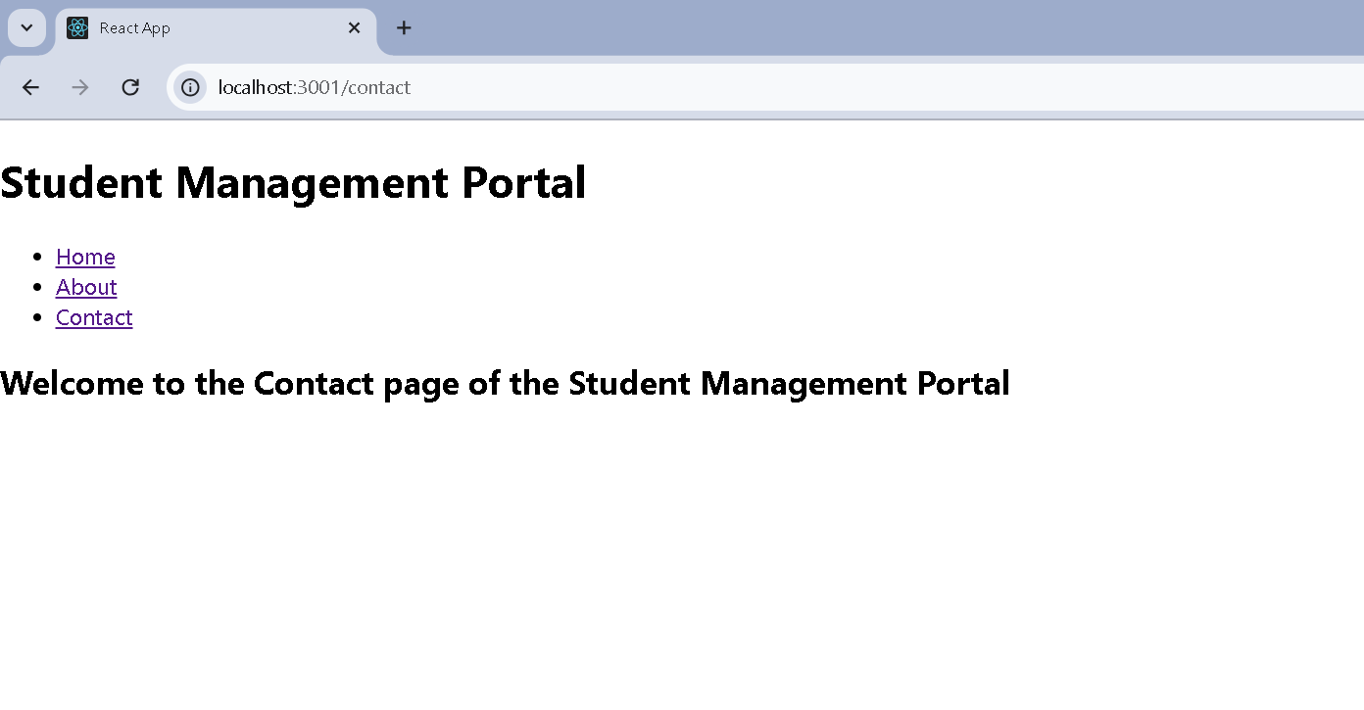

3.Create a react app for Student Management Portal named scorecalculatorapp and create a function component named “CalculateScore” which will accept Name, School, Total and goal in order to calculate the average score of a student and display the same.

CalculateScore.js

import React from 'react';
import '../Stylesheets/mystyle.css';

function CalculateScore() {
const student = {
name: "John Doe",
school: "Green Valley High School",
total: 450,
goal: 500
};

const average = ((student.total / student.goal) * 100).toFixed(2);

return (
<div className="score-container">
<h2>Student Score Calculator</h2>
<p><strong>Name:</strong> {student.name}</p>
<p><strong>School:</strong> {student.school}</p>
<p><strong>Total Marks:</strong> {student.total}</p>
<p><strong>Goal:</strong> {student.goal}</p>
<p><strong>Average Score:</strong> {average}%</p>
</div>
);
}

export default CalculateScore;

mystyle.css

/* src/Stylesheets/mystyle.css */
.score-container {
margin: 30px auto;
padding: 20px;
width: 400px;
border: 2px solid #4CAF50;
border-radius: 10px;
background-color: #f9f9f9;
font-family: Arial, sans-serif;
text-align: left;
}

.score-container h2 {
text-align: center;
color: #4CAF50;
}

.score-container p {
margin: 10px 0;
font-size: 16px;
}

App.js

import React from 'react';
import './App.css';
import CalculateScore from './Components/CalculateScore';

function App() {
return (
<div className="App">
<CalculateScore />
</div>
);
}

export default App;

OUTPUT

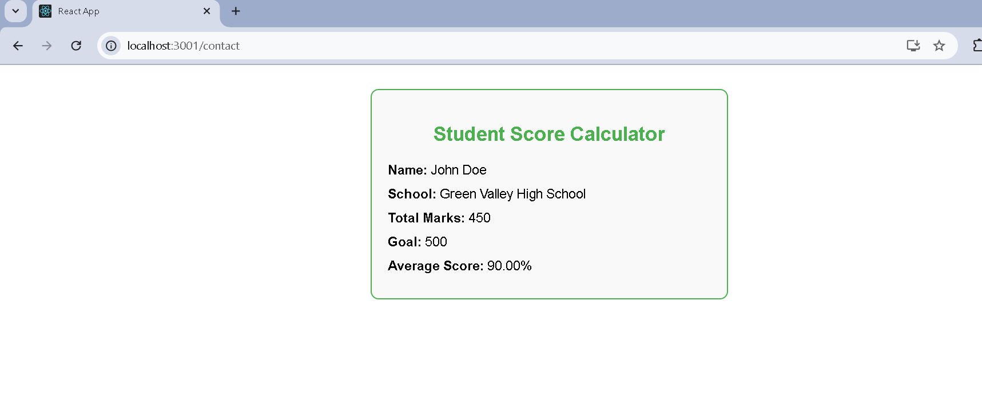

4.1. Create a new react application using create-react-app tool with the name as “blogapp”

Post.js

// src/Post.js

class Post {
constructor(userId, id, title, body) {
this.userId = userId;
this.id = id;
this.title = title;
this.body = body;
}
}

export default Post;

Posts.js

// src/Posts.js

import React, { Component } from 'react';
import Post from './Post';

class Posts extends Component {
constructor(props) {
super(props);
this.state = {
posts: [],
error: false
};
}

componentDidMount() {
fetch("https://jsonplaceholder.typicode.com/posts")
.then(res => res.json())
.then(data => {
const postList = data.map(p => new Post(p.userId, p.id, p.title, p.body));
this.setState({ posts: postList });
})
.catch(() => {
this.setState({ error: true });
});
}

componentDidCatch(error, info) {
alert("Error: " + error.message);
this.setState({ error: true });
}

render() {
if (this.state.error) {
return <h2>Something went wrong.</h2>;
}

return (
<div>
<h1>Blog Posts</h1>
{this.state.posts.map(post => (
<div key={post.id} style={{ marginBottom: "20px" }}>
<h3>{post.title}</h3>
<p>{post.body}</p>
</div>
))}
</div>
);
}
}

export default Posts;

App.js

import React from 'react';
import './App.css';
import Posts from './Posts';

function App() {
return (
<div className="App">
<Posts />
</div>
);
}

export default App;

OUTPUT

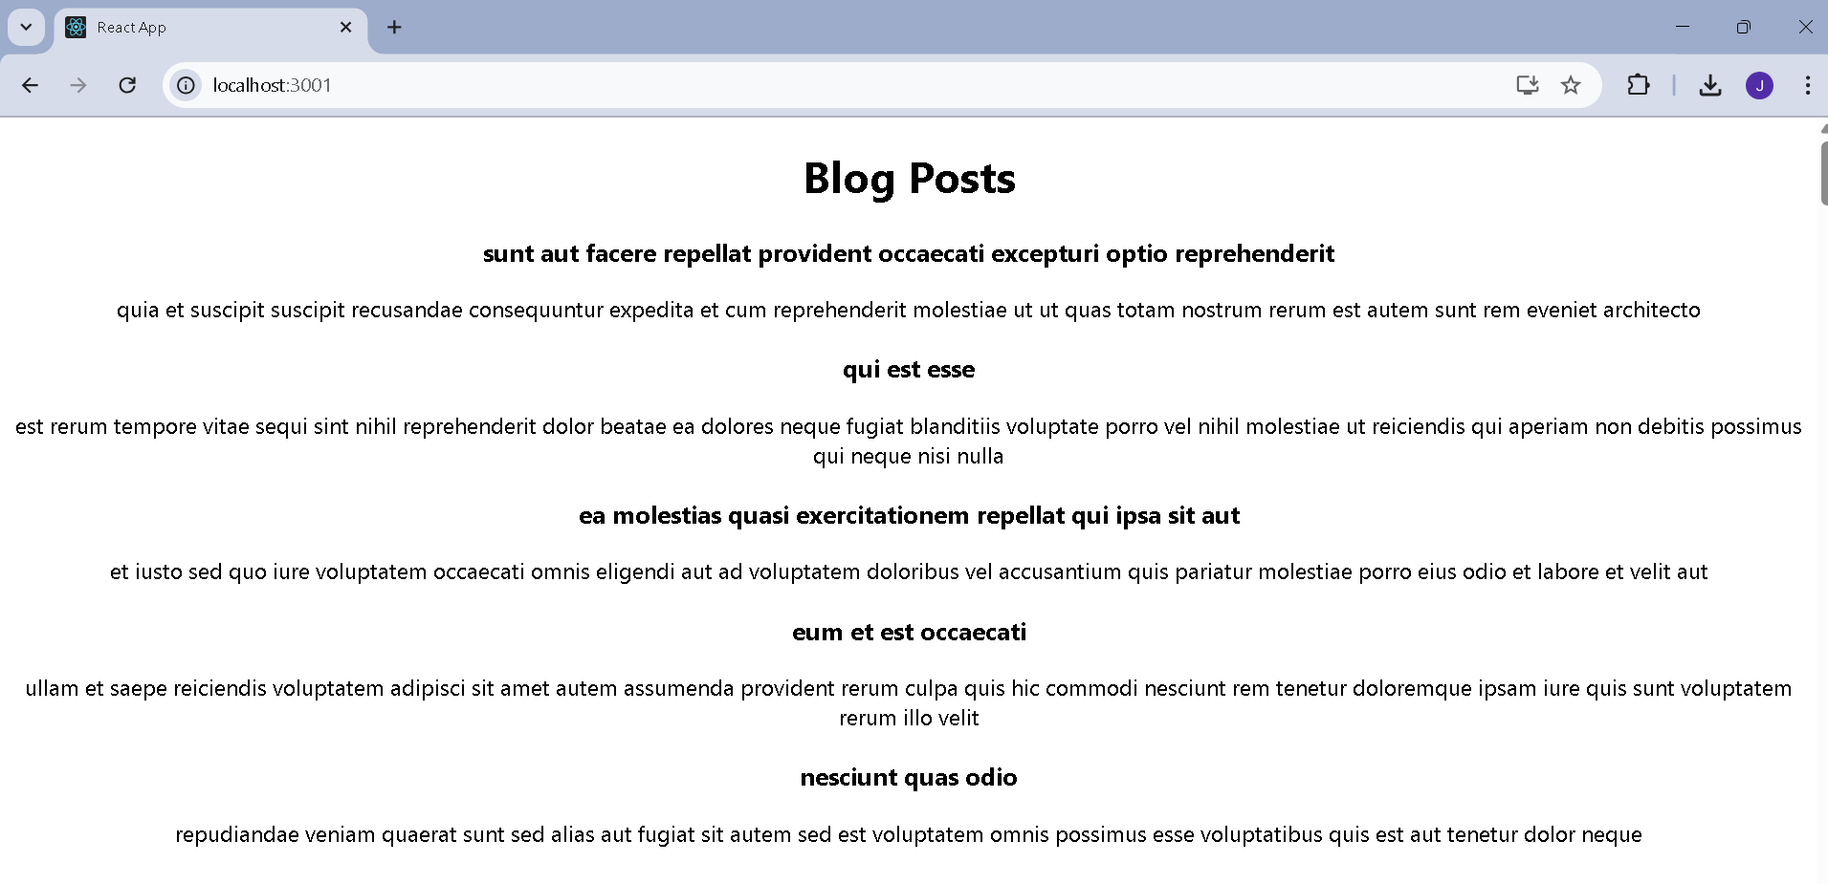

5.My Academy team at Cognizant want to create a dashboard containing the details of ongoing and completed cohorts. A react application is created which displays the detail of the cohorts using react component. You are assigned the task of styling these react components.

CohortDetails.js

// src/CohortDetails.js

import React from 'react';
import styles from './CohortDetails.module.css';

function CohortDetails({ cohort }) {
const titleColor = cohort.status === 'ongoing' ? 'green' : 'blue';

return (
<div className={styles.box}>
<h3 style={{ color: titleColor }}>{cohort.name}</h3>
<dl>
<dt>Status:</dt>
<dd>{cohort.status}</dd>
<dt>Start Date:</dt>
<dd>{cohort.startDate}</dd>
<dt>End Date:</dt>
<dd>{cohort.endDate}</dd>
</dl>
</div>
);
}

export default CohortDetails;

CohortDetails.module.css

/* src/CohortDetails.module.css */

.box {
width: 300px;
display: inline-block;
margin: 10px;
padding: 10px 20px;
border: 1px solid black;
border-radius: 10px;
background-color: #f9f9f9;
}

dt {
font-weight: 500;
}

App.js

// src/App.js

import React from 'react';
import CohortDetails from './CohortDetails';

function App() {
const cohorts = [
{
name: 'React Bootcamp',
status: 'ongoing',
startDate: '2025-07-01',
endDate: '2025-09-30'
},
{
name: 'Java Fullstack',
status: 'completed',
startDate: '2025-03-01',
endDate: '2025-06-30'
}
];

return (
<div style={{ padding: '20px' }}>
<h1>My Academy Cohorts</h1>
{cohorts.map((cohort, index) => (
<CohortDetails key={index} cohort={cohort} />
))}
</div>
);
}

export default App;

OUTPUT

